**Program-2**

**TABLEAU JOINS**

**Dataset used: Tableau Joins File: Contains 3 sheets : Demographics , Salary, JobTitle .**

**1. Connecting to Excel Files in Tableau:**

* Open Tableau and click on Connect in the left pane.
* Under To a File, choose Microsoft Excel.
* Browse and select your Excel file (Tableau Joins File.xlsx).
* Tableau will display the sheets from the Excel file in the Data Source tab.
* Drag the relevant sheets to the workspace.

**2. Tableau Joins File.xlsx Dataset: has three Excel sheets**

* Demographics:
  + - EmployeeID
    - NameofEmployee
    - EmployeeAge
    - EmployeeGender
* Salary:
  + - EmployeeID
    - EmployeeSalary
* Job Title:
  + - EmployeeID
    - EmployeeName
    - JobTitle

These sheets have a relationship based on the EmployeeID, and you can jointhem using this field. Drag and drop Demographics table- Right click-select open- that allows you to do following types of joins. Now Drag and drop Salary table - That allows you to do join of your choice.

**3. Types of Joins in Tableau:**

Once both tables are in the Data Source tab, Tableau automatically suggests an inner join, but you can modify the type of join depending on the scenario.

**a. Inner Join:**

* Description: Returns only records where there is a match in both tables.When you use an **inner join** to combine tables, the result is a table that contains values that have matches in both tables. When a value doesn't match across both tables, it is dropped entirely.

**How to Create in Tableau:**

* Drag Demographics and Salary sheets into the canvas.
* Tableau automatically detects the common field (EmployeeID). If not, manually select

it.

* Choose Inner Join in the Join Type options.
* Result: You will see only employees whose employee id matches in bothDemographics and Salary table.

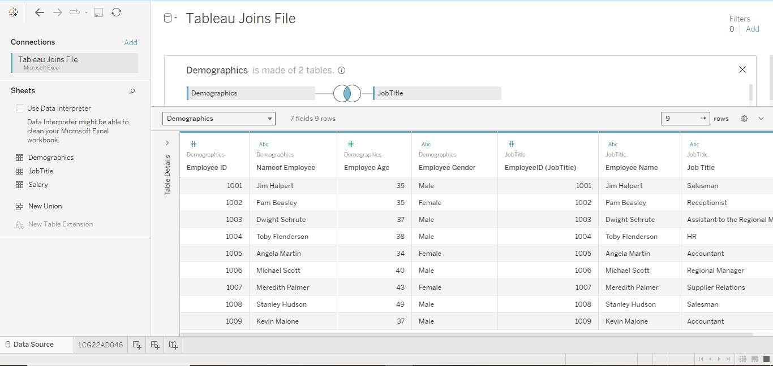

**b. Left Join:**

* Description: Returns all records from the left table (Demographics), and

matched records from the right table (salary).If there’s no match, NULL values

are returned for fields from the right table.

**How to Create in Tableau:**

* In the join settings, select Left Join.

Result: All employees will be returned, even if data missing in Salary. Salary

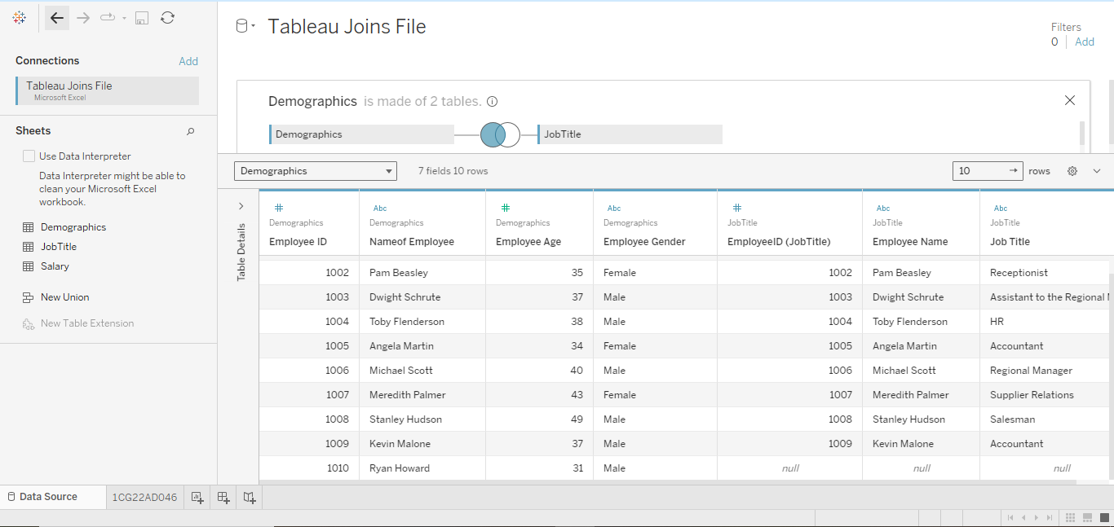

**c. Right Join:**

* Description: Returns all records from the right table (Salary), and matched

records from the left table(Demographics). If there’s no match, NULL values are

returned for fields from the left table.

**How to Create in Tableau:**

* Select Right Join.
* Result: You will see all salary, even if they don't

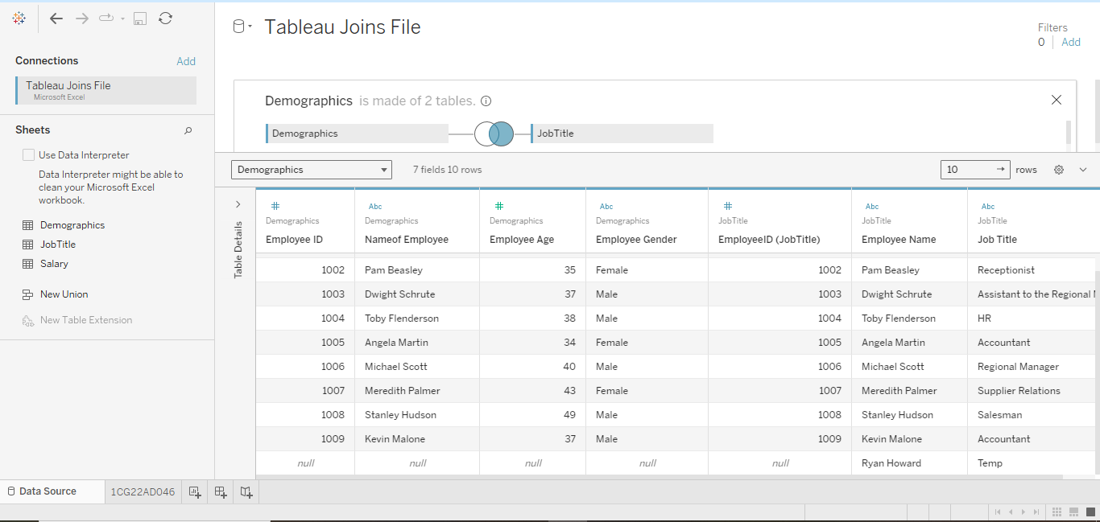

**d. Full Outer Join:**

* Description: Returns all records when there is a match in either theleft (Demographics) or right (JobTitle) table. If there’s no match,NULL values are returned for the missing side.

**How to Create in Tableau:**

* Select Full Outer Join.
* Result: You will see all employees and all salary, even if they don’t have a match in the othertable. NULL values will appear where there’s no corresponding .

