Project :Event management system using MYSQL
Step 1: create table
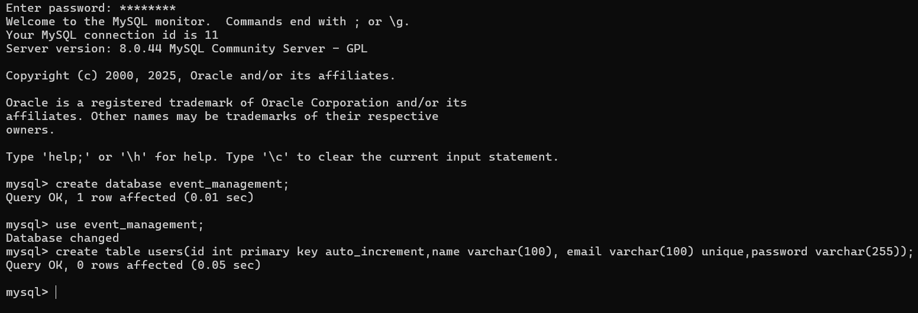
Step2: setup a backend
Create folder:
backend
Initialize:
npm init -y
Install packages:
npm install express mysql2 cors dotenv bcryptjs jsonwebtoken
npm install nodemon --save-dev

Step 3: Project Structure
backend
│
├── config
│ └── db.js
│
├── routes
│ └── userRoutes.js
│
├── controllers
│ └── userController.js
│
├── .env
├── server.js

Step 4: Connect MySQL

.env
PORT=5000
DB_HOST=localhost
DB_USER=root
DB_PASSWORD=root@123
DB_NAME=event_management

config/db.js
const mysql = require("mysql2");
const db = mysql.createConnection({
host: process.env.DB_HOST,
user: process.env.DB_USER,
password: process.env.DB_PASSWORD,
database: process.env.DB_NAME
});
db.connect((err)=>{
if(err){
console.log(err);
}
console.log("MySQL Connected");
});
module.exports = db;

Step 5: Create Custom APIs
A custom API means your own endpoint.
Example:

Register User API
POST /api/users/register

Login API
POST /api/users/login

Get All Users API
GET /api/users

Step 6: Controller

controllers/userController.js
const db = require("../config/db");
const getUsers = (req,res)=>{
const sql = "SELECT * FROM users";
db.query(sql,(err,result)=>{
if(err){
return res.status(500).json(err);
}
res.json(result);
});
};
module.exports = { getUsers };

Step 7: Routes

routes/userRoutes.js
const express = require("express");
const router = express.Router();
const { getUsers } =
require("../controllers/userController");
router.get("/", getUsers);
module.exports = router;

Step 8: Main Server

server.js
require("dotenv").config();
const express = require("express");
const cors = require("cors");
const userRoutes =
require("./routes/userRoutes");
const app = express();
app.use(cors());
app.use(express.json());
app.use("/api/users", userRoutes);
app.listen(process.env.PORT, ()=>{
console.log("Server Running");
});

Step 9: Start Backend
Add script:
"scripts":{
"dev":"nodemon server.js"
}
Run:
npm run dev

Step 10: Test API
Open browser:
http://localhost:5000/api/users
or use Postman.
Expected:
[
{
"id":1,
"name":"Sanika",
"email":"sanika@gmail.com"
}
]

How React Connects
Install Axios:
npm install axios
Fetch users:
useEffect(() => {
axios
.get("http://localhost:5000/api/users")
.then(res => setUsers(res.data));
}, []);

For your Event Management Project, create these custom APIs:
POST /api/auth/register
POST /api/auth/login
GET /api/events
POST /api/events
POST /api/payment/create-order
POST /api/upload
GET /api/bookings
POST /api/chat
This project will let you demonstrate:
✅ JWT Authentication
✅ MySQL Joins
✅ Custom REST APIs
✅ Cloudinary Uploads
✅ Razorpay Integration
✅ WebSockets (Socket.IO)
✅ React + Express + MySQL Full Stack Development

Project Technical Details & Architecture Reference
This document outlines the technical architecture, database schema, API endpoints, and core AI integrations of the Eventify Event Management System.
1. Database Schema
The application utilizes a MySQL database. Below are the key tables used:
Table: users
Stores user profiles and roles (regular users vs managers).
Columns:
id (INT, PK, Auto-Increment)
name (VARCHAR)
email (VARCHAR, Unique)
password (VARCHAR, Hashed)
role (VARCHAR, 'user' or 'manager')
created_at (TIMESTAMP)
Table: events
Stores event details, venues, ticket pricing, and manager ownership.
Columns:
id (INT, PK, Auto-Increment)
name (VARCHAR)
description (TEXT)
date (VARCHAR)
time (VARCHAR)
venue (VARCHAR)
ticket_price (INT)
created_by (INT, FK to users)
created_at (TIMESTAMP)
Table: bookings
Stores event slot bookings registered by users.
Columns:
id (INT, PK, Auto-Increment)
name (VARCHAR)
email (VARCHAR)
phone (VARCHAR)
event_id (INT, FK to events)
created_at (TIMESTAMP)
Table: payments
Stores payment logs and transaction amounts for event tickets.
Columns:
id (INT, PK, Auto-Increment)
event_id (INT)
amount (DECIMAL)
created_at (TIMESTAMP)
2. Backend API Endpoints
Authentication
POST /api/auth/register
Registers a new user (role defaults to 'user').
POST /api/auth/login
Authenticates a user and returns a JWT token.
Events
GET /api/events/events
Fetches all events. If logged in as a manager, only returns events they created.
POST /api/events/events
Creates a new event. (Requires manager token)
PUT /api/events/events/:id/description
Updates the description of an event. (Requires manager token)
DELETE /api/events/events/:id
Deletes an event. (Requires manager token)
Bookings
GET /api/bookings/bookings
Fetches slot bookings. Regular users see their bookings; managers see all bookings.
POST /api/bookings/bookings
Creates a new slot booking. (Requires authenticated token)
Payments
POST /api/payment/create-order
Creates a new Razorpay order. Falls back to generating a mock order if Razorpay is offline.
POST /api/payment/save
Records a transaction in the payments database table.
GET /api/payment/orders
Fetches transaction logs for display in the payments dashboard tab.
AI Integrations
POST /api/ai/generate-description
Generates a descriptive catchphrase for events using title, date, time, and venue context.
POST /api/ai/chat
Interactive endpoint for the Eventify chatbot. It reads active events from the SQL database and passes them to Gemini for context.
3. Core AI Integration & Features
AI Event Description Generator
Built using Google's Gemini 2.5 Flash API, this feature allows managers to generate catchy, personalized event descriptions instantly. It accepts metadata details (name, date, time, and venue) and formulates an engaging paragraph structure, streamlining the event registration process.
Interactive AI Event Chatbot Assistant
A premium glassmorphic floating chatbot widget integrated directly into the user dashboard. The backend dynamically queries all events in the MySQL database and feeds this context into the Gemini API system instructions. Users can ask questions in natural language, request event recommendations, search for free/paid events, or query ticket prices. It supports message history preservation and auto-scrolling.

