Real-Time Ferry Ticket Sales & Redemption Analytics
for Toronto Island Park
Research Paper
Prepared for: Toronto Government — Parks, Forestry & Recreation
Submitted by: Unified Mentor Analytics Program
August 2026

Abstract
Toronto Island Park's ferry network moves passengers between the Jack Layton Ferry Terminal and three island destinations — Centre Island, Hanlan's Point, and Ward's Island. Ticket sales and redemptions are logged in fifteen-minute intervals, producing a rich but previously unexploited operational dataset spanning May 2015 through December 2025 (261,538 interval records). This paper presents an exploratory and diagnostic analysis of that dataset to identify peak passenger-flow windows, quantify net passenger movement, and translate those findings into concrete recommendations for ferry scheduling, staffing, and public-safety planning. The analysis is accompanied by an interactive Streamlit dashboard that operationalizes these findings for three stakeholder groups: operations staff, policy planners, and management.

1. Introduction
Ferries are the sole means of public access to the Toronto Islands, making accurate demand forecasting essential to visitor experience, terminal congestion management, and safety. While ticket sales and redemptions have long been recorded at fifteen-minute granularity, no centralized analytics system previously existed to convert these records into actionable operational intelligence. This project addresses that gap by building a full analytics pipeline — from raw data ingestion through cleaning, feature engineering, exploratory analysis, and an interactive dashboard — to support Parks, Forestry & Recreation decision-makers.

1.1 Objectives
Primary objectives:
- Analyze historical and near real-time ticket activity across an 10.5-year window.
- Identify peak and off-peak ferry demand periods at the hourly, daily, and seasonal level.
- Quantify passenger inflow (sales) and outflow (redemption) trends and their net effect on terminal occupancy.
Secondary objectives:
- Support operational decision-making for ferry scheduling and crew allocation.
- Improve passenger experience during peak hours through evidence-based congestion management.

2. Dataset Description
The dataset consists of 261,538 records spanning May 1, 2015 to December 21, 2025, with three primary fields:
Column | Description
_id | Unique row identifier
Timestamp | Start of the 15-minute (occasionally 30/45-minute) recording interval
Sales Count | Tickets sold within the interval
Redemption Count | Tickets redeemed (boarded) within the interval

No missing values were present in any of the three data fields. Interval spacing is predominantly 15 minutes (90.3% of consecutive records), with longer gaps corresponding to overnight and off-season hours when the ferry service does not operate continuously.

3. Methodology

3.1 Data Ingestion & Cleaning
- Timestamps were parsed to native datetime objects and the dataset was sorted chronologically.
- Negative counts (data-entry artifacts) were clipped to zero; none were found to require this in the current extract, but the safeguard is retained in the pipeline.
- Outlier screening used the interquartile range (IQR) method. Values beyond 3×IQR above the third quartile were flagged (approximately 7.6% of Sales Count records, 9.5% of Redemption Count records). Inspection showed these are concentrated in July–August daytime hours and reflect genuine high-season peaks rather than data errors, so they were retained rather than removed.
- Interval-consistency checks confirmed the 15-minute cadence during operating hours, with expected gaps overnight and during the winter off-season.

3.2 Feature Engineering
- Hour of day (0–23)
- Day of week and weekend/weekday flag
- Month and derived meteorological season (Winter/Spring/Summer/Fall)
- Net Passenger Movement = Sales Count − Redemption Count

3.3 Exploratory Data Analysis
Hourly and daily aggregation, seasonal comparison, sales-vs-redemption distributional analysis, and 1-hour / 4-hour rolling averages (computed for both Sales and Redemption counts) were used to characterize demand dynamics at multiple time scales. All analyses were replicated in an interactive Streamlit application allowing stakeholders to apply their own date, hour, year, season, and weekday/weekend filters. The application also includes a dedicated Data Quality tab exposing the cleaning summary, IQR outlier flags, and interval-consistency checks described in Section 3.1, and a Live Feed Simulator that replays the most recent interval records to approximate a near real-time operational view.

4. Key Findings

4.1 Overall Volumes
Across the full study window, the terminal recorded 12,972,051 ticket sales and 12,785,293 redemptions, a cumulative net positive movement of 186,758 — consistent with ticket sales that are occasionally redeemed on a different day (e.g., multi-day passes) or not redeemed at all.

4.2 Hourly Demand Pattern
Demand follows a pronounced single-peak daily curve. Sales activity is minimal before 07:00, rises sharply through the morning, and peaks between 11:00 and 14:00, with the single highest average interval volume occurring at 12:00 (approximately 94.5 tickets sold per 15-minute interval on average). Redemptions lag sales by roughly one hour, peaking at 12:00–13:00 as arriving visitors board outbound ferries. Demand tapers steadily into the evening, falling below 15 tickets/interval after 22:00.
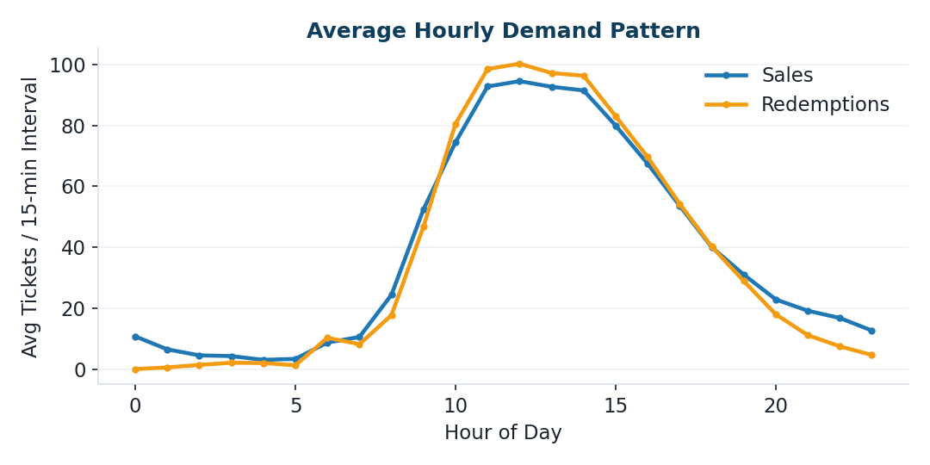
Figure 1. Average hourly demand pattern — sales vs. redemptions (15-minute interval average).
Hour | Avg Sales / 15-min | Avg Redemptions / 15-min
08:00 | 24.4 | 17.8
10:00 | 74.5 | 80.5
12:00 (Peak) | 94.5 | 100.2
14:00 | 91.5 | 96.3
16:00 | 67.4 | 69.6
20:00 | 22.9 | 18.0

4.3 Day-of-Week Pattern
Weekend demand is substantially higher than weekday demand: average sales per interval are approximately 70.6 on weekends versus 41.2 on weekdays, a 71% uplift. Saturday (71.2 avg) and Sunday (70.0 avg) are the two highest-demand days; Tuesday (36.2 avg) is the lowest.
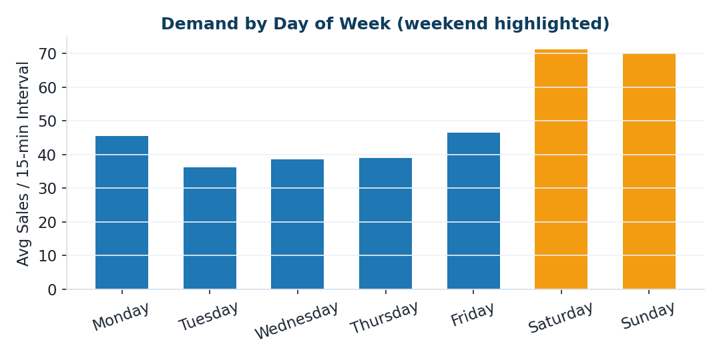
Figure 2. Average sales per 15-minute interval by day of week; weekend days shown in orange.

4.4 Seasonal Pattern
Demand is heavily concentrated in the summer months. Summer (June–August) accounts for 64.3% of annual ticket sales, while winter (December–February) accounts for just 3.4%. July and August are individually the two highest-volume months in every year of the dataset. This strongly seasonal profile supports a seasonally variable staffing and vessel-deployment model rather than a flat year-round schedule.
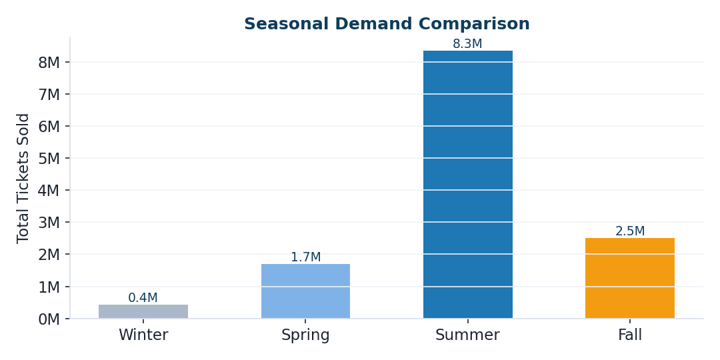
Figure 3. Total ticket sales by season, full study period (2015–2025).
Season | Share of Annual Sales
Summer (Jun–Aug) | 64.3%
Fall (Sep–Nov) | 19.3%
Spring (Mar–May) | 13.1%
Winter (Dec–Feb) | 3.4%

4.5 Net Passenger Movement
Net movement (sales minus redemptions) is a useful proxy for terminal-side crowd accumulation. Positive net movement during the late morning indicates a build-up of ticketed, not-yet-boarded passengers — a leading indicator for queue and congestion management — while the pattern reverses in late afternoon as redemptions catch up with earlier sales.

5. Key Performance Indicators (KPIs)
KPI | Value / Definition
Tickets Sold per Hour (peak) | ~378 (12:00–13:00 window)
Tickets Redeemed per Hour (peak) | ~401 (12:00–13:00 window)
Net Passenger Movement (total) | +186,758 across study window
Peak Demand Window | 11:00–14:00 daily; Jun–Aug seasonally; Sat–Sun weekly
Off-Season Utilization Index | Off-peak-season avg demand ≈ 20–25% of summer peak

6. Recommendations
- Deploy additional staffing and, where feasible, additional vessels during the 11:00–14:00 daily peak window, particularly on weekends between June and August.
- Introduce shoulder-season promotional pricing or programming in spring and fall to smooth the sharp seasonal demand curve and improve off-season utilization.
- Use the Net Passenger Movement metric as a real-time queue-management signal — rising net movement in the late morning can trigger proactive crowd-control measures at the terminal.
- Adopt the accompanying Streamlit dashboard as a standing operational tool, refreshed as new interval data becomes available, to support daily staffing decisions and quarterly capacity planning.

7. Limitations & Future Work
- The dataset captures only sales and redemption counts; it does not include weather, special-event calendars, or vessel-capacity data, all of which would sharpen forecasting accuracy.
- Redemptions are not necessarily matched to same-day sales, so net movement should be interpreted as a terminal-level flow indicator rather than a precise passenger-count reconciliation.
- Future work could incorporate short-horizon demand forecasting (e.g., next-hour sales prediction) and integrate weather and event data as external regressors.

8. Conclusion
This analysis converts over a decade of fifteen-minute interval ticketing data into a clear, actionable picture of ferry demand at Toronto Island Park. Demand is highly predictable: it peaks daily around midday, weekly on weekends, and seasonally in summer. These patterns provide a solid evidentiary basis for data-driven scheduling, staffing, and passenger-experience improvements, and the accompanying dashboard operationalizes these insights for ongoing use by Parks, Forestry & Recreation stakeholders.

