**IoT-Based Bicycle Traffic Monitoring: Fremont Bridge**

**1. Title Page**

**Project Title:** IoT-Based Bicycle Traffic Monitoring: Fremont Bridge  
**Name:** Sanika Shridhar Palaw  
**Date:** 17-03-2025

**2. Abstract**

This project explores the **implementation of an IoT-based system** for monitoring and analyzing bicycle traffic on the **Fremont Bridge**. By integrating **historical traffic data with simulated IoT sensor data**, we analyze bicycle movement trends, identify peak traffic hours, and demonstrate the potential of real-time IoT monitoring. **Principal Component Analysis (PCA) and Gaussian Mixture Model (GMM)** clustering techniques are used to extract traffic patterns, and **ThingSpeak** is utilized for IoT data transmission and remote monitoring. The findings offer **valuable insights for city planners** to optimize cycling infrastructure and traffic management.

**3. Introduction**

**3.1 Problem Statement**

With the increasing adoption of bicycles in urban transportation, understanding traffic movement is crucial for infrastructure development. The **Fremont Bridge** serves as a key cycling route, and an effective monitoring system can enhance safety and efficiency. However, **manual data collection** is inefficient, and existing systems **lack real-time capabilities**. This project **simulates an IoT-based monitoring system** to demonstrate how real-time traffic tracking can improve urban mobility.

**3.2 About Fremont Bridge**

The **Fremont Bridge** is a **double-leaf bascule (drawbridge)** in **Seattle, Washington**, connecting the **Fremont neighborhood** to **Queen Anne** over the **Lake Washington Ship Canal**. It is **one of the busiest bridges for cyclists and pedestrians** in Seattle. Since **2012**, inductive loop sensors have been installed to monitor bicycle traffic on the **East and West pathways**. The bridge remains **operational for cyclists and pedestrians**, providing valuable data for traffic analysis and urban planning.

**3.3 Objectives**

✅ **Develop an IoT-powered system** to monitor and analyze bicycle traffic on the Fremont Bridge.  
✅ **Simulate real-time traffic data** using IoT-based fluctuations and integrate it with historical data.  
✅ **Use AI techniques (PCA & GMM)** to identify traffic patterns and peak hours.  
✅ **Visualize trends interactively** using **Power BI** and store IoT data on **ThingSpeak Cloud**.  
✅ **Demonstrate the feasibility of real-time IoT monitoring** for future smart city applications.

**4. Data Preparation**

**4.1 Fremont Bridge Dataset**

* The dataset contains **bicycle traffic counts** collected hourly from the **East & West pathways** of the Fremont Bridge.
* The data was recorded between **2012 and 2017** and includes **timestamps and traffic counts**.

**4.2 Simulated IoT Traffic Data**

* IoT-based traffic data is **generated using Python** to simulate **real-world sensor fluctuations**.
* Small variations (±5) are introduced to **mimic real-world sensor inaccuracies**.
  + **Example:** If the actual bicycle count on the East sidewalk is **50**, the simulated IoT sensor may record a value between **45 and 55** due to sensor fluctuations. Similarly, if the West sidewalk count is **30**, the IoT-simulated value might range from **25 to 35**.
* The dataset is then **integrated into ThingSpeak** for remote IoT monitoring.

**5. Methodology**

**5.1 Data Processing**

✅ **Cleaned dataset** by handling missing values and formatting timestamps.  
✅ **Generated simulated IoT traffic data** using NumPy-based random fluctuations.  
✅ **Merged simulated data** with actual traffic records.  
✅ **Sent IoT data to ThingSpeak** for real-time cloud storage.

**5.2 Clustering & PCA for Pattern Analysis**

✅ **Applied PCA** to reduce dataset dimensions and extract key traffic patterns.  
✅ **Used Gaussian Mixture Model (GMM)** clustering to segment traffic behaviors.  
✅ **Visualized traffic clusters** in Power BI and Python.

**5.3 IoT Data Visualization & Integration**

✅ **ThingSpeak dashboard created** for live IoT traffic data visualization.  
✅ **Power BI dashboards designed** to present historical traffic trends, peak hours, and seasonal variations.  
✅ **Interactive filtering options** included for in-depth exploration of trends.

**6. Results & Discussion**

**6.1 Key Findings**

📌 **Peak traffic hours identified** for optimal infrastructure planning.  
📌 **Traffic clustering revealed distinct movement behaviors** based on seasonal trends.  
📌 **Real-time IoT integration demonstrated feasibility** for remote bicycle monitoring.  
📌 **Power BI visualizations provided actionable insights** for urban planners.

**6.2 Limitations**

* The dataset is **historical (2012-2017)** and lacks recent data.
* IoT-based simulations do not **account for extreme external factors** (e.g., weather, road conditions).
* Further improvements can be made by integrating **real-time IoT sensors** instead of simulated values.

**7. Recommendations**

🚀 **Deploy real-time IoT sensors** for continuous monitoring.  
🚀 **Develop a web-based live dashboard** for instant traffic analysis.  
🚀 **Integrate IoT data with broader transportation datasets** for better planning.  
🚀 **Implement real-time alerts** for congestion or unusual traffic patterns.

**8. Conclusion**

This project successfully demonstrates an **IoT-powered approach** to bicycle traffic monitoring on the **Fremont Bridge**. By integrating **real-world data, AI-based clustering, and ThingSpeak cloud storage**, valuable insights were generated for **urban infrastructure planning**. The **Power BI dashboard** enables **real-time visualization**, making data-driven decisions easier for **transportation authorities**. Future improvements include **real-time sensor deployment** and **advanced cloud integration** for live monitoring.

## ****9. References****

📚 [1] Fremont Bridge Bicycle Traffic Data - Kaggle.  
📚 [2] IoT Cloud Computing for Smart Cities – Research Paper.  
📚 [3] Machine Learning for Traffic Analysis – IEEE Xplore.  
📚 [4] Power BI Dashboard Design – Microsoft Docs.  
📚 [5] ThingSpeak API Documentation.

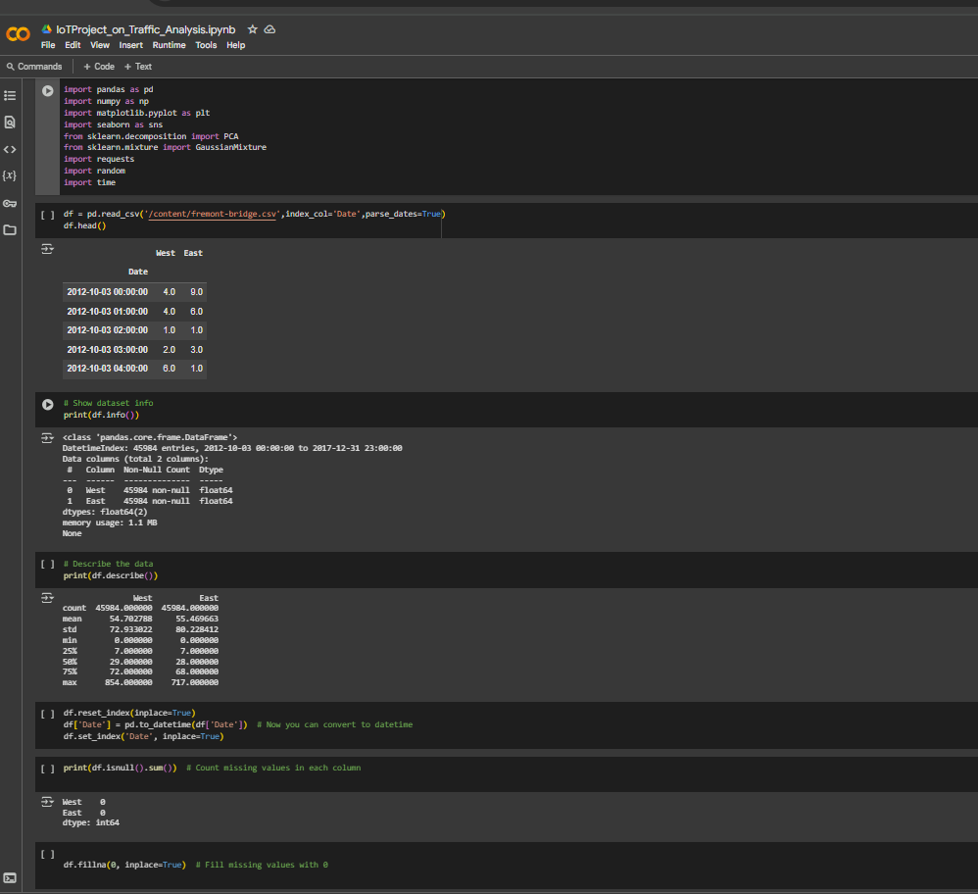**Python Codes and IoT Stimulation Codes**

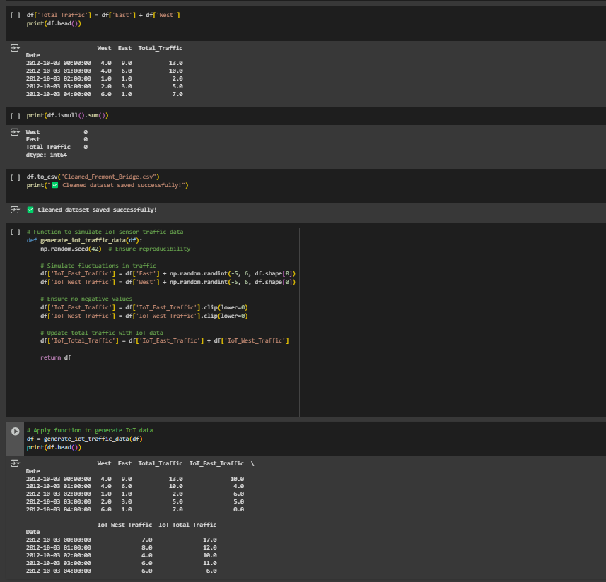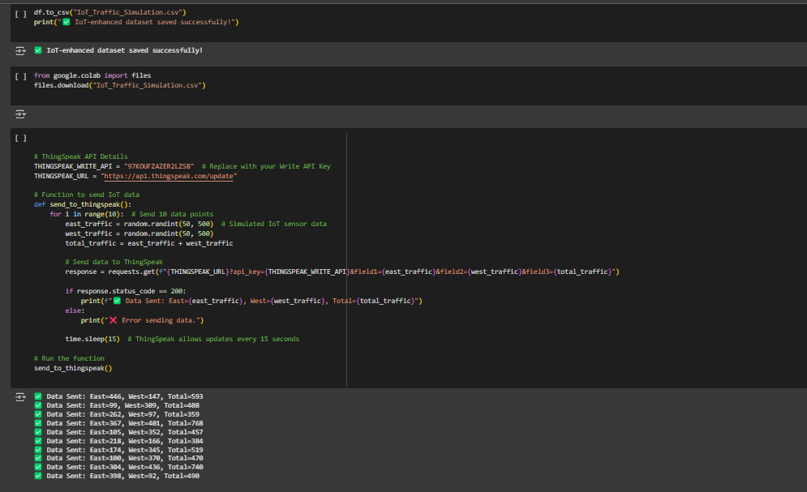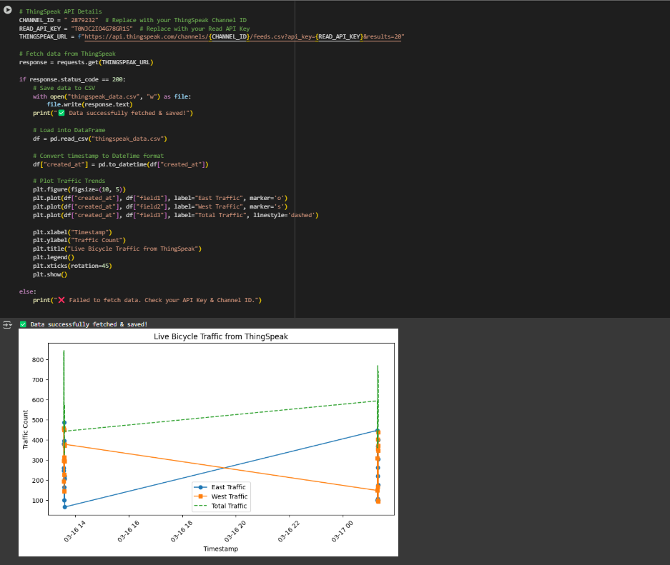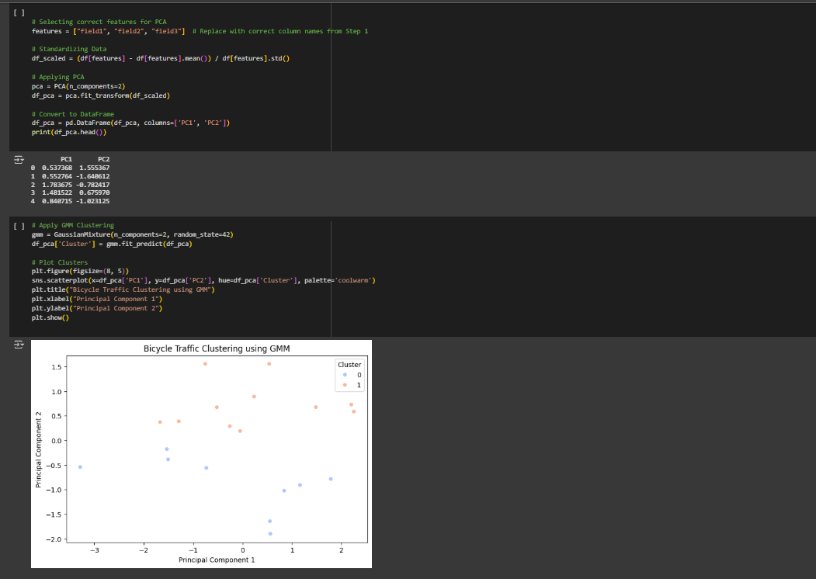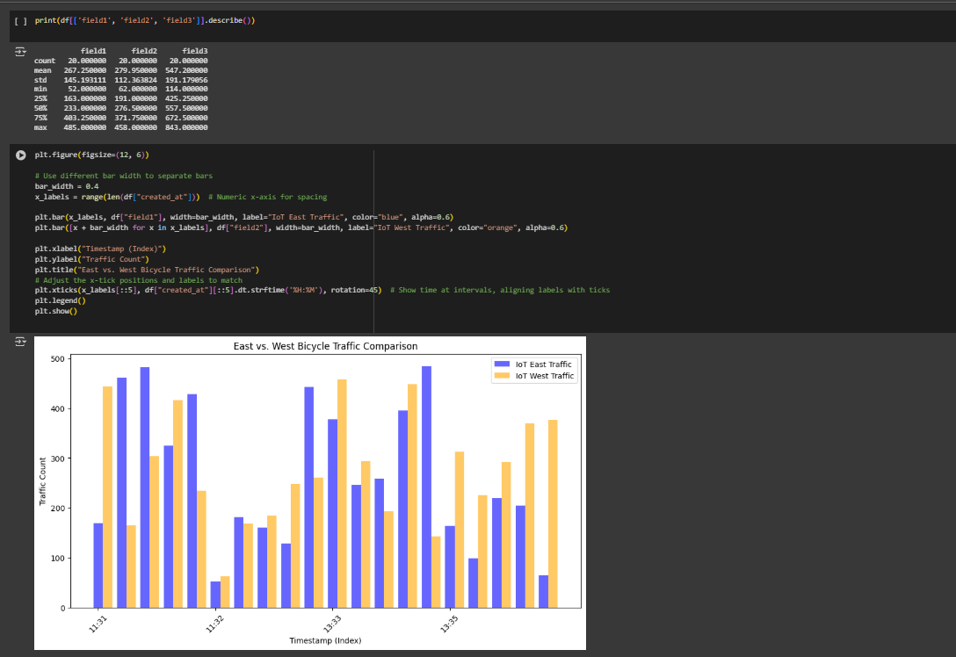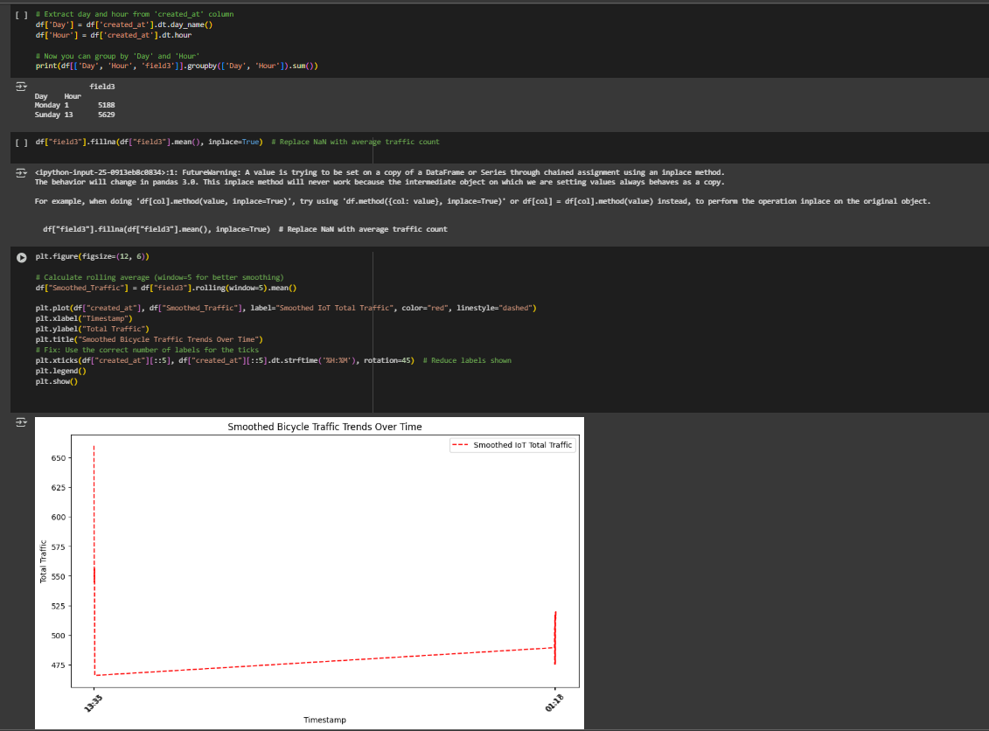

**ThingSpeak Platform Visualization.**

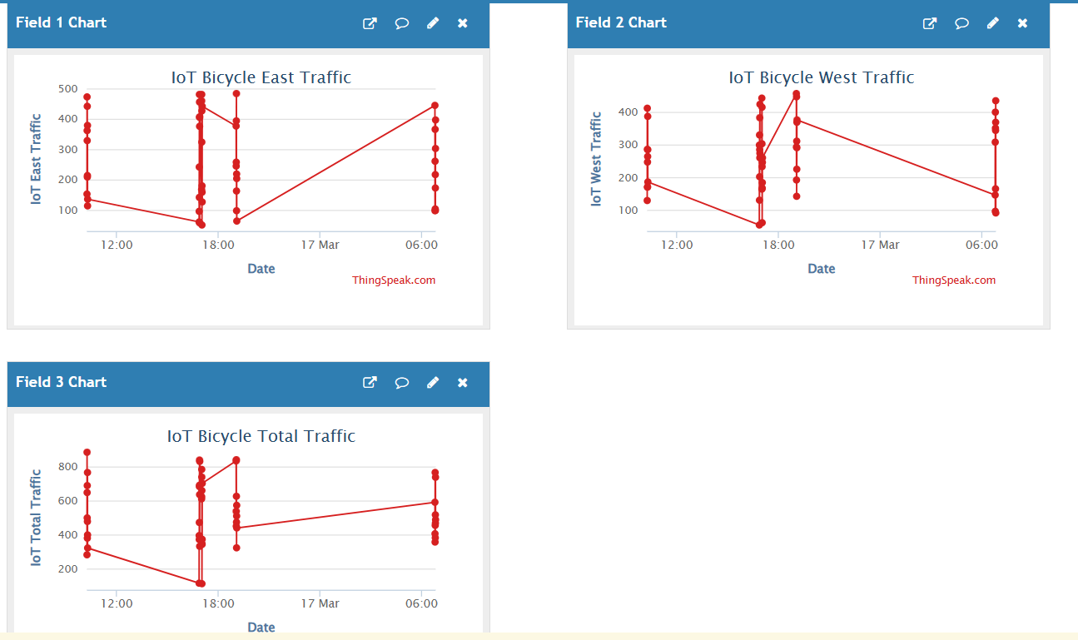

**PowerBi Visualization.**

**Sheet 1**

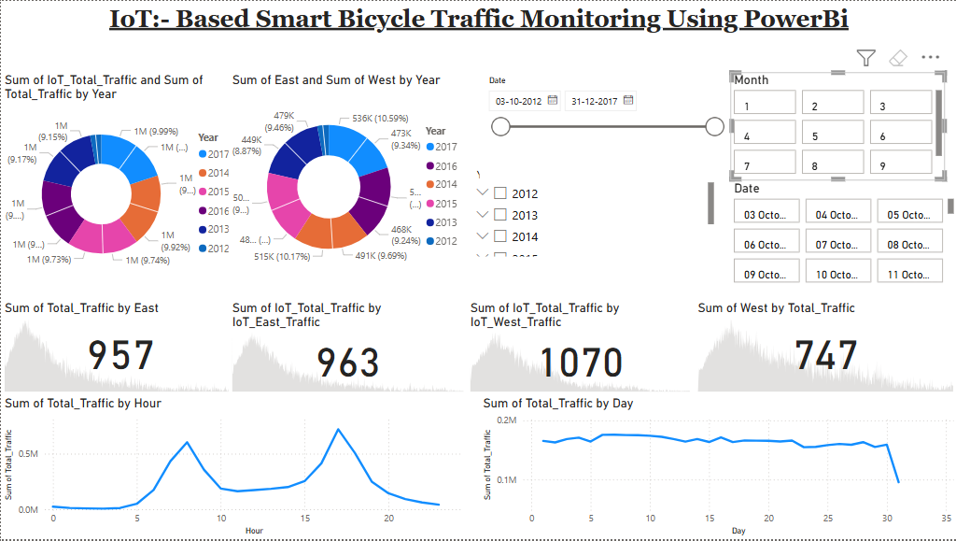

**Sheet 2**

