WEEK-5
1. Define SPA and its Benefits
SPA (Single-Page Application): A Single-Page Application is a web application that loads a single HTML page and updates only the required content dynamically without reloading the entire page.
Benefits of SPA:
- Faster page loading after the initial load.
- Smooth and responsive user experience.
- Reduces server requests.
- Better performance through caching.
- Easy to build interactive web applications.
- Works well with REST APIs.
2. Define React and Identify its Working
React: React is an open-source JavaScript library developed by Facebook for building fast and interactive user interfaces, especially for Single-Page Applications.
Working of React
- React creates UI using components.
- Components return JavaScript XML.
- React creates a Virtual DOM.
- When data changes, React updates the Virtual DOM.
- Only the changed elements are updated in the Real DOM.
- The browser displays the updated UI efficiently.
3. Differences Between SPA and MPA
SPA (Single-Page Application) | MPA (Multi-Page Application)
Loads only one HTML page | Loads a new HTML page for every request
No full page reload | Full page reload on every request
Faster navigation | Slower navigation
Better user experience | Traditional user experience
Mostly uses JavaScript frameworks like React | Can be built using traditional server-side technologies
Suitable for Gmail, Facebook | Suitable for banking websites, e-commerce with many pages
4. Pros and Cons of Single-Page Application (SPA)
Pros
- Fast navigation.
- Better user experience.
- Less server load.
- Easy API integration.
- Caches resources efficiently.
- Responsive interface.
Cons
- Initial loading time may be high.
- SEO is more difficult.
- JavaScript dependency.
- Browser history management can be complex.
- Security concerns if not properly implemented.
5. Explain About React
React is a JavaScript library used for building reusable and interactive user interfaces.
Key Points
- Developed by Facebook (Meta).
- Open-source.
- Component-based architecture.
- Uses Virtual DOM for faster updates.
- Supports reusable components.
- Uses JSX syntax.
- Mainly used for building SPAs.
- One-way data binding.
- Easy integration with APIs.
6. Define Virtual DOM
Virtual DOM (VDOM):
Virtual DOM is a lightweight copy of the Real DOM maintained in memory by React.
How it Works
- React creates a Virtual DOM.
- When state or props change, a new Virtual DOM is created.
- React compares the new Virtual DOM with the old one (Diffing).
- Only the changed parts are updated in the Real DOM.
- This improves performance.
Advantages
- Faster rendering.
- Better performance.
- Reduces unnecessary DOM updates.
- Improves user experience.
7. Features of React
- Component-Based Architecture
- Virtual DOM
- JSX (JavaScript XML)
- One-Way Data Binding
- Reusable Components
- High Performance
- Fast Rendering
- Easy to Learn
MYFIRSTREACT:
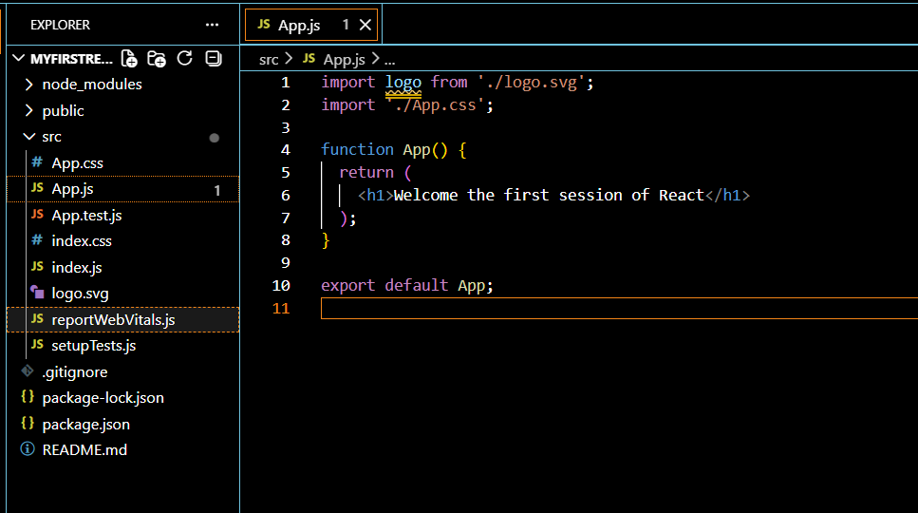
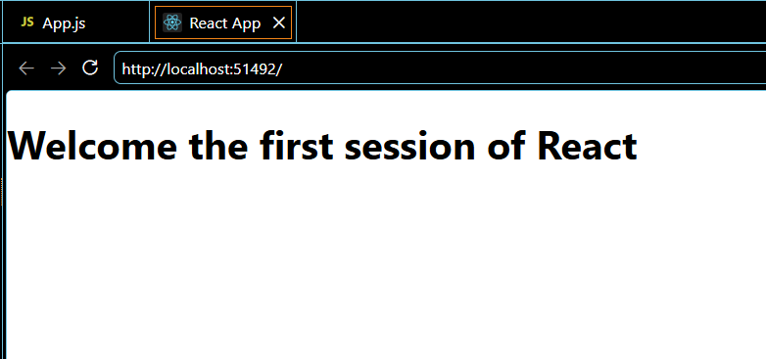
REACT-2
1. Explain React Components
React Components are the building blocks of a React application. They are reusable, independent pieces of code that return UI (User Interface) elements.
Characteristics
- Reusable
- Independent
- Easy to maintain
- Accept inputs through Props
- Can manage data using State
2. Differences Between Components and JavaScript Functions
React Component | JavaScript Function
Returns JSX (UI elements) | Returns any JavaScript value
Used to build user interfaces | Used for general programming tasks
Can receive Props | Receives normal parameters
Can manage State (class or hooks) | Cannot manage React state directly
First letter should be uppercase | Can start with lowercase
Used only in React | Used in any JavaScript program

3. Types of Components
There are two types of React components:
- Function Component
- Class Component
4. Explain Class Component
A Class Component is a JavaScript class that extends React. Component and must include a render() method.
Features
- Uses ES6 classes.
- Can maintain State.
- Supports lifecycle methods.
- Uses this keyword.
- More code than function components.
Advantages
- Supports lifecycle methods.
- Can manage complex state.
Disadvantages
- More boilerplate code.
- Uses this, making it more complex.
5. Explain Function Component
A Function Component is a simple JavaScript function that returns JSX.
Features
- Simpler and shorter.
- Easy to understand.
- Uses Hooks (useState, useEffect) for state and lifecycle.
- No this keyword.
Advantages
- Easy to write.
- Better readability.
- Better performance in modern React.
- Preferred in new React applications.
Disadvantages
- Earlier versions of React did not support state (before Hooks).
6. Define Component Constructor
A Constructor is a special method in a class component that is executed when the component is created.
Uses
- Initialize the component's state.
- Bind event handler methods.
- Perform initial setup.
7. Define render() Function
The render() function is a mandatory method in a class component that returns the JSX (UI) to be displayed on the screen.
Features
- Must return JSX or null.
- Called whenever the component needs to update.
- Displays the component's UI.
STUDENTAPP
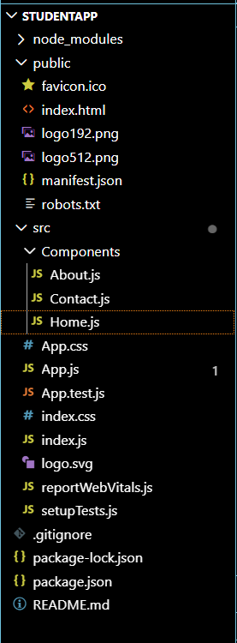
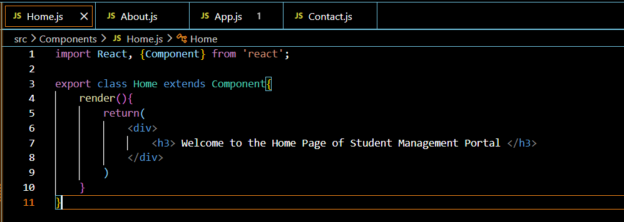
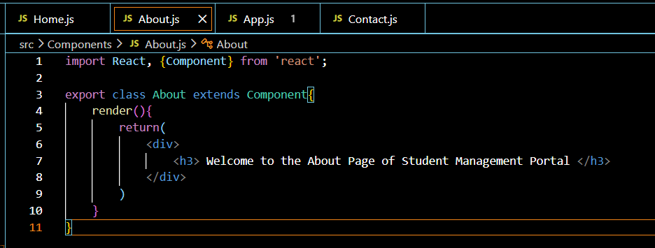

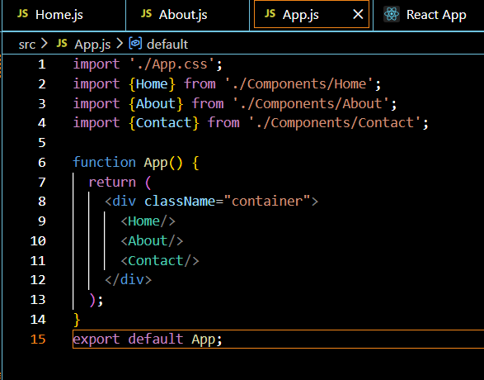
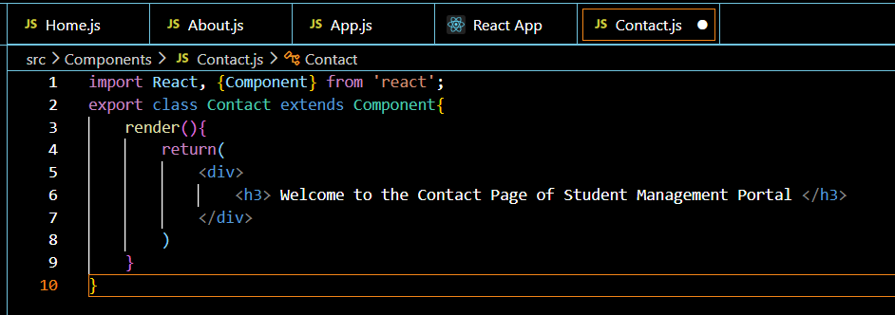
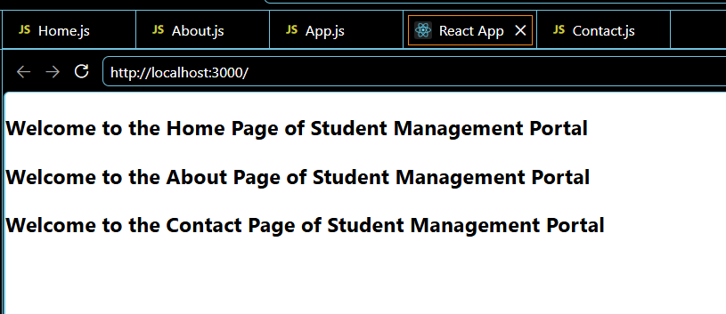
REACT-3
1. Explain React Components
Definition: A React Component is a reusable and independent block of code that represents a part of the user interface (UI). Components help build complex applications by dividing the UI into smaller, manageable pieces.
Features
- Reusable
- Independent
- Easy to maintain
- Accepts input through Props
- Can manage State
- Returns JSX (UI)
2. Differences Between React Components and JavaScript Functions
React Component | JavaScript Function
Used to create UI | Used for general programming tasks
Returns JSX (HTML-like code) | Returns any JavaScript value
Can receive Props | Receives normal parameters
Can manage State (using Hooks or class state) | Cannot manage React state directly
Component names start with a capital letter | Function names can be any valid identifier
Used only in React | Used in all JavaScript programs

3. Types of Components
React has two types of components:
- Function Component
- Class Component
4. Explain Class Component
Definition: A Class Component is an ES6 JavaScript class that extends React. Component and must contain a render() method to display the UI.
Features
- Uses ES6 classes.
- Supports State.
- Supports Lifecycle Methods.
- Uses the this keyword.
- Contains a render() method.
Advantages
- Supports lifecycle methods.
- Can manage complex state.
Disadvantages
- More code.
- Uses this, making it more complex.

5. Explain Function Component
Definition:
A Function Component is a JavaScript function that accepts props as input and returns JSX.
Features
- Simple and easy to write.
- Uses Hooks for state and lifecycle.
- No this keyword.
- Preferred in modern React.
Advantages
- Less code.
- Easy to understand.
- Better readability.
- Preferred in modern React development.
Disadvantages
- Earlier React versions did not support state (before Hooks).

6. Define Component Constructor
Definition: A Constructor is a special method in a Class Component that is called automatically when the component is created. It is used to initialize the component's state and bind event handler methods.
Uses
- Initializes state.
- Binds event methods.
- Performs initial setup.
7. Define render() Function
Definition: The render() method is a mandatory method in a Class Component. It returns the JSX that should be displayed on the screen.
Features
- Returns JSX or null.
- Called whenever the component is rendered or updated.
- Defines the UI of the component.

SCORECALCULATORAPP:
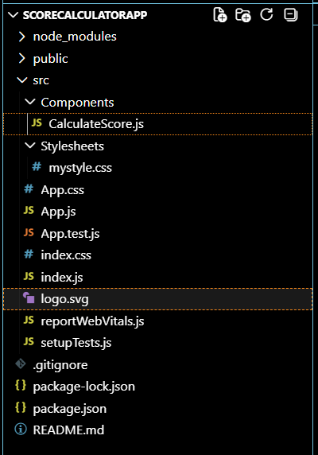
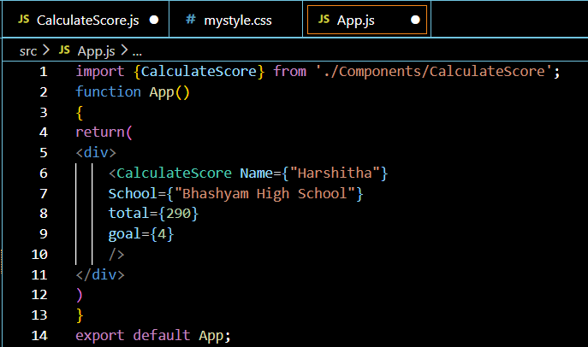
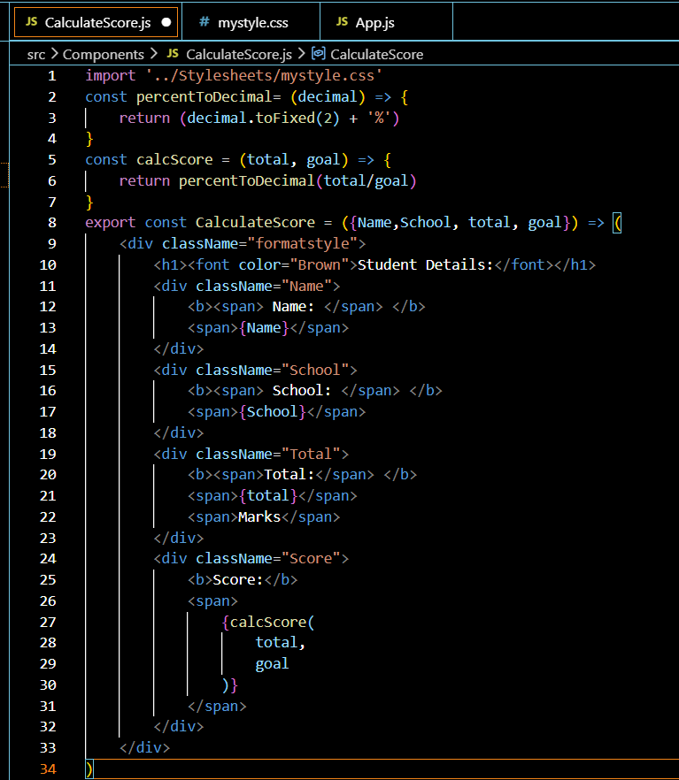
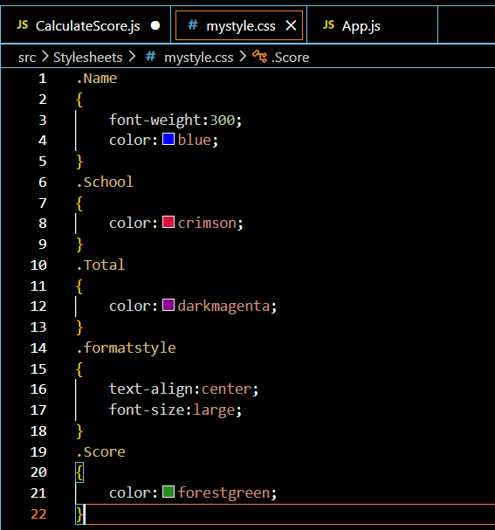


REACT-4
1. Explain the Need and Benefits of Component Life Cycle
What is Component Life Cycle?
The Component Life Cycle is the series of stages that a React component goes through from its creation until it is removed from the DOM.
The three main phases are:
- Mounting
- Updating
- Unmounting
Need of Component Life Cycle
The component life cycle helps developers to:
- Initialize data when a component is created.
- Fetch data from APIs.
- Update the UI when props or state change.
- Improve performance by controlling re-rendering.
- Clean up resources before removing a component.
Benefits
- Data Initialization: Load initial data when the component is created.
- Efficient Rendering: Prevent unnecessary rendering.
- State Management: Update the UI whenever state changes.
- Resource Cleanup: Remove timers, event listeners, or subscriptions.
- Better Performance: Execute code only when needed.
2. Identify Various Life Cycle Hook Methods
React class components have lifecycle methods grouped into three phases.
A. Mounting Phase
Occurs when the component is created and inserted into the DOM.
constructor()
- Called first.
- Initializes state and binds methods.
static getDerivedStateFromProps()
- Invoked before rendering.
- Updates state based on props.
- Rarely used.
render()
- Returns JSX.
- Mandatory lifecycle method.
- Does not modify state.
componentDidMount()
- Called after the component is added to the DOM.
- Used for:
  - API calls
  - Timers
  - Event listeners
B. Updating Phase
Occurs whenever state or props change.
static getDerivedStateFromProps()
Called before every render.
shouldComponentUpdate()
- Decides whether the component should re-render.
- Returns true or false.
render()
Re-renders the UI.
getSnapshotBeforeUpdate()
Captures information before DOM updates.
componentDidUpdate()
Runs after the DOM is updated.
Used for:
- API updates
- DOM manipulation
- Logging
C. Unmounting Phase
Occurs when the component is removed from the DOM.
componentWillUnmount()
Used for cleanup.
Examples:
- Stop timers
- Remove event listeners
componentWillUnmount(){
clearInterval(this.timer);
}
3. List the Sequence of Steps in Rendering a Component
A. Mounting Sequence
constructor()
↓
getDerivedStateFromProps()
↓
render()
↓
componentDidMount()
B. Updating Sequence
State/Props Change
↓
getDerivedStateFromProps()
↓
shouldComponentUpdate()
↓
render()
↓
getSnapshotBeforeUpdate()
↓
componentDidUpdate()
C. Unmounting Sequence
componentWillUnmount()
BLOGAPP
