WEEK-6
ES6 (ECMAScript 2015)
1. Features of ES6
ES6 (ECMAScript 2015) introduced several new features to make JavaScript more efficient, readable, and easier to develop.
Features:
- let and const declarations
- Arrow functions
- Classes
- Class inheritance
- Template literals
- Default parameters
- Destructuring assignment
- Spread and Rest operators
- Promises
- Modules (import and export)
- Map and Set collections
- Enhanced object literals
- Iterators and Generators
2. JavaScript let
let is used to declare variables with block scope.
Characteristics:
- Block-scoped.
- Can be reassigned.
- Cannot be redeclared within the same scope.
- Must be declared before use.
- Helps avoid issues caused by function-scoped variables.
3. Difference Between var and let
var | let
Function scoped | Block scoped
Can be redeclared | Cannot be redeclared in the same scope
Can be reassigned | Can be reassigned
Hoisted and initialized with undefined | Hoisted but not initialized before declaration
May cause scope-related issues | Provides better scope management

4. JavaScript const
const is used to declare variables whose reference cannot be reassigned.
Characteristics:
- Block-scoped.
- Must be initialized at the time of declaration.
- Cannot be reassigned.
- Cannot be redeclared in the same scope.
- Suitable for values that should remain constant.
5. ES6 Class Fundamentals
An ES6 class is a blueprint for creating objects and organizing related data and methods.
Fundamentals:
- Declared using the class keyword.
- Includes a constructor for object initialization.
- Supports methods inside the class.
- Promotes object-oriented programming.
- Improves code organization and reusability.
6. ES6 Class Inheritance
Inheritance allows one class to acquire the properties and methods of another class.
Features:
- Implemented using the extends keyword.
- super() is used to access the parent class constructor and methods.
- Promotes code reuse.
- Supports hierarchical relationships between classes.
- Makes applications easier to maintain and extend.
7. ES6 Arrow Functions
Arrow functions provide a concise syntax for writing functions.
Characteristics:
- Shorter and cleaner syntax.
- Suitable for simple functions.
- Do not have their own this context.
- Improve code readability.
- Frequently used with array methods and callbacks.
8. Set and Map
Set
A Set is a collection that stores unique values.
Characteristics:
- Stores only unique elements.
- Automatically removes duplicate values.
- Maintains insertion order.
- Allows adding, deleting, checking, and clearing elements.
- Useful for handling collections of distinct values.
Map
A Map is a collection of key-value pairs.
Characteristics:
- Stores data as key-value pairs.
- Keys can be of any data type.
- Maintains insertion order.
- Supports efficient insertion, retrieval, and deletion.
- Useful for managing structured data with associated keys.
Difference Between Set and Map
Set | Map
Stores unique values | Stores key-value pairs
Values are stored directly | Data is stored using keys and values
Duplicate values are not allowed | Duplicate keys are not allowed
Used for unique collections | Used for mapping keys to values
Access is based on values | Access is based on keys

REACT-9
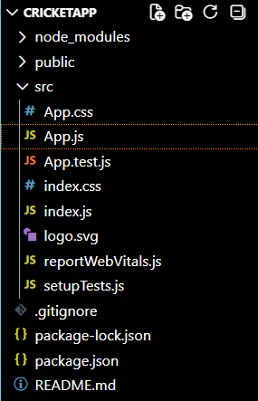
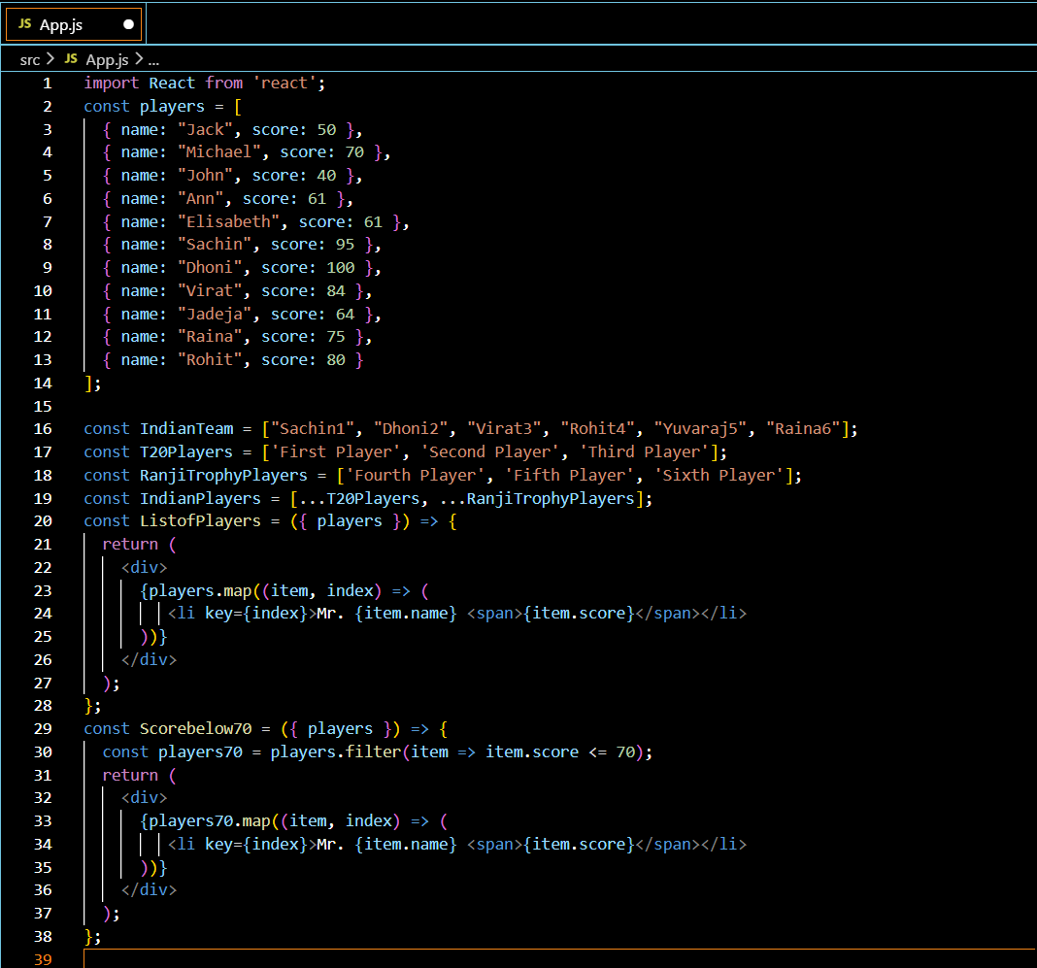

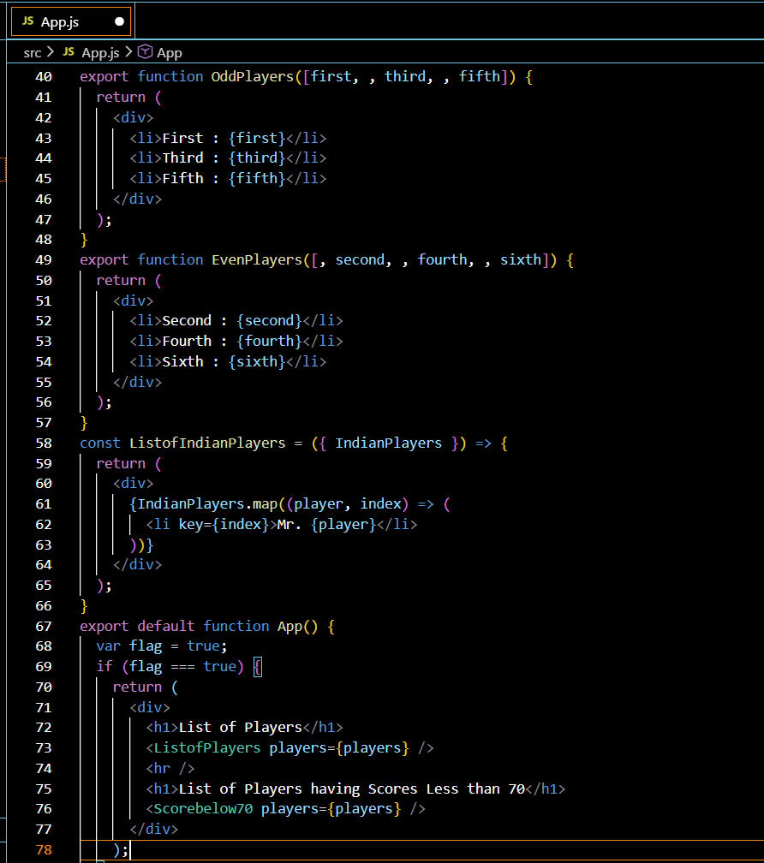

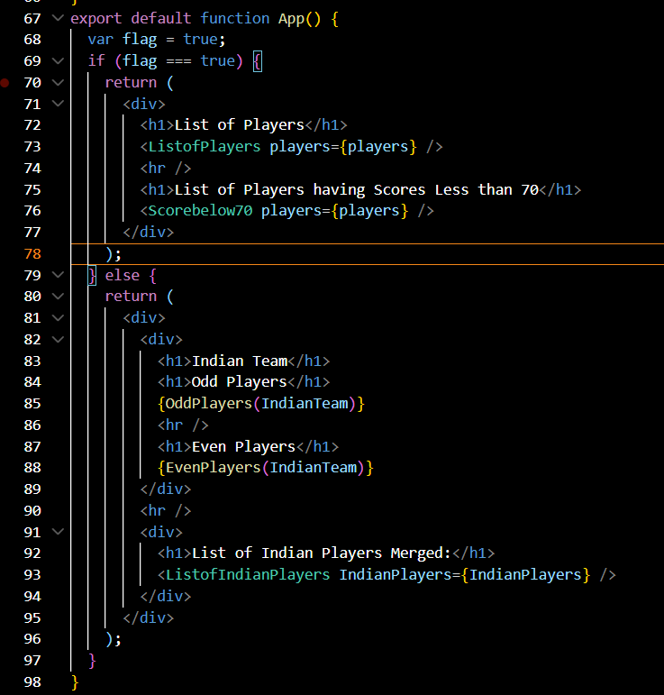
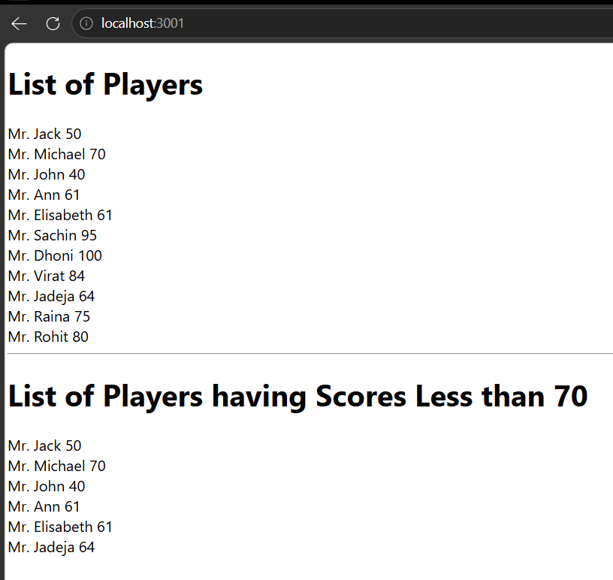

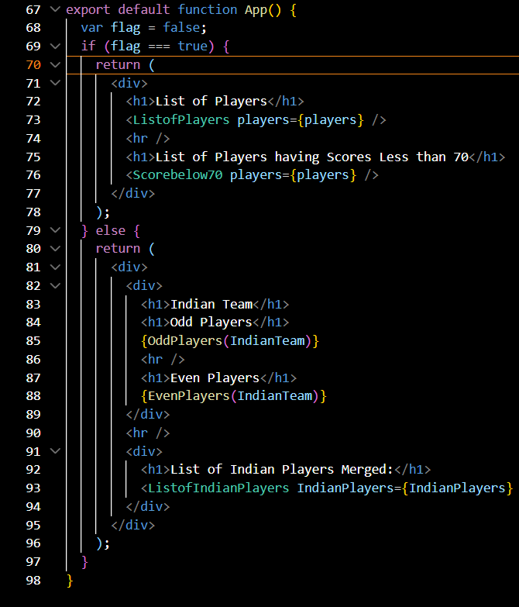



React JSX Notes
1. Define JSX
JSX (JavaScript XML) is a syntax extension for JavaScript used in React to describe the structure of user interfaces. It allows developers to write HTML-like code within JavaScript, making code more readable and easier to understand.
Features:
- HTML-like syntax.
- Easier to write and maintain UI components.
- Compiled into JavaScript using Babel.
- Supports JavaScript expressions.
- Produces React elements.
2. Explain ECMAScript
ECMAScript (ES) is the standardized specification on which JavaScript is based. It defines the language features, syntax, and behavior that JavaScript engines implement.
Features of ECMAScript:
- Standardizes JavaScript.
- Introduces modern language features.
- Improves code readability and performance.
- Ensures compatibility across browsers.
- New versions include features like let, const, arrow functions, classes, modules, promises, and template literals.
3. Explain React.createElement()
React.createElement() is a React method used to create React elements. It is the function that JSX is transformed into during compilation.
Characteristics:
- Creates React elements.
- Accepts element type, properties, and children.
- Forms the Virtual DOM.
- Used internally by React.
- JSX is converted into React.createElement() calls.
4. Explain How to Create React Nodes with JSX
React nodes can be created by writing JSX expressions inside components.
Characteristics:
- Uses HTML-like syntax.
- Can contain elements, components, text, and expressions.
- Supports nesting of elements.
- Allows reusable UI components.
- Converted into React elements before execution.
5. Define How to Render JSX to DOM
Rendering JSX means displaying React elements in the browser's Document Object Model (DOM).
Process:
- JSX is converted into React elements.
- React renders these elements into the Virtual DOM.
- The Virtual DOM compares changes with the previous version.
- Only the updated parts are rendered to the actual DOM.
- This improves application performance.
6. Explain How to Use JavaScript Expressions in JSX
JSX allows JavaScript expressions to be embedded within curly braces {}.
Characteristics:
- Supports variables and constants.
- Supports arithmetic and logical expressions.
- Allows function calls.
- Enables conditional rendering.
- Makes UI dynamic and interactive.
7. Explain How to Use Inline CSS in JSX
Inline CSS in JSX is written using the style attribute with a JavaScript object.
Characteristics:
- Styles are defined as JavaScript objects.
- CSS property names use camelCase.
- Multiple styles can be applied together.
- Values are assigned as strings or numbers.
- Useful for applying dynamic styles.
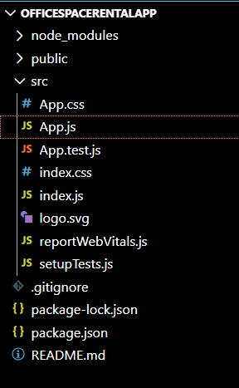
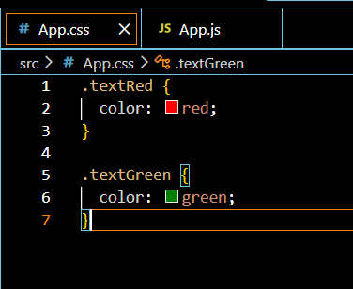
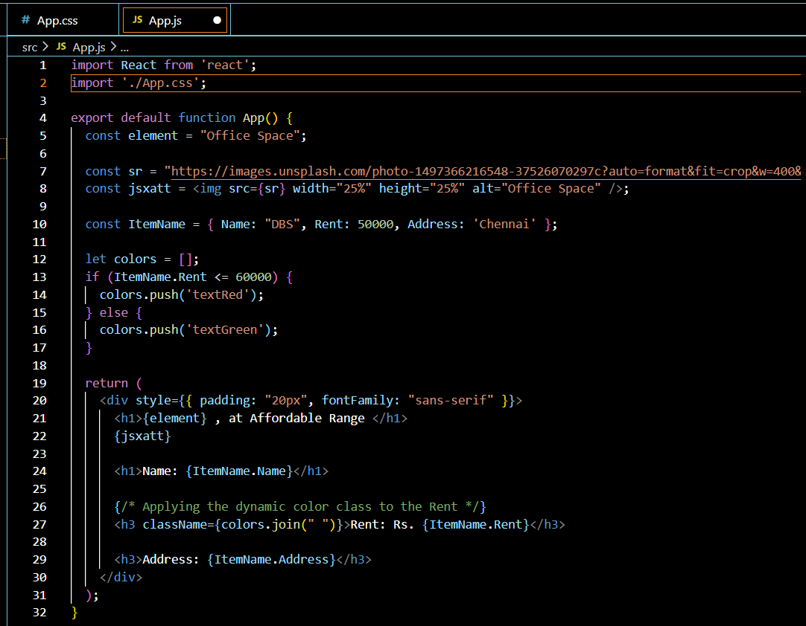

React Events Notes
1. Explain React Events
React events are actions or occurrences that happen in the browser, such as user interactions with elements. React provides an event handling system similar to JavaScript but with a consistent interface across different browsers.
Characteristics:
- Used to handle user interactions.
- Similar to DOM events but implemented in React.
- Improve interactivity of applications.
- Work consistently across browsers.
- Trigger event handler functions when an event occurs.
2. Explain Event Handlers
An event handler is a function that is executed when a specific event occurs.
Characteristics:
- Responds to user actions.
- Written as JavaScript functions.
- Can update the component's state.
- Can receive event information as an argument.
- Makes applications interactive and dynamic.
3. Define Synthetic Event
A Synthetic Event is a cross-browser wrapper around the browser's native event. React uses Synthetic Events to provide consistent event behavior across all browsers.
Characteristics:
- Cross-browser compatible.
- Wraps the native browser event.
- Provides the same interface as native events.
- Improves performance and consistency.
- Used automatically by React event handling.
4. React Event Naming Convention
React follows a specific naming convention for events.
Rules:
- Event names use camelCase.
- Event handlers are written inside JSX using curly braces {}.
- Event handler values are function references.
- React event names begin with on followed by the event name.
- Event names are case-sensitive.
Examples of Event Names:
- onClick
- onChange
- onSubmit
- onMouseOver
- onMouseOut
- onKeyDown
- onKeyUp
- onFocus
- onBlur
- onDoubleClick

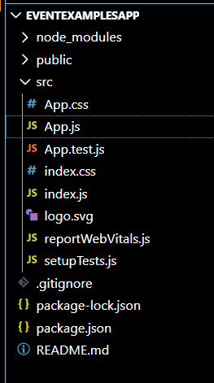
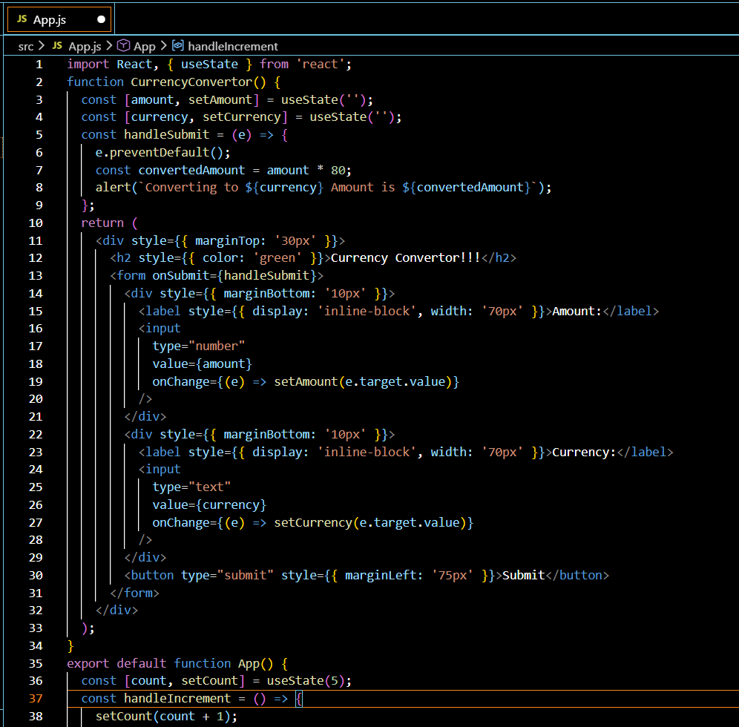
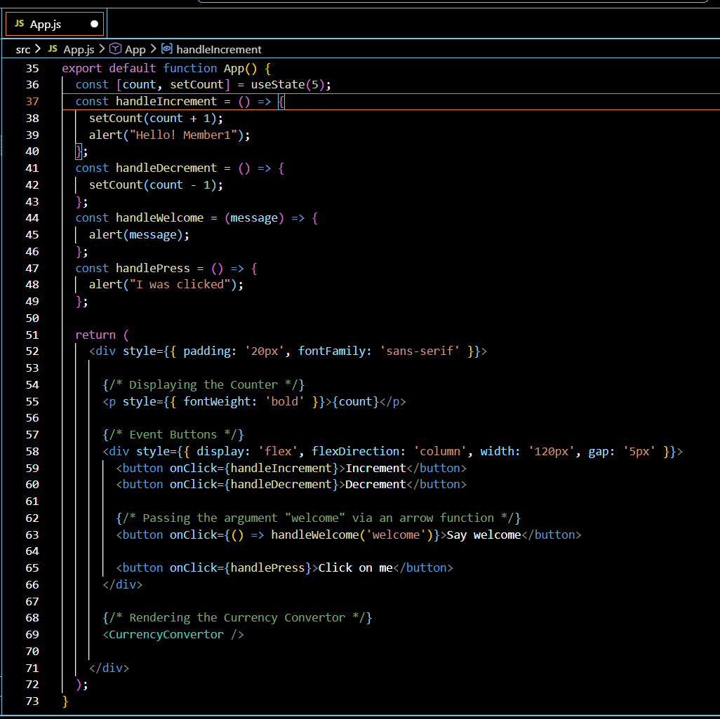
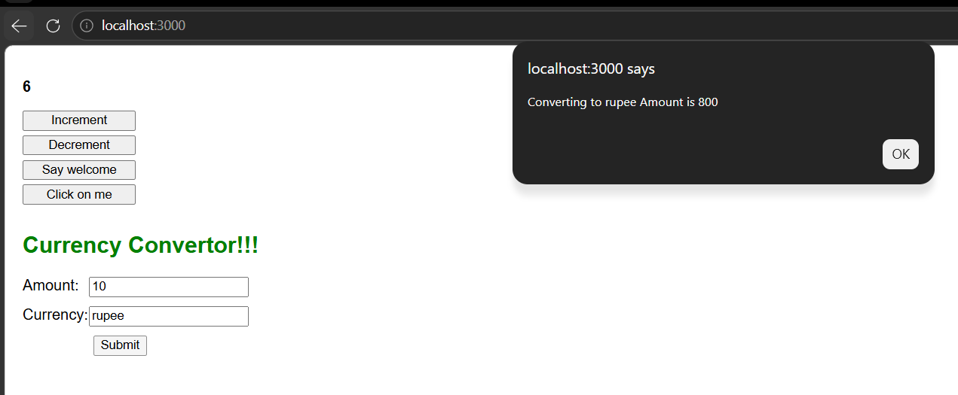

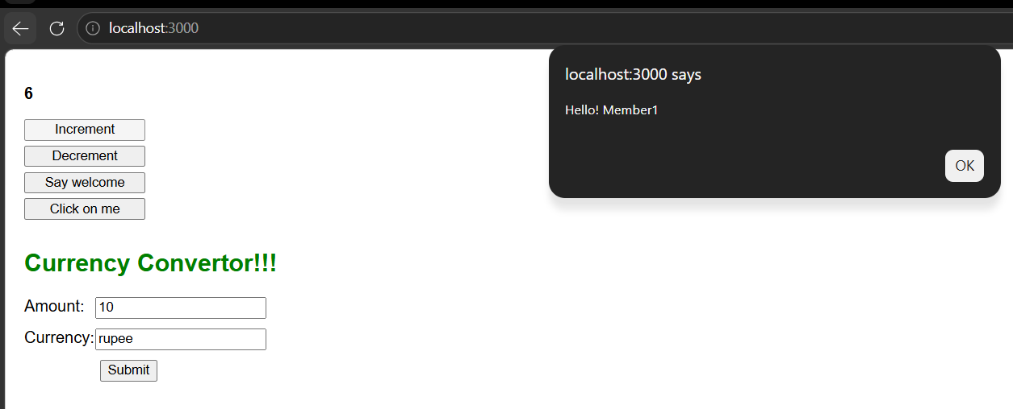

React Conditional Rendering
1. Explain Conditional Rendering in React
Conditional rendering is a technique used to display different UI elements or components based on specific conditions. It allows React applications to render content dynamically according to the application's state or user input.
Characteristics:
- Displays different content based on conditions.
- Improves user experience by showing relevant information.
- Uses JavaScript conditions within JSX.
- Can render or hide components dynamically.
- Makes applications more interactive and flexible.
2. Define Element Variables
Element variables are variables that store React elements. They are used to simplify conditional rendering by holding different UI elements and rendering them based on conditions.
Characteristics:
- Store React elements.
- Improve code readability.
- Simplify conditional rendering.
- Reduce code duplication.
- Make components easier to maintain.
3. Explain How to Prevent Components from Rendering
In React, a component can be prevented from rendering by returning null when a specific condition is not satisfied. Returning null means the component renders nothing to the DOM.
Characteristics:
- Used to hide components when they are not needed.
- Improves application performance by avoiding unnecessary rendering.
- Helps implement conditional UI.
- Keeps the code clean and organized.
- Does not remove the component's logic; it only prevents its output from being displayed.

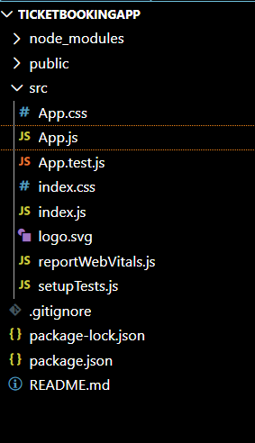

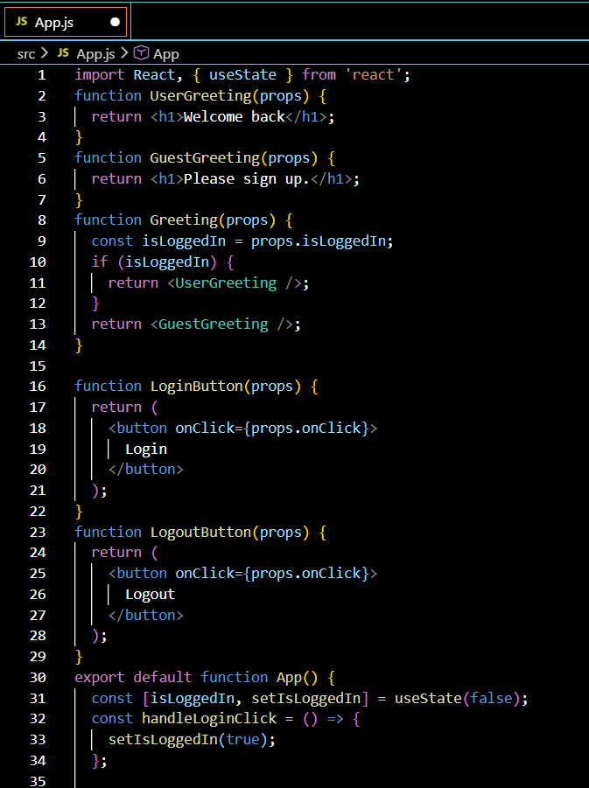
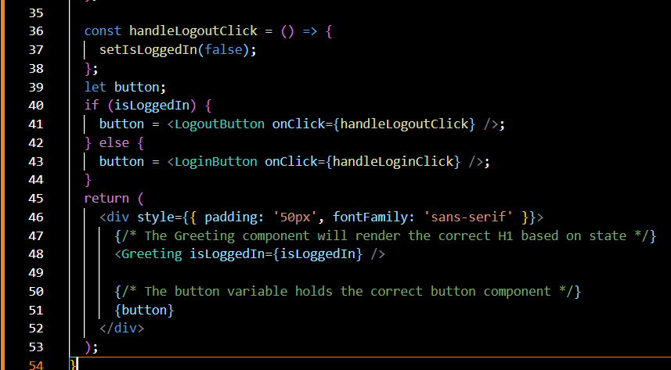

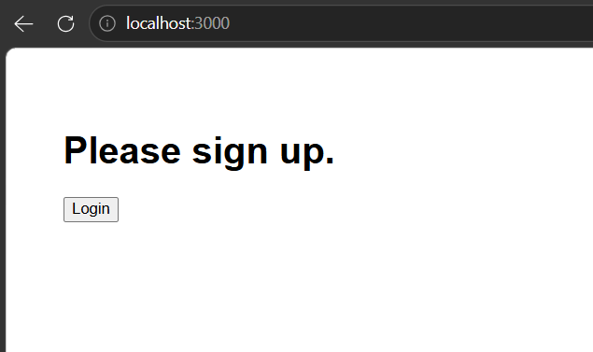
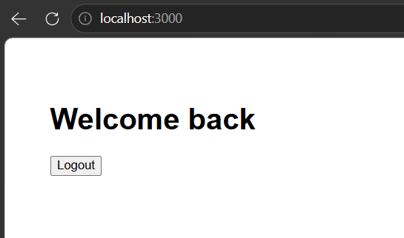
React Lists and Conditional Rendering
1. Explain Various Ways of Conditional Rendering
Conditional rendering allows React to display different UI based on conditions.
Various ways:
- if statement – Used to execute different rendering logic based on a condition.
- Element variables – Store different React elements in variables and render them conditionally.
- Logical AND (&&) operator – Renders content only when the condition is true.
- Returning null – Prevents a component from rendering when a condition is not met.
2. Explain How to Render Multiple Components
React allows multiple components to be displayed together within a parent component.
Characteristics:
- Multiple components can be combined to build complex user interfaces.
- Parent components can contain one or more child components.
- Components can be reused in different parts of an application.
- Improves modularity and code organization.
- Supports component nesting for better structure.
3. Define List Component
A list component is a React component used to display a collection of similar items by rendering each item from an array or data source.
Characteristics:
- Displays multiple items dynamically.
- Generates UI from arrays or collections.
- Reduces repetitive code.
- Commonly used for menus, tables, and product lists.
- Usually created using the map() function.
4. Explain Keys in React Applications
A key is a special attribute used to uniquely identify elements in a list.
Characteristics:
- Provides a unique identity for each list item.
- Helps React efficiently update and re-render the UI.
- Improves rendering performance.
- Should be unique among sibling elements.
- Prevents unnecessary re-rendering and UI inconsistencies.
5. Explain How to Extract Components with Keys
When a list item is extracted into a separate component, the key should be assigned where the list is created, not inside the extracted component.
Characteristics:
- The parent component assigns the key.
- The extracted child component receives data through props.
- Keys remain associated with list elements.
- Improves code reusability and readability.
- Helps React correctly identify list items during updates.
6. Explain React map() Function
The map() function is a JavaScript array method widely used in React to transform each item in an array into a React element.
Characteristics:
- Iterates through every element of an array.
- Returns a new array of React elements.
- Simplifies rendering dynamic lists.
- Does not modify the original array.

