WEEK-2
Spring Core and Maven
Exercise-1
pom.xml
<project xmlns="http://maven.apache.org/POM/4.0.0"
xmlns:xsi="http://www.w3.org/2001/XMLSchema-instance"
xsi:schemaLocation="http://maven.apache.org/POM/4.0.0
http://maven.apache.org/xsd/maven-4.0.0.xsd">
<modelVersion>4.0.0</modelVersion>
<groupId>com.library</groupId>
<artifactId>LibraryManagement</artifactId>
<version>1.0</version>
<dependencies>
<dependency>
<groupId>org.springframework</groupId>
<artifactId>spring-context</artifactId>
<version>5.3.30</version>
</dependency>
</dependencies>
</project>

applicationContext.xml
<?xml version="1.0" encoding="UTF-8"?>
<beans xmlns="http://www.springframework.org/schema/beans"
xmlns:xsi="http://www.w3.org/2001/XMLSchema-instance"
xsi:schemaLocation="
http://www.springframework.org/schema/beans
https://www.springframework.org/schema/beans/spring-beans.xsd">
<bean id="bookRepository"
class="com.library.repository.BookRepository"/>
<bean id="bookService"
class="com.library.service.BookService">
<property name="bookRepository"
ref="bookRepository"/>

</bean>
</beans>

BookRepository.java
package com.library.repository;
public class BookRepository {
public String getBookDetails() {
return "Spring Framework in Action";
}
}
BookService.java
package com.library.service;
import com.library.repository.BookRepository;
public class BookService {
private BookRepository bookRepository;
public void setBookRepository(BookRepository bookRepository) {
this.bookRepository = bookRepository;
}
public void displayBook() {
System.out.println("Book Name: " + bookRepository.getBookDetails());
}
}
MainApp.java
package com.library;
import org.springframework.context.ApplicationContext;
import org.springframework.context.support.ClassPathXmlApplicationContext;
import com.library.service.BookService;
public class MainApp {
public static void main(String[] args) {
ApplicationContext context =
new ClassPathXmlApplicationContext(
"applicationContext.xml");
BookService service =
(BookService) context.getBean("bookService");
service.displayBook();
}
}

Exercise-2
pom.xml
<dependencies>
<dependency>
<groupId>org.springframework</groupId>
<artifactId>spring-context</artifactId>
<version>5.3.30</version>
</dependency>
</dependencies>
applicationContext.xml
<?xml version="1.0" encoding="UTF-8"?>
<beans xmlns="http://www.springframework.org/schema/beans"
xmlns:xsi="http://www.w3.org/2001/XMLSchema-instance"
xsi:schemaLocation="
http://www.springframework.org/schema/beans
https://www.springframework.org/schema/beans/spring-beans.xsd">
<bean id="bookRepository"
class="com.library.repository.BookRepository"/>
<bean id="bookService"
class="com.library.service.BookService">
<property name="bookRepository"
ref="bookRepository"/>
</bean>
</beans>
BookRepository.java
package com.library.repository;
public class BookRepository {
public String getBookInfo() {
return "Spring Framework Book";
}
}

BookService.java
package com.library.service;
import com.library.repository.BookRepository;
public class BookService {
private BookRepository bookRepository;
public void setBookRepository(BookRepository bookRepository) {
this.bookRepository = bookRepository;
}
public void displayBook() {
System.out.println("Book Name: " +
bookRepository.getBookInfo());
}
}
LibraryManagementApplication.java
package com.library;
import org.springframework.context.ApplicationContext;
import org.springframework.context.support.ClassPathXmlApplicationContext;
import com.library.service.BookService;
public class LibraryManagementApplication {
public static void main(String[] args) {
ApplicationContext context =
new ClassPathXmlApplicationContext(
"applicationContext.xml");
BookService service =
(BookService) context.getBean("bookService");

service.displayBook();
}
}

Exercise-4
pom.xlm
<project xmlns="http://maven.apache.org/POM/4.0.0"
xmlns:xsi="http://www.w3.org/2001/XMLSchema-instance"
xsi:schemaLocation="http://maven.apache.org/POM/4.0.0
https://maven.apache.org/xsd/maven-4.0.0.xsd">
<modelVersion>4.0.0</modelVersion>
<groupId>com.library</groupId>
<artifactId>LibraryManagement</artifactId>
<version>1.0-SNAPSHOT</version>
<packaging>jar</packaging>
<dependencies>
<dependency>
<groupId>org.springframework</groupId>
<artifactId>spring-context</artifactId>
<version>5.3.30</version>
</dependency>
<dependency>
<groupId>org.springframework</groupId>
<artifactId>spring-aop</artifactId>
<version>5.3.30</version>
</dependency>
<dependency>
<groupId>org.springframework</groupId>
<artifactId>spring-webmvc</artifactId>
<version>5.3.30</version>
</dependency>
</dependencies>
<build>
<plugins>
<plugin>
<groupId>org.apache.maven.plugins</groupId>
<artifactId>maven-compiler-plugin</artifactId>
<version>3.8.1</version>
<configuration>
<source>1.8</source>
<target>1.8</target>
</configuration>
</plugin>
</plugins>
</build>
</project>
Spring Data JPA - Quick Example
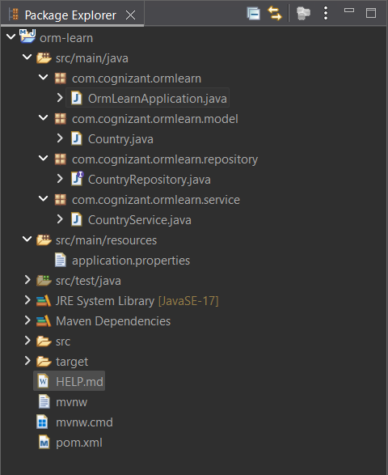

OrmLearnApplication.java
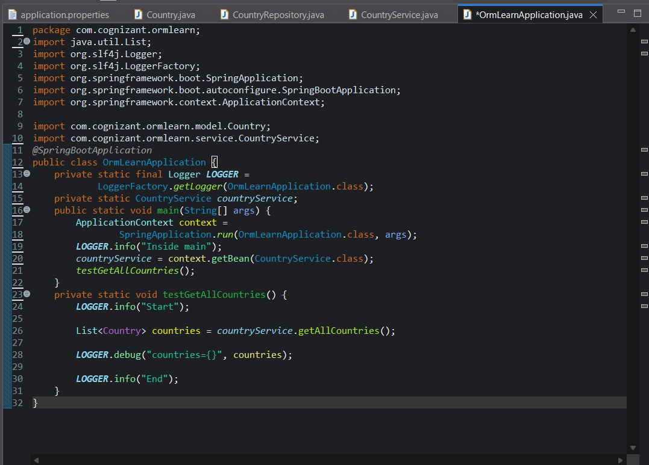
Country.java
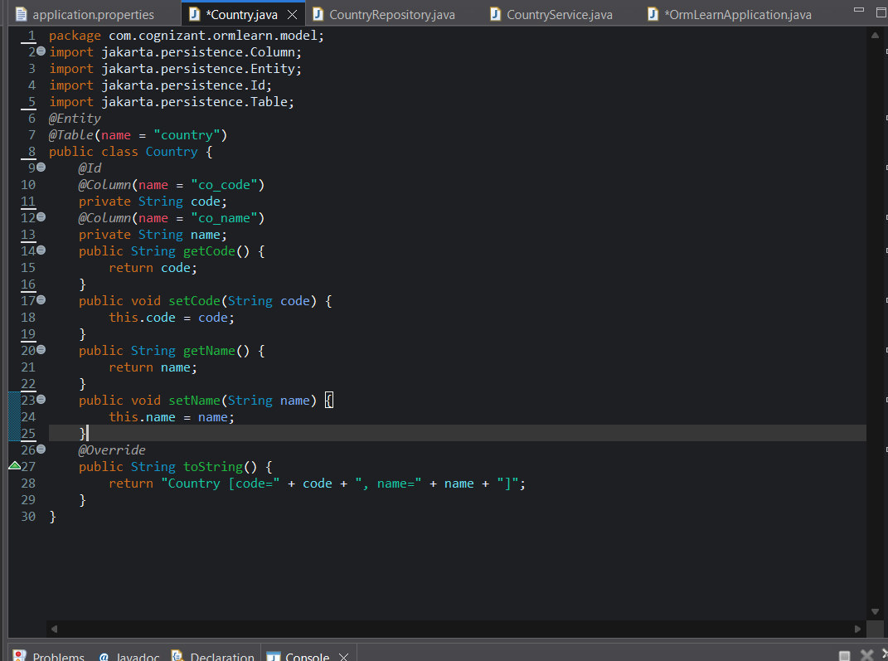
CountryRepositor.java
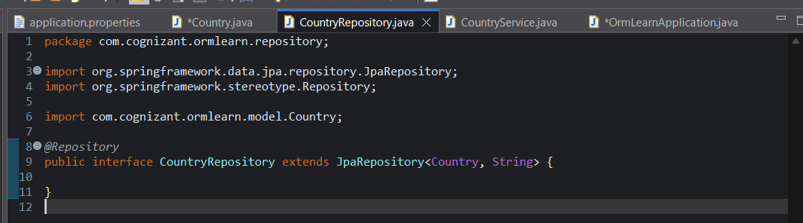
CountryService.java
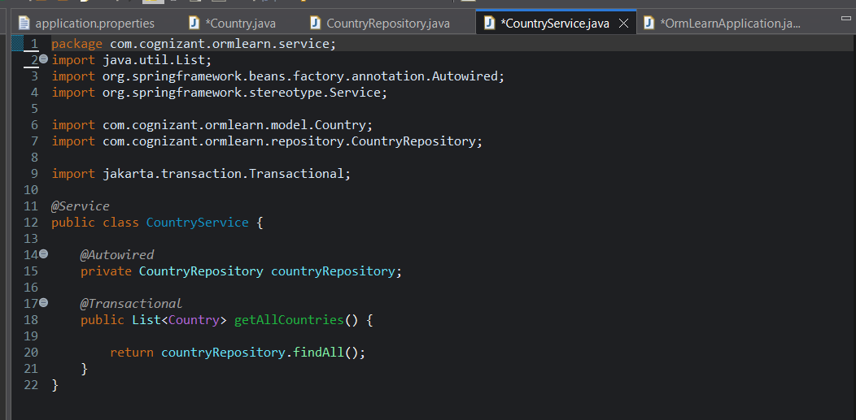

Application.properties
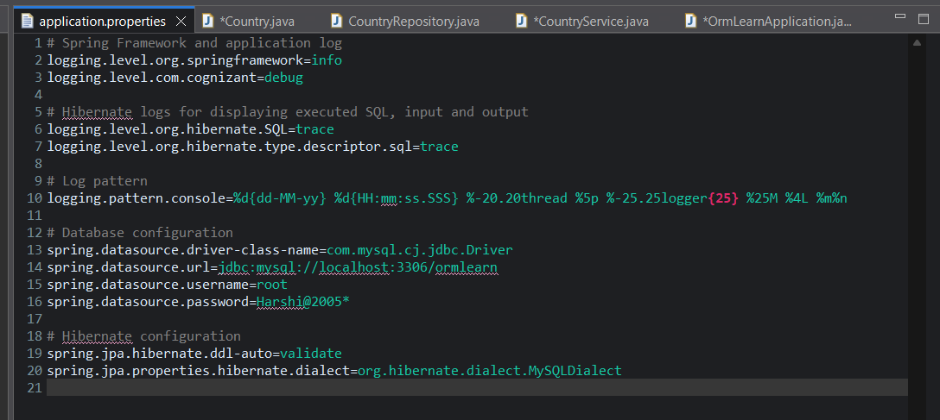
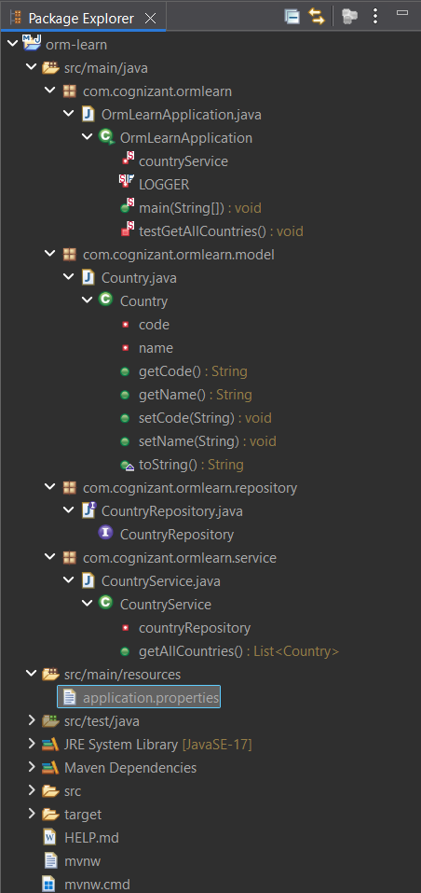
Output:
