Week-1
Design Patterns and Principles
- Implementing the Singleton Pattern
Logger.java
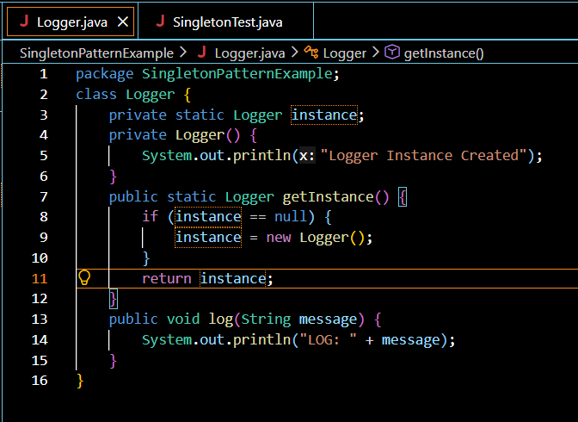
SingletonTest.java
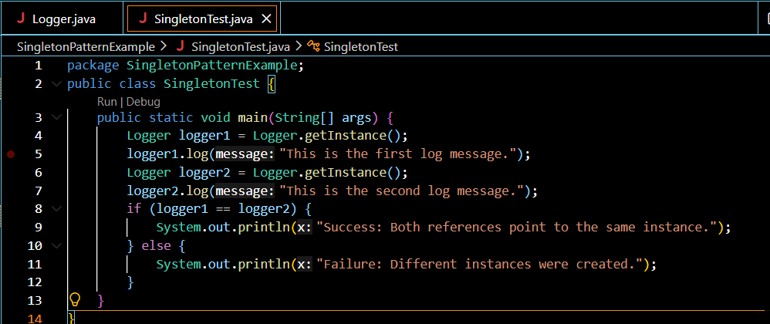
Output:
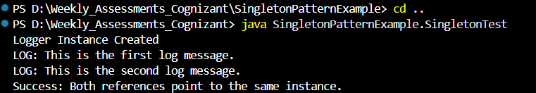
- Implementing the Factory Method Pattern
Main.java
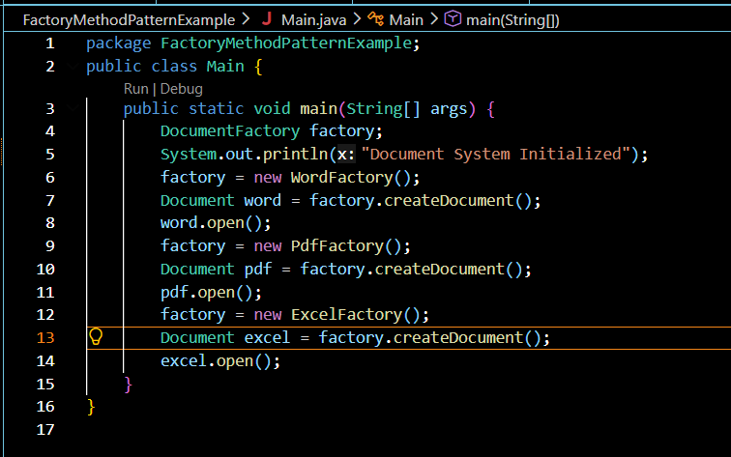
Document.java
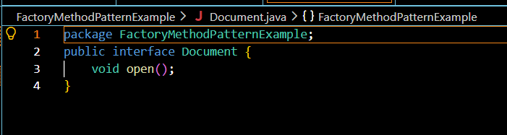
DocumentFactory.java
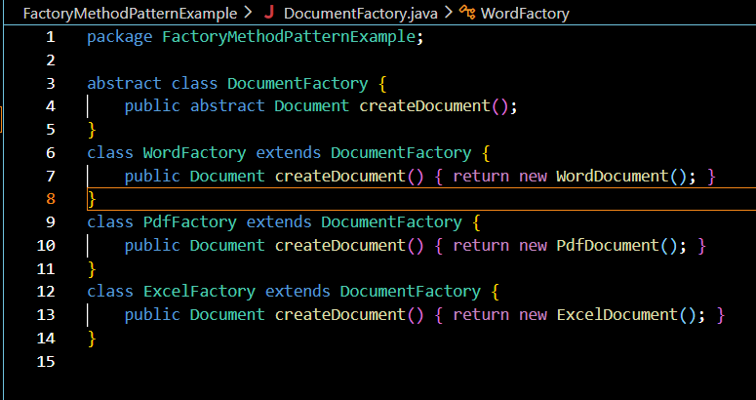
ConcreteDocuments.java
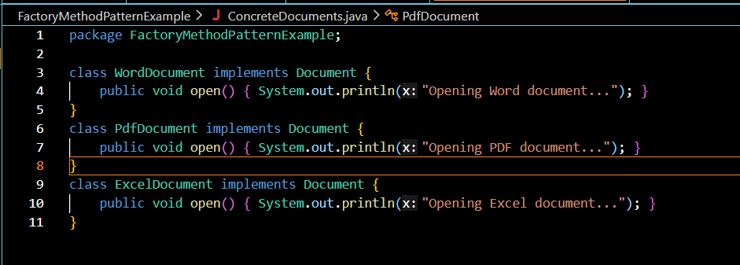
Output:
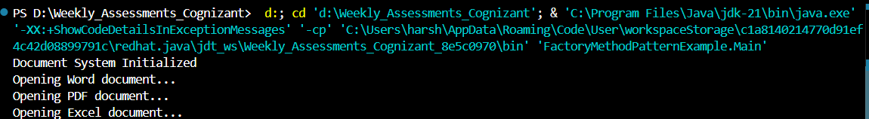
Data Structures and Algorithms
3. E-commerce Platform Search Function
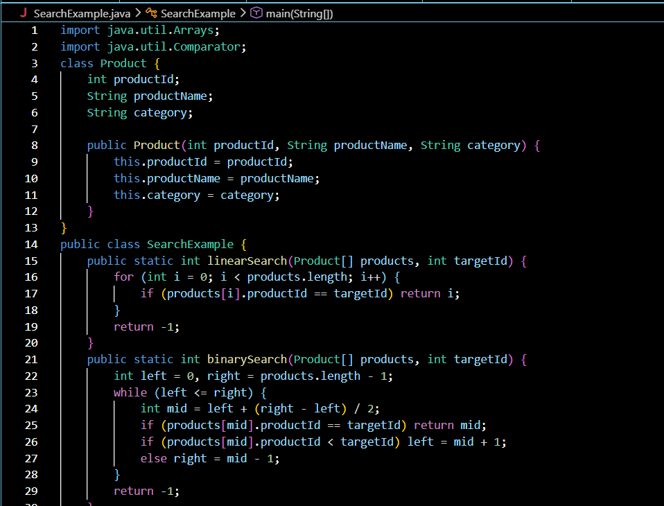
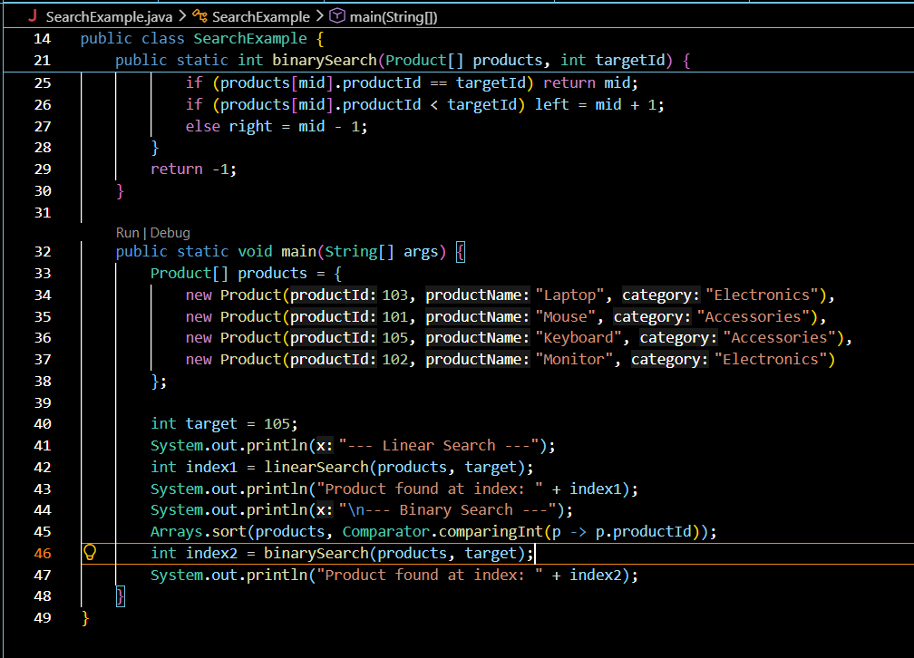
Output:
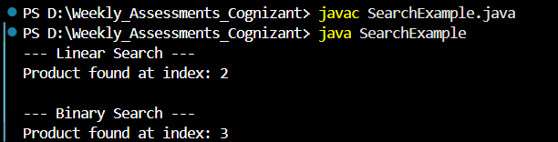
Analysis:
1. Comparison of Time Complexity
Feature | Linear Search | Binary Search
Concept | Sequential Scanning | Divide and Conquer
Prerequisite | None (Data can be unsorted) | Data must be sorted
Best Case | O(1) (Found at index 0) | O(1) (Found at exact middle)
Worst Case | O(n) (Found at last index or absent) | O(log n) (Divided until element found)

Linear vs. Binary Search
When Linear Search O(n) is better:
If the number of products is small (e.g., less than 50–100 items), Linear Search is often faster. This is because Linear Search is extremely simple and avoids the overhead of sorting the data. In a small array, the CPU can scan sequentially so quickly that the "divide and conquer" complexity of Binary Search doesn't provide a noticeable benefit.
When Binary Search O(log n) is better:
As the number of products grows into the thousands or millions, Linear Search becomes a performance bottleneck. In this case, Binary Search is the only viable option for a responsive user experience.

4. Financial Forecasting
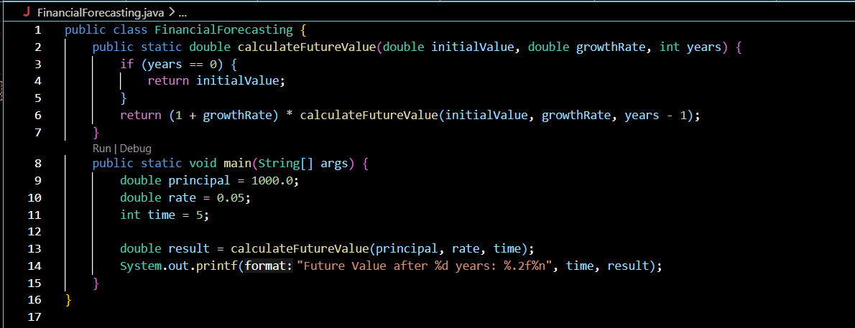
Output:
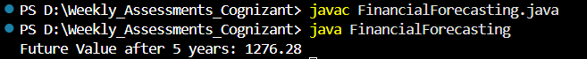

PL/SQL
5. Control Structures
Scenario-1:
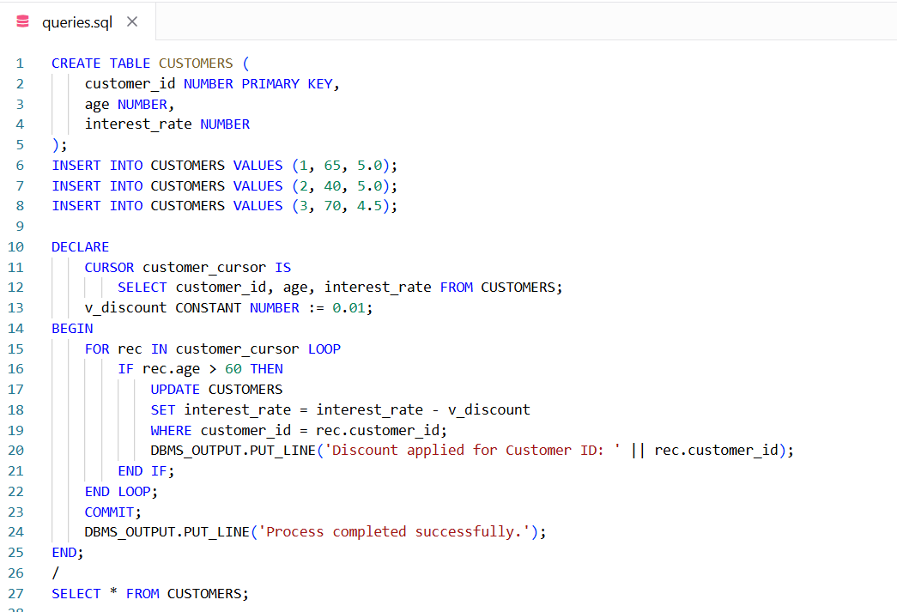
Output:
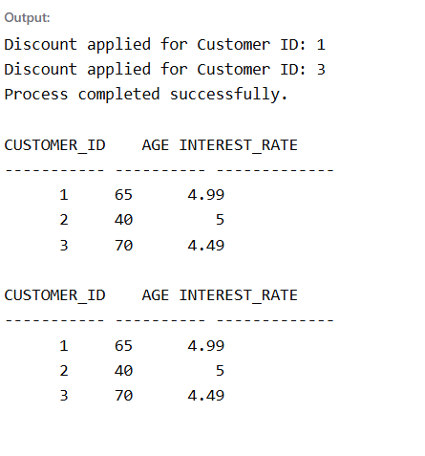
Scenario-2:
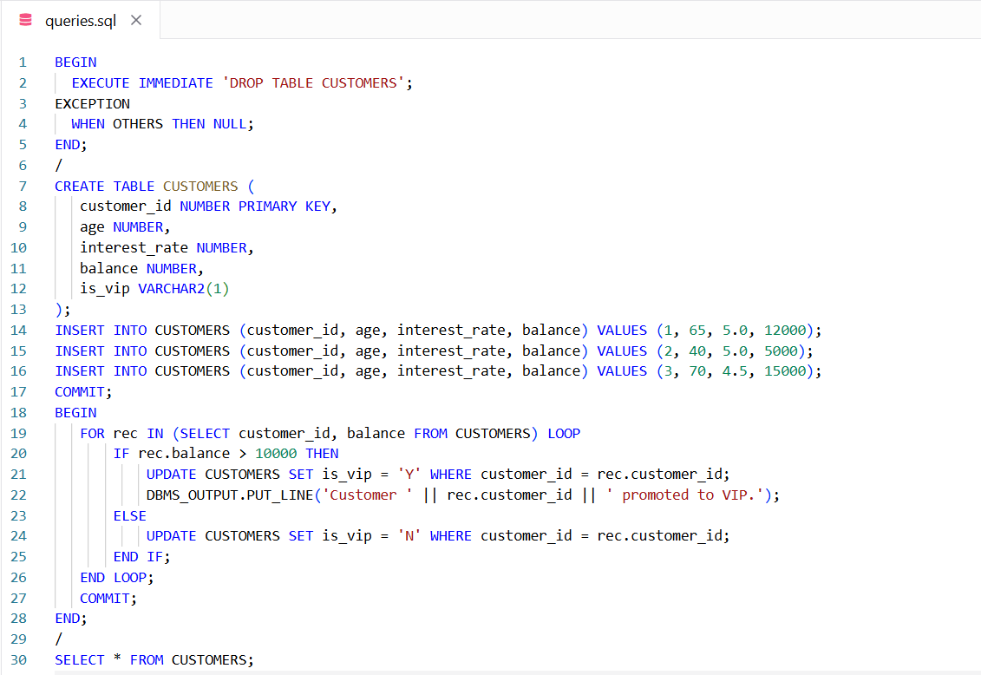
Output:
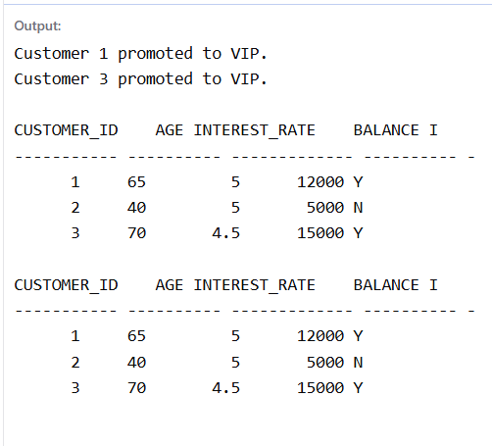

Scenario-3:
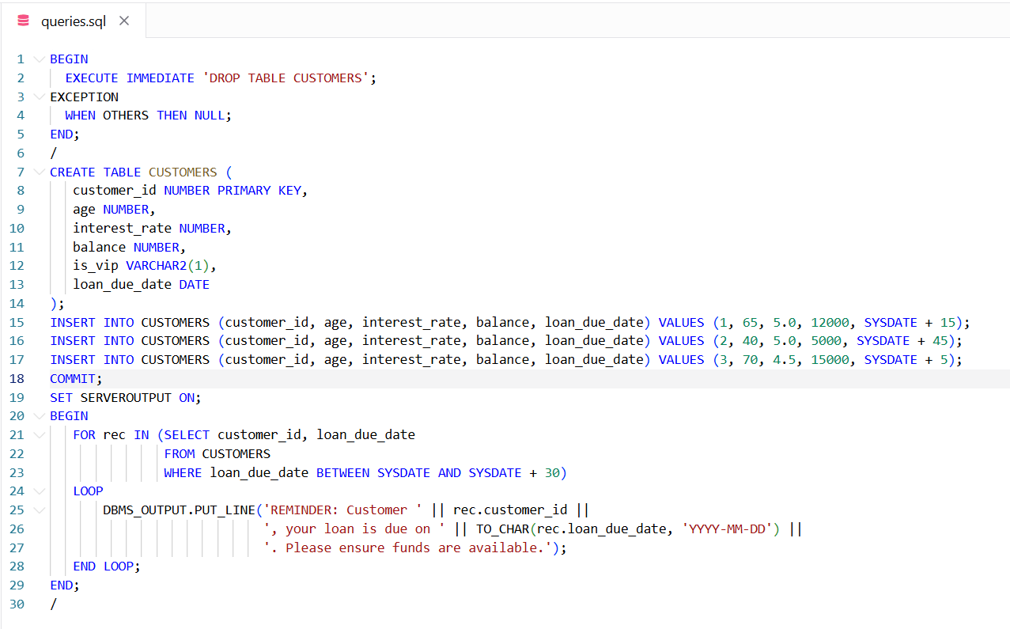
Output:
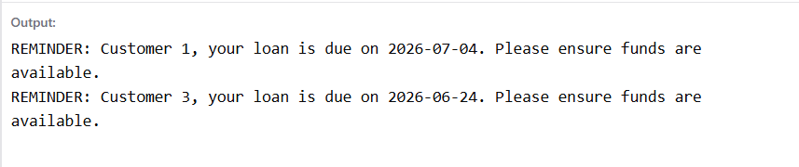
6.Stored Procedures
Scenario-1:
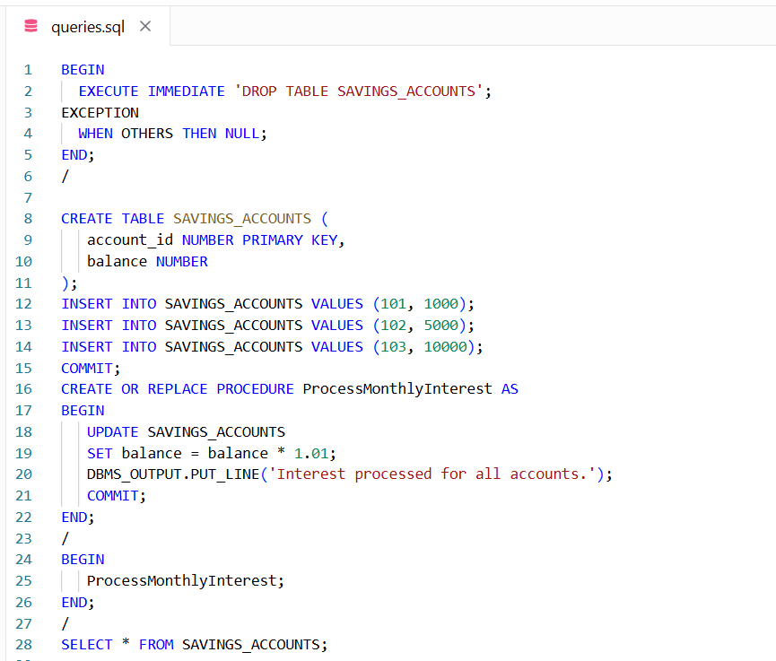
Output:
