WEEK-5
1. Define SPA and its Benefits
SPA (Single-Page Application): A Single-Page Application is a web application that loads a single HTML page and updates only the required content dynamically without reloading the entire page.
Benefits of SPA:
- Faster page loading after the initial load.
- Smooth and responsive user experience.
- Reduces server requests.
- Better performance through caching.
- Easy to build interactive web applications.
- Works well with REST APIs.
2. Define React and Identify its Working
React: React is an open-source JavaScript library developed by Facebook for building fast and interactive user interfaces, especially for Single-Page Applications.
Working of React
- React creates UI using components.
- Components return JavaScript XML.
- React creates a Virtual DOM.
- When data changes, React updates the Virtual DOM.
- Only the changed elements are updated in the Real DOM.
- The browser displays the updated UI efficiently.
3. Differences Between SPA and MPA
SPA (Single-Page Application) | MPA (Multi-Page Application)
Loads only one HTML page | Loads a new HTML page for every request
No full page reload | Full page reload on every request
Faster navigation | Slower navigation
Better user experience | Traditional user experience
Mostly uses JavaScript frameworks like React | Can be built using traditional server-side technologies
Suitable for Gmail, Facebook | Suitable for banking websites, e-commerce with many pages
4. Pros and Cons of Single-Page Application (SPA)
Pros
- Fast navigation.
- Better user experience.
- Less server load.
- Easy API integration.
- Caches resources efficiently.
- Responsive interface.
Cons
- Initial loading time may be high.
- SEO is more difficult.
- JavaScript dependency.
- Browser history management can be complex.
- Security concerns if not properly implemented.
5. Explain About React
React is a JavaScript library used for building reusable and interactive user interfaces.
Key Points
- Developed by Facebook (Meta).
- Open-source.
- Component-based architecture.
- Uses Virtual DOM for faster updates.
- Supports reusable components.
- Uses JSX syntax.
- Mainly used for building SPAs.
- One-way data binding.
- Easy integration with APIs.
6. Define Virtual DOM
Virtual DOM (VDOM):
Virtual DOM is a lightweight copy of the Real DOM maintained in memory by React.
How it Works
- React creates a Virtual DOM.
- When state or props change, a new Virtual DOM is created.
- React compares the new Virtual DOM with the old one (Diffing).
- Only the changed parts are updated in the Real DOM.
- This improves performance.
Advantages
- Faster rendering.
- Better performance.
- Reduces unnecessary DOM updates.
- Improves user experience.
7. Features of React
- Component-Based Architecture
- Virtual DOM
- JSX (JavaScript XML)
- One-Way Data Binding
- Reusable Components
- High Performance
- Fast Rendering
- Easy to Learn
MYFIRSTREACT:
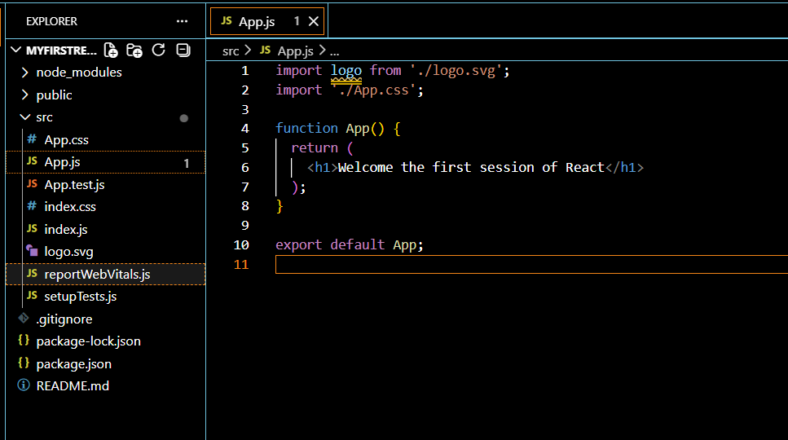
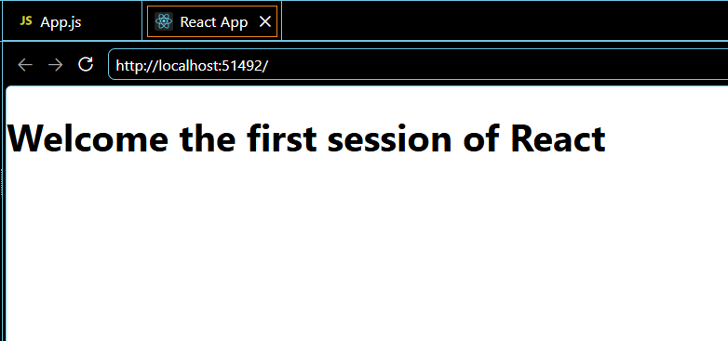
REACT-2
1. Explain React Components
React Components are the building blocks of a React application. They are reusable, independent pieces of code that return UI (User Interface) elements.
Characteristics
- Reusable
- Independent
- Easy to maintain
- Accept inputs through Props
- Can manage data using State
2. Differences Between Components and JavaScript Functions
React Component | JavaScript Function
Returns JSX (UI elements) | Returns any JavaScript value
Used to build user interfaces | Used for general programming tasks
Can receive Props | Receives normal parameters
Can manage State (class or hooks) | Cannot manage React state directly
First letter should be uppercase | Can start with lowercase
Used only in React | Used in any JavaScript program

3. Types of Components
There are two types of React components:
- Function Component
- Class Component
4. Explain Class Component
A Class Component is a JavaScript class that extends React. Component and must include a render() method.
Features
- Uses ES6 classes.
- Can maintain State.
- Supports lifecycle methods.
- Uses this keyword.
- More code than function components.
Advantages
- Supports lifecycle methods.
- Can manage complex state.
Disadvantages
- More boilerplate code.
- Uses this, making it more complex.
5. Explain Function Component
A Function Component is a simple JavaScript function that returns JSX.
Features
- Simpler and shorter.
- Easy to understand.
- Uses Hooks (useState, useEffect) for state and lifecycle.
- No this keyword.
Advantages
- Easy to write.
- Better readability.
- Better performance in modern React.
- Preferred in new React applications.
Disadvantages
- Earlier versions of React did not support state (before Hooks).
6. Define Component Constructor
A Constructor is a special method in a class component that is executed when the component is created.
Uses
- Initialize the component's state.
- Bind event handler methods.
- Perform initial setup.
7. Define render() Function
The render() function is a mandatory method in a class component that returns the JSX (UI) to be displayed on the screen.
Features
- Must return JSX or null.
- Called whenever the component needs to update.
- Displays the component's UI.
STUDENTAPP

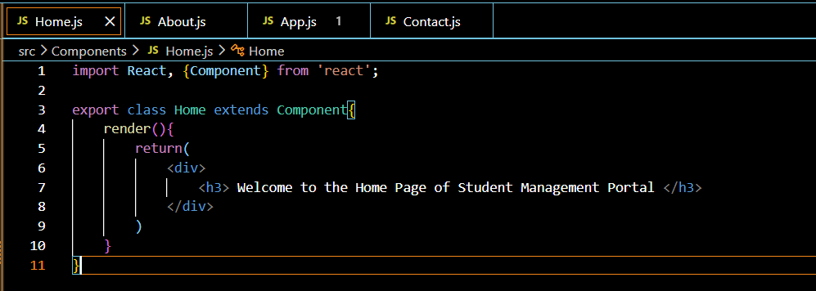
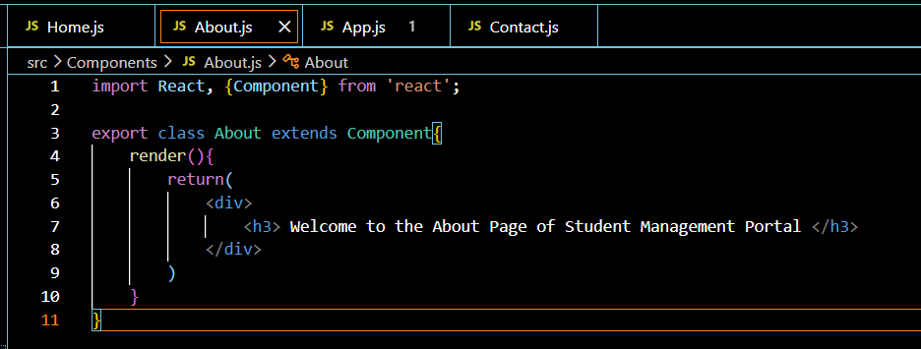

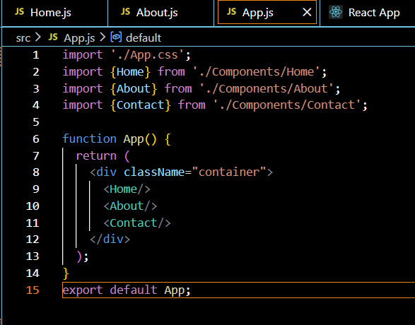
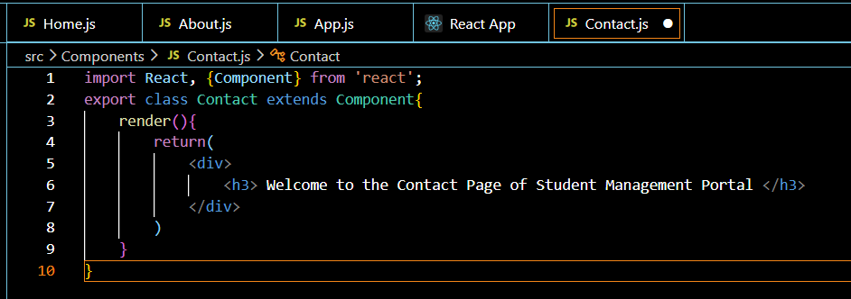
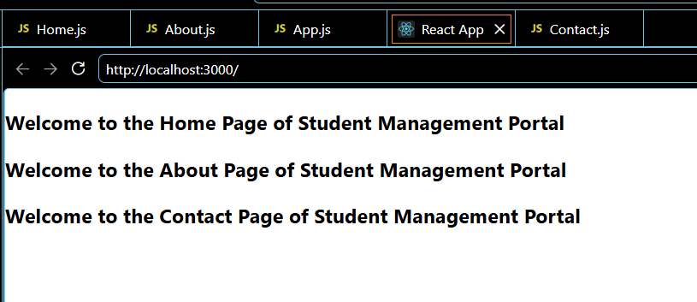
REACT-3
1. Explain React Components
Definition: A React Component is a reusable and independent block of code that represents a part of the user interface (UI). Components help build complex applications by dividing the UI into smaller, manageable pieces.
Features
- Reusable
- Independent
- Easy to maintain
- Accepts input through Props
- Can manage State
- Returns JSX (UI)
2. Differences Between React Components and JavaScript Functions
React Component | JavaScript Function
Used to create UI | Used for general programming tasks
Returns JSX (HTML-like code) | Returns any JavaScript value
Can receive Props | Receives normal parameters
Can manage State (using Hooks or class state) | Cannot manage React state directly
Component names start with a capital letter | Function names can be any valid identifier
Used only in React | Used in all JavaScript programs

3. Types of Components
React has two types of components:
- Function Component
- Class Component
4. Explain Class Component
Definition: A Class Component is an ES6 JavaScript class that extends React. Component and must contain a render() method to display the UI.
Features
- Uses ES6 classes.
- Supports State.
- Supports Lifecycle Methods.
- Uses the this keyword.
- Contains a render() method.
Advantages
- Supports lifecycle methods.
- Can manage complex state.
Disadvantages
- More code.
- Uses this, making it more complex.

5. Explain Function Component
Definition:
A Function Component is a JavaScript function that accepts props as input and returns JSX.
Features
- Simple and easy to write.
- Uses Hooks for state and lifecycle.
- No this keyword.
- Preferred in modern React.
Advantages
- Less code.
- Easy to understand.
- Better readability.
- Preferred in modern React development.
Disadvantages
- Earlier React versions did not support state (before Hooks).

6. Define Component Constructor
Definition: A Constructor is a special method in a Class Component that is called automatically when the component is created. It is used to initialize the component's state and bind event handler methods.
Uses
- Initializes state.
- Binds event methods.
- Performs initial setup.
7. Define render() Function
Definition: The render() method is a mandatory method in a Class Component. It returns the JSX that should be displayed on the screen.
Features
- Returns JSX or null.
- Called whenever the component is rendered or updated.
- Defines the UI of the component.

