WEEK-2
Spring Core and Maven
Exercise-1
pom.xml
<project xmlns="http://maven.apache.org/POM/4.0.0"
xmlns:xsi="http://www.w3.org/2001/XMLSchema-instance"
xsi:schemaLocation="http://maven.apache.org/POM/4.0.0
http://maven.apache.org/xsd/maven-4.0.0.xsd">
<modelVersion>4.0.0</modelVersion>
<groupId>com.library</groupId>
<artifactId>LibraryManagement</artifactId>
<version>1.0</version>
<dependencies>
<dependency>
<groupId>org.springframework</groupId>
<artifactId>spring-context</artifactId>
<version>5.3.30</version>
</dependency>
</dependencies>
</project>

applicationContext.xml
<?xml version="1.0" encoding="UTF-8"?>
<beans xmlns="http://www.springframework.org/schema/beans"
xmlns:xsi="http://www.w3.org/2001/XMLSchema-instance"
xsi:schemaLocation="
http://www.springframework.org/schema/beans
https://www.springframework.org/schema/beans/spring-beans.xsd">
<bean id="bookRepository"
class="com.library.repository.BookRepository"/>
<bean id="bookService"
class="com.library.service.BookService">
<property name="bookRepository"
ref="bookRepository"/>

</bean>
</beans>

BookRepository.java
package com.library.repository;
public class BookRepository {
public String getBookDetails() {
return "Spring Framework in Action";
}
}
BookService.java
package com.library.service;
import com.library.repository.BookRepository;
public class BookService {
private BookRepository bookRepository;
public void setBookRepository(BookRepository bookRepository) {
this.bookRepository = bookRepository;
}
public void displayBook() {
System.out.println("Book Name: " + bookRepository.getBookDetails());
}
}
MainApp.java
package com.library;
import org.springframework.context.ApplicationContext;
import org.springframework.context.support.ClassPathXmlApplicationContext;
import com.library.service.BookService;
public class MainApp {
public static void main(String[] args) {
ApplicationContext context =
new ClassPathXmlApplicationContext(
"applicationContext.xml");
BookService service =
(BookService) context.getBean("bookService");
service.displayBook();
}
}

Exercise-2
pom.xml
<dependencies>
<dependency>
<groupId>org.springframework</groupId>
<artifactId>spring-context</artifactId>
<version>5.3.30</version>
</dependency>
</dependencies>
applicationContext.xml
<?xml version="1.0" encoding="UTF-8"?>
<beans xmlns="http://www.springframework.org/schema/beans"
xmlns:xsi="http://www.w3.org/2001/XMLSchema-instance"
xsi:schemaLocation="
http://www.springframework.org/schema/beans
https://www.springframework.org/schema/beans/spring-beans.xsd">
<bean id="bookRepository"
class="com.library.repository.BookRepository"/>
<bean id="bookService"
class="com.library.service.BookService">
<property name="bookRepository"
ref="bookRepository"/>
</bean>
</beans>
BookRepository.java
package com.library.repository;
public class BookRepository {
public String getBookInfo() {
return "Spring Framework Book";
}
}

BookService.java
package com.library.service;
import com.library.repository.BookRepository;
public class BookService {
private BookRepository bookRepository;
public void setBookRepository(BookRepository bookRepository) {
this.bookRepository = bookRepository;
}
public void displayBook() {
System.out.println("Book Name: " +
bookRepository.getBookInfo());
}
}
LibraryManagementApplication.java
package com.library;
import org.springframework.context.ApplicationContext;
import org.springframework.context.support.ClassPathXmlApplicationContext;
import com.library.service.BookService;
public class LibraryManagementApplication {
public static void main(String[] args) {
ApplicationContext context =
new ClassPathXmlApplicationContext(
"applicationContext.xml");
BookService service =
(BookService) context.getBean("bookService");

service.displayBook();
}
}

Exercise-4
pom.xlm
<project xmlns="http://maven.apache.org/POM/4.0.0"
xmlns:xsi="http://www.w3.org/2001/XMLSchema-instance"
xsi:schemaLocation="http://maven.apache.org/POM/4.0.0
https://maven.apache.org/xsd/maven-4.0.0.xsd">
<modelVersion>4.0.0</modelVersion>
<groupId>com.library</groupId>
<artifactId>LibraryManagement</artifactId>
<version>1.0-SNAPSHOT</version>
<packaging>jar</packaging>
<dependencies>
<dependency>
<groupId>org.springframework</groupId>
<artifactId>spring-context</artifactId>
<version>5.3.30</version>
</dependency>
<dependency>
<groupId>org.springframework</groupId>
<artifactId>spring-aop</artifactId>
<version>5.3.30</version>
</dependency>
<dependency>
<groupId>org.springframework</groupId>
<artifactId>spring-webmvc</artifactId>
<version>5.3.30</version>
</dependency>
</dependencies>
<build>
<plugins>
<plugin>
<groupId>org.apache.maven.plugins</groupId>
<artifactId>maven-compiler-plugin</artifactId>
<version>3.8.1</version>
<configuration>
<source>1.8</source>
<target>1.8</target>
</configuration>
</plugin>
</plugins>
</build>
</project>
Spring Data JPA - Quick Example
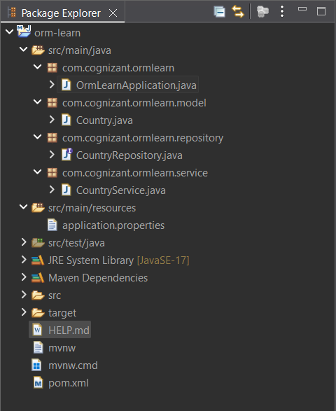

OrmLearnApplication.java
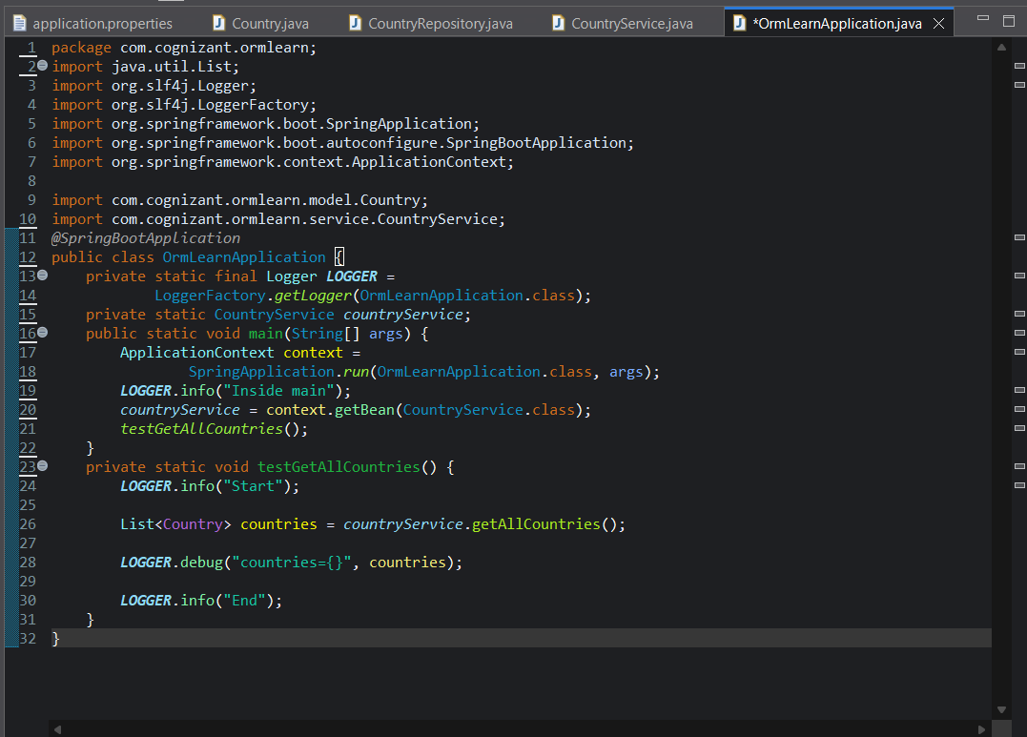
Country.java
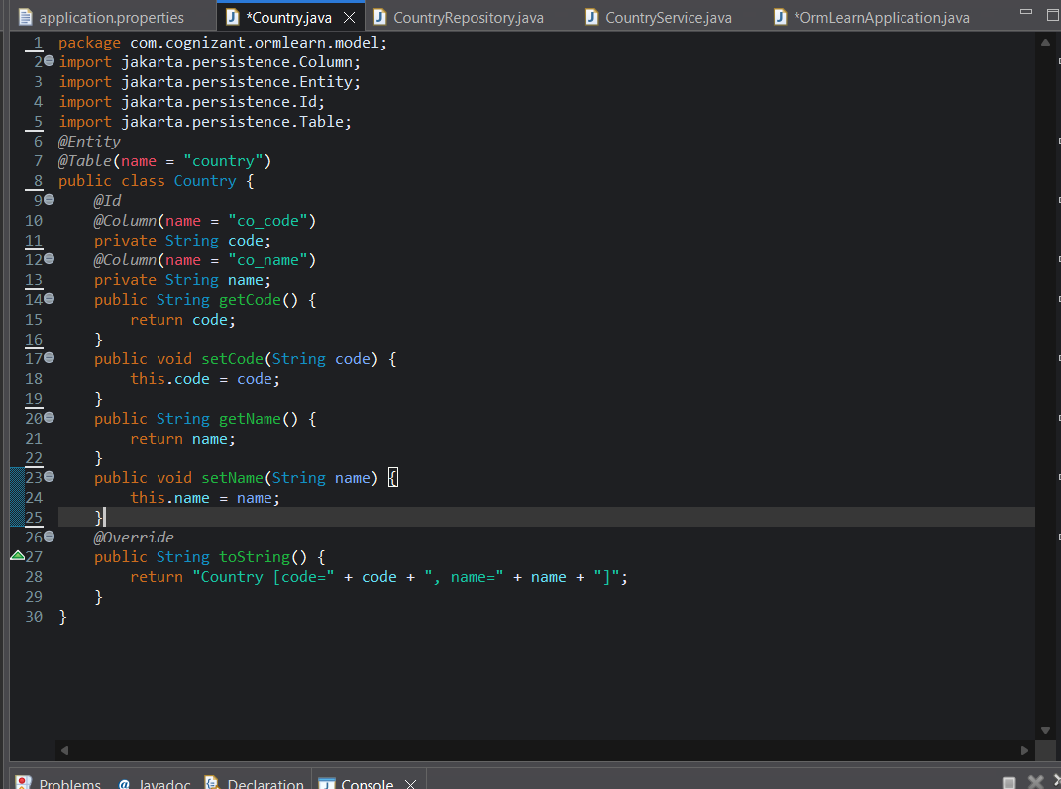
CountryRepositor.java
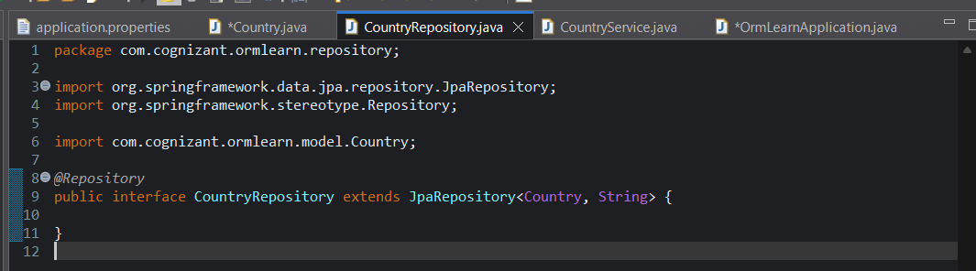
CountryService.java
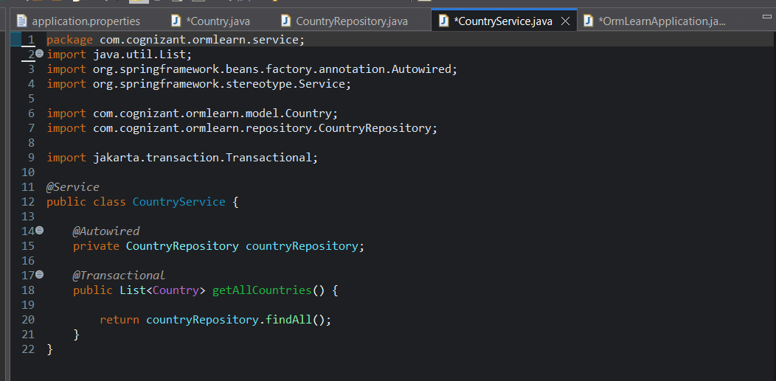

Application.properties
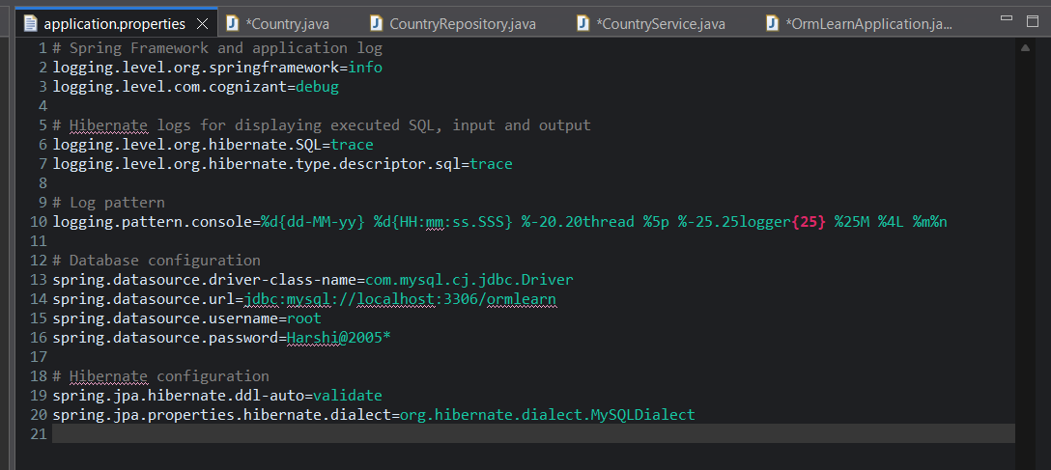
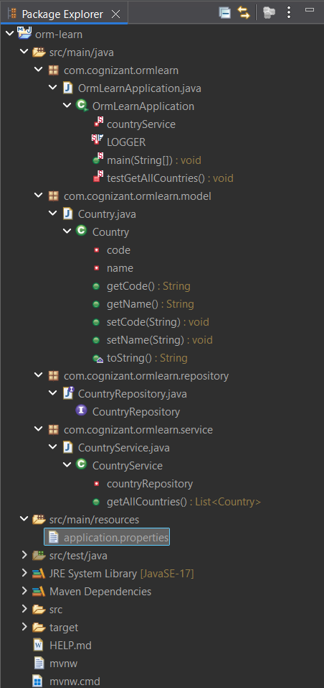
Output:
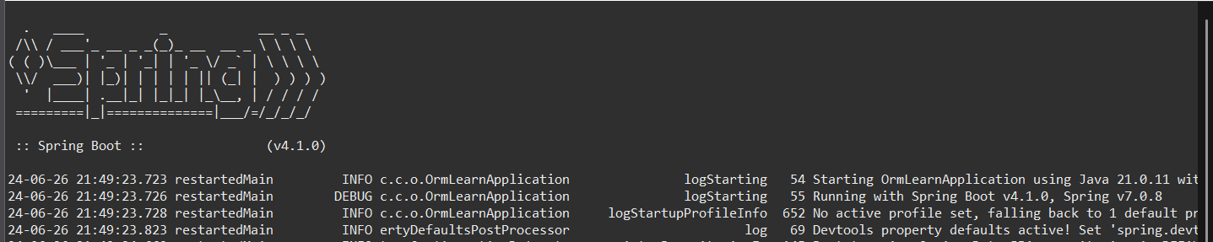
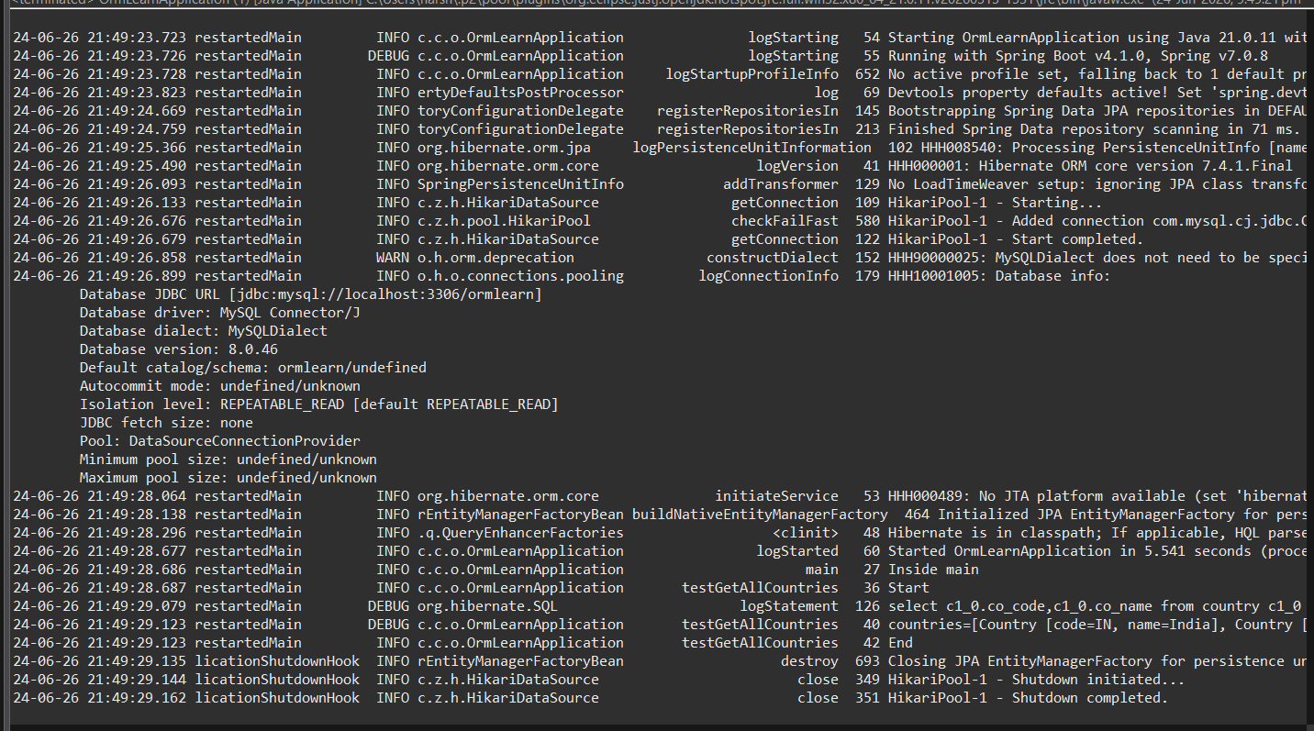
Difference between JPA, Hibernate and Spring Data JPA
JPA, Hibernate and Spring Data JPA
When developing Java applications, we use JPA, Hibernate, and Spring Data JPA to interact with databases. Although they are related, each has a different role.
JPA (Java Persistence API)
JPA is a specification defined by Java (JSR 338) for persisting and managing data in Java applications. It provides standard annotations such as @Entity, @Table, @Id, and @Column.
JPA itself does not perform any database operations because it is only a set of rules and interfaces. An implementation is required to make it work.
Hibernate
Hibernate is an ORM (Object Relational Mapping) framework and one of the most popular implementations of JPA.
It converts Java objects into database records and database records back into Java objects. Hibernate handles SQL generation, session management, and transaction management.
In Hibernate, developers need to manually manage sessions and transactions:
Session session = factory.openSession();
Transaction tx = session.beginTransaction();
session.save(employee);
tx.commit();
session.close();
This approach works well but requires a considerable amount of boilerplate code.
Spring Data JPA
Spring Data JPA is a Spring framework module built on top of JPA and Hibernate.
It does not provide its own JPA implementation. Instead, it uses implementations such as Hibernate and simplifies database operations by reducing boilerplate code.
Using Spring Data JPA, we only need to create a repository interface:
public interface EmployeeRepository
extends JpaRepository<Employee, Integer> {
}
Then in the service layer:
@Autowired
private EmployeeRepository employeeRepository;
@Transactional
public void addEmployee(Employee employee) {
employeeRepository.save(employee);
}
Spring Data JPA automatically handles repository implementation, transaction management, and common CRUD operations.
JPA | Hibernate | Spring Data JPA
Specification | Framework | Spring Module
Defines rules for persistence | Implements JPA | Simplifies JPA/Hibernate usage
No implementation | Provides implementation | Uses Hibernate internally
Cannot work alone | Can work independently | Requires a JPA implementation
Standard API | ORM Framework | Repository abstraction

