# MDS and its case:

MDS(Medical Data Sharing ) is a growing company which has done multiple medical projects in 2012 and 2018 which was especially a data collection and sharing project. It made MDS an unique relationship with hospitals worldwide. The COVID-19 pandemic hit early in 2020. The relationship with hospitals made it grow even in larger time (highest in past eight years).

The quick and huge increase in the company’s growth created significant challenges in IT sector of MDS. They managed with some ad-hoc expansions but its rapid growth in business took the company in a point where these ad-hoc were not able to manageable. Because MDS has gained so much publicity, it increased high risk of script kiddies, hactivists and other attacks. So, they showed concerned in designing more secured network design especially regarding security and their system privacy gave this contract to our team.

# Project work

MDS asked us to:

* Design a cloud-based website, with features to support a large, scalable site, e.g. load balancing, distributed databases, high availability, fast scale up of servers.
* Design a defense system for the website, including firewall, DDoS prevention strategies.
* Conduct a risk assessment of the website.
* Build a prototype website and supporting infrastructure. The website contents do not need to be real; instead, the prototype should demonstrate your design for a scalable and secure site (e.g. firewall, load balancing, hardening).
* Design and recommended security mechanisms, including any policies, for the site, e.g. to minimize the impact of ransomware or other compromises.
* Perform penetration testing on the site to show MDS of potential flaws, and mechanisms you would use to mitigate attacks.

At first, we introduce our project introduction, describe the background of the project and its scope. Then statement of work was provided. Then we schedule our project using gantt chart after describing various roles in the project and their responsibilities. Finally, we came up with a risk assessment plan.

Various phases of our project are given below with their days of assessment and completion. The table below includes all the phases, activities, allocated time and date of initiation and completion.

|  |  |  |  |
| --- | --- | --- | --- |
| Name of Activity | Time Allotted | Starting date | Finishing date |
| **Project MDS** | 60 Days | 12/3/21 | 3/6/21 |
| **Requirement Gathering** | 24 Days | 12/3/21 | 14/4/21 |
| MDS Case Analysis | 1 Day | 12/3/21 | 12/3/21 |
| Security Requirements Gathering | 2 Days | 15/3/21 | 16/3/21 |
|  |  |  |  |
| Functional Requirements | 3 Days | 17/3/21 | 19/3/21 |
| Non-functional requirements | 2 Days | 22/3/21 | 23/3/21 |
| Research Methodologies | 3 Days | 24/3/21 | 26/3/21 |
| Tools and Technologies | 4 Days | 29/3/21 | 1/4/21 |
| RACI Matrix Developing | 2 Days | 2/4/21 | 5/4/21 |
| Creating Project Plan | 3 Days | 6/4/21 | 8/4/21 |
| Journal 1 Preparation | 4 Days | 9/4/21 | 14/4/21 |
| Requirement Gathering Finished | 0 | 14/4/21 | 14/4/21 |
| **Design** | 17 Days | 15/4/21 | 7/5/21 |
| Creating security layout | 2 Days | 15/4/21 | 16/4/21 |
| Researching security controls and protocols | 4 Days | 19/4/21 | 22/4/21 |
| Analysing configuration process of proposed security controls | 2 Days | 23/4/21 | 26/4/21 |
| Designing layout structure of proposed architecture | 2 Days | 27/4/21 | 28/4/21 |
| Interim Report Generation Started | 3 Days | 29/4/21 | 3/5/21 |
| Interim Report Finished | 2 Days | 4/5/21 | 5/5/21 |
| Addressing scheme creating | 1 Day | 6/5/21 | 6/5/21 |
| Naming scheme creating | 1 Day | 7/5/21 | 7/5/21 |
| Design Phase finished | 0 Days | 7/5/21 | 7/5/21 |
| **Implementation** | 6 Days | 10/5/21 | 17/5/21 |
| Physical Infrastructure Creation | 2 Days | 10/5/21 | 10/5/21 |
| Logical Infrastructure Creation | 1 Day | 12/5/21 | 12/5/21 |
| Including cloud infrastructure connection | 2 Days | 13/5/21 | 13/5/21 |
| Validating design and infrastructural working | 1 Day | 17/5/21 | 17/5/21 |
| Implementation Finished | 0 Days | 17/5/21 | 17/5/21 |
| **Test and Plans Development** | 13 Days | 18/5/21 | 31/5/21 |
| Penetration Testing | 2 Days | 18/5/21 | 19/5/21 |
| Performance and Functionality Testing | 1 Day | 20/5/21 | 20/5/21 |
| On-demand testing if any | 2 Days | 21/5/21 | 24/5/21 |
| Business Continuity Plan development | 1 Day | 25/5/21 | 25/5/21 |
| Risk assessment plan | 1 Day | 26/5/21 | 26/5/21 |
| Disaster Recovery plan | 1 Day | 27/5/21 | 27/5/21 |
| Documentation of test and plans development | 2 Days | 28/5/21 | 31/5/21 |
| Test and Plans documentation finished | 0 Days | 31/5/21 | 31/5/21 |
| **Final Report Submission** | 3 Days | 1/6/21 | 3/6/21 |
| Final Report prepared | 2 Days | 1/6/21 | 2/6/21 |
| Presentation delivered | 1 Day | 3/6/21 | 3/6/21 |
| Final report submission | 0 Days | 3/6/21 | 3/6/21 |

# Evidence of work

Next we represented various roles and responsibilities in RACI matrix as it is very effective for assigning roles and responsibilities. A small screenshot as a evidence of scheduling using gantt chart is given below:

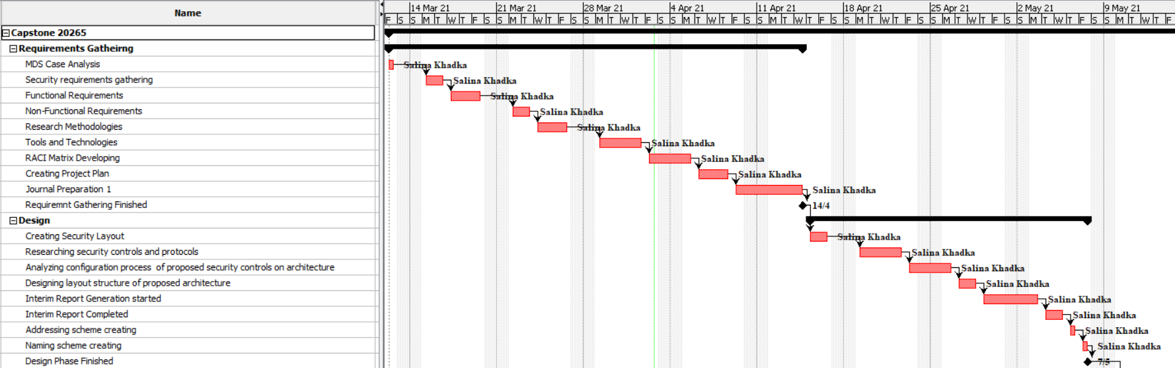

More work evidence is given below:

I looked for various resources to have more information regarding our project. A screenshot is given below:

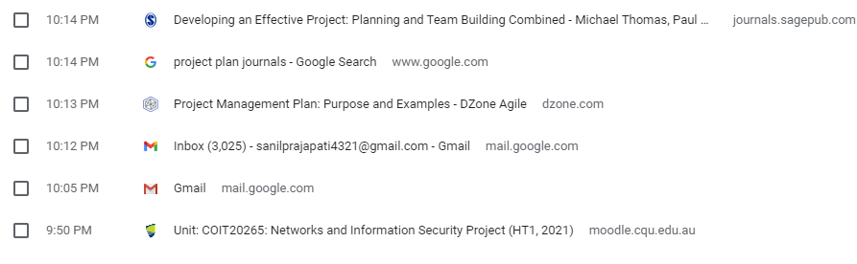

# Problems and Successes in the project

Some problems we faced during developing our project plan are:

1. We created our group in second week and finalize our topic in 3rd week.
2. Easter holidays was one of the distractions and reason for ups and downs in the planning.
3. Difficulty in finding common time to discuss.

Although we had these problems going on, we successfully sketched our project plan by adopting the following principles:

1. We utilize our time during the class mostly.
2. Online and offline chats and conversation really help us updated about each other’s progress.
3. We organized a weekly discussion online despite having different time schedules.

# References

Wilson, F., 2020. Project Management Plan: Purpose and Examples - DZone Agile. [online] dzone.com. Available at: <https://dzone.com/articles/project-management-plan-purpose-and-examples> [Accessed 5 April 2021].

Haworth, S., 2021. Example RACI Chart For Project Managers & How To Make It. [online] The Digital Project Manager. Available at: <https://thedigitalprojectmanager.com/raci-chart-made-simple> [Accessed 5 April 2021].