**ASSIGNMENT 4. : PROLOG FAMILY TREE**

**ROLL NO. 50**

/* Facts */

male(sanil).

male(nikhil).

male(ravindra).

male(rugved).

male(vedant).

male(kiran).

female(sarika).

female(pallavi).

female(manjari).

parent_of(nikhil,sanil).

parent_of(sarika,sanil).

parent_of(ravindra, nikhil).

parent_of(pallavi, nikhil).

parent_of(kiran,rugved).

parent_of(manjari, rugved).

parent_of(kiran, vedant).

parent_of(manjari, vedant).

parent_of(ravindra, manjari).

parent_of(pallavi, manjari).

/* Rules */

father_of(X,Y):- male(X),

parent_of(X,Y).

mother_of(X,Y):- female(X),

parent_of(X,Y).

grandfather_of(X,Y):- male(X),

parent_of(X,Z),

parent_of(Z,Y).

grandmother_of(X,Y):- female(X),

parent_of(X,Z),

parent_of(Z,Y).

sister_of(X,Y):- %(X,Y or Y,X)%

female(X),

father_of(Father, Y), father_of(Father,X),X \= Y.

sister_of(X,Y):- female(X),

mother_of(Mother, Y), mother_of(Mother,X),X \= Y.

aunt_of(X,Y):- female(X),

parent_of(Z,Y), sister_of(X,Z),X \= Y.

brother_of(X,Y):- %(X,Y or Y,X)%

male(X),

father_of(F, Y), father_of(F,X),X \= Y.

brother_of(X,Y):- male(X),

mother_of(M, Y), mother_of(M,X),X \= Y.

uncle_of(X,Y):-

parent_of(Z,Y), brother_of(Z,X).

ancestor_of(X,Y):- parent_of(X,Y).

ancestor_of(X,Y):- parent_of(X,Z),

ancestor_of(Z,Y).

husband_of(X,Y) :- male(X),

father_of(X,Child), mother_of(Y,Child).

**TREE FOR REFERENCE:**

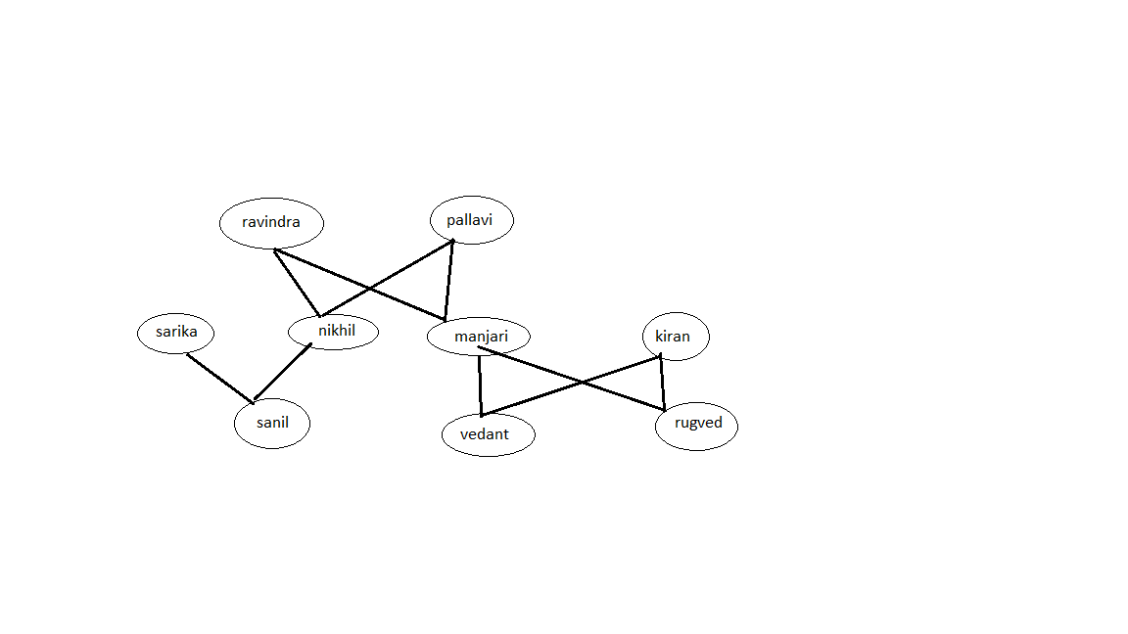

**OUTPUT QUERY:**



