Part 1: Deploy Flask and Express on a Single EC2 Instance

Launch an EC2 instance on AWS: and public ip is 13.50.235.14
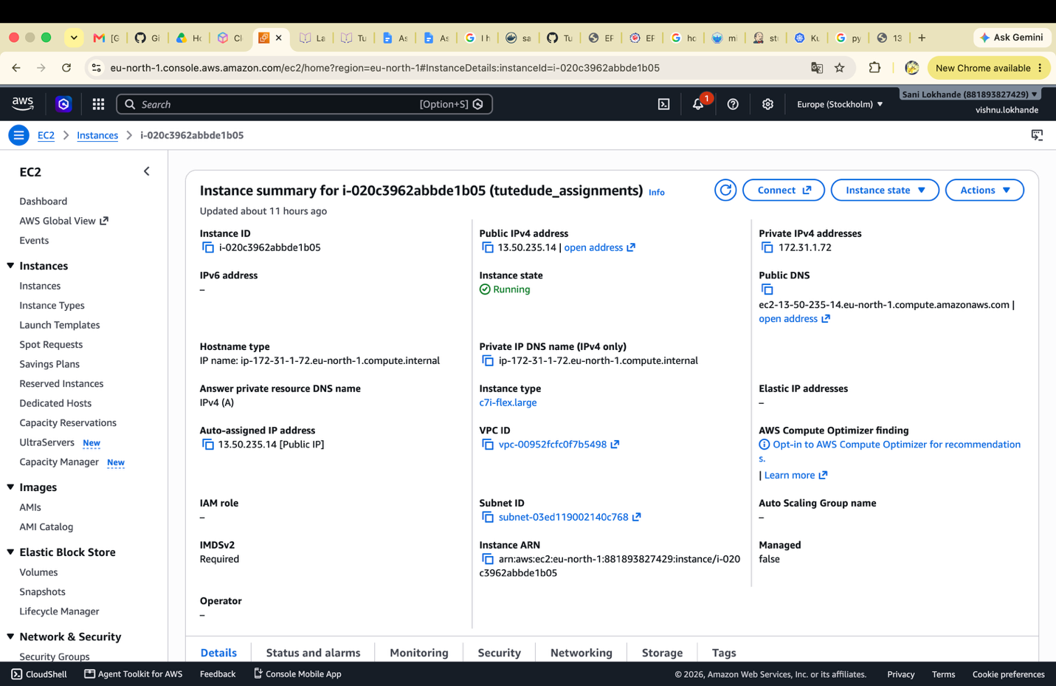

- Cloned the git repository and added the flask backend and express frontend. And added the env variables to access the ports from frontend to backend. Using the Flask on port 5000 and Express on port 3000
- Running backend using:
Step1 : Added the content in system file using this command
“sudo vi /etc/systemd/system/student_flask_app.service”

Step2 : enabled and started the newly created service :
sudo systemctl enable student_flask_app.service
sudo systemctl start student_flask_app.service
step3: restarted the systemctl and restarted the service
sudo systemctl daemon-reload
“sudo systemctl restart student_flask_app.service”
Step 4: Checking the status using this:
“sudo systemctl status student_flask_app.service”
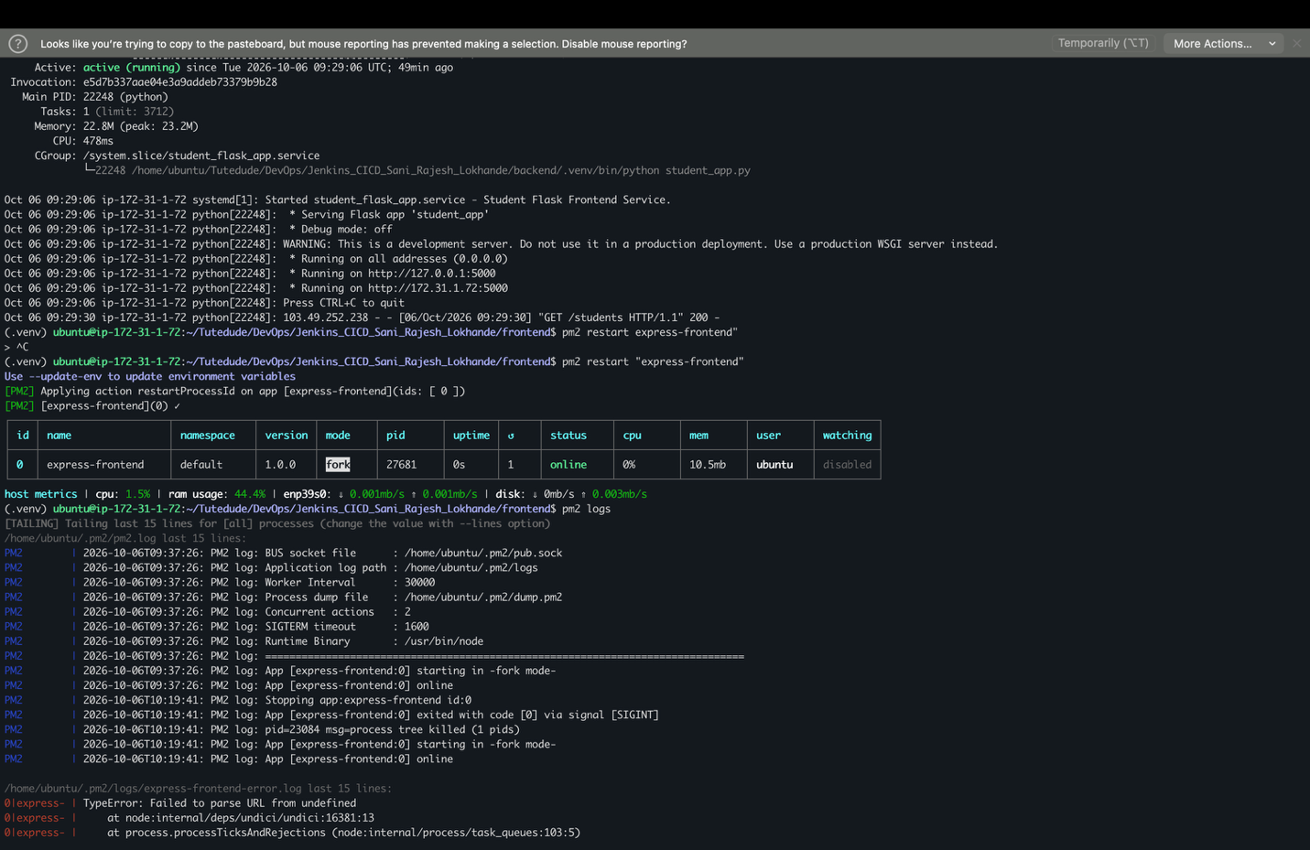

Running the fronend using the process manager PM2. PM2 and systemctl commad run as backend process continuously so this can be reachable throughout the instace life even if the instance rebooted application will be auto launched.
Using pm2 restart: restarted the frontend application: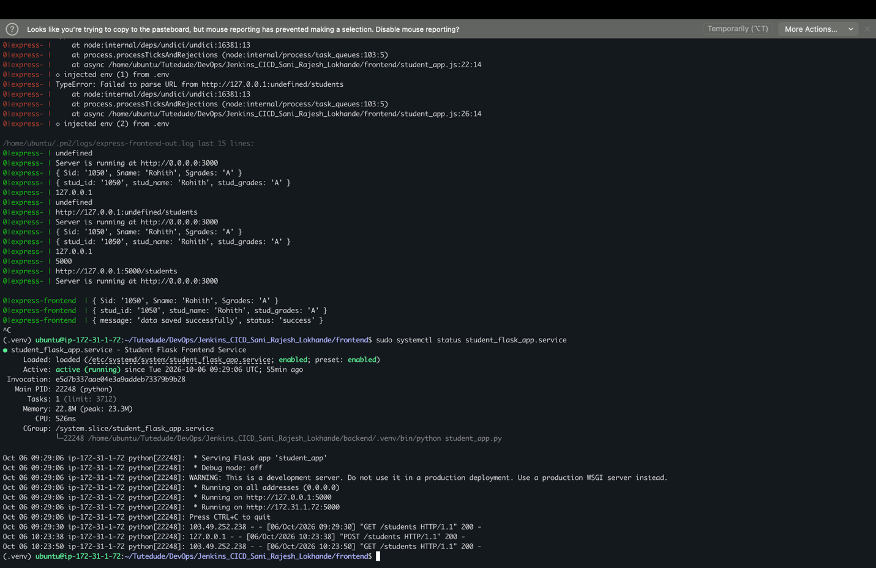

PM2 Logs
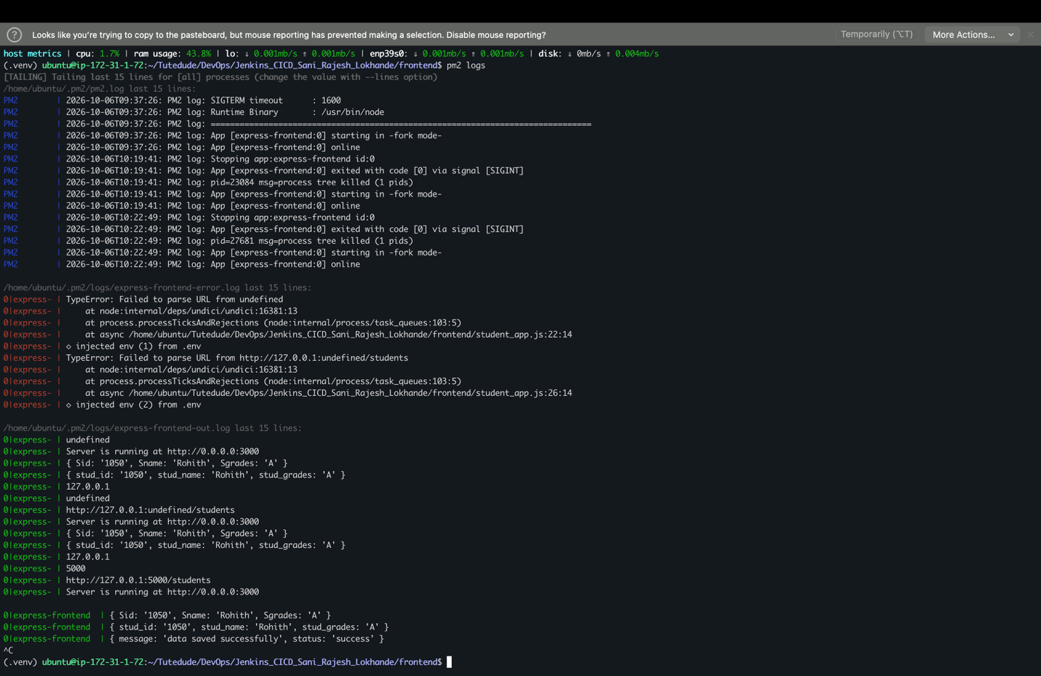
Frontend running:
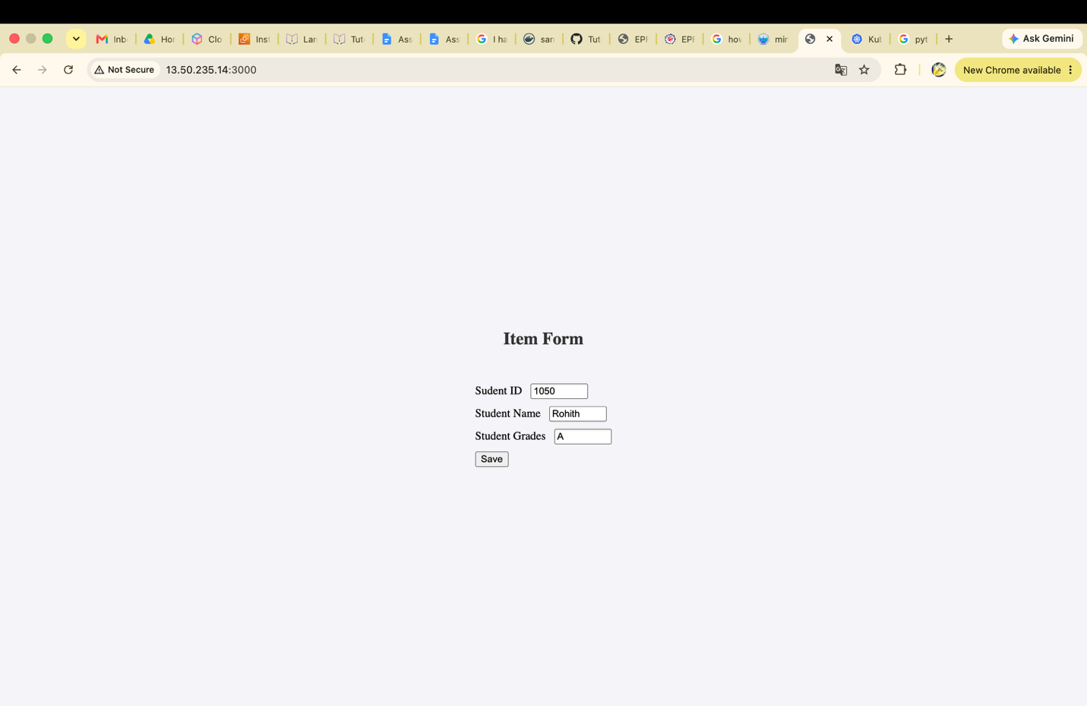

Data saved successfully message from backend:
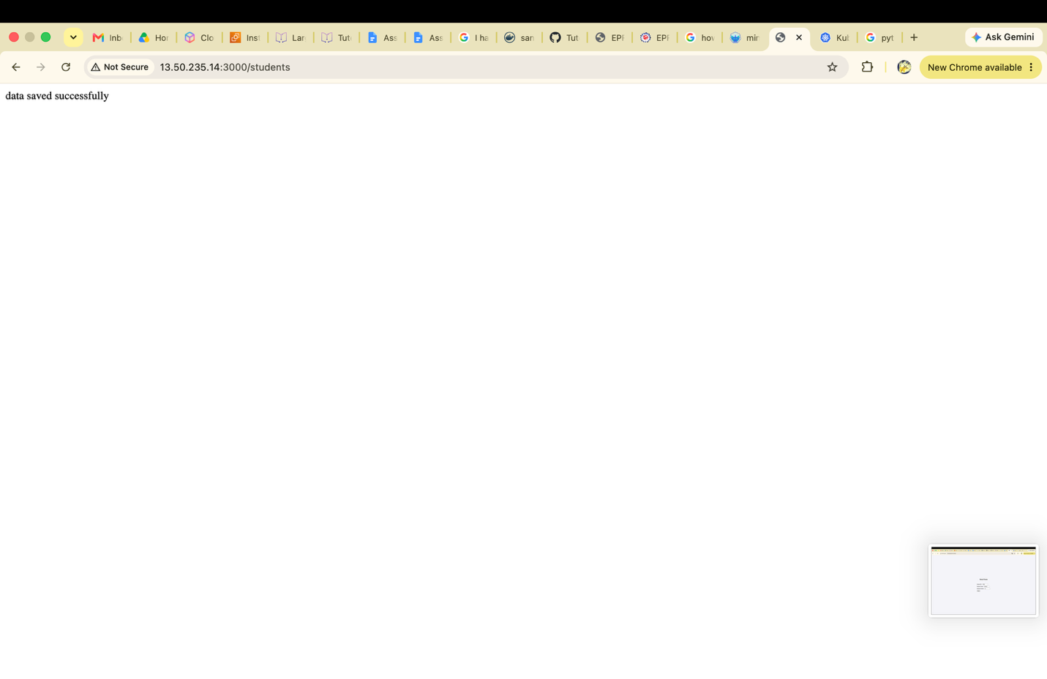
Saved in database get response from backend:
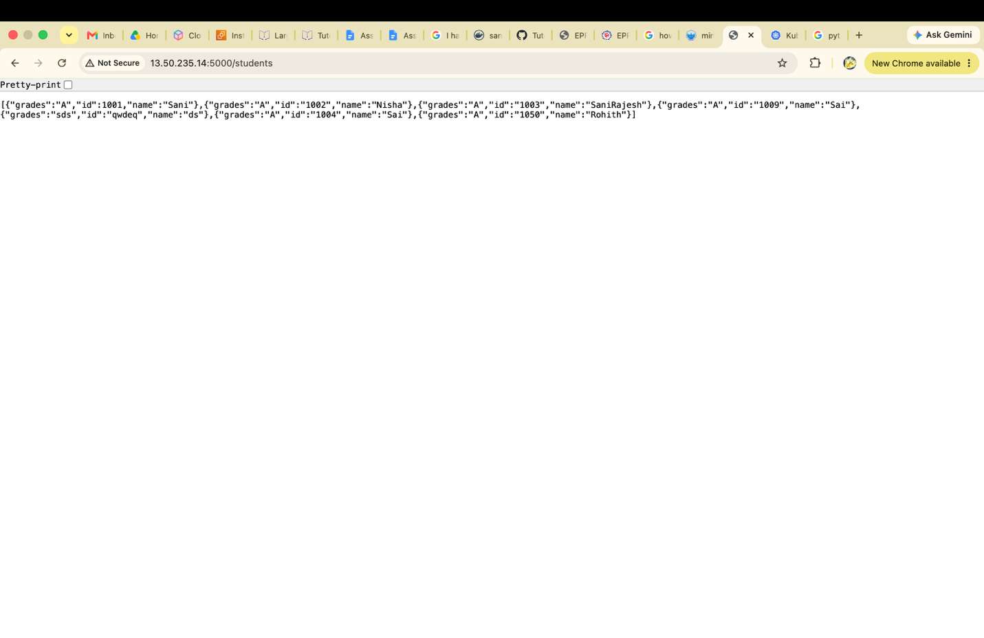

Part 2: Implement CI/CD Pipeline Using Jenkins

Installed Jenkins and created admin account.
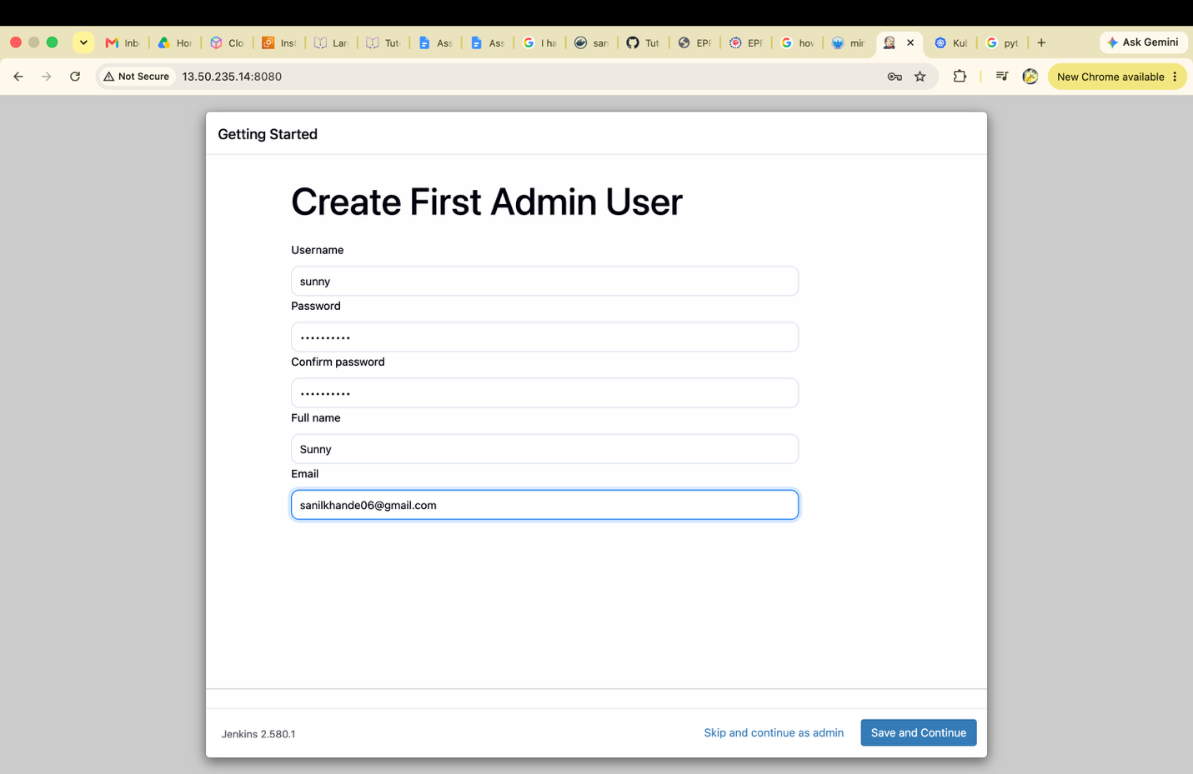

Created new Jenkins FreeStyle job
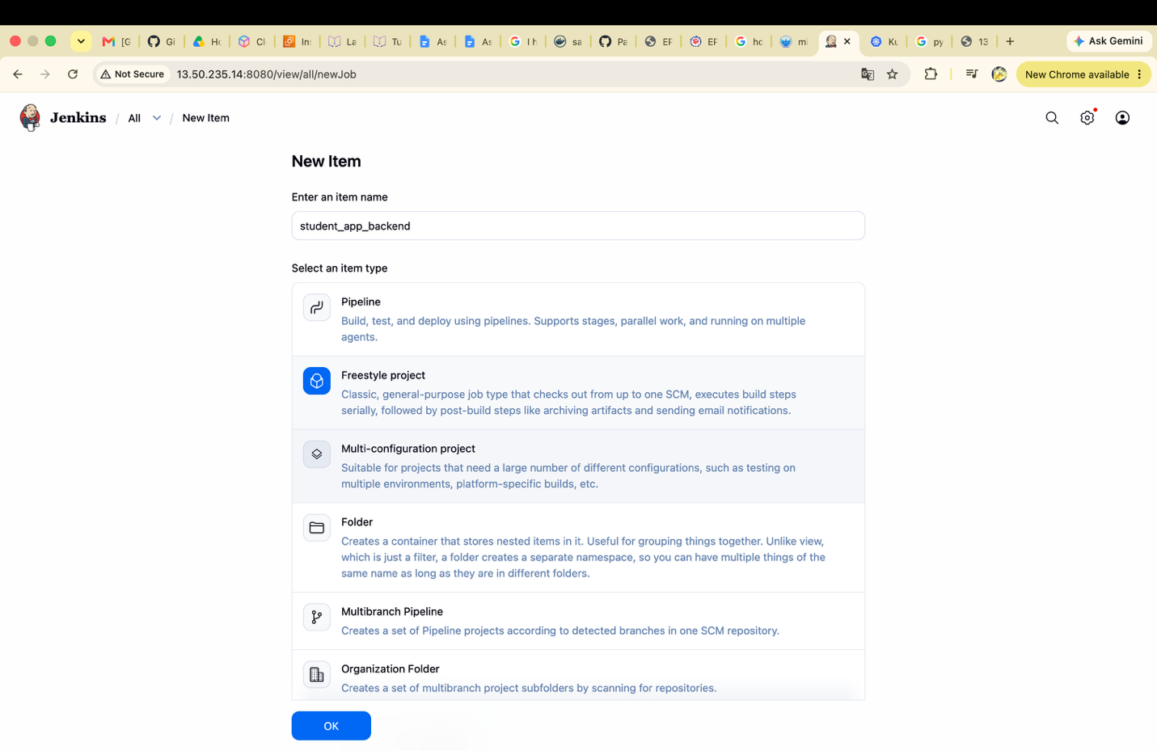

Created the student_app_backend

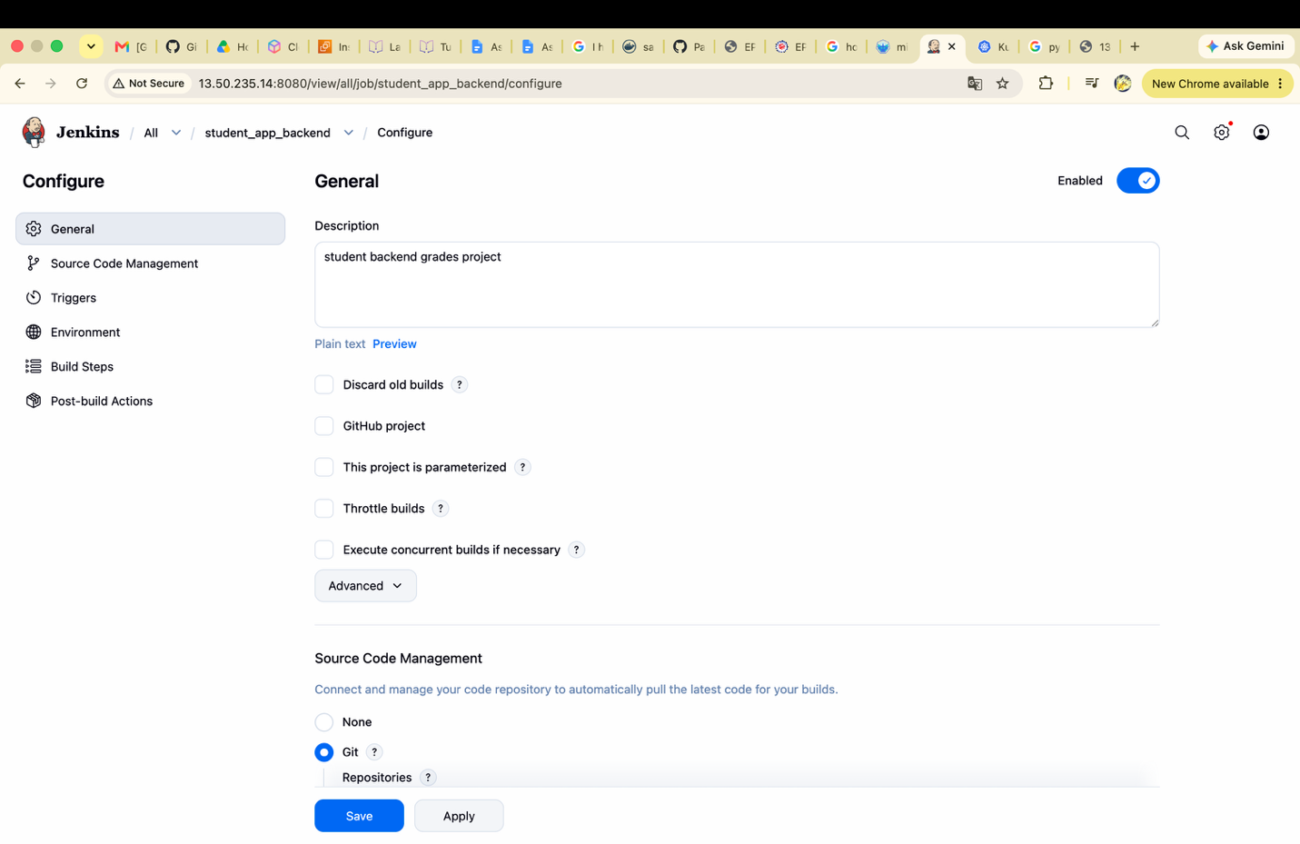

Student app frontend Jenkins project
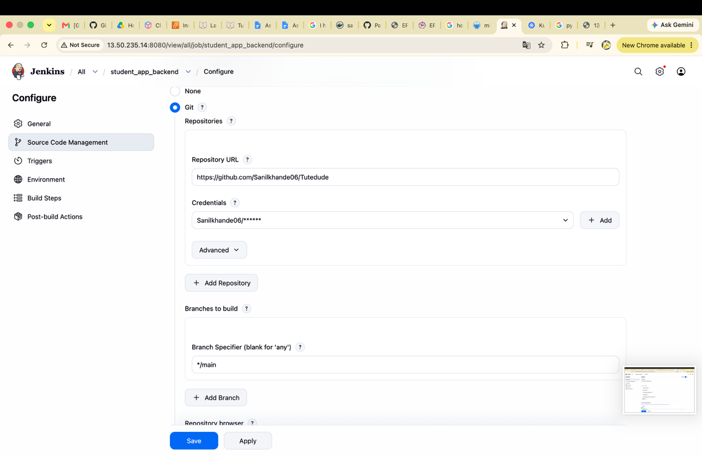
\

Configured backend steps to restart stident_app service on each github push.
sudo systemctl daemon-reload
sudo systemctl restart student_flask_app.service
sudo systemctl status student_flask_app.service
requirement pip install -r requirements.txt
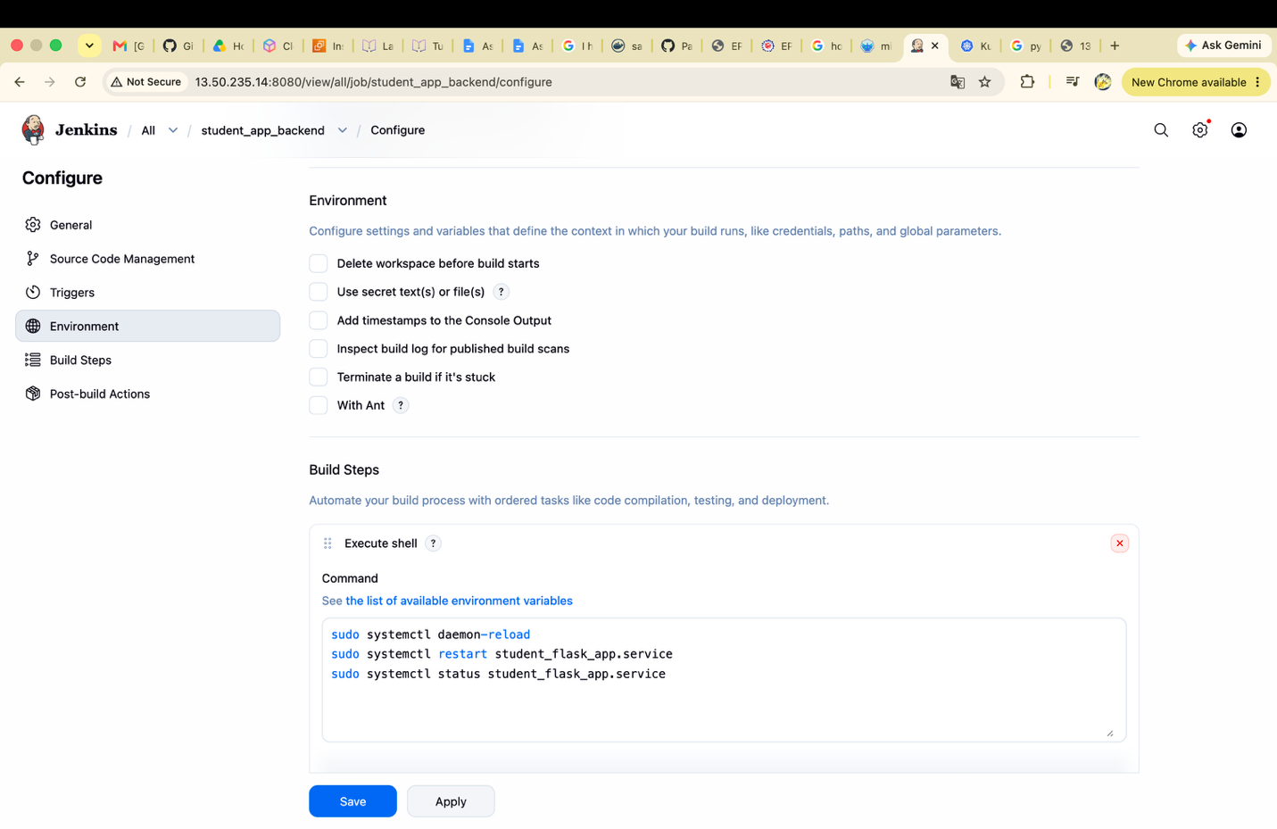

Configured frontend steps to run frontend app on each github push
ls
pwd
cd DevOps/Jenkins_CICD_Sani_Rajesh_Lokhande/frontend/
pm2 start student_app.js --name "express-frontend"

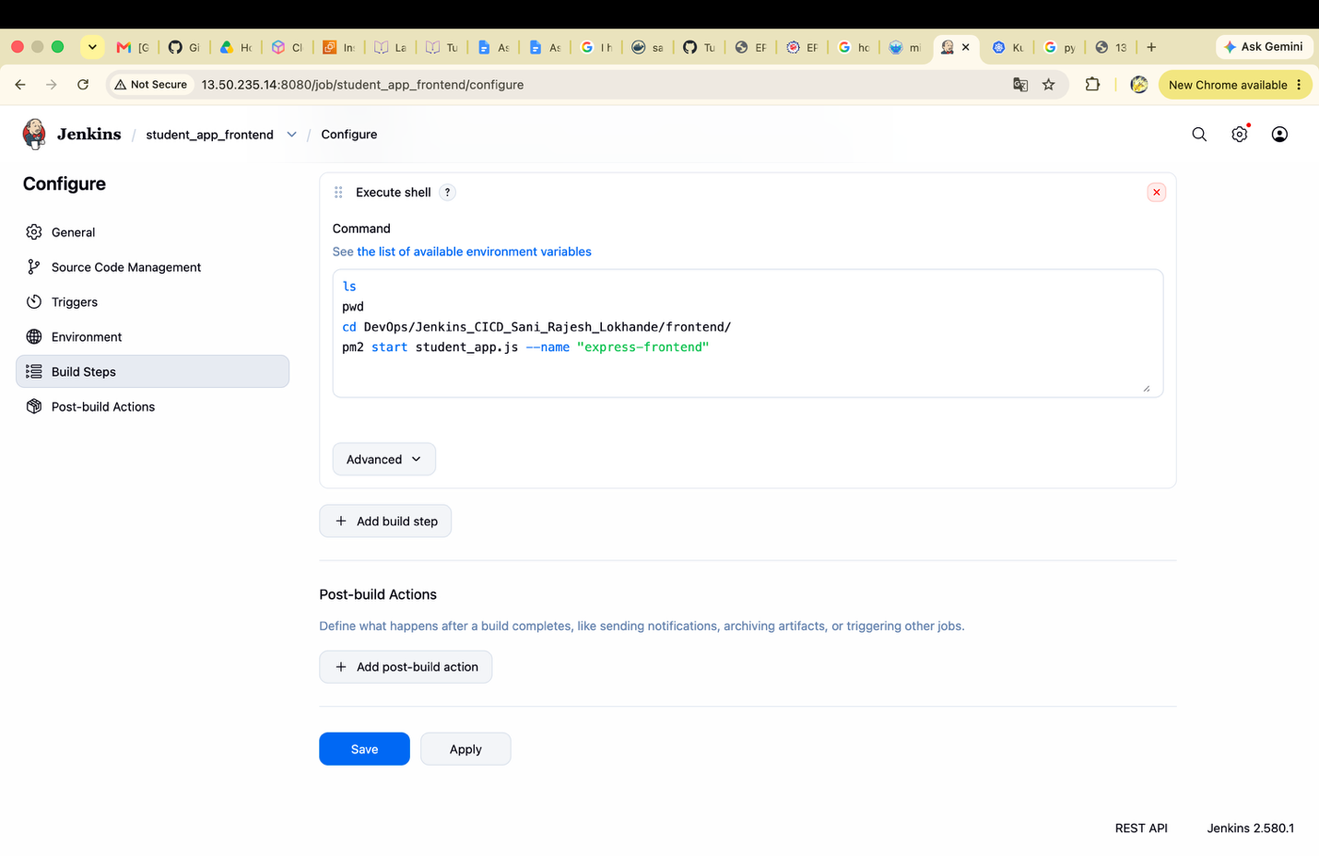

Created a webhook in github and gave Jenkins url using EC2 instance public IP and port 8080:
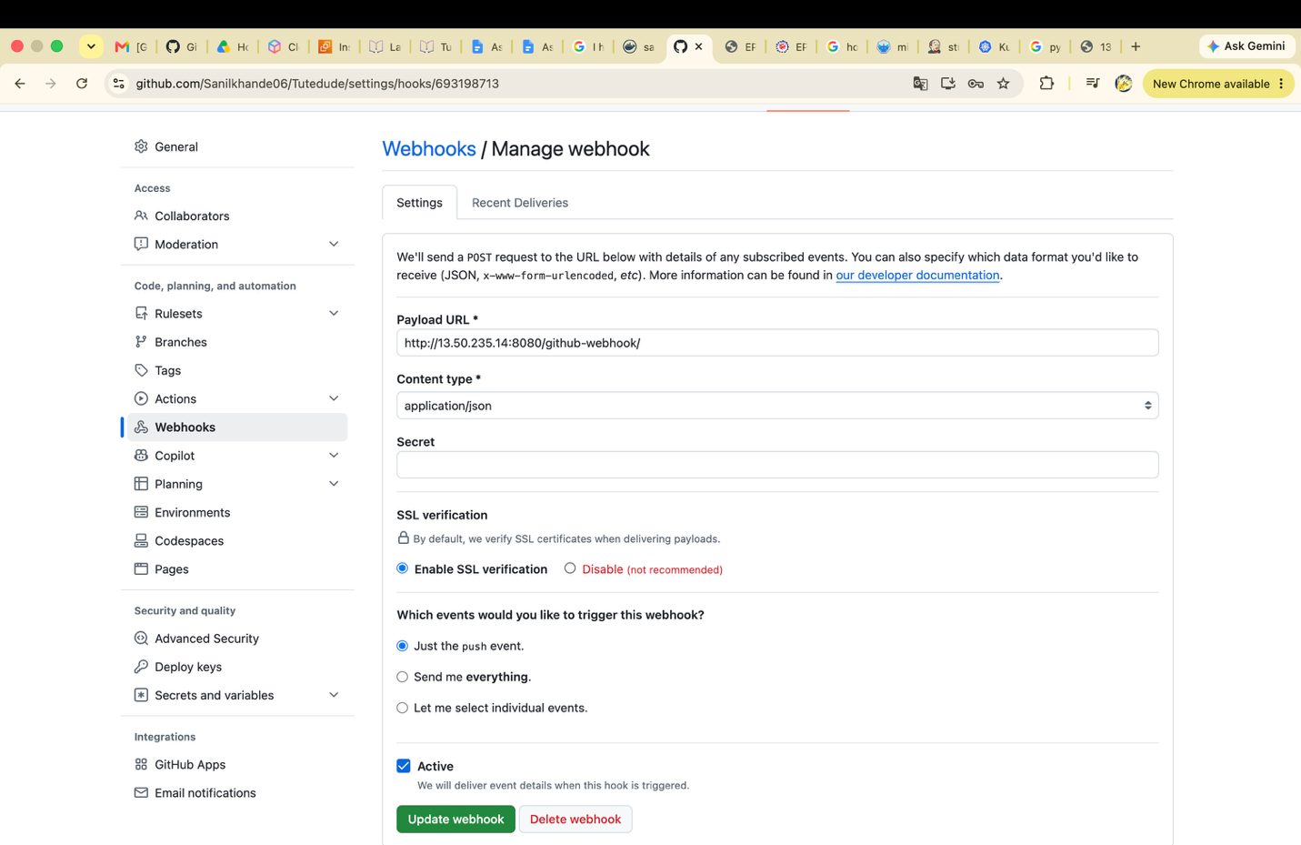

Before push status
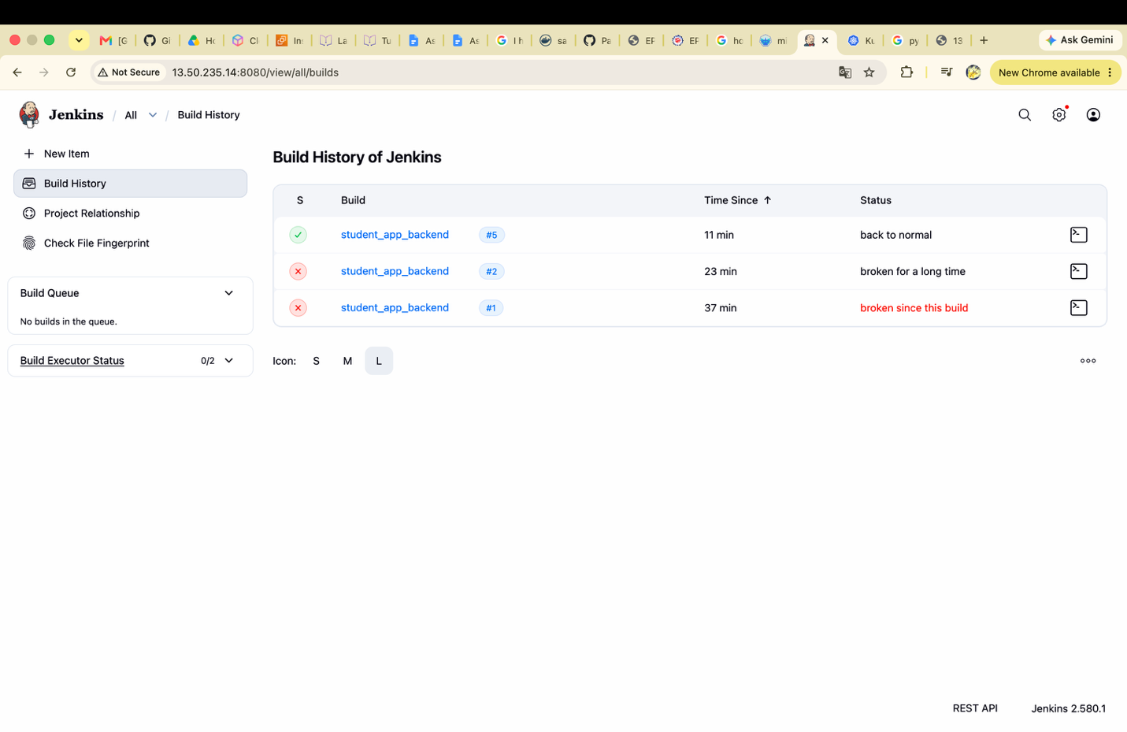
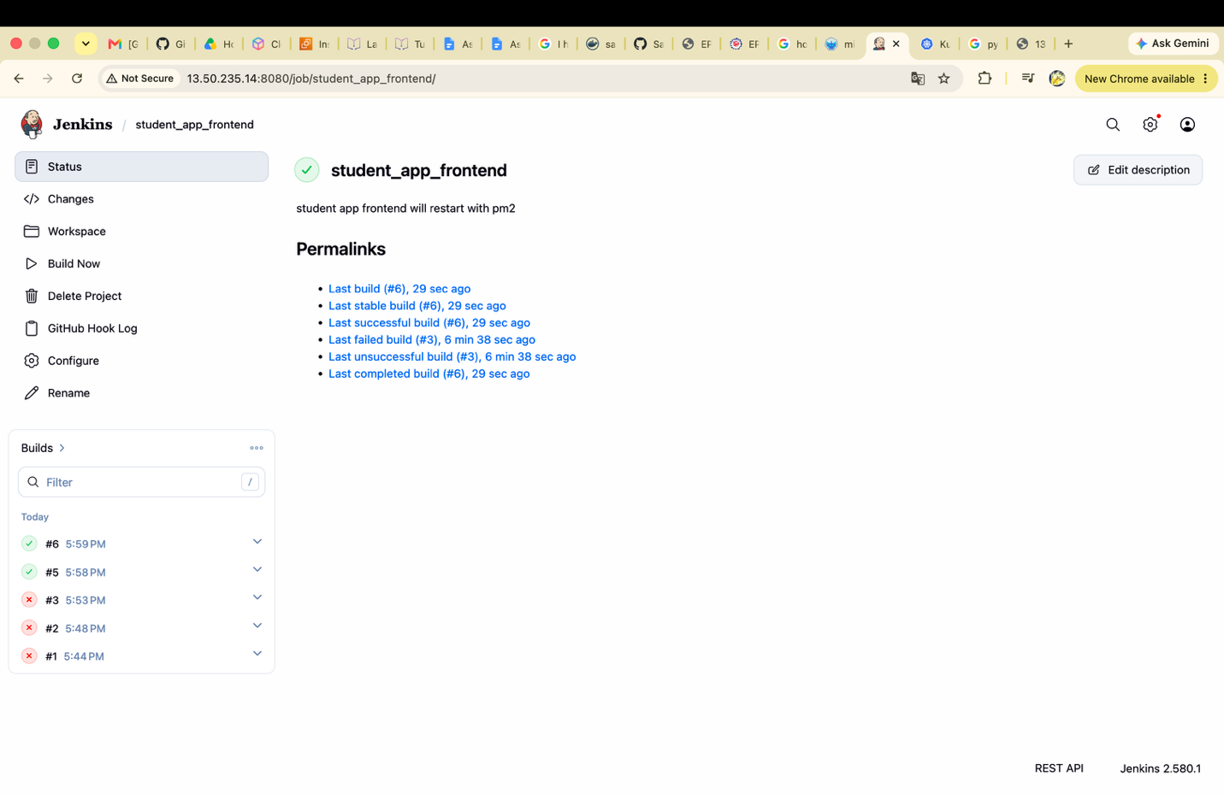

Git push to change the frontend form title in label tag

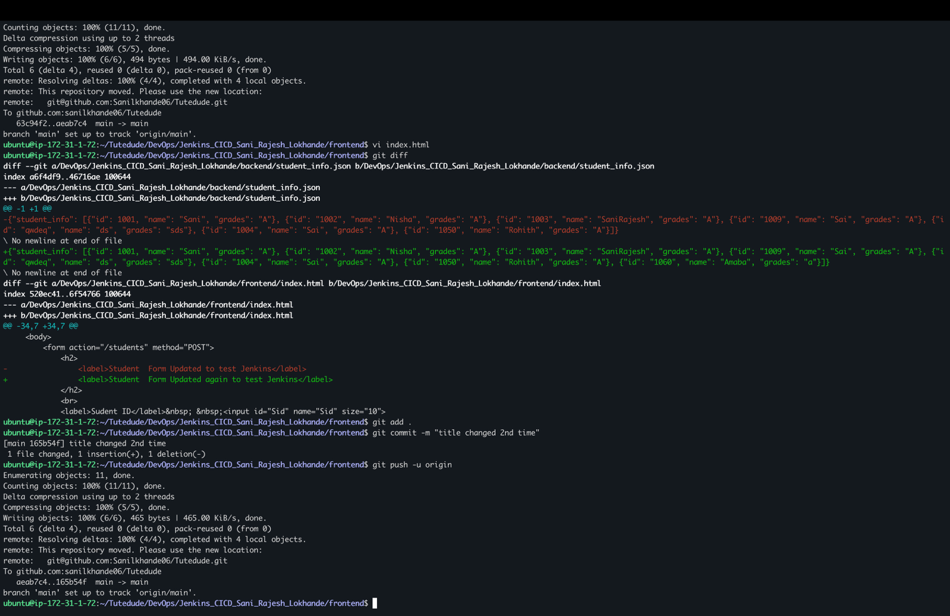

In Jenkins Build auto triggered for backend and frontend after push to github
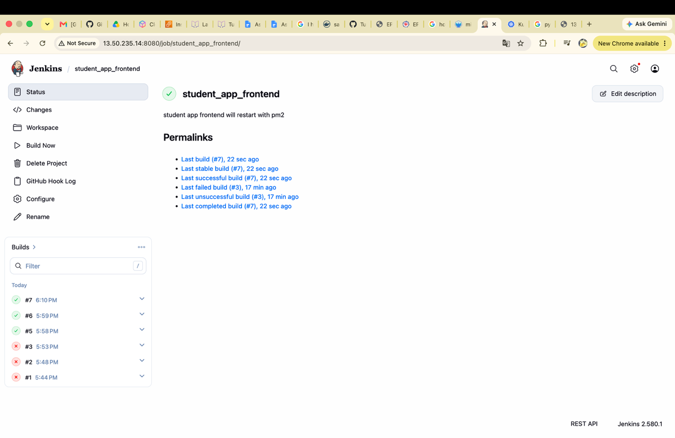
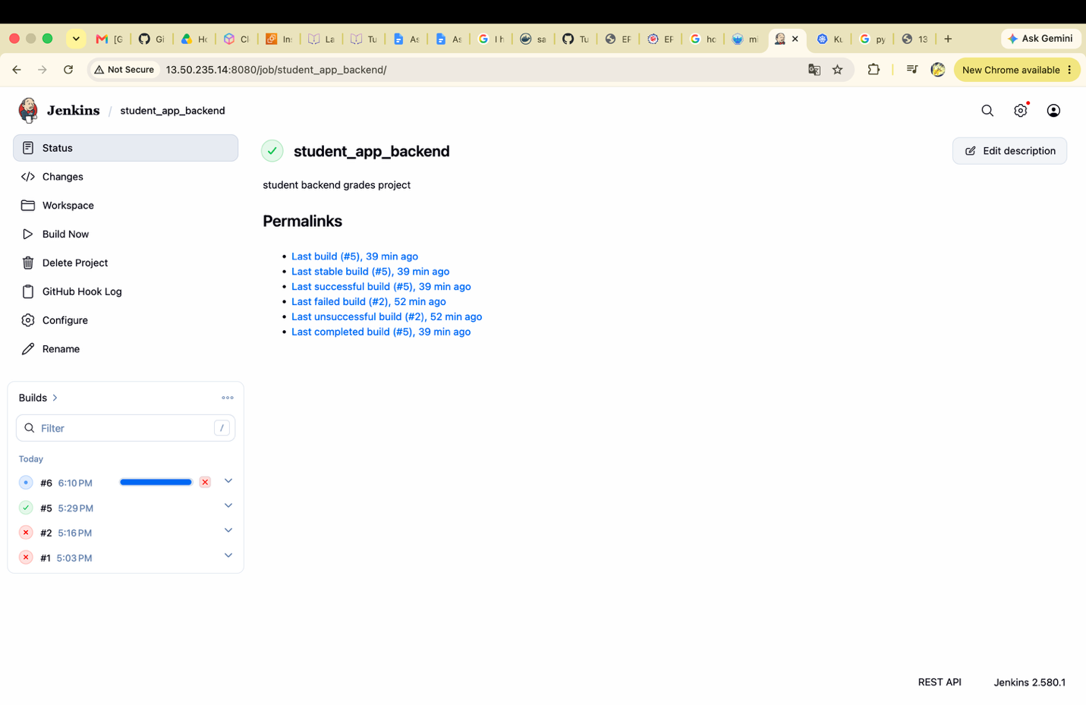

Build is succeded
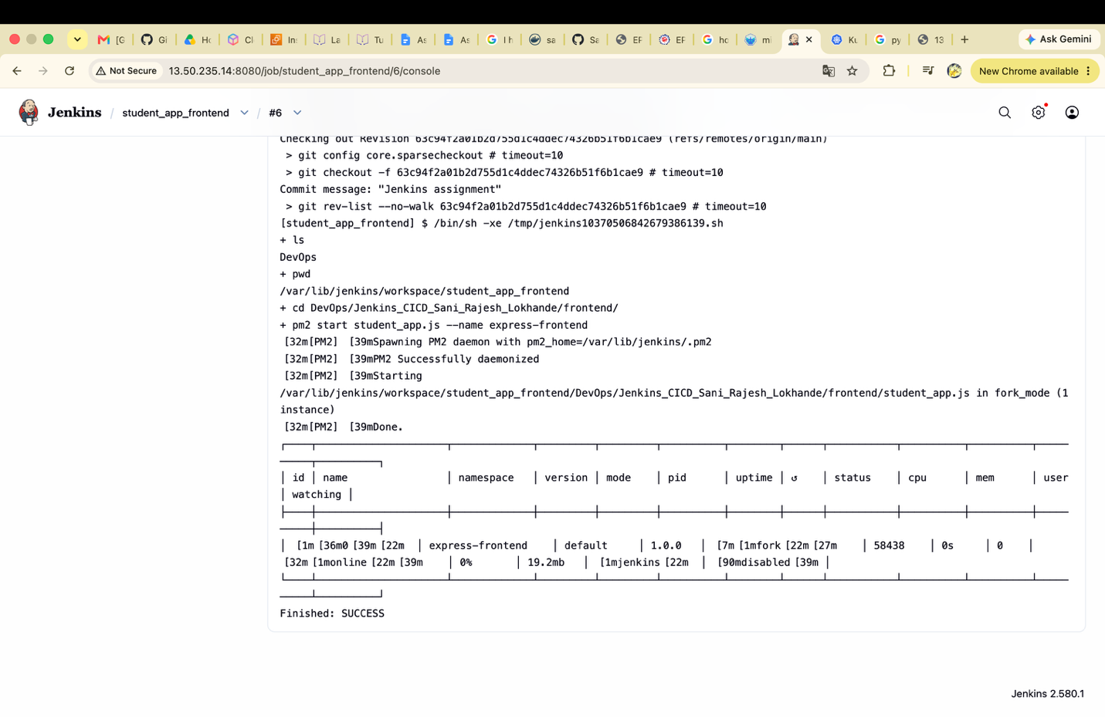

Student app service status

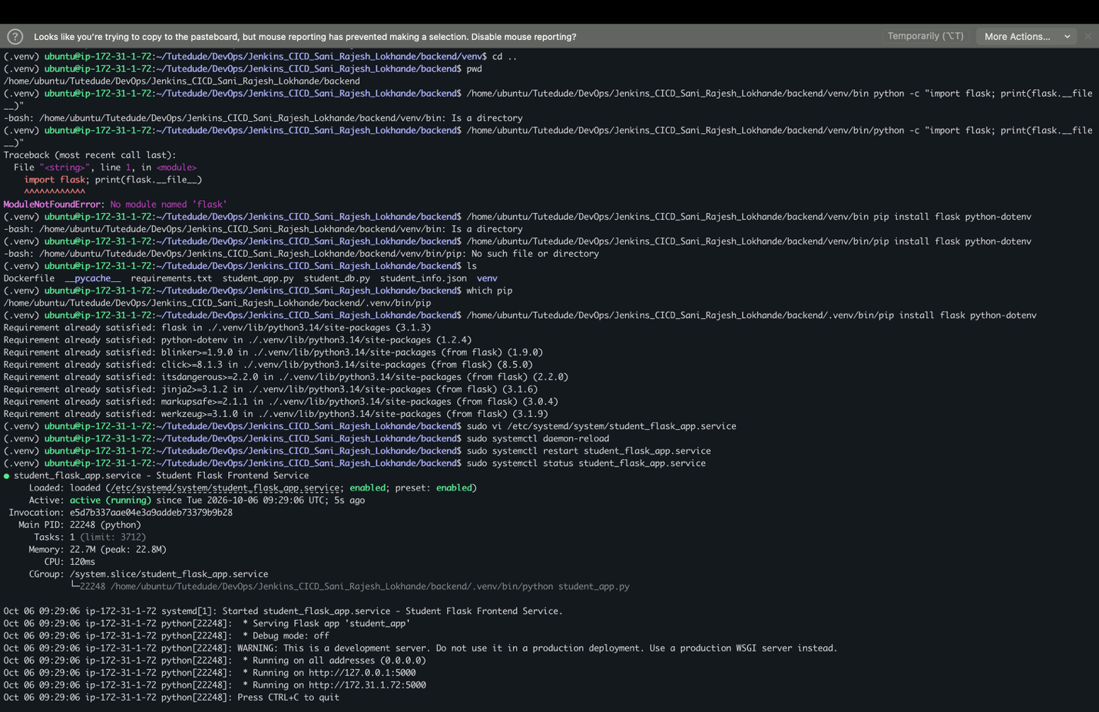

Frontend changes after push :
