Part 1: Deploy Both Flask and Express on a Single EC2 Instance

Installed Terraform
- wget -O - https://apt.releases.hashicorp.com/gpg | sudo gpg --dearmor -o /usr/share/keyrings/hashicorp-archive-keyring.gpg
- echo "deb [arch=$(dpkg --print-architecture) signed-by=/usr/share/keyrings/hashicorp-archive-keyring.gpg] https://apt.releases.hashicorp.com $(grep -oP '(?<=UBUNTU_CODENAME=).*' /etc/os-release || lsb_release -cs) main" | sudo tee /etc/apt/sources.list.d/hashicorp.list
- sudo apt update && sudo apt install terraform

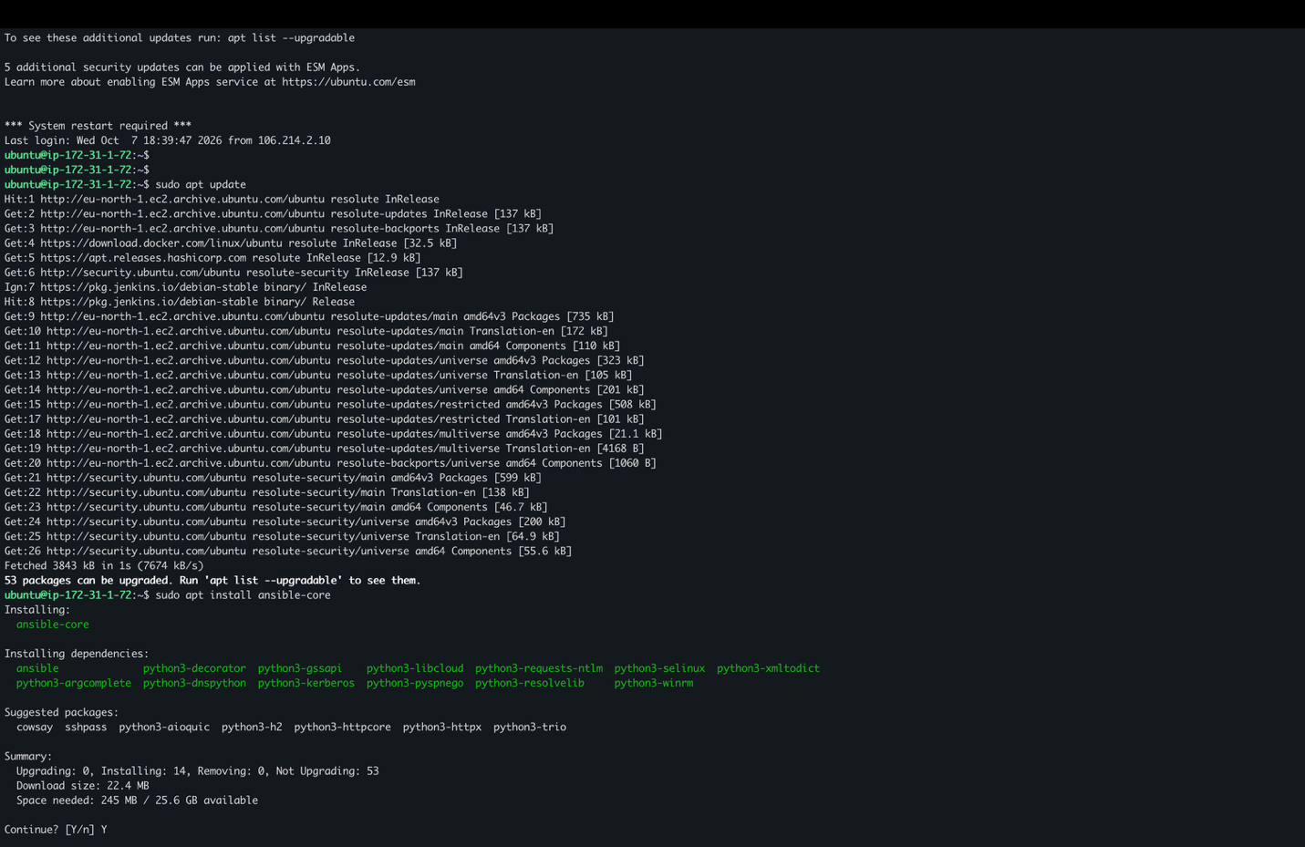

Installed Ansible-core
- sudo apt install ansible-core

Created the trerraform main.tf file and executed terraform init

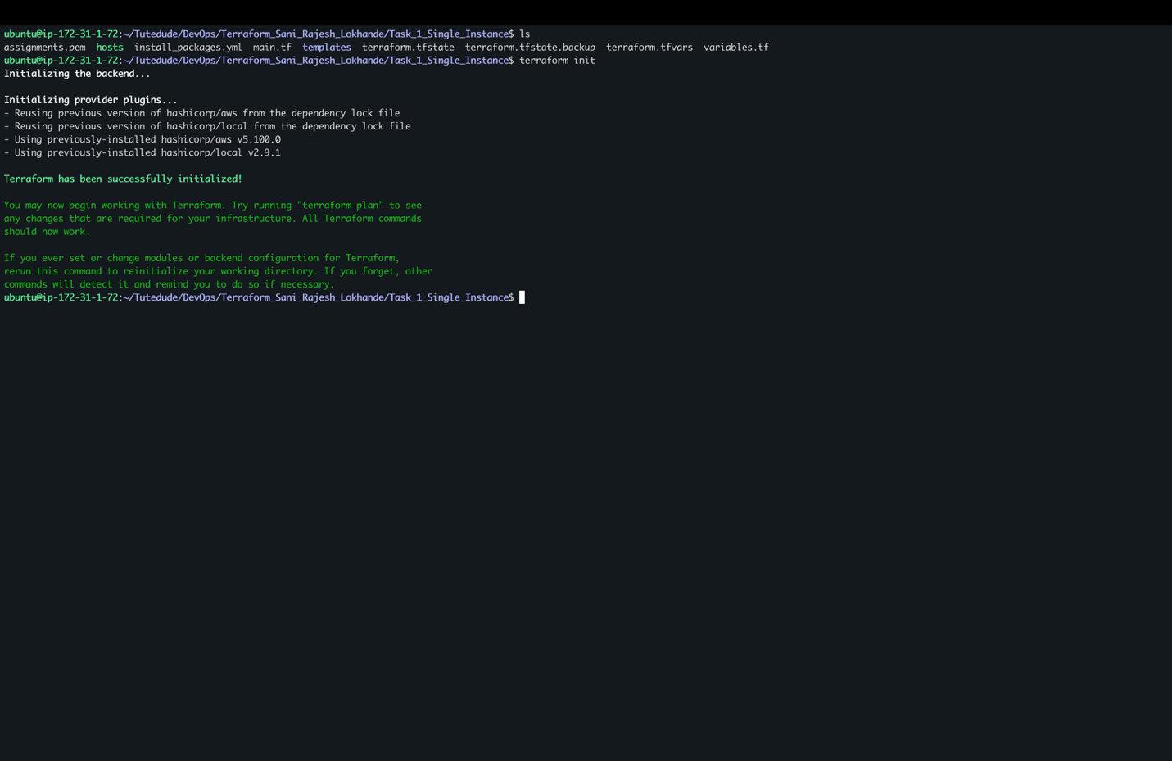

Terraform plan to check the file is correct

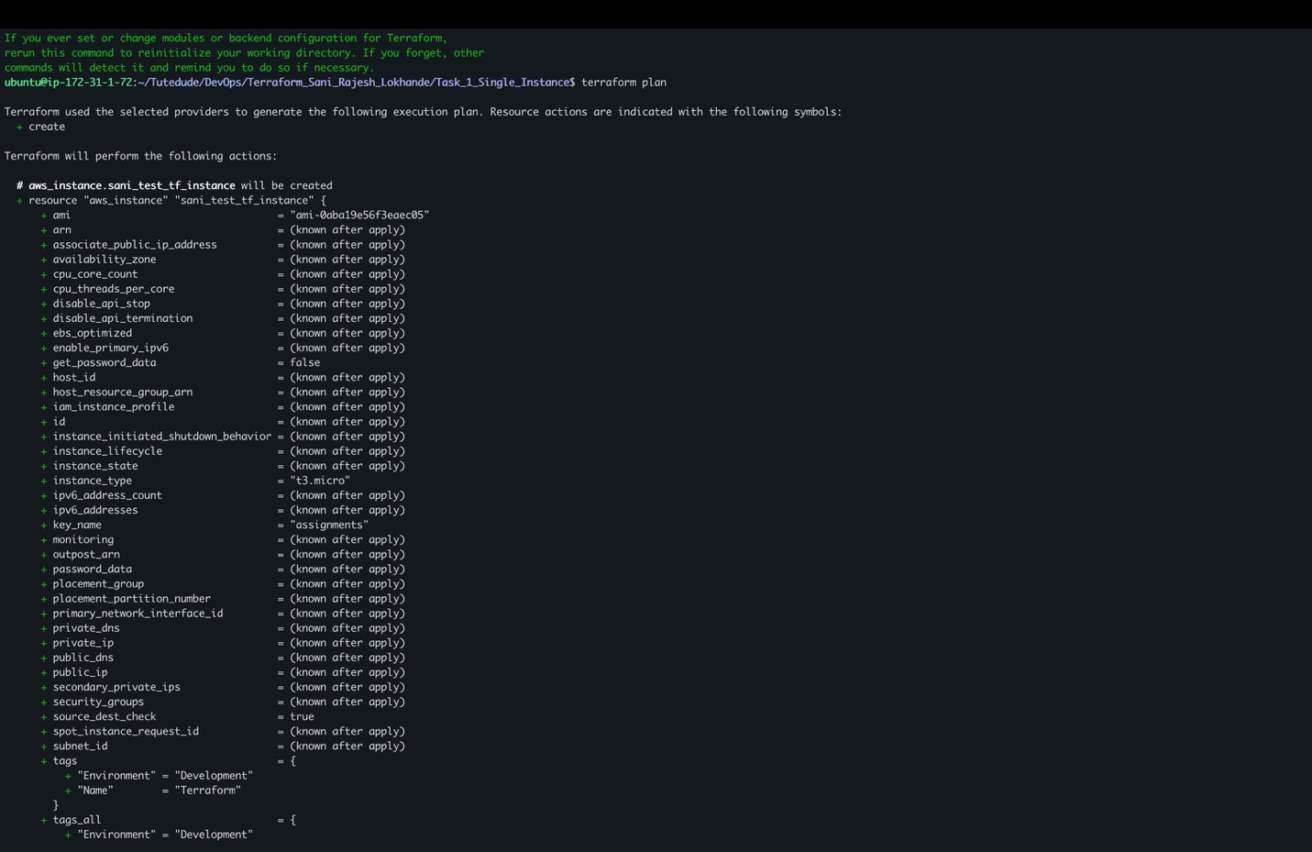

Terraform apply to create instances in aws

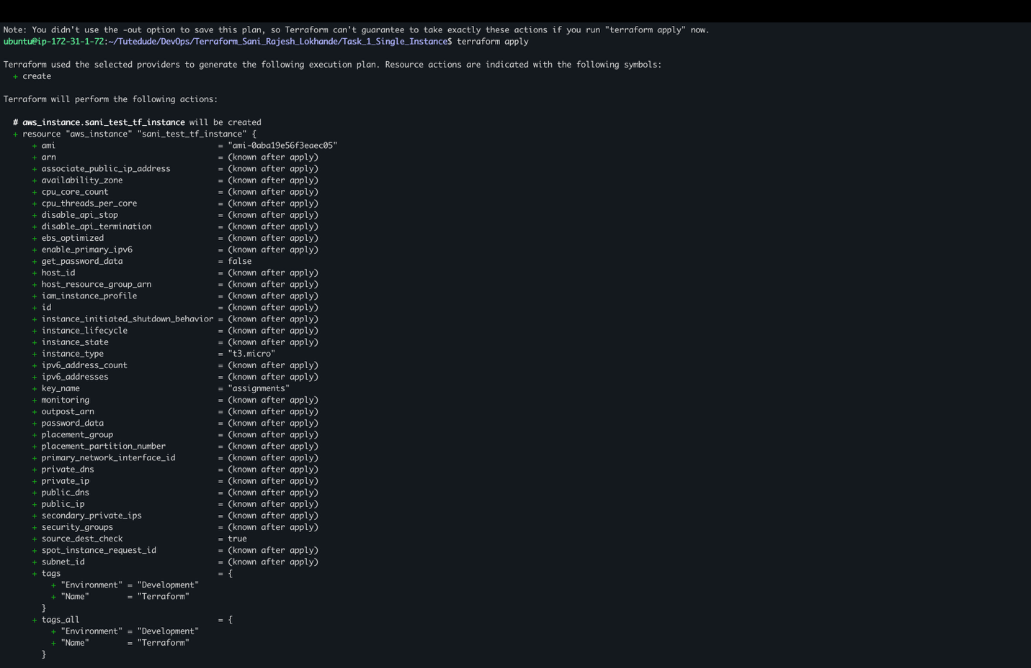

Instance Created using terraform :
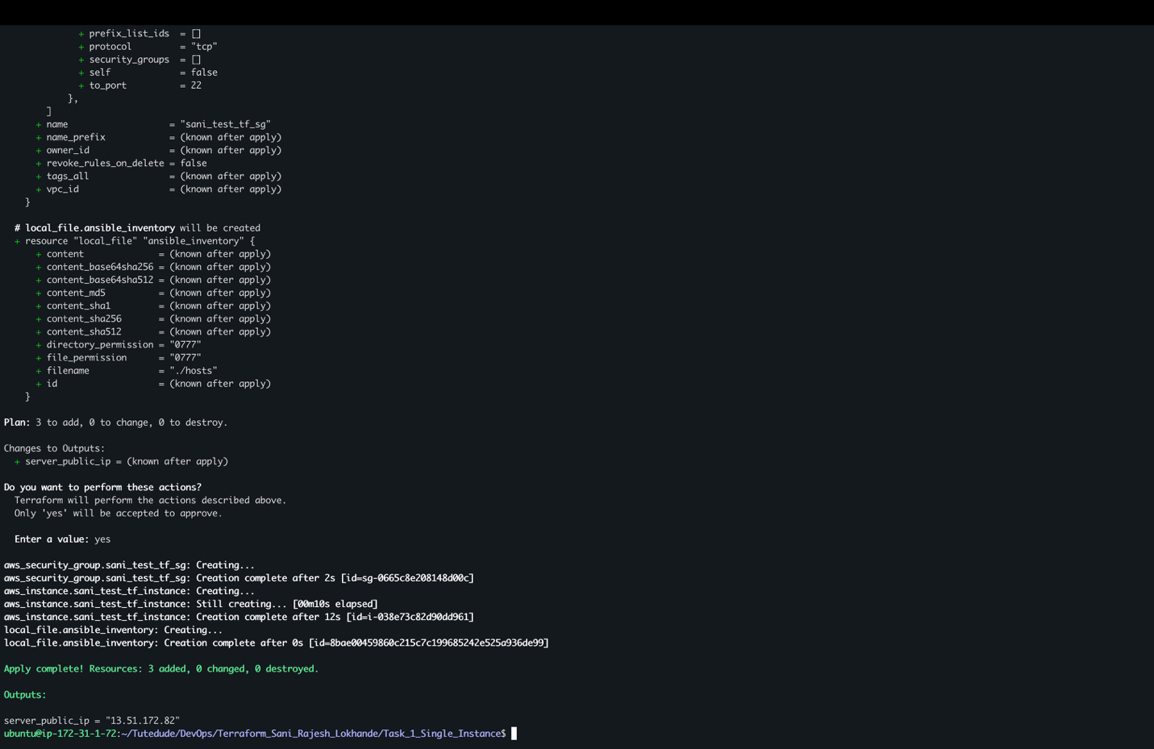
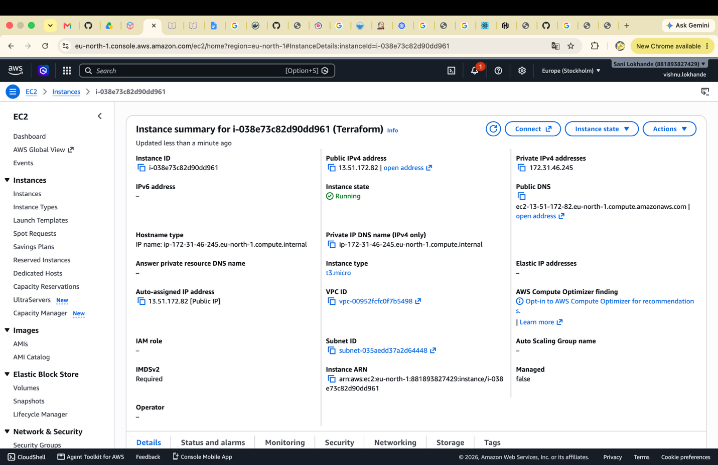

running Ansible to install dependencies and launch applications using the ansible-playbook
  - ANSIBLE_HOST_KEY_CHECKING=False : used to disable the host key check
  - -i hosts : run this on hosts present in hosts file
  - install_packages.yml : yml file of ansible to install dependencies
  - private-key=assignments.pem : private key to access host
  - -u ubuntu : host username
ANSIBLE_HOST_KEY_CHECKING=False ansible-playbook -i hosts install_packages.yml --private-key=assignments.pem -u ubuntu

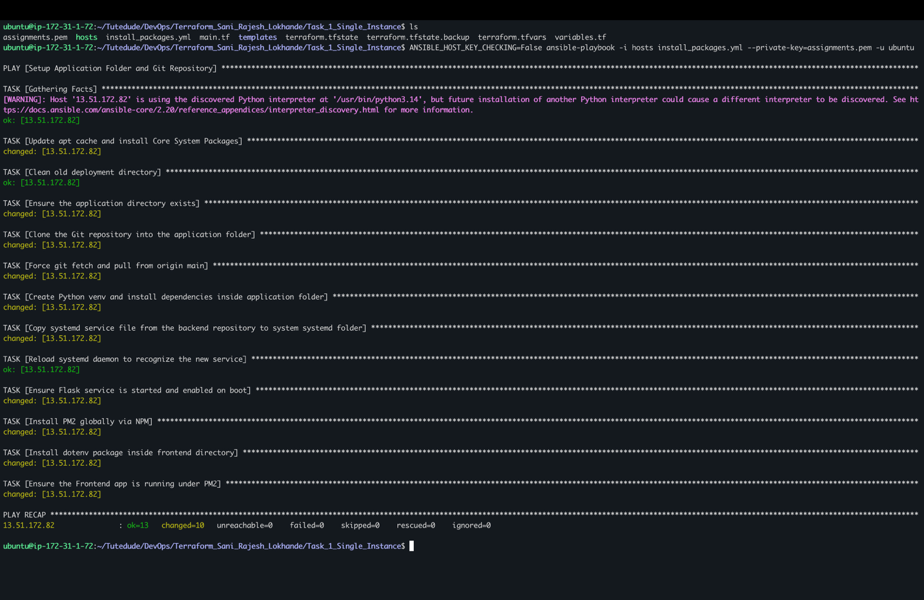

Front end running on port 3000
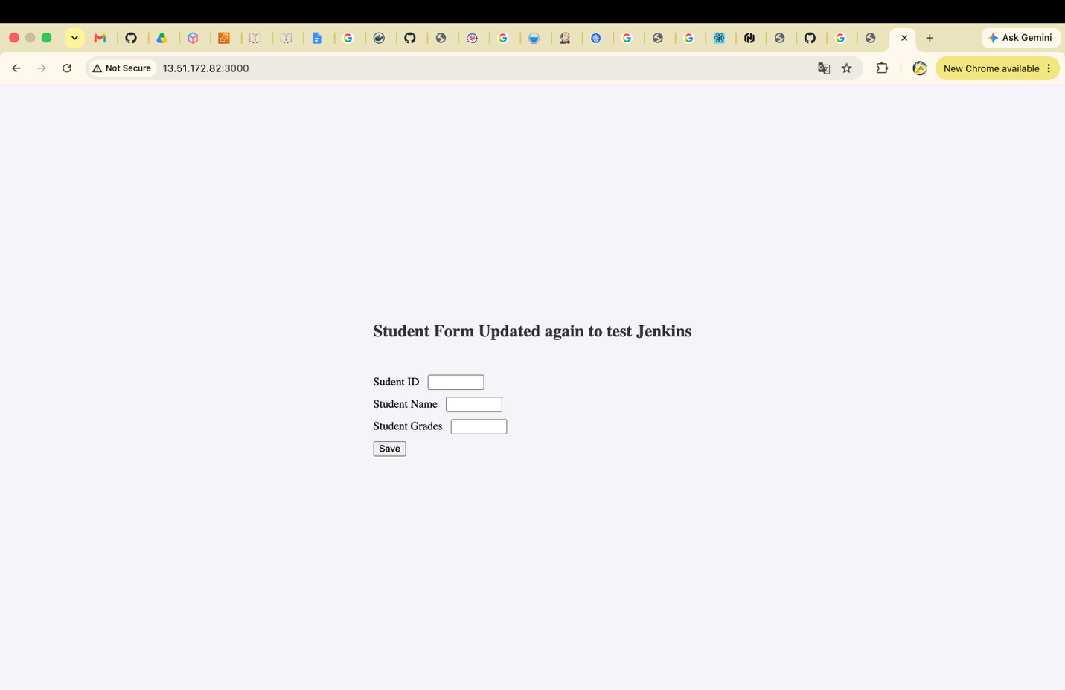

Backend running on port 5000
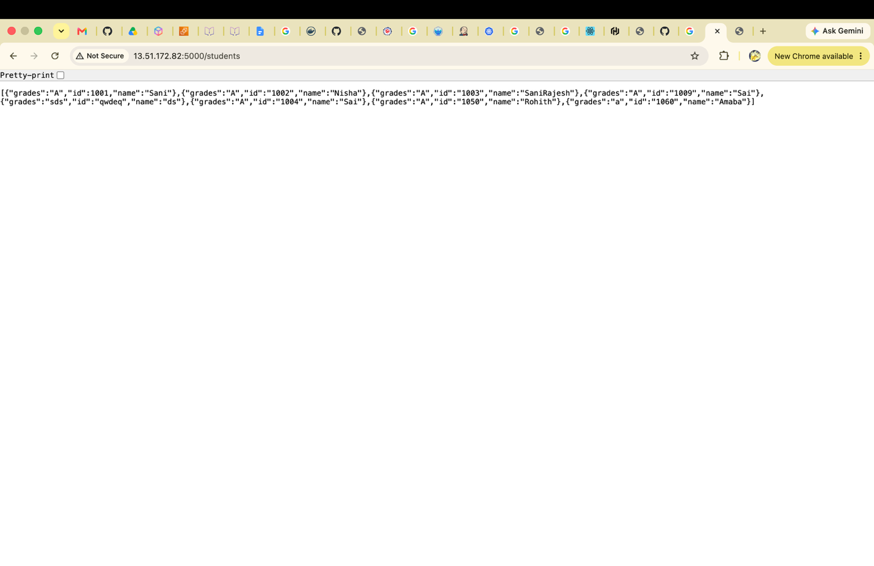

Terraform init to store the state to remote and successfully stored to remote S3 bucket on path Task1/terraform.tfstate

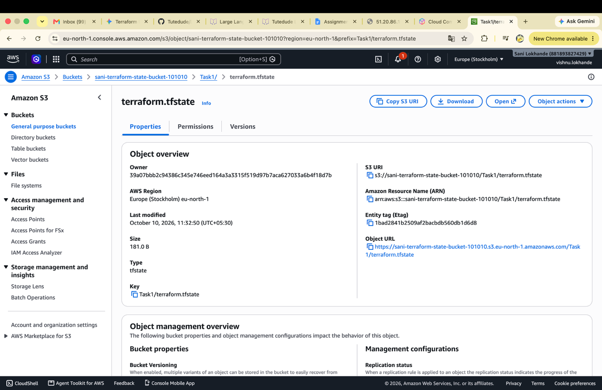

Part 2: Deploy Flask and Express on Separate EC2 Instances

Created two instaces using terraform. gave count 2 in main.tf to create 2 instances.

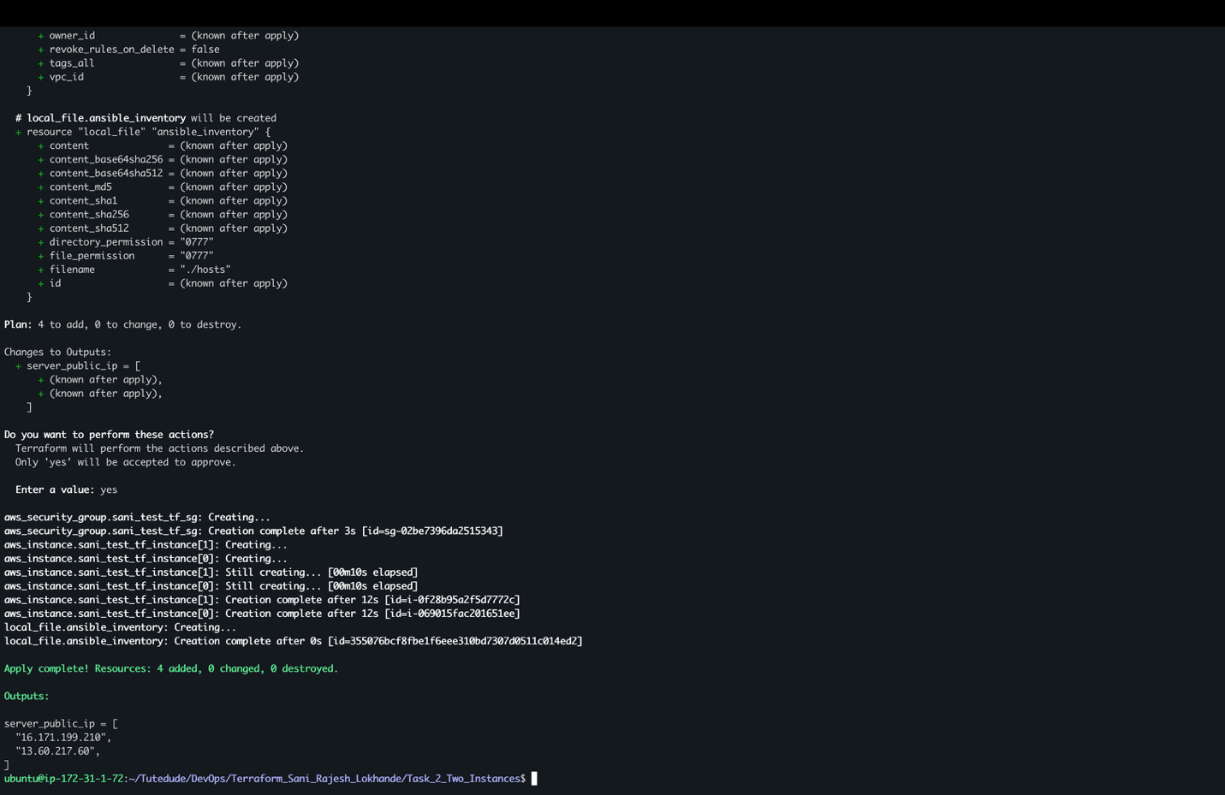

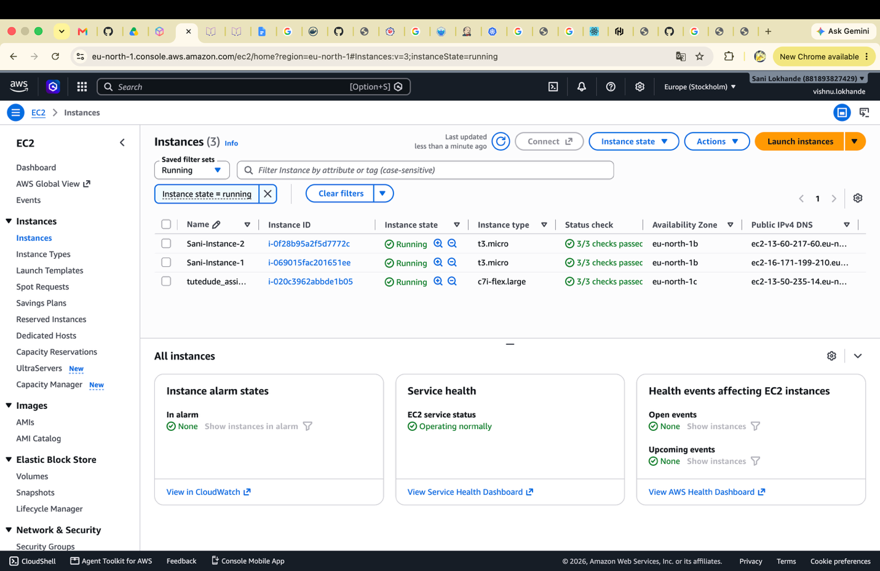

Running the backend_packages.yml to deploy backend flask application on first EC2
Ansible steps to
Steps1: installed dependencies like python, git, pip and venv
Steps 2: clearing the backend folder and pulling the new changes from github repo
Steps 3: created a directory student_app and cloned the git repo.
Steps 4: installed python Flask and dotenv
Step5: copied the student_flask service file in system folder so can run as service
Step6: reload the systemd
Step7: start the student_flask_app

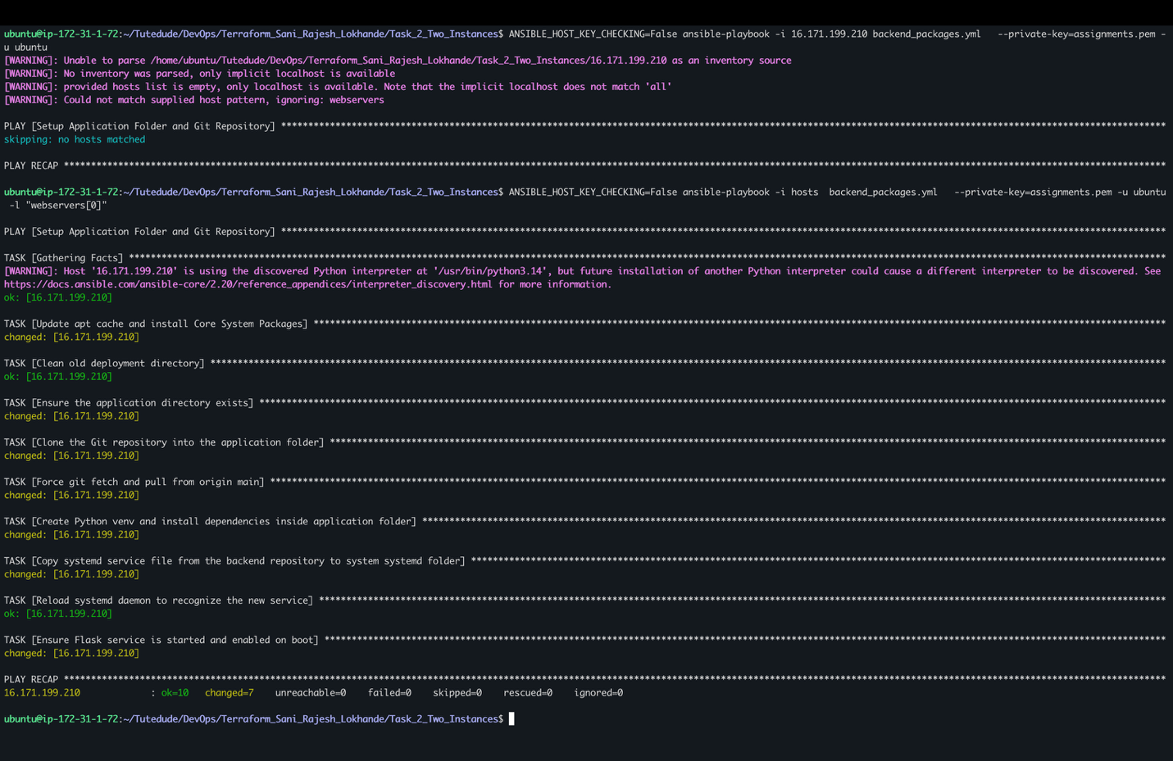

Backend is running successfully got the grades output on browser on port 5000

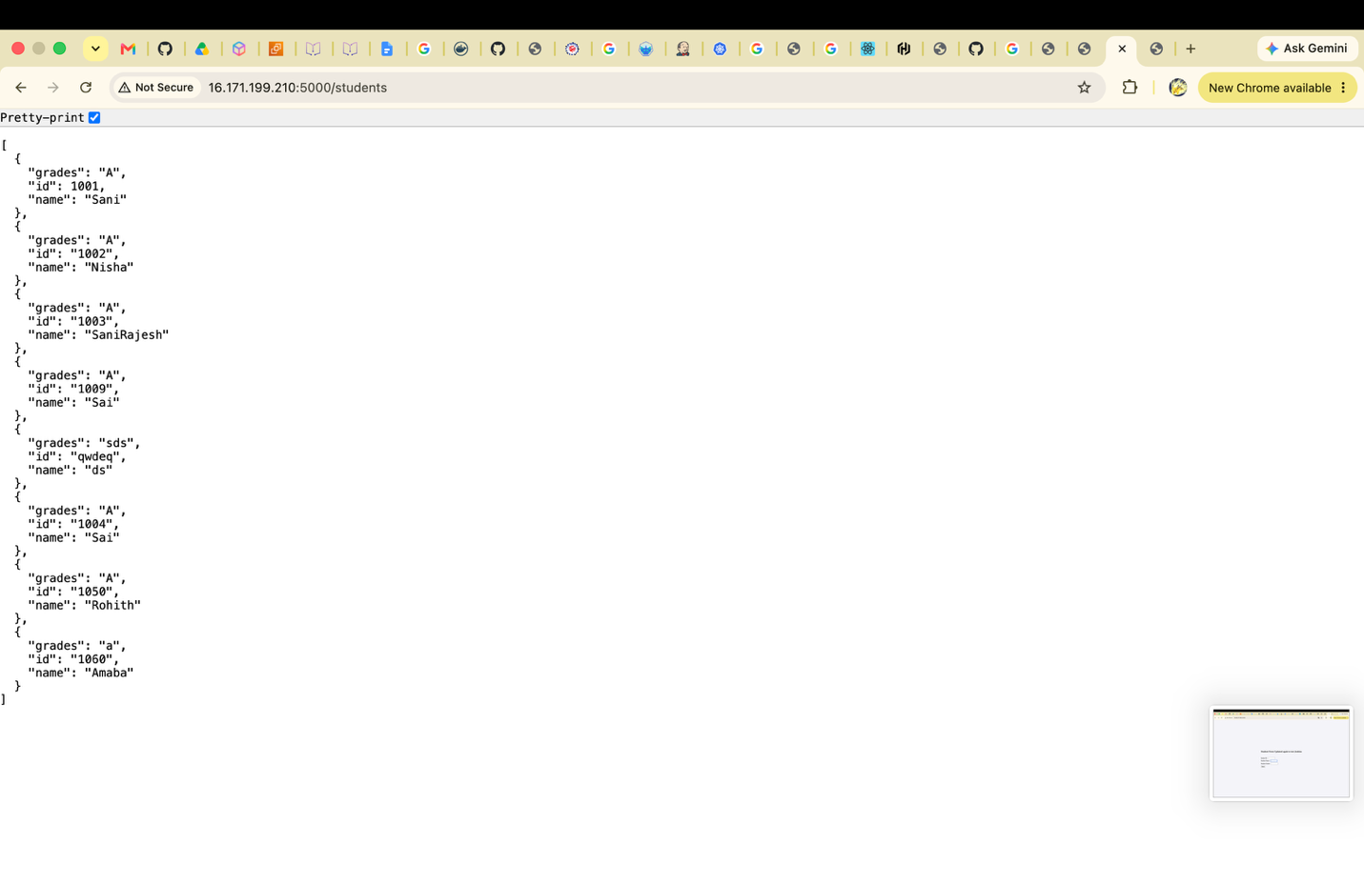

Ran a frontend on second EC2 machine.
Ansible steps to deploy frontend:
Steps1: installed dependencies like git, nodeJS, express and npm
Steps 2: clearing the backend folder and pulling the new changes from github repo
Steps 3: created a directory student_app and cloned the git repo.
Step4: install mp2 usning npm
Step5:insalled dotenv using npm
Step6: changing the .env file of frontend to have backend host and port
Step7: using pm2 deployed frontend app

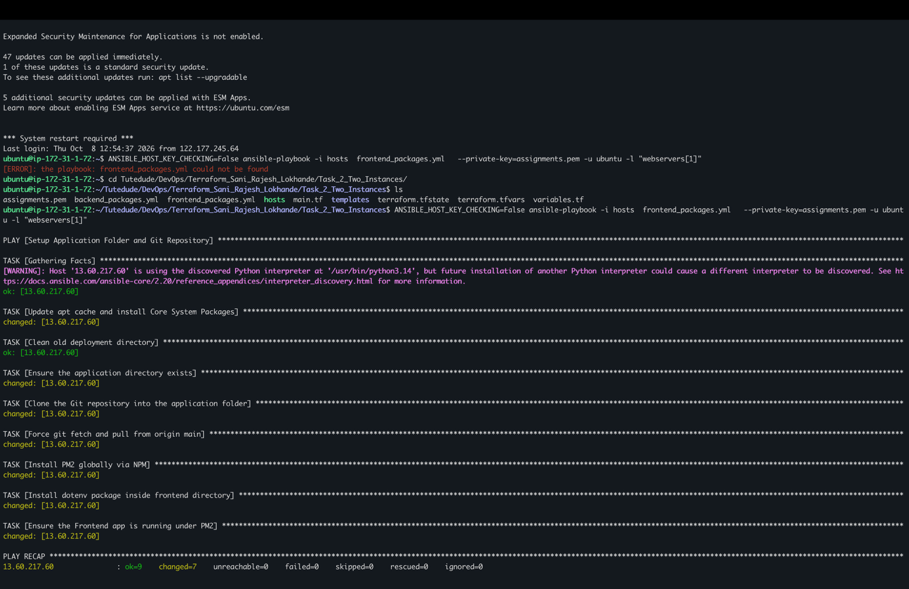

Frontend running on port 3000 on second EC2
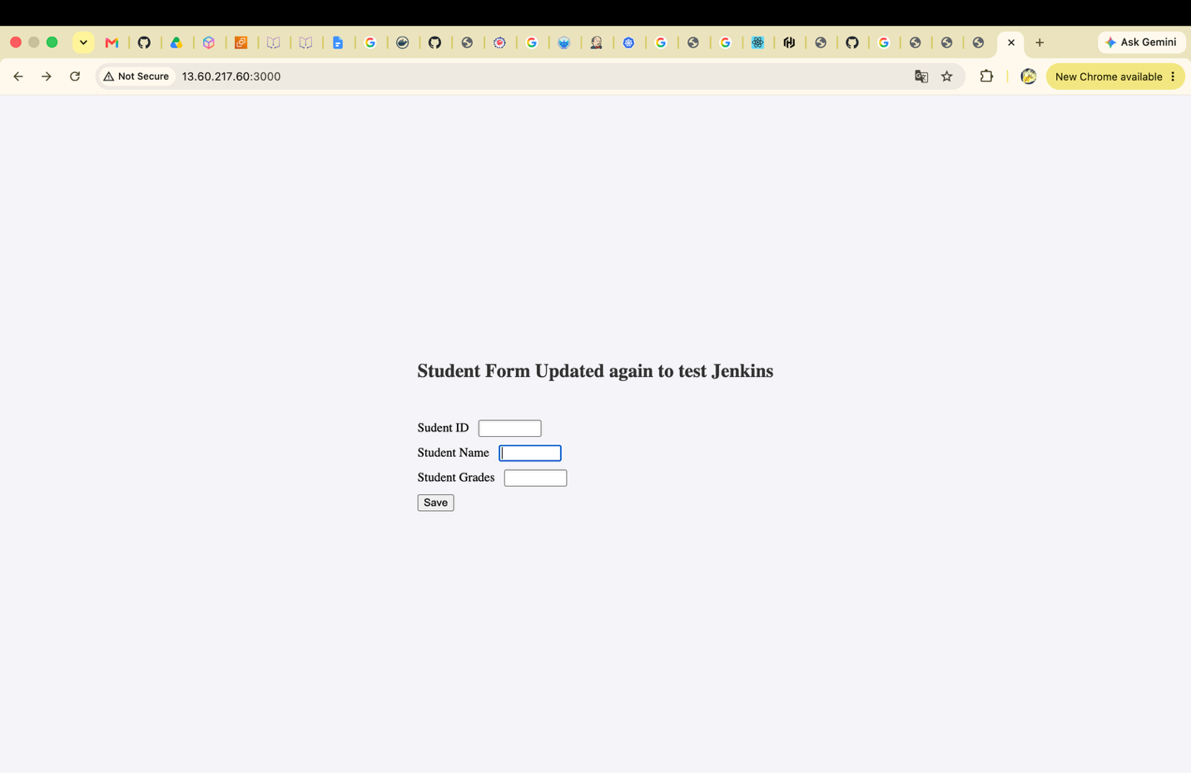

Deleting all resources created by terraform using terraform destroy

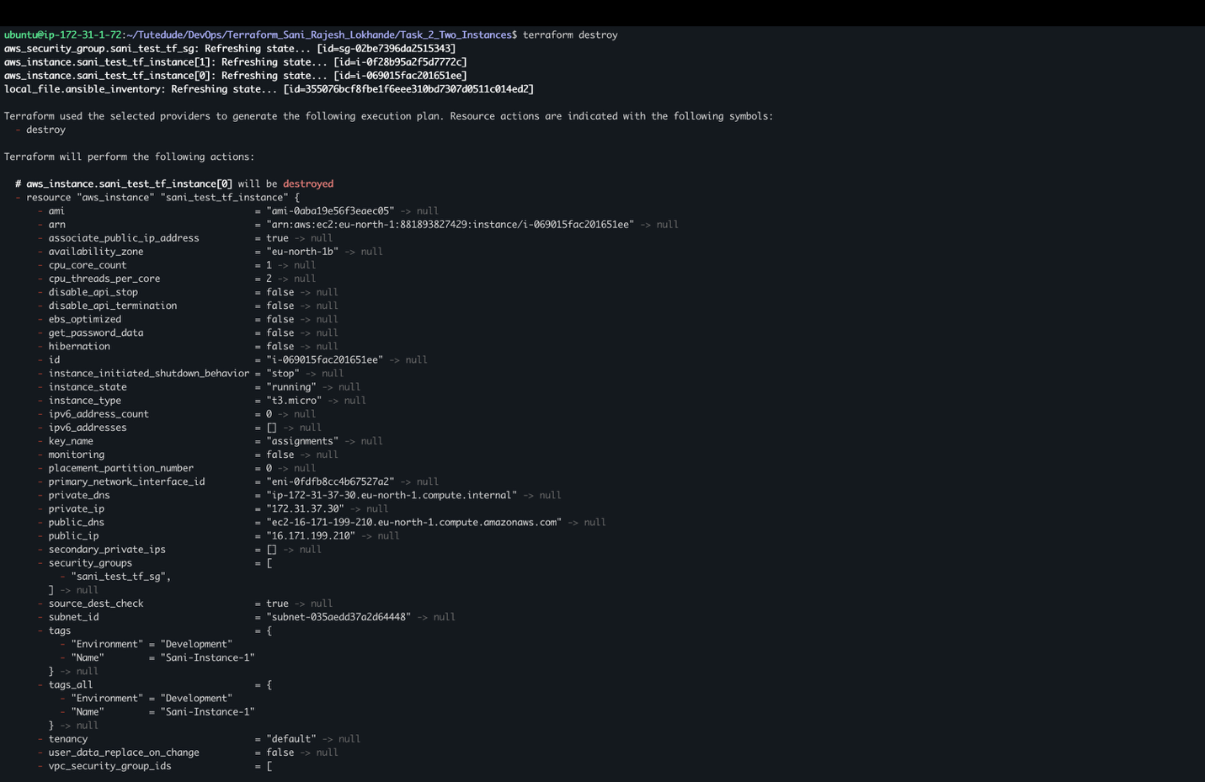

Terraform init to store the state to remote and successfully stored to remote S3 bucket on path Task2/terraform.tfstate

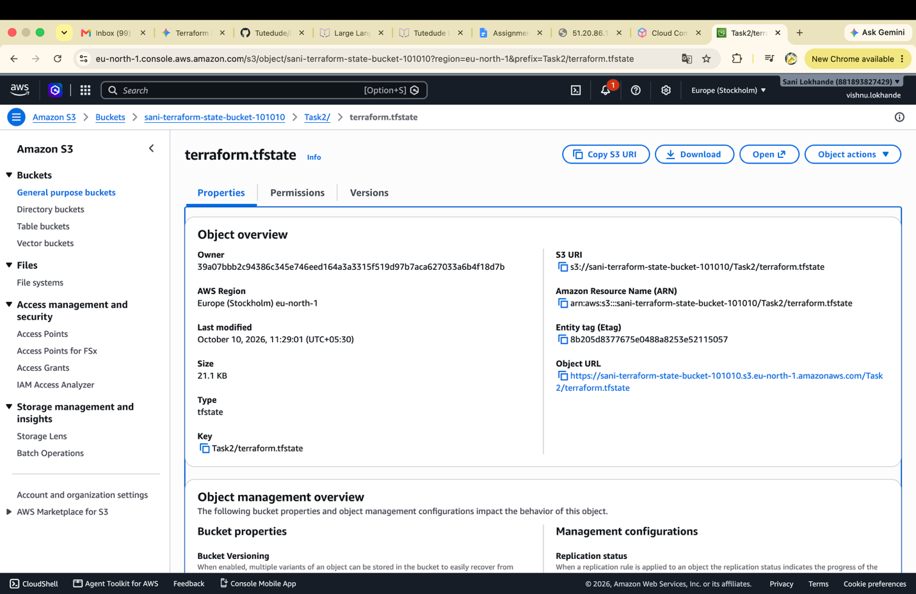

Part 3: Deploy Flask and Express Using Docker and AWS Services

Steps of terraform file:

- For provider added the region and considering the access key and secrete key from variables defined in terraform.tfvars and variables.tf
- Created vpc and two public subnets inside the vpc. The subnet CIDR must fall under the CIDR mentioned in VPC.
- Created one gateway to reach internet
- Then it’s mapped to route table of default route 0.0.0.0/0 to the gateway so can it’s reach internet if ip is not under the vpc .
- Created the security group and allowed the ingress on port 22 and 3000-5500 ports so I can access the services on port 3000 and 5000 and accessible to all ips. Mentioned the VPC id because ECS task required the two subnets from the same vpc
- Now created the two repositories, jenkins_cicd_sani_rajesh_lokhande-backend and jenkins_cicd_sani_rajesh_lokhande-frontend.
- Using the ansible file uploading the images from local to respositories
- Now created the ecs cluster
- Created the task two definations for frontend and backend
- Created the load balancer target groups and listners so can loadbalancer reach the frontend service and backend service
- Now created the two fargate services for backend and frontend services

Running the terraform plan and apply to create aws entities

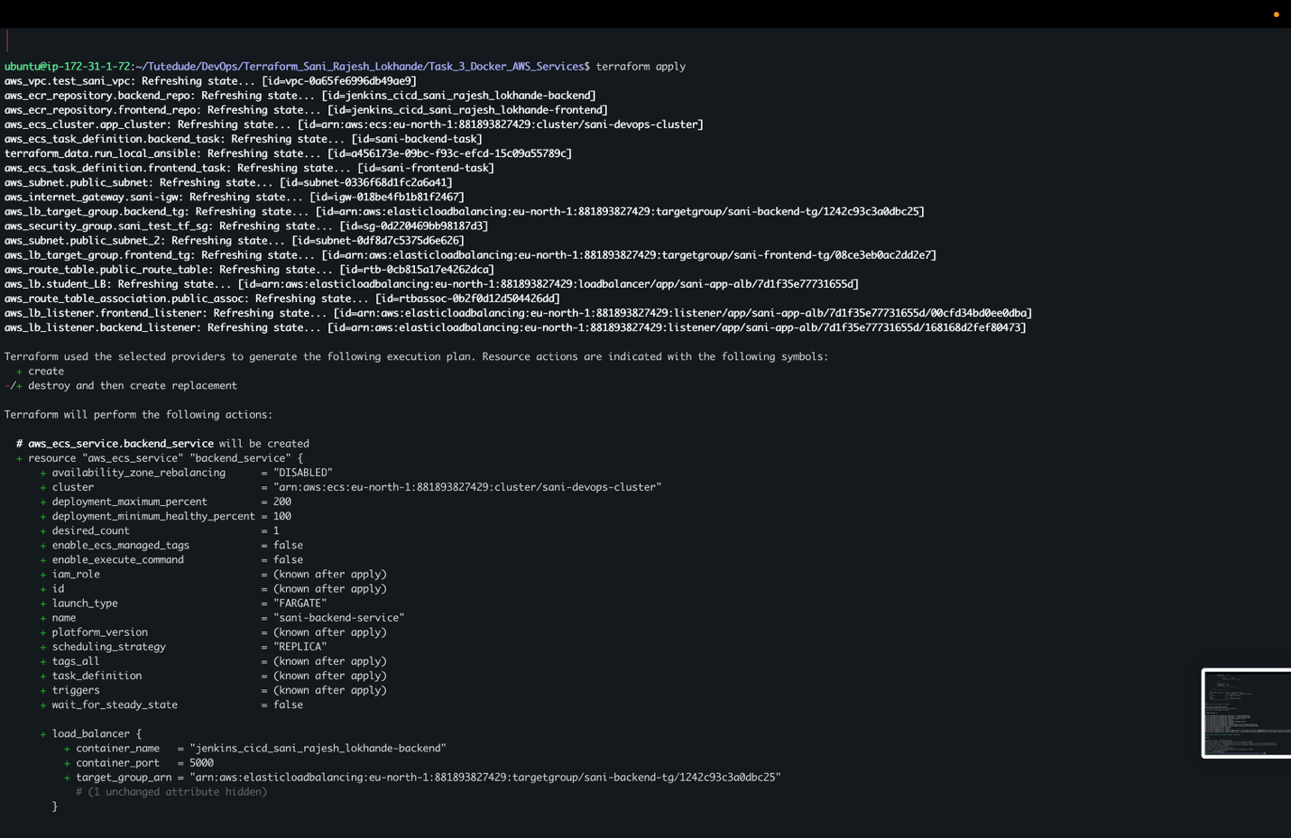

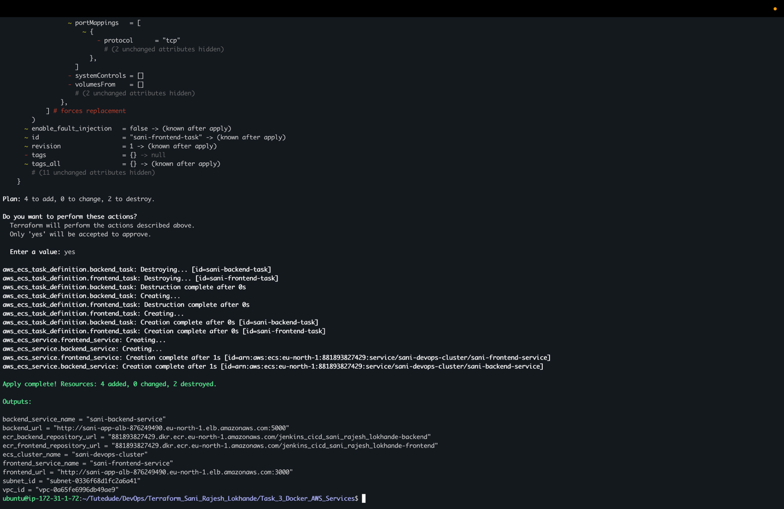

Backend url reachable from the internet
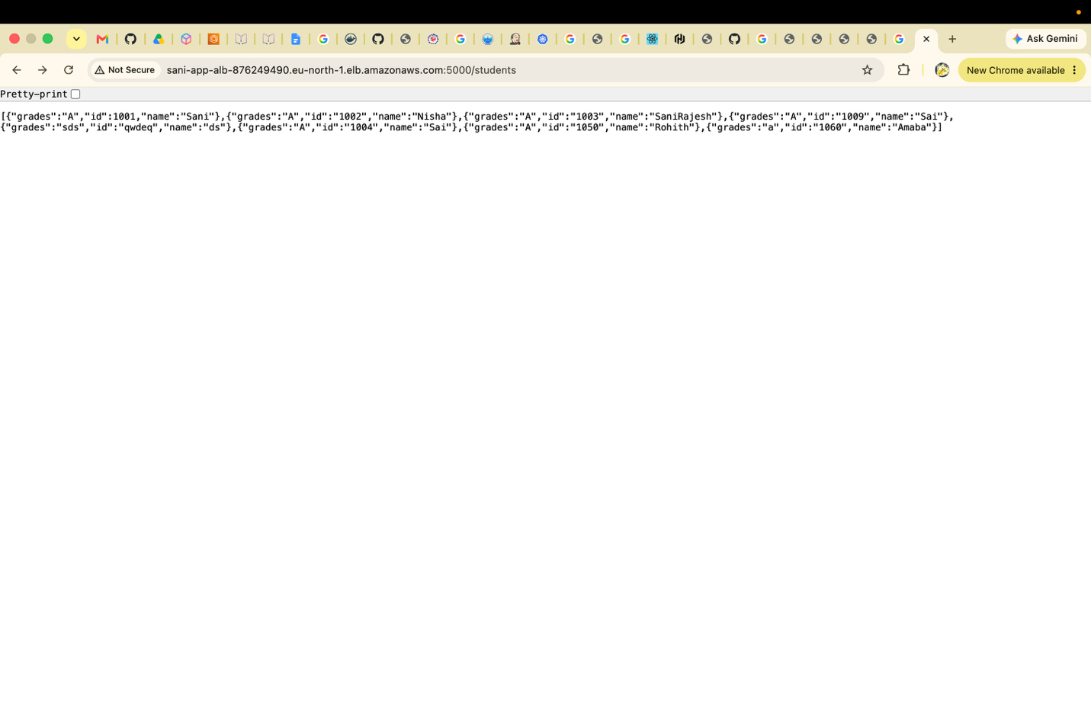

Frontend is reachable from the internet:

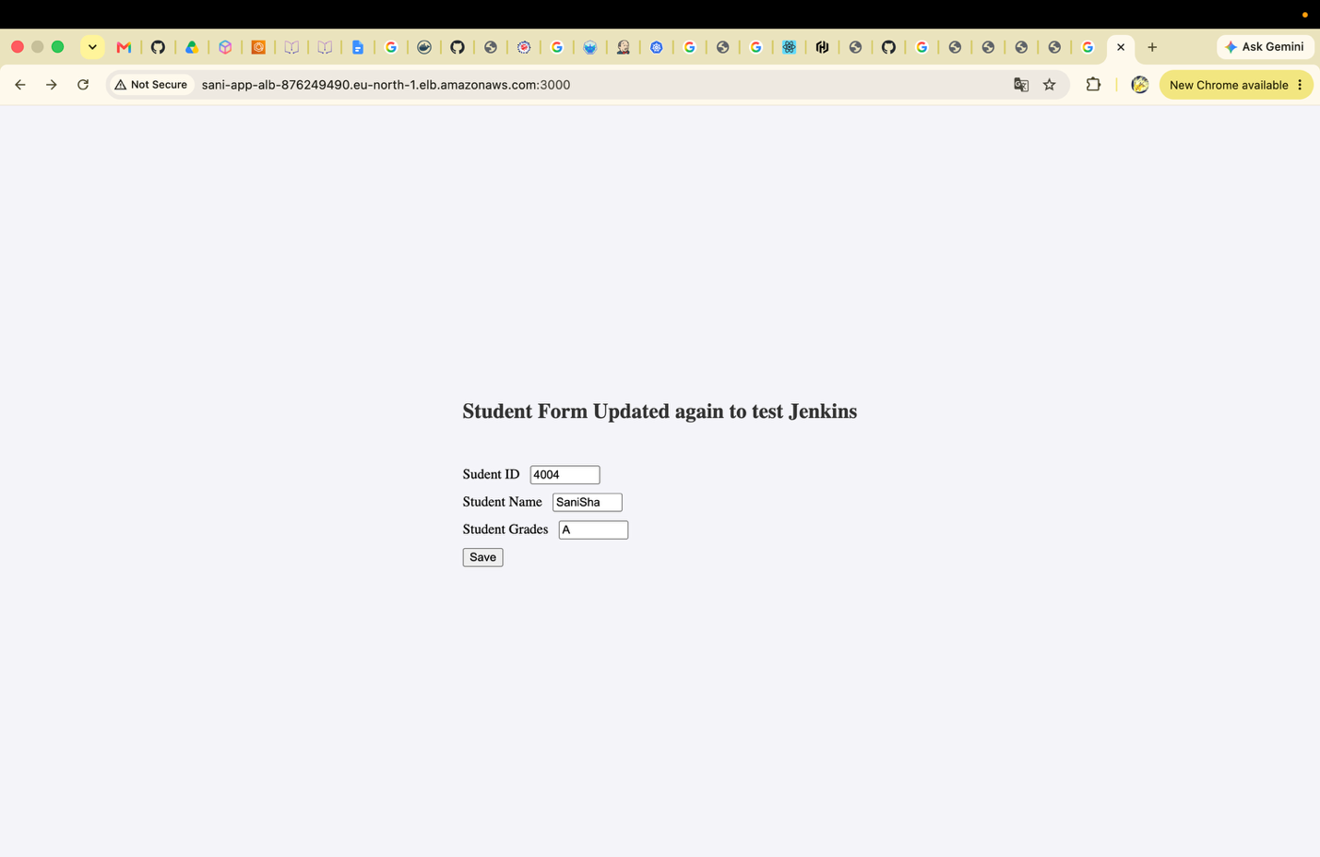

VPC Created :
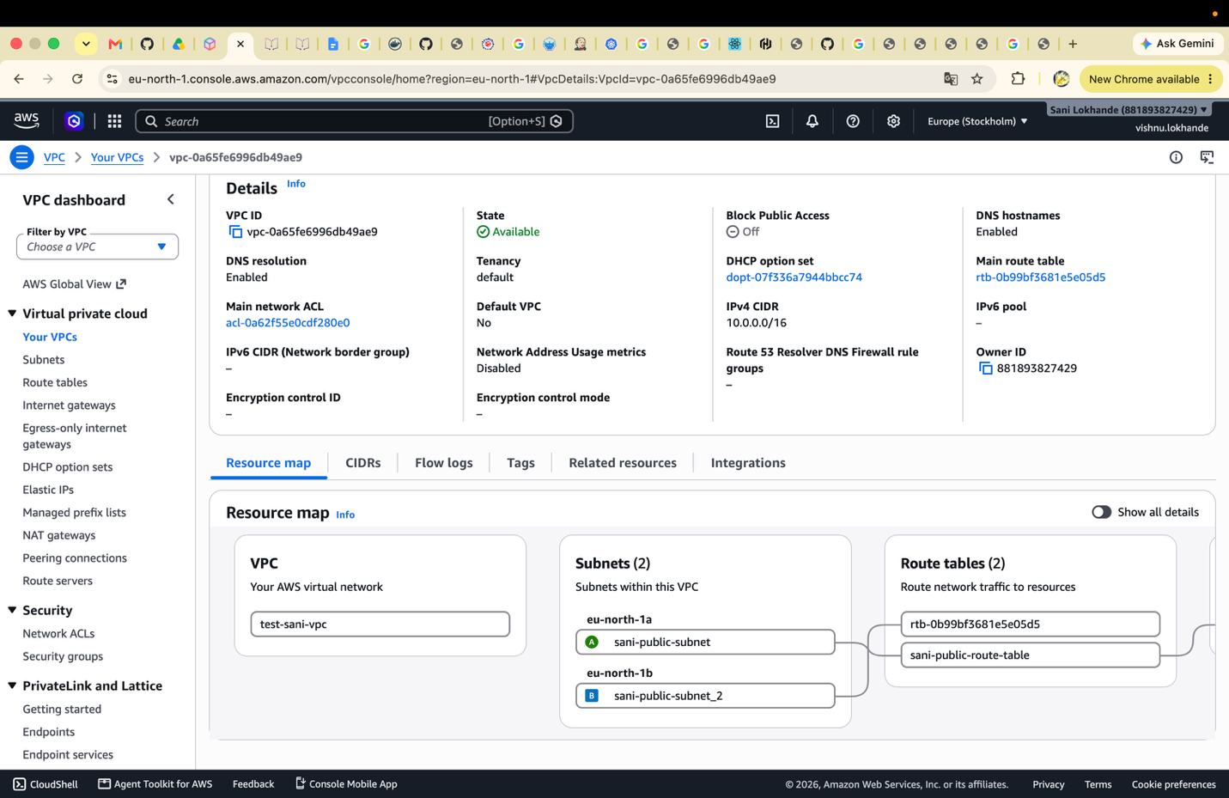

Subnets Created:
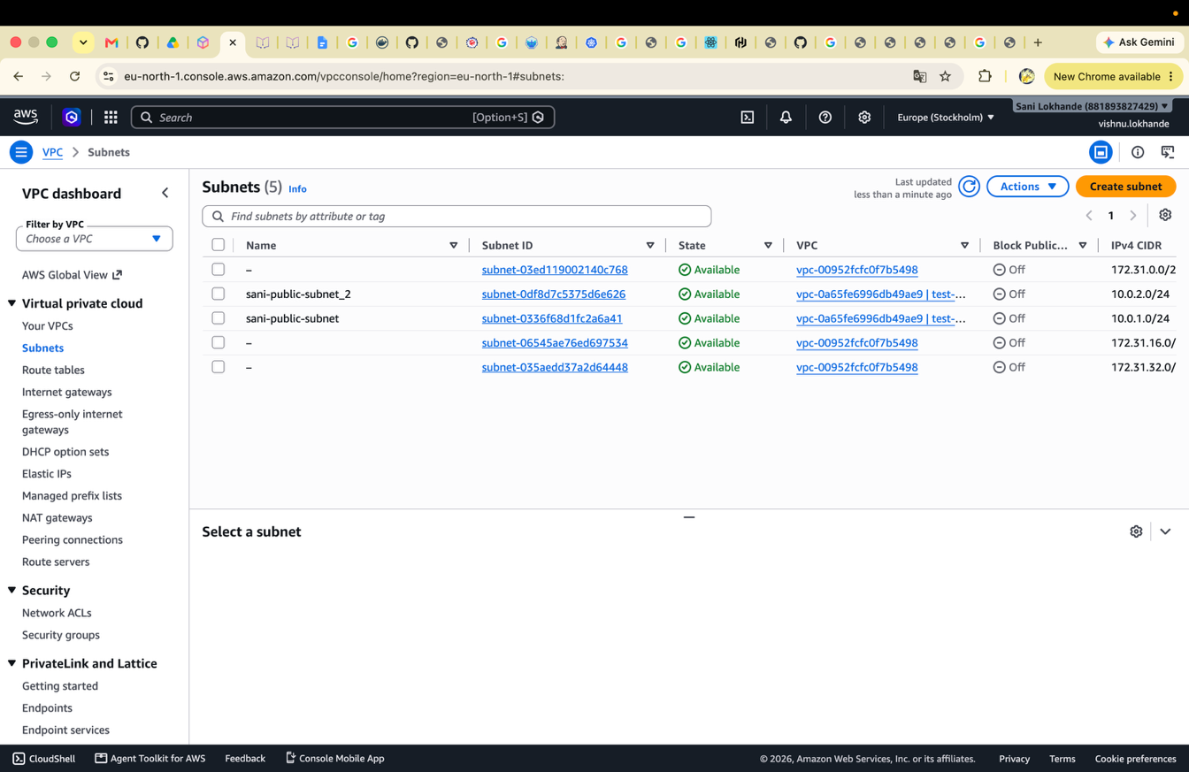

Internet gateway:
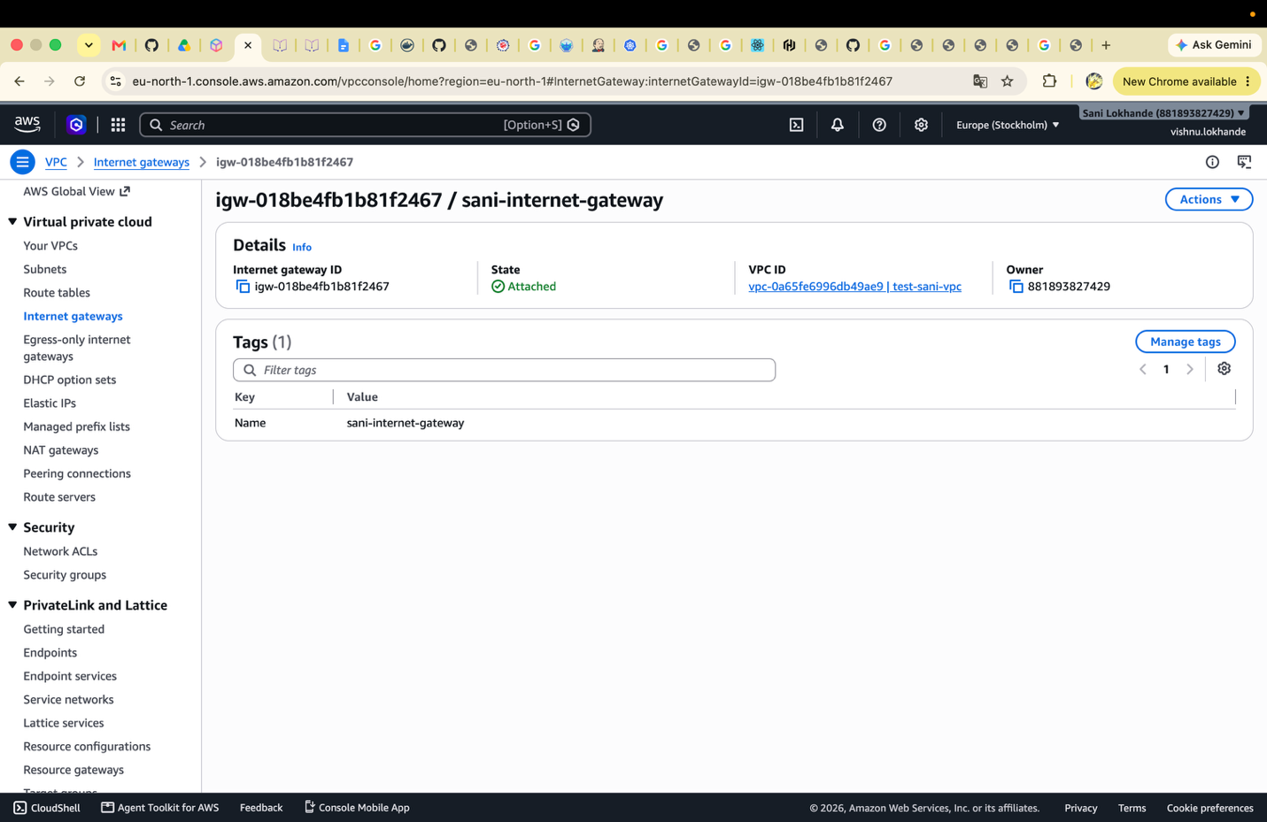

Security group:
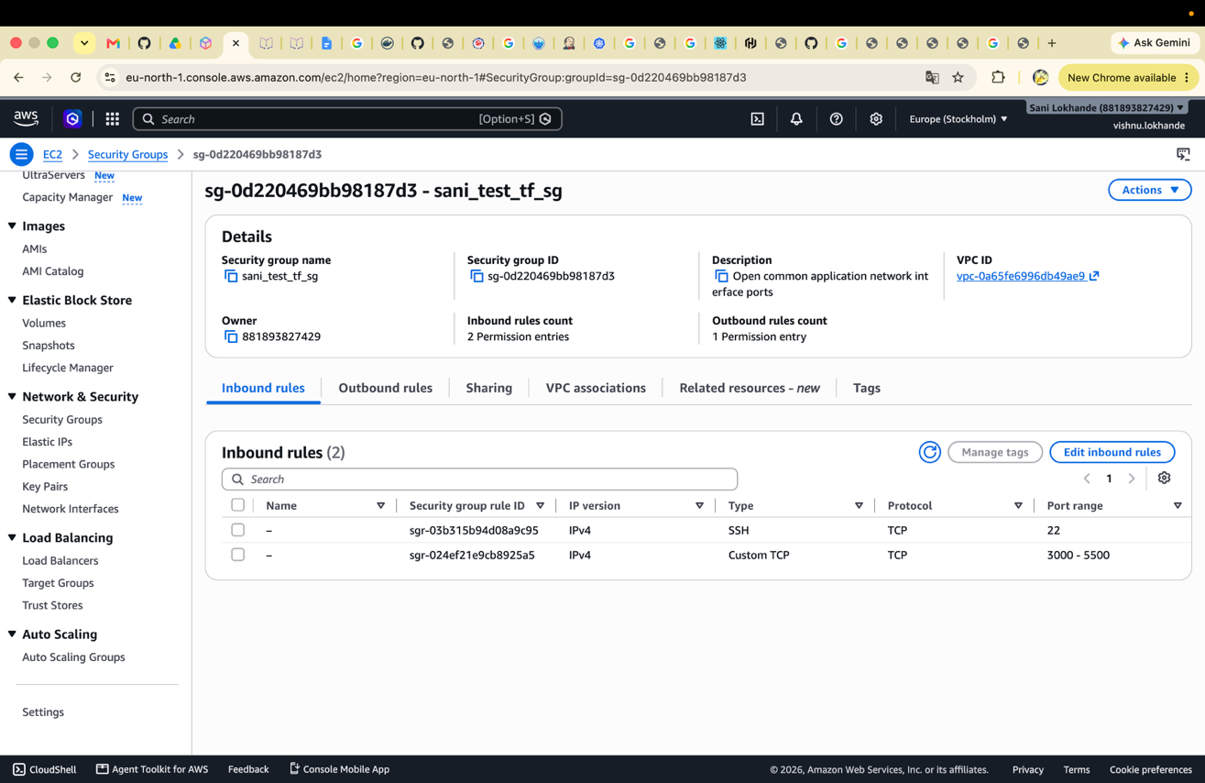
Images uploaded in ECR:

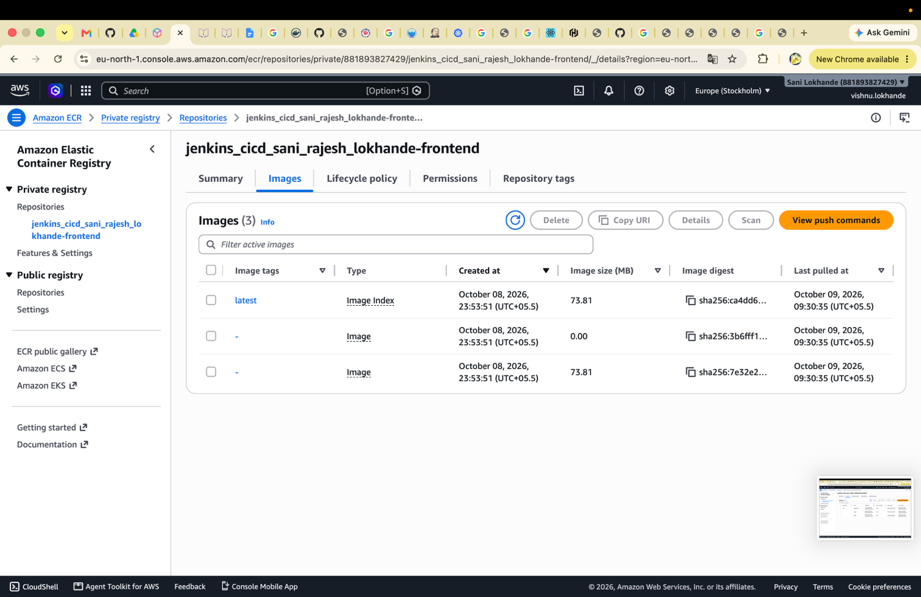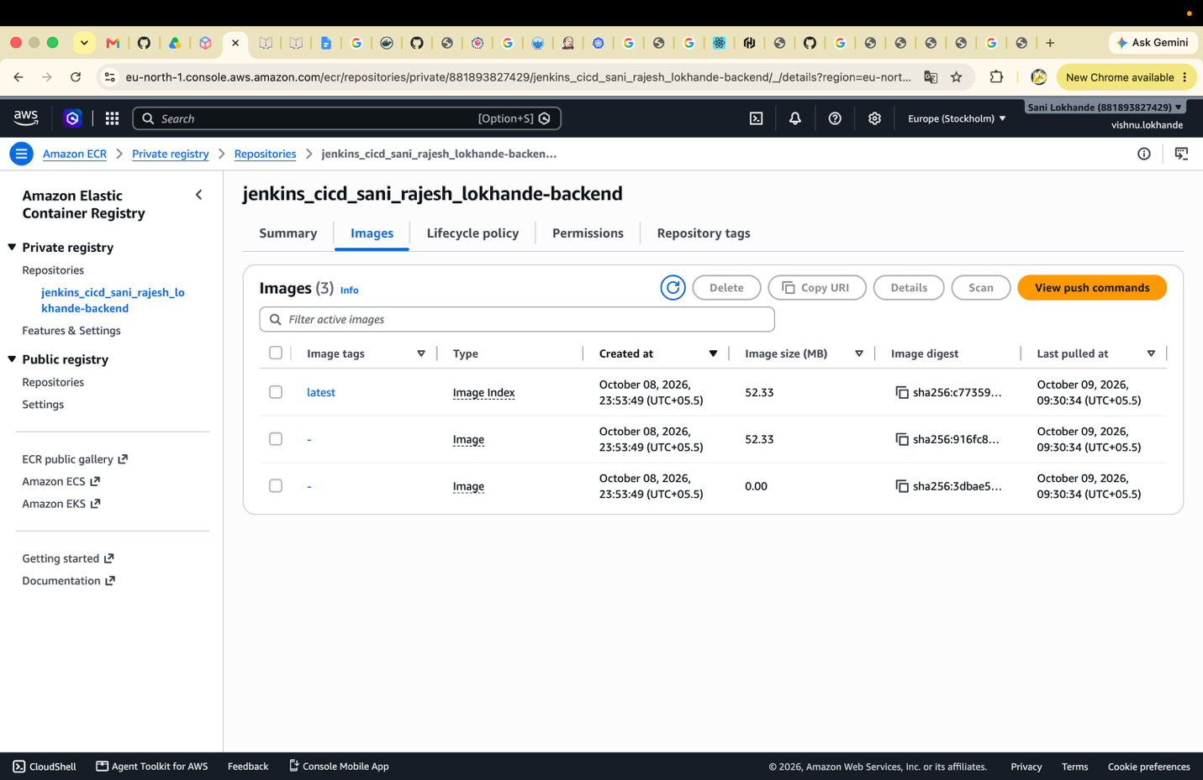

AWS Cluster created:

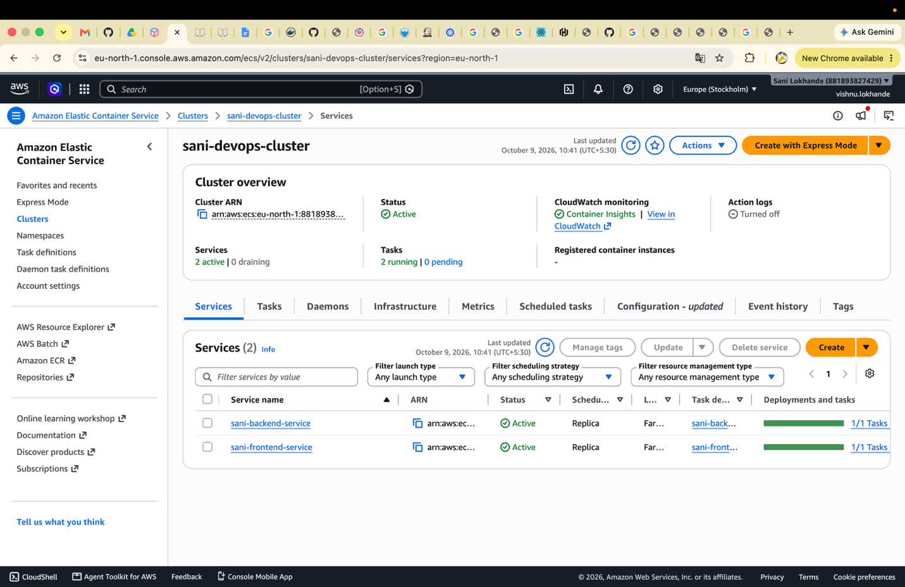

Created load balancer
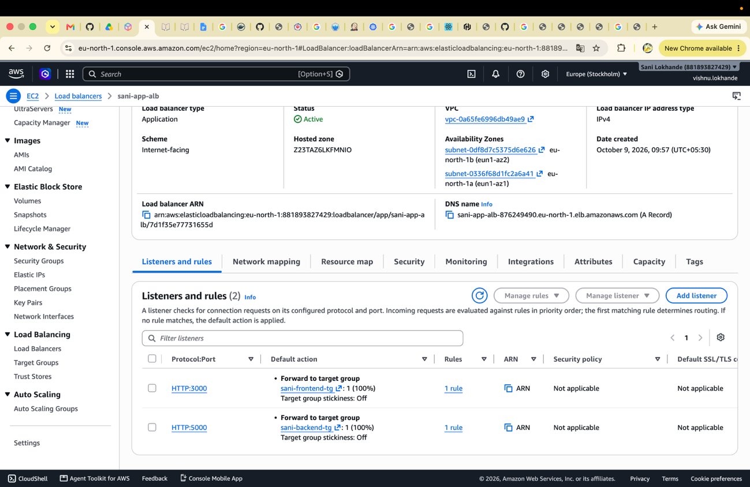

Target groups:

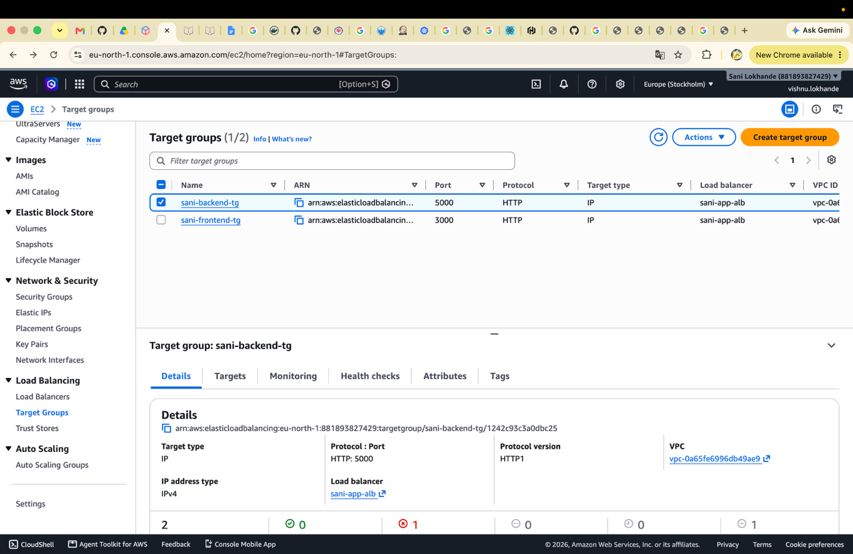

Services Created :
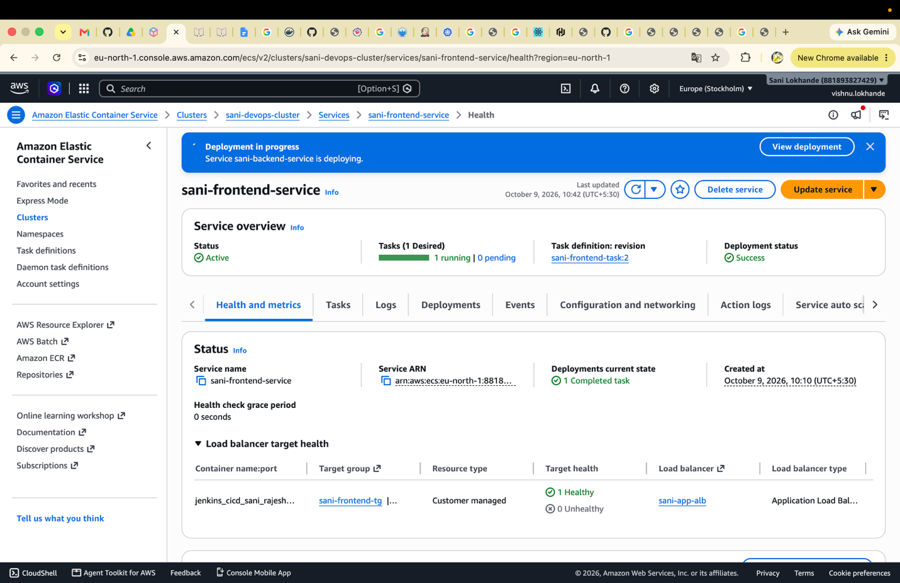

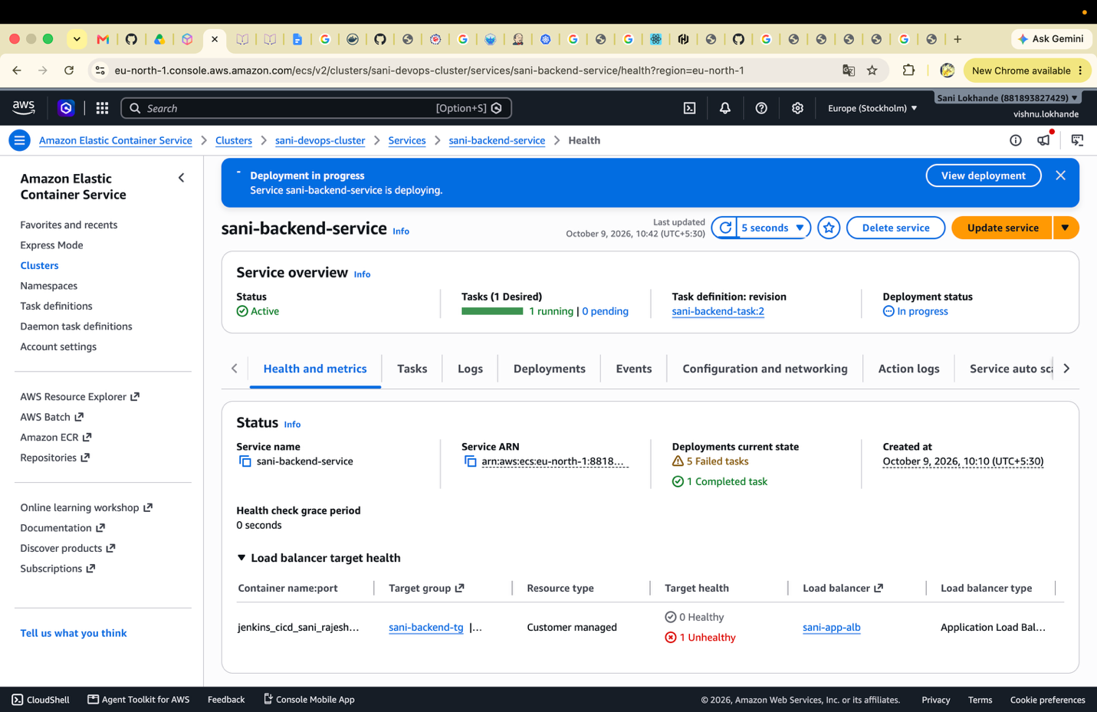

Task Definations
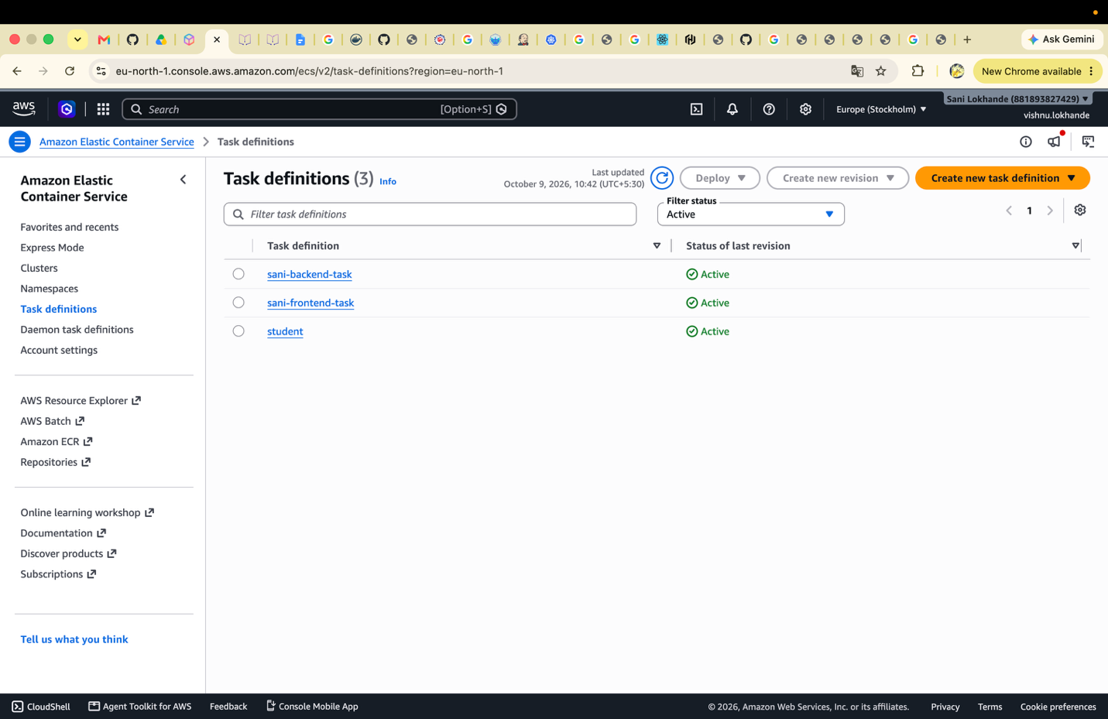

Terraform init to store the state to remote and successfully stored to remote S3 bucket on path Task3/terraform.tfstate

