Objective: Deploy a full-stack application in a local Kubernetes cluster using Minikube.

Task
- Deploy your previous assignment's Flask frontend and Express backend in a Kubernetes cluster locally using minikube.

Steps to create images in docker
- Cloned the repo fron git hub using the git clone
- Removed all containers using docker rm command
- Removed all previously running images using docker rmi commad.
- Navigated to new kubernaties folder and copied the student application from docker folder.
- Ran the docker compose up command to build and run the docker images.

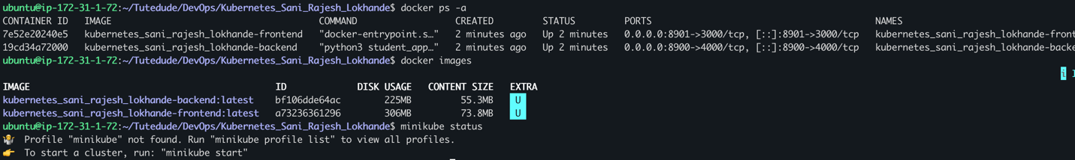

Minikube started
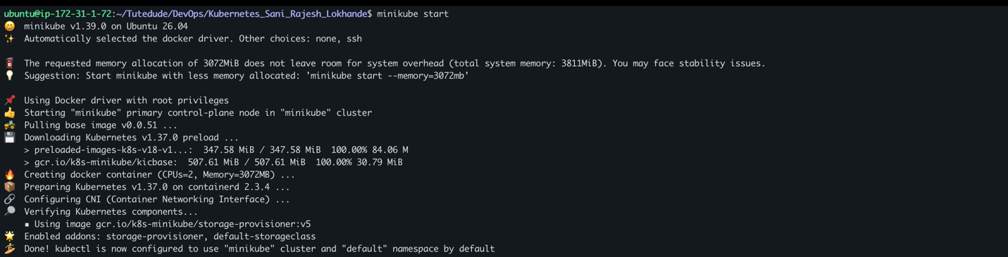

Using minikue load loaded the images to Kubernetes.

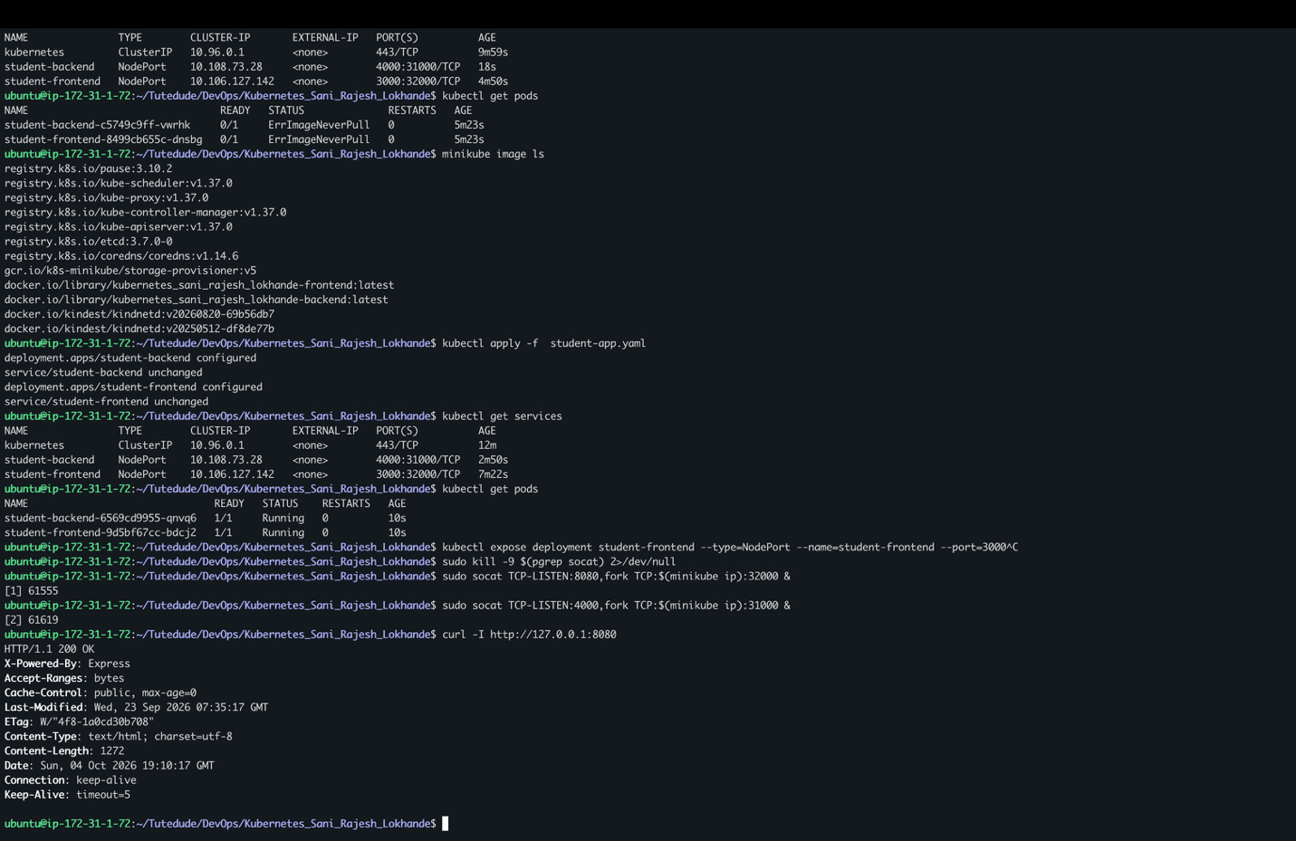

Created the manifest file as student-app.yaml
Mentioned the two deployments student-backend and student-frontend
With one replica as, I am running on AWS instance so due to memory issue.
In template spec added the image name which is loaded from docker images and kept imagePullPolicy: Never so it will not search the images in docker hub and uses the internal images. And running the backend on port 4000 and frontend on 3000

Added 1 service for each deployment as type NodePort and mentioned the ports of that serive will be running. Exposed the frontend service on port 8080 and backend on port 4000
URLs are still accessible:
Frontend to post student data : http://16.192.198.216:8080
Backend to get student data : http://16.192.198.216:4000/students

Frontend running:
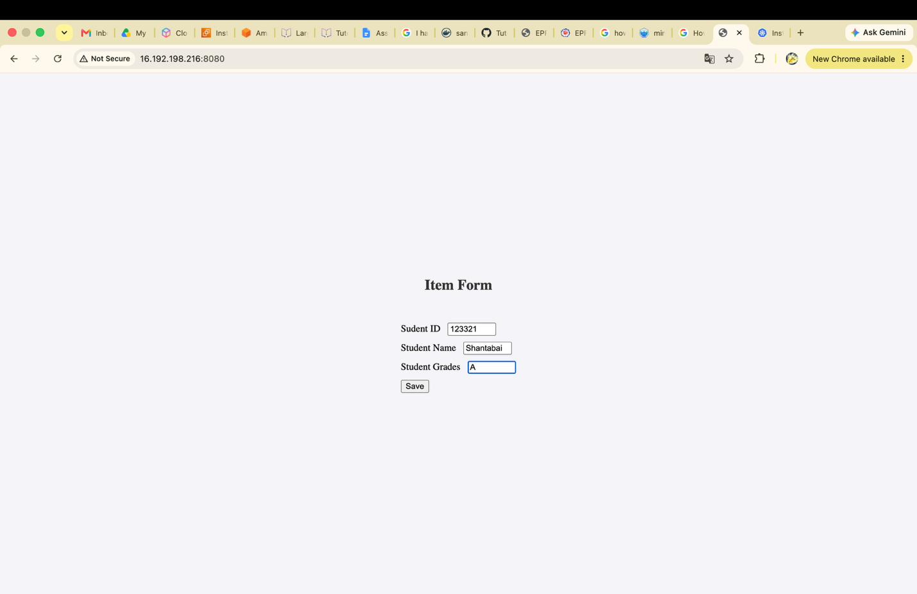

Backend response after submitting the data:
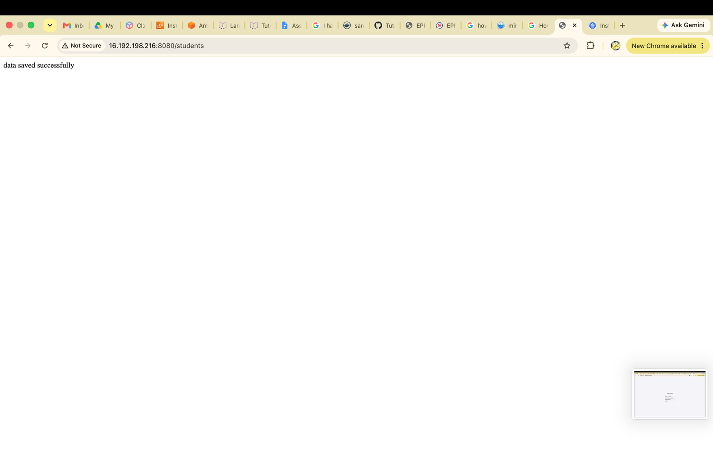

Get the saved data :
