- Deploy your Flask backend and Express frontend on a single Amazon EC2 instance.
ANS:
Deploy your Flask backend and Express frontend on a single Amazon EC2 instance.

Created the Amazon AWS account

Created the security group to get access all inbound and outbound traffic on all traffic and all port range.
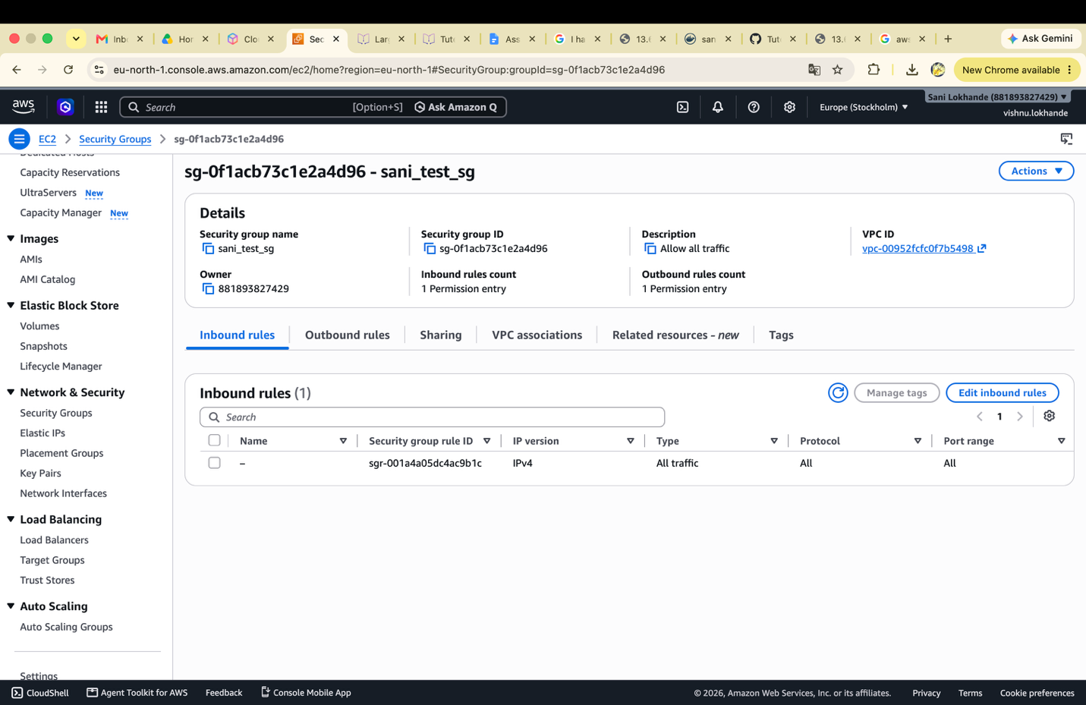
Created the EC2 instance

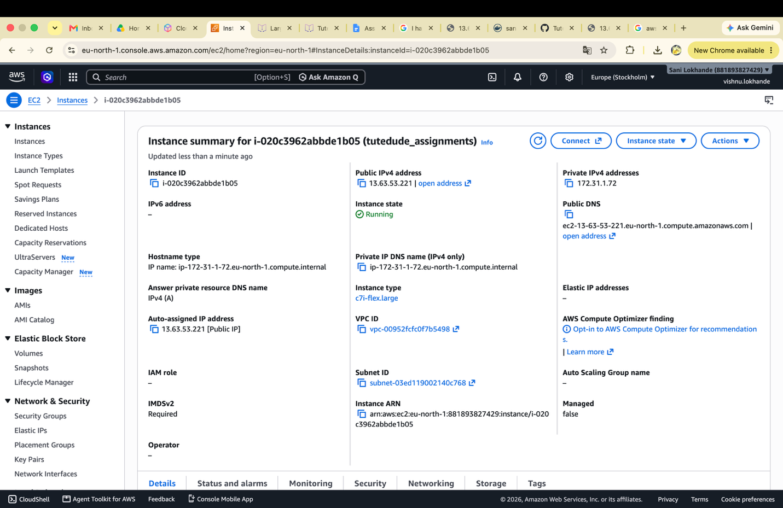

Downloaded the .pem file and changed the access of that file using
chmod 400 /Users/sani.lokhande/Downloads/assignments.pem

then accessed the EC2 instance using ssh
ssh -i /Users/sani.lokhande/Downloads/assignments.pem ubuntu@13.63.53.221

using the git clone downloaded the previous assignment from GitHub and running the frontend and backend.
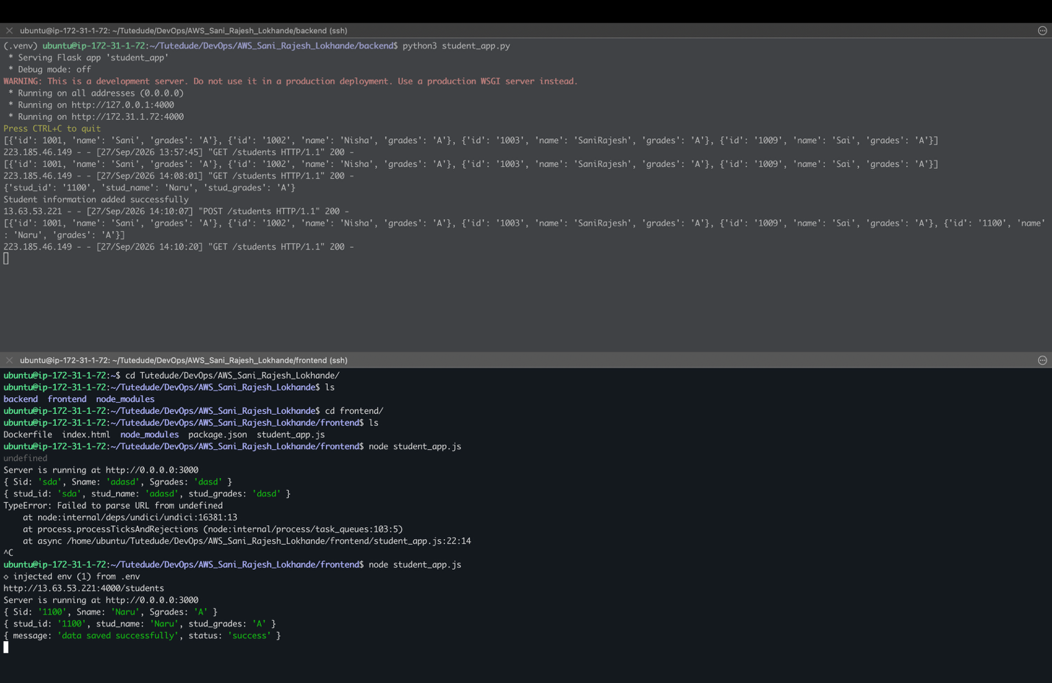

Student form
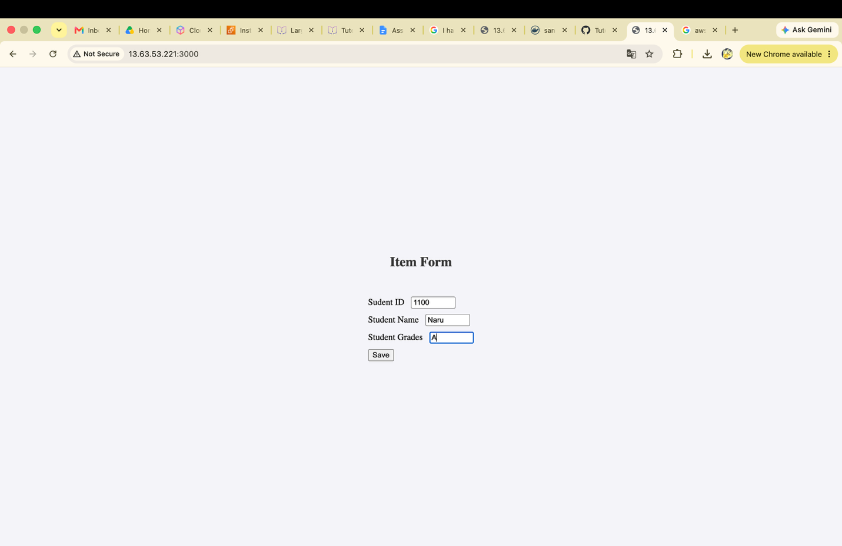

Data Saved successful
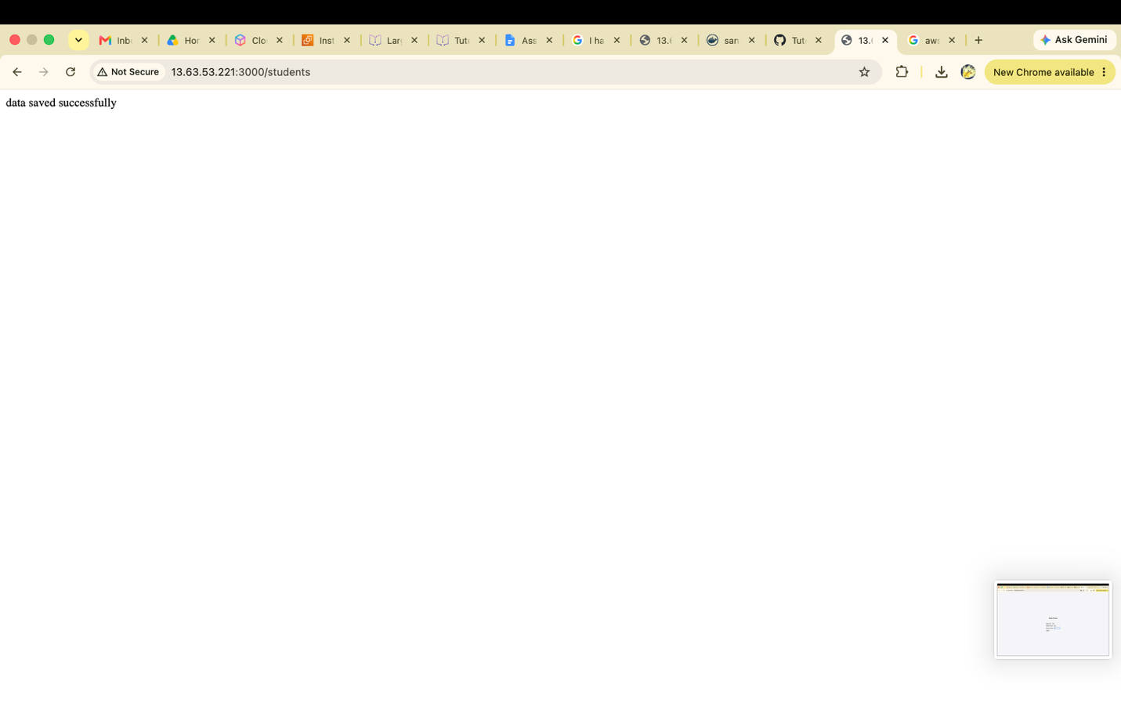

Accessed backend get on port 4000
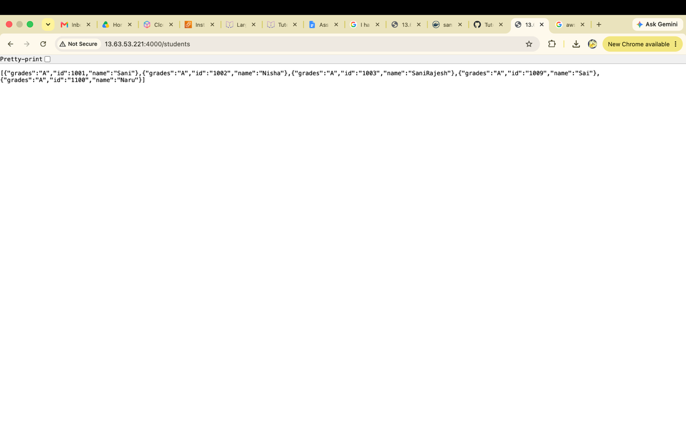

- Deploy your Flask backend and Express frontend on separate EC2 instances.

ANS:

Created second EC2 instance

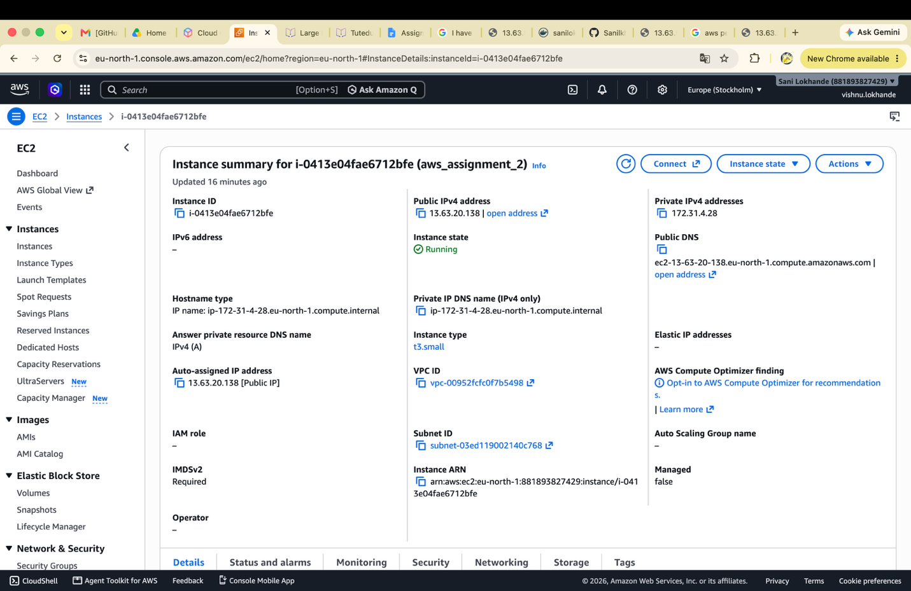

Created ssh keys for github and added to git hub account and cloned the repo

Installed Flask and dotenv and running the backend app on this instance and running the frontend on first instance. Changed the backend URL in .env file on frontend so frontend can access the backend of second EC2.

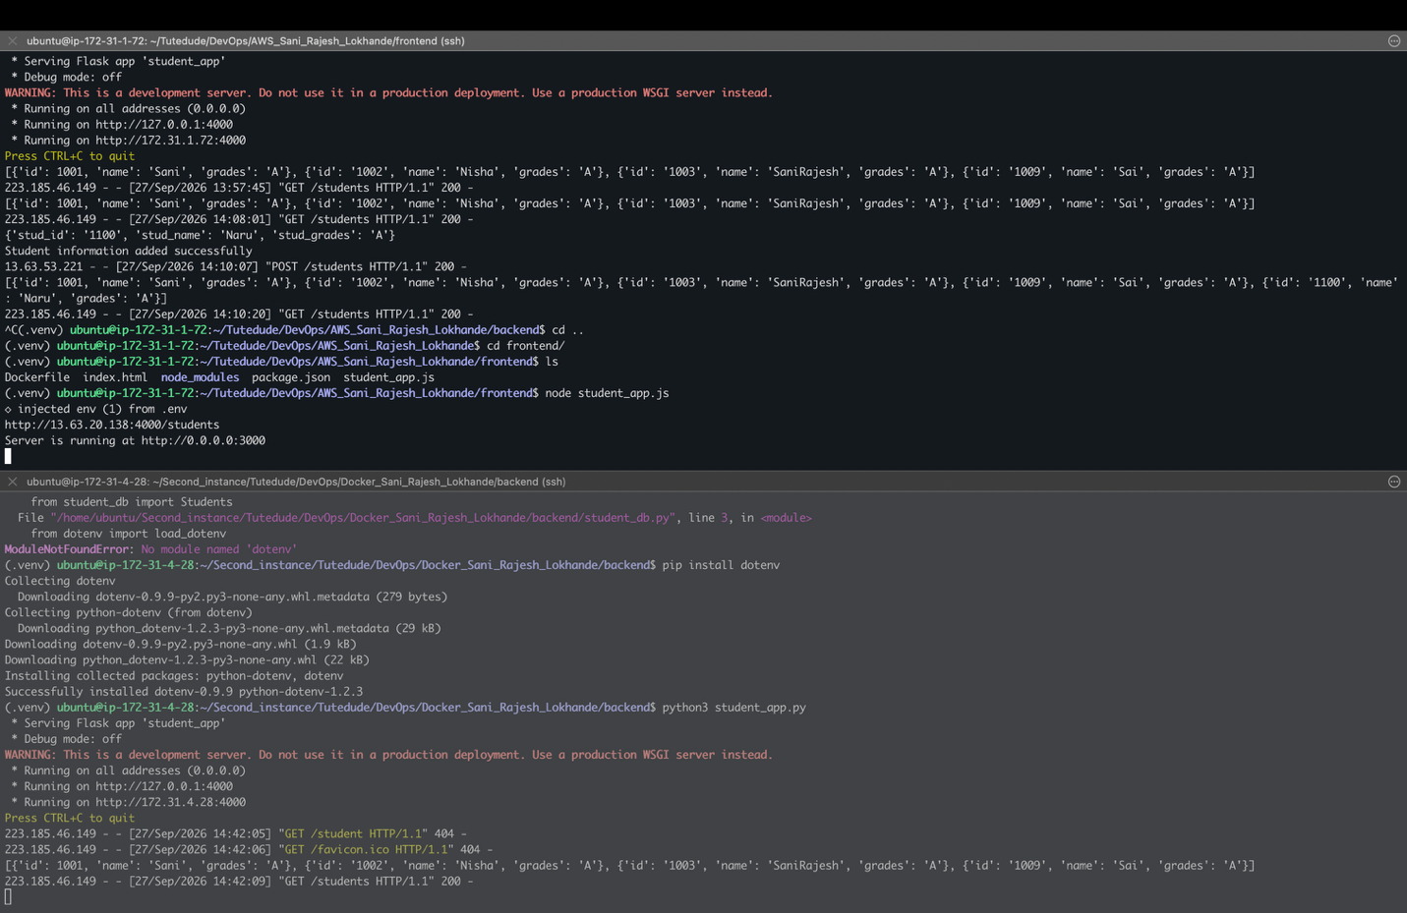

Student form frontend running on http://13.63.53.221:3000/ and backend running on http://13.63.20.138:4000/students

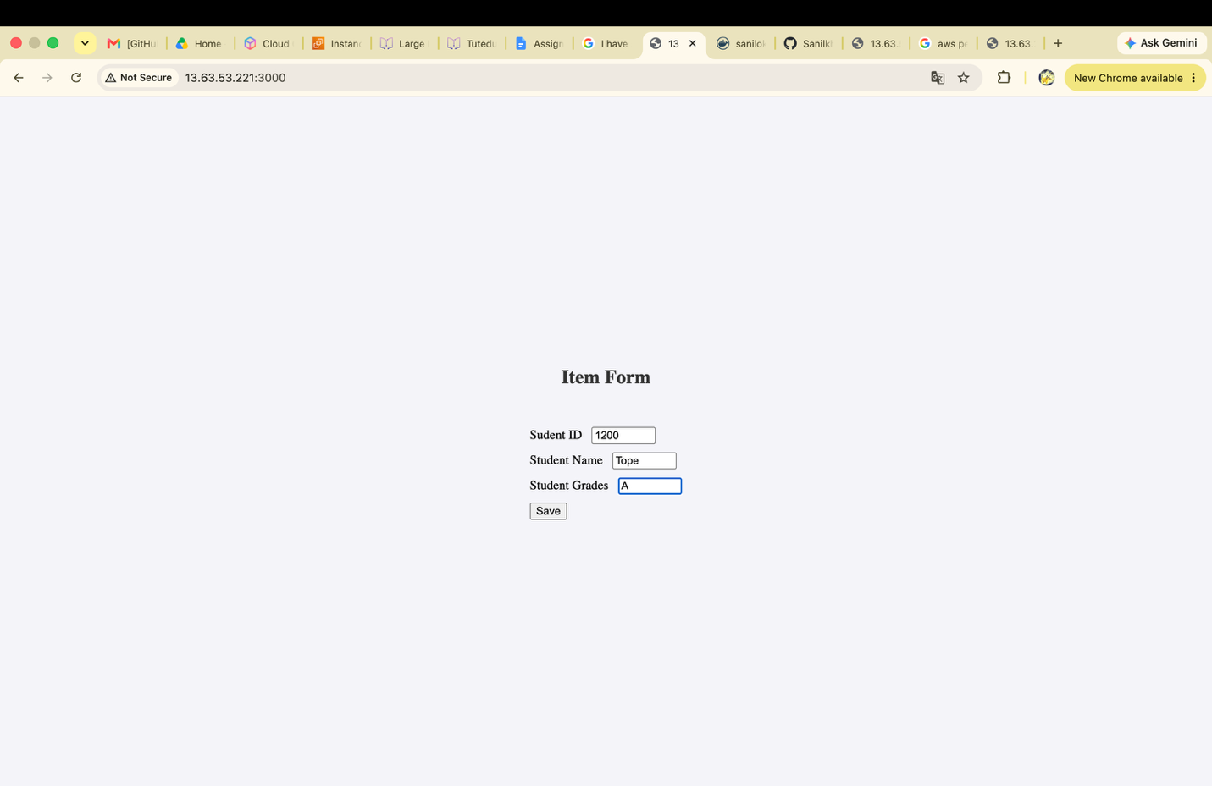

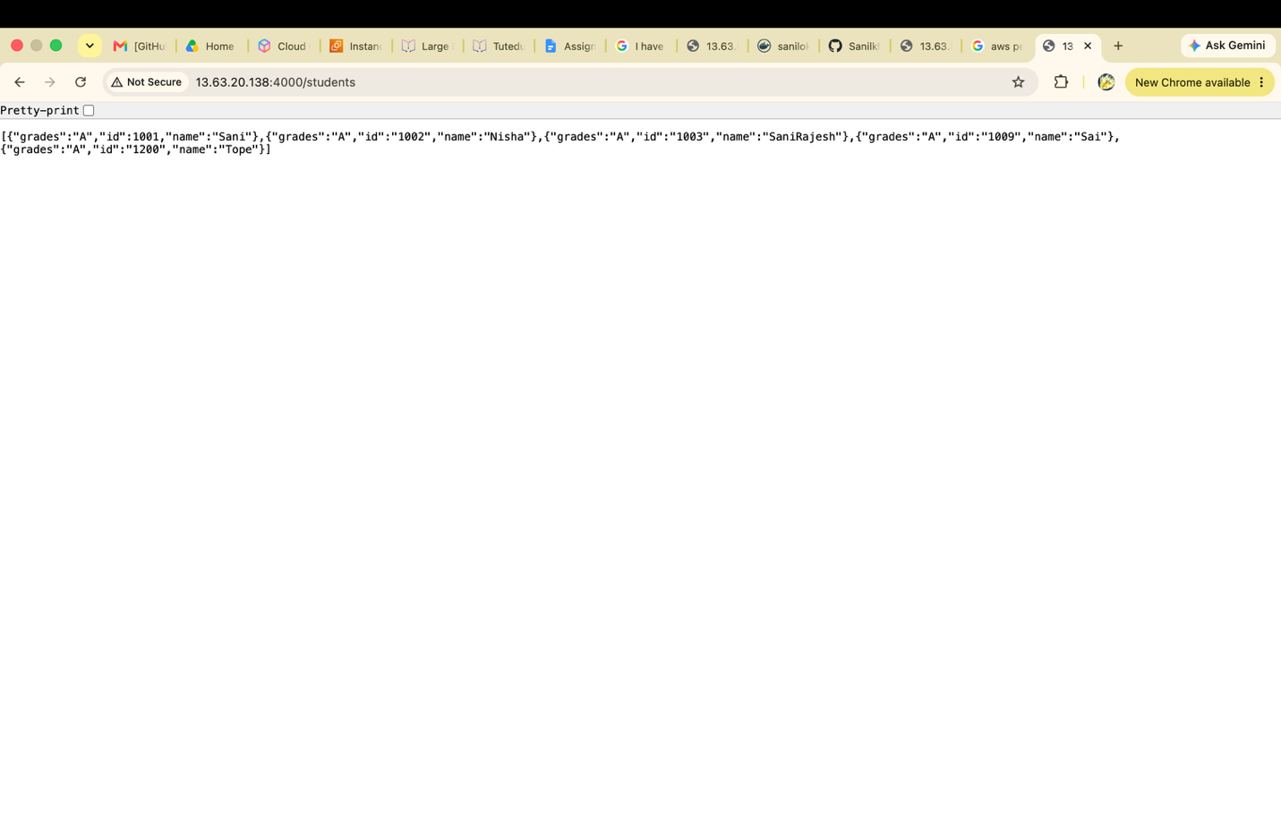

- Deploy your Flask backend and Express frontend as Docker containers using AWS ECR, ECS, and VPC services

ANS :
Created the ECR repositories for frontend and backend.

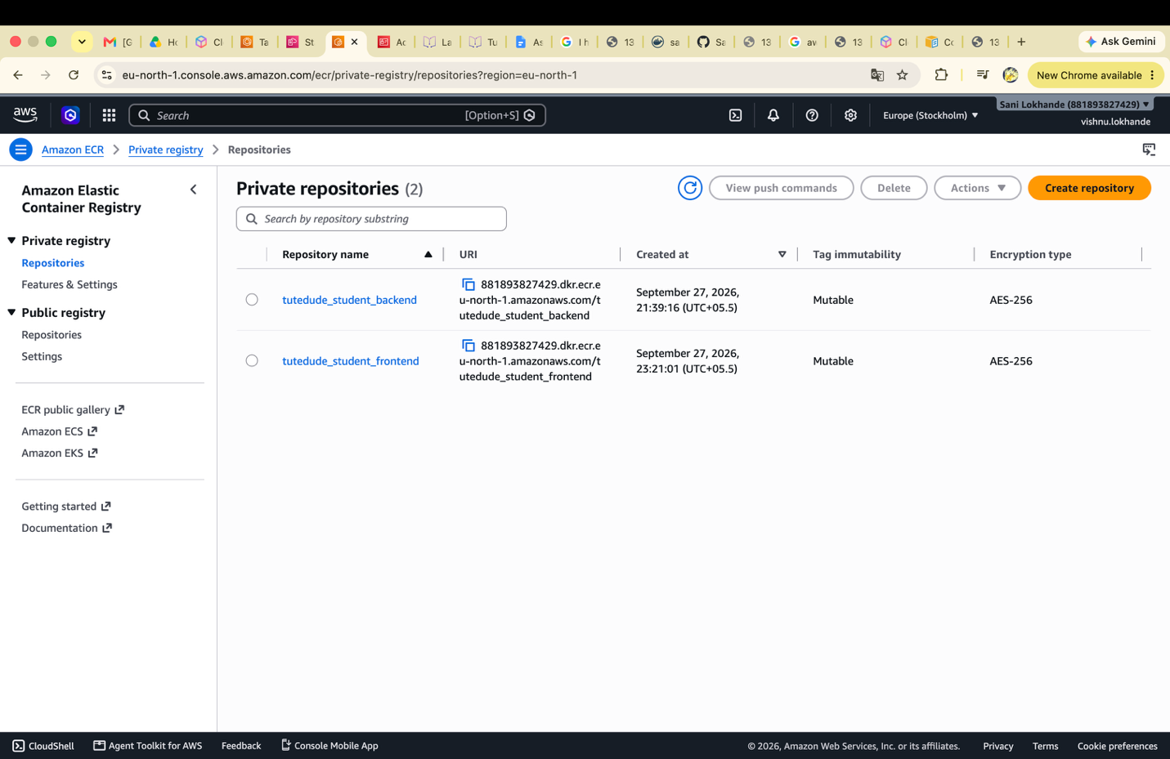

Logged in aws ecr get-login-password commad
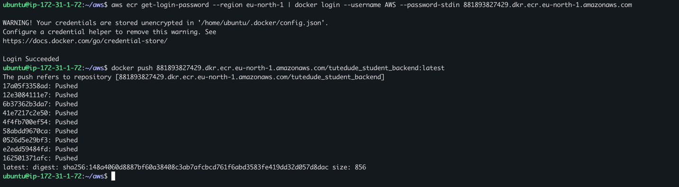

Used docker tag to tag the ecr repository.
docker tag docker_sani_rajesh_lokhande-frontend:latest 881893827429.dkr.ecr.eu-north-amazonaws.com/tutedude_student_frontend:latest
and using the docker push pushed the both images on aws ecr.

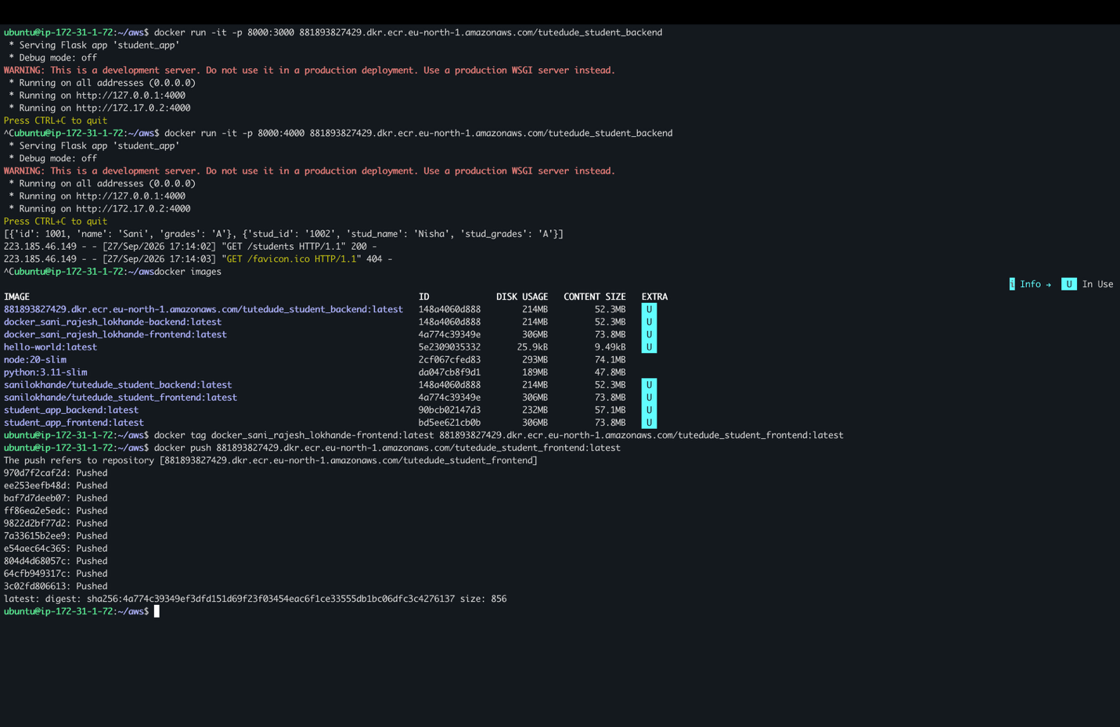

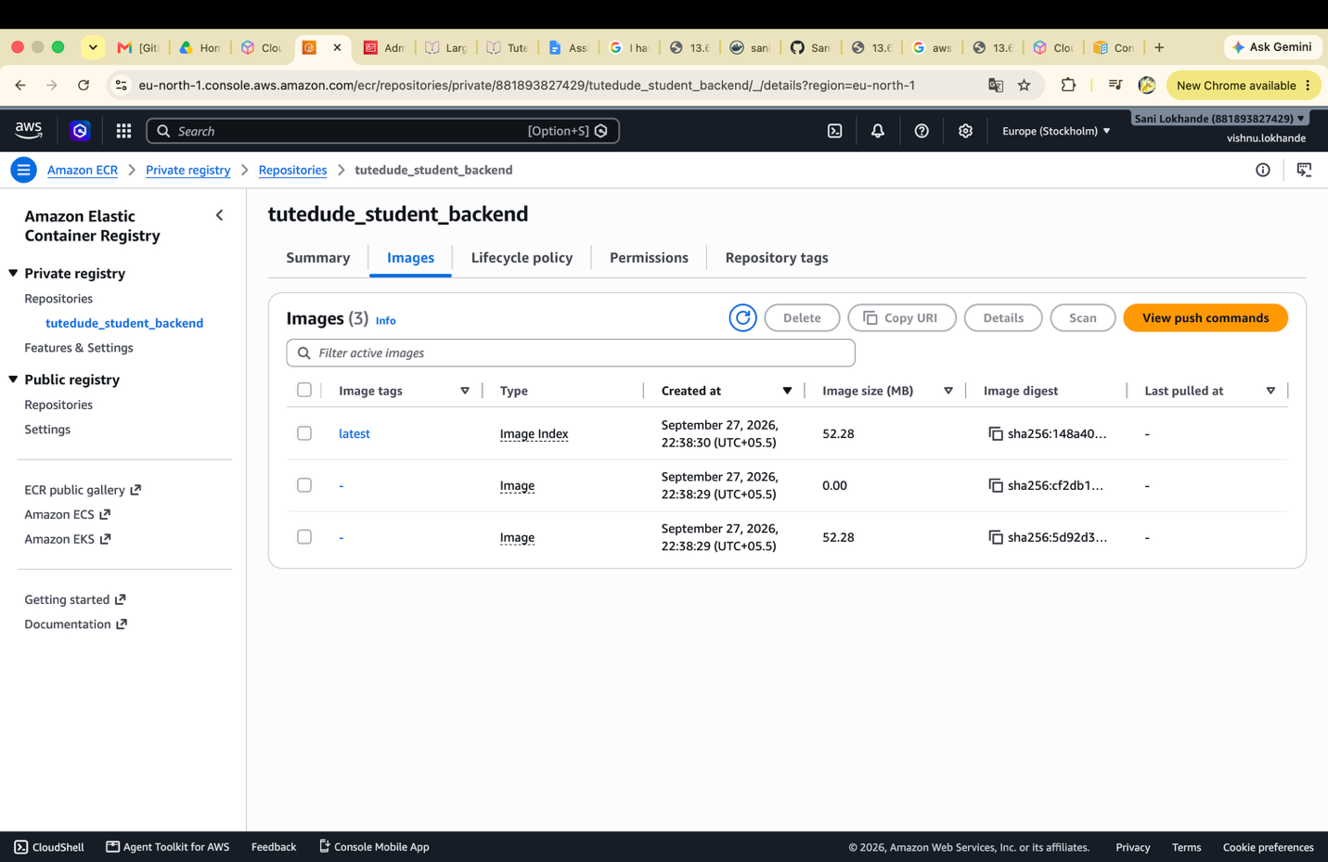

ECS:
Created the cluster on default vpc:

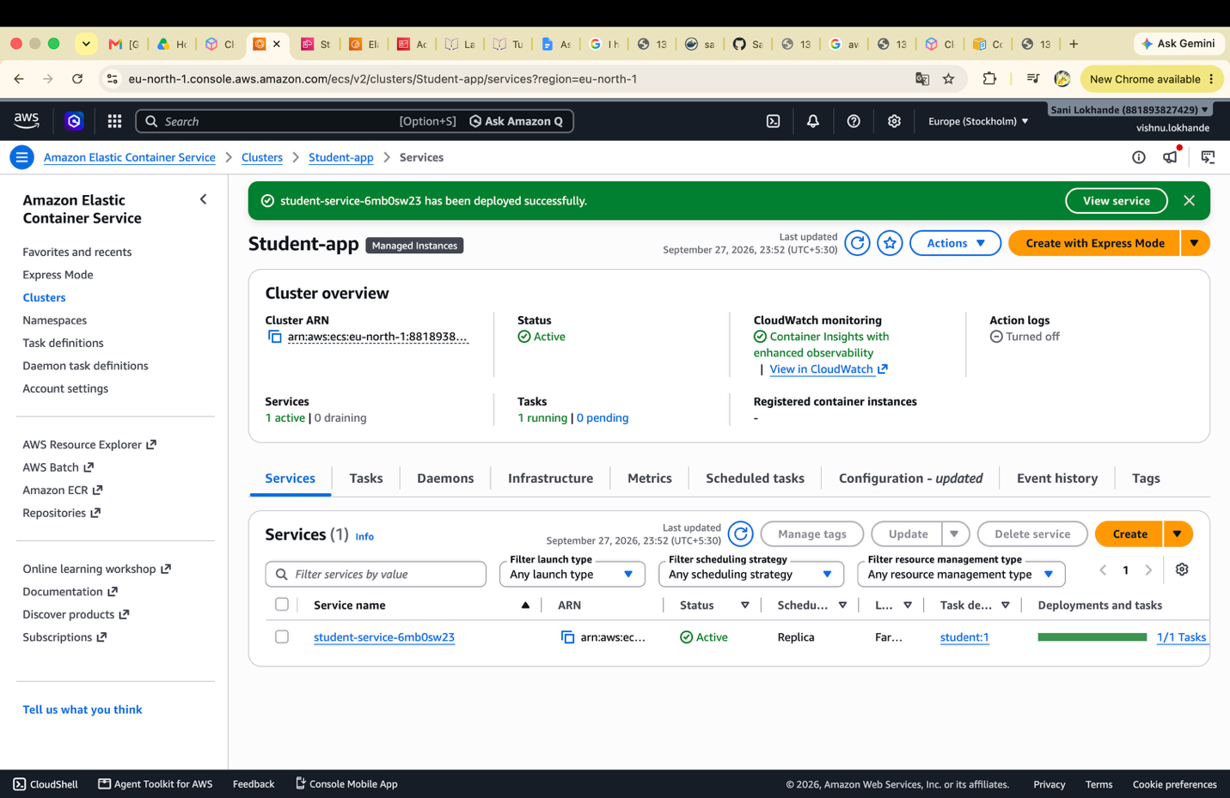

Created a task definition and added 2 container 1st is student frontend and 2nd is student backend. And uses the uploaded ECR images.
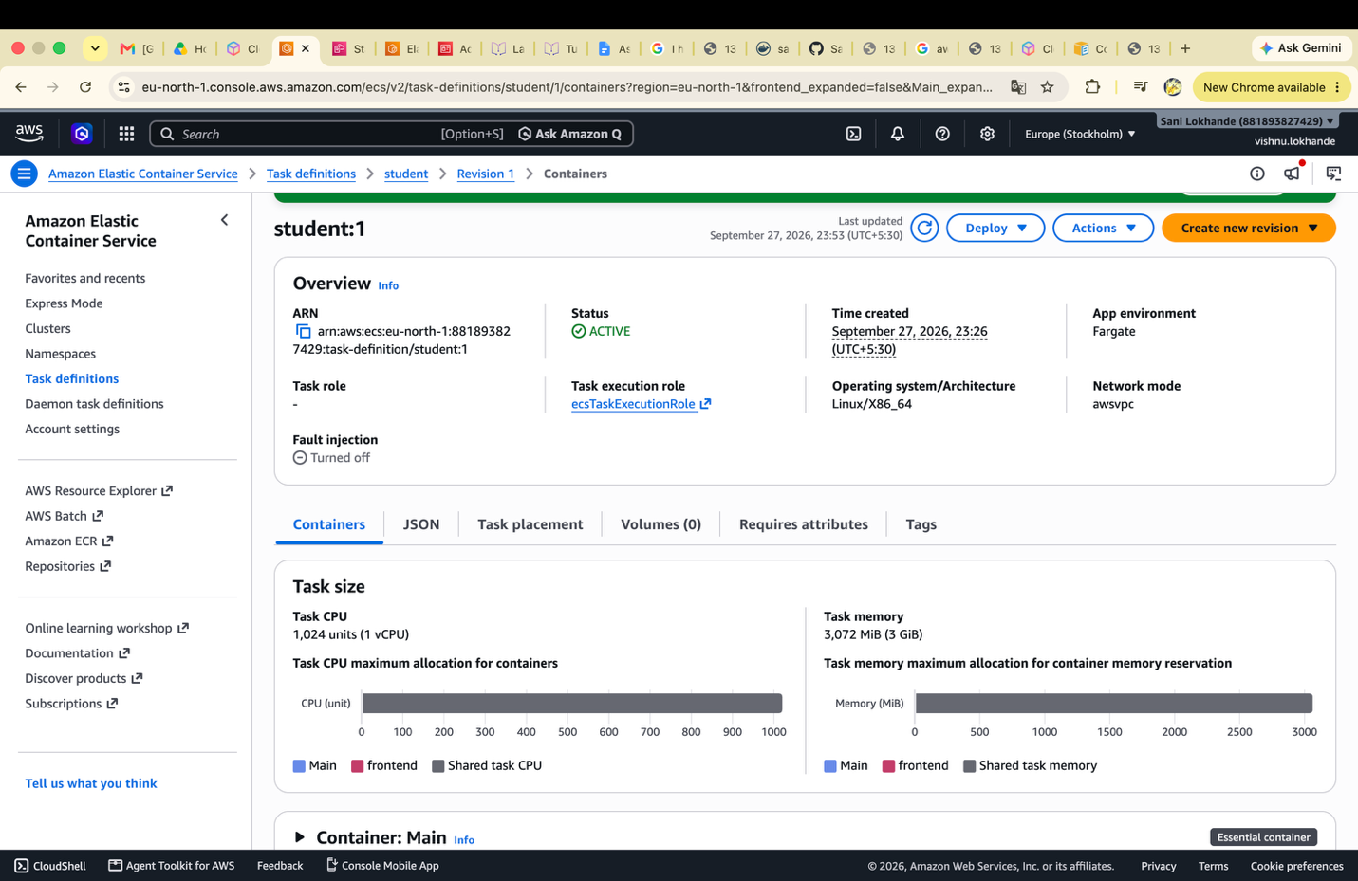

Now created the services using the student task definition.

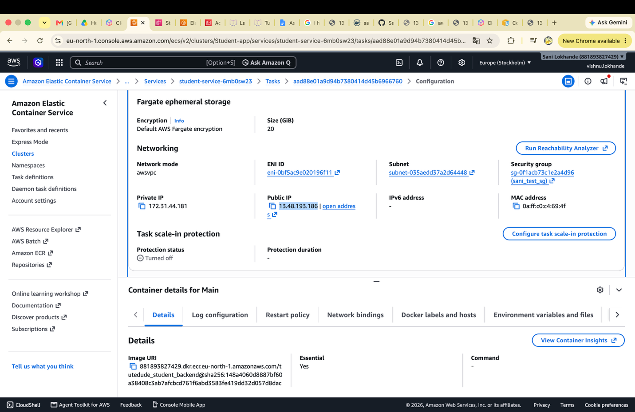

Got the public Ip now backend running on http://13.48.193.186:4000/students
And frontend running on http://13.48.193.186:3000/

