1. Frontend (Node.js with Express)
- Create a frontend using Express and Node.js.
- Include a form similar to the one from the Flask Assignment 2.
- Configure the form to send a request to the Flask backend.

ANS:
Created a webpage using html and CSS to accept the student info with grades as index.html and retuning this page via student_app.js on “/” api route.
Express() obj app and app.get is used for get api call. In response sending the index.html file for form load. And in html file sending the post call to express post call on /student route.
Using the req variable accessing the form data and using the fetch methos sending the data to backend. BACKEND_URL accessing from environment variable and this environment variable is set by docker_compose.yaml file
App.listen() is used to run the server. Provided the port to run on 3000 and host is blank so cosiderded the 0.0.0.0 .

Package.json file is a metadata of this project and dependencies. Dependencies field is used to specify the frontend downloaded packages in my case I used express and dotenv, In docker file added the RUN npm install to install the all dependencies mentioned in package.json
Scripts are used to create the terminal shortcuts like I have used in this. I have spsified as start to run the node student_app.js and in docker file to run the app just add CMD “npm start”

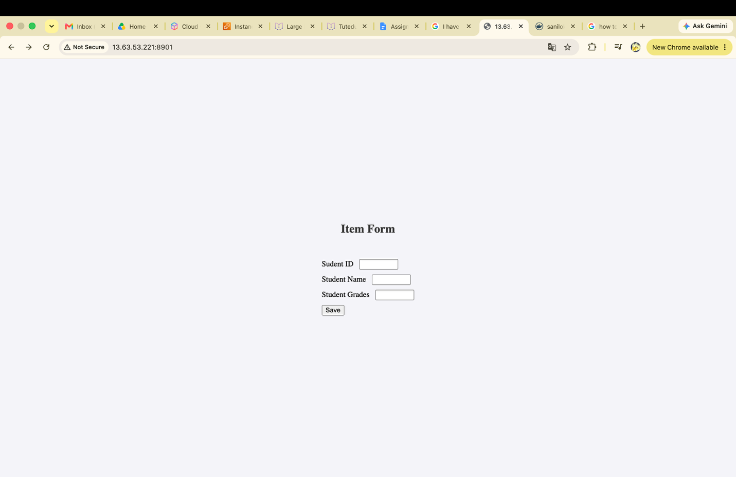

2. Backend (Flask)
- Use the Flask backend to handle the form submission and process the data.

ANS:
Created Flask app to store the student data into file and retrieve the data. Student_app is running on port 4000 and accessable for as I mentioned 0.0.0.0 to app.run()
Created the Student class in separate file so can access and reuse the same file by creating the Student obj.
Student_db.py file is imported in student_app.py file.

Post request is accessed by save_student_info () and calling the insert() of student class to save the data.

Created the docker file and added the requirements.txt and installing required packages using the RUN pip install -r requirements.txt. and running the app using CMD python3 student_app.py

3. Folder Structure
- Organize the project with separate folders for the frontend and backend.

ANS:

Created two folder as backend and frontend.

4. Docker Configuration
- Create a Dockerfile for both the frontend and backend.
- Write a .yaml file (Docker Compose) to connect both services in the same network.
- Upload both images to Docker Hub, and push your whole code to GitHub. Add node_modules and other non-required files (e.g., .vscode) to .gitignore.

Created a Dockerfile for both frontend and backend.

FROM: specified the base image where I need to run my student app

WORKDIR: to change the directory

COPY: to copy the files and from my local to docker image

ADD: this is also used for copying the files from local to docker image and it’s also supports for URLs, .tar files

RUN: used to run the command on terminal while building an image. So, this is use full if any dependencies need to install

CMD: used to run the command on terminal when launching the containers So this is use full for application launching commands.

Created the Docker Compose file to run both frontend and backend images with single docker compose command.
- Defined two services frontend and backend and given the from as same as folder created under for both applications.
- Ports: containers runs on their own private networks so mapping the ports allowing to access my application by localhost. Port 4000 is inside of the container where my application is running and 8900 is mapped to 4000 so can access my application by accessing port 8900 of my local machine.
- Networks: this is configured so can containers can talk to each other’s. configured student_network in Networks as bridge and this address is get resolved by docker’s built-in DNS. And specified this in both frontend and backend services.
- Hostname: backend hostname given so can frond access it
- Environment: specified this to set env variable of backend url as frondend accessing the backend via env variable.
- Depends on: this specified because frontend is dependent on backend. So to set the order to run the containers used this depends on.
- Volumns: when container is deleted, all files created inside those also be get deleted. So using the volumes we can map folders to outside/local machine. Due to this I can see the student info is still present in my local machine file as well which are stored while running the applications backend and front end.

Running the app:
Docker compose up : running the all services. Specified in docker-compose.yaml file

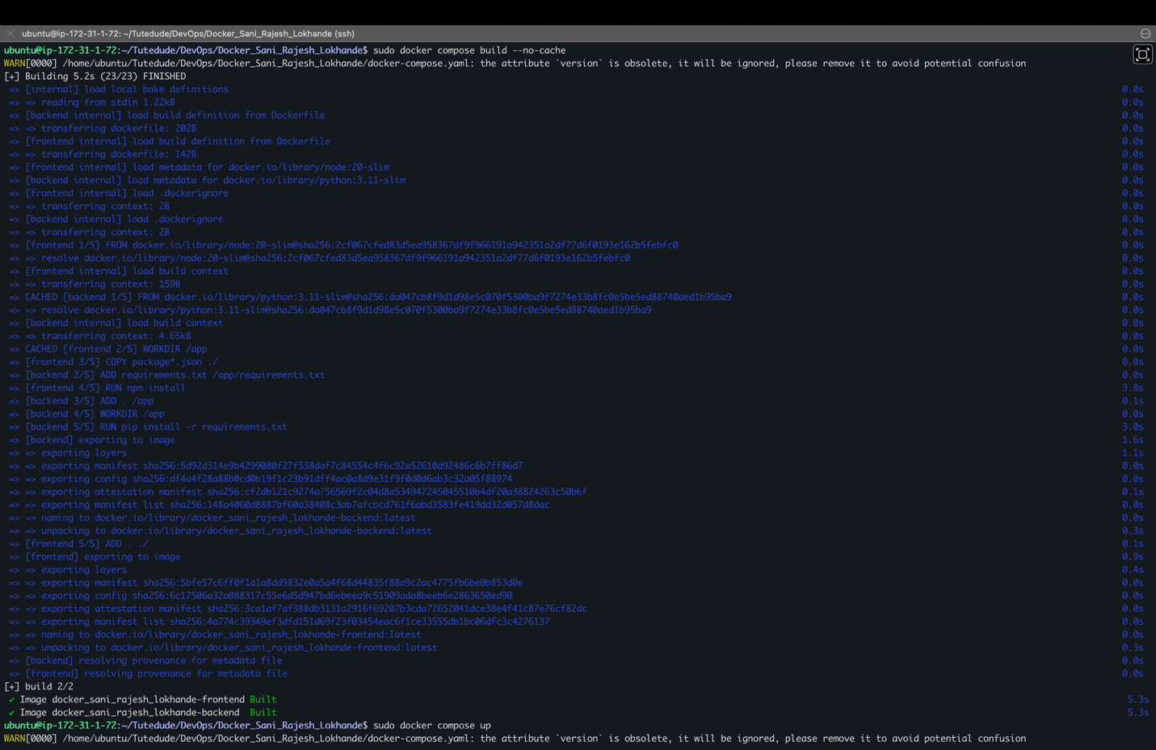

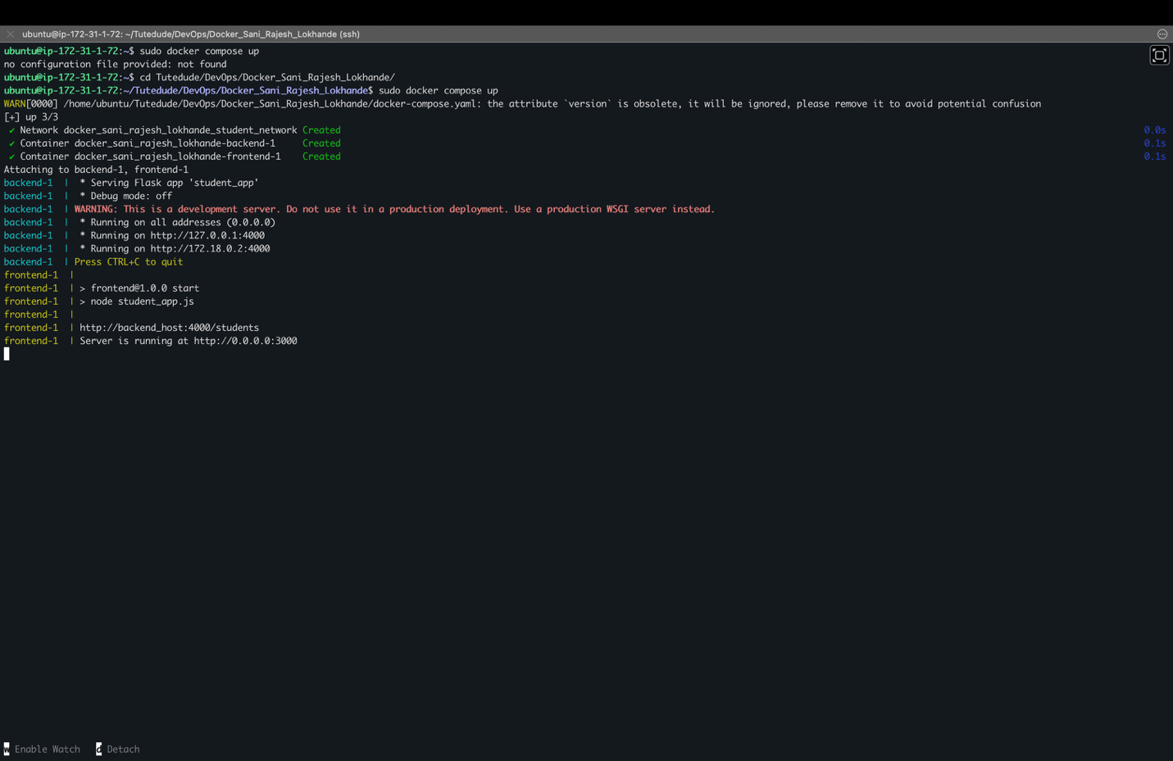

Frontend form on port 8901:

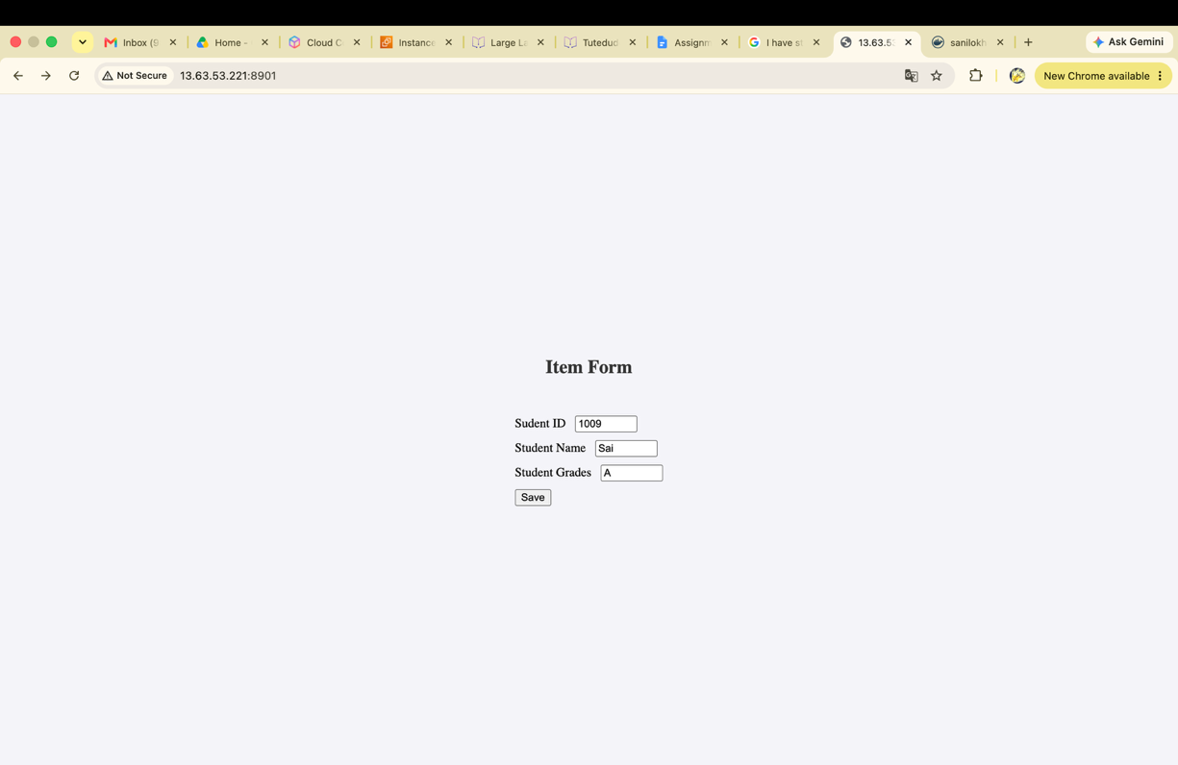

Success message:

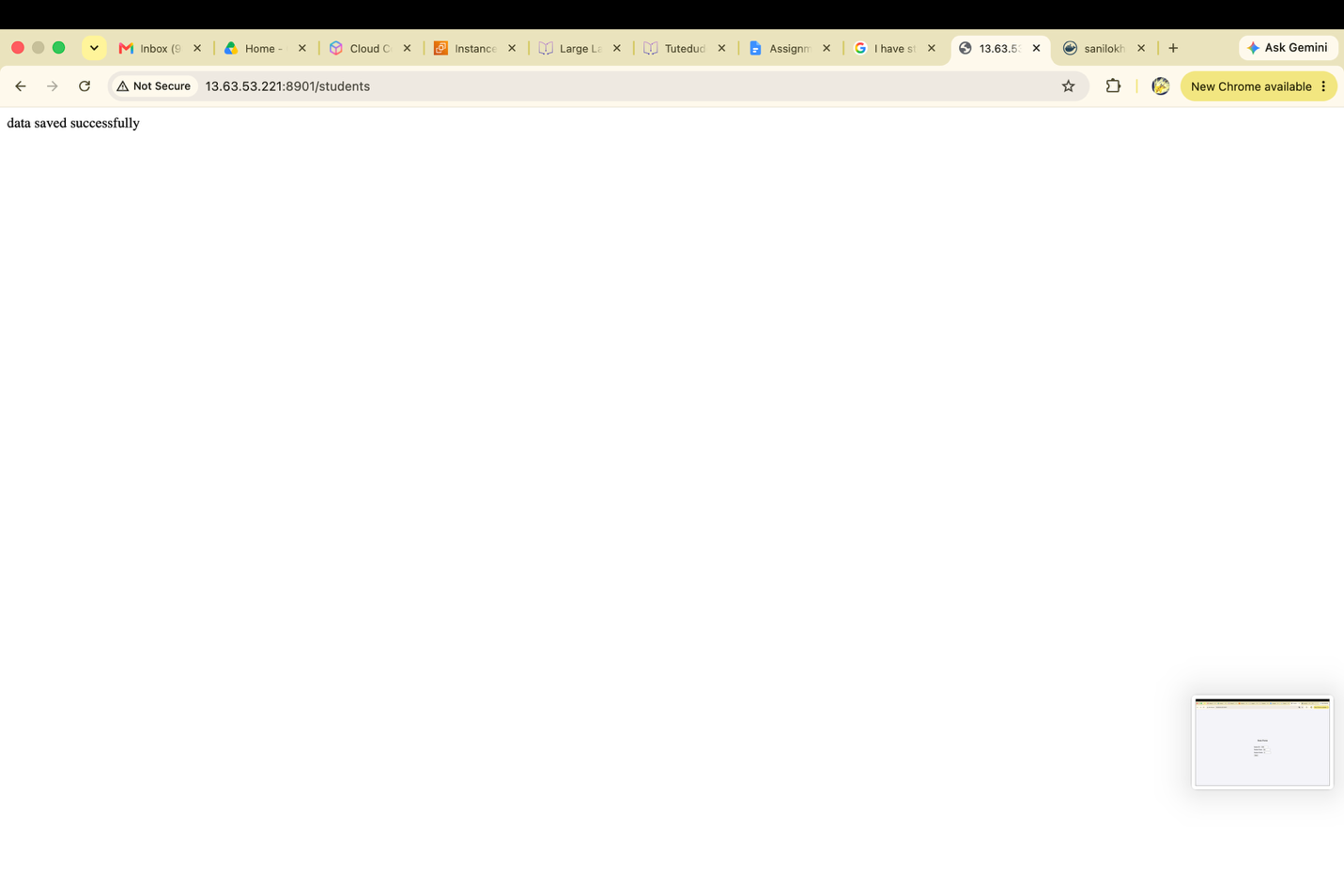

Get data using the backend port 8900

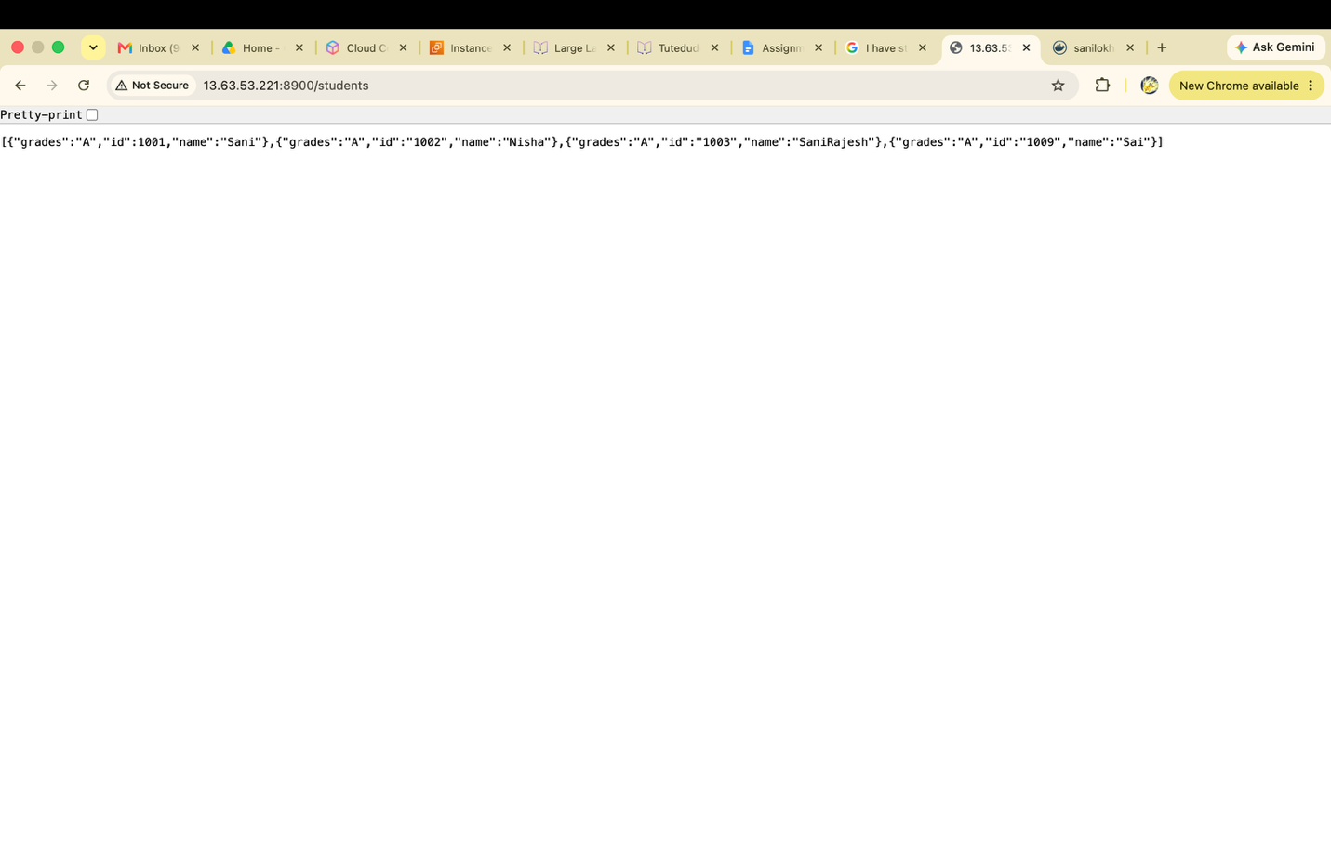

Uploaded both images on Docker hub:
sudo docker tag docker_sani_rajesh_lokhande-frontend sanilokhande/tutedude_student_frontend:latest

used to tag the front end image

sudo docker login -u sanilokhande : used to login to docker hub

sudo docker push sanilokhande/tutedude_student_backend:latest

used to push the image to dockerhub

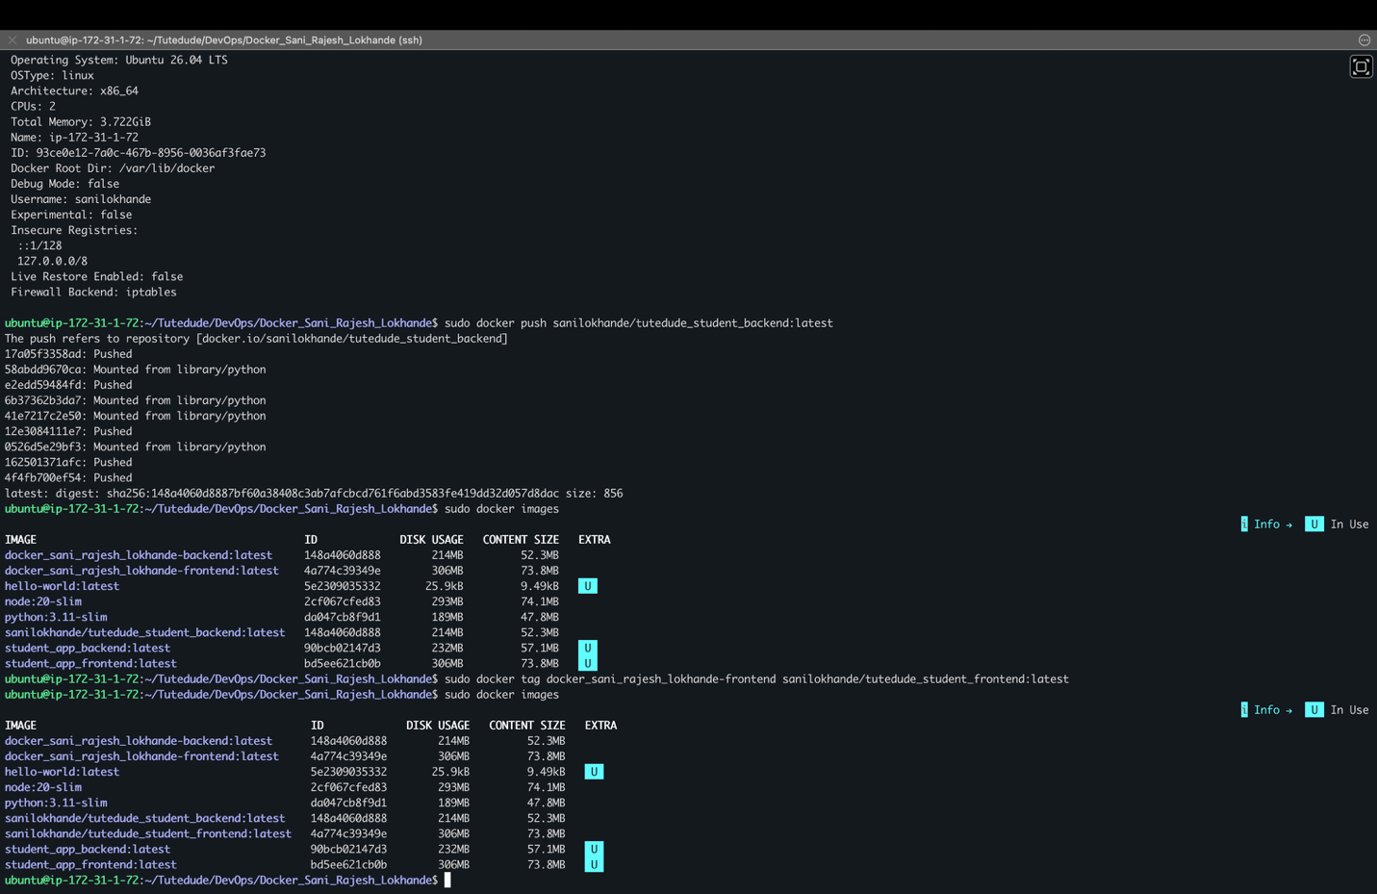

Docker hub repositories:

Frontend location:

https://hub.docker.com/repository/docker/sanilokhande/tutedude_student_frontend/general

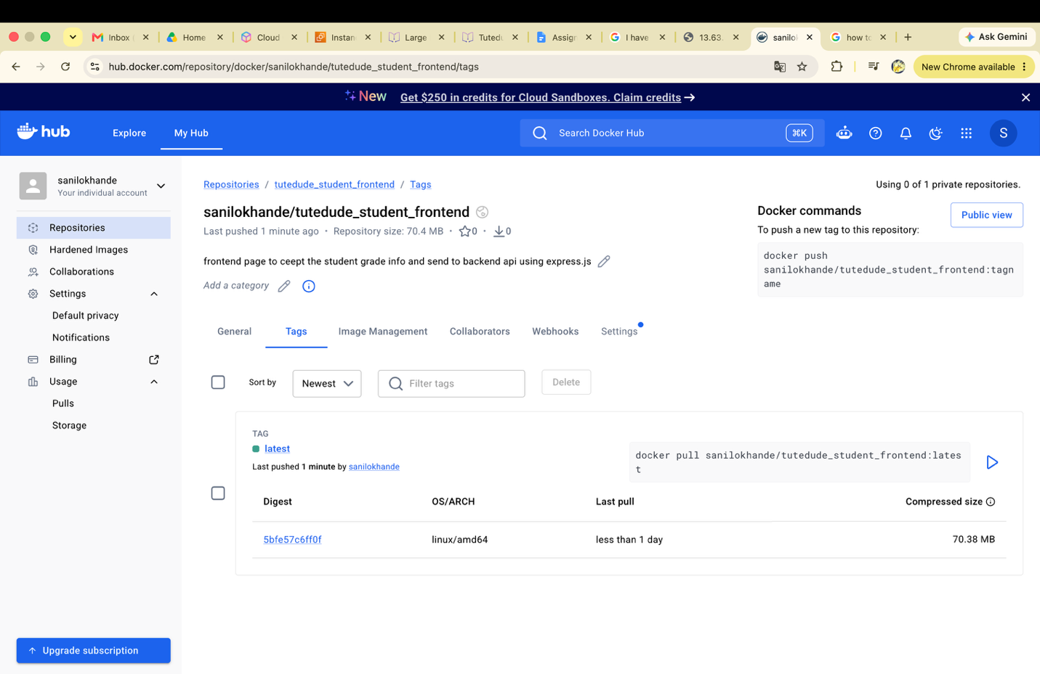

Backend location:
https://hub.docker.com/repository/docker/sanilokhande/tutedude_student_backend/tags

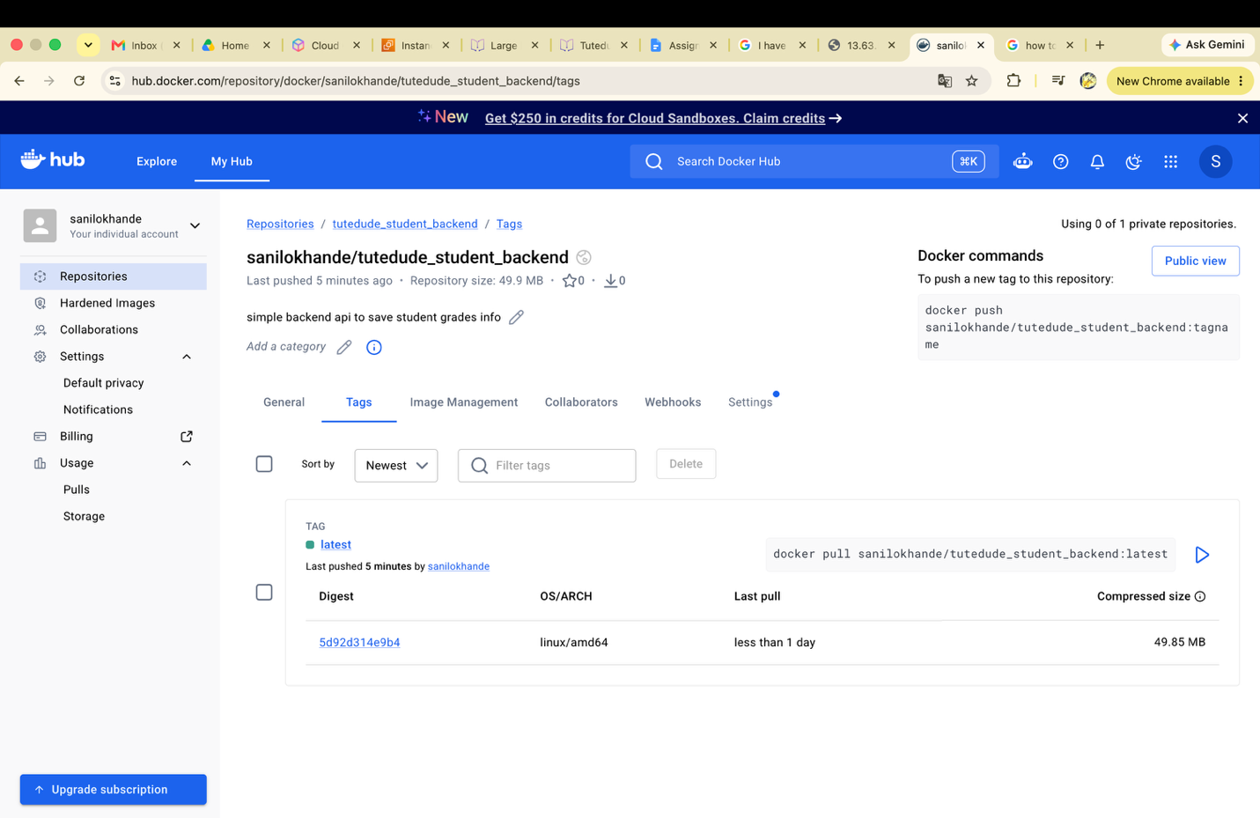

Git hub location :
https://github.com/Sanilkhande06/Tutedude/tree/main/DevOps/Docker_Sani_Rajesh_Lokhande

