1. Creating and Renaming Files/Directories
Create a directory named test_dir using mkdir.
Inside test_dir, create an empty file called example.txt.
Rename example.txt to renamed_example.txt using mv
ANS :
Mkdir : used to create folder/directory
Ls : list files in current directory
Cd : to go into folder
Touch : create the new file
Mv to move the file from source to destinations or rename the file

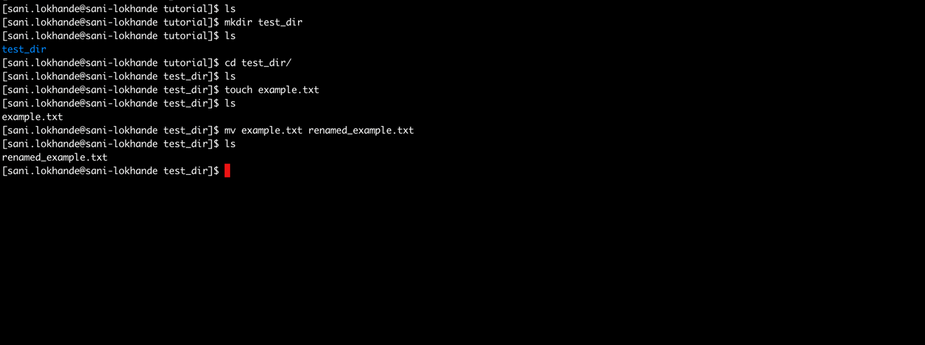

Q2 : Viewing File Contents
Use cat to display the contents of /etc/passwd.
Display only the first 5 lines of /etc/passwd using head.
Display only the last 5 lines of /etc/passwd using tail.

ANS :

Cat to display content of file
Head to display first lines of file : -5 is a number of lines to diplay
Tail : todisplay last lines of file : -n 5 is a number of lines to diplay

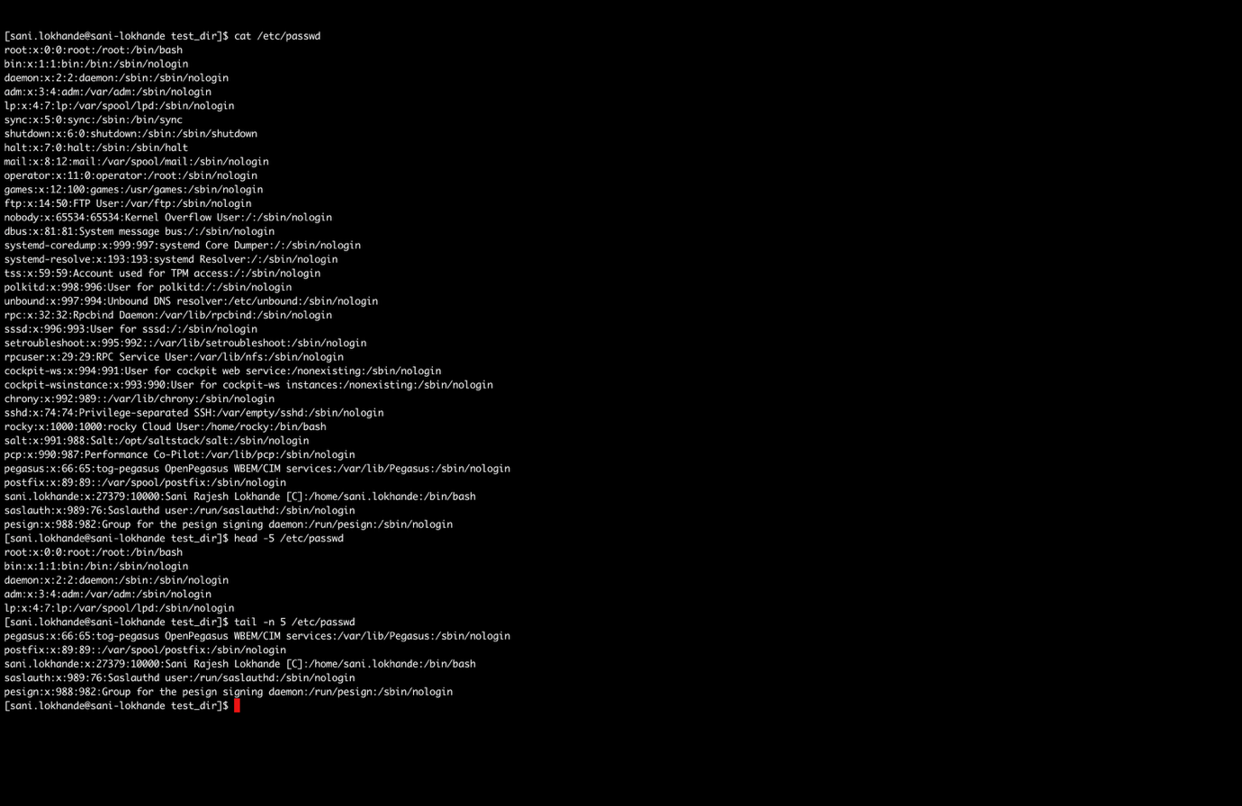

Q3 : Searching for Patterns
Use grep to find all lines containing the word "root" in
/etc/passwd.
ANS :

Grep : is used for pattern matching of file



Q4: Zipping and Unzipping
Compress the test_dir directory into a file named test_dir.zip using zip.
Unzip test_dir.zip into a new directory named unzipped_dir.

ANS :

Zip : to zip the files. -r used for all files present in folder to be zipped

Unzip : to get files from zip file: -d is used to provide destination file path

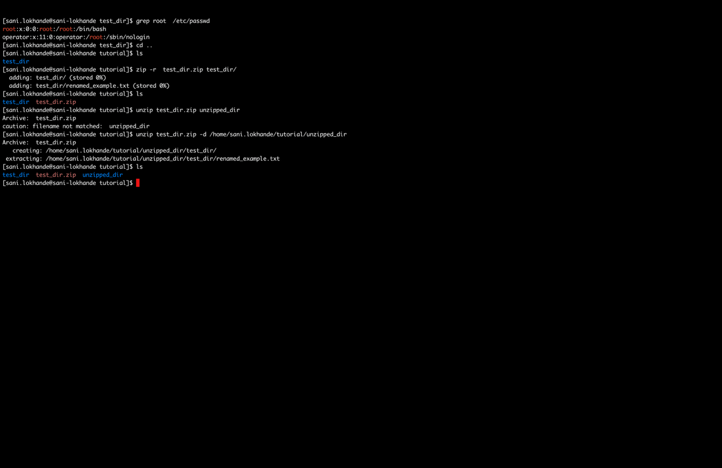

Q5 ; Downloading Files
Use wget to download a file from a URL (e.g., https://example.com/sample.txt).

ANS :
Wget : used to download files from the internet
--content-on-error : this flag is used to save the downloaded file even if the server returns an error code

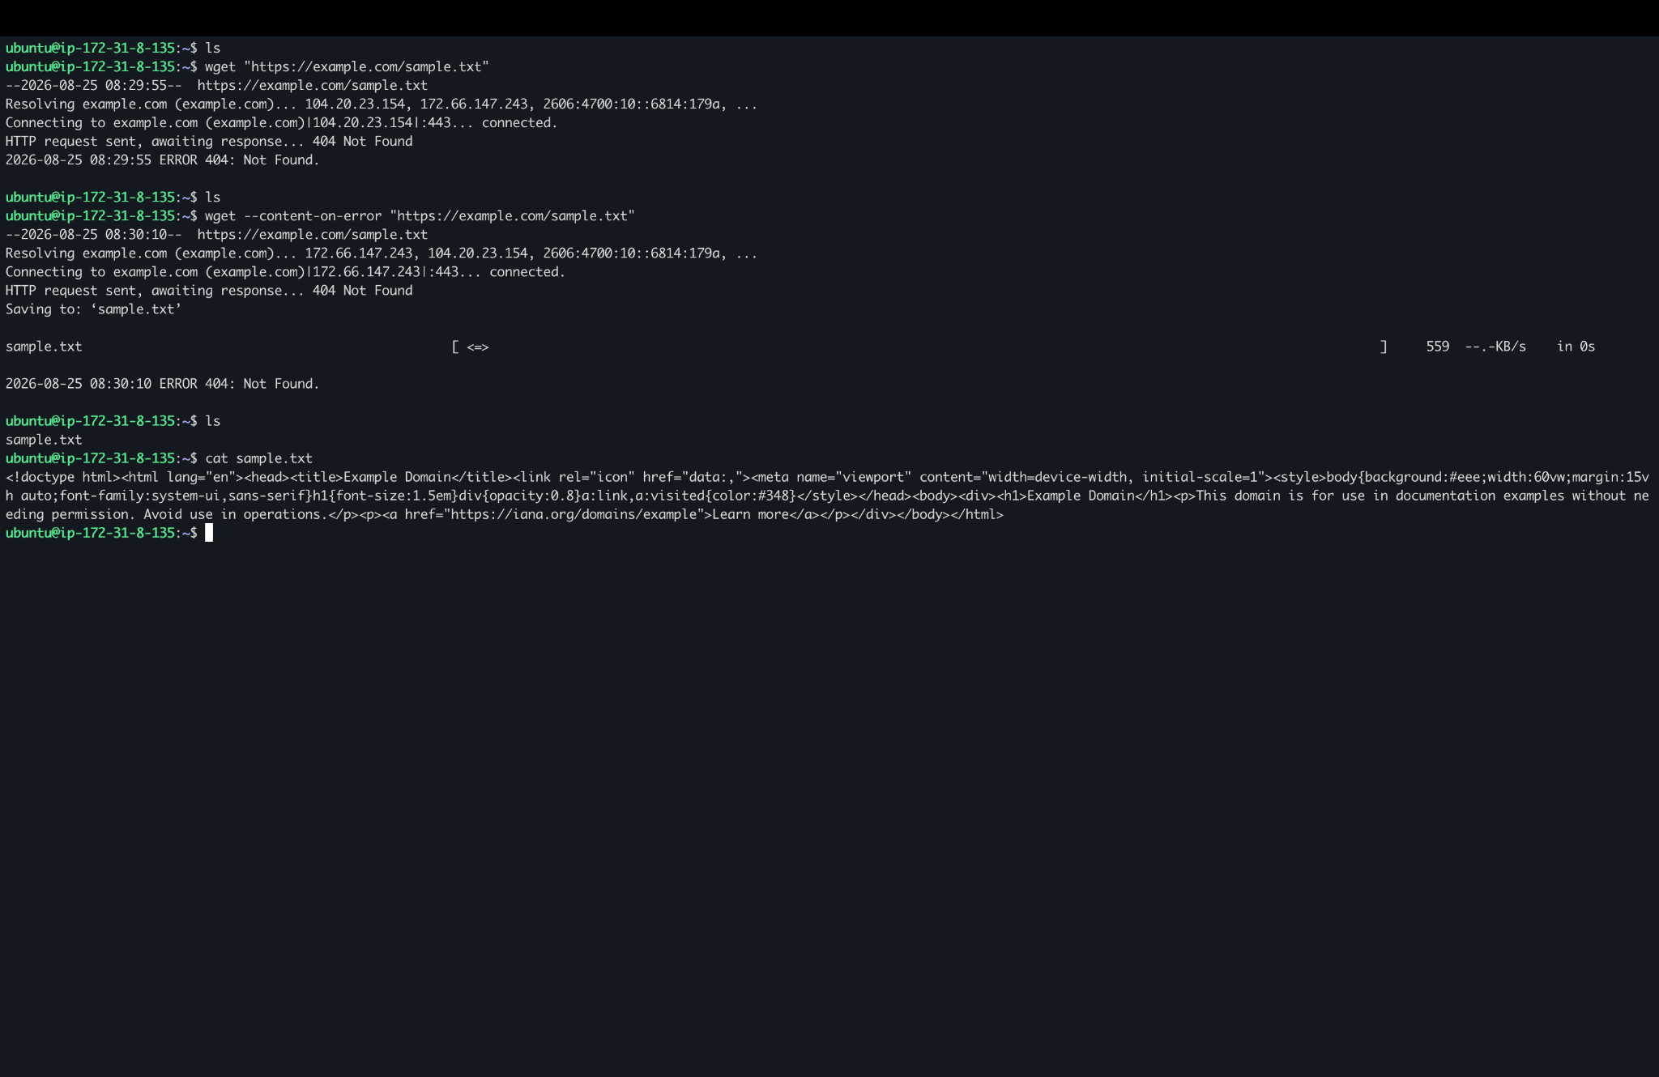

Q6 : Changing Perm
Create a file named secure.txt and change its permissions to read-only for everyone using chmod.

ANS :

Chmod : used to change the file permissions
Ls – al : list the files with file permission
444 is used to give read permissions to all

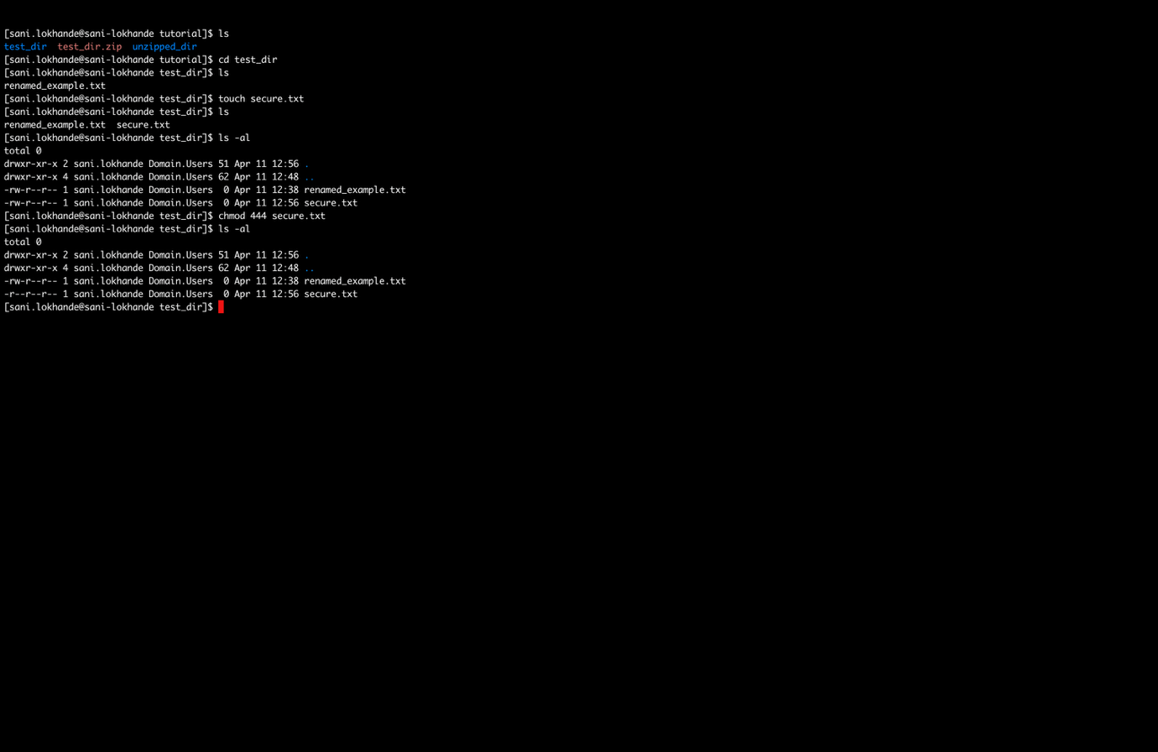

Q7 : Working with Environment Variables
Use export to set a new environment variable called MY_VAR with
the value "Hello, Linux!".

ANS :
Export : is used to set the env variables



