[Date]

Sanim Khadgi

00175034

L5DC

**Retail inventory**

& point of sale system

**Toc**

**TOF**

# **INTRODUCTION**

## Project Introduction

In todays scenario, the world we live in is getting smarter each day. The way we do and precive things have transformed into more practical and easier route. From trading goods as a method for payment to using paper currency and now turning paper currency into digital wallets. To assist todays improving transaction procedure this system will keep track of user payment and will accept both cash and digital payment method from their own devices. The retail shop in this theme accpets inventory, analyzes daily profit and provide a reciept to the customer to validate purchase of a product.

## Justification for Project

### Bacground of the project

The core task of this project is to create a seamless enviroment between customer and retailer. The retailer can preview every purchase history and collect information to compare for future references. The customer are given an invoice of the purchase with valid signatures.

The retail unit will have multiple user. Incase of absence of one employee additional employee can be added and begin the process. The retailer will act as a system admin for the project with top level control. As this project is aimed to be lightwieght and attractive it will be developed using Personal Home Page(PHP).

### Problem Statement

Using paper based journals and ledgers for storing transaction is uncertain. Records will not be properly stored and retrived at a given time period. Flippping through all the transaction of a journal is not the most time effiecient or an effective process. The chances of informatioin being manipulated and stolen is very high. Handing out handwritten invoices can include human errors as well. Identifying which employee performed the transaction is also an issue in case of a fatal error.

To solve these and various other problems in the business my software will assist the organization. It will create a seamless interaction of stock information. A printed out or digital invoice will be generated with each purchase transaction. To store all the information a new database system will be installed in the retail department.

## Description of the project

### Features of the system

The system will elevate the experience of users through these fundamentat elements included in the system.

1. Record invertory details

After a customer purchases an item the time,paid amount, cashier name will be stored in database securely. Incase of returned product or damaged product the item will be replaced after validating records.

1. Paper or digital Invoices

Customers are handed out printed out invoices will all the transaction and a copy of the transaction is store in database for future comparisons.

1. Hirerachical control

Owner can preview employee presence, amount of transaction made in a paticular day with top level control.

1. Self explanatory UI

UI will include skeuomorphic design to the icons help user to interact easily rather than search for particular menu without hints or suggestions.

1. Calculate transaction details per session

All the transaction done by an employee in a session will be logged and calculated then stored in the database.

1. Pay through QR code

Users will be able to scan and pay for their purchases scanning our QR code. It redirects customers to a digital payment gateway.

Overview

# Project Scope

## Scope and Limitaion of the Project

This project is determined to focus on developing a seamless data storing and retriving experience to the involved stakeholders. The internal delivariables of the project include data protection and data efficieny for the retail shop and as for the external delivaribles, the customers will have a hassle free experince paying and finding out details about their transactions. The payment is done either with paper currency or by digital wallet.

However the project has some minor limitations. As the project is server based, failure of certain server hardware can halt the operation. Employees may have issues understanding components from the rapid shift of paper journals and ledgers to digital system.

## Aims and Objectives

Overall my agenda of the project is to transform from the current paper based system to a more modern and efficient system. Creation of a data hirerachy and safe data storage is a must. Shift the payment method into digital methods to decrease chaces of possible losses. Implementing a QR code gateway for payment would be a personal challenge to explore and conquest.

Obejctives of the project are as follow

* Development of a database with hirerachial flow.
* Preview transaction details at a glance.
* Track record with search functionality.
* Construct a skeumorphic UI design.

# Development methodology

## Methodology Used

To develop the program I have preferred Waterfall model. As it is a linear approach to development life cycle. The sequential nature of waterfall model provides checkpoint during the development process. Goals are set between each milestones and are besy suited in condition of having fixed resources with a timline. (Rouse,2019)

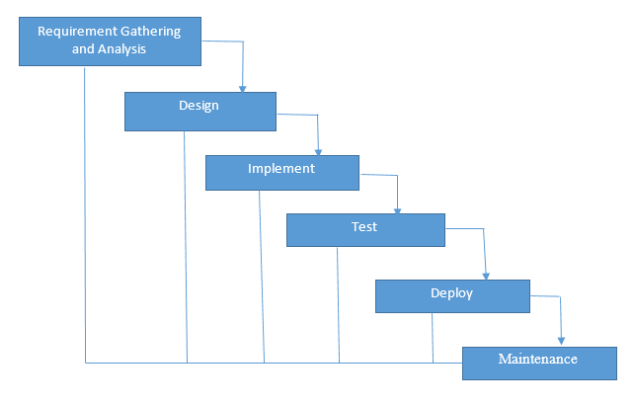

Figure 1Waterfall Model