**IP ADDRESS EXERCISES**

1. The IP addresses of devices and their subnet masks are shown below. Find out which part of the address is network and which part is host.

**Note:**

1. **Network part**: Bits that are 1 in the subnet mask.
2. **Host part**: Bits that are 0 in the subnet mask.
   1. 192.168.6.25, 255.255.0.0

Network part: 192.168

Host part:6.25

* 1. 170.10.0.15, 255.255.255.0

Network part: 170.10.0

Host part:15

* 1. 10.10.10.1, 255.255.255.0

Network part: 10.10.10

Host part:1

1. Which of the computers in the network below can operate with each other?

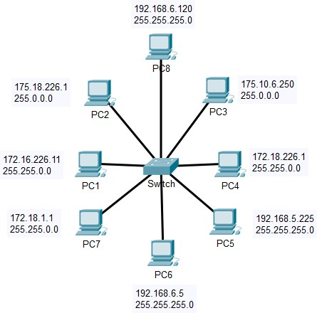

Pc2:

IP address: 175.18.226.1

Subnet mask: 255.0.0.0

Network: 175.0.0.0

Host: 18.226.1

Pc3:

IP address: 175.10.6.250

Subnet mask: 255.0.0.0

Network: 175.0.0.0

Host:10.6.250

PC2 and PC3 both have the same Network ID ,so they can communicate.

Pc4:

IP address: 172.18.226.1

Subnet mask: 255.255.0.0

Network: 172.18.0.0

Host: 1.1

Pc7:

IP address: 172.18.1.1

Subnet mask: 255.255.0.0

Network: 172.18.0.0

Host: 1.1

PC4 and PC7 both have the same Network ID, so they can communicate.

Pc6:

IP address: 192.168.6.5

Subnet mask: 255.255.225.0

Network: 172.168.0.0

Host: 5

Pc8:

IP address: 192.168.6.120

Subnet mask: 255.255.225.0

Network: 192.168.6.0

Host: 120

PC6 and PC8 both have the same Network ID 192.168.6.0, so they can communicate

PC1 wont have the connection with any PC’s.

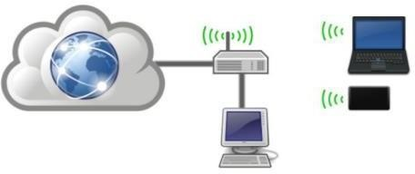

1. The computer, "laptop" and mobile device in the picture are connected to the Internet via the router in the picture. The router's IP address is 172.18.226.1 and the subnet mask is 255.255.255.0.
   1. What should the IP addresses and masks of terminal devices be like in order for Internet access to be possible?

* Each device should have a unique IP address within the same subnet as router. Which means the device should have same network address but different
* The rage for IP address is between 172.18.226.2 to 172.18.226.254
  1. What kind of IP address should be defined as the default gateway for terminal devices
* The router IP (172.18.226.1) address must be unique and be defined as the default gateway for terminal devices.

1. What is the first and last address available for devices on the networks below. Why?
   1. 192.0.0.0 ; 255.255.255.0

First Host Address: 192.0.0.1

Last Host Address:192.0.0.254

* 1. 172.0.0.0 ; 255.255.0.0

First Host Address: 172.0.0.1

Last Host Address:172.0.255.254

* 1. 112.0.0.0 ; 255.0.0.0

First Host Address: 112.0.0.1

Last Host Address:112.255.255.254

* 1. 192.168.0.0 ; 255.255.0.0

First Host Address: 192.168.225.224

Last Host Address:192.168.255.254

1. Find out from your own computer:
   1. Your IP address -192.168.0.121
   2. Gateway IP address - 192.168.0.1
   3. DNS server IP address - 192.168.0.1
   4. DHCP server IP address - 192.168.0.1
   5. Does your computer use a public or private

* IP address My computer use is private IP address

