DAY 06 – TASK 2
Purchase Order Quantity Validation Using Claude Code
Phase 5: Agentic AI & Applications
Project: CAP Node.js Purchase Order Service
Technology: SAP CAP, Node.js, JavaScript, OData V4, SQLite, Claude Code
Repository: Sanishaik/ai-labs
Task Status: Completed

1. Introduction
In Day 06 – Task 2, I worked on adding quantity validation to an existing SAP CAP Node.js Purchase Order Service using Claude Code.
The main purpose of this task was to make sure that purchase order quantities are valid before saving records. I used Claude Code to understand the existing project, analyze the requirements, plan the changes, implement the validation logic, and run automated tests.
I followed the Plan → Approve → Act → Review approach. I reviewed the proposed changes before allowing Claude Code to implement them.
2. Objective
The objective of this task was to implement purchase order quantity validation in the existing CAP service.
The service should reject invalid purchase order data and display clear error messages when the quantity rules are not satisfied.
The main objectives were:
- Prevent negative ordered quantities.
- Prevent negative delivered quantities.
- Ensure delivered quantity does not exceed ordered quantity.
- Preserve existing amount validation.
- Preserve the existing late purchase order calculation.
- Test the implementation without affecting existing functionality.
3. Functional Requirements
The following validation rules were implemented.
3.1 Ordered Quantity Validation
The ordered quantity must not be negative.
Rule:
orderedQty >= 0
Error message:
Ordered quantity must not be negative.
3.2 Delivered Quantity Validation
The delivered quantity must not be negative.
Rule:
deliveredQty >= 0
Error message:
Delivered quantity must not be negative.
3.3 Delivered Quantity Must Not Exceed Ordered Quantity
The delivered quantity must be less than or equal to the ordered quantity.
Rule:
deliveredQty <= orderedQty
Error message:
Delivered quantity must not exceed ordered quantity.
3.4 Existing Amount Validation
The existing amount validation must continue working.
The purchase order amount must be greater than zero.
Rule:
amount > 0
Invalid amounts must be rejected.
3.5 Existing Late Purchase Order Calculation
The existing isLate calculation in the after-READ handler must remain unchanged.
This functionality identifies whether a purchase order is late based on its due date.
4. Implementation Details
I used Claude Code to analyze the existing CAP Purchase Order Service and implement the required quantity validation.
The validation was added to the CREATE event handler in:
day-0/po-service/srv/po-service.js
The implementation checks the quantity values before allowing a new purchase order to be created.
If any validation rule fails, the service rejects the request with an HTTP 400 Bad Request response and an appropriate error message.
The implementation also preserves the existing amount validation and after-READ isLate calculation.
No database schema changes or seed-data changes were required.
5. Files Modified and Created
The following five files were included in the implementation commit.
File | Purpose
CLAUDE.md | Contains project instructions for Claude Code.
package.json | Contains the project configuration and test script.
srv/po-service.js | Contains the purchase order service logic and quantity validation.
test/po-quantity.test.js | Contains automated quantity validation tests.
test/po.http | Contains HTTP requests for testing the service.

Day 06 – Task 2 folder structure
ai-labs/
│
├── day-0/
│ └── po-service/
│ ├── CLAUDE.md
│ ├── package.json
│ ├── package-lock.json
│ ├── db/
│ ├── srv/
│ │ └── po-service.js
│ └── test/
│ ├── po-quantity.test.js
│ └── po.http
│
└── day-06/
└── task-2/
│
├── README.md
├── plan.md
├── spec.md
│
├── files/
│ ├── CLAUDE.md
│ ├── package.json
│ ├── po-service.js
│ ├── po-quantity.test.js
│ └── po.http
│
└── screenshots/
├── Day6_Task2-Claude-Code-Explanation.png
├── Day6-Task2-Quantity-Validation-Code-final.png
├── Day6-Task2-Quantity-Validation-Code.png
├── Day6-Task2-4-Test-Results.png
├── Day6-Task2-3B – Existing Functionality Tests.png
└── Day6-Task2-3A-Quantity-Tests.png

6. Testing and Validation
After implementing the changes, I executed the automated test suite.
I first navigated to the CAP project directory:
cd ~/projects/ai-labs/day-0/po-service/
Then I executed:
npm test
The tests verified the new quantity validation rules and checked that existing functionality continued to work.
6.1 Quantity Validation Tests
The following cases were tested:
- Negative ordered quantity should be rejected.
- Negative delivered quantity should be rejected.
- Delivered quantity greater than ordered quantity should be rejected.
- Valid quantities should be accepted.
6.2 Existing Functionality Tests
I also verified that the existing functionality was not affected.
The tests covered the existing amount validation and the late purchase order calculation.
6.3 Final Test Results
Final automated test results:
- Total tests: 8
- Passed: 8
- Failed: 0
- Exit code: 0
All eight automated tests passed successfully.
Some HTTP 400 and 404 responses appeared in the test logs because the tests intentionally checked invalid requests and verified that rejected purchase orders were not saved. These responses were expected as part of the tests.
7. Screenshots
The following screenshots provide evidence of the implementation and successful testing.
Screenshot 1 – Claude Code Explanation
File: Day6_Task2-Claude-Code-Explanation.png

This screenshot shows Claude Code explaining the existing project and the required quantity validation changes.
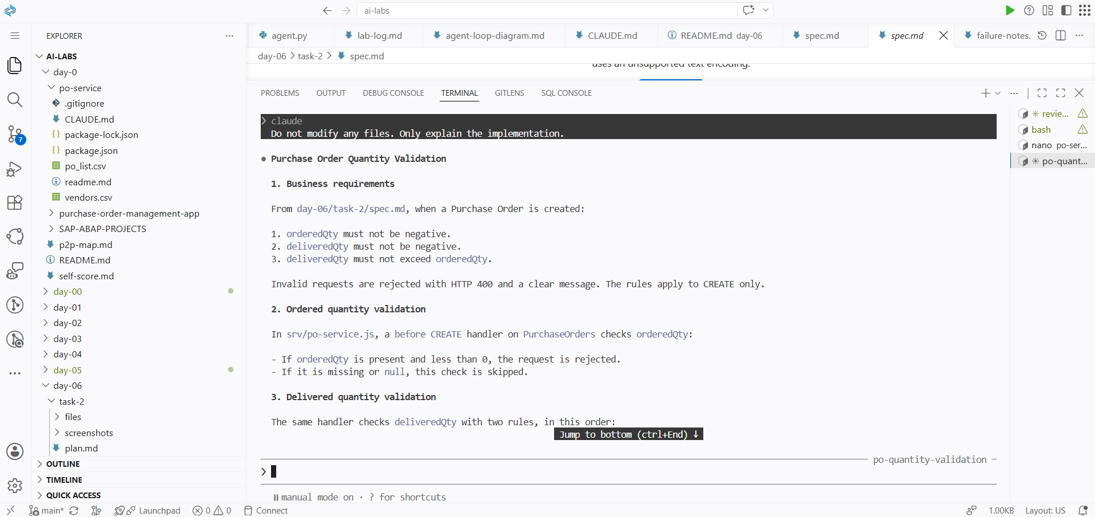
Screenshot 2 – Quantity Validation Code
File: Day6-Task2-Quantity-Validation-Code.png
This screenshot shows the quantity validation implementation in the CAP service.
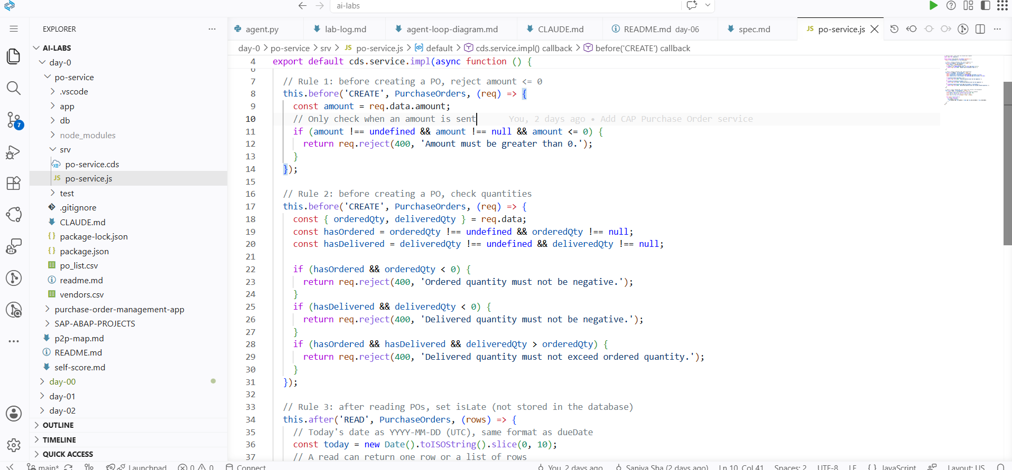
Screenshot 3 – Final Quantity Validation Code
File: Day6-Task2-Quantity-Validation-Code-final.png
This screenshot shows the final version of the updated validation code.
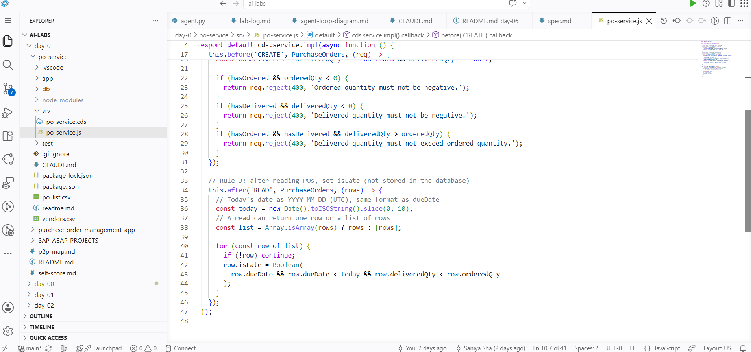
Screenshot 4 – Quantity Validation Tests
File: Day6-Task2-3A-Quantity-Tests.png
This screenshot shows the automated tests for ordered quantity and delivered quantity validation.
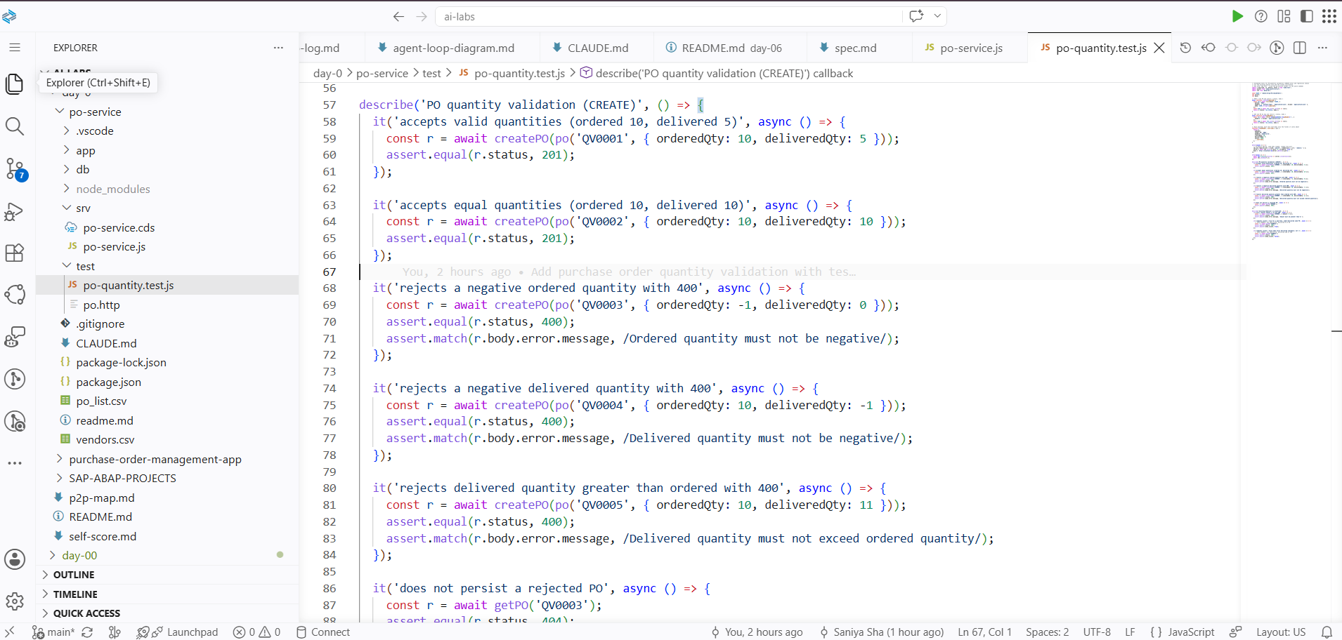
Screenshot 5 – Existing Functionality Tests
File: Day6-Task2-3B – Existing Functionality Tests.png
This screenshot shows the tests used to verify that existing functionality continued to work after the changes.
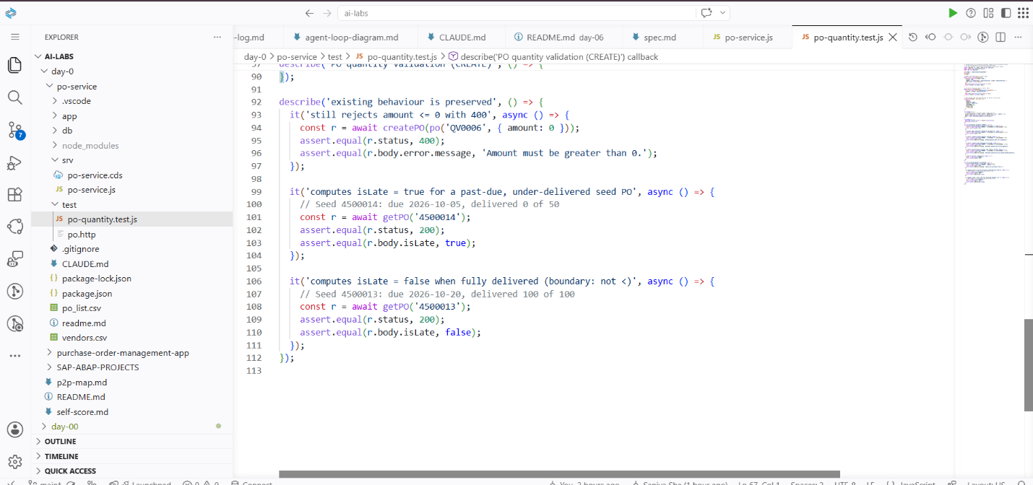
Screenshot 6 – Final Test Results
File: Day6-Task2-4-Test-Results.png
This screenshot shows the final test execution with eight tests passed and zero failures.
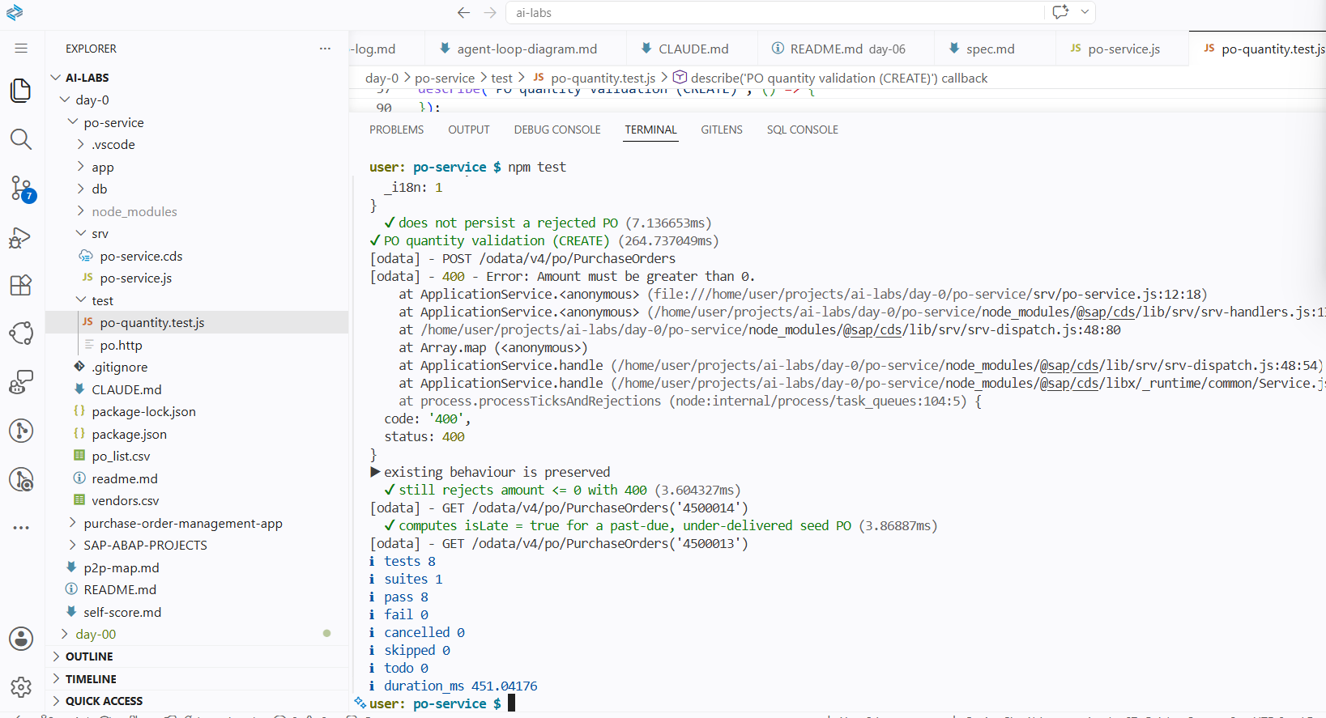
8. Git Commit and Push Details
After completing the implementation and testing, I saved the task files in the GitHub repository.
Implementation Commit
Commit message:
Add purchase order quantity validation with tests
Commit hash:
71cbe30
Task Submission Commit
Commit message:
Add Day 06 Task 2 quantity validation submission
Commit hash:
0f46289
Screenshot Commit
Commit message:
Add Day 06 Task 2 screenshots
Commit hash:
5eb589f
Git Push
Command used:
git push origin main
The push completed successfully.
The local main branch and origin/main were confirmed to be up to date.
The six task screenshots were also added to the repository.
9. Challenges and How I Handled Them
Challenge 1 – Understanding the Existing Code
Initially, I needed to understand how the existing CAP service handled purchase order creation and reading records.
Solution: I used Claude Code to analyze the existing service logic before implementing the changes.
Challenge 2 – Adding Validation Without Breaking Existing Functionality
I needed to add the new quantity checks without changing the existing amount validation or late purchase order calculation.
Solution: I reviewed the proposed changes and tested both new and existing functionality.
Challenge 3 – Running Tests From the Correct Directory
Initially, I executed npm test from the repository root. It returned an ENOENT error because the root directory did not contain a package.json file.
Solution: I navigated to the correct CAP project directory, day-0/po-service, and executed npm test again. The test suite completed successfully.
10. What I Learned
Through this task, I learned:
- How to use Claude Code to understand an existing software project.
- How to analyze requirements before changing code.
- How the Plan → Approve → Act → Review workflow works.
- How to implement validation logic in an SAP CAP Node.js service.
- How to validate ordered and delivered quantities.
- How to return meaningful error messages for invalid requests.
- How to write and execute automated tests using Node.js.
- How to verify that existing functionality is not affected by new changes.
- How to understand test results, including expected error responses.
- How to use Git to commit and push project changes to GitHub.
- Why it is important to execute commands from the correct project directory.
- How AI coding tools can help with development while keeping the developer involved in reviewing and approving changes.
11. Conclusion
Day 06 – Task 2 was completed successfully.
I implemented purchase order quantity validation in the SAP CAP Node.js service using Claude Code. The service now checks ordered quantity, delivered quantity, and the relationship between both values before creating a purchase order.
The existing amount validation and late purchase order calculation were preserved.
All eight automated tests passed successfully, with zero failures. The implementation, task submission files, and screenshots were committed and pushed to GitHub.
This task helped me understand how to use an AI coding agent responsibly for analyzing, modifying, and testing an existing software project.
12. Final Submission Checklist
- Analyzed the existing CAP service.
- Implemented ordered quantity validation.
- Implemented delivered quantity validation.
- Implemented delivered quantity comparison.
- Preserved existing amount validation.
- Preserved existing isLate calculation.
- Created automated quantity validation tests.
- Executed the test suite successfully.
- Verified 8 tests passed and 0 failed.
- Added task submission files.
- Added all six screenshots.
- Committed the changes.
- Pushed the changes to GitHub.
- Verified that local main and origin/main are up to date.
Task Status: COMPLETED
End of Day 06 – Task 2 Report

