DAY 04 – TASK 1: FIRST ANTHROPIC API CALL
Objective: Create an Anthropic Console API key, configure a spending limit, and call Claude Haiku 5.5 using Python.
Technologies Used:
- Python 3.15.2
- Anthropic Python SDK
- Claude Haiku 5.5
- PowerShell
Implementation Steps:
- Created an Anthropic API key in the Training workspace.
- Installed the Anthropic Python SDK.
- Configured the API key using a PowerShell environment variable.
- Created the hello.py Python script.
- Called Claude Haiku 5.5 through the API.
- Displayed Claude's response and input/output token usage.
Execution Proof:
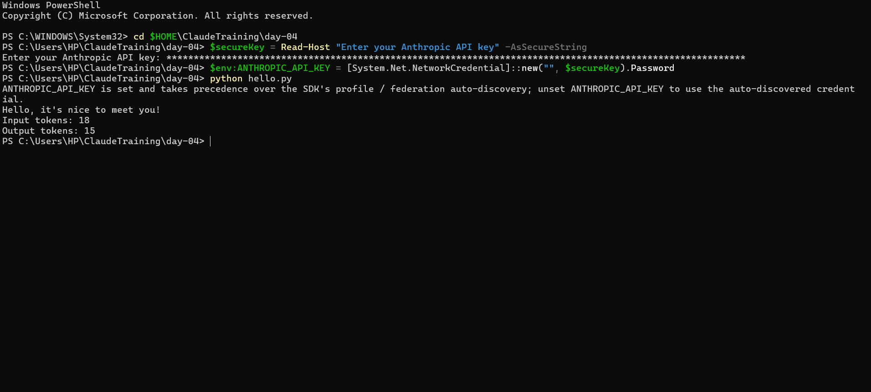
Result: Successfully connected Python to Claude Haiku 5.5 and received a response with token usage details.

