DAY 04 – TASK 2: MINI RAG APPLICATION
Name: Shaik Saniya
Task: Build a Mini Retrieval-Augmented Generation (RAG) Application
Date: 02 November 2026
1. Objective
The objective of this task was to build a simple RAG application using Python and Claude Haiku 5.5. The application reads an HR policy document, divides it into smaller sections, retrieves the most relevant sections based on a user's question, and generates an answer using the retrieved information.
2. Technologies Used
- Python 3.15.2
- Anthropic Python SDK
- Claude Haiku 5.5
- Regular Expressions
- PowerShell
- Notepad
3. What I Learned
- I learned what Retrieval-Augmented Generation (RAG) means and how it works.
- I learned how to read a text file using Python.
- I understood how to split a large document into smaller sections.
- I learned how regular expressions help identify numbered policy sections.
- I understood how keyword matching helps retrieve relevant information.
- I learned how to select the top three relevant sections for a question.
- I learned how to connect Python with the Anthropic API.
- I understood how Claude generates answers using the retrieved policy information.
- I learned how to instruct the AI to answer only from the given policy.
- I learned how to test the application using multiple questions and check the results.
4. Project Files
The following files were created for this task:
File Name | Purpose
hr_policy.txt | Contains the HR policy with 10 numbered sections.
rag.py | Contains the RAG application logic.
tests.py | Contains 10 test questions to validate the application.
README.md | Contains project documentation and execution steps.
5. HR Policy Document
I created an HR policy document with the following 10 sections:
- Casual Leave
- Paternity Leave
- Sick Leave
- Annual Leave
- Work From Home
- Public Holidays
- Leave Approval
- Leave Carry Forward
- Emergency Leave
- Probation Period
6. Implementation Steps
Step 1: Read the HR Policy
I used Python to read the content from the hr_policy.txt file.
Step 2: Split the Policy into Sections
I used regular expressions to identify the numbered headings and divide the policy into separate sections.
Step 3: Retrieve Relevant Sections
I created a retrieval function that compares the keywords in the user's question with the policy sections and selects up to three relevant sections.
Step 4: Generate the Answer
I sent the retrieved policy sections and the user's question to Claude Haiku 5.5 using the Anthropic API.
Step 5: Display the Answer
Claude generates an answer based on the retrieved policy information and mentions the relevant section number. If the information is unavailable, the application returns "Not in policy."
7. Screenshots – Implementation
Screenshot 1: HR Policy Document
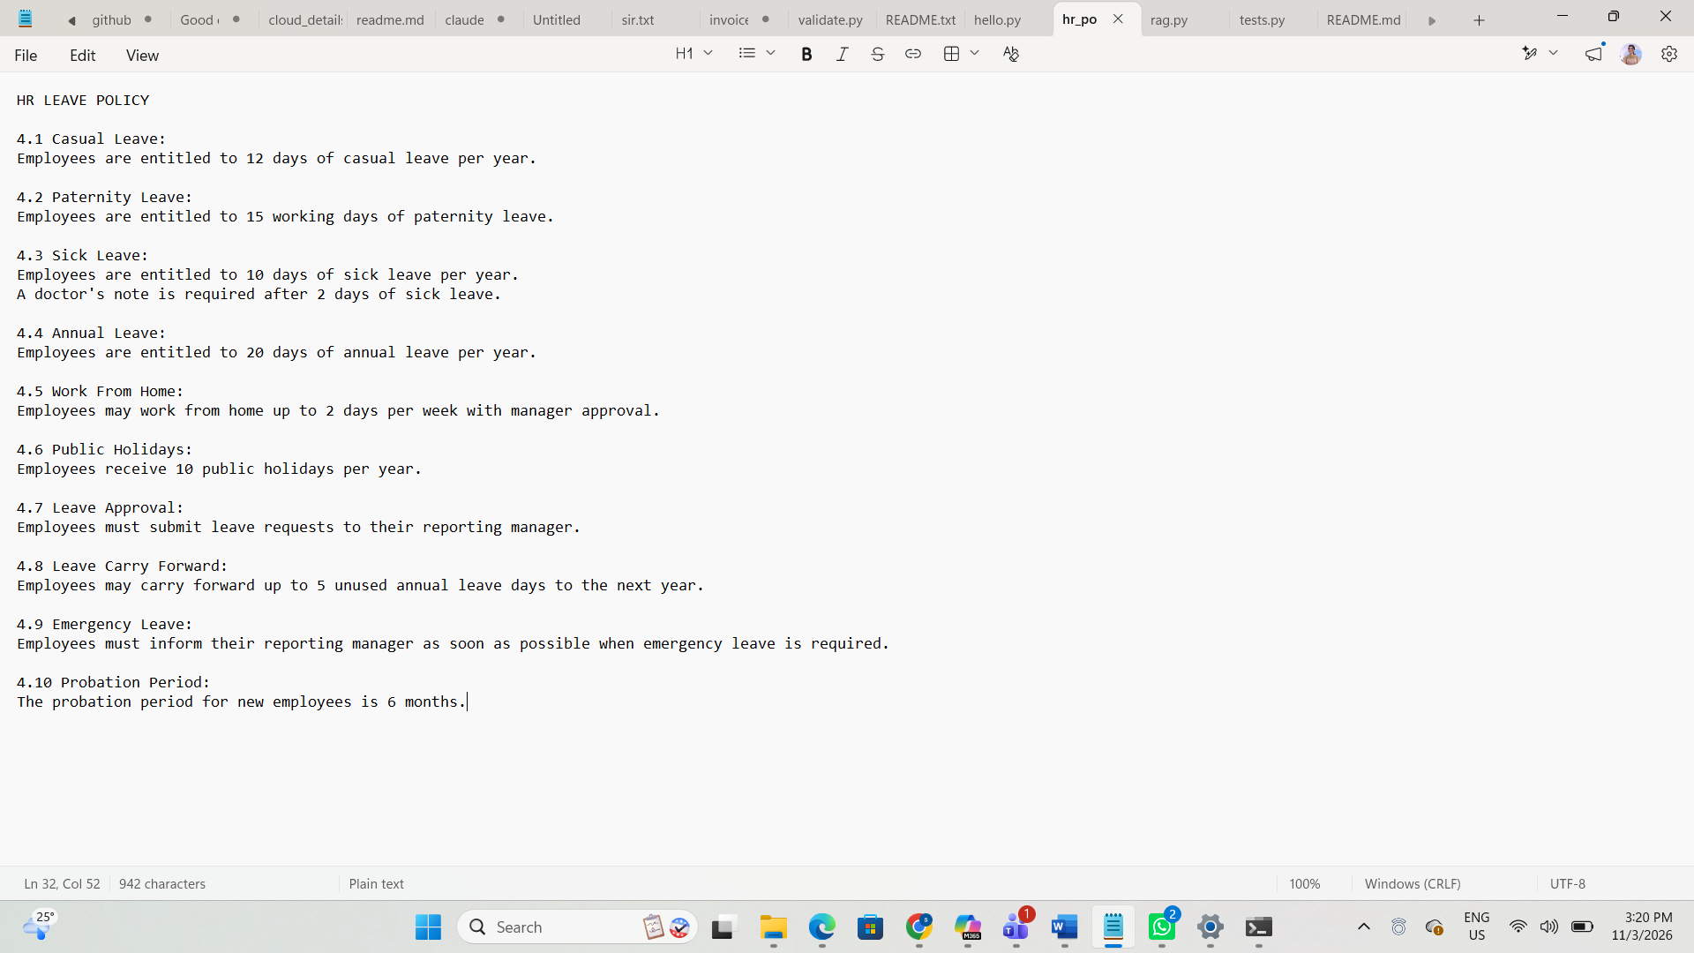
Screenshot 2: RAG Python Code
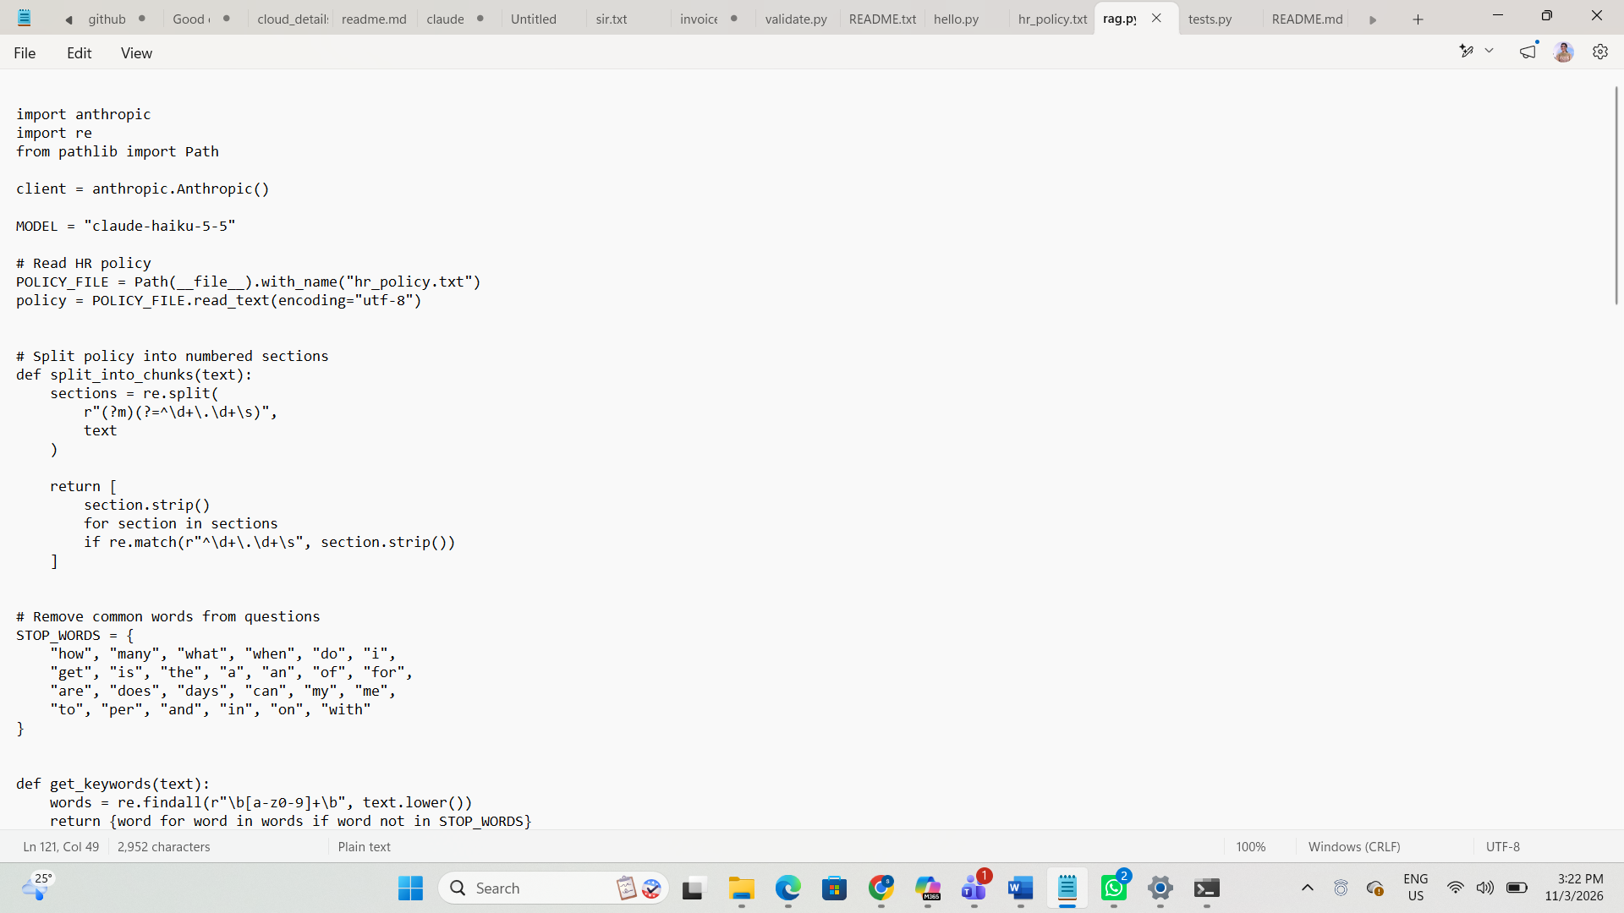

import anthropic
import re
from pathlib import Path
client = anthropic.Anthropic()
MODEL = "claude-haiku-5-5"
# Read HR policy
POLICY_FILE = Path(__file__).with_name("hr_policy.txt")
policy = POLICY_FILE.read_text(encoding="utf-8")
# Split policy into numbered sections
def split_into_chunks(text):
sections = re.split(
r"(?m)(?=^\d+\.\d+\s)",
text
)

return [
section.strip()
for section in sections
if re.match(r"^\d+\.\d+\s", section.strip())
]
# Remove common words from questions
STOP_WORDS = {
"how", "many", "what", "when", "do", "i",
"get", "is", "the", "a", "an", "of", "for",
"are", "does", "days", "can", "my", "me",
"to", "per", "and", "in", "on", "with"
}
def get_keywords(text):
words = re.findall(r"\b[a-z0-9]+\b", text.lower())
return {word for word in words if word not in STOP_WORDS}
# Retrieve the top 3 relevant policy sections
def retrieve(question, chunks):
question_words = get_keywords(question)
scored_chunks = []
for chunk in chunks:
chunk_words = get_keywords(chunk)
score = len(question_words.intersection(chunk_words))
if score > 0:
scored_chunks.append((score, chunk))

scored_chunks.sort(
key=lambda item: item[0],
reverse=True
)
return [
chunk
for score, chunk in scored_chunks[:3]
]
# Ask Claude using retrieved policy sections
def ask(question, chunks):
if not chunks:
return "Not in policy."
context = "\n\n".join(chunks)
system_prompt = """
You are an HR policy question-answering assistant.
Follow these rules:
1. Answer only using the supplied policy sections.
2. Do not use outside knowledge.
3. Do not guess or invent information.
4. Mention the correct policy section number.
5. If the answer is not available in the supplied sections,
reply exactly: Not in policy.
6. Keep the answer short and clear.
"""
msg = client.messages.create(
model=MODEL,
max_tokens=300,
system=system_prompt,
messages=[
{
"role": "user",
"content": (
f"POLICY SECTIONS:\n{context}\n\n"
f"QUESTION: {question}"
)
}
]
)
for block in msg.content:
if block.type == "text":
return block.text
return "No text response received from Claude."
# Run the Mini RAG application
if __name__ == "__main__":
chunks = split_into_chunks(policy)
print("HR POLICY - MINI RAG ASSISTANT")
print("Sections loaded:", len(chunks))
question = input("\nEnter your HR policy question: ")
relevant_chunks = retrieve(question, chunks)
print("\nRetrieved sections:")
for chunk in relevant_chunks:
print(chunk)
answer = ask(question, relevant_chunks)
print("\nClaude's Answer:")
print(answer)
Screenshot 3: RAG Application Execution
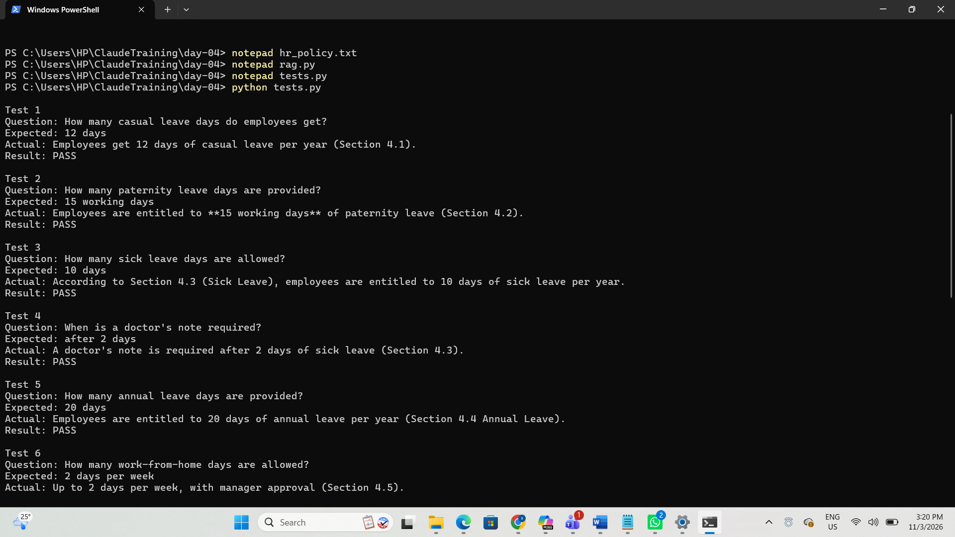
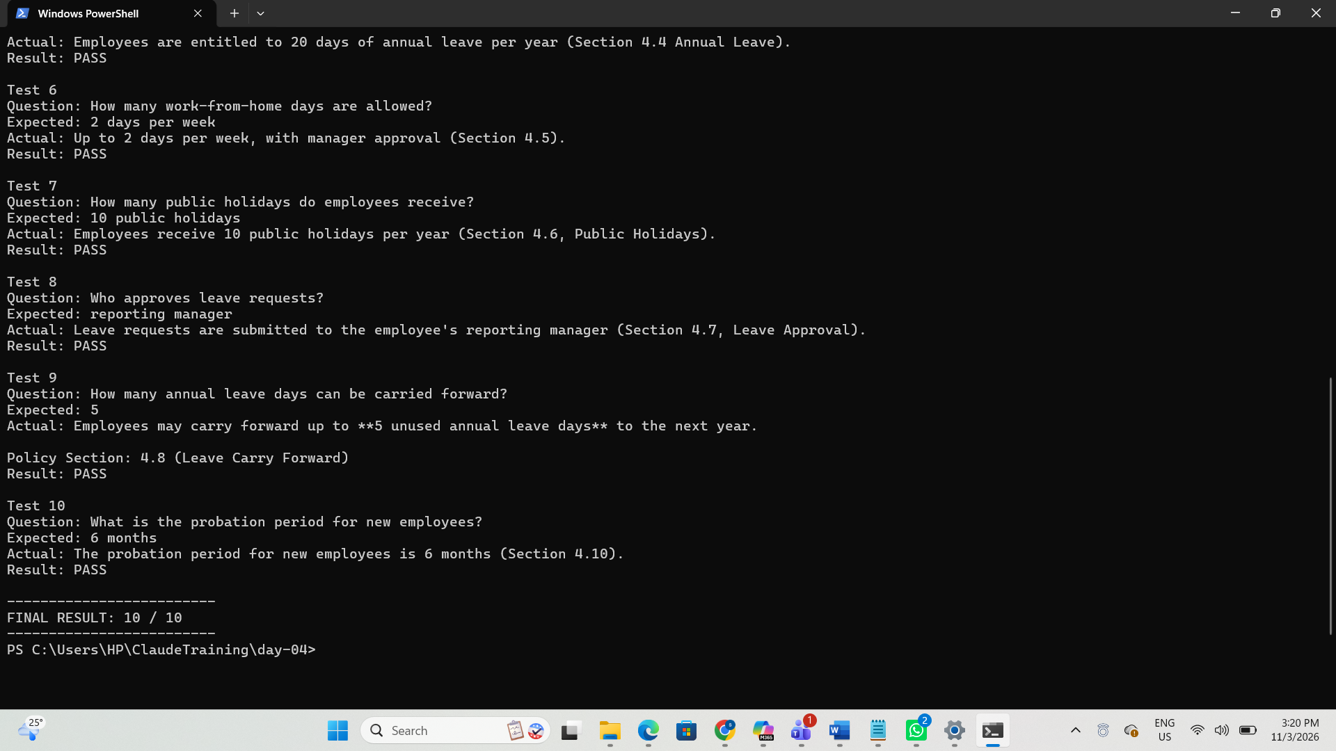
8. Testing and Validation
I created a separate tests.py file to check the application using 10 test questions.
The test cases cover:
- Casual Leave
- Paternity Leave
- Sick Leave
- Doctor's Note Requirement
- Annual Leave
- Work From Home
- Public Holidays
- Leave Approval
- Leave Carry Forward
- Probation Period
The test script compares the actual answers with the expected answers and checks whether the correct policy section number is included.
Screenshot 4: Test Execution
[Attach screenshot of PowerShell running python tests.py and showing the final result.]
Expected Test Result:
FINAL RESULT: 10 / 10
Update this result after running the tests and confirming that all 10 cases pass.
9. What I Understood
Through this task, I understood how RAG connects document retrieval with AI-generated answers. Instead of asking Claude to answer from general knowledge, the application first retrieves relevant information from the HR policy document and provides that information as context.
I also understood the importance of testing the application with different questions to check whether it gives correct answers.
10. Conclusion
I successfully developed a Mini RAG application using Python and Claude Haiku 5.5. I learned how to read a document, split it into sections, retrieve relevant information, connect with an AI API, and generate answers using the retrieved content. I also created test cases to validate the application.

