DAY 05 – TASK 1: TOOLS AS FUNCTIONS
Training Program: Resoftwa – Future-Ready Tech Training Program
Phase: Phase 5 – Agentic AI & Apps
Task: Tools as Functions
Technologies: Python 3 and JSON

1. Objective
The main aim of this task was to use the Purchase Order data from Day 0 and work with it using Python.
I exported my Purchase Order data into a JSON file and created four Python functions to perform different operations, such as checking open purchase orders, getting PO details, creating vendor email drafts, and simulating the email approval process.
Through this task, I wanted to understand how Python functions can be used as tools by an AI agent to perform business-related tasks.
2. Technologies Used
- Python 3: To write and execute the functions.
- JSON: To store and read Purchase Order data.
- SAP Business Application Studio (BAS): To create files and run the Python program.
- GitHub: To maintain the project files.
3. Project Folder Structure
I created a day-05 folder inside my ai-labs project.
The folder contains the following files:
File Name | Purpose
pos.json | Stores the Purchase Order data from Day 0.
tools.py | Contains the four Python tool functions.
task-1-test-results.md | Records the manual testing results.
screenshots/ | Stores screenshots of implementation and testing.
4. Implementation
First, I used the Purchase Order data that I had prepared during Day 0 and saved it in a JSON file named pos.json.
The file contains 8 Purchase Order records with details such as PO number, vendor ID, vendor name, due date, ordered quantity, delivered quantity, amount, and late status.
After preparing the JSON file, I created tools.py and implemented four Python functions.
Tool 1: list_open_pos()
I created this function to display all purchase orders that are still pending.
It checks the ordered quantity against the delivered quantity. If the delivered quantity is less than the ordered quantity, the purchase order is considered open.
Condition used:
deliveredQty < orderedQty
Result: Retrieved 6 open purchase orders out of 8 total records.
Tool 2: get_po_status(po_number)
This function helps me check the details of a particular purchase order by entering its PO number.
I also added a calculation to find how many items are still pending for delivery.
Calculation:
pendingQty = orderedQty - deliveredQty
Test performed: PO Number 4500012.
Result: Ordered quantity was 100, delivered quantity was 60, and pending quantity was 40.
Tool 3: draft_email(vendor, text)
I created this function to prepare an email message for a vendor.
It accepts the vendor name and message as input. It then generates a unique draft ID and temporarily stores the email draft.
Test performed: Created an email draft for Sharma Steels.
Result: The email draft was created successfully with a unique draft ID.
Tool 4: send_email(draft_id)
This function checks an email draft using its draft ID and simulates the sending process.
For safety, I kept human approval as a requirement before sending an email. The current function does not send any actual email.
Result: The status was displayed as "Pending human approval". No actual email was sent.
5. JSON Data – pos.json
I created the pos.json file to store the 8 Purchase Order records from my Day 0 project.
The data includes the vendor information, delivery details, PO amount, and late status.
File Name: pos.json
Complete file content:
[
{
"poNumber": "4500012",
"vendor_ID": "V001",
"vendorName": "Sharma Steels",
"dueDate": "2026-10-10",
"orderedQty": 100,
"deliveredQty": 60,
"amount": 450000.00,
"isLate": true
},
{
"poNumber": "4500013",
"vendor_ID": "V002",
"vendorName": "Vizag Paints",
"dueDate": "2026-10-20",
"orderedQty": 100,
"deliveredQty": 100,
"amount": 320000.00,
"isLate": false
},
{
"poNumber": "4500014",
"vendor_ID": "V003",
"vendorName": "Guntur Cables",
"dueDate": "2026-10-05",
"orderedQty": 50,
"deliveredQty": 0,
"amount": 175000.00,
"isLate": true
},
{
"poNumber": "4500015",
"vendor_ID": "V002",
"vendorName": "Vizag Paints",
"dueDate": "2026-09-15",
"orderedQty": 80,
"deliveredQty": 20,
"amount": 240000.00,
"isLate": true
},
{
"poNumber": "4500016",
"vendor_ID": "V004",
"vendorName": "New Vendor Co",
"dueDate": "2026-10-28",
"orderedQty": 25,
"deliveredQty": 0,
"amount": 62500.00,
"isLate": true
},
{
"poNumber": "4500017",
"vendor_ID": "V001",
"vendorName": "Sharma Steels",
"dueDate": "2026-12-01",
"orderedQty": 120,
"deliveredQty": 0,
"amount": 980000.00,
"isLate": false
},
{
"poNumber": "4500018",
"vendor_ID": "V003",
"vendorName": "Guntur Cables",
"dueDate": "2026-11-20",
"orderedQty": 75,
"deliveredQty": 30,
"amount": 412500.00,
"isLate": false
},
{
"poNumber": "4500019",
"vendor_ID": "V001",
"vendorName": "Sharma Steels",
"dueDate": "2026-09-30",
"orderedQty": 50,
"deliveredQty": 50,
"amount": 150000.00,
"isLate": false
}
]
6. Python Implementation – tools.py
After creating the JSON file, I created tools.py to read the PO data and perform the required operations.
The file contains four functions:
- list_open_pos()
- get_po_status(po_number)
- draft_email(vendor, text)
- send_email(draft_id)
I also added a manual testing section at the bottom of the Python file to execute and check all four functions.
File Name: tools.py
Complete file content:
import json
from pathlib import Path
from uuid import uuid4
# File containing the purchase order data
PO_FILE = Path(__file__).with_name("pos.json")
# Temporary storage for email drafts
DRAFTS = {}
# Tool 1: List open purchase orders
def list_open_pos():
with open(PO_FILE, "r", encoding="utf-8") as file:
pos = json.load(file)
open_pos = [
po for po in pos
if po["deliveredQty"] < po["orderedQty"]
]
return open_pos
# Tool 2: Get purchase order status
def get_po_status(po_number):
with open(PO_FILE, "r", encoding="utf-8") as file:
pos = json.load(file)
for po in pos:
if po["poNumber"] == str(po_number):
return {
**po,
"pendingQty": po["orderedQty"] - po["deliveredQty"]
}
return {"error": "Purchase order not found"}

# Tool 3: Draft an email
def draft_email(vendor, text):
draft_id = str(uuid4())
draft = {
"draft_id": draft_id,
"vendor": vendor,
"message": text,
"status": "Draft"
}
DRAFTS[draft_id] = draft
return draft
# Tool 4: Send email (safe simulation)
def send_email(draft_id):
if draft_id not in DRAFTS:
return {"error": "Draft not found"}
return {
"draft_id": draft_id,
"status": "Pending human approval",
"message": "Email not sent. Human approval required."
}
# Manual testing of all four tools
if __name__ == "__main__":
print("\nTEST 1: List Open Purchase Orders")
open_pos = list_open_pos()
print("Open POs:", len(open_pos))
print(json.dumps(open_pos, indent=2))
print("\nTEST 2: Get Purchase Order Status")
status = get_po_status("4500012")
print(json.dumps(status, indent=2))
print("\nTEST 3: Draft Email")
draft = draft_email(
"Sharma Steels",
"Please update the delivery status of PO 4500012."
)
print(json.dumps(draft, indent=2))
print("\nTEST 4: Send Email")
result = send_email(draft["draft_id"])
print(json.dumps(result, indent=2))
7. Testing and Execution
After completing the JSON and Python files, I ran the program in the BAS terminal to check whether all four functions were working correctly.
Command used:
cd ~/projects/ai-labs/day-05/
python tools.py
I tested each function through the manual testing section in the Python program.
Test Results
Test Case | Actual Result | Status
List Open POs | Retrieved 6 open purchase orders. | PASS
Get PO Status | Retrieved PO 4500012 with 40 pending items. | PASS
Draft Email | Created an email draft for Sharma Steels. | PASS
Send Email | Displayed pending human approval. No email was sent. | PASS
Purchase Order Summary
After checking my PO data, I got the following results:
Description | Count
Total Purchase Orders | 8
Open Purchase Orders | 6
Completed Purchase Orders | 2
Late Purchase Orders | 4
Note: The late PO count is based on the date 04 November 2026 used for the JSON data.
8. Key Learning Outcomes
While working on this task, I learned:
- How to store and manage business data using JSON files.
- How to read JSON files using Python.
- How to create and call reusable Python functions.
- How to filter purchase orders based on delivery status.
- How to retrieve a particular PO using its PO number.
- How to calculate pending quantities using Python.
- How to create vendor email drafts dynamically.
- How to generate and use unique IDs for email drafts.
- How to simulate an action without actually sending an email.
- Why human approval is important before performing external actions.
- How Python functions can be used as tools by an AI agent.
9. Practical Experience
In this task, I worked with the same Purchase Order data that I had prepared during Day 0.
I created four Python functions and tested them using the BAS terminal. I was able to retrieve open POs, check individual PO details, create an email draft, and check the approval status.
Initially, I faced a file-not-found error because the JSON filename had an extra dot at the end. I corrected the filename and executed the program again. After that, all four tests ran successfully.
This experience helped me understand how to connect business data with Python functions and use them to perform simple business operations.
10. What I Learned
Before doing this task, I knew how to work with basic Python code, but I had not used Python functions as tools for business operations.
By completing this exercise, I understood that each function can perform a specific task. For example, one function can retrieve purchase orders, another can check their status, and another can prepare a vendor email.
I also learned that an AI agent can use these functions as tools to interact with business data instead of doing everything manually.
Most importantly, I understood that actions such as sending emails should have proper human approval before they are performed.
My Key Takeaway: I learned how to create and test Python functions that can help an AI agent perform simple Purchase Order-related tasks.
11. Conclusion
I successfully completed Day 5 – Task 1: Tools as Functions.
I created the JSON file using my Day 0 PO data, implemented all four Python functions, and tested them through the BAS terminal. All four tests passed successfully.
This task gave me practical experience with Python tool development, JSON data handling, business workflow automation, and the basic idea of how tools are used in agentic AI applications.
12. Screenshots / Evidence
I have captured screenshots of the files created and the execution results as proof of my work.
1)Shows the list of open purchase orders.
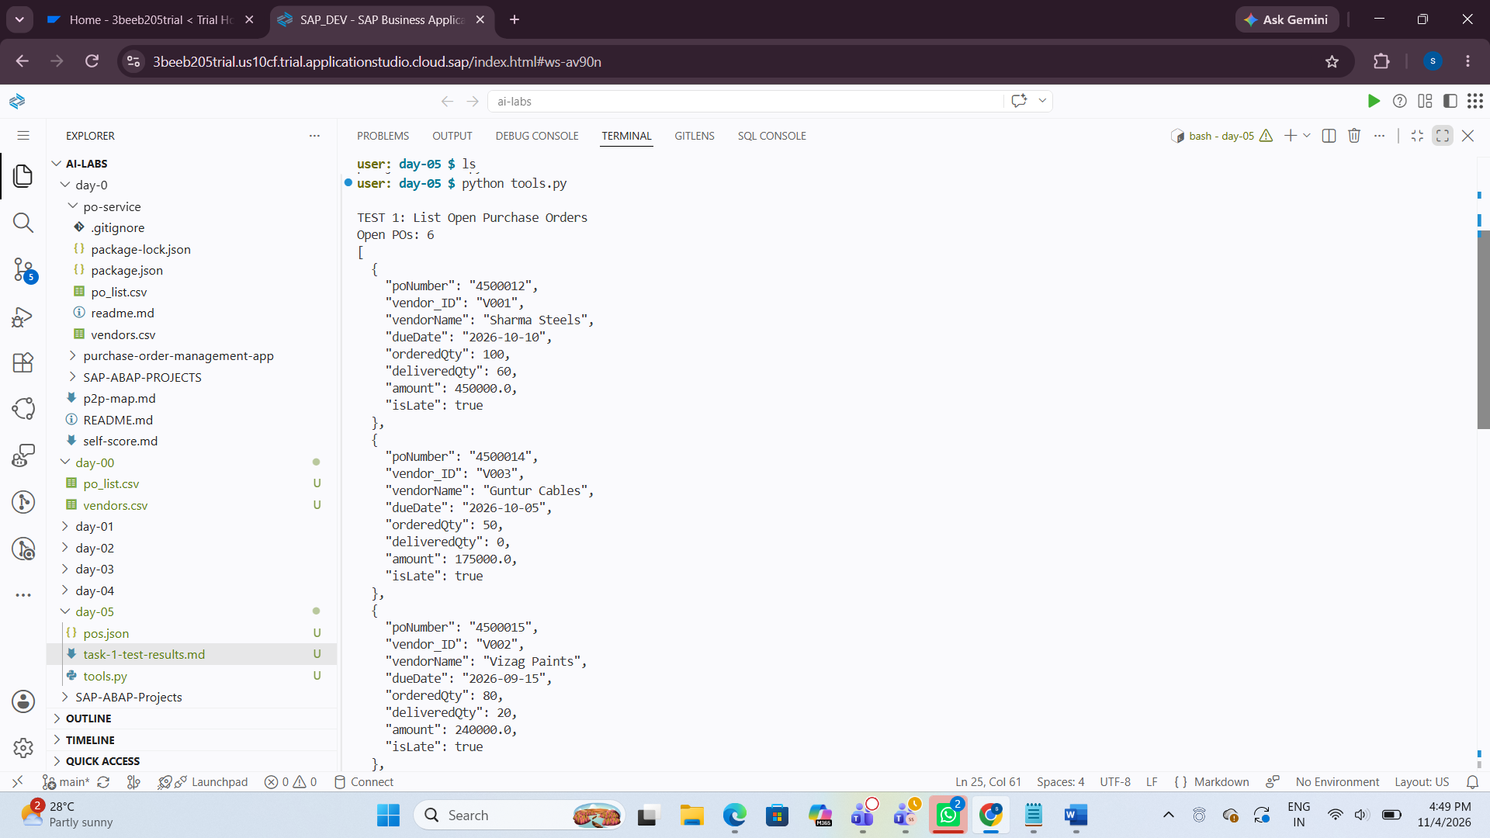
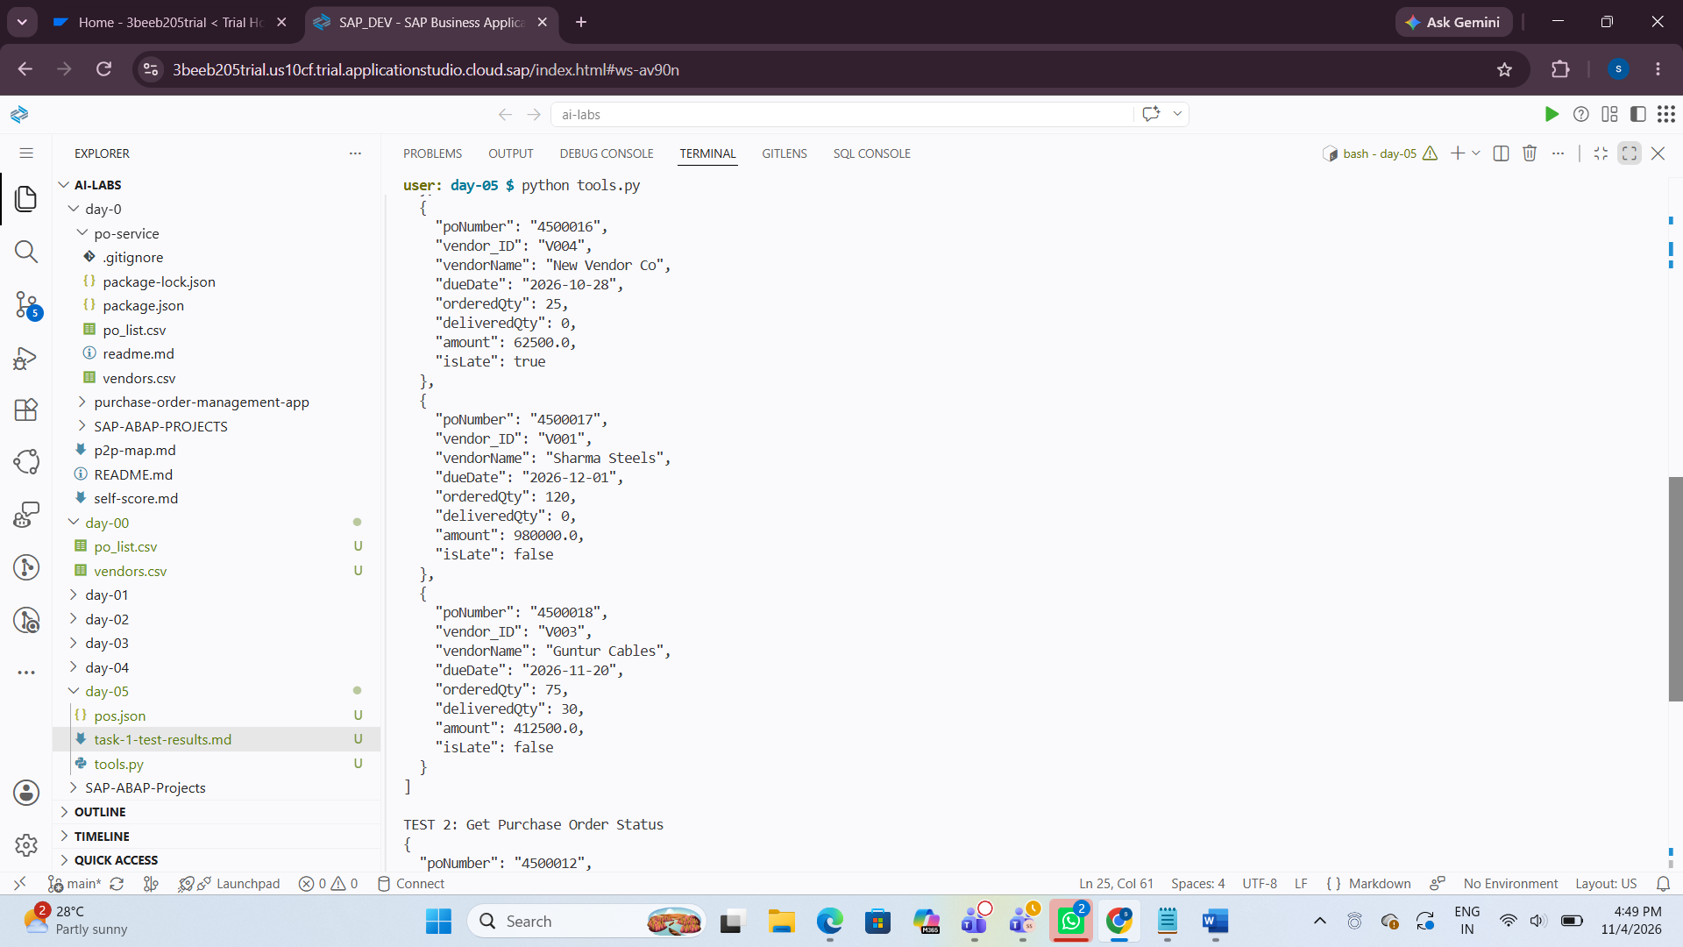
2)the below Pic Shows the status of PO 4500012 and its pending quantity.
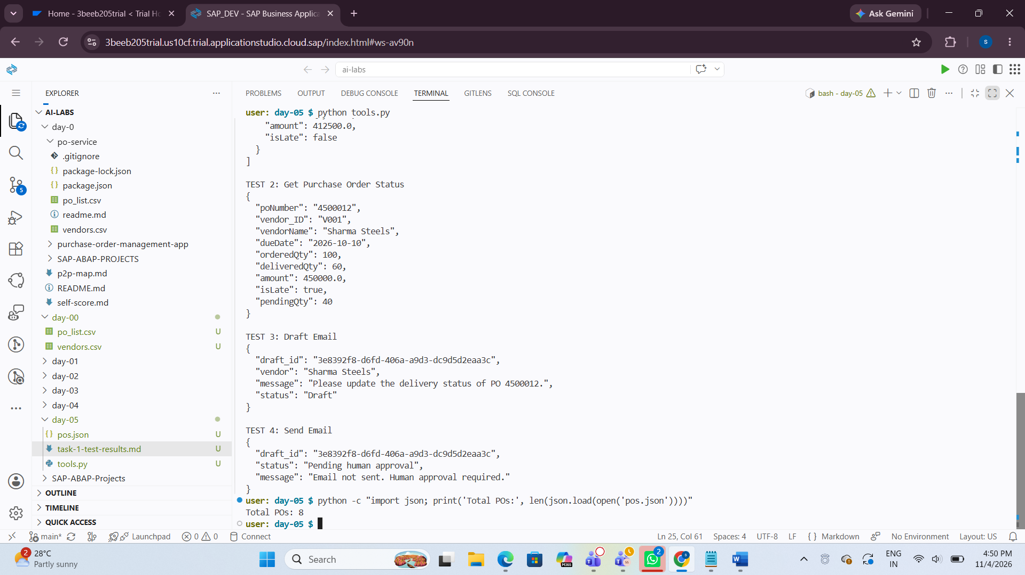
3. Shows the successfully created vendor email draft.
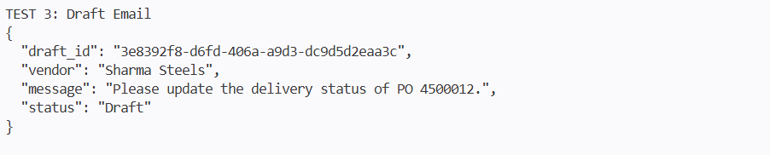
4. Shows the human approval requirement before sending an email.
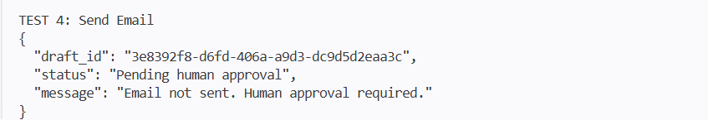

Task Status: COMPLETED
Resoftwa – Future-Ready Tech Training Program Phase 5 – Agentic AI & Apps | Day 5 | Task 1

