DAY 06 – TASK 1
Claude Code: Project Analysis, Plan Mode and Risk Identification
Name: Shaik Saniya
Training: Resoftwa – Future-Ready Tech Training Program
Task: Repeat the class activity on Phase 1 ABAP code using /init, Plan Mode, code explanation and risk identification.
1. Objective
The objective of this task was to understand how Claude Code analyzes an existing project, explains its code structure, identifies possible risks and creates project instructions using the /init command.
I completed this activity on two existing projects:
- Phase 1 – SAP ABAP Project
- CAP – Purchase Order Service Project
2. Project 1 – Phase 1 SAP ABAP Project
Project location:
~/projects/ai-labs/SAP-ABAP-Projects
Main ABAP file:
ZPO_OPEN_LIST.abap
Step 1: Opened the project
I opened the Phase 1 SAP ABAP project in the terminal using Claude Code.
Step 2: Executed /init
I ran the /init command in Claude Code.
Claude analyzed the project files and generated a CLAUDE.md file. This file provides project-specific instructions and explains the project structure, code flow and important points to consider before making changes.
Generated file:
SAP-ABAP-Projects/CLAUDE.md
Step 3: Used Plan Mode
I switched Claude Code to Plan Mode using Shift + Tab.
I asked Claude to explain the existing ABAP program, describe its execution flow and identify possible risks without modifying the code.
Claude analyzed the ZPO_OPEN_LIST.abap program. No code changes were made.
3. Explanation of the ABAP Program
The project contains an ABAP report that displays purchase order header and item details using an ALV grid.
The program uses three main SAP tables:
Table | Purpose
EKKO | Purchase order header information
EKPO | Purchase order item information
LFA1 | Vendor information
Main program flow:
- The user enters selection criteria such as purchase order number, vendor, date and plant.
- The START-OF-SELECTION event creates the report object.
- The get_data method retrieves purchase order information.
- The program joins EKKO, EKPO and LFA1 tables.
- The retrieved data is stored in an internal table.
- If records are available, the program displays them using CL_SALV_TABLE.
- If no records are found, an appropriate message is displayed.
4. Risks Identified by Claude
Claude identified the following possible issues in the ABAP program.
No. | Risk | Explanation
1 | Program name mismatch | The file name is ZPO_OPEN_LIST.abap, but the REPORT statement uses ZSS_PO_OPEN_LIST.
2 | Missing text symbol | The selection screen uses text-001, which must be maintained in the text elements.
3 | Incorrect open PO description | The program does not have filters to identify only open purchase orders.
4 | Performance issue | Reading large amounts of purchase order data may affect performance.
5 | Authorization check | The program does not contain an authorization check.
6 | Error handling | The SALV error is handled with an error message, which should be reviewed.
7 | Documentation mismatch | The README mentions MAKT, but the program does not join the MAKT table.
5. Recommendations
Claude suggested the following improvements:
- Correct the program name mismatch.
- Clearly define what qualifies as an open purchase order.
- Add suitable authorization checks.
- Improve performance by restricting unnecessary data retrieval.
- Maintain the required text symbols.
- Improve ALV column headings and display settings.
- Update the README documentation.
6. Project 2 – CAP Purchase Order Service
Project location:
~/projects/ai-labs/day-0/po-service
This project is a CAP Node.js application for managing purchase orders and vendor information.
Main project files:
File | Purpose
db/schema.cds | Defines the data model and entities.
srv/po-service.cds | Defines the OData service.
srv/po-service.js | Contains service event handlers and business logic.
db/data/resoftwa.po-Vendors.csv | Contains vendor sample data.
db/data/resoftwa.po-PurchaseOrders.csv | Contains purchase order sample data.
test/po.http | Contains HTTP requests for testing.
package.json | Contains project dependencies and scripts.
readme.md | Contains project documentation.
7. Executed /init in the CAP Project
I opened the CAP PO Service project in Claude Code and executed /init.
Claude analyzed the project structure and generated another CLAUDE.md file.
Generated file:
day-0/po-service/CLAUDE.md
The generated file describes:
- Project architecture and folder structure.
- Data model and service definitions.
- Purchase order and vendor entities.
- Business logic in the JavaScript handler.
- Commands to install dependencies and run the application.
- Important project-specific observations and possible issues.
8. Important CAP Project Observations
Claude identified some important points:
- The application checks the purchase order amount during CREATE. Amounts less than or equal to zero are rejected.
- The isLate field is calculated during READ.
- The isLate field is virtual, so it cannot be used directly in database filtering with $filter.
- The root-level po_list.csv and vendors.csv files are not automatically loaded as CAP seed data from their current location.
- The README contains an example using $filter=isLate eq true, which needs to be reviewed because isLate is virtual.
9. Files Created for This Task
Two project instruction files were generated.
No. | File name | Project
1 | CLAUDE.md | Phase 1 SAP ABAP Project
2 | CLAUDE.md | CAP PO Service Project
File locations:
ai-labs/
│
├── SAP-ABAP-Projects/
│ └── CLAUDE.md
│
└── day-0/
└── po-service/
└── CLAUDE.md
10. GitHub Submission
Both CLAUDE.md files were committed and pushed successfully to the GitHub repository.
Repository: https://github.com/Sanishaik/ai-labs
Branch: main
The following commits were pushed:
- Add CLAUDE.md for Phase 1 SAP ABAP project
- Add CLAUDE.md for CAP PO service project
The push was successful.
11. Screenshots to Paste
Paste your actual screenshots in the following places in this document.
Screenshot 1 – Phase 1 ABAP Project
This screenshot showing the Phase 1 SAP ABAP project opened in Claude Code.
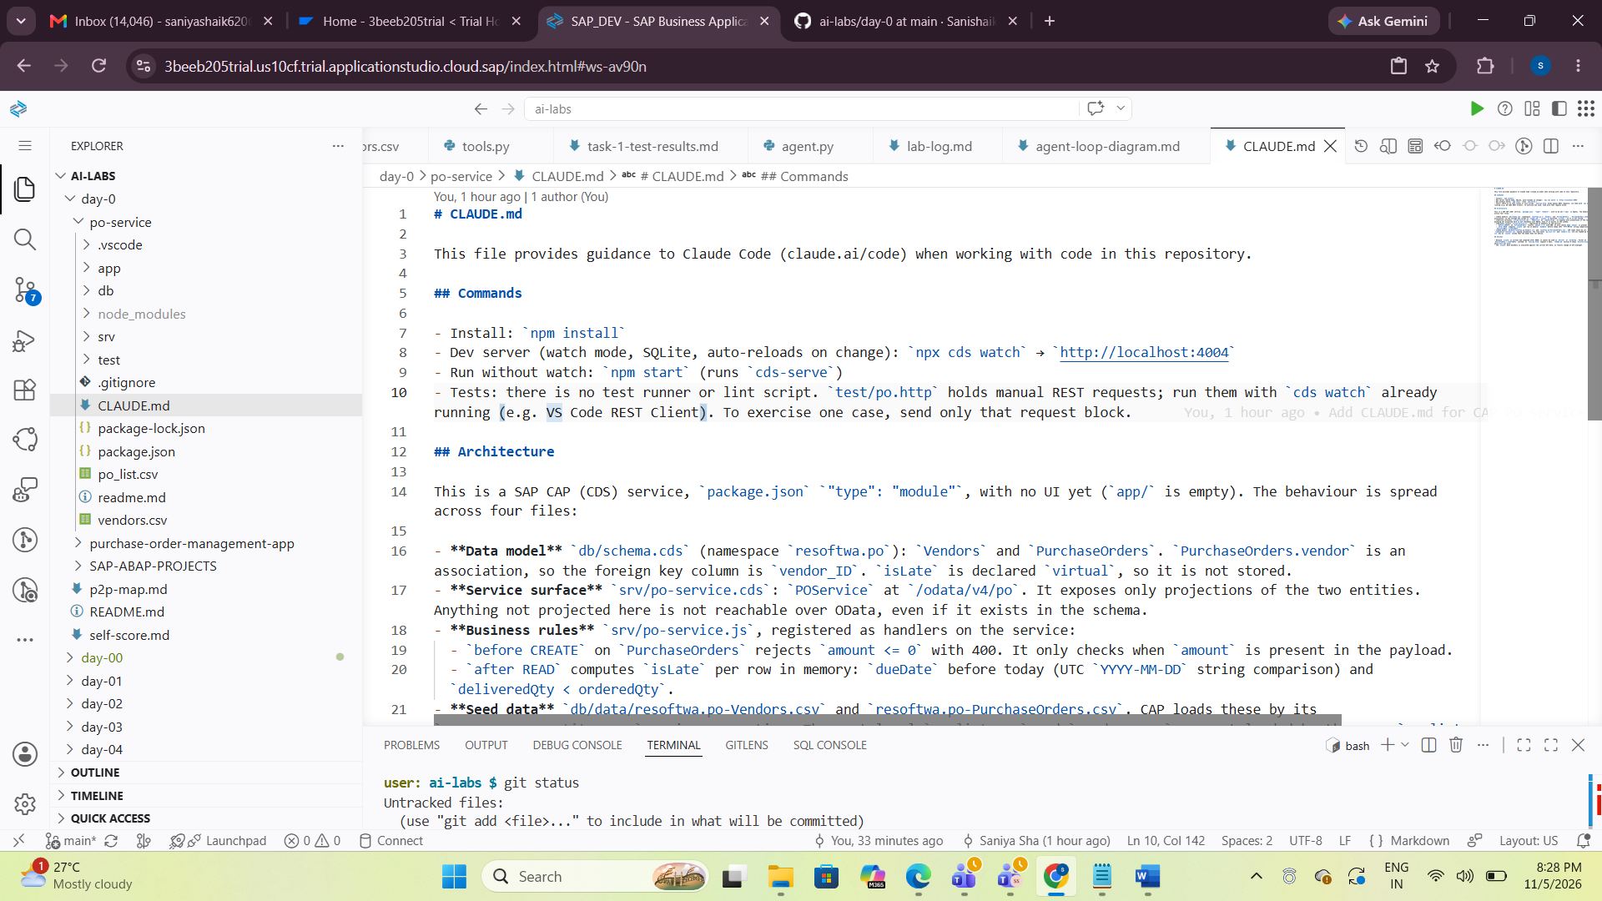Screenshot 2 – /init Execution
This screenshot showing successful /init execution and generation of the ABAP project's CLAUDE.md file.

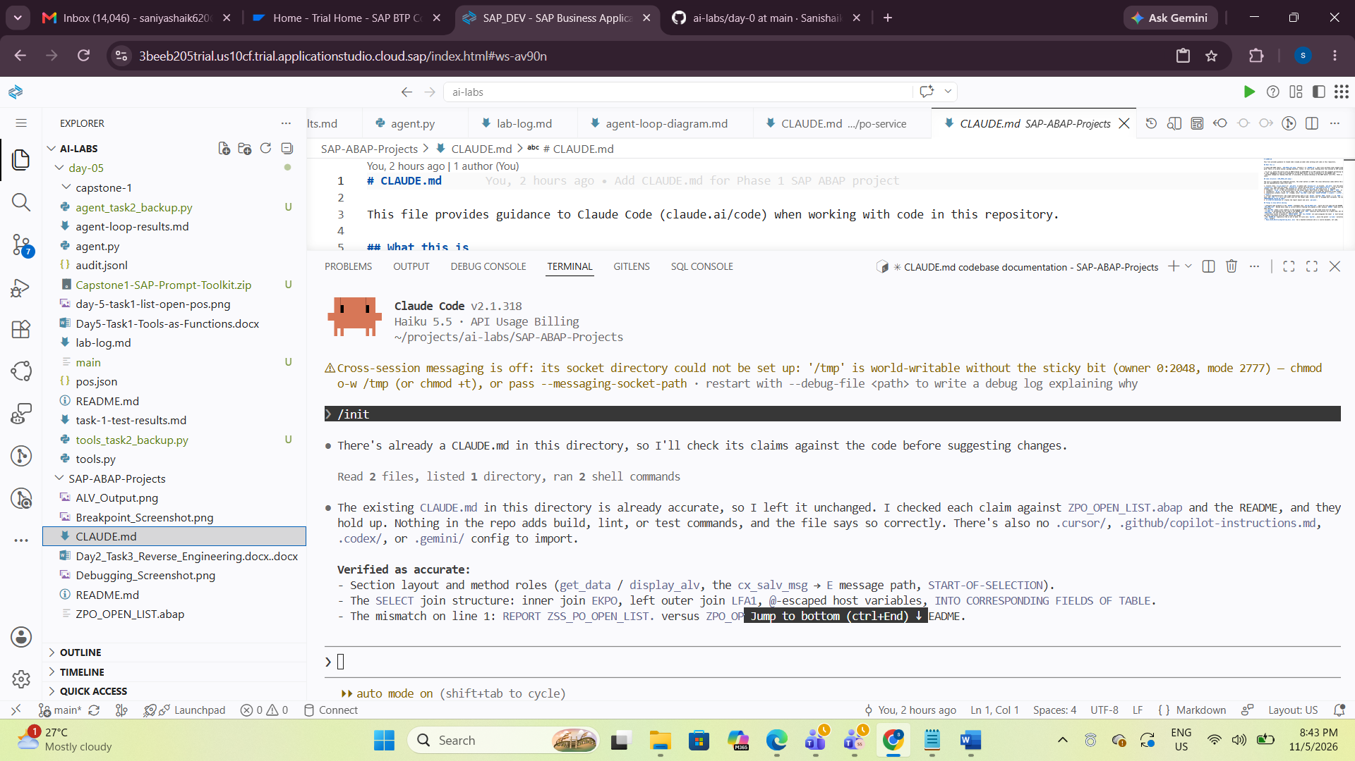

Screenshot 3 – Plan Mode Analysis
This screenshot showing Claude explaining the ABAP program and identifying risks in Plan Mode.
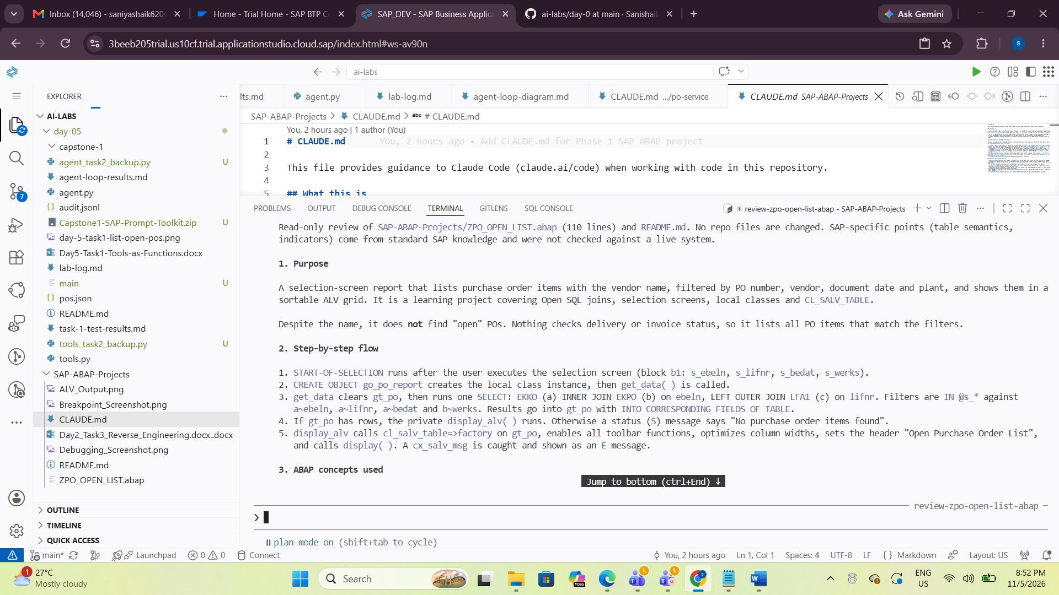
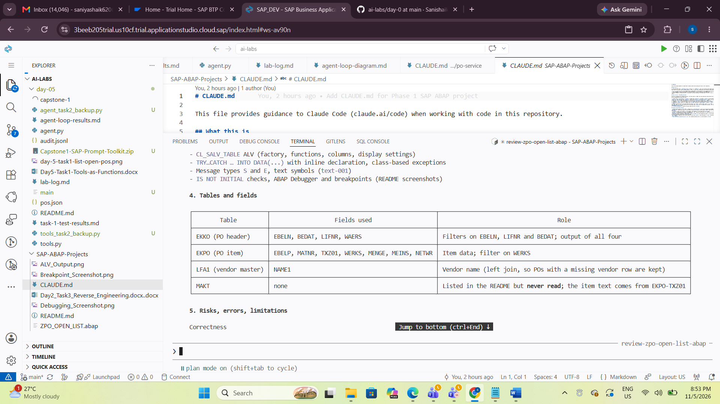
risk and issues:
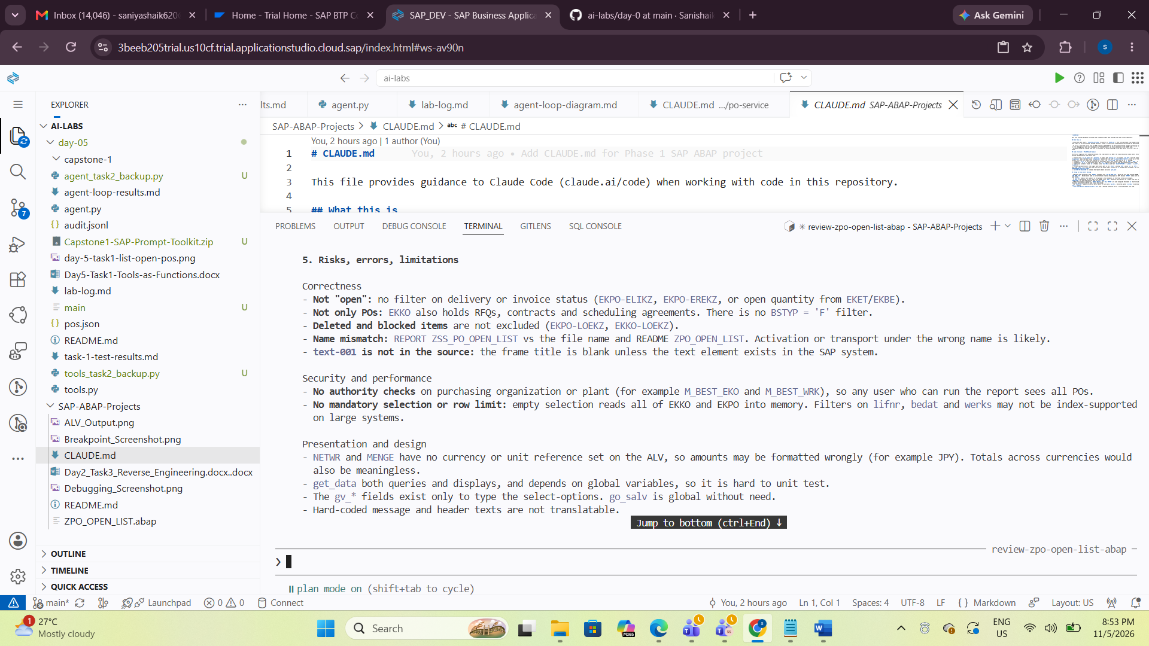
Screenshot 4 – CAP PO Service Project
This screenshot showing the CAP PO Service project and its generated CLAUDE.md file.
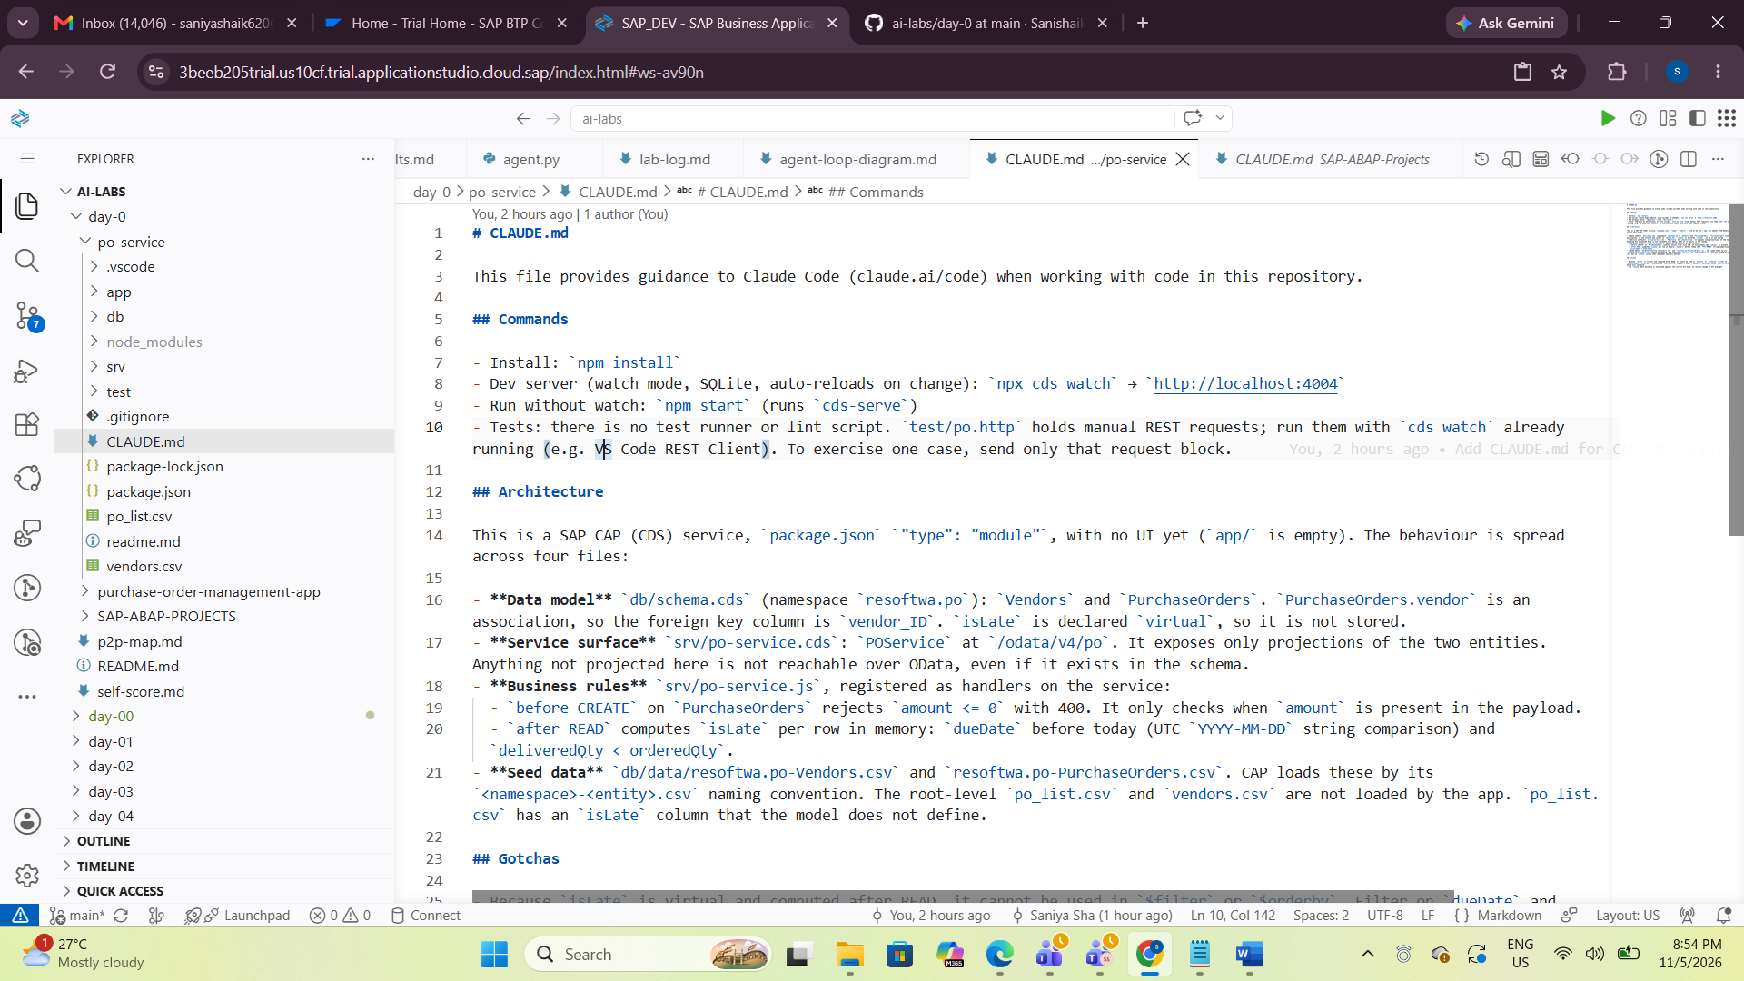
Screenshot 5 – GitHub Submission
This Screenshot showing both CLAUDE.md files in GitHub or the successful Git push output.
PO-Service >>>Under Claude.md File.
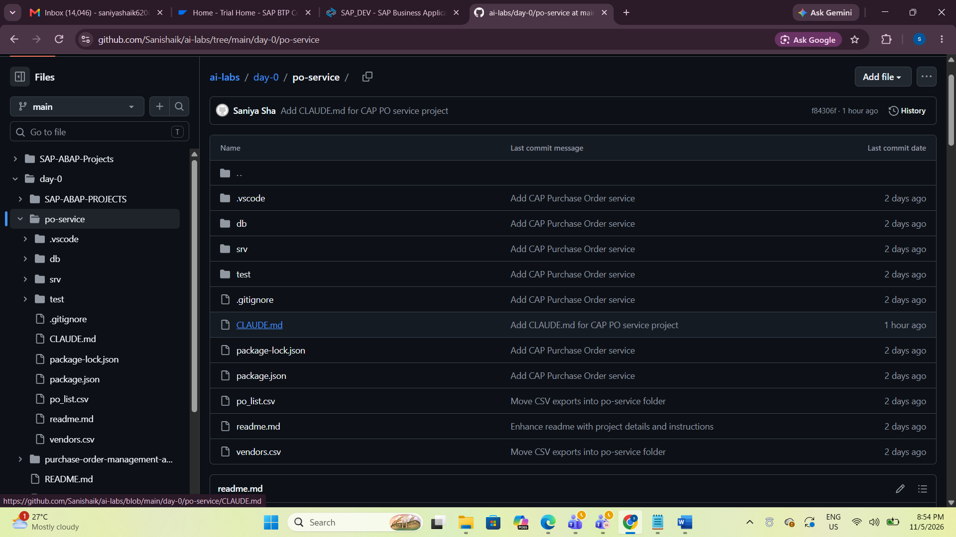
claude.md file:
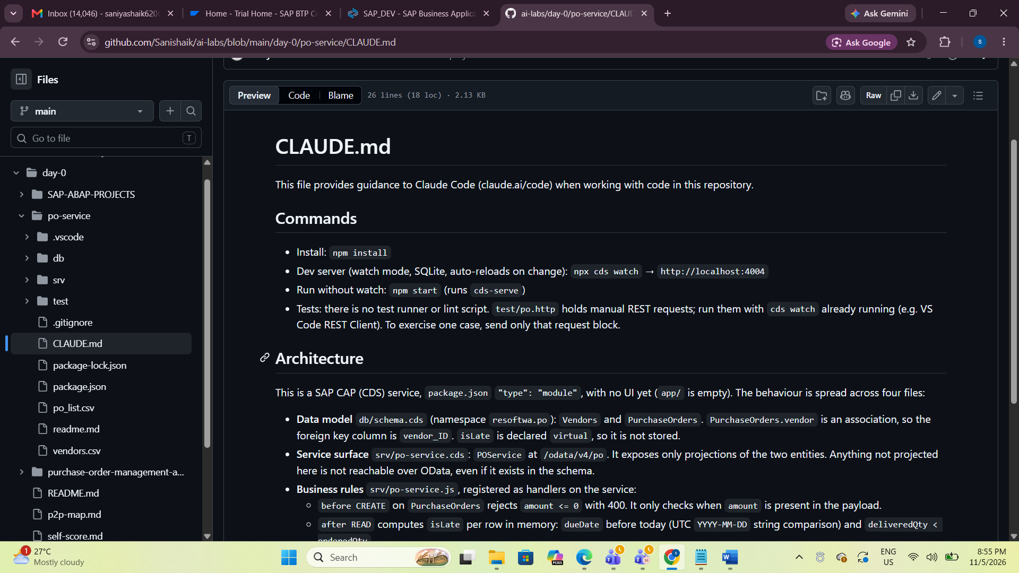
CLAUDE.md
This file provides guidance to Claude Code (claude.ai/code) when working with code in this repository.
Commands
- Install: npm install
- Dev server (watch mode, SQLite, auto-reloads on change): npx cds watch → http://localhost:4004
- Run without watch: npm start (runs cds-serve)
- Tests: there is no test runner or lint script. test/po.http holds manual REST requests; run them with cds watch already running (e.g. VS Code REST Client). To exercise one case, send only that request block.
Architecture
This is a SAP CAP (CDS) service, package.json "type": "module", with no UI yet (app/ is empty). The behaviour is spread across four files:
- Data model db/schema.cds (namespace resoftwa.po): Vendors and PurchaseOrders. PurchaseOrders.vendor is an association, so the foreign key column is vendor_ID. isLate is declared virtual, so it is not stored.
- Service surface srv/po-service.cds: POService at /odata/v4/po. It exposes only projections of the two entities. Anything not projected here is not reachable over OData, even if it exists in the schema.
- Business rules srv/po-service.js, registered as handlers on the service:
  - before CREATE on PurchaseOrders rejects amount <= 0 with 400. It only checks when amount is present in the payload.
  - after READ computes isLate per row in memory: dueDate before today (UTC YYYY-MM-DD string comparison) and deliveredQty < orderedQty.
- Seed data db/data/resoftwa.po-Vendors.csv and resoftwa.po-PurchaseOrders.csv. CAP loads these by its <namespace>-<entity>.csv naming convention. The root-level po_list.csv and vendors.csv are not loaded by the app. po_list.csv has an isLate column that the model does not define.
Gotchas
- Because isLate is virtual and computed after READ, it cannot be used in $filter or $orderby. Filter on dueDate and deliveredQty/orderedQty instead, as test/po.http request 2 does. readme.md section 9 shows $filter=isLate eq true, which will not work.
- The isLate date boundary is evaluated against the current UTC date, so results change at UTC midnight.
in sap-abap-projects ----Section.
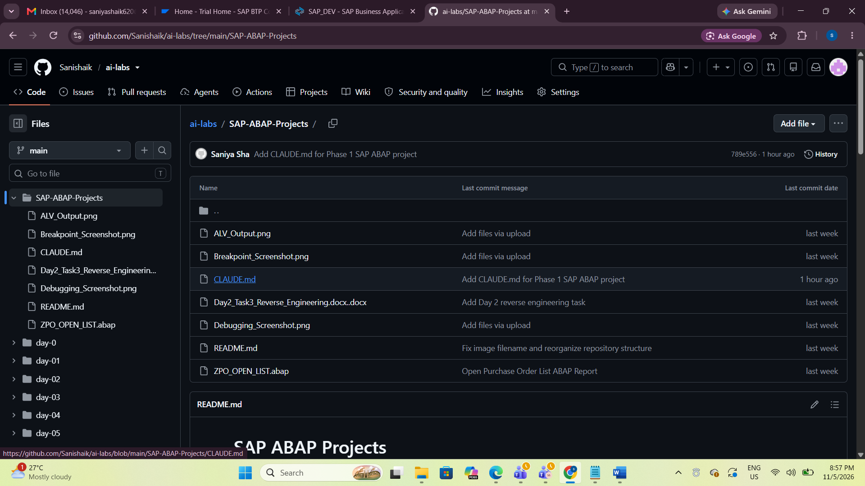
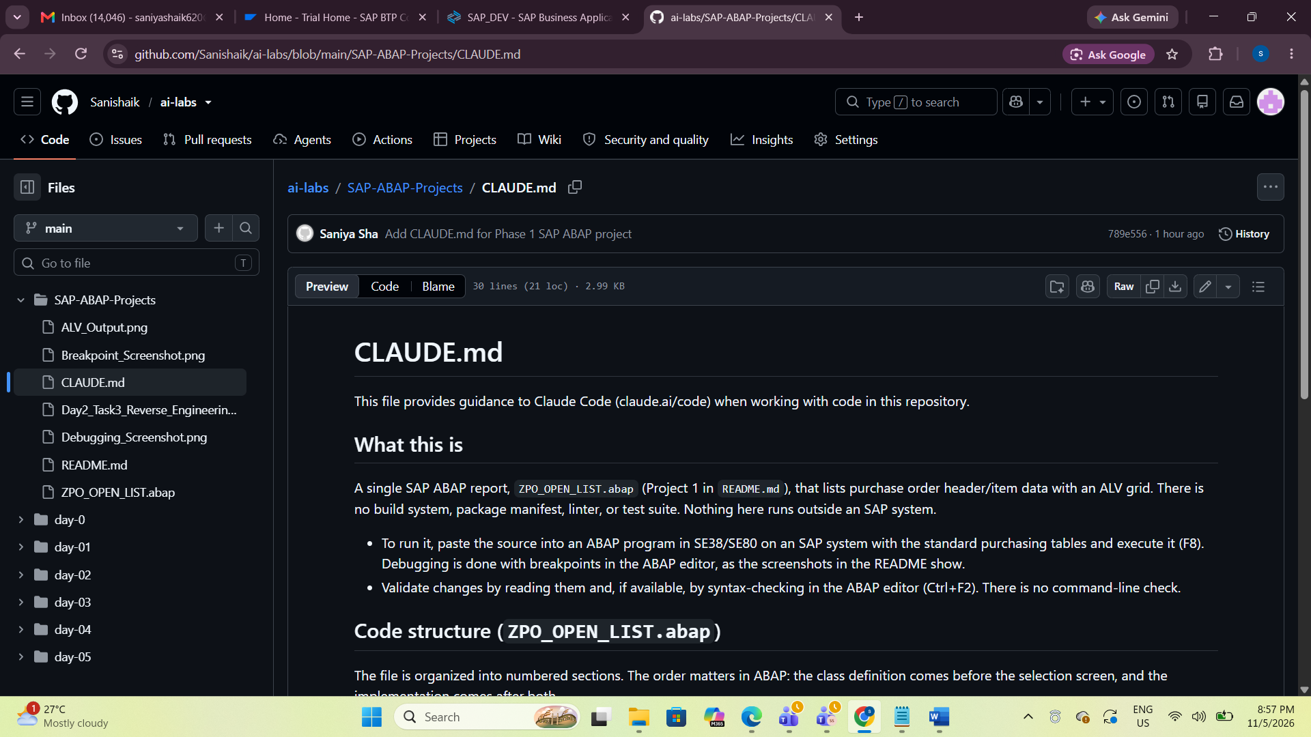
CLAUDE.md
This file provides guidance to Claude Code (claude.ai/code) when working with code in this repository.
What this is
A single SAP ABAP report, ZPO_OPEN_LIST.abap (Project 1 in README.md), that lists purchase order header/item data with an ALV grid. There is no build system, package manifest, linter, or test suite. Nothing here runs outside an SAP system.
- To run it, paste the source into an ABAP program in SE38/SE80 on an SAP system with the standard purchasing tables and execute it (F8). Debugging is done with breakpoints in the ABAP editor, as the screenshots in the README show.
- Validate changes by reading them and, if available, by syntax-checking in the ABAP editor (Ctrl+F2). There is no command-line check.
Code structure (ZPO_OPEN_LIST.abap)
The file is organized into numbered sections. The order matters in ABAP: the class definition comes before the selection screen, and the implementation comes after both.
- Local class lcl_po_report: get_data is public and display_alv is private. get_data runs the query and calls display_alv when rows are found. display_alv builds the grid with CL_SALV_TABLE=>factory, turns on all functions, optimizes columns, sets the list header, and displays it. Errors from cx_salv_msg are shown as an E message.
- Types: ty_po is the row structure for the output table. Each field is typed from an EKKO, EKPO, or LFA1 column.
- Globals: gt_po is the result table. The gv_* fields exist only to type the selection-screen ranges.
- Selection screen: block b1 (framed, title text-001) with four SELECT-OPTIONS (s_ebeln, s_lifnr, s_bedat, s_werks).
- Class implementation: the single data-access path is one SELECT joining EKKO (alias a) to EKPO (b) as an inner join, and LFA1 (c) as a left outer join for the vendor name. Filters use @-escaped host variables. The result goes INTO CORRESPONDING FIELDS OF TABLE.
- START-OF-SELECTION: creates the report object and calls get_data.
Things to know before editing
- Program name mismatch. The REPORT statement says ZSS_PO_OPEN_LIST, while the file name and the README say ZPO_OPEN_LIST. Decide which name is correct before creating the program in SAP, because REPORT names must match the program name there.
- text-001 needs a text symbol in the program's text elements, or the frame title will be empty.
- MAKT is documented but not read. The README lists MAKT (material descriptions) as a table used, but the query uses EKPO-TXZ01 for the item text and does not join MAKT.
- Old-style syntax in places: CREATE OBJECT and CALL METHOD are used alongside the newer @ host-variable syntax. Keep the style consistent with the code around the change.
- The README.md repository tree is out of date. It lists only day-01/, while the parent ai-labs/ directory now has several day-* folders.
- Day2_Task3_Reverse_Engineering.docx..docx has a doubled extension and is a course document, not code.
12. What I Learned
Through this task, I learned how to use Claude Code to understand existing projects without manually reading every file.
I understood that /init analyzes a project and creates a CLAUDE.md file containing project-specific instructions.
I also learned how to use Plan Mode to ask Claude to explain code, understand program flow and identify possible risks without changing the existing code.
By working on both the SAP ABAP and CAP projects, I understood that Claude Code can analyze different types of development projects and provide useful guidance.
I also learned that AI-generated suggestions should be reviewed and validated before applying them to actual development work.
13. Conclusion
I successfully completed Day 06 Task 1 by running /init on two existing projects, using Plan Mode to analyze the Phase 1 ABAP program, understanding its execution flow and identifying potential risks.
Both project-specific CLAUDE.md files were generated, committed and pushed to GitHub successfully.
Task Status: Completed

