# Event Ticket Booking Platform - Deployment Guide

---

# 1. Overview

This document describes the deployment process for the Event Ticket Booking Platform.

The application is a cloud-native microservices-based system built using Spring Boot and deployed using Docker containers. It can be deployed locally using Docker Compose, on Kubernetes, or on AWS.

---

# 2. Prerequisites

Before deployment, ensure the following software is installed:

| Software | Version |
|----------|----------|
| Java | 17 |
| Maven | 3.9+ |
| Docker | Latest |
| Docker Compose | Latest |
| Git | Latest |
| PostgreSQL | 18 (for local development) |
| Jenkins | 2.x |
| AWS CLI | Latest |

---

# 3. Clone Repository

Clone the GitHub repository.
git clone https://github.com/<your-github>/Event-Ticket-Booking-Platform.git
---

# 4. Build the Project

Build all microservices.
mvn clean install

This generates executable JAR files inside each service's **target** folder.
---

# 5. Local Deployment using Docker Compose

The project includes Dockerfiles for each microservice and a Docker Compose configuration.

Build all Docker images.

```bash
docker compose build
```

Start all containers.

```bash
docker compose up -d
```

Verify running containers.

```bash
docker ps
```

Expected containers:

- PostgreSQL
- Zookeeper
- Kafka
- User Service
- Event Service
- Booking Service
- Notification Service

Stop containers.

```bash
docker compose down
```

---

# 6. Accessing the Application

| Service | URL |
|----------|-----|
| User Service | http://localhost:7071 |
| Event Service | http://localhost:7072 |
| Booking Service | http://localhost:7073 |
| Notification Service | http://localhost:7074 |

Swagger UI

| Service | Swagger |
|----------|----------|
| User | http://localhost:7071/swagger-ui/index.html |
| Event | http://localhost:7072/swagger-ui/index.html |
| Booking | http://localhost:7073/swagger-ui/index.html |

---

# 7. Health Checks

Verify that each service is running.

Example:

```
http://localhost:7071/actuator/health
```

Other services:

```
http://localhost:7072/actuator/health

http://localhost:7073/actuator/health

http://localhost:7074/actuator/health
```

Expected response:

```json
{
"status":"UP"
}
```

---

# 8. Prometheus Metrics

Metrics endpoint:

```
http://localhost:7073/actuator/prometheus
```
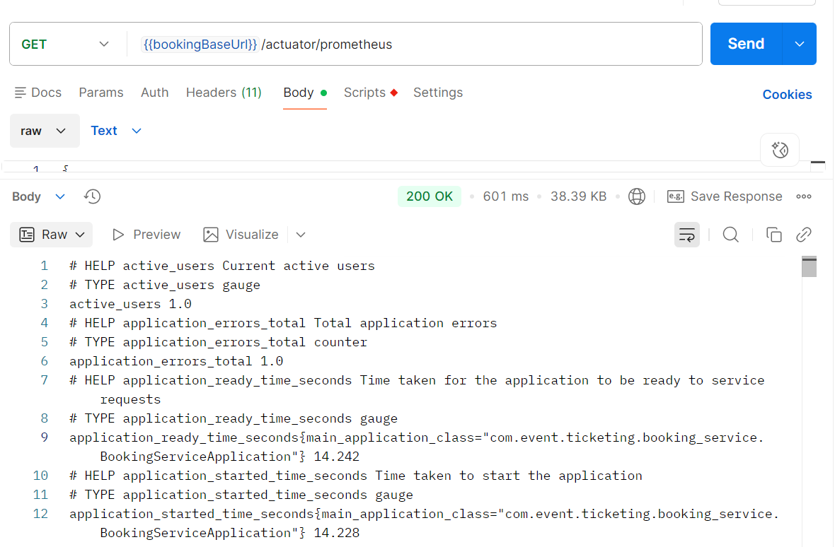
Example custom metrics:

- booking_created_total
- booking_cancelled_total
- booking_failed_total
- application_errors_total
- active_users
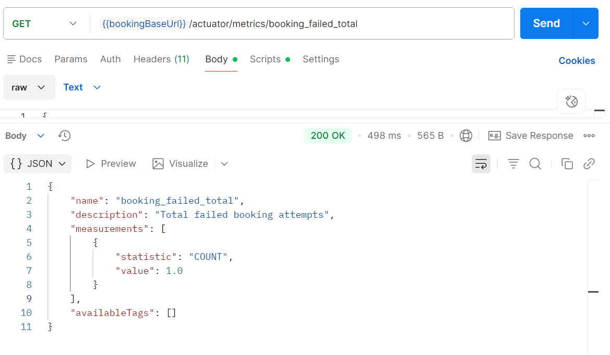
---

# 9. AWS Deployment

The application is deployed using:

- Amazon EC2
- Amazon ECR
- Amazon S3

## Step 1

Create Amazon ECR repositories.

Repositories:

- user-service
- event-service
- booking-service
- notification-service

Authenticate Docker.

```bash
aws ecr get-login-password --region ap-south-1 \
| docker login \
--username AWS \
--password-stdin <ACCOUNT_ID>.dkr.ecr.ap-south-1.amazonaws.com
```

Build Docker image.

```bash
docker build -t user-service ./user-service
```

Tag image.

```bash
docker tag user-service:latest \
<ACCOUNT_ID>.dkr.ecr.ap-south-1.amazonaws.com/user-service:latest
```

Push image.

```bash
docker push \
<ACCOUNT_ID>.dkr.ecr.ap-south-1.amazonaws.com/user-service:latest
```

Repeat for all services.

---

## Step 2

Launch an EC2 instance.

Recommended configuration:

- Amazon Linux 2023
- t2.medium
- 20 GB Storage

Open ports:

- 22
- 7071
- 7072
- 7073
- 7074
- 9092
- 5433

---

## Step 3

Install Docker.

```bash
sudo yum update

sudo yum install docker -y

sudo service docker start

sudo usermod -aG docker ec2-user
```

---

## Step 4

Install Docker Compose.

```bash
sudo curl -L \
https://github.com/docker/compose/releases/latest/download/docker-compose-linux-x86_64 \
-o /usr/local/bin/docker-compose

sudo chmod +x /usr/local/bin/docker-compose
```

---

## Step 5

Clone repository.

```bash
git clone <repository>

cd Event-Ticket-Booking-Platform
```

---

## Step 6

Start the application.

```bash
docker compose up -d
```

Verify.

```bash
docker ps
```

---

# 11. AWS S3 Configuration

Create an S3 bucket.

Example:

```
event-ticket-banner-storage
```

Configure environment variables.

```bash
AWS_ACCESS_KEY=<access-key>

AWS_SECRET_KEY=<secret-key>
```

Event banners uploaded by administrators are stored in Amazon S3, and only the generated S3 URL is stored in the PostgreSQL database.

---

# 12. SonarQube

Run analysis.

```bash
mvn sonar:sonar
```

Open dashboard.

```
http://localhost:9000
```
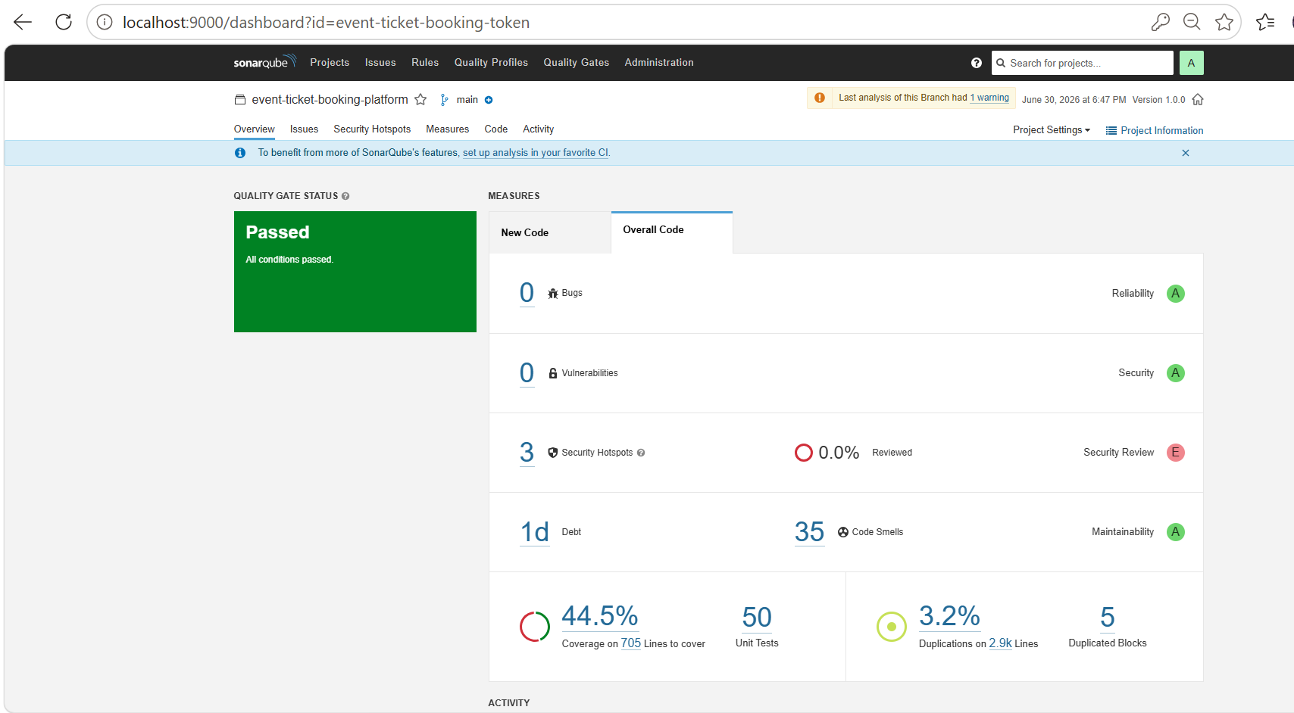

---

# 13. Jenkins Pipeline

The project includes a Jenkinsfile implementing the following stages:

- Checkout
- Build
- Unit Testing
- JaCoCo
- SonarQube Analysis
- Package
- Docker Image Build

Run the pipeline from Jenkins Dashboard.
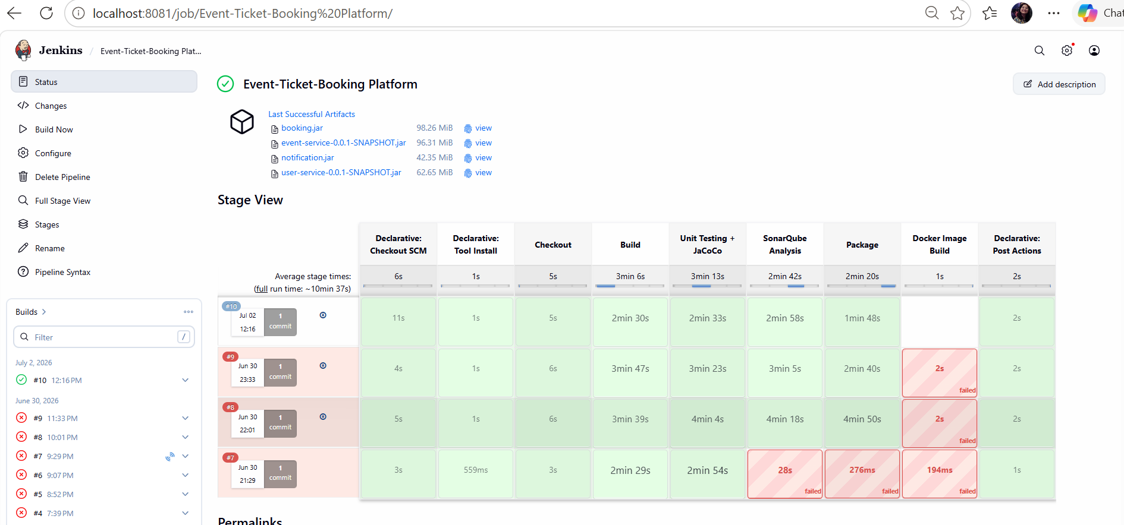
---

# 14. Troubleshooting

## Application does not start

Verify PostgreSQL and Kafka containers are running.

```bash
docker ps
```

---

## Database connection error

Check datasource configuration.

Verify:

- Database URL
- Username
- Password

---

## Kafka connection error

Verify Kafka container.

```bash
docker logs kafka
```

---

## Docker image build failure

Clean the project.

```bash
mvn clean
```

Rebuild Docker image.

```bash
docker compose build
```

---

# 15. Deployment Verification Checklist

After deployment verify:

- All Docker containers are running
- All Kubernetes pods are in Running state
- Health endpoints return UP
- Swagger UI is accessible
- User registration and login work
- Event creation and publishing work
- Ticket booking and cancellation work
- Notifications are consumed from Kafka
- Event banners upload successfully to Amazon S3
- Prometheus metrics are exposed

---

# 16. Conclusion

The Event Ticket Booking Platform is successfully deployed using Docker containers.The deployment provides scalability, observability, security, and cloud-native capabilities suitable for production-ready applications.

