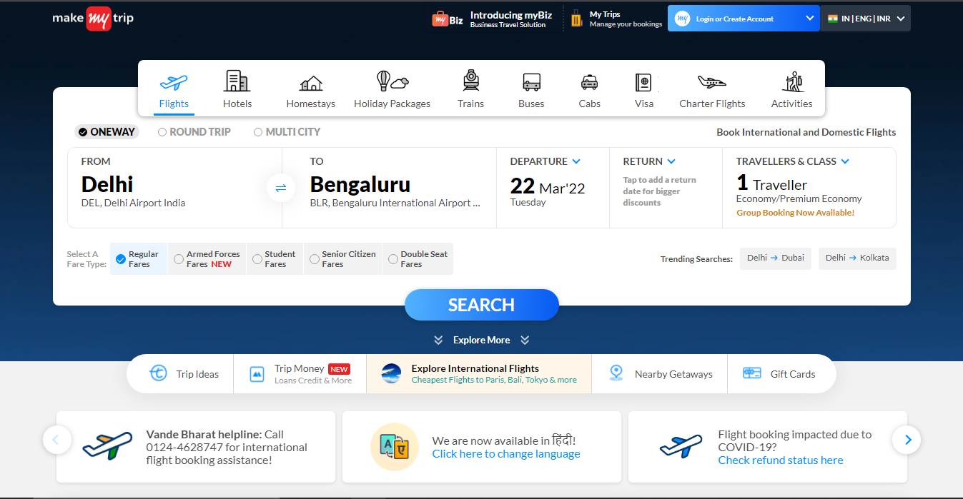

**Project Title: MakeMyTrip**

Syed Saniya Samreen Faizi

Edureka presents

**Overview**

**MakeMyTrip** is an Indian online travel company, the company provides online travel services including airline tickets, domestic and international holiday packages, hotel reservations, rail, and bus tickets.

**Page Structure:**

* **Home Page**
* Navigation bar on top (Logo, Filter, Login or Create Account, Select Country, Select Language)
* Search bar
* Navigation bar (Trip Ideas, Trip Money, Explore International Flights, Nearby Getaways, Gift Cards)
* Offers
* Download App
* Handpicked Collections
* Unlock Lesser-Known Wonders of India
* Trip Money (Credit Cards, Personal Loan, Travel Loan)
* Footer
* **Details Page**
* **Booking Page**