Credit Card Fraud & Transaction Risk Analysis
Fraud frequency, financial impact and risk-monitoring dashboard
Tools: Python • Pandas • Seaborn • Power BI • DAX

Table of Contents
1. Company Background
2. Business Problem
3. Business Objectives
4. Stakeholders
5. Business KPIs
6. Domain Knowledge
7. Dataset Overview
8. Data Dictionary
9. Business Questions
10. Data Cleaning & Preparation (Python)
11. Exploratory & Statistical Analysis (Python)
12. Power BI Dashboard
13. Key Business Insights
14. Business Recommendations
15. ROI / Business Impact
16. Limitations
17. Business Analyst Deliverables
18. Conclusion, Tools & Deliverables

1. Company Background
This project is based on an illustrative business scenario: a retail card issuer ("the Bank") that provides credit cards to customers and processes thousands of card transactions every hour. Every transaction is either genuine or, rarely, fraudulent.
The Bank earns income from card usage but loses money and customer trust when fraudulent transactions are approved. The data used here is a public, anonymised dataset of European cardholders (published by the ULB Machine Learning Group), so no real company name or private bank data is used.

2. Business Problem
Fraud is rare but costly. In this dataset only about 1 in 600 transactions is fraudulent, so fraud is almost invisible in normal volume reports. At the same time, the Bank cannot manually review every transaction, and blocking genuine customers damages customer experience.
The fraud and risk team therefore needs clear answers to three questions:
- How often does fraud happen? (frequency)
- How much money is involved? (financial impact)
- Where is the risk concentrated? (amount sizes and time windows)
This project turns raw transaction data into fraud KPIs, an interactive Power BI monitoring dashboard and practical recommendations. It is a descriptive risk-analytics project, not a machine-learning prediction model.

3. Business Objectives
# | Objective | Measured by | Result
1 | Measure fraud frequency and financial impact | Fraud Rate %, Fraud Value Rate % | 0.167% of transactions; 0.233% of value
2 | Compare fraud and legitimate amount behaviour | Average, median, 90th percentile | Fraud median 9.82 vs 22.00; fraud average 123.87 vs 88.41
3 | Find where fraud cases and fraud money are concentrated | % of fraud cases and % of fraud value by amount band | "0 to 10": 50.3% of cases, 0.8% of value; "500+": 7.2% of cases, 52.4% of value
4 | Check whether fraud rate changes over the data window | Fraud rate by 6-hour elapsed-time period | Ranges from 0.076% to 0.520%
5 | Identify anonymised features statistically linked to fraud | Correlation with Class | V17, V14, V12 strongest
6 | Define monitoring KPIs and give recommendations | KPI dashboard and recommendation list | 5 headline KPI cards on the dashboard (10 KPIs calculated in Python), 7 recommendations

4. Stakeholders
Stakeholder | What they need to decide | Dashboard view used
Fraud Operations Manager | Which alerts to review first; reviewer workload | Fraud by amount band, time period, Top 10 fraud table
Head of Risk | Loss exposure and strength of controls | Fraud value, fraud value rate, concentration chart
Card Product Manager | How much customer friction is acceptable | Fraud rate by amount band
Senior Management | Overall fraud health of the portfolio | KPI cards
Risk Analytics / Data Science team | Where to build detection rules | Feature analysis, deep-dive page
Customers | Safe card use with few false blocks | Indirect (benefit from better controls)

5. Business KPIs
KPI | Formula | Value
Total Transactions | Count of all transactions | 283,726
Fraud Transactions | Count where Class = 1 | 473
Legitimate Transactions | Count where Class = 0 | 283,253
Fraud Rate % | Fraud Transactions ÷ Total Transactions × 100 | 0.167%
Total Transaction Value | Sum of Amount | 25,102,001.68
Fraud Transaction Value | Sum of Amount where Class = 1 | 58,591.39
Fraud Value Rate % | Fraud Value ÷ Total Value × 100 | 0.233%
Average Transaction Amount | Total Value ÷ Total Transactions | 88.47
Average Fraud Amount | Fraud Value ÷ Fraud Transactions | 123.87
Maximum Fraud Amount | Maximum Amount where Class = 1 | 2,125.87
All 10 KPIs are calculated in Python. The Power BI dashboard shows the 5 headline KPIs as cards (Total Transactions, Fraud Transactions, Fraud Rate %, Fraud Transaction Value, Fraud Value Rate %).

Four terms to keep separate: transaction count (how many) · fraud rate (how often) · fraud amount (how much money) · fraud value rate (fraud money as a share of all money).
Fraud value rate (0.233%) is higher than fraud rate (0.167%) because fraud transactions are larger on average.

6. Domain Knowledge
Key banking and fraud terms needed to understand this project:
Term | Meaning
Issuer | The bank that issues the card to the customer and bears fraud losses (our "Bank").
Authorisation | The real-time decision to approve or decline a card transaction, taken in a fraction of a second.
Card-not-present (CNP) fraud | Fraud using stolen card details online or by phone, without the physical card.
Card testing | Fraudsters try very small purchases to check a stolen card works before larger fraud. This is a possible explanation for many small-value frauds, but cannot be confirmed from this dataset.
Chargeback | A customer dispute that returns money for a transaction they say they did not make.
False positive | A genuine transaction wrongly flagged or blocked. It creates customer friction.
Velocity check | A rule that flags many transactions on one card in a short time.
Step-up authentication | Asking for extra verification (for example a one-time code) only on riskier transactions.
Manual review queue | Alerts that a human analyst checks. Limited by staff capacity.
Class imbalance | One class (fraud) is far smaller than the other. Accuracy becomes a misleading metric.
PCI DSS | Global security standard for organisations that handle card data.
Common industry challenges: fraud is rare, fraud patterns change, customers expect fast approvals, and review teams have limited capacity. Regulations and customer-liability rules differ by country and change over time, so they should be checked for the relevant market before real-world use.

7. Dataset Overview
Item | Detail
Source | Credit Card Fraud Detection dataset, ULB Machine Learning Group (Kaggle). European cardholders, September 2013.
Records / features | 284,807 transactions · 31 columns
Time covered | About 48 hours (172,792 seconds)
Data types | All 31 columns numeric
Missing values | 0
Exact duplicate rows | 1,081 (19 fraud) → removed. Cleaned data: 283,726 rows, 473 fraud
Target variable | Class: 0 = legitimate, 1 = fraud
Class balance | Fraud = 0.167% (extreme imbalance)

8. Data Dictionary
Column | Description
Time | Seconds elapsed since the first transaction in the dataset. Not clock time.
V1 – V28 | Anonymised numerical features produced by PCA (a mathematical transformation applied by the data owners to protect confidentiality). They have no known business meaning; they must not be described as age, merchant, location, etc.
Amount | Transaction amount (currency not stated in the dataset).
Class | Target label. 0 = legitimate, 1 = fraud.
Transaction_Type *(created)* | "Legitimate" or "Fraud", readable version of Class.
Time_Hours *(created)* | Time ÷ 3600: elapsed hours.
Time_Period *(created)* | Eight 6-hour elapsed-time bins: 0 to 6 hrs … 42 to 48 hrs. Not real-world clock time.
Elapsed_Hour *(created)* | Whole elapsed hour, 0 to 47.
Amount_Band *(created)* | 0 to 10, 10 to 50, 50 to 100, 100 to 500, 500+ (upper edge included).
*_Order columns *(created)* | Numbers 1, 2, 3… used so Power BI sorts bands and periods correctly.

9. Business Questions
Instead of simple "what is the average?" queries, the analysis answers business questions:
Business question | Answer from the data
Where is fraud money concentrated compared with fraud cases? | Small transactions ("0 to 10") hold 50.3% of fraud cases but 0.8% of fraud value. Transactions above 500 hold 7.2% of cases but 52.4% of value.
Which transaction sizes need the strictest controls? | "500+" has the highest fraud rate (0.373%, 2.2× average). Bands above 100 hold 88.3% of fraud value.
Are fraud transactions typically larger than genuine ones? | Not typically: median fraud is 9.82 vs 22.00. But a few large frauds lift the average (123.87 vs 88.41).
Does fraud risk change across the 48-hour window? | Yes. Rate ranges from 0.076% to 0.520%; the highest-rate periods are also the quietest in volume.
How much of the loss comes from a few cases? | The top 5 frauds are 14.1% of fraud value; 34 frauds above 500 hold 52.4%.
Which anonymised signals separate fraud from genuine? | V17, V14, V12 (negative correlation with fraud). Statistical only.
What should a fraud team monitor every week? | Fraud rate, fraud value rate, average/max fraud amount, fraud concentration by amount band.

10. Data Cleaning & Preparation (Python)
The analysis was done in a Google Colab notebook using Python, Pandas, NumPy, Matplotlib and Seaborn. The raw file was uploaded once and kept unchanged; all cleaning was done on a copy.

Data quality check
Check | Result | Decision and reason
Missing values | 0 | Nothing to fix
Non-numeric columns / invalid Class / negative Amount or Time | 0 | Nothing to fix
Exact duplicate rows | 1,081 (19 fraud) | Removed. Rows identical in all 31 columns are almost certainly repeated records and would double-count transactions.
Zero-amount transactions | 1,825 (27 fraud) | Kept. Zero is a valid value and does not distort totals. Meaning cannot be confirmed.
Class imbalance | 0.167% fraud | No resampling. Analytics project, so rates are used instead of accuracy.
Result: 284,807 → 283,726 rows; fraud cases 492 → 473.

Feature engineering
- Transaction_Type from Class (Legitimate / Fraud).
- Time_Hours, Time_Period, Elapsed_Hour from Time. The data covers 48 hours, so eight 6-hour bins were needed. These are elapsed-time bins, not clock time.
- Amount_Band: 0 to 10, 10 to 50, 50 to 100, 100 to 500, 500+. Bands were chosen after inspecting the amount distribution (median about 22, most values below 100, very high amounts rare).
- Eight CSV files were exported and loaded into Power BI.

11. Exploratory & Statistical Analysis (Python)

11.1 Extreme class imbalance
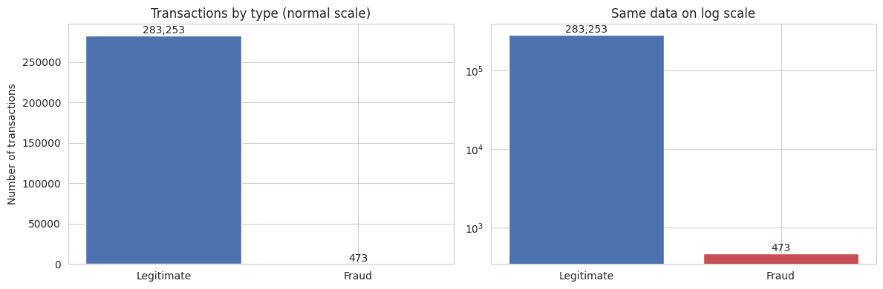
Figure 1: Fraud is a very thin slice of all transactions (normal scale vs log scale)
Only 473 of 283,726 transactions are fraud (0.167%). A report that labels every transaction "legitimate" would be 99.83% "accurate" and catch no fraud, so accuracy is not used. Rates and values are used instead.

11.2 Fraud vs legitimate amounts
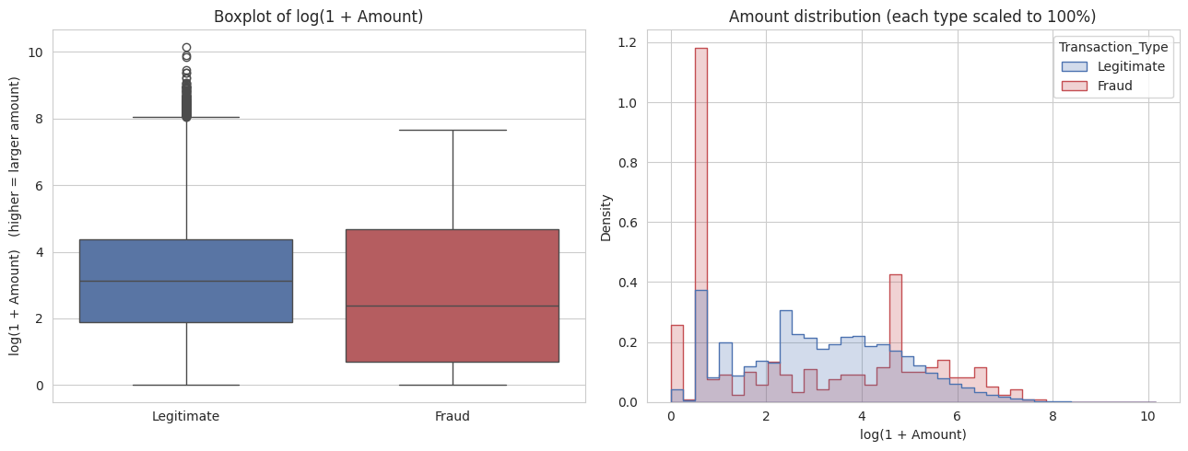
Figure 2: Amount comparison (log scale because amounts are highly skewed)
 | Transactions | Average | Median | 90th percentile | Maximum
Fraud | 473 | 123.87 | 9.82 | 348.65 | 2,125.87
Legitimate | 283,253 | 88.41 | 22.00 | 203.00 | 25,691.16
Half of the fraud cases are below 9.82, yet the 90th percentile of fraud (348.65) is higher than for legitimate transactions (203.00). Fraud has more small and more large amounts than genuine activity.

11.3 Fraud frequency vs financial impact
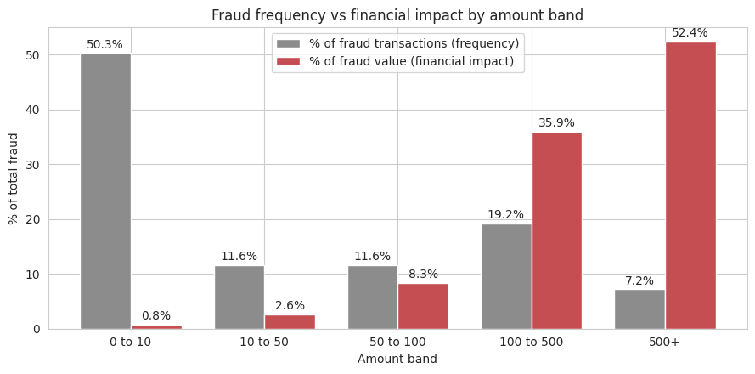
Figure 3: Where fraud cases are vs where fraud money is, by amount band
Amount band | Transactions | Fraud | Fraud rate | % of fraud cases | % of fraud value
0 to 10 | 99,821 | 238 | 0.238% | 50.3% | 0.8%
10 to 50 | 90,327 | 55 | 0.061% | 11.6% | 2.6%
50 to 100 | 37,179 | 55 | 0.148% | 11.6% | 8.3%
100 to 500 | 47,290 | 91 | 0.192% | 19.2% | 35.9%
500+ | 9,109 | 34 | 0.373% | 7.2% | 52.4%
This is the key finding. Small transactions create most fraud cases (workload), but large transactions hold most of the fraud money (loss). The two need different controls.

11.4 Statistical analysis: correlation with Class
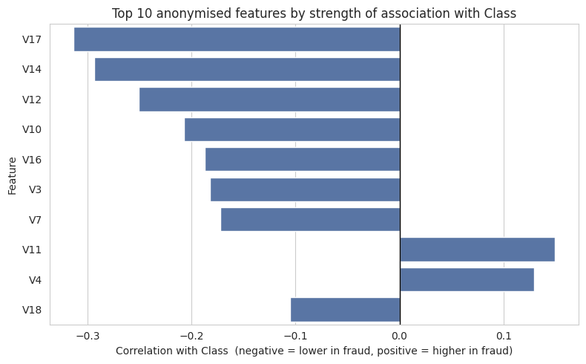
Figure 4: Top 10 anonymised features by strength of association with Class
Feature | Correlation with Class | Reading
V17 | -0.313 | Lower in fraud
V14 | -0.293 | Lower in fraud
V12 | -0.251 | Lower in fraud
V10 | -0.207 | Lower in fraud
V16 | -0.187 | Lower in fraud
Correlation shows a statistical association, not a cause. V1–V28 are anonymised PCA components, so the analysis identifies statistical patterns rather than directly interpretable business attributes.

12. Power BI Dashboard
The cleaned data was loaded into Power BI. DAX measures were created for fraud rate, fraud value rate and the other KPIs, and the dashboard was validated against the Python results (283,726 transactions, 473 fraud, 58,591.39 fraud value).
- Page 1 – Executive Overview: 5 KPI cards (Total Transactions, Fraud Transactions, Fraud Rate %, Fraud Transaction Value, Fraud Value Rate %), Fraud vs Legitimate transactions, Fraud rate by amount band, and slicers for Amount Band and Time Period.
- Page 2 – Fraud Analysis (deep dive): Fraud rate by elapsed hour, Fraud frequency vs financial impact, Average vs median vs P90 amount, and the Top fraudulent transactions table.
- Page 3 – Insights & Risk Recommendations: key findings and recommendations summarised for stakeholders.
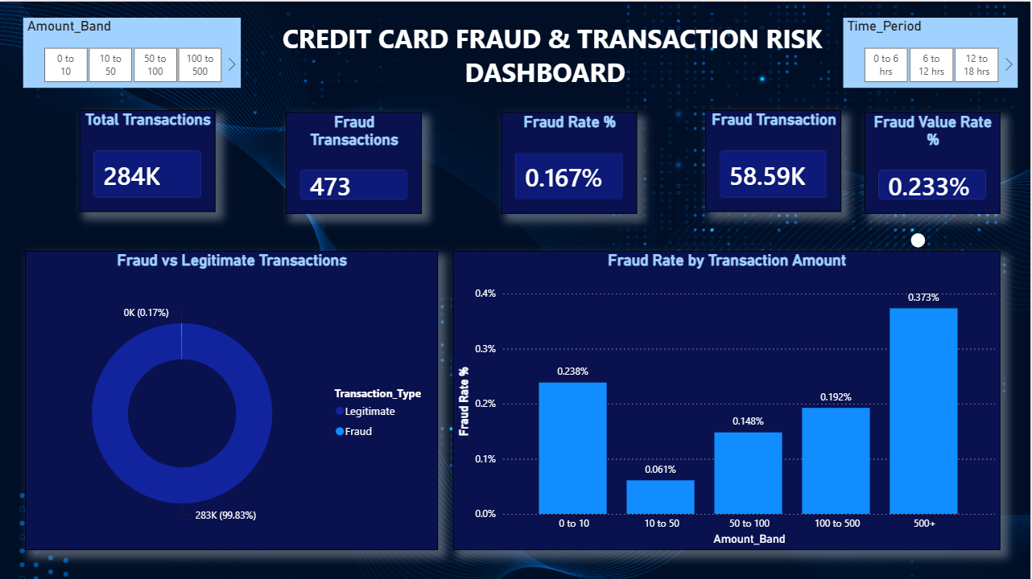
Figure 5: Power BI dashboard, Page 1 (Executive Overview)
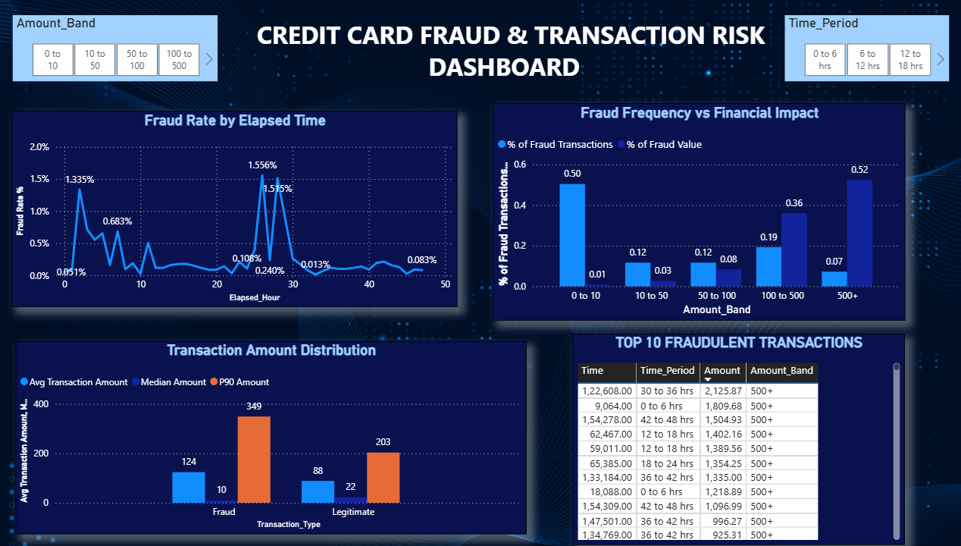
Figure 6: Power BI dashboard, Page 2 (Fraud Analysis). Time is elapsed since the first transaction, not clock time.

13. Key Business Insights
# | Insight | Evidence
1 | Fraud is rare but real | 473 of 283,726 transactions = 0.167% (about 1 in 600).
2 | Accuracy is a misleading KPI | "Everything is legitimate" would be 99.83% right and catch 0 frauds.
3 | Fraud hurts more by value than by count | Fraud value rate 0.233% vs fraud rate 0.167%.
4 | Typical fraud is small; a few large cases lift the average | Median fraud 9.82 vs 22.00 legitimate; average 123.87 vs 88.41.
5 | Small transactions: many cases, little money | "0 to 10" = 50.3% of fraud cases, 0.8% of fraud value.
6 | Large transactions: highest rate and most money | "500+" = 3.2% of transactions, fraud rate 0.373% (2.2× average), 52.4% of fraud value.
7 | Bands above 100 carry most of the loss | 88.3% of fraud value from 26.4% of fraud cases.
8 | Fraud rate varies by elapsed period | 0.076% (30 to 36 hrs) to 0.520% (24 to 30 hrs). The highest-rate periods also have the lowest volume (about 12,000 transactions vs 35,000 average).
9 | A few large frauds matter | Largest fraud 2,125.87; 34 frauds above 500; top 5 = 14.1% of fraud value.
10 | Some anonymised features are statistically linked to fraud | V17 (−0.313), V14 (−0.293), V12 (−0.251).

14. Business Recommendations
These are suggestions based on the observed patterns. They are not guaranteed to reduce fraud and should be piloted or back-tested before full rollout.
# | Recommendation | Based on | Owner | Success measure
1 | Create a priority alert queue for transactions above 500, using automated checks first and manual review only for the riskiest | Insight 6, 9 | Fraud Ops Manager | % of fraud value caught; review time
2 | Apply step-up authentication (extra verification) for transactions above 100 instead of blocking | Insight 7 | Head of Risk / Product Manager | Fraud value rate; customer drop-off
3 | Handle small-value fraud with automated velocity rules, not manual review | Insight 5 | Fraud Ops / Analytics | Fraud count in small bands; alert volume
4 | Monitor fraud rate by time window with thresholds; confirm with real timestamps before changing staffing | Insight 8 | Fraud Ops Manager | Rate vs threshold; time to detect a spike
5 | Test anomaly rules on the real attributes behind the strongest statistical signals | Insight 10 | Risk Analytics | Share of alerts that are truly fraud
6 | Run the KPI dashboard weekly: fraud rate, fraud value rate, average/max fraud amount, concentration | Insights 1–3 | Head of Risk | Dashboard refreshed on schedule
7 | Capture merchant, location, channel, real timestamp and a unique transaction ID | Limitations, duplicates | Data Engineering | Data completeness; duplicate rate

15. ROI / Business Impact
A real return on investment cannot be calculated without costs, review capacity and customer-friction data. The table below is an illustrative scenario using only numbers from this dataset (about 48 hours of transactions, amount units).
The "500+" band has 9,109 transactions (3.2% of all), 34 frauds and 30,682.65 of fraud value (52.4% of all fraud value). Suppose a control (such as step-up authentication) stops part of the fraud in this band:
Assumed share of 500+ fraud value prevented | Fraud value protected (48 hours of data)
10% | 3,068.27
25% | 7,670.66
50% | 15,341.33

The trade-off (be honest about it): 9,075 of the 9,109 transactions above 500 (99.6%) are genuine. Only about 1 in 268 is fraud. Manual review of every one of them would be inefficient and extra verification on all of them creates customer friction.
That is why the recommendation is a risk-ranked priority queue and step-up checks, not blanket blocking. Real value = fraud prevented − review cost − lost genuine sales.
Other business benefits: faster detection of fraud-rate spikes, better use of limited reviewer time, one agreed set of fraud KPIs, and clearer data requirements for future analysis.

16. Limitations
- V1–V28 are anonymised PCA features; no business meaning can be given to them.
- Time is elapsed time, so no conclusions about hour-of-day, weekday or night/day are possible.
- Only about 2 days of data and 473 fraud cases after de-duplication. Hourly results are noisy and may not generalise.
- No merchant, customer, location or channel information, so no customer or merchant segmentation.
- Amount currency is not stated, and the dataset is historic (2013) and from one region. The 0.167% rate must not be presented as an industry fraud rate.
- Correlation is association, not causation. This is descriptive analytics, not a detection model.

17. Business Analyst Deliverables

17.1 Business Requirement summary (BRD)
Item | Detail
Business need | A trusted, repeatable view of fraud frequency, fraud value and fraud concentration for risk monitoring.
Scope (in) | Descriptive fraud analytics (Python), KPI definitions, Power BI dashboard, recommendations.
Scope (out) | Fraud prediction models, real-time scoring, customer-level investigation.
Success criteria | KPIs match between Python and Power BI; stakeholders can answer the 7 business questions from the dashboard.
Assumptions | Class labels are correct; duplicates are repeated records; elapsed time is the only time field.

17.2 Functional requirements (FRD summary)
ID | Requirement
FR-1 | Dashboard shall show 5 headline KPI cards: total transactions, fraud transactions, fraud rate, fraud transaction value and fraud value rate. The remaining KPIs (total value, average and maximum fraud amount) are calculated in Python.
FR-2 | Dashboard shall show fraud rate by amount band and by elapsed-time period.
FR-3 | Dashboard shall show % of fraud cases vs % of fraud value by amount band.
FR-4 | Dashboard shall list the Top 10 fraudulent transactions by amount.
FR-5 | Users shall filter all visuals by Amount Band and Time Period using slicers.
FR-6 | All time visuals shall state that time is elapsed, not clock time.

17.3 User stories and acceptance criteria
User story | Acceptance criteria
As a Fraud Operations Manager, I want to see fraud rate by amount band so that I can decide which transactions to review first. | Chart shows 5 bands in correct order; "500+" shows 0.373%; slicers update the chart.
As the Head of Risk, I want fraud value and fraud value rate so that I can understand financial exposure. | Cards show 58,591.39 and 0.233% and match the Python output.
As a Product Manager, I want to see which bands hold most fraud money so that I limit customer friction to where it matters. | Chart shows 52.4% of fraud value in "500+" and 0.8% in "0 to 10".
As a Senior Manager, I want one page of KPIs so that I can check fraud health in under a minute. | Page 1 shows the 5 headline KPI cards with readable formatting and consistent colours.

17.4 As-Is vs To-Be process
 | As-Is | To-Be
Monitoring | Fraud is seen only in total volume reports, so it is easy to miss. | Fraud rate and fraud value rate tracked on a dashboard with defined KPIs.
Prioritisation | All transactions treated alike. | Review and verification focused on high-value bands.
Small-value fraud | No specific treatment. | Automated velocity rules.
Data | Duplicates and missing context (merchant, location, timestamp). | De-duplication rules; richer data captured.
To-Be process flow: Transaction data → de-duplication and quality check → fraud KPIs and amount/time bands → dashboard → weekly review → alerts and rule changes → re-measure KPIs.

17.5 Stakeholder matrix
Stakeholder | Influence | Interest | How to engage
Head of Risk | High | High | Weekly KPI review; approves controls
Fraud Operations Manager | Medium | High | Uses dashboard daily; feedback on queues
Card Product Manager | Medium | Medium | Consulted on customer friction
Senior Management | High | Medium | Summary KPIs
Risk Analytics team | Medium | High | Owns data and rule testing

17.6 Risk register
Risk | Impact | Mitigation
Anonymised features cannot be explained | Limited business insight | Use them only as statistical signals; request real attributes
Few fraud cases (473) | Unstable rates in small groups | Report counts with rates; avoid over-reading hourly results
Elapsed time mistaken for clock time | Wrong staffing decisions | Label every time chart; use real timestamps in production
Blocking genuine customers (false positives) | Customer dissatisfaction | Use step-up checks; track false-positive ratio
Duplicates distort KPIs | Overstated counts | De-duplication rule documented and applied
Fraud patterns change over time | Dashboard becomes outdated | Refresh data and review thresholds regularly

18. Conclusion, Tools & Deliverables
This project shows how analytics can support fraud-risk decisions even when fraud is very rare. The key lesson is that fraud frequency and fraud money tell different stories: small transactions generate most fraud cases, while large transactions hold most of the fraud value. A monitoring dashboard built on fraud rate, fraud value rate and concentration gives the risk team a more useful view than total volumes or accuracy. Recommendations are based on observed patterns and should be tested before rollout.

Tools & technologies
- Python (Google Colab): data quality checks, cleaning, feature engineering, EDA, correlation analysis
- Pandas, NumPy: data manipulation · Matplotlib, Seaborn: visualisation
- Power BI and DAX: KPI measures, interactive dashboard, slicers

Project deliverables
- Credit_Card_Fraud_Risk_Analytics.ipynb (Colab notebook)
- fraud_cleaned.csv (Power BI ready) and 7 summary CSV files
- Credit_Card_Fraud_Risk_Dashboard.pbix (Power BI dashboard)
- This project report and the GitHub README

