Olist Marketing Funnel & Lead Conversion Analysis
From marketing-qualified lead to closed deal: where leads convert and where they are lost
Tools: Python • Pandas • SQL • Excel (PivotTables, formulas, charts)

Table of Contents
1. Company Background
2. Business Problem
3. Business Objectives
4. Stakeholders
5. Business KPIs
6. Domain Knowledge
7. Dataset Overview
8. Data Dictionary
9. Business Questions
10. Data Cleaning & Preparation
11. Python & SQL Analysis
12. Excel Dashboard
13. Key Business Insights
14. Business Recommendations
15. Business Impact (illustrative)
16. Limitations
17. Business Analyst Deliverables
18. Conclusion, Tools & Deliverables

1. Company Background
Olist is a Brazilian e-commerce company that helps small and medium businesses sell their products through online marketplaces. To grow its network of sellers, Olist runs a sales funnel: marketing attracts interested merchants, and a sales team turns them into active sellers.
This project analyses the public Olist Marketing Funnel dataset (Kaggle): 8,000 marketing-qualified leads (MQLs) who first made contact between June 2017 and May 2018, and the 842 of them who became closed deals (new sellers).

2. Business Problem
Only about 1 in 10 marketing-qualified leads becomes a closed deal. The sales and marketing teams need to know where leads are being lost, which lead sources convert, and how long deals take to close, so that marketing budget and sales effort go to the right places.
The analysis answers three questions:
- How many leads convert, and how does this change over time and by lead source?
- How long does it take to close a deal?
- What do the closed deals look like (lead type, segment, behaviour profile, sales team)?

3. Business Objectives
# | Objective | Measured by | Result
1 | Measure MQL to closed-deal conversion overall, by origin and by month cohort | Conversion rate % | 10.5% overall; 3.0% (Jun-Dec 2017) vs 13.0% (Jan-May 2018)
2 | Find which lead origins convert well or badly | Conversion rate and share of MQLs vs closed deals | Organic and paid search about 12%; social 5.6%; email 3.0%
3 | Measure sales-cycle length | Days from first contact to won date | Median 14 days, average 48.5, 17.8% over 90 days
4 | Profile the closed deals | Share of closed deals by lead type, segment, behaviour, SDR, SR | online_medium 39.4%; top 5 SDRs 49.9%
5 | Build an Excel dashboard and give recommendations | 8 KPI cards, 6 charts, 6 PivotTables, 18 self-checks, 7 recommendations | Delivered

4. Stakeholders
Stakeholder | What they need to decide | Dashboard view used
Head of Sales / Sales Manager | Where to focus follow-up; workload across reps | Funnel, days to close, SDR/SR tables
Marketing Manager | Which channels deserve budget | Lead origin chart and origin table
SDR and SR team leads | Follow-up timing and lead allocation | Time to close, closed deals by lead type
Sales / BI Operations | Data quality and tracking | Origin tracking (unknown / blank origin)
Senior Management | Overall funnel health | KPI cards and monthly cohort chart

5. Business KPIs
KPI | Formula | Value
Total MQLs | Count of marketing-qualified leads | 8,000
Closed Deals | MQLs with a matching closed-deal record | 842
Conversion Rate (all months) | Closed Deals ÷ Total MQLs. Blends two periods that are not comparable | 10.5% (10.525%)
Conversion Rate, Jan-May 2018 | Same formula on the comparable window (781 of 5,998). Use as the benchmark | 13.0%
Non-converted leads | Total MQLs − Closed Deals | 7,158
Drop-off | Non-converted ÷ Total MQLs | 89.5%
Average days to close | Mean of (won date − first contact date) | 48.5
Median days to close | Middle value of the same measure | 14.0
Closed within 30 days | Deals closed in 30 days or less ÷ deals with a valid date gap (554 of 841) | 65.9%
Unique SDRs / Sales Reps | Distinct IDs among closed deals | 32 / 22

Use the median (14 days), not the average (48.5), as the typical sales cycle. A small number of very slow deals pull the average up.

6. Domain Knowledge
Term | Meaning
MQL (Marketing Qualified Lead) | A lead that marketing considers ready for the sales team, here a merchant who showed interest through a landing page.
SDR (Sales Development Representative) | Qualifies the lead and holds the first conversations.
SR (Sales Representative) | Closes the deal. The converted merchant becomes a seller.
Funnel | The stages a lead passes through. This dataset covers only the first and last: MQL → closed deal. Intermediate stages (contacted, consultancy) are not in the data.
Conversion rate | Share of leads that reach the next stage. Always read it together with volume.
Lead origin | The marketing channel the lead came from (organic search, paid search, social, email ...).
Cohort | A group of leads that first made contact in the same month, followed over time.
Sales cycle | Time from first contact to winning the deal.
Attribution | Linking a conversion to its source. Missing or "unknown" origin weakens it.

7. Dataset Overview
Item | Detail
Source | Olist Marketing Funnel dataset (Kaggle). Two CSV files.
MQL table | 8,000 rows × 4 columns: mql_id, first_contact_date, landing_page_id, origin. First contact 14 Jun 2017 to 31 May 2018.
Closed deals table | 842 rows × 14 columns. Won dates 5 Dec 2017 to 14 Nov 2018.
Join | LEFT JOIN of closed deals onto MQLs on mql_id (one to one). A lead is "Converted" if a closed-deal record exists. Every closed deal exists in the MQL table.
Duplicates | 0
Missing values | MQL origin: 60 (0.75%). Closed deals: behaviour profile 177 (21%); company, GTIN, stock and catalog-size questionnaire fields about 92% missing.
Other data issues | 1 deal with a won date before its first-contact date (excluded from days-to-close); 797 of 842 declared monthly revenue values are 0 and one is 50,000,000, so revenue is not used.

8. Data Dictionary
Column | Table | Description
mql_id | Both | Unique lead ID; join key
first_contact_date | MQL | Date the lead first made contact (start of the sales clock)
landing_page_id | MQL | Landing page the lead signed up on
origin | MQL | Marketing channel (organic_search, paid_search, social, ...)
seller_id | Closed | Seller account created after the deal was won
sdr_id, sr_id | Closed | Sales Development Rep and Sales Rep on the deal
won_date | Closed | Date-time the deal was won (end of the sales clock)
business_segment | Closed | Product category the seller will sell
lead_type | Closed | Kind of seller (online_medium, industry, offline ...)
lead_behaviour_profile | Closed | Behaviour persona (cat, eagle, wolf, shark; some have two)
has_company, has_gtin, average_stock, declared_product_catalog_size | Closed | Questionnaire answers, filled for only about 8% of deals. A blank means not answered, not "No".
business_type | Closed | reseller / manufacturer / other
declared_monthly_revenue | Closed | Declared monthly revenue (BRL). Mostly 0, not used.
*Created:* conversion_status, converted_flag, days_to_close, first_contact_month, won_day | Master | Analytical columns built in Python

9. Business Questions
Business question | Answer from the data
What share of leads becomes sellers, and is it improving? | 10.5% overall. Jan-May 2018 cohorts convert at 13.0%; earlier cohorts are not comparable (first deal won Dec 2017).
Which channels bring leads that actually convert? | Organic and paid search: about 12%. Social 5.6% and email 3.0% are far below the 10.5% average.
Is any channel under-reported? | 14.5% of MQLs have unknown or blank origin, so the true channel mix is unclear.
How long does a deal take? | Median 14 days; 65.9% close within 30 days; 17.8% take over 90.
What do closed deals look like? | online_medium is 39.4%; top 5 segments are 49.3%; "cat" profile is 48.3%.
Which profiles close slowly? | Wolf: median 36 days vs 13 for cat.
Is the sales workload balanced? | No. The top 5 SDRs handled 49.9% and the top 5 SRs 49.4% of closed deals.

10. Data Cleaning & Preparation
Cleaning was done in a Google Colab notebook with Python and Pandas. No rows were deleted; every decision is documented.
Issue | Decision | Reason
Text values with different case or spaces | Trimmed and lower-cased | Avoid duplicate categories
first_contact_date is a date, won_date is a date-time | Compared on the date only (won_day) | Like-for-like day count
60 MQLs with blank origin | Labelled "not_provided"; kept separate from the existing "unknown" | Blank and unknown may mean different things
177 closed deals without behaviour profile | Labelled "Not Provided"; never guessed | Do not invent a persona
About 92% of questionnaire fields blank | Kept as NULL; not used in KPIs | Blank = not answered, not "No"
Revenue mostly 0 with one extreme value | Not used | Zero most likely means not declared
1 deal won before first contact | days_to_close set to blank; row kept | Data error; keep the lead in conversion counts
16 deals with two behaviour profiles (for example "cat, wolf") | Flagged, kept as given | Do not split without business rules
A master table was built as MQL LEFT JOIN closed deals with conversion_status, days_to_close and first_contact_month, and exported to Excel for PivotTables.

11. Python & SQL Analysis
Python (Pandas) was used for cleaning, the master table, KPIs and the Excel export. SQL was used to answer the same business questions from a database: four scripts in the sql folder (create tables, load data, quality checks with an analysis view, and 12 analysis queries). Every query result is saved in data/query_results and matches the Python and Excel numbers.
SQL script | What it does
01_create_database_and_tables.sql | Creates the database and two tables (mql, closed_deals) with keys and indexes
02_load_data.sql | Loads the two cleaned CSV files; checks 8,000 and 842 rows
03_data_quality_and_cleaning.sql | 8 data-quality checks, then builds the lead_master view (one row per lead) and a control query
04_analysis_queries.sql | 12 business queries: funnel, comparable window, monthly cohort, origin, channel groups, landing pages, time to close, lead type, segments, behaviour, SDR workload

SQL technique | Business question | Result
Aggregates on a LEFT JOIN view | How many leads sign up? | 8,000 leads; 842 closed; 10.5%
GROUP BY cohort period | Is 10.5% a fair headline? | Jun-Dec 2017: 3.05%; Jan-May 2018: 13.02%
CASE WHEN for 30-day conversion | Do months compare fairly? | Jan-Apr 2018: 8.4% to 11.0% within 30 days; May: 7.1%
GROUP BY + conditional SUM | Which channel converts? | Search about 12%; social 5.56%; email 3.04%
CASE channel groups | How do channel groups compare? | Social + email: 23.0% of leads, 10.7% of deals
CTE + ROW_NUMBER (median) | Typical time to close? | Median 14 days; average 48.5
GROUP BY + LIMIT | Biggest landing pages | Two big weak pages are 93-94% social traffic
Subquery share | Closed deals by SDR | Top 5 SDRs = 49.9% of deals

Conversion by lead origin
Origin | MQLs | Closed | Conversion | % of MQLs | % of closed | Jan-May 2018 only
organic_search | 2,296 | 271 | 11.80% | 28.7% | 32.2% | 14.7%
paid_search | 1,586 | 195 | 12.30% | 19.8% | 23.2% | 14.8%
social | 1,350 | 75 | 5.56% | 16.9% | 8.9% | 6.3%
unknown | 1,099 | 179 | 16.29% | 13.7% | 21.3% | 20.7%
direct_traffic | 499 | 56 | 11.22% | 6.2% | 6.7% | 14.2%
email | 493 | 15 | 3.04% | 6.2% | 1.8% | 4.0%
referral | 284 | 24 | 8.45% | 3.5% | 2.9% | 11.4%
other | 150 | 4 | 2.67% | 1.9% | 0.5% | 3.5%
display | 118 | 6 | 5.08% | 1.5% | 0.7% | 6.7%
other_publicities* | 65 | 3 | 4.62% | 0.8% | 0.4% | 7.3%
not_provided* | 60 | 14 | 23.33% | 0.8% | 1.7% | 27.1%
* fewer than 100 leads: read with caution.

Monthly cohort (grouped by first-contact month)
Month | MQLs | Closed | Conversion (ever) | Closed within 30 days | Conversion (30 days)
2017-06 | 4 | 0 | 0.00% | 0 | 0.00%
2017-07 | 239 | 2 | 0.84% | 0 | 0.00%
2017-08 | 386 | 9 | 2.33% | 0 | 0.00%
2017-09 | 312 | 7 | 2.24% | 0 | 0.00%
2017-10 | 416 | 14 | 3.37% | 0 | 0.00%
2017-11 | 445 | 18 | 4.04% | 2 | 0.45%
2017-12 | 200 | 11 | 5.50% | 1 | 0.50%
2018-01 | 1,141 | 152 | 13.32% | 96 | 8.41%
2018-02 | 1,028 | 149 | 14.49% | 101 | 9.82%
2018-03 | 1,174 | 167 | 14.22% | 114 | 9.71%
2018-04 | 1,352 | 183 | 13.54% | 148 | 10.95%
2018-05 | 1,303 | 130 | 9.98% | 92 | 7.06%
Read the cohort table carefully. The first deal in the data was won in Dec 2017 and MQL volume jumps from 200 (Dec) to 1,141 (Jan). Jun-Dec 2017 cohorts convert at 3.0% (61 of 2,002) and Jan-May 2018 at 13.0% (781 of 5,998). The early months are not comparable with the later ones, so the rise is not proof of improvement. Jan 2018 onward is the better benchmark, and the 30-day column gives every month the same time to close.

Time to close
Days to close | Closed deals | Share
0-7 days | 283 | 33.7%
8-30 days | 271 | 32.2%
31-90 days | 137 | 16.3%
Over 90 days | 150 | 17.8%

12. Excel Dashboard
The dashboard workbook (Olist_Funnel_Dashboard.xlsx) is built in Excel. Every number on it is a live formula on the data sheet, the six PivotTables are native Excel PivotTables, and a Checks sheet proves the numbers tie out.
Sheet | What it contains
Dashboard | 8 KPI cards, 6 charts, an origin table with colour scale and arrows, a top-5 landing-page table and a live "ALL CHECKS PASS" footer
Insights | 11 findings with live-formula evidence, 7 recommendations and the limitations
Analysis | All tables behind the charts (live formulas, no pasted values)
PivotTables | 6 native PivotTables: origin, month, lead type, segment, SDR and cohort period
Checks | 18 self-tests: row counts, totals tie out, pivot totals, KPIs vs the notebook
Master_Data, MQL_Data, Closed_Deals, Data_Notes | All the data, the data dictionary and the cleaning decisions

- KPI cards: Total MQLs, Closed Deals, Conversion Rate (all months), Conversion Rate Jan-May 2018 (comparable benchmark), Not Converted, Average days, Median days, Closed within 30 days.
- Charts: funnel; monthly cohort (MQLs, conversion % ever and within 30 days, with a caveat that months before 2018 are not comparable); lead origin (volume and conversion %, * = under 100 leads); closed deals by lead type; days to close; top 10 segments.
- Built-in cautions: origins under 100 leads are starred, closed-deal views are labelled as counts and not conversion rates, and the unknown-origin group is flagged as a tracking gap.

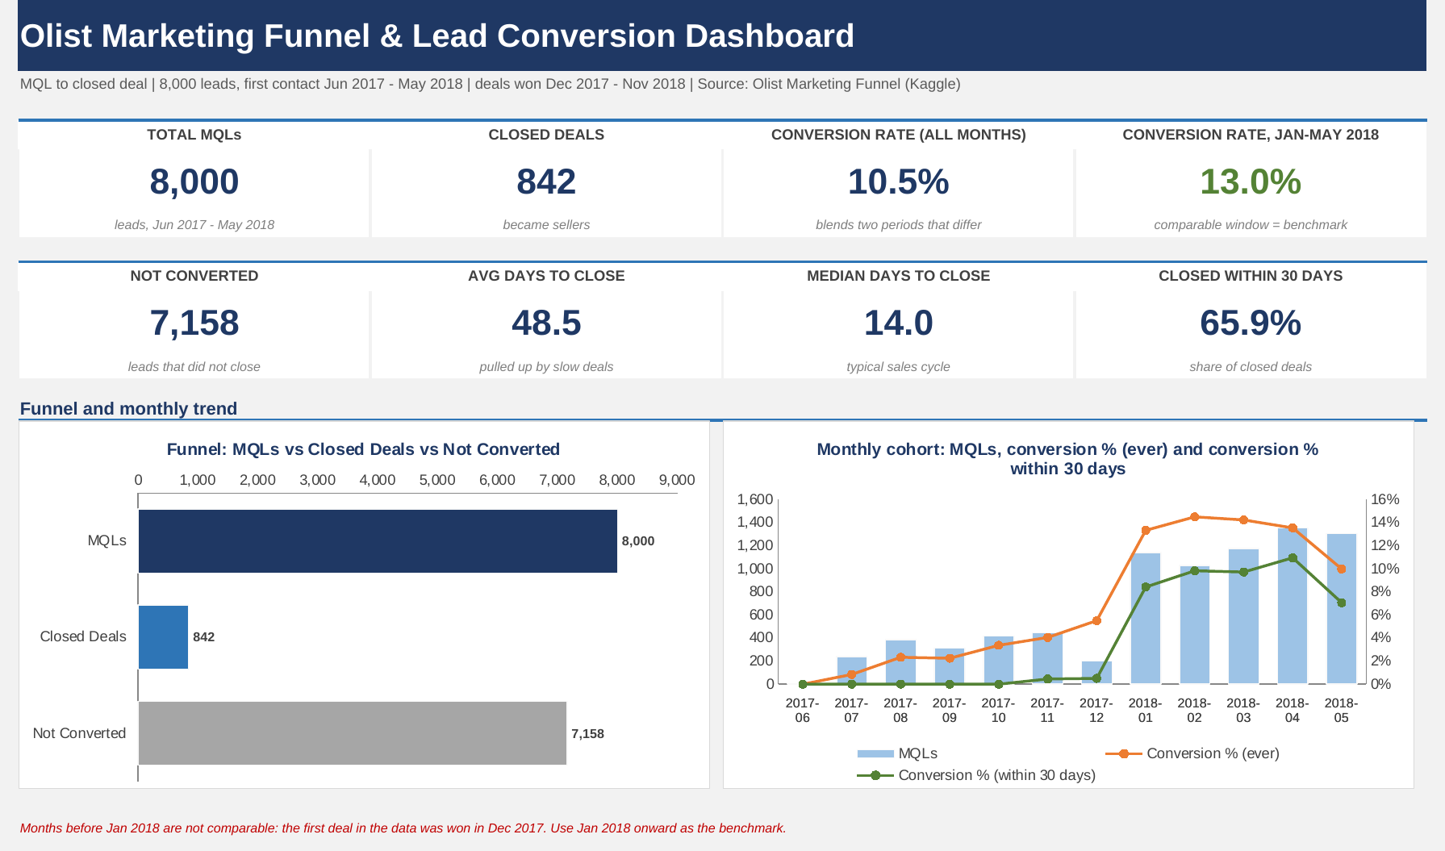
Figure 1: Excel dashboard (top): KPI cards, funnel and monthly cohort
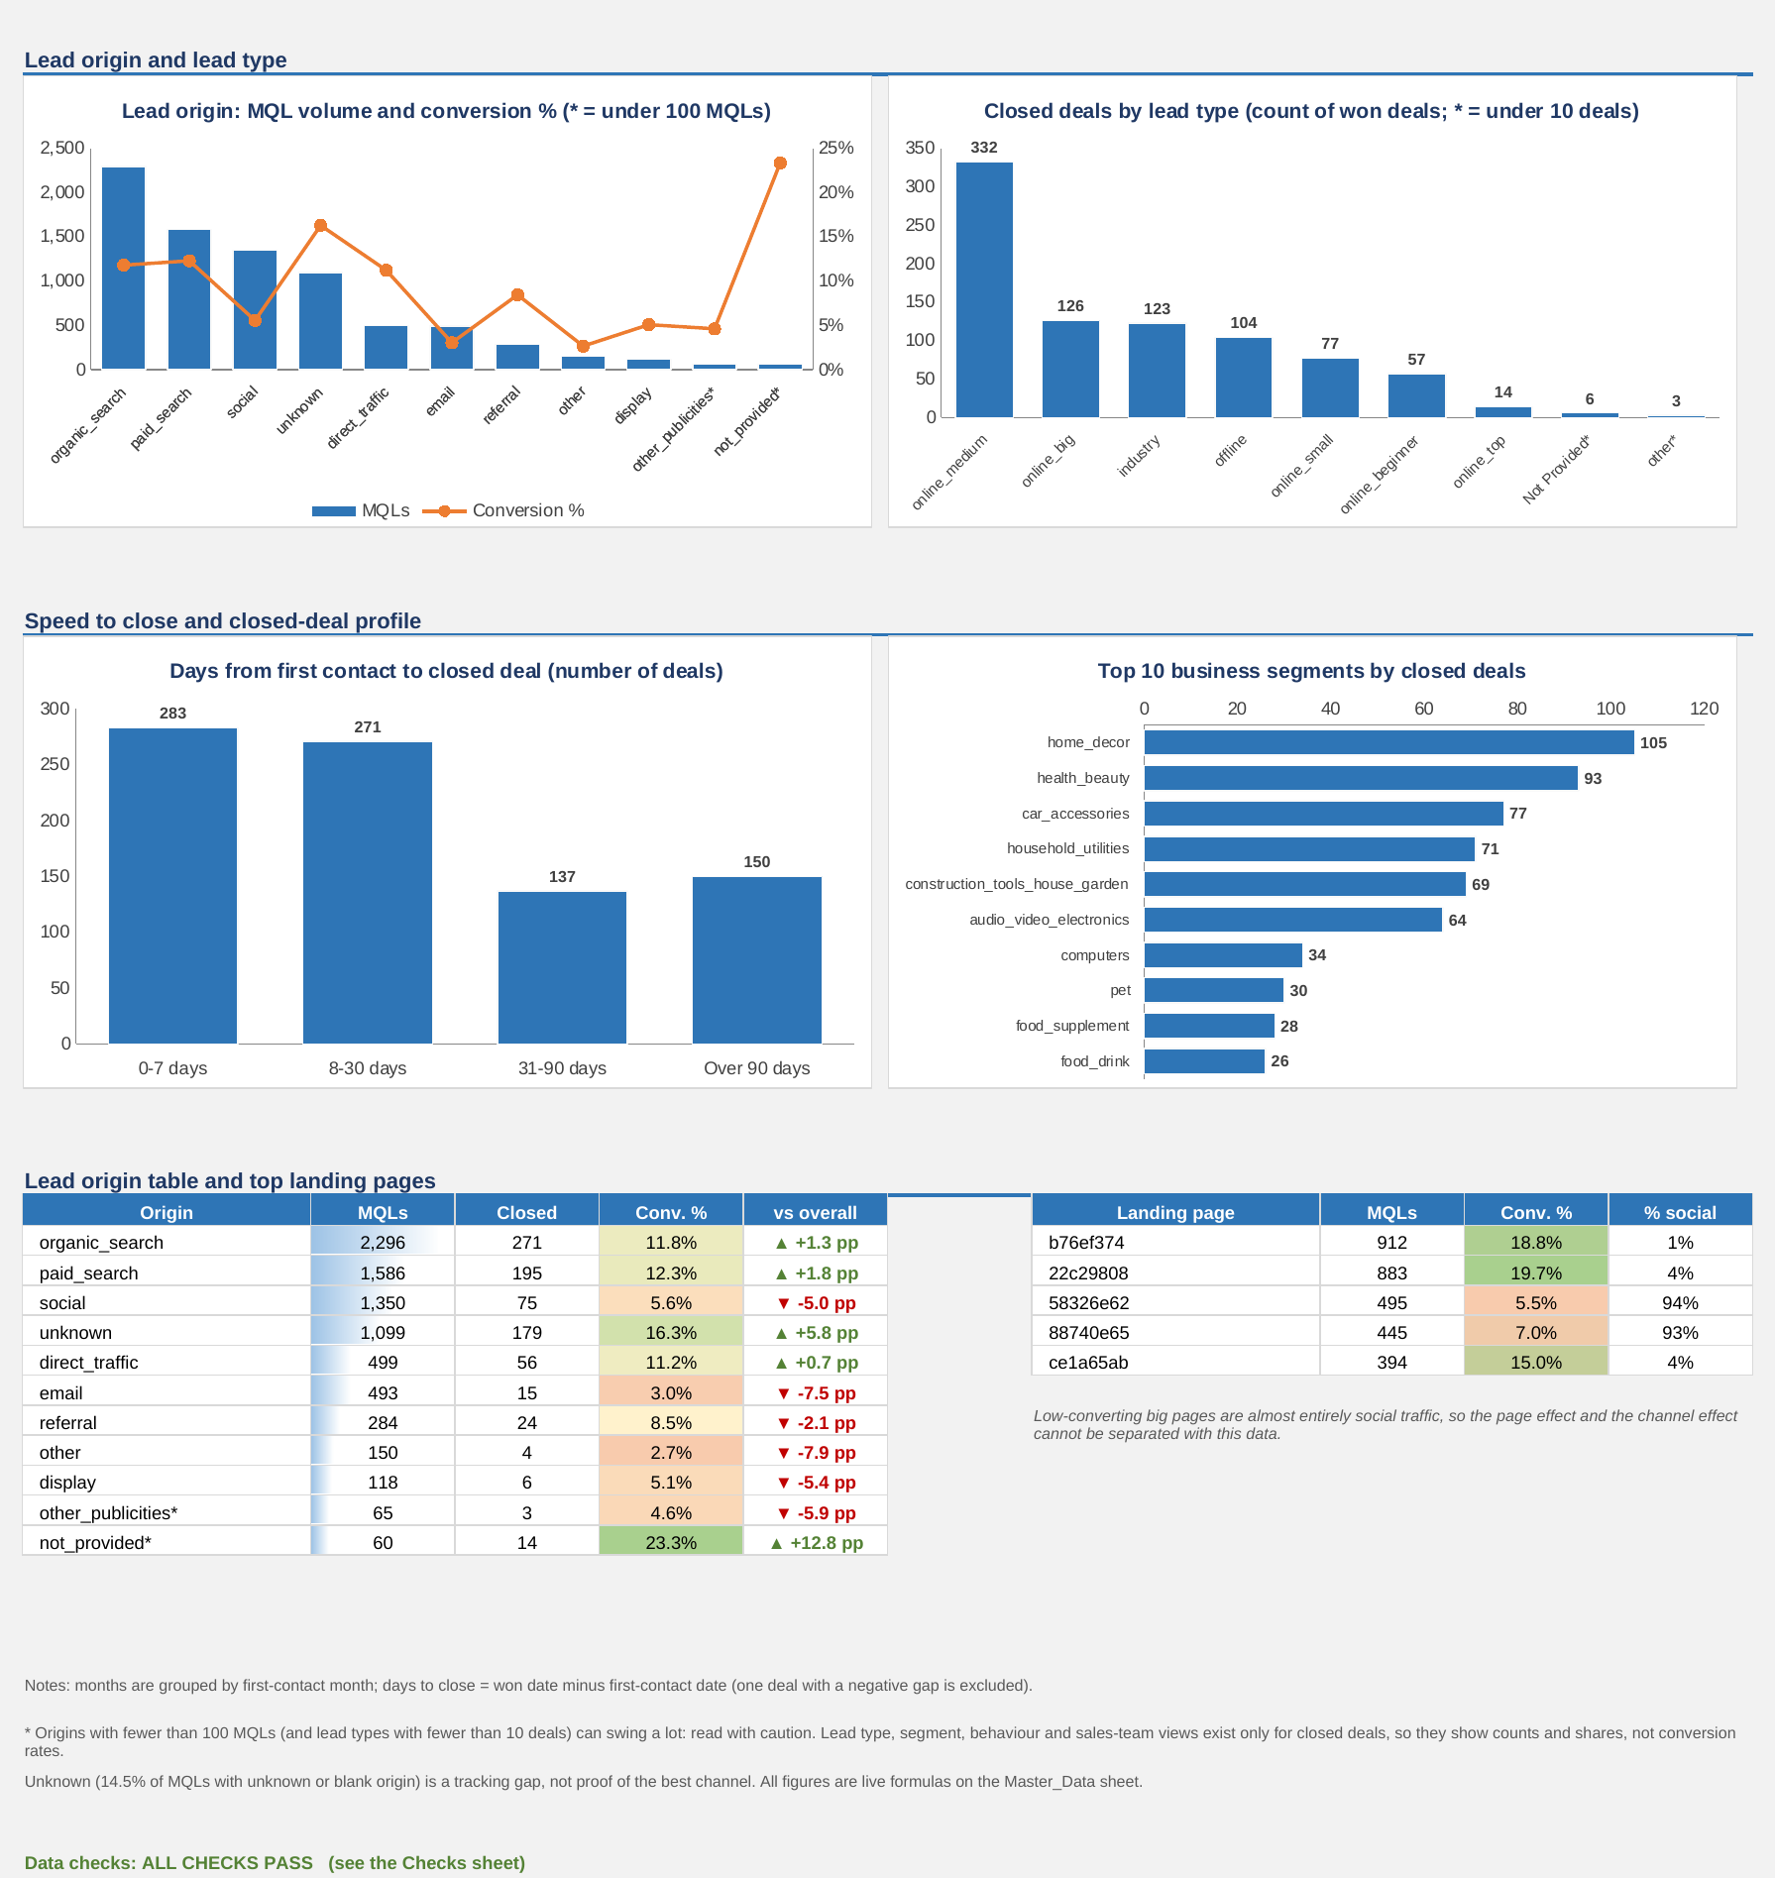
Figure 2: Excel dashboard (lower): lead origin, lead type, speed to close, segments and tables

13. Key Business Insights
# | Insight | Evidence
1 | Only about 1 in 10 leads becomes a closed deal | 842 of 8,000 = 10.5%; 7,158 not converted. Intermediate stages are not in the data, so the stage where leads leak cannot be identified.
2 | Early months are not comparable with later months | Jun-Dec 2017: 61 of 2,002 = 3.0%. Jan-May 2018: 781 of 5,998 = 13.0%. First deal won Dec 2017; MQL volume 200 → 1,141. The 10.5% headline blends both periods.
3 | Organic and paid search are the core channels | 48.5% of MQLs and 55.3% of closed deals; conversion 11.8% and 12.3%.
4 | Social and email have volume but low conversion | Social 1,350 MQLs at 5.6%; email 493 at 3.0%. Together 23.0% of MQLs but 10.7% of closed deals. Restricted to Jan-May 2018 the gap remains (social 6.3%, email 4.0% vs about 14.7% for organic and paid search).
5 | Origin tracking has a gap | 1,159 MQLs (14.5%) have unknown or blank origin; 193 closed (16.7%). This is a tracking problem, not evidence of the best channel.
6 | The sales cycle has a long tail | Median 14 days vs average 48.5. 65.9% close within 30 days; 17.8% take over 90 days.
7 | A few lead types make most closed deals | online_medium 332 deals (39.4%); top 3 types 69.0%. This is a share of won deals, not a conversion rate.
8 | Closed deals concentrate in a few segments | Top 5 segments = 49.3% (home_decor 105, health_beauty 93).
9 | Wolf-profile deals take longer | Median 36 days vs 13 (cat) and 10 (eagle); 21.0% of deals have no profile.
10 | Closed deals are concentrated among a few reps | 32 SDRs and 22 SRs; top 5 SDRs = 49.9%, top 5 SRs = 49.4%. Leads worked per person are not in the data, so this is workload, not performance.
Every figure above is reproduced by a live formula in the Insights sheet of the Excel workbook and by the SQL queries.

14. Business Recommendations
These are suggestions based on the observed patterns. They are not guaranteed to raise conversion and should be tested before changing budgets.
# | Recommendation | Based on | Owner | Success measure
1 | Review lead quality and follow-up for social and email before adding budget | Insight 4 | Marketing Manager | Conversion % by channel each month
2 | Keep organic and paid search as core channels; compare channels on volume and conversion together | Insight 3 | Marketing Manager | Share of closed deals; cost per closed deal (needs spend data)
3 | Improve origin tracking so unknown and blank origins can be attributed | Insight 5 | Sales / BI Operations | % of MQLs with unknown or blank origin (now 14.5%)
4 | Use Jan 2018 onward as the benchmark; confirm whether deal recording changed around Dec 2017; compare cohorts on a fixed window such as 30-day conversion | Insight 2 | BI team with data owners | Cohort conversion on a like-for-like window
5 | Set a follow-up checkpoint around 30 days; review 90+ day deals and slower profiles such as wolf separately | Insights 6, 9 | Sales Manager | % closed within 30 days (now 65.9%); share over 90 days (now 17.8%)
6 | Capture lead type and segment at the MQL stage | Insights 7, 8 | Sales Operations | Conversion rate by lead type and segment becomes measurable
7 | Check how deals are spread across SDRs and SRs; record leads worked per rep | Insight 10 | Sales Manager | Conversion per rep; allocation balance

15. Business Impact (illustrative)
The data has no revenue per deal and no marketing spend (declared revenue is 0 for 95% of deals), so a financial return cannot be calculated. The scenario below uses deal counts only and is not a forecast.
In the comparable Jan-May 2018 window, social and email brought 1,398 MQLs and 80 closed deals (5.7%), while organic and paid search converted at 14.7%. If social and email conversion rose to:
Assumed conversion for social + email | Extra closed deals (5 months) | Increase on the 781 deals in the window
8% | about 32 | about +4%
10% | about 60 | about +8%
12% | about 88 | about +11%

Caution: these channels may not be able to reach these rates, and improving lead quality has a cost. Use the scenario to size the opportunity, not to promise a result.
Other benefits: one agreed set of funnel KPIs, earlier detection of conversion drops, and a clear list of data to capture (leads worked per rep, stage dates, marketing spend).

16. Limitations
- Only two funnel stages (MQL and closed deal) exist. Contacted and consultancy stages are not in the data, so the stage where leads leak cannot be identified.
- Lead type, segment, behaviour profile, SDR and SR exist only for closed deals, so those views show shares of won deals, not conversion rates, and reps cannot be ranked.
- The first deal was won in Dec 2017 and MQL volume changes sharply in Jan 2018, so months before 2018 are not comparable. Cohorts that first made contact later have had less time to close deals.
- About 92% of questionnaire fields are blank and revenue is mostly 0, so these fields are not used.
- The unknown and blank origin group (14.5% of MQLs) limits channel attribution.
- No marketing cost or revenue per deal, so no cost-per-deal or ROI. Origin differences are observational and do not prove cause.
- landing_page_id is available for every lead but was not analysed. It is closely tied to origin (the two largest low-converting pages are about 94% social traffic), so any landing-page analysis must be read together with origin.

17. Business Analyst Deliverables

17.1 Business requirement summary (BRD)
Item | Detail
Business need | A trusted, repeatable view of lead conversion, lead-source performance and sales-cycle length.
Scope (in) | Conversion analysis from MQL to closed deal in Python and SQL, an Excel dashboard, insights and recommendations.
Scope (out) | Prediction models, marketing cost and revenue analysis, rep performance ranking.
Success criteria | KPIs agree between Python, SQL and Excel; stakeholders can answer the 7 business questions from the dashboard.
Assumptions | A lead is converted if a closed-deal record exists; won date is the end of the sales clock; origin values are as recorded.

17.2 Functional requirements (FRD summary)
ID | Requirement
FR-1 | Dashboard shall show 8 KPI cards: total MQLs, closed deals, conversion rate (all months), conversion rate Jan-May 2018, non-converted, average days, median days and % closed within 30 days.
FR-2 | Dashboard shall show the funnel and the monthly cohort (MQLs, closed deals, conversion %).
FR-3 | Dashboard shall show MQL volume and conversion % by lead origin, with a comparison to the overall rate.
FR-4 | Dashboard shall show closed deals and average days to close by lead type.
FR-5 | Views based on closed deals only shall state that they are counts or shares, not conversion rates.

17.3 User stories and acceptance criteria
User story | Acceptance criteria
As a Marketing Manager, I want conversion by lead origin so that I can decide which channels to fund. | Origin chart and table show all origins; social shows 5.56% and paid search 12.30%.
As a Sales Manager, I want the typical time to close so that I can set a follow-up checkpoint. | Median 14.0 and average 48.5 days are shown; time bands add to 842 deals less one excluded.
As Senior Management, I want one page of funnel KPIs so that I can check health quickly. | KPI cards show 8,000, 842, 10.5%, 13.0%, 7,158, 48.5, 14.0 and 65.9%.
As a BI analyst, I want caveats shown so that nobody misreads the cohort trend. | Notes and the Insights sheet state that early months are not comparable.

17.4 As-Is vs To-Be
 | As-Is | To-Be
Funnel view | Lead and deal counts are not tied together. | One master table links every MQL to its outcome.
Channel decisions | Judged by lead volume. | Judged by volume and conversion together.
Sales cycle | Average only, distorted by slow deals. | Median and time bands with a 30-day checkpoint.
Data | Unknown origin and missing stage data. | Origin tracking and stage dates captured.
To-Be process flow: MQL and closed-deal data → cleaning and join → KPIs and cohorts → Excel dashboard → monthly review → channel and follow-up actions → re-measure conversion.

17.5 Stakeholder matrix
Stakeholder | Influence | Interest | How to engage
Head of Sales | High | High | Monthly funnel review
Marketing Manager | High | High | Channel results and tracking fixes
SDR / SR team leads | Medium | High | Follow-up timing and allocation
BI / Data team | Medium | High | Owns data, KPIs and dashboard
Senior Management | High | Medium | Summary KPIs

17.6 Risk register
Risk | Impact | Mitigation
Early cohorts read as real improvement | Wrong conclusion about performance | Annotate cohort chart; use Jan 2018 onward as benchmark
Small origins show extreme rates (for example not_provided, n = 60) | Over-reading noise | Flag origins under 100 MQLs
Closed-deal views read as conversion rates | Wrong segment decisions | Label as counts and shares
Unknown origin treated as best channel | Misdirected budget | Fix tracking before using it
SDR/SR shares read as performance | Unfair people decisions | Record leads worked per rep first
Pivot tables not refreshed | Pivot view shows stale values | Pivots refresh on open; dashboard uses live formulas; Checks sheet reconciles pivot totals

18. Conclusion, Tools & Deliverables
About 1 in 10 Olist leads becomes a closed deal. Organic and paid search are the strongest sources at about 12% conversion, while social (5.6%) and email (3.0%) bring volume but convert poorly. Half of deals close within two weeks, but a long tail of slow deals pulls the average up to 48.5 days. Two cautions matter for decisions: months before 2018 are not comparable with later ones, and lead type, segment and sales-team views describe won deals only, not conversion. The recommendations are based on observed patterns and should be tested before changing budgets.

Tools & technologies
- Python (Google Colab): Pandas, NumPy for cleaning, joins, KPIs, cohorts and exports
- SQL (MySQL 8 syntax): LEFT JOIN view, CASE, GROUP BY, CTEs, window functions (ROW_NUMBER) and subqueries
- Excel: native PivotTables, live formulas, charts, conditional formatting and a self-checking Checks sheet

Project deliverables
- python/Olist_Funnel_Analysis_Colab.ipynb (Python and SQL notebook)
- sql/01 to 04 (MySQL scripts: tables, load, quality checks, 12 analysis queries)
- excel/Olist_Funnel_Dashboard.xlsx (dashboard, 6 PivotTables, Checks) and dashboard_screenshot.png
- data/raw, data/cleaned, data/query_results and data_dictionary.csv
- This project report and the GitHub README

