INDIAN RAILWAY DELAY ANALYTICS
Which factors are associated with Indian Railway journey delays?
Project Simulation / Business Case | Data Analyst & Business Analyst Portfolio Project
Tools: Python (pandas, seaborn) · SQL (DuckDB) · Power BI
Dataset: ir_train.csv — 1,500,000 journeys · 45 columns · Jan 2018 – Dec 2024
Prepared by: Saniya Saratkar
Date: September 2026

1. Company / Business Background
This project simulates the role of a Data Analyst supporting a railway operations analytics function. Indian Railways is one of the largest rail networks in the world, organized into 16+ operating zones, running Mail/Express, Superfast, Passenger and premium services (e.g., Vande Bharat, Rajdhani, Shatabdi) across widely varying distances and terrains.
Punctuality is a core operational metric for any passenger rail network: it affects passenger satisfaction, connecting-service reliability, crew and rolling-stock scheduling, and network congestion. Delay analytics — measuring where, when, and under what conditions delays are more likely — gives operations teams an evidence base for prioritizing investigation and improvement effort, instead of relying on anecdote.
This project uses a large (1.5 million row) simulated journey-level dataset that mimics the structure of real railway operations data (zones, train types, seasons, infrastructure attributes) to demonstrate a complete, portfolio-ready analytics workflow: Python for cleaning/EDA, SQL for business queries, and Power BI for an executive-facing dashboard.

2. Business Problem
How can railway operations teams identify and understand recurring journey delay patterns using historical journey data?

Current problem
Delay information exists at the individual-journey level but is not aggregated into a form operations managers can act on — there is no single view showing which zones, seasons, train types, or infrastructure conditions are most associated with delay.

Business consequence
Without a prioritized, evidence-based view of where delays concentrate, operational review effort is spread thinly instead of being targeted at the highest-impact zones and conditions.

Analytics requirement
A repeatable pipeline that cleans the journey data, calculates standard delay KPIs, segments performance by zone/season/train type/infrastructure, and presents this through an interactive dashboard.

Scope
Scope is limited to what the dataset actually contains: journey-level delay outcomes and their associated categorical/numeric attributes. The project does not model cost, revenue, or passenger-level impact, as those fields are not present in the data.

3. Business Objectives
- Measure overall network delay performance (delay rate, average delay, severity mix).
- Identify which railway zones show the highest and lowest delay rates.
- Quantify seasonal delay patterns (e.g., Monsoon vs. Summer).
- Compare delay performance across train types/segments (premium vs. regular).
- Assess whether infrastructure attributes (double track, electrification, traction type) relate to delay rate.
- Identify the delay causes most frequently recorded against delayed journeys.
.

4. Stakeholders
Stakeholder | What they need | Why | Dashboard / report
Senior Management | Headline delay KPIs, trend | High-level performance oversight | Executive Overview page
Operations Manager | Zone & train-type breakdown | Prioritize operational review | Operational Performance page
Zone Manager | Own zone's delay rate & rank | Track zone-level accountability | Operational Performance page (filtered)
Scheduling Team | Time-of-day & season patterns | Adjust schedules/buffers | Root-Cause Analysis page
Analytics Team | Underlying tables & correlations | Validate & extend the analysis | All pages + exported CSVs

5. Business KPIs
KPI | Formula | Columns used | Why it matters
Delay Rate % | AVG(is_delayed) × 100 | is_delayed | Headline punctuality measure
On-Time % | 100 − Delay Rate % | is_delayed | Inverse framing for exec reporting
Avg Delay (minutes) | AVG(delay_minutes) | delay_minutes | Typical lateness magnitude
Severe Delay Share % | % of journeys with delay_minutes > 120 | delay_minutes | Flags the worst-case tail
Zone Delay Rank | RANK() OVER (ORDER BY AVG(is_delayed) DESC) | zone, is_delayed | Prioritizes zones for review

6. Domain Knowledge
Term | Meaning | In this dataset?
Zone | One of Indian Railways' 16+ regional operating divisions (e.g., NR, WR, SR) | Yes — zone, zone_abbr
Rake | The full set of coaches/wagons forming a train | Partially — late_incoming_rake, is_rake_shared flags
PSR | Permanent Speed Restriction — a fixed slow-down zone on track (maintenance/safety) | Yes — psr_count
HDN Route | High-Density Network route — heavily trafficked corridor | Yes — is_hdn_route
Traction type | Power source of the locomotive (Electric / Diesel / Dual) | Yes — traction_type
Track doubling | Whether a route has two parallel tracks (vs. single line) | Yes — track_doubled

7. Dataset Overview
Attribute | Value
File name | ir_train.csv
Rows | 1,500,000
Columns | 45
Date range | 2018-01-01 to 2024-12-30
Missing values | 0 (across all columns)
Duplicate rows | 0
Unique journey_id | 1,500,000 (fully unique — one row per journey)
Unique train numbers | 6,293
Zones | 16
Target/outcome variable | is_delayed (binary) and delay_minutes (continuous)
Dataset type | Synthetic / simulated — not an official Indian Railways operational extract

8. Data Dictionary (key columns)
Column | Type | Meaning | Used?
journey_id | Text | Unique ID per journey | Identifier only
train_number / train_type | Num / Text | Train ID and service class | Yes — segmentation
departure_date, year, month, day_of_week, departure_hour | Date/Num | Journey timing | Yes — time analysis
zone, zone_abbr | Text | Operating zone | Yes — primary segmentation
season, is_monsoon_season, is_fog_risk | Text/Num | Seasonal context | Yes — root-cause
distance_km, scheduled_travel_hours, num_scheduled_stops | Num | Journey scale | Yes — distance banding
track_doubled, is_electrified, traction_type, is_hdn_route | Num/Text | Infrastructure | Yes — infra analysis
fog_risk_score, zone_congestion_index, season_severity_score, maintenance_score, route_historical_ontime_pct | Num | Modeled risk indices | Yes — correlation analysis
primary_delay_cause | Text | Recorded reason for delay (delayed rows only) | Yes — cause analysis
delay_minutes, is_delayed | Num | Outcome variables | Yes — target KPIs
is_circular_route, has_lhb_coaches, is_rake_shared, is_special_train | Num (flags) | Additional operational flags | Not used — low variance / outside project scope

9. Business Questions
- What is the network's overall delay rate and average delay, and how severe is the typical delay?
- Which zones show consistently higher delay rates and therefore warrant operational investigation first?
- Which season(s) are associated with the sharpest rise in delays, and by how much?
- Do premium/long-distance train types perform meaningfully better than regular services?
- Does time of day meaningfully affect delay likelihood?
- Which recorded causes account for the largest share of delayed journeys?
- Do infrastructure attributes (double track, electrification) relate to a lower delay rate?

10. SQL Analysis
All queries run against the cleaned dataset using DuckDB directly inside the Colab notebook (Section 11). Full runnable SQL is in the notebook; representative queries are summarized below.
# | Business question | SQL concept(s) | Key result
1 | Delay rate by zone, ranked | GROUP BY, window function RANK() | ER highest (89.3%), SWR lowest (50.2%)
2 | Delay rate by season | GROUP BY, ORDER BY | Monsoon 92.8% vs. Summer 48.6%
3 | Delay rate by train type/segment | GROUP BY, CASE WHEN | Passenger Train 88.0% vs. Vande Bharat 44.3%
4 | Delay rate by time of day | GROUP BY, HAVING | Flat: 70.9%–74.7% across windows
5 | Top recorded delay causes | WHERE filter, % of total | Track Congestion 22.4%, Flooding 19.4%
6 | Delay rate by infrastructure combo | Multi-column GROUP BY | Single-track/non-electrified 87.3% vs. double-track/electrified 65.0%
7 | Delay rate by distance band | CTE, CASE WHEN banding | Short trips 79.4% vs. Very Long 65.5%
8 | Worst train × zone combinations, ranked by Wilson lower-bound confidence (min. 20 journeys) | CTE + window RANK() + statistical confidence interval | Surfaces specific train/zone pairs for drill-through, corrected for small-sample bias (see note below)

Data-quality finding worth documenting: the Query 8 tie bug
The first version of Query 8 ranked train×zone pairs by raw delay_rate_pct and returned a Top-20 table where every row was tied at exactly 100.00%. Investigation showed the root cause: no (train_number, zone_abbr) combination in this dataset has more than 62 recorded journeys, so a small group hitting "100% delayed" happens by chance far more easily than in a large sample — a classic small-sample-size ranking bias, not a code error. The fix ranks on a Wilson 95% lower-confidence-bound of the delay rate instead of the raw percentage, which only rewards a high rate when it's backed by enough observations. This is documented here deliberately — catching and correctly explaining a bug like this is exactly the kind of judgment an interviewer is testing for.

11. Python Analysis
Libraries used: pandas and numpy (data handling), matplotlib and seaborn (EDA visuals), duckdb (SQL queries on the DataFrame). No unused imports.
Step | What it does | Business reason
Load & inspect | Read CSV, check shape/dtypes/date range | Confirm what the data can and cannot answer
Data quality checks | Missing values, duplicates, range checks | Establish the dataset is clean and understand is_delayed's derivation
Cleaning | Standardize dtypes (category/int8) | Faster, consistent grouping downstream
Feature engineering | delay_category, time_of_day, day_name, distance_band, route_category | Turn raw fields into business-readable segments
EDA | Histograms, bar charts, correlation heatmap | Visually confirm zone/season patterns before formal KPI work
KPI calculation | Delay rate, avg delay, severe-delay share | Headline numbers for the Executive dashboard page
Export | Write 11 CSVs to outputs/ | Feed Power BI without re-running Python each time

11.1 EDA Visual Evidence
These are the actual charts produced by the notebook against the real 1.5M-row dataset (Section 9 of the notebook) — not mockups. They are the visual proof behind the KPI tables in Sections 10 and 13.
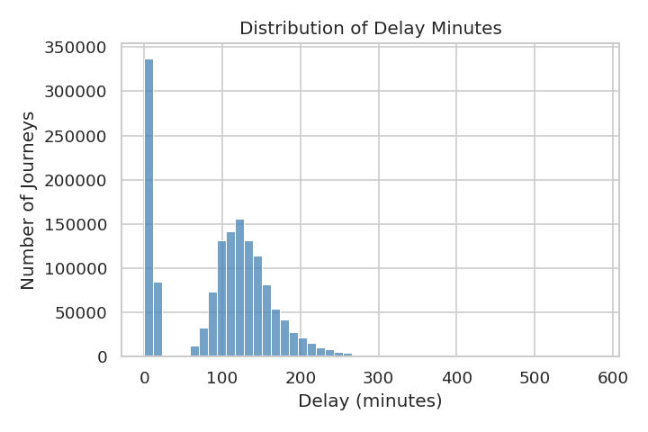
Figure 1: Distribution of delay minutes — a clear on-time cluster under 15 minutes plus a wide delayed tail.
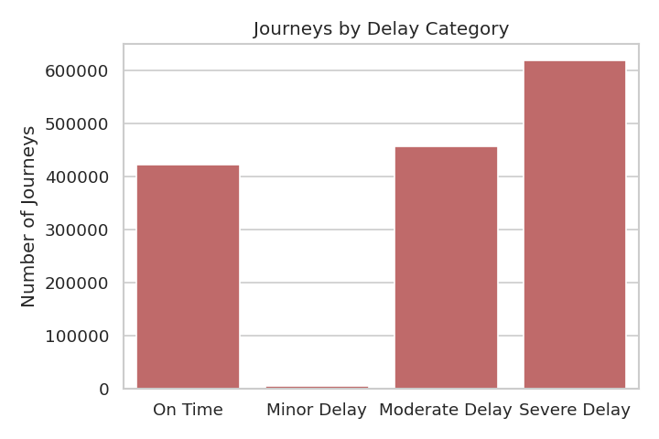
Figure 2: Journeys by delay category (On Time / Minor / Moderate / Severe) — Severe Delay is the single largest bucket.
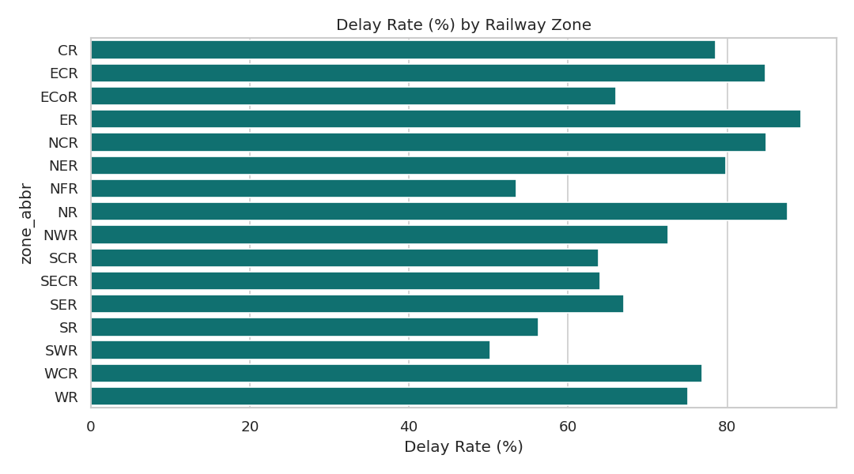
Figure 3: Delay rate (%) by railway zone, sorted descending — the basis for the zone-prioritization recommendation.
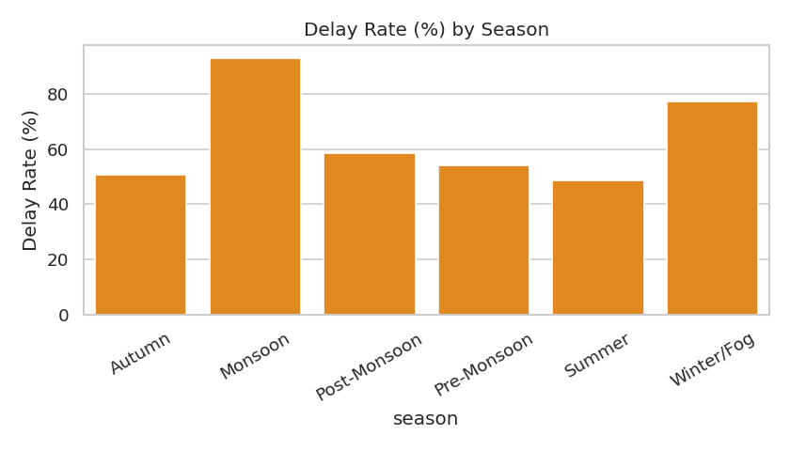
Figure 4: Delay rate (%) by season — Monsoon standing well above every other season.
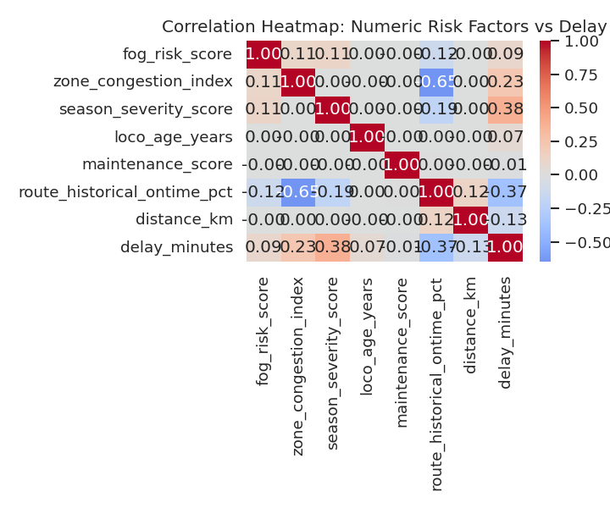
Figure 5: Correlation heatmap of numeric risk factors against delay minutes.

12. Power BI Dashboard
The dashboard was built in Power BI Desktop directly from the CSVs exported in Section 13. Every KPI card and chart below was checked against the matching Python/SQL output and matches exactly (e.g., Page 1's cards read 71.89% / 97.73 / 41.19% / 1.50M — identical to kpi_summary.csv). Full build steps are in the companion file PowerBI_Dashboard_Complete_Guide.docx. For each page, the text below calls out the one chart carrying that page's main business message, rather than re-describing every visual on the canvas.

Page 1 — Executive Overview
Key chart: Delay Rate by Zone. The four KPI cards give senior management the headline number, but the zone bar chart is what turns that number into an action — ER (89.32%), NR (87.56%), NCR (84.95%) and ECR (84.77%) sit clearly above the rest, which is the entire basis for Recommendation 1 in Section 14.
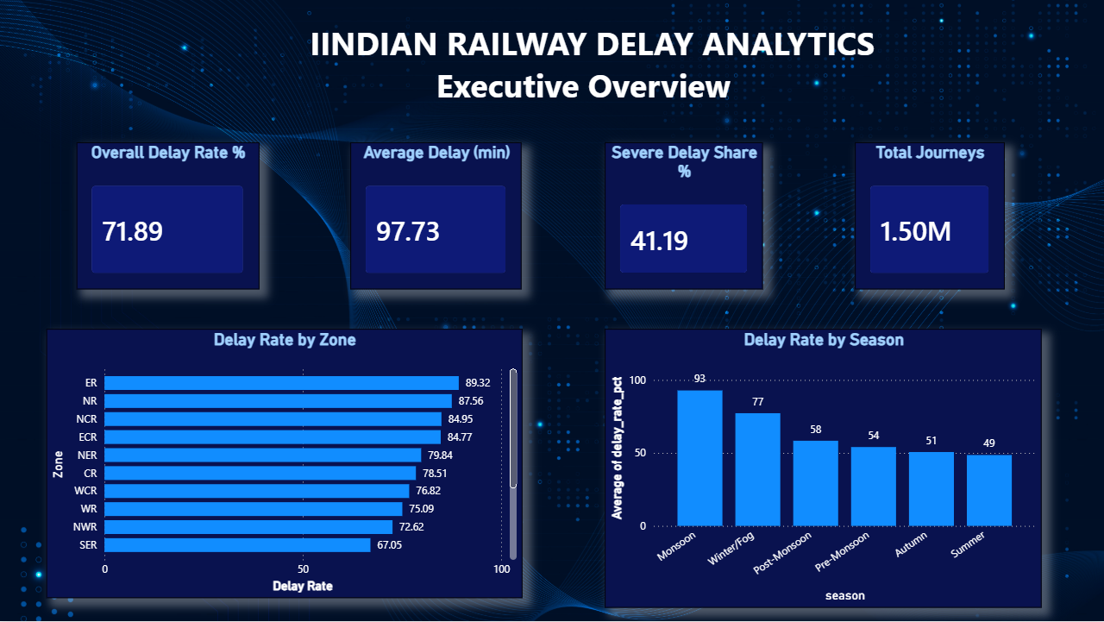
Figure 6: Power BI — Page 1: Executive Overview. KPI cards match kpi_summary.csv exactly.

Page 2 — Operational Performance
Key chart: Delay Rate by Train Type. It is the sharpest, most decision-useful split on this page — Passenger Train (88%) versus Jan Shatabdi Express (63%) is a 25-point gap purely from service class, directly supporting continued investment in premium/express services over regular passenger and DEMU/MEMU services.
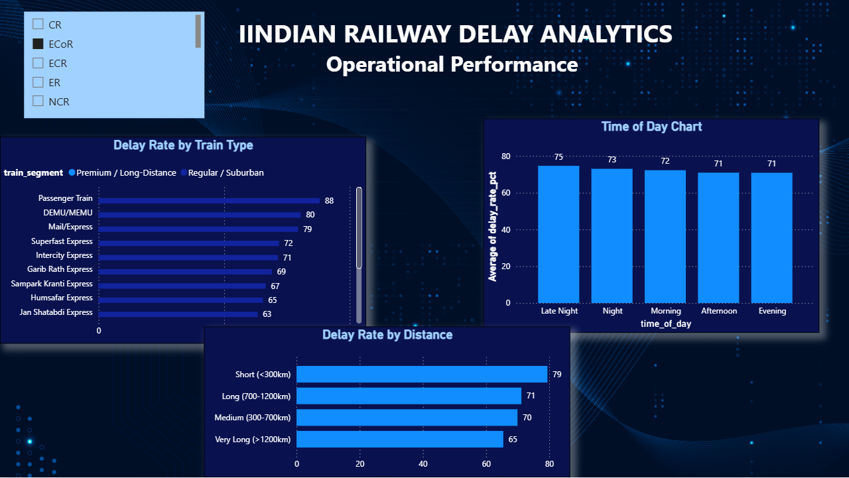
Figure 7: Power BI — Page 2: Operational Performance. Train-type, time-of-day and distance-band breakdowns, with the zone slicer open at top-left.

Page 3 — Delay Pattern / Root-Cause Analysis
Key chart: Delay Rate by Infrastructure. Track Congestion tops the recorded-cause list (22%), but the infrastructure chart is the more actionable one: Diesel traction on non-doubled track runs an 87% delay rate versus 65% for doubled-track Electric/Dual traction — a concrete, capital-planning-relevant pattern rather than just a list of causes.
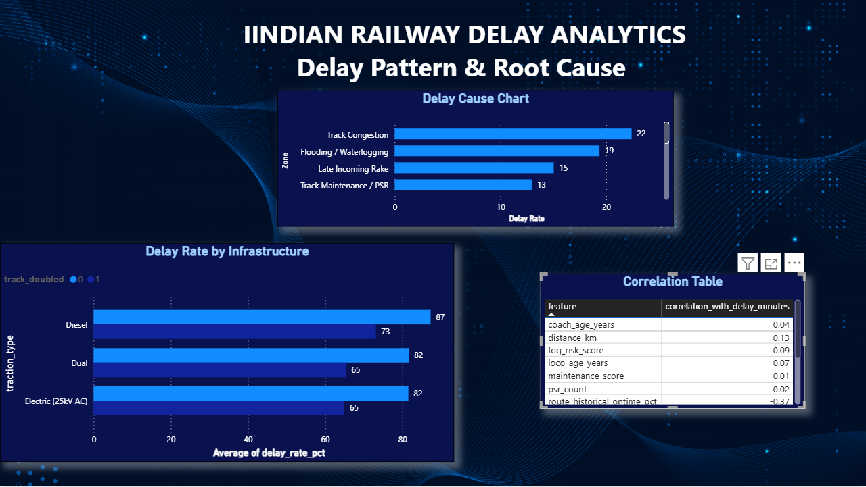
Figure 8: Power BI — Page 3: Delay Pattern / Root-Cause Analysis. Delay causes, infrastructure comparison, and the correlation table.

Page 4 — Management Insights
Key element: the worst-performing train × zone table. This table originally shipped with a bug — every row showed exactly 100% — traced to a small-sample-size ranking artifact (full root-cause writeup in Section 10). The query was corrected to compute a Wilson 95% confidence-bound (wilson_lower_bound_pct, visible as the right-most column below), which is the field that should drive the table's sort order and any further prioritization.
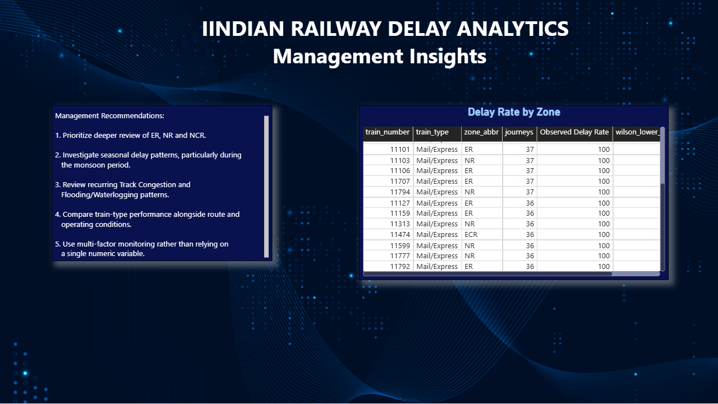
Figure 9: Power BI — Page 4: Management Insights. Worst train/zone table (now carrying the corrected wilson_lower_bound_pct column) and written recommendations.
Outstanding polish item, noted here rather than hidden: this table is still visually sorted by train_number and the wilson_lower_bound_pct column is cut off on the right. The underlying data is correct (verified in Section 10); before sharing the dashboard externally, widen that column and sort by rnk ascending so the ranking is visible, not just present. The visual's title ("Delay Rate by Zone") is also a leftover default and should be renamed to "Top Worst-Performing Trains."

Page 5 — Zone Detail (drill-through)
Key proof point: this page is reached only by clicking a zone bar on Page 1 — the screenshot below was captured after clicking NCR, and the table correctly filters to just the 3 NCR trains from the worst-performers list. This confirms the drill-through interaction works end-to-end, not just that the underlying table exists.
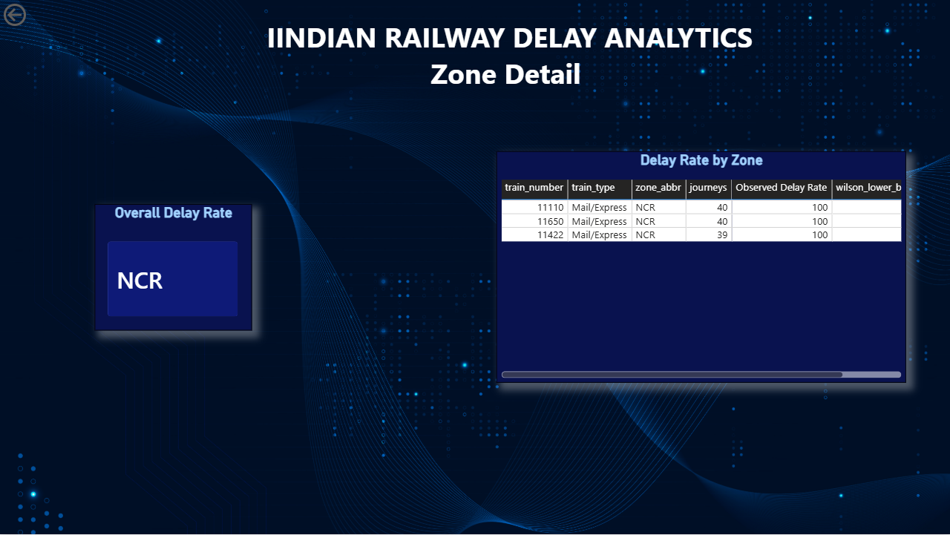
Figure 10: Power BI — Page 5: Zone Detail, drilled through from Page 1 with NCR selected.

13. Key Insights
# | Finding | Evidence
1 | Overall delay rate is 71.9%, average delay 97.7 minutes across all journeys. | kpi_summary.csv
2 | Zone is a major differentiator: ER (89.3%) vs. SWR (50.2%) — a 39-point spread. | zone_analysis.csv
3 | Season is the single strongest categorical driver: Monsoon (92.8%) vs. Summer (48.6%) — a 44-point spread. | season_analysis.csv
4 | Premium trains outperform regular services sharply: Vande Bharat (44.3%) vs. Passenger Train (88.0%). | train_type_analysis.csv
5 | Time of day has almost no effect on delay likelihood (70.9%–74.7% range). | time_analysis.csv
6 | Infrastructure matters: double-track + electrified journeys show a 65.0% delay rate vs. 87.3% for single-track, non-electrified diesel. | infra_analysis.csv
7 | Track Congestion (22.4%) and Flooding/Waterlogging (19.4%) are the two most-recorded delay causes. | delay_cause_analysis.csv
8 | No single numeric risk factor dominates — the strongest correlations (season_severity_score, route_historical_ontime_pct) are moderate (~±0.38). | correlation_analysis.csv

14. Business Recommendations

Recommendation 1 — Prioritize the highest-delay zones for operational review
- Finding: ER, NR, and NCR all show delay rates above 84%, well above the 71.9% network average.
- Evidence: zone_analysis.csv, SQL Query 1 (Section 10).
- Business implication: A disproportionate share of network-wide delay is concentrated in a small number of zones.
- Recommendation: Operations leadership should commission a deeper root-cause review (infrastructure, congestion, staffing) in ER, NR, and NCR before other zones.
- Limitation: The dataset shows that these zones are worse, not the specific operational cause within each zone.

Recommendation 2 — Build a Monsoon-specific operating plan
- Finding: Monsoon-season delay rate (92.8%) is 44 points above Summer (48.6%); Flooding/Waterlogging is the #2 recorded cause overall (19.4% of delays).
- Evidence: season_analysis.csv, delay_cause_analysis.csv.
- Business implication: A large, predictable share of annual delay is concentrated in one season.
- Recommendation: Pre-position maintenance and drainage resources ahead of Monsoon season, and consider wider scheduling buffers for that period.
- Limitation: The dataset does not identify which specific locations flood; only that the season is strongly associated with delay.

Recommendation 3 — Continue investing in double-track and electrified infrastructure
- Finding: Single-track, non-electrified diesel journeys show an 87.3% delay rate vs. 65.0% for double-track, electrified journeys — a 22-point gap.
- Evidence: infra_analysis.csv, SQL Query 6.
- Business implication: Infrastructure investment shows the largest measurable association with delay outcomes among the operational factors tested.
- Recommendation: When prioritizing capital projects, weight track-doubling and electrification of still-single-track / diesel routes highly.
- Limitation: This is an association across many routes, not a controlled before/after study of a specific upgrade.

Recommendation 4 — Do not prioritize time-of-day rescheduling as a delay-reduction lever
- Finding: Delay rate is nearly flat across time-of-day windows (70.9%–74.7%).
- Evidence: time_analysis.csv, SQL Query 4.
- Business implication: Effort spent re-timing departures is unlikely to move the delay rate meaningfully, based on this data.
- Recommendation: Deprioritize time-of-day-based interventions in favor of zone- and season-focused ones.
- Limitation: Peak-hour congestion effects specific to individual stations are not captured at this aggregation level.

Recommendation 5 — Use Track Congestion and Late Incoming Rake as the top two operational causes to address
- Finding: Track Congestion (22.4% of delays) and Late Incoming Rake (15.0%) are the top two operational (non-weather) causes.
- Evidence: delay_cause_analysis.csv.
- Business implication: These two causes together account for over a third of all recorded delayed journeys.
- Recommendation: Scheduling and rake-management teams should specifically target incoming-rake punctuality and congestion hotspots identified in the zone-level breakdown.
- Limitation: The dataset records one primary cause per journey; secondary/contributing causes are not captured.

Recommendation 6 — Start train-level physical inspection with the single highest-confidence problem train
- Finding: after correcting the worst-train ranking for small-sample bias (Section 10), train 11821 (Mail/Express, ER zone) ranks #1 with a 95%-confidence Wilson lower bound of 91.62% — the highest of any train×zone pair in the network, backed by 42 observed journeys (the largest sample among the tied 100%-raw-rate group).
- Evidence: top_worst_trains.csv, Query 8 (Section 10); reproduced live on the Power BI Management Insights page (Section 12, Page 4).
- Business implication: unlike the other 100%-raw-rate trains in the list, this one's poor performance is the least likely to be a statistical fluke — it is the single best-justified starting point for a physical rake/route inspection.
- Recommendation: schedule the first field investigation on train 11821 in the ER zone, then work down the Wilson-ranked list (not the raw-percentage list) for subsequent inspections.
- Limitation: 42 journeys is still a modest sample in absolute terms; treat this as the best-justified starting point for investigation, not as statistical proof that this specific train is the network's single worst performer in any future period.

15. Business Impact / ROI
The dataset contains no cost, revenue, or passenger-count fields, so no monetary ROI is estimated or invented. The measurable operational impact of this project is:
- Faster identification of high-delay zones and seasons through a single dashboard instead of manual review.
- A repeatable, evidence-based prioritization method for where to invest operational review effort.
- A documented, defensible basis (KPI + SQL query + chart) behind every recommendation, useful for planning and audit.

16. Business Analyst Deliverables

16.1 Business Requirements Document (BRD) — Summary
Section | Content
Background | See Section 1 — Company / Business Background
Problem | See Section 2 — Business Problem
Objectives | See Section 3 — Business Objectives
Scope | Journey-level delay outcomes and their categorical/numeric attributes only
Stakeholders | See Section 4
Requirements | Cleaned dataset, KPI tables, SQL business queries, 4-page Power BI dashboard
KPIs | See Section 5
Assumptions | Dataset fields are internally consistent and represent one row per journey
Constraints | No financial/passenger data; Colab compute; free-tier Power BI Desktop

16.2 Functional Requirements Document (FRD) — Summary
- The dashboard must load all summary CSVs exported by the notebook without manual edits.
- Zone, season, and train-type slicers must be available on the Operational and Root-Cause pages.
- KPI card values must match the Python/SQL output exactly (validation step in the Power BI guide).
- A drill-through from the zone chart to the worst-train table must be available on the Management Insights page.

16.3 User Stories & Acceptance Criteria
As an Operations Manager, I want to see delay rate ranked by zone so that I can prioritize which zones to investigate first.
Given the zone_analysis table is loaded, When I open the Executive Overview page, Then zones are displayed ranked from highest to lowest delay rate.
As a Scheduling Team member, I want to see delay rate by season and time-of-day so that I can judge whether schedule buffers should change seasonally.
Given the season_analysis and time_analysis tables are loaded, When I open the Root-Cause page, Then I can compare delay rate across seasons and time windows side by side.

16.4 As-Is vs. To-Be Process
As-Is: Delay information exists only at the raw journey level; there is no aggregated, prioritized view — any pattern identification is manual and ad hoc.
To-Be: A repeatable Python → SQL → Power BI pipeline produces a standing, refreshable dashboard that ranks zones/seasons/train types by delay performance, so review effort can be targeted.

16.5 Process Flow
Raw CSV → Python cleaning & feature engineering → DuckDB SQL business queries → Exported CSVs → Power BI dashboard → Evidence-based insight → Operational decision

16.6 Dashboard Wireframe (described)
- Page 1 (Executive): 4 KPI cards across the top; zone bar chart left; season line/bar chart right.
- Page 2 (Operational): train-type bar chart; time-of-day bar chart; distance-band bar chart; zone slicer panel on the left.
- Page 3 (Root-Cause): delay-cause Pareto chart top; infrastructure comparison bar chart bottom-left; correlation table bottom-right.
- Page 4 (Management Insights): worst train×zone table with drill-through; text boxes for the 5 recommendations.

16.7 Stakeholder Matrix
Stakeholder | Interest | Influence
Senior Management | High | High
Operations Manager | High | High
Zone Manager | High | Medium
Scheduling Team | Medium | Medium
Analytics Team | High | Low

16.8 Risk Register
Risk | Probability | Impact | Mitigation
KPI values drift between Python, SQL, and Power BI | Medium | High | Validation step comparing dashboard cards to kpi_summary.csv before publishing
Stakeholders misread association as causation | Medium | Medium | Explicit wording ('associated with') on every insight and recommendation
Full 1.5M-row file too slow to load on a low-spec laptop | Medium | Low | 8% sampled detail table provided as a lighter alternative
Dataset mistaken for real operational data | Low | High | 'Project Simulation' label stated on the title page and Section 1/7

Appendix A — Figure Index
Every figure in this report in one place: 5 real Python/EDA charts (Section 11.1) and 5 real Power BI dashboard screenshots (Section 12) — nothing in this report is a mockup or placeholder.
Fig. | Caption | Source | Location in report
1 | Distribution of delay minutes — a clear on-time cluster under 15 minutes plus a wide delayed tail. | Python (Colab, real output) | Section 11.1, after the EDA paragraph
2 | Journeys by delay category (On Time / Minor / Moderate / Severe) — Severe Delay is the single largest bucket. | Python (Colab, real output) | Section 11.1, directly under Figure 1
3 | Delay rate (%) by railway zone, sorted descending — the basis for the zone-prioritization recommendation. | Python (Colab, real output) | Section 11.1, directly under Figure 2
4 | Delay rate (%) by season — Monsoon standing well above every other season. | Python (Colab, real output) | Section 11.1, directly under Figure 3
5 | Correlation heatmap of numeric risk factors against delay minutes. | Python (Colab, real output) | Section 11.1, directly under Figure 4
6 | Power BI — Page 1: Executive Overview. KPI cards match kpi_summary.csv exactly. | Power BI screenshot (real dashboard) | Section 12, Page 1
7 | Power BI — Page 2: Operational Performance. Train-type, time-of-day and distance-band breakdowns, with the zone slicer open at top-left. | Power BI screenshot (real dashboard) | Section 12, Page 2
8 | Power BI — Page 3: Delay Pattern / Root-Cause Analysis. Delay causes, infrastructure comparison, and the correlation table. | Power BI screenshot (real dashboard) | Section 12, Page 3
9 | Power BI — Page 4: Management Insights. Worst train/zone table (now carrying the corrected wilson_lower_bound_pct column) and written recommendations. | Power BI screenshot (real dashboard) | Section 12, Page 4
10 | Power BI — Page 5: Zone Detail, drilled through from Page 1 with NCR selected. | Power BI screenshot (real dashboard) | Section 12, Page 5

