Project Report — Search Typeahead System
Author: Saniya Patil Course: HLD101 — High Level Design Repository: https://github.com/Saniya1613/search-typeahead

1. Overview
A search typeahead (autocomplete) system that returns popularity-ranked prefix suggestions as the user types, records committed searches to update popularity, serves repeated lookups from a distributed cache addressed by consistent hashing, persists search counts using batched writes, and ranks trending searches by recent activity rather than all-time popularity. A small React frontend exercises the full flow.
The design separates two concerns that are often conflated: durability (a SQLite source of truth) and read speed (an in-memory trie index rebuilt from SQLite on boot). Everything else — cache, batching, trending — is built around that split.

2. Tech stack
Layer | Technology | Reason
Backend | Node.js + TypeScript, Fastify | Typed, fast, minimal boilerplate
Primary store | SQLite (better-sqlite3) | Durable, zero-ops, inspectable
Read index | Hand-written Trie | O(prefix length) lookups
Cache | 3 Redis nodes + hand-written consistent-hashing ring (ioredis) | Distributed cache graded by the rubric
Frontend | React 18 + Vite | Debounce, keyboard nav, trending UI
Dataset | Python wordfreq (149,998 rows) | Real frequency signal, > 100k minimum
Infra | Docker Compose (3 Redis containers) | “Use Docker” requirement

3. Architecture
Browser (React/Vite) Fastify backend
┌────────────────┐ GET /suggest?q= ┌──────────────────────────────────┐
│ debounced box │ ────────────────► │ cache-aside ─miss─► Trie (RAM) │
│ dropdown + kbd │ ◄──────────────── │ │ ▲ on boot │
│ trending list │ POST /search │ ▼ │ │
└────────────────┘ │ consistent-hashing SQLite │
│ ring (app code) (durable) │
│ │ │ │ ▲ │
│ ▼ ▼ ▼ │batched│
│ Redis Redis Redis BatchWriter │
│ :6379 :6380 :6381 │
└──────────────────────────────────┘
Request flow (typing “ip”): debounced GET /suggest?q=ip → hash key suggest:ip → ring picks the owning Redis node → hit returns cached top-10; miss walks the trie, sorts by count, caches with a 60 s TTL, returns.
Search flow (Enter): POST /search → returns {message:"Searched"}, bumps the in-memory trie immediately, enqueues the event; the batch flusher writes the aggregated counts to SQLite and invalidates affected cache keys.

4. Key design decisions and trade-offs
Decision | Why | Trade-off accepted
Trie as read index, not SQL LIKE | O(P) lookup, no per-keystroke table scan | Trie lives in RAM, ~300 ms to rebuild on boot
Map children in trie | Supports digits/apostrophes, not just a–z | Slightly more memory than a fixed array
Consistent hashing, not hash % N | Adding/removing a node moves only ~K/N keys, not ~all | More code than a modulus
150 virtual nodes/node | Even load (~1/3 each); measured 645/615/617 | More ring entries to sort/search
FNV-1a + fmix32 finalizer | Good avalanche → even distribution (43% → 9% spread) | —
Cache-aside, 60 s TTL | Simple, cache never a correctness dependency | Up to 60 s staleness (bounded; + explicit invalidation)
Batched writes (size 500 / 2 s) | ~99% fewer DB writes under load | Un-flushed events lost on crash (≤ ~2 s)
Recency = exp. decay over hourly buckets | One-time spikes decay away naturally | Window/half-life is a freshness↔stability tuning choice
α·ln(1+count) + β·recency blend | Popularity prior without letting giants dominate | Two constants to justify (α=1, β=2)
Each of these is explained inline in the source code comments, which document the reasoning behind every component.

5. Data model
- queries(query PRIMARY KEY, count) — all-time popularity (source of truth).
- query_hourly(query, hour, hits) — recent activity bucketed by clock-hour, feeds the trending recency score; pruned to a 48 h window.
- SQLite runs in WAL mode so committed writes are crash-safe.

6. Performance (measured)
npm run bench — 5000 serial /suggest requests, hot-prefix-biased workload, backend + 3 Redis nodes on one laptop:
Metric | Value
Latency p50 | ~0.3 ms
Latency p95 | ~2 ms
Latency p99 | ~8 ms
Cache hit rate | ~75%
Throughput (1 serial client) | ~1,100 req/s
Trie build on boot | ~300 ms / 150k rows
Batch write reduction | 1000 events → 7 DB writes (99.3%)
Live counters are exposed at GET /metrics.

7. Requirement coverage
# | Requirement | Status | Evidence
1 | Prefix suggestions, ≤10, sorted by count desc | ✅ | trie.ts, routes/suggest.ts
2 | Empty / no-match / mixed-case handled | ✅ | Trie.normalize, suggest route
3 | Debounced UI, avoids redundant calls | ✅ | App.jsx (300 ms)
4 | GET /suggest?q=<prefix> | ✅ | routes/suggest.ts
5 | POST /search → {message:"Searched"} | ✅ | routes/search.ts
6 | Existing query count++, new query created | ✅ | batch upsert
7 | Durable query-count store | ✅ | SQLite
8 | Cache checked before DB; stores prefix results | ✅ | cache-aside in suggest
9 | Cache expiry / invalidation (not stale forever) | ✅ | 60 s TTL + flush-time invalidation
10 | Cache distributed across multiple nodes | ✅ | 3 Redis nodes
11 | Consistent hashing decides key ownership | ✅ | cache/ring.ts
12 | GET /cache/debug?prefix= (node + hit/miss) | ✅ | routes/cache.ts
13 | Trending — basic (count) | ✅ | /trending?mode=basic
14 | Trending — enhanced (recency) | ✅ | /trending?mode=enhanced
15 | Recency tracking + decay + rank-change invalidation | ✅ | trending.ts, batch invalidation
16 | Batch writes: buffer, aggregate, size/time flush | ✅ | batch.ts
17 | Show DB-write reduction | ✅ | /metrics (99%)
18 | Crash-before-flush discussed | ✅ | this report §4; batch.ts comments
19 | UI: box, dropdown, enter/click, dummy response, trending, loading/error, keyboard | ✅ | App.jsx
20 | Non-functional: runs locally, p95 measured, hit rate, modular, documented | ✅ | bench.ts, /metrics, docs
21 | Docker | ✅ | docker-compose.yml
Known limitations and future work: - Suggestions for very short prefixes (1 char) do a collect+sort; a production system would precompute top-k per trie node. Mitigated by cache + measured p95. - Batch buffer is in-process, so a crash loses ≤ ~2 s of count increments; a production system would use a durable queue. - DB read counts aren’t separately metered (reads are almost entirely the in-memory trie; SQLite reads happen on boot and for trending only).

8. How to run
See the README “Running it” section. In short: generate + ingest the dataset, start the 3 cache nodes (docker compose up -d or npm run redis:up), then npm run dev in backend/ and frontend/.

9. Screenshots
Prefix suggestions (typeahead), ranked by popularity:
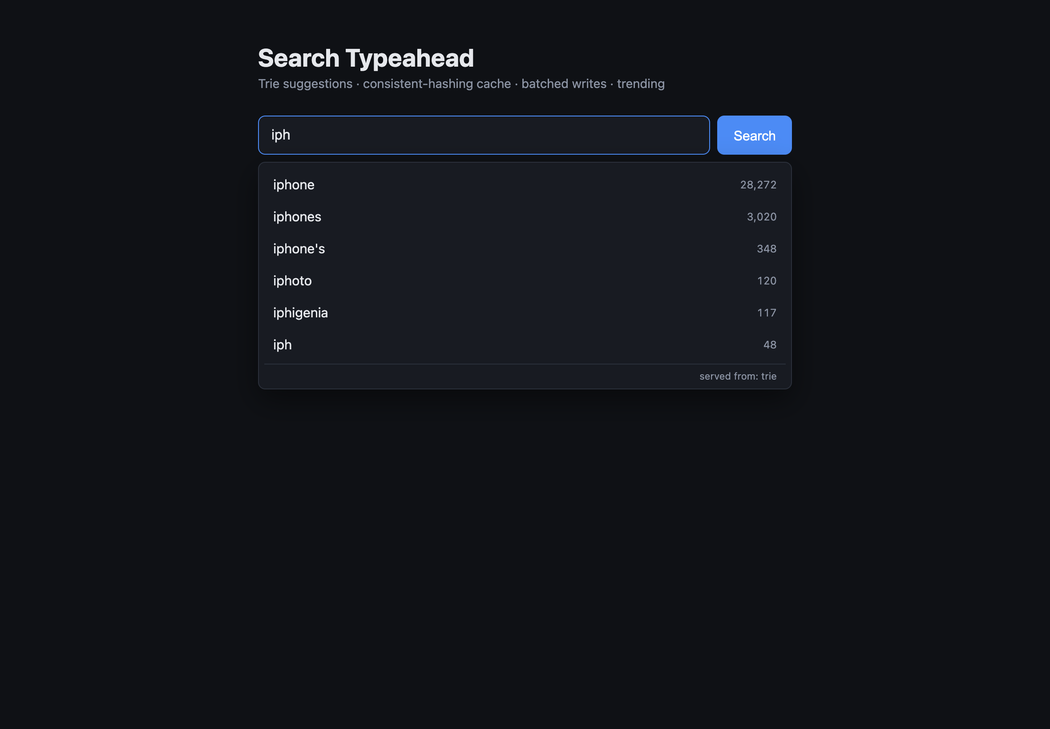
Suggestions dropdown
Keyboard navigation through the dropdown:
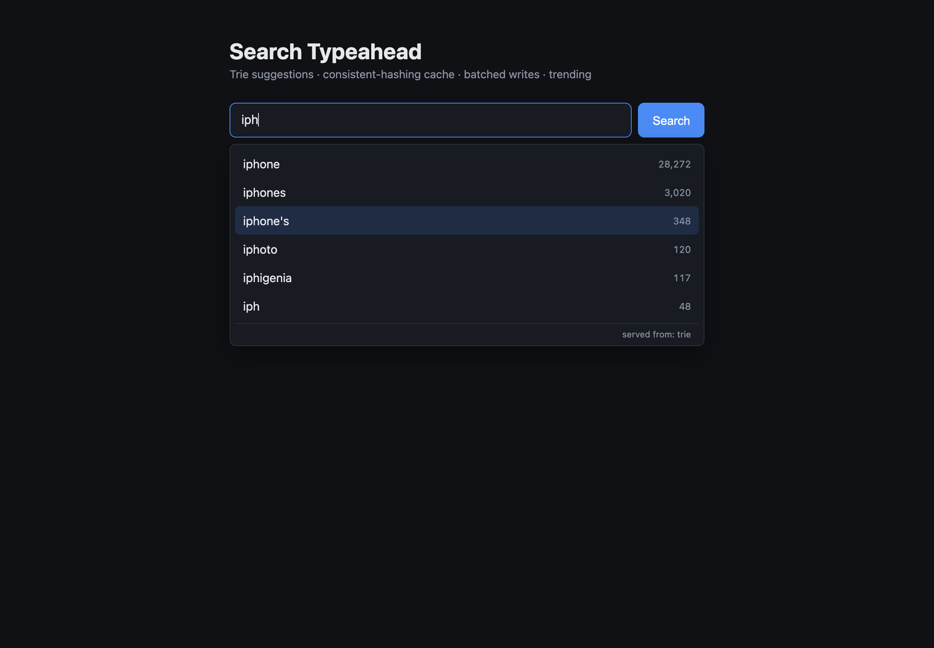
Keyboard navigation
Search submitted — dummy response + trending list:
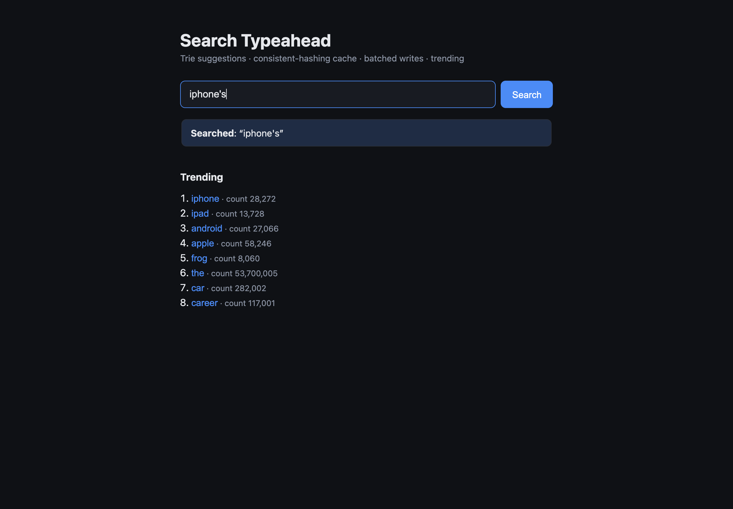
Search result and trending
Backend: consistent-hashing load balance, cache routing, and batch metrics:
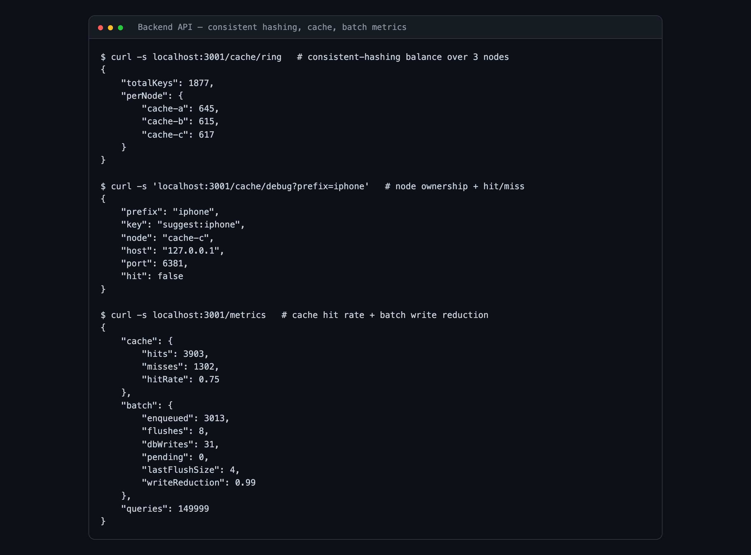
Backend metrics
Latency benchmark (p50/p95/p99) and cache hit rate:
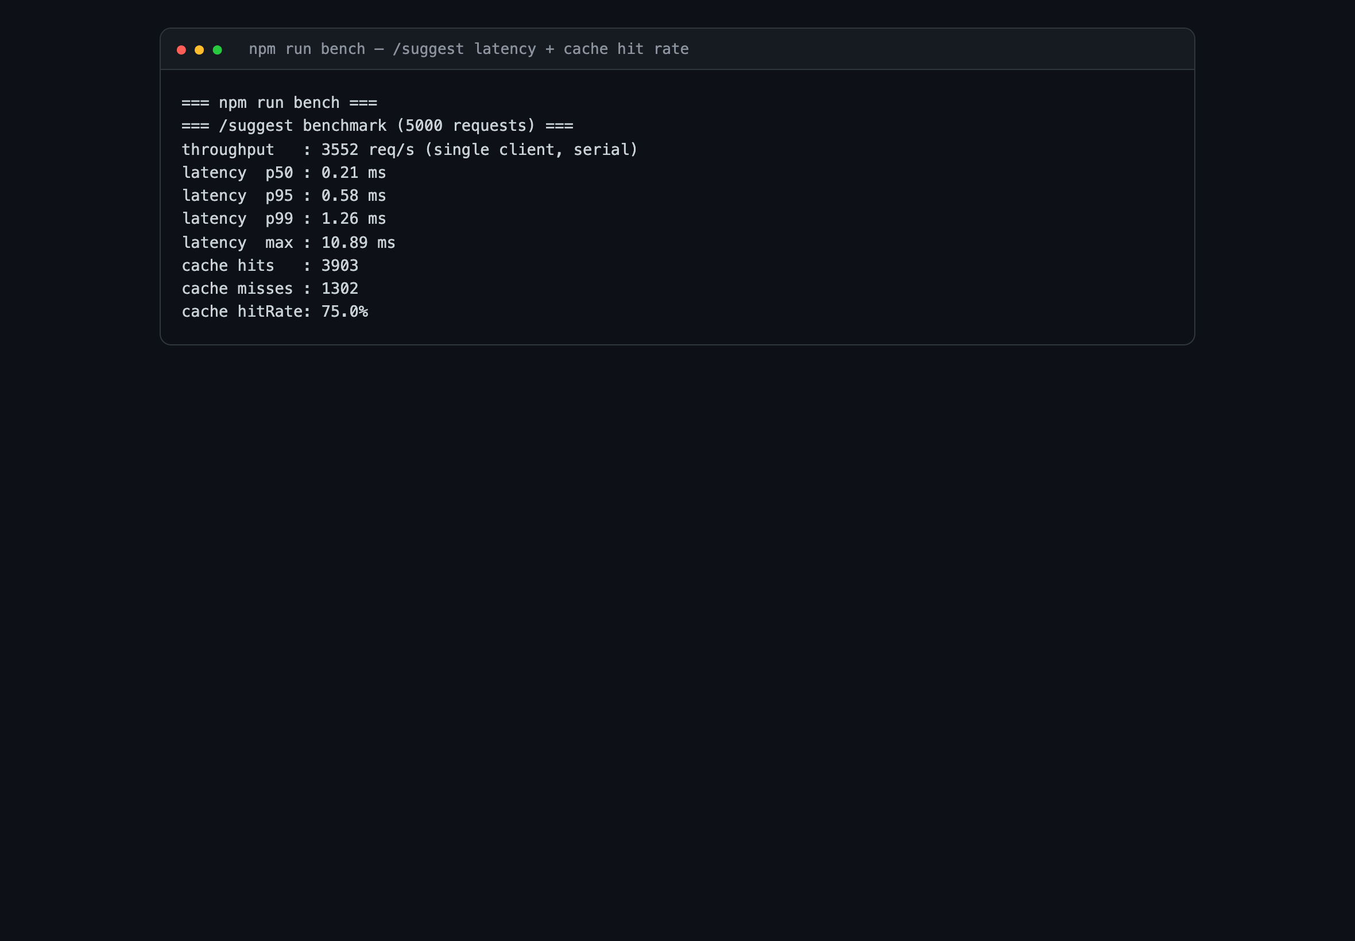
Benchmark

