EXPERIMENT 1
Feature Transformation: To use PCA Algorithm for dimensionality reduction. You have a dataset that includes measurements for different variables on wine (alcohol, ash, magnesium, and so on). Apply PCA algorithm & transform this data so that most variations in the measurements of the variables are captured by a small number of principal components so that it is easier to distinguish between red and white wine by inspecting these principal components.
import pandas as pd
import matplotlib.pyplot as plt
from sklearn.preprocessing import StandardScaler
from sklearn.decomposition import PCA

#Load dataset
df = pd.read_csv('Datasets/Wine.csv')
x = df.drop('Customer_Segment', axis=1)
y = df['Customer_Segment']

#---- Brfore PCA ----
plt.scatter(x['Alcohol'],x['Malic_Acid'], c=y, cmap='viridis', alpha=0.7)
plt.xlabel('Alcohol')
plt.ylabel('Malic_Acid')
plt.title('Original Data')
plt.show()
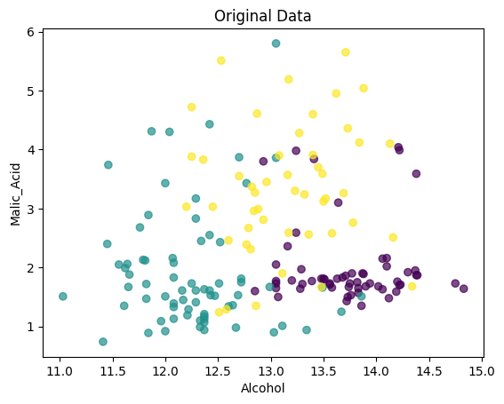

#--- PCA ---
X_scaled = StandardScaler().fit_transform(x)
X_pca = PCA(n_components=2).fit_transform(X_scaled)

# --- After PCA ---
plt.scatter(X_pca[:,0], X_pca[:,1], c=y, cmap='viridis', alpha=0.7)
plt.xlabel('PC1'); plt.ylabel('PC2')
plt.title('PCA: Wine Data'); plt.show()
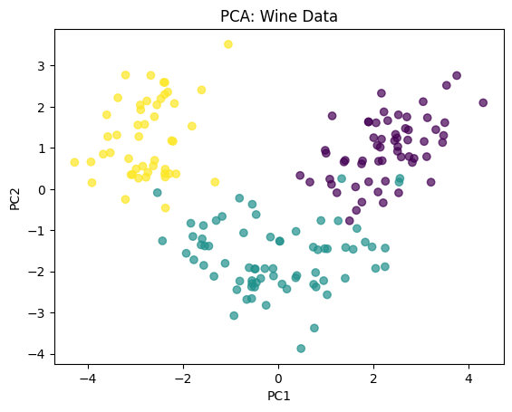

EXPERIMENT 2
Regression Analysis: Predict the price of the Uber ride from a given pickup point to the agreed drop-off location. Perform following tasks: 1. Pre-process the dataset. 2. Identify outliers. 3. Check the correlation. 4. Implement linear regression and ridge, Lasso regression models. 5. Evaluate the models and compare their respective scores like R2, RMSE, etc.
import pandas as pd
import numpy as np
import seaborn as sns
import matplotlib.pyplot as plt
from sklearn.model_selection import train_test_split
from sklearn.preprocessing import StandardScaler
from sklearn.linear_model import LinearRegression, Ridge, Lasso
from sklearn.metrics import r2_score, mean_squared_error
from sklearn.impute import SimpleImputer

# 1. Load & clean dataset
df = pd.read_csv('Datasets/uber.csv')
df = df.drop(columns=['Unnamed: 0','key','pickup_datetime'])
df = pd.DataFrame(SimpleImputer(strategy='mean').fit_transform(df), columns=df.columns)
print(df)
# 2. Outlier check (boxplot)
sns.boxplot(df['fare_amount'])
plt.show()
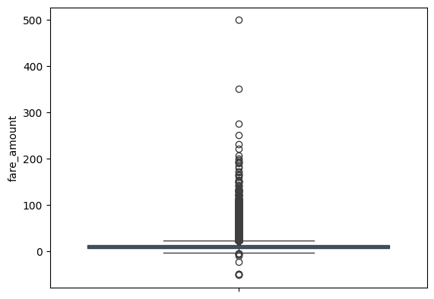

sns.heatmap(df.corr(), annot=True, cmap="coolwarm")
plt.show()
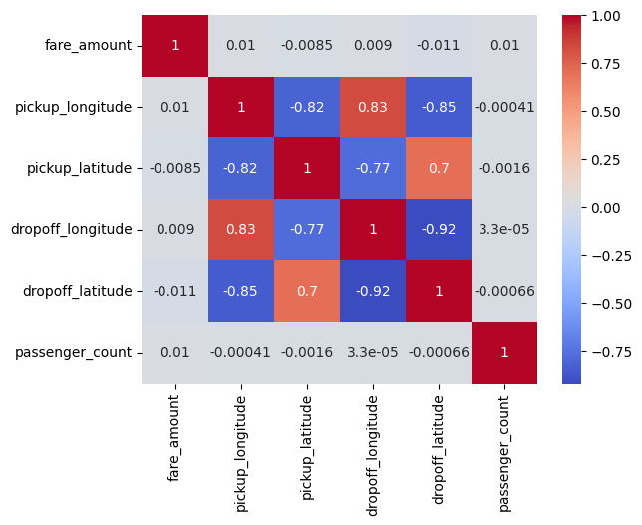

X = df.drop('fare_amount', axis=1)
y = df['fare_amount']
X_train, X_test, y_train, y_test = train_test_split(X, y, test_size=0.2, random_state=42)
print(df)
scaler = StandardScaler()
X_train = scaler.fit_transform(X_train)
X_test = scaler.transform(X_test)
models = {"Linear": LinearRegression(), "Ridge": Ridge(alpha=1.0), "Lasso": Lasso(alpha=0.1)}
for name, model in models.items():
model.fit(X_train, y_train)
y_pred = model.predict(X_test)
r2 = r2_score(y_test, y_pred)
rmse = np.sqrt(mean_squared_error(y_test, y_pred))
print(f"{name} → R2: {r2:.4f}, RMSE: {rmse:.2f}")

Linear → R2: 0.0003, RMSE: 10.31
Ridge → R2: 0.0003, RMSE: 10.31
Lasso → R2: -0.0000, RMSE: 10.31
EXPERIMENT 3
Implement K-Nearest Neighbours’ algorithm on Social network ad dataset. Compute confusion matrix, accuracy, error rate, precision and recall on the given dataset.
import pandas as pd
import numpy as np
from sklearn.model_selection import train_test_split
from sklearn.preprocessing import StandardScaler
from sklearn.neighbors import KNeighborsClassifier
from sklearn import metrics
import matplotlib.pyplot as plt
import seaborn as sns
# Load dataset
data = pd.read_csv('Datasets/Social_Network_Ads.csv')
print(data.head())

User ID Gender Age EstimatedSalary Purchased
0 15624510 Male 19 19000 0
1 15810944 Male 35 20000 0
2 15668575 Female 26 43000 0
3 15603246 Female 27 57000 0
4 15804002 Male 19 76000 0

# Step 1: Features (Age, EstimatedSalary), Target (Purchased)
X = data[['Age', 'EstimatedSalary']]
y = data['Purchased']

#Step 2: Train-Test Split
X_train, X_test, y_train, y_test = train_test_split(X, y, test_size=0.25, random_state=42)

# Step 3: Feature Scaling (KNN is distance-based, so scaling is important)
scaler = StandardScaler()
X_train = scaler.fit_transform(X_train)
X_test = scaler.transform(X_test)

# Step 4: Apply KNN
knn = KNeighborsClassifier(n_neighbors=5, metric='minkowski', p=2) # Euclidean distance
knn.fit(X_train, y_train)

# Step 5: Predictions
y_pred = knn.predict(X_test)

# Step 6: Evaluation Metrics
conf_matrix = metrics.confusion_matrix(y_test, y_pred)
accuracy = metrics.accuracy_score(y_test, y_pred)
error_rate = 1 - accuracy
precision = metrics.precision_score(y_test, y_pred)
recall = metrics.recall_score(y_test, y_pred)

print("Confusion Matrix:\n", conf_matrix)
print("Accuracy:", accuracy)
print("Error Rate:", error_rate)
print("Precision:", precision)
print("Recall:", recall)

Confusion Matrix:
[[59 4]
[ 3 34]]
Accuracy: 0.93
Error Rate: 0.06999999999999995
Precision: 0.8947368421052632
Recall: 0.918918918918919

# Step 7: Visualization of Confusion Matrix
plt.figure(figsize=(6,4))
sns.heatmap(conf_matrix, annot=True, fmt='d', cmap="Blues")
plt.xlabel("Predicted")
plt.ylabel("Actual")
plt.title("Confusion Matrix - KNN")
plt.show()
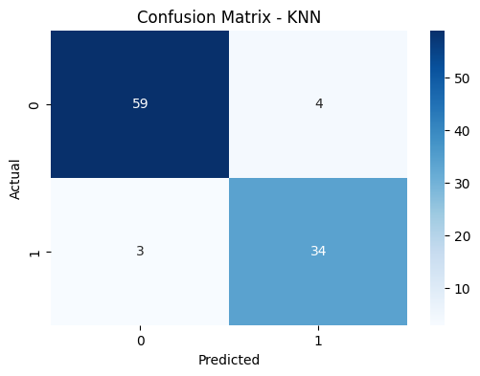

EXPERIMENT 4
Clustering Analysis: Implement K-Means clustering on Iris.csv dataset. Determine the number of clusters using the elbow method.
import pandas as pd
import numpy as np
import matplotlib.pyplot as plt
from sklearn.cluster import KMeans
from sklearn.preprocessing import StandardScaler

df = pd.read_csv('Datasets/Iris.csv')
X = df.iloc[:, 1:-1]
X = StandardScaler().fit_transform(X)

# Elbow method
inertia = [KMeans(n_clusters=k,
random_state=42).fit(X).inertia_ for k in range(1, 11)]
# Plot
plt.plot(range(1, 11), inertia, 'o--')
plt.xlabel("Clusters (k)")
plt.ylabel("Inertia")
plt.title("Elbow Method")
plt.show()
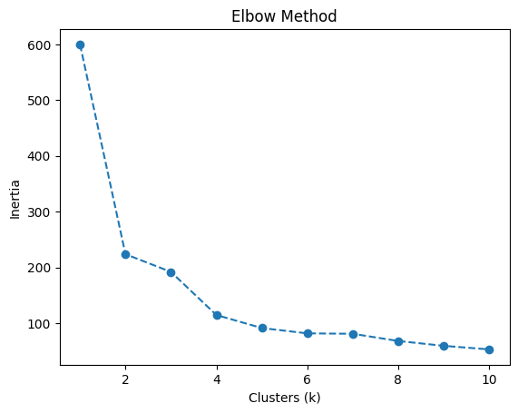

EXPERIMENT 5
Ensemble Learning: Implement Random Forest Classifier model to predict the safety of the car.
import pandas as pd
from sklearn.model_selection import train_test_split
from sklearn.preprocessing import LabelEncoder
from sklearn.ensemble import RandomForestClassifier
from sklearn.metrics import accuracy_score, classification_report, confusion_matrix

# Load the car evaluation dataset
data = pd.read_csv('Datasets/car_evaluation.csv')
# Encoding all the string data
data = data.apply(LabelEncoder().fit_transform)

X = data.iloc[:, :-1]
y = data.iloc[:, -1]

X_train, X_test, y_train, y_test = train_test_split(X, y, test_size=0.2, random_state=42)

rf_classifier = RandomForestClassifier(n_estimators=100, random_state=42)

y_pred = rf_classifier.predict(X_test)

accuracy = accuracy_score(y_test, y_pred)
confusion = confusion_matrix(y_test, y_pred)
classification_rep = classification_report(y_test, y_pred)

print(f"Accuracy: {accuracy}")
print("\nConfusion Matrix:\n", confusion)
print("\nClassification Report:\n", classification_rep)

Accuracy: 0.9624277456647399

Confusion Matrix:
[[ 72 1 3 1]
[ 2 10 0 3]
[ 1 0 236 0]
[ 2 0 0 15]]

Classification Report:
precision recall f1-score support

0 0.94 0.94 0.94 77
1 0.91 0.67 0.77 15
2 0.99 1.00 0.99 237
3 0.79 0.88 0.83 17

accuracy 0.96 346
macro avg 0.91 0.87 0.88 346
weighted avg 0.96 0.96 0.96 346

EXPERIMENT 6
Reinforcement Learning: Solve the Taxi problem using reinforcement learning where the agent acts as a taxi driver to pick up a passenger at one location and then drop the passenger off at their destination.

import numpy as np
if not hasattr(np, "bool8"): # Patch fix
np.bool8 = np.bool_

import gym
import random

env = gym.make("Taxi-v3", render_mode="ansi")

state, _ = env.reset()
done = False
steps = 0

while not done and steps < 50:
action = random.choice(range(env.action_space.n)) # random move
state, reward, done, _, _ = env.step(action)
steps += 1
print(env.render())

OUTPUT:

