**PIZZA SALES SQL QUERIES**

**A. KPI’s**

**1. Total Revenue:**

select sum(total_price) as Total_Revenue from pizza_sales;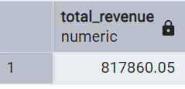

**2. Average Order Value**

select sum(total_price)/count(distinct(order_id)) as Avg_Order_Value from

pizza_sales;

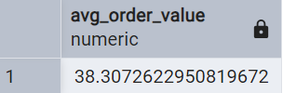

**3. Total Pizzas Sold**

select sum(quantity) as total_Pizza_sold from pizza_sales;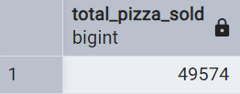

**4. Total Orders**

select count(distinct(order_id)) as total_orders from pizza_sales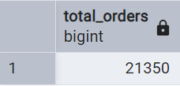

**5. Average Pizzas Per Order**

select cast(cast (sum(quantity)as decimal(10,2))/

cast(count(distinct(order_id))as decimal(10,2))as decimal(10,2))

as Avg_pizza_per_order from pizza_sales;

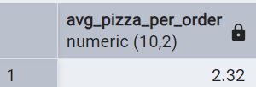

**B. Daily Trend for Total Orders**select to_char(order_date,'Day') as order_day,

count(distinct(order_id)) as Total_order

from pizza_sales

group by to_char(order_date,'Day');***Output:***

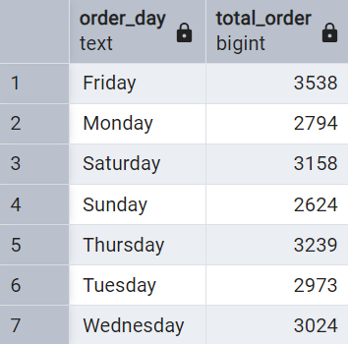

**C. Monthly Trend for Orders**

select to_char(order_date,'Month') as Month_Name,

count(distinct(order_id)) as Total_order

from pizza_sales

group by to_char(order_date,'Month')

order by Total_order desc;***Output***

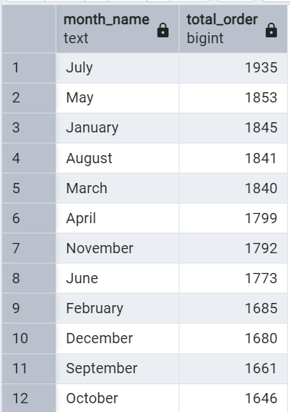

**D. % of Sales by Pizza Category**

select pizza_category,sum(total_price ) as total_sales,

sum(total_price)*100/(select sum(total_price) from pizza_sales

)

as PCT

from pizza_sales

group by pizza_category;

***Output***

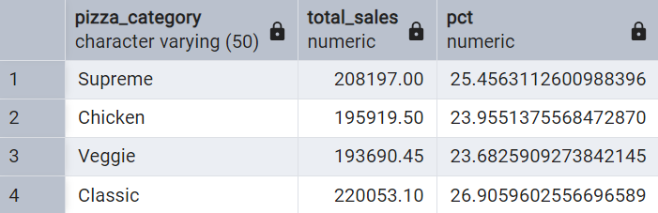

**E. % of Sales by Pizza Size**

select pizza_size,cast(sum(total_price) as Decimal(10,2)) as total_sales,cast(

sum(total_price)*100/(select sum(total_price) from pizza_sales)

as decimal(10,2))

as PCT

from pizza_sales

group by pizza_size

order by PCT desc;

***Output***

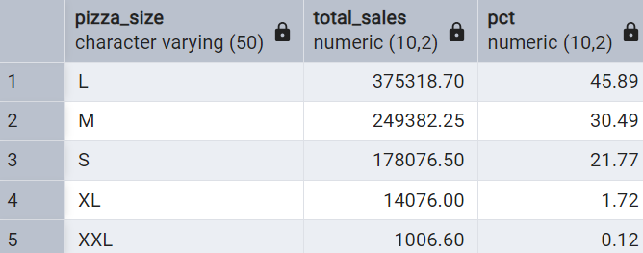

**F. Top 5 Pizzas by Revenue**

select pizza_name,sum(total_price) as total_revenu from pizza_sales

group by pizza_name order by total_revenue desc

limit 5; ***Output***

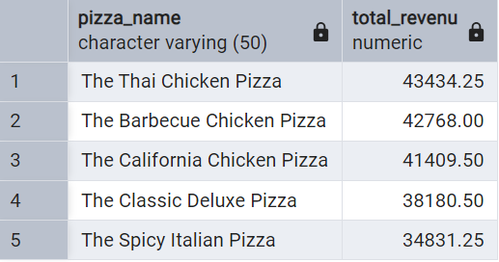

**G. Bottom 5 Pizzas by Revenue**

select pizza_name,sum(total_price) as total_revenu from pizza_sales

group by pizza_name order by total_revenue asc

limit 5; ***Output***

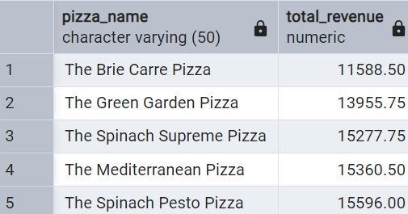

**H. Top 5 Pizzas by Quantity**

select pizza_name,sum(quantity) as total_quantity from pizza_sales

group by pizza_name order by total_quantity desc

limit 5 ;

***Output***

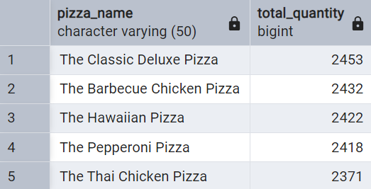

**I. Bottom 5 Pizzas by Quantity**

select pizza_name,sum(quantity) as total_quantity from pizza_sales

group by pizza_name order by total_quantity asc

limit 5 ;***Output***

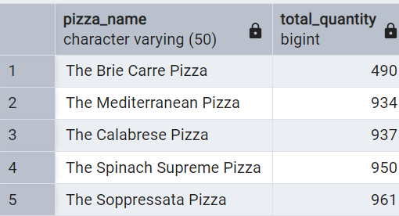

**J. Top 5 Pizzas by Total Orders**

select pizza_name,count(distinct(order_id)) as total_order from pizza_sales

group by pizza_name order by Total_order desc

limit 5; ***Output***

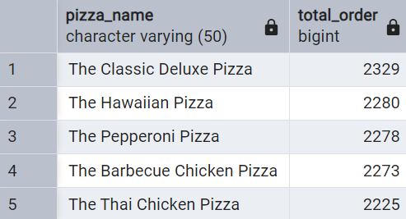

**K. Bottom 5 Pizzas by Total Orders**

select pizza_name,count(distinct(order_id)) as total_order from pizza_sales

group by pizza_name order by Total_order asc

limit 5; ***Output***

