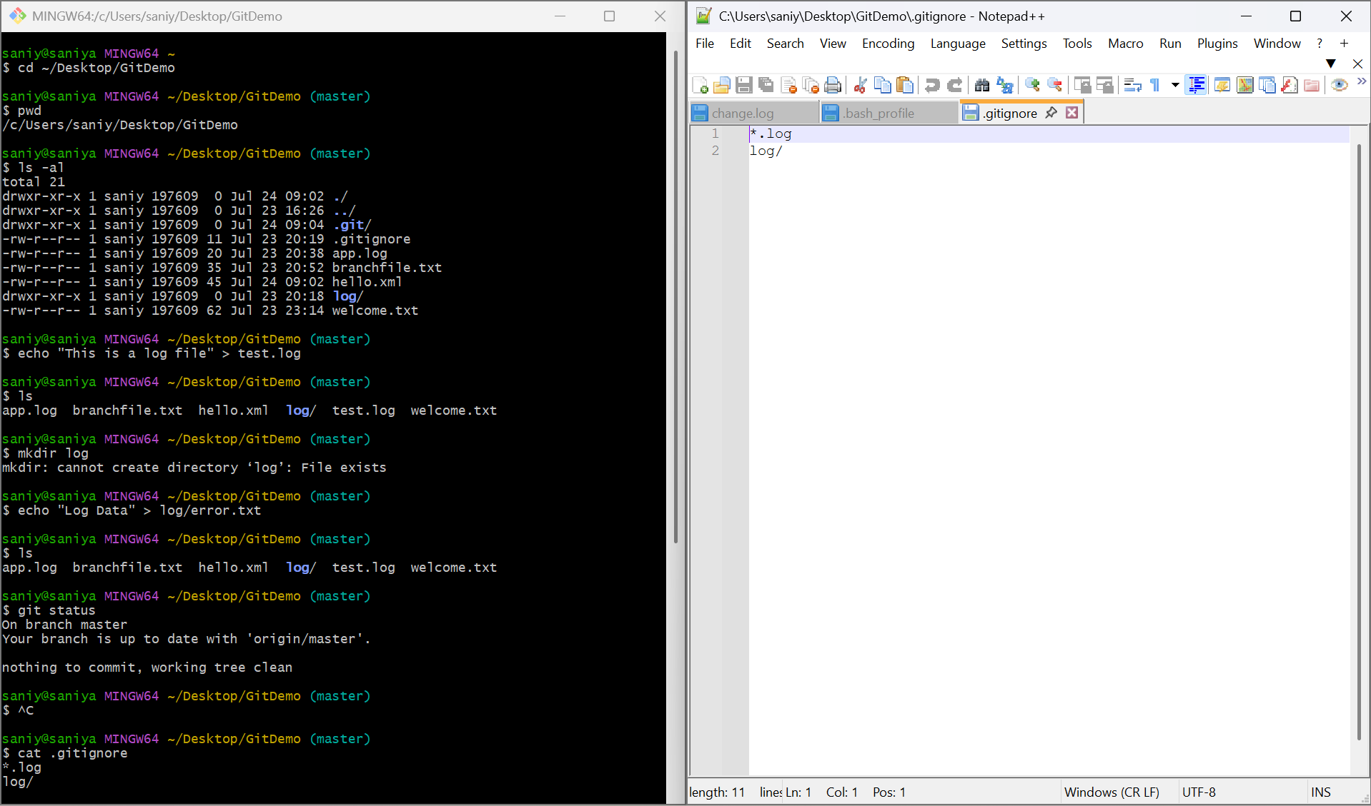

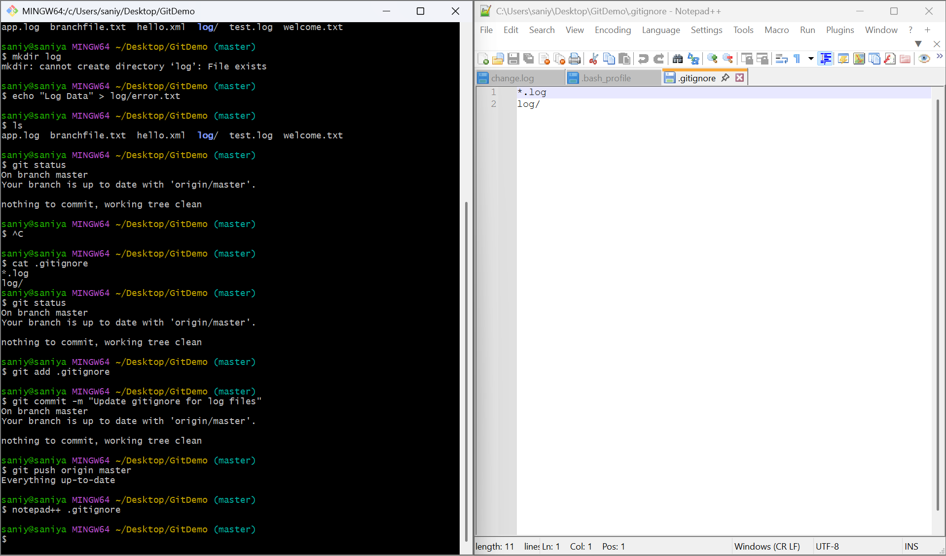
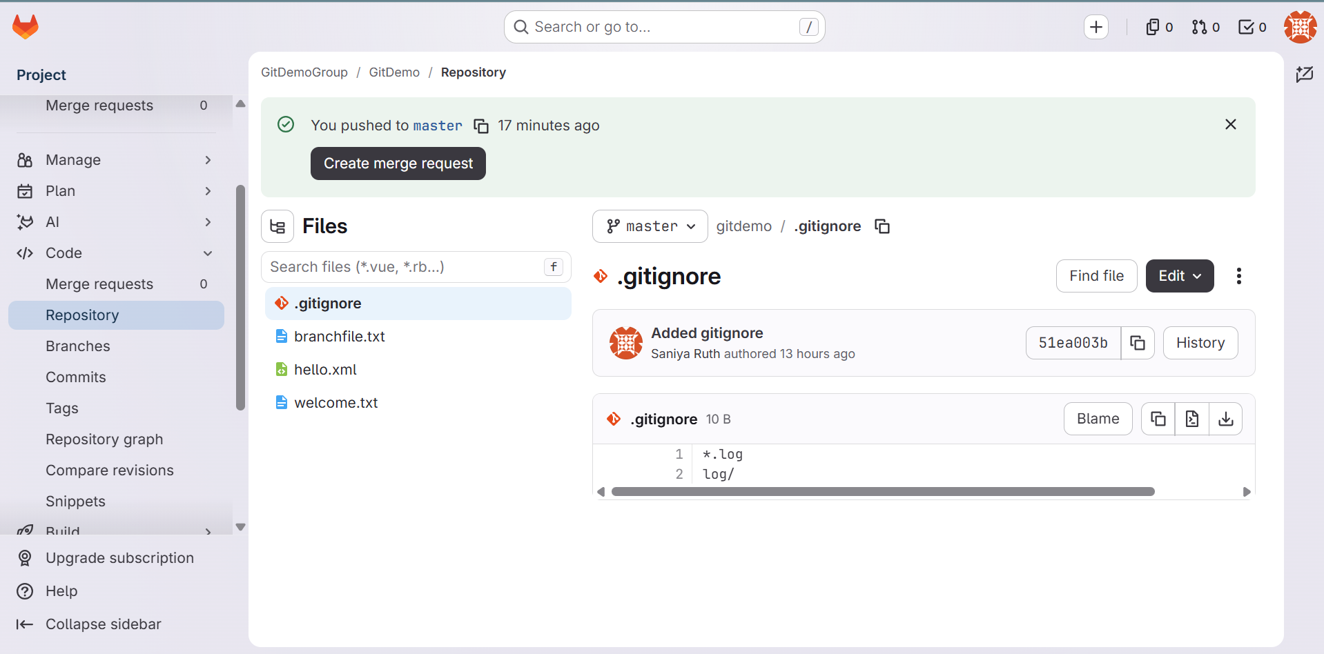
GitLab - https://gitlab.com/gitdemogroup9954230/gitdemo/-/blob/master/.gitignore?ref_type=heads

