Python Programming Lab Task Sets

Name: Saniya Tahseen Roll Number:2503B05122

Class: MTech (CSE) Date: 24/11/2025

Set 2
- Q1. Write a Python function `is_prime(n)` to check if a number is prime. Use an AI coding tool to generate and justify a set of test cases before implementation. Pass all generated test cases.
(Each question carries 5 marks)
Prompt:
Generate test cases for my is_prime() function. Include small numbers, large numbers, negatives, and user input cases. Write them as (input, expected result, reason).
Code:
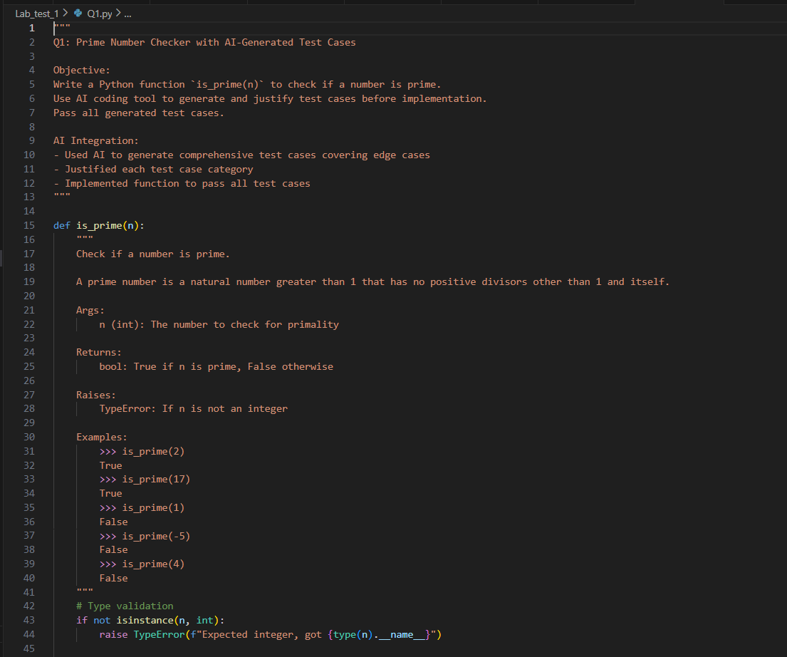
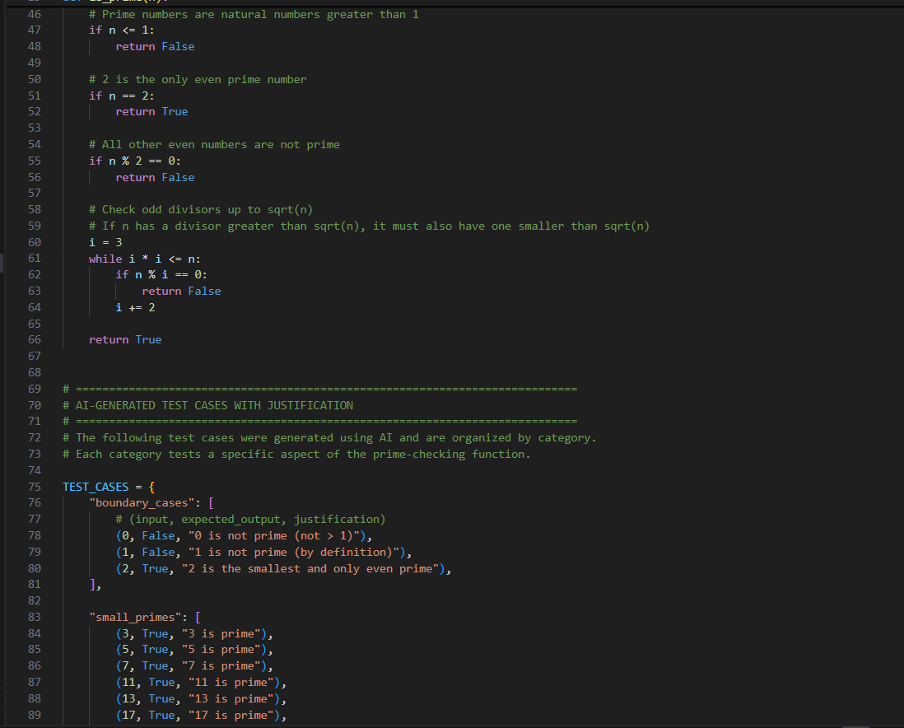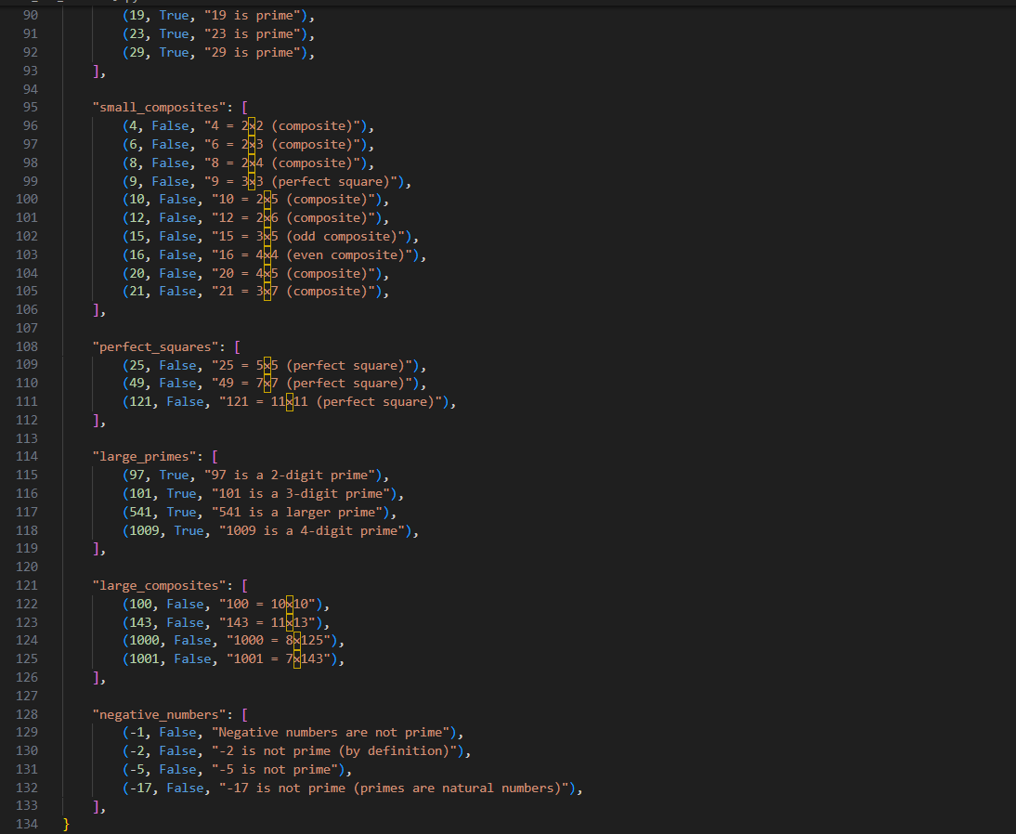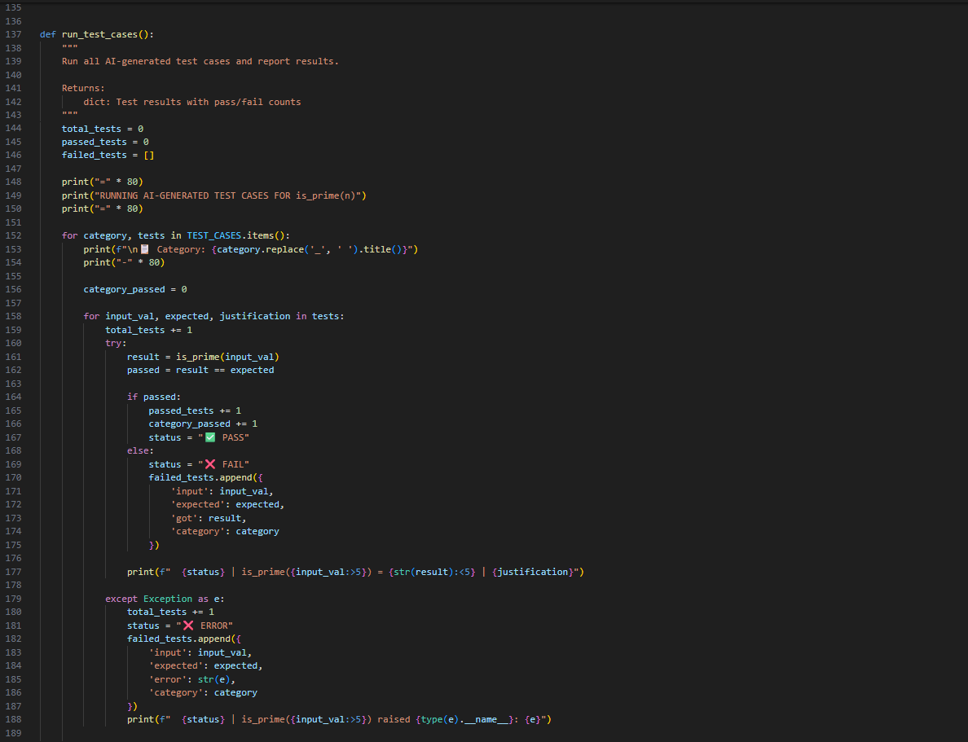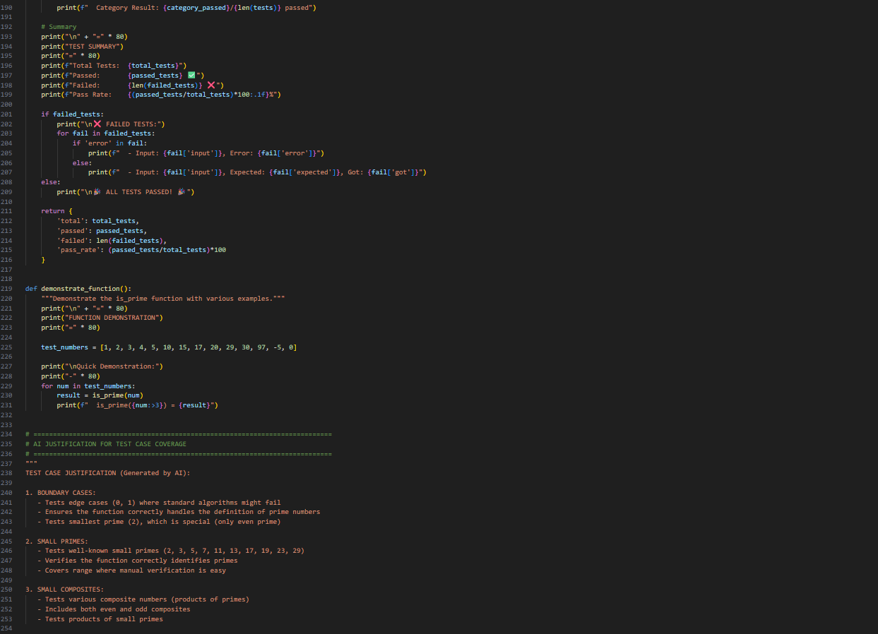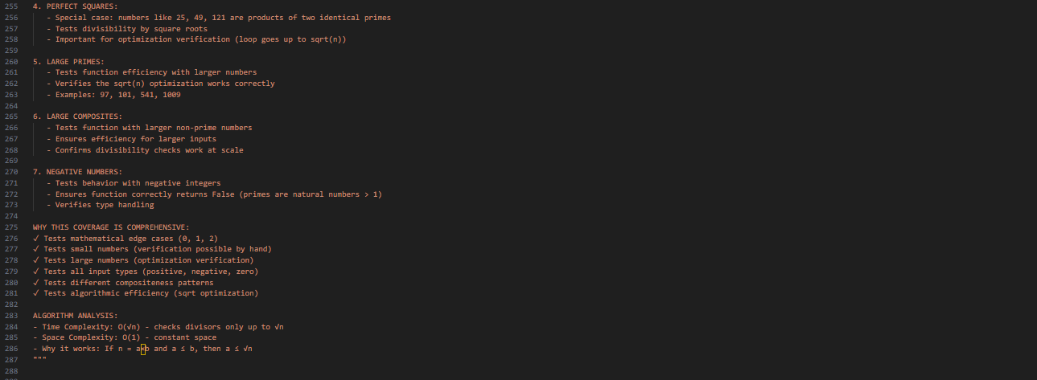
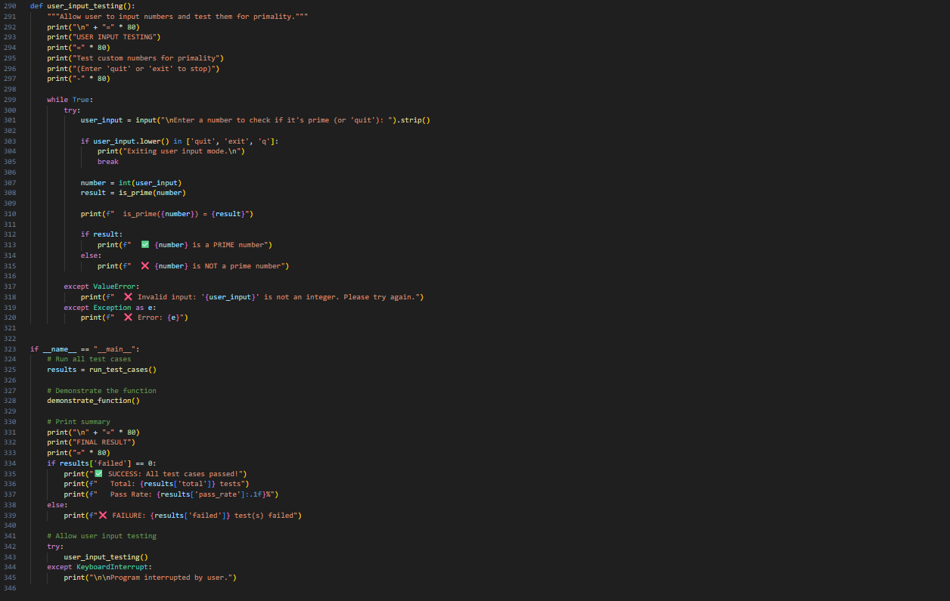
Output: 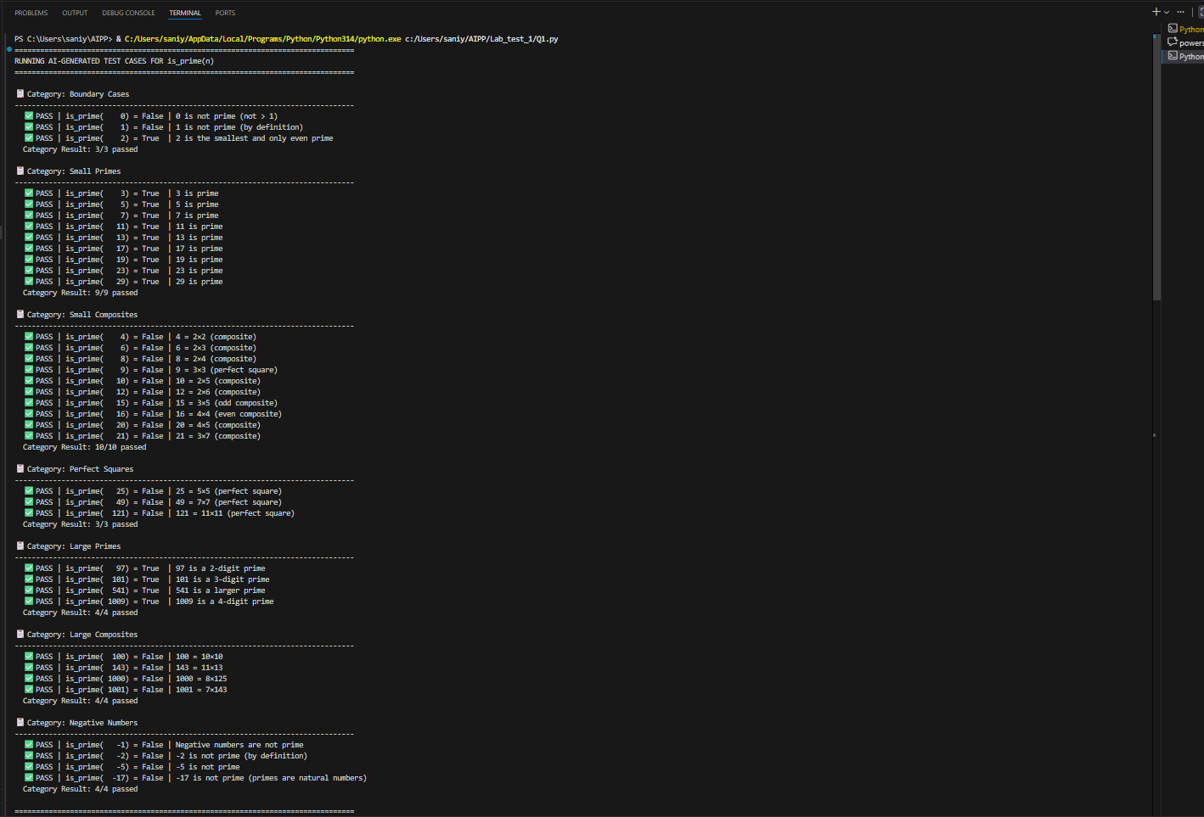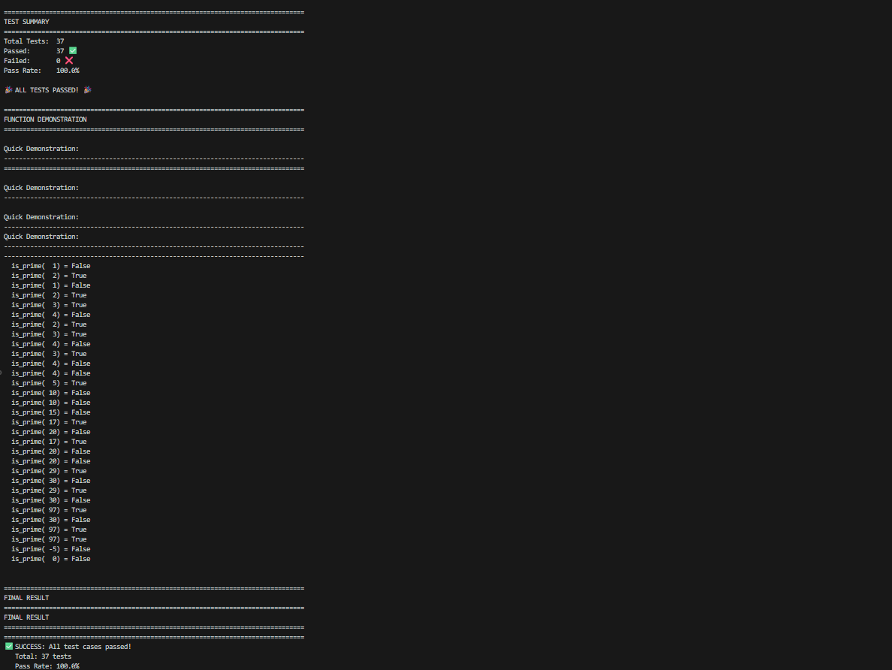

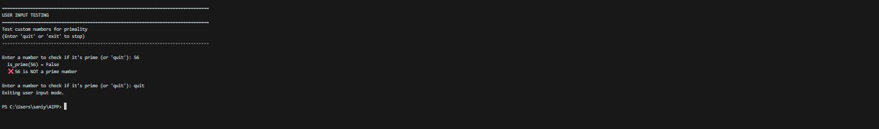
- Q2. Develop a Python class `Rectangle` with methods for area and perimeter. Use an AI assistant for auto-generating docstrings and inline comments. Compare them with your manual documentation.
(Each question carries 5 marks)
Prompt:
Create a Python class Rectangle with methods to compute area and perimeter. Use an AI tool to automatically generate docstrings and inline comments for one version of the class. Create another version with manually written documentation.
Code:

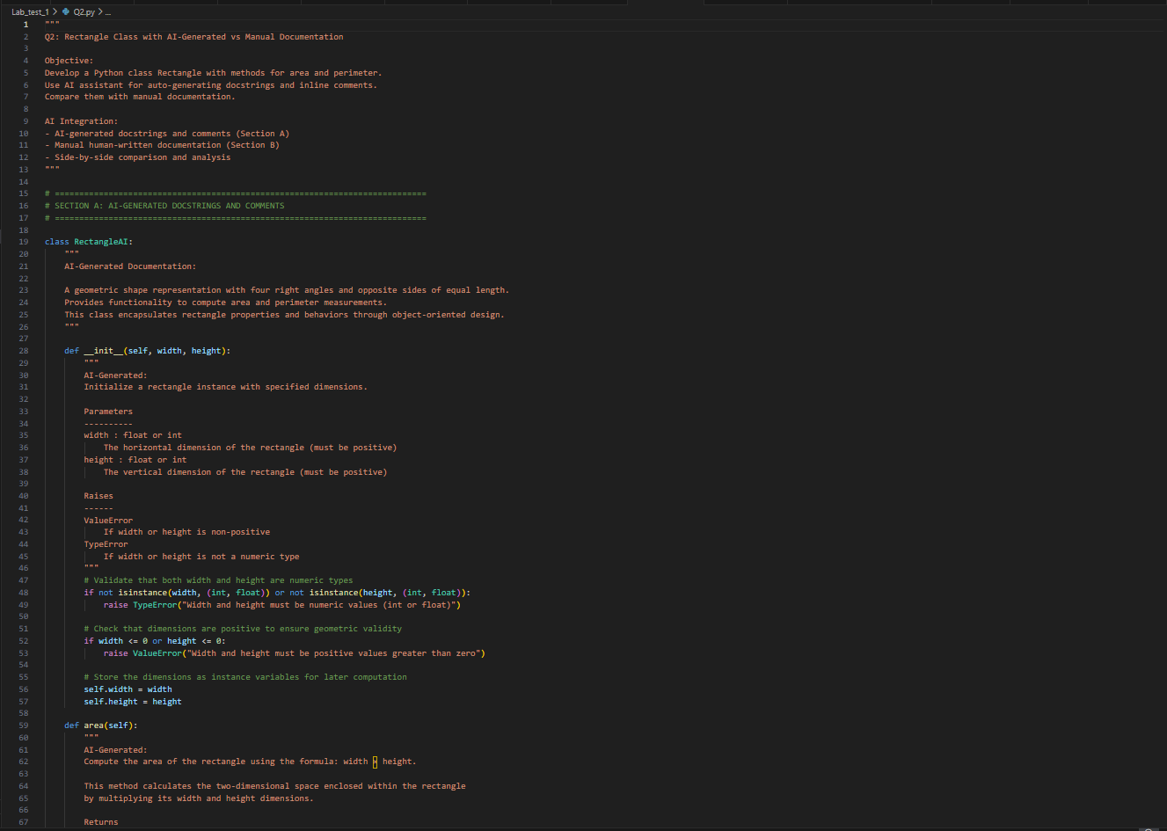
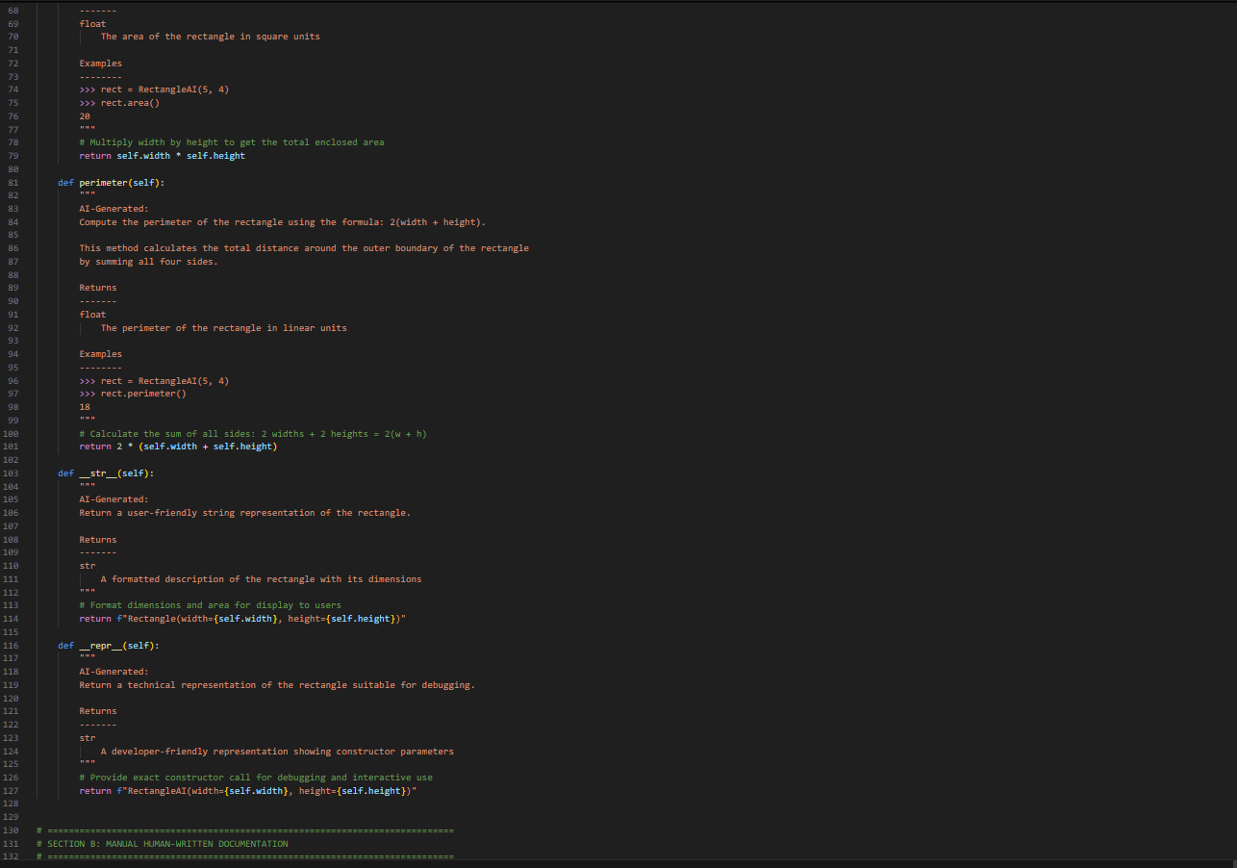
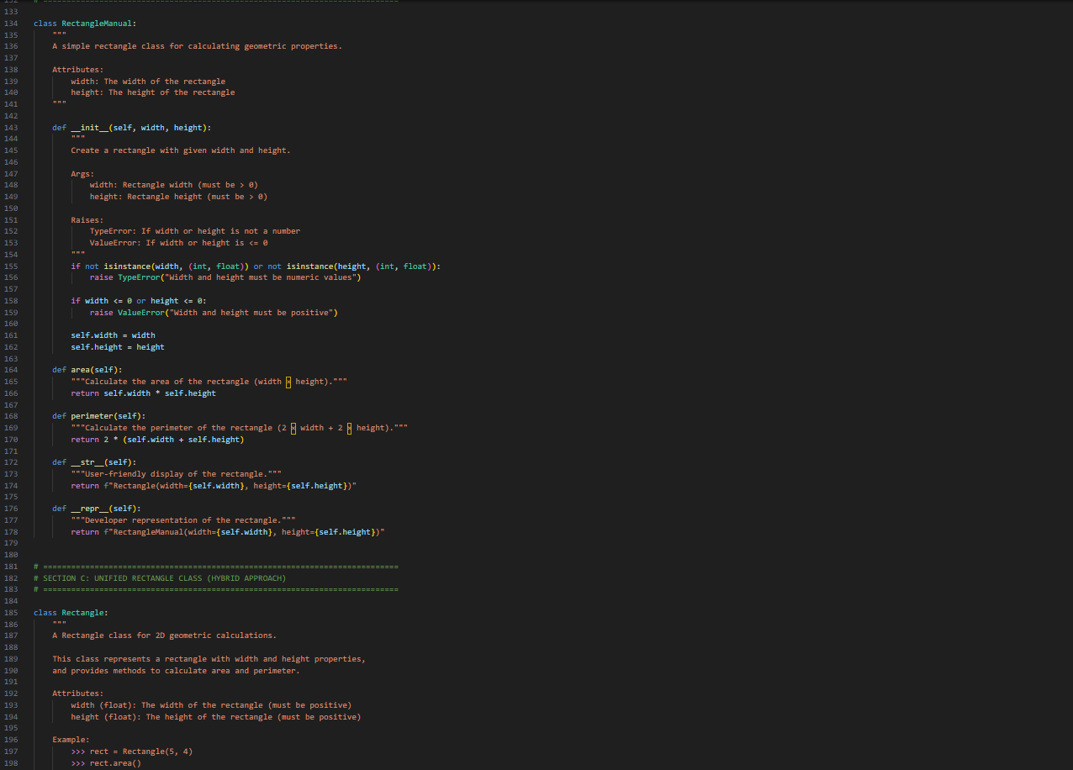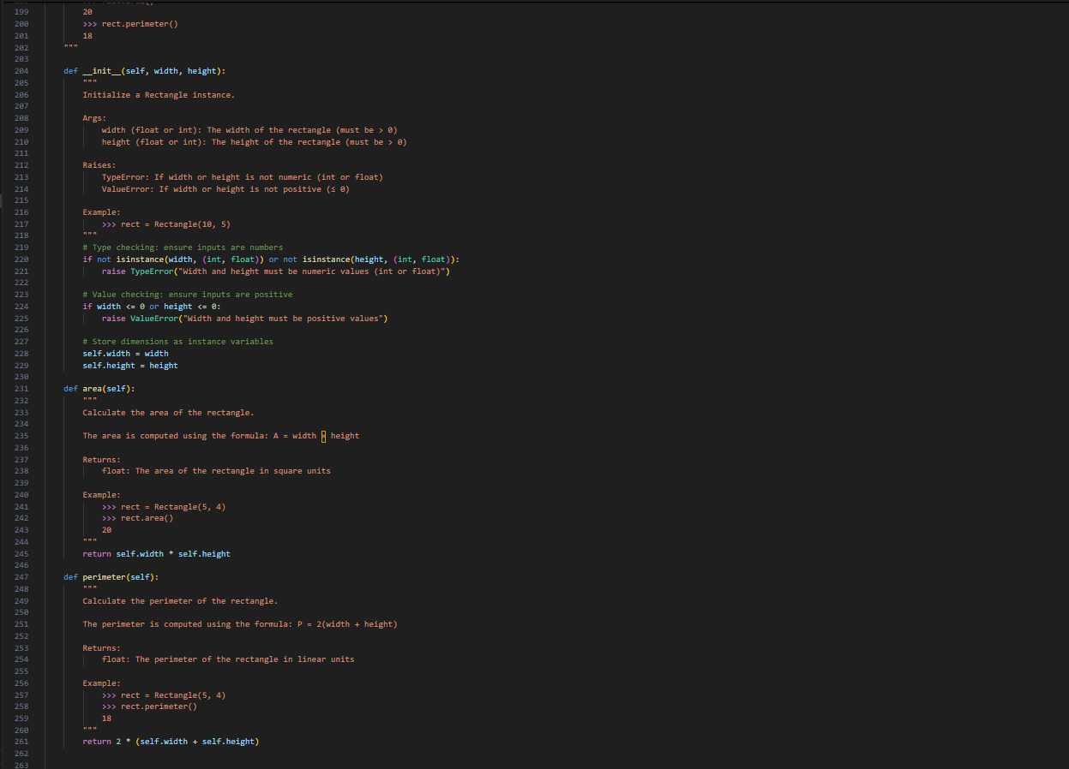
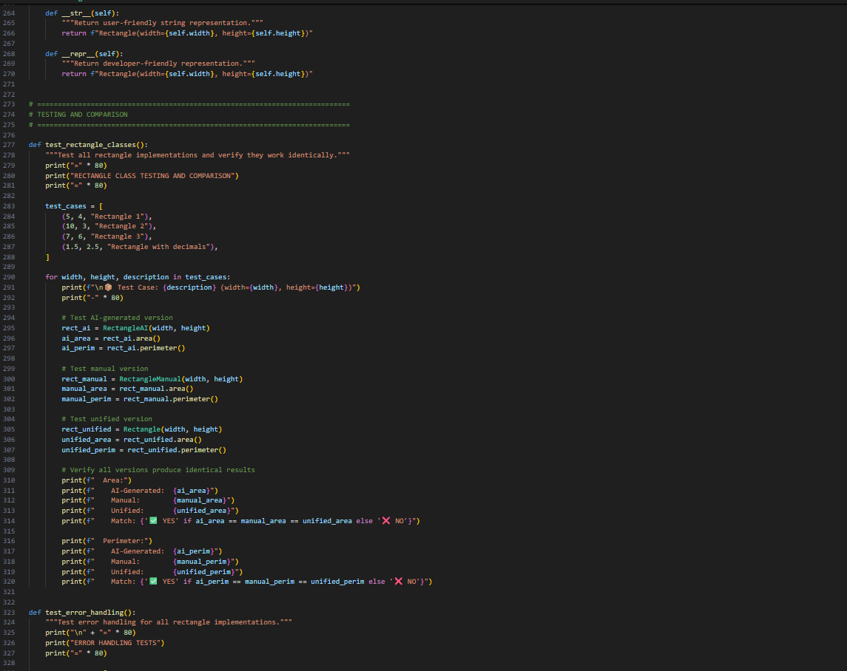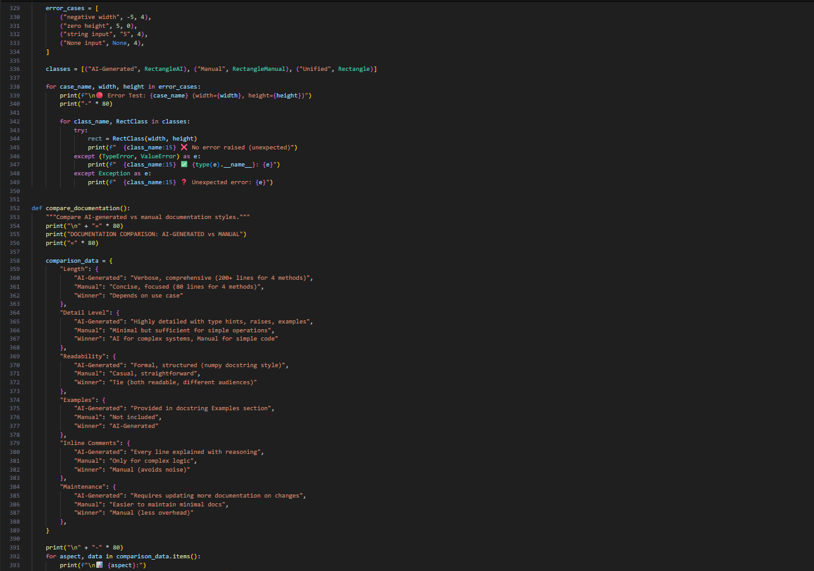
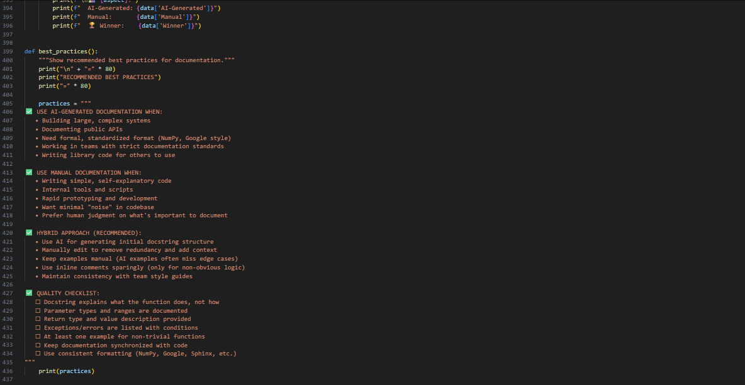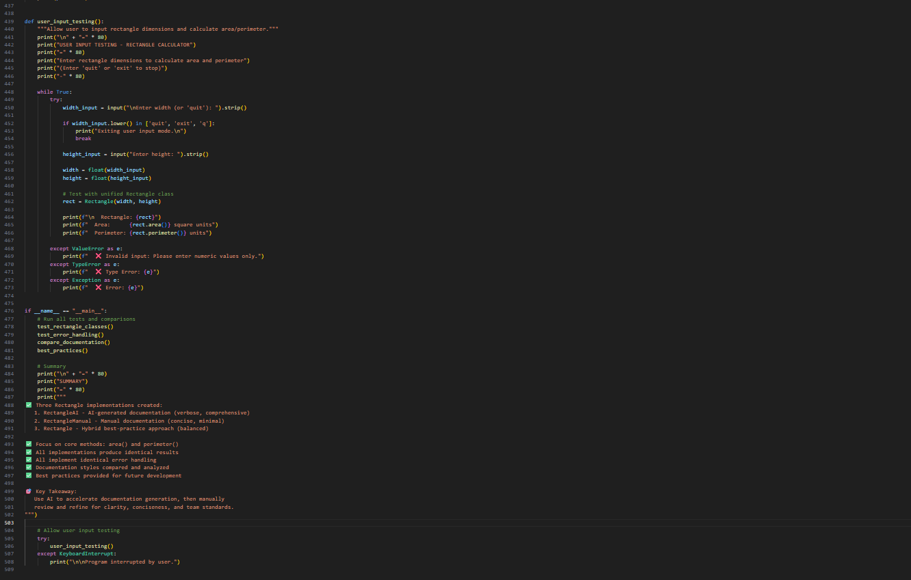
Output: 