A

PROJECT REPORT ON

# Vehicle parking Management System

SUBMITTED BY

**Miss. Saniya Shabbir Qureshi**

SUBMITTED TO

## SAVITRIBAI PHULE PUNE UNIVERSITY, PUNE

IN PARTIAL FULFILLMENT OF DEGREE

### MASTER OF COMPUTER APPLICATION (SEM-III)

UNDER THE GUIDANCE OF

**Miss. Neeta Raskar**

Through,



**Sadhu Vaswani Institute of Management Studies for Girls,**

**Koregoan Park, Pune-411001**

**2024-25**

**CERTIFICATE**

This is to certify that **Saniya Shabbir Qureshi, Seat No. -----------** of **MCA II SEM – III** has been completed the Mini Project entitled **“Vehicle Parking Management System”** for the fulfilment of **MASTER OF COMPUTER APPLICATION** under **Savitribai Phule Pune University, Pune.** This is the result of the original project work under the supervision and guidance of **“Ms. Neeta Raskar”** to the best of my knowledge and belief.

The project is completed to our satisfaction and is submitted in partial fulfillment of requirement for Master of Business Administration Program as per the rules of the Savitribai Phule Pune University.

Ms. Neeta Raskar Ms. Neeta Raskar Dr. B H Nanwani

Project Guide HOD Director

Date:

Place: Pune

**DECLARATION BY STUDENT**

To,

The Director,

SVIMS, Koregaon Park, Pune

I, undersigned hereby declare that this project titled, “**Vehicle ParkingManagement System”** written and submitted by me to SPPU, Pune, in partial fulfillment of the requirement of the award of the degree of **MASTER OF COMPUTER APPLICATION (MCA-II)** under the guidance of **Ms**

**Neeta Raskar,** is my original work.

I further declare that to the best of my knowledge and belief, this project has not been submitted to this or any other University or Institution for the award of any

Degree.

|  |  |
| --- | --- |
| **Place: Pune** |  |
| **Date:** | **(SANIYA SHABBIR QURESHI)** |

**ACKNOWLEDGEMENT**

I am overwhelmed in all humbleness and gratefulness to acknowledge all those who have helped me to put the ideas, well above the level of simplicity and into something concrete.

I owe a great debt to my guide **Ms. Neeta Raskar** who provided wholesome direction and support to me at every stage of this work. Her wisdom, knowledge and commitment to the highest standards inspired and motivated me. My gratitude is also due to our Director **Dr. B H Nanwani**, for her unconditional support and guidance.

**Place: Pune**

**Date:  Saniya Shabbir Qureshi**

**INDEX**

|  |  |  |
| --- | --- | --- |
| **CHAPTER** | **DETAILS** | **PAGE NO** |
| 1 | CHAPTER 1: INTRODUCTION  1.1 Client/Organization Profile  1.2 Need for System  1.3 Scope & Feasibility of Work  1.4 Operating Environment – H/w & S/w  1.5 Architecture of system  1.6 Detail Description of Technology Used |  |
|  |
|  |
|  |
|  |
|  |
| 2 | PROPOSED SYSTEM  2.1 Proposed System  2.2 Objectives of System  2.3 User Requirements |  |
|  |
|  |
|  |
| 3 | ANALYSIS & DESIGN  3.1 DFD  3.2 Table specifications (Database)  3.3 ERD  3.4 Object Diagram  3.5 Class Diagram  3.6 Use Case Diagrams  3.7 Web Site Map Diagram (if Website) |  |
|  |
|  |
|  |
|  |
|  |
|  |
|  |
| 4 | USER MANUAL  4.1 User Interface Design (Screens etc.)  4.2 Limitations  4.3 Future enhancement |  |
|  | BIBLIOGRAPHY  ANNEXURE: SAMPLE PROGRAM CODE  Synopsis  Progress Report |  |
|  |
|  |
|  |

**CHAPTER 1: INTRODUCTION**

**1.1 Client Profile:**

**Client Name:** Mr. Pabby Paramjit Balsingh

**Location:** Five Star Apartment Bund Garden Road, Sangamvadi, Pune,

Maharashtra, 411001. **About Organization:** Established in 1976 and currently in its 47 year Five-star co-housing society. Five Star Apartments is a well-planned and ideally positioned in Bund Garden, Sangamvadi, Pune. The residential dwellings are in a Ready to Move state. The society comprises of one tower, each of which has been carefully constructed. The address of this smartly planned project is Bund Garden Rd, Sangamvadi, Pune, Maharashtra. The project is on one of the most sought-after pin codes, 411001. Five Star Apartments lets you enjoy a convenient lifestyle with all contemporary conveniences at your disposal.

**1.2 Need for System:**

The problem might be inefficient parking allocation, disputes over parking spaces, or a lack of transparency in parking availability.The System is needed to optimize the use of available parking spaces, ensuring that each spot is used efficiently. The system enhances the user experience by offering features like real-time availability updates, reservation options.The system can automate allocation and reservation, reducing conflicts and enhancing fairness.

***1.3* Scope of the System:**

Vehicle parking management an automatic system which delivers data processing in extremely high speed in a systematic manner. Parking is a growing need of the time. This system's development is useful in this field. We can sell this system to any organization. By using our system, they can maintain records very easily. Our system covers every area of parking management. In coming future there will be excessive need of Vehicle parking management system.

**Admin:**

* Manage new registrations and profile updates.
* Admin will be able to keep information of their users.
* Manage and oversee the allocation and status of parking spaces.
* Manually assign parking spaces if necessary.

**User:**

* The user will be able to register, login/signup to the system.
* Update personal information and vehicle details.
* Booking and reservation features for users.
* Stay informed about parking-related matters.

**1.3 Feasibility Study:**

**1)TECHOLOGICAL FEASIBILTY:**

The proposed system is developed using HTML5, CSS3, JavaScript and Bootstrap as front-end tool and PHP as the back end. The proposed system needs a web Server i.e., Xampp 8.1.12 to serve the requests submitted by the users. The Web browser is used to view the web page that is available within the Windows operating system itself. The proposed system will run under Microsoft Windows 7 or above, Linux 6.1 or above, Mac OS X 10.1 or above. All the required hardware and software are readily available on the market. Hence the system is technically feasible.

**2)ECONOMICAL FEASIBILITY**

Costs: Calculate the total cost of implementing the system, including hardware, software, installation, maintenance, and operational costs.

Return on Investment (ROI): Assess the potential benefits of the system, such as increased revenue, improved customer satisfaction, and cost savings, to figure out if the investment is justified.

Funding: Find potential funding sources, such as government grants, private investors, or user fees, to cover the initial and ongoing costs.

3)OPERATIONAL FEASIBILITY:

Maintenance: Evaluate the ability to keep and troubleshoot the system over time. Consider the availability of trained personnel or third-party support.

Scalability: Determine if the system can be easily scaled to accommodate future growth in parking demand.

**1.4 Operating Environment – H/W & S/W:**

**Software:**

Operating System: Minimum Windows 10 or Above

Application: Web Application

XAMPP: 3.3.0

PHP: 3.3.0

Apache server: version 2.4

MySQL: 8.1

***1.5*** **Architecture of System:**

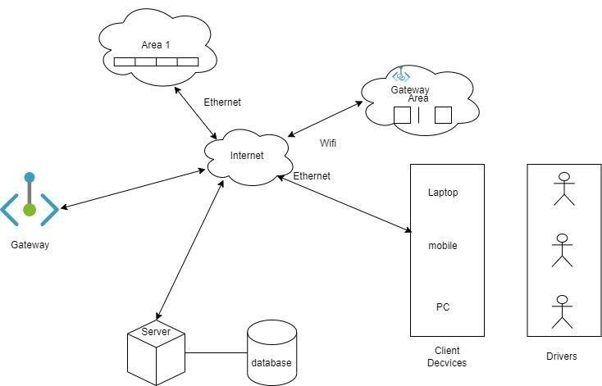

**1.6** **Detail Description of Technology Used:**

**JavaScript:**

JavaScript was invented by Brendan Eich in 1995 and became an ECMA standard in 1997.

ECMAScript is the official name of the language.

ECMAScript versions have been abbreviated to ES1, ES2, ES3, ES5, and ES6.

Since 2016, versions are named by year (ECMAScript 2016, 2017, 2018, 2019, 2020).

JavaScript is the world's most popular programming language.

JavaScript is the programming language of the Web.

JavaScript is easy to learn.

**HTML (Version HTML 5):**

HTML stands for Hyper Text Markup Language HTML is the standard markup language for creating Web pages HTML describes the structure of a Web page HTML consists of a series of elements HTML elements tell the browser how to display the content HTML elements label pieces of content such as "this is a heading", "this is a paragraph", "this is a link", etc.

**CSS (Version CSS 3):**

CSS stands for Cascading Style Sheets CSS describes how HTML elements are to be displayed on screen, paper, or in other media CSS saves a lot of work. It can control the layout of multiple web pages all at once External stylesheets are stored in CSS files.

**PHP (Version 8.2.6):**

PHP is an acronym for "PHP: Hypertext Preprocessor”.

PHP is a widely used, open-source scripting language.

PHP scripts are executed on the server.

It is powerful enough to be at the core of the biggest blogging system on the web.

It is deep enough to run large social networks!

It is also easy enough to be a beginner's first server-side language!

**MySQL (Version: 8.1):**

MySQL is a Relational Database Manage System which is used to store the data in the form of tables which are in the form of rows and columns. It is freely available on the internet, that is why it is an open-source database. MySQL uses SQL which can manipulate, define, and control the data by firing the SQL queries. MySQL is a popular open-source relational database management system that is widely used in web development. It is a roband scalable database solution that provides several advantages for web developers.

#### CHAPTER 2: PROPOSED SYSTEM

**2.1Proposed System**

The proposed system introduces a user-friendly mobile application and a web-based dashboard. It offers features such as real-time parking space availability, online booking, and reservation. Security features include surveillance integration and visitor verification. This proposed system consists of the deployed web development module which delivers real-time output and monitors the flow of vehicles parking in and out of that parking lot. The methodology provides the optimal solution for parking space.

**2.2 Objectives of System :**

* To enable users to locate and reserve a parking place online through accessing web platform.
* To minimize traffic congestion and air pollution by reducing the time vehicles spend idling in search of parking.
* To identify a vehicle's presence or absence in a particular parking space with a high degree of accuracy, and to pass on this data into a system for visualization and analysis.
* To offer safe and secure parking spaces within a limited area.
* To manage historical data in database.
* To simplify administrative tasks for parking facility managers, such as monitoring occupancy, managing reservations, and generating reports.
* To continuously gather user feedback to make improvements and ensure important levels of customer satisfaction.

**2.3 User Requirements:**

* The system should allow users to have access to real-time data on parking space availability, location, and pricing through a mobile app or website.
* The system should allow users to reserve parking spaces in advance, ensuring they have a guaranteed spot upon arrival.
* The system should provide directions to available parking spaces within the facility, minimizing search time.
* The system provides a way for users to submit feedback or report issues related to the parking facility or the system.
* The system administrators should have access to real-time data on parking occupancy, reservations, and financial transactions.
* The system could manage parking reservations, including allocation of reserved spaces and monitoring reservation availability.
* The system generates reports and analytics to gain insights into parking usage patterns, revenue generation, and system performance.
* The system can integrate with existing access control systems, security systems, and other facility management systems.
* The system maximizes revenue through efficient space allocation, pricing strategies, and payment processing.

**CHAPTER 3: ANALYSIS & DESIGN**

**3.1 DFD:**

**3.2 Table Specifications (Database) Admin:**

|  |  |  |  |
| --- | --- | --- | --- |
| **NAME** | **DATA TYPE** | **CONSTRAINTS** | **DESCRIPTION** |
| id | int(10) | NULL | Id |
| adminname | varchar(10) | NULL | AdminName |
| Username | varchar(120) | NULL | UserName |
| MobileNumber | bignit(10) | NULL | MobileNumber |
| Email | varchar(200) | NULL | Email |
| Password | Varchar(120) | NULL | Password |
| AdminRegdate | timestamp | NULL | AdminRegDate |

**tblregusers:**

|  |  |  |  |
| --- | --- | --- | --- |
| **NAME** | **DATATYPE** | **CONSTRIANTS** | **DESCRIPTION** |
| id | int(11) | NULL | Id |
| FristName | varchar(250) | NULL | FristName |
| LastName | Varchar(250) | NULL | LastName |
| MobileNumber | Bigint(10) | NULL | MobileNumber |
| Email | varchar(250) | NULL | Email |
| Password | varchar(250) | NULL | Password |
| RegDate | timestamp | NULL | RegDate |

**tblcategory:**

|  |  |  |  |
| --- | --- | --- | --- |
| **NAME** | **DATATYPE** | **CONSTRIANTS** | **DESCRIPTION** |
| Id | int(10) | NULL | Id |
| VehicleCat | Varchar(120) | NULL | VehicleCat |
| creationdate | timestamp | NULL | CreationDate |

**Tblvehicle:**

|  |  |  |  |
| --- | --- | --- | --- |
| **NAME** | **DATATYPE** | **CONSTRAINTS** | **DESCRIPTION** |
| Id | Int(10) | NULL | Id |
| ParkingNumber | Varchar(120) | NULL | ParkingNumber |
| VehicleCompanyname | varchar(120) | NULL | VehicleCompanyname |
| RegistrationNumber | varchar(120) | NULL | RegistrationNumber |
| OwnerName | varchar(120) | NULL | OwnerName |
| OwnerContactNumber | bigint(10) | NULL | OwnerContactNumber |
| InTime | timestamp | NULL | InTime |
| OutTime | timestam | NULL | OutTime |
| parkingCharge | varchar(120) | NULL | parkingCharge |
| Remark | mediumText | NULL | Remark |
| Status | varchar(5) | NULL | status |

##### 3.3 ERD :

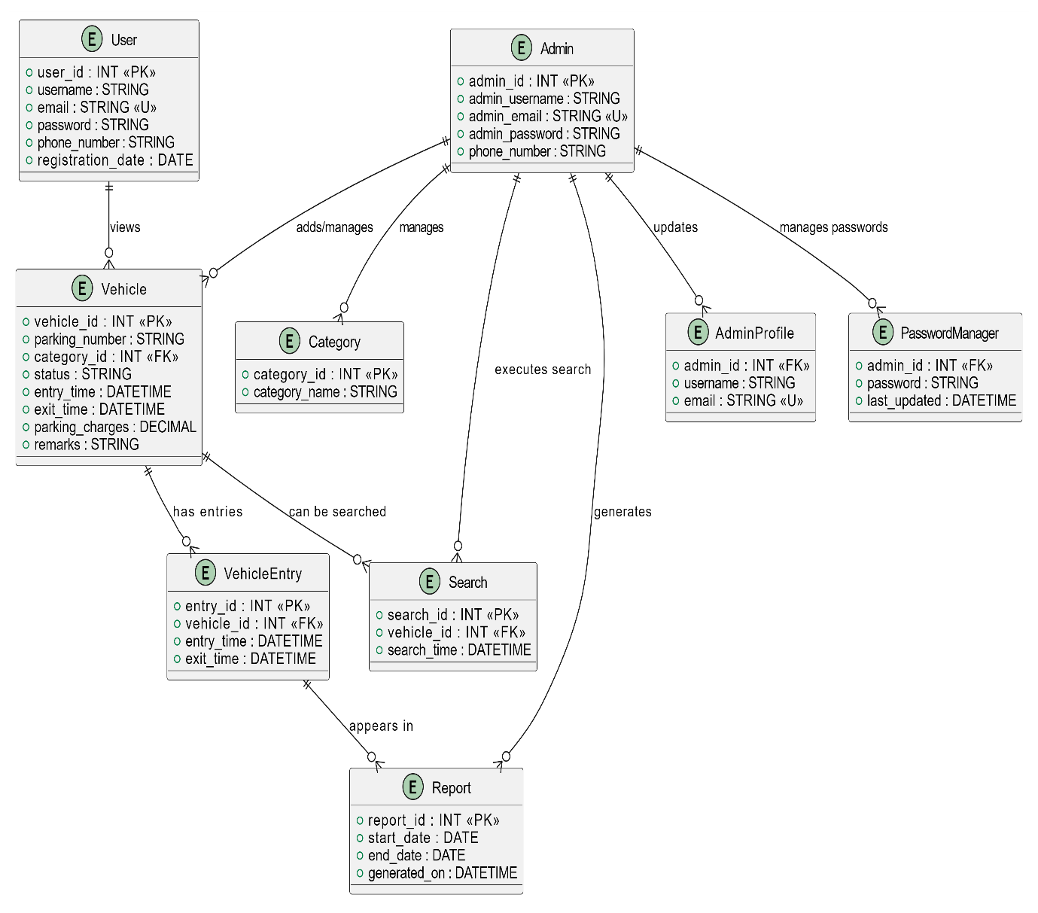

***3*.4 Object Diagram**

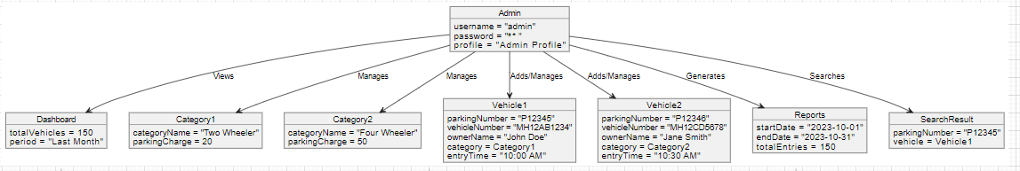

##### 3.5 Class Diagram :

***3.6 Use Case Diagram:***

***3.7 Website Map Diagram :***

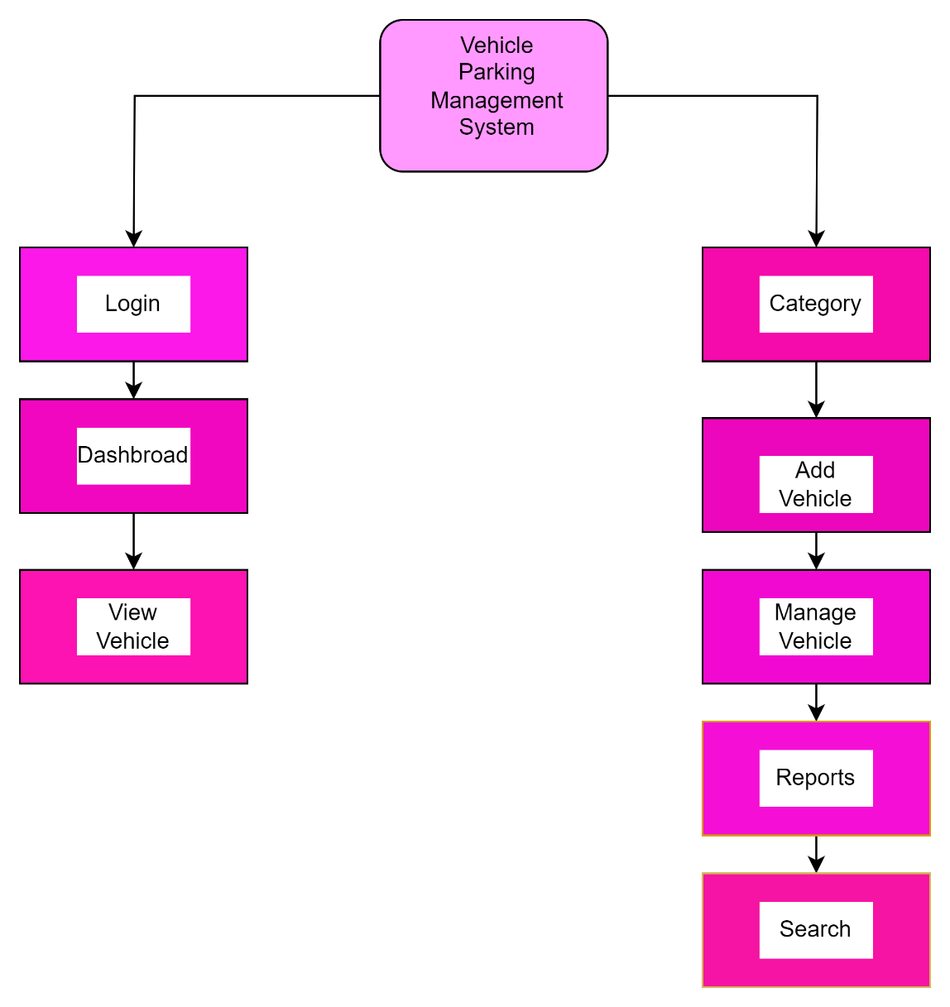

#### CHAPTER 4: USER MANUAL

**4.1 User Interface Design:**

**homepage:**

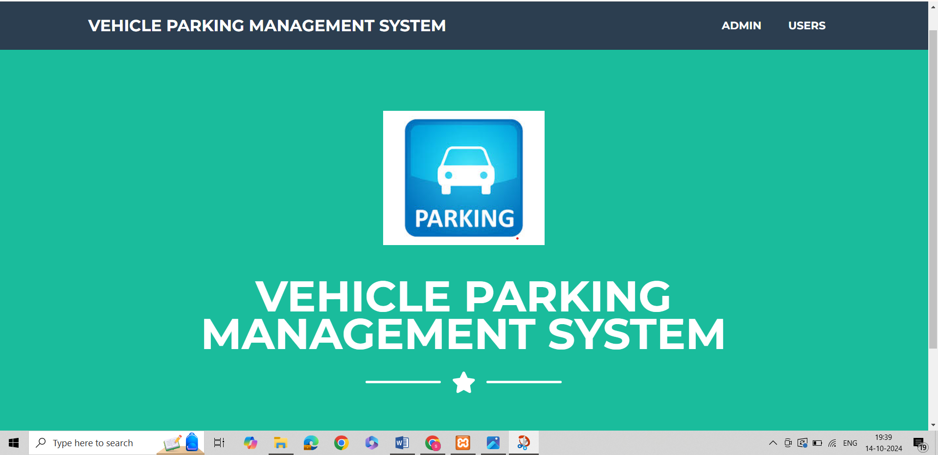

LoginPage:

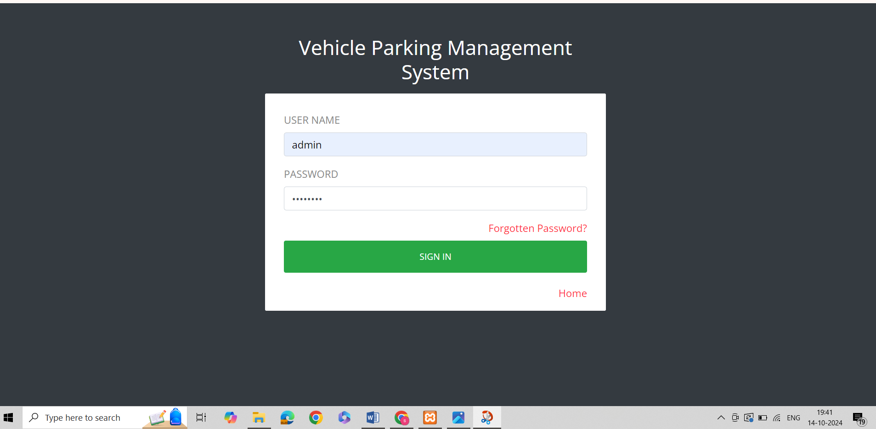

**AdminDashBoard:**

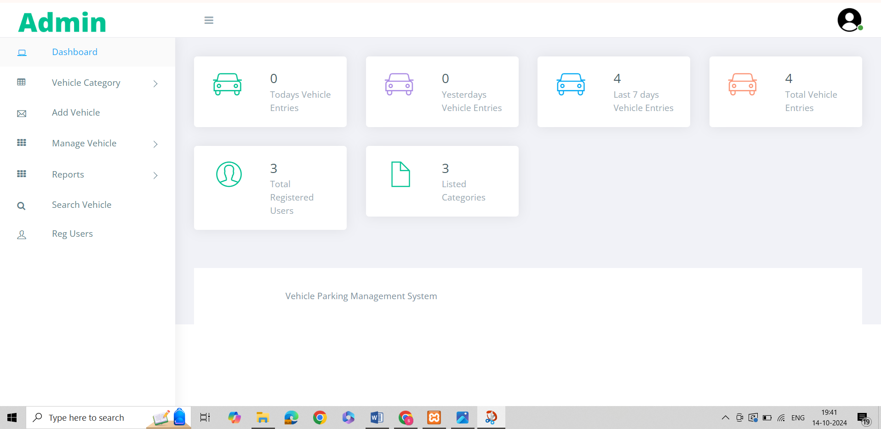

**Add category:**

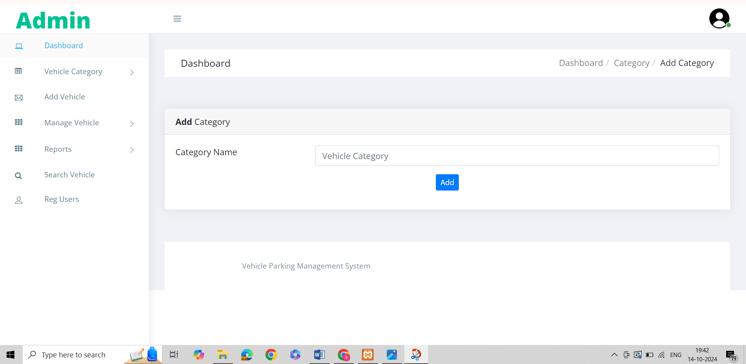

**Mange category:**

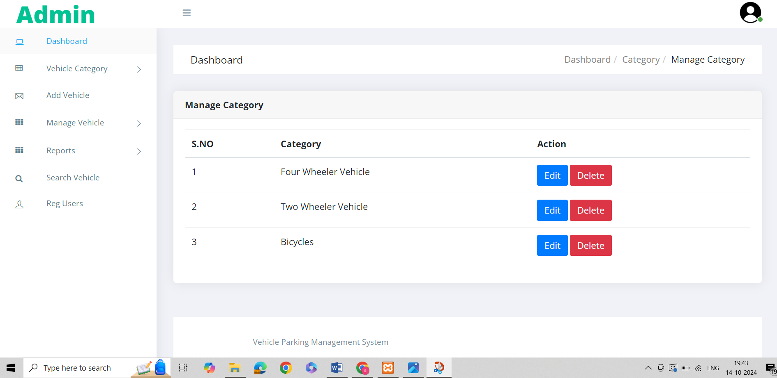

**Add vehicle:**

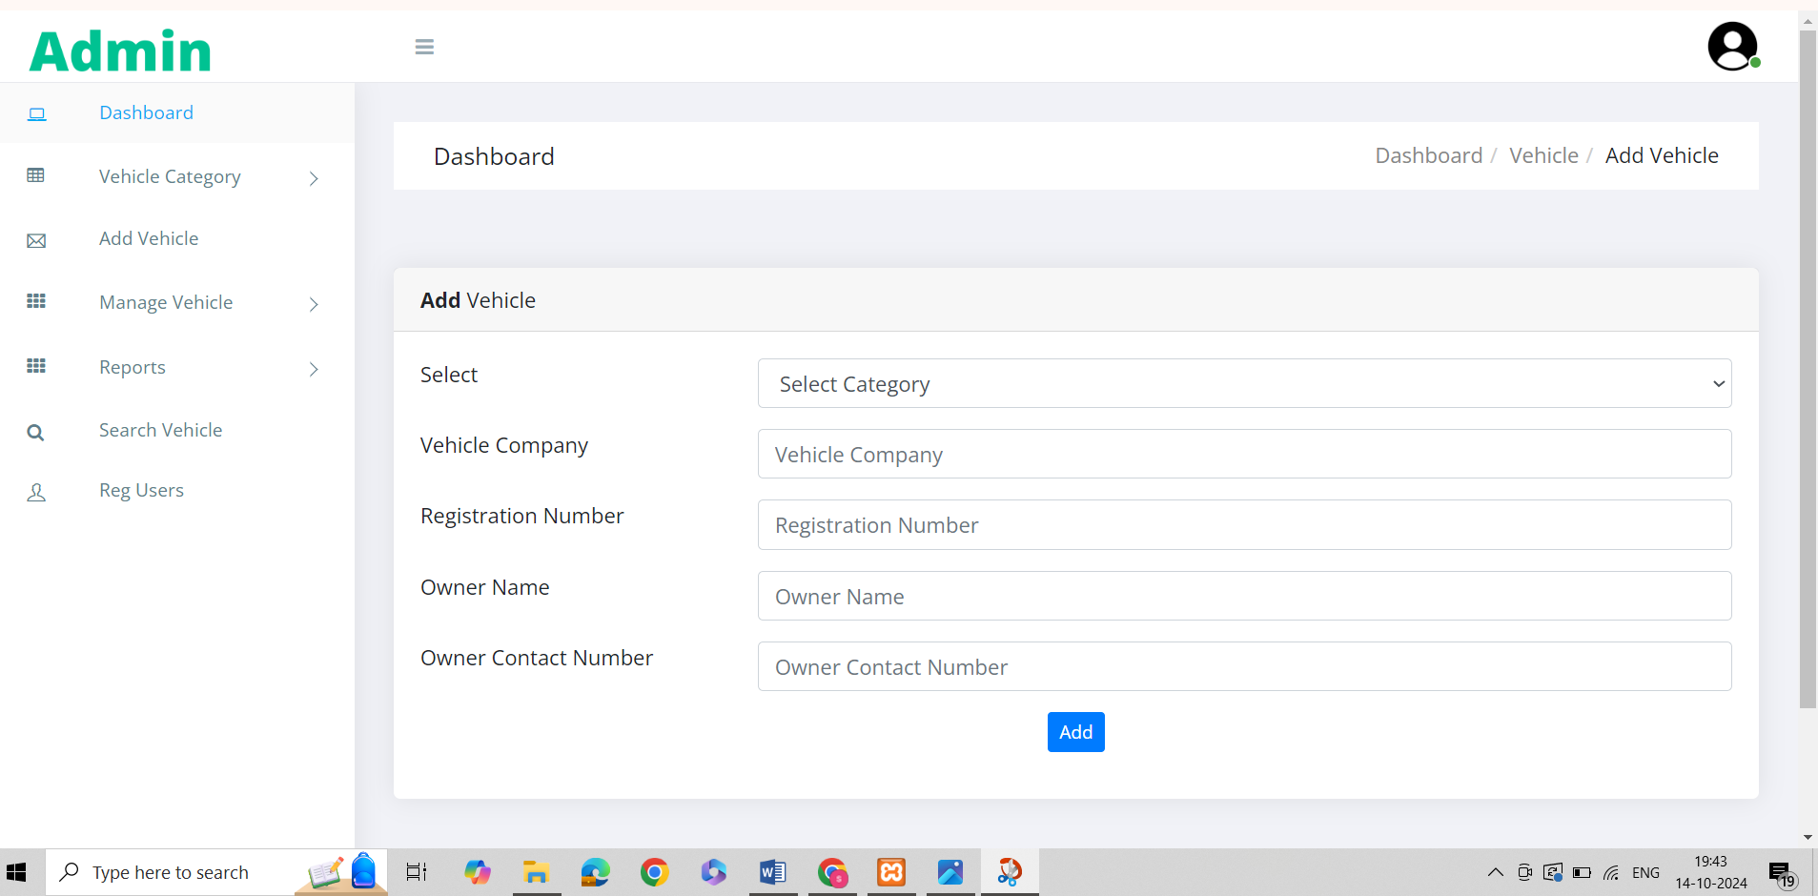

**Manage Incoming Vehicle:**

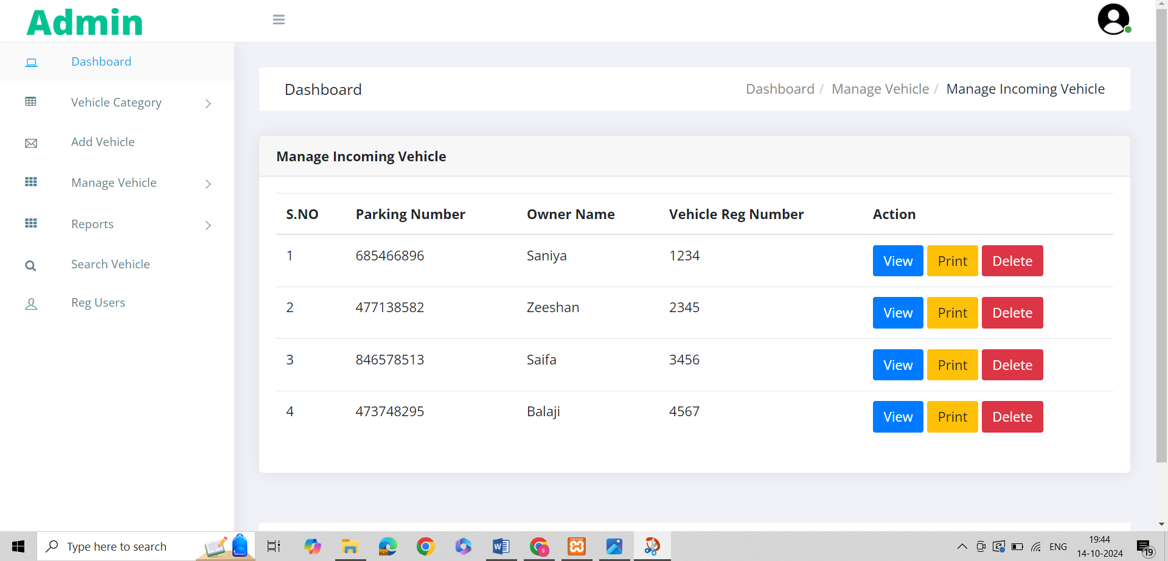

**Manage Outcoming Vehicle:**

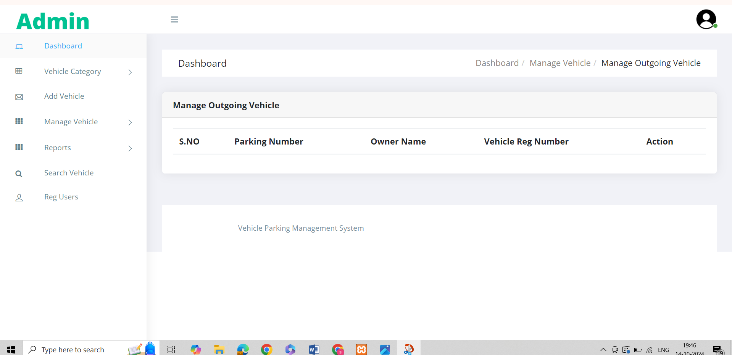

**Report:**

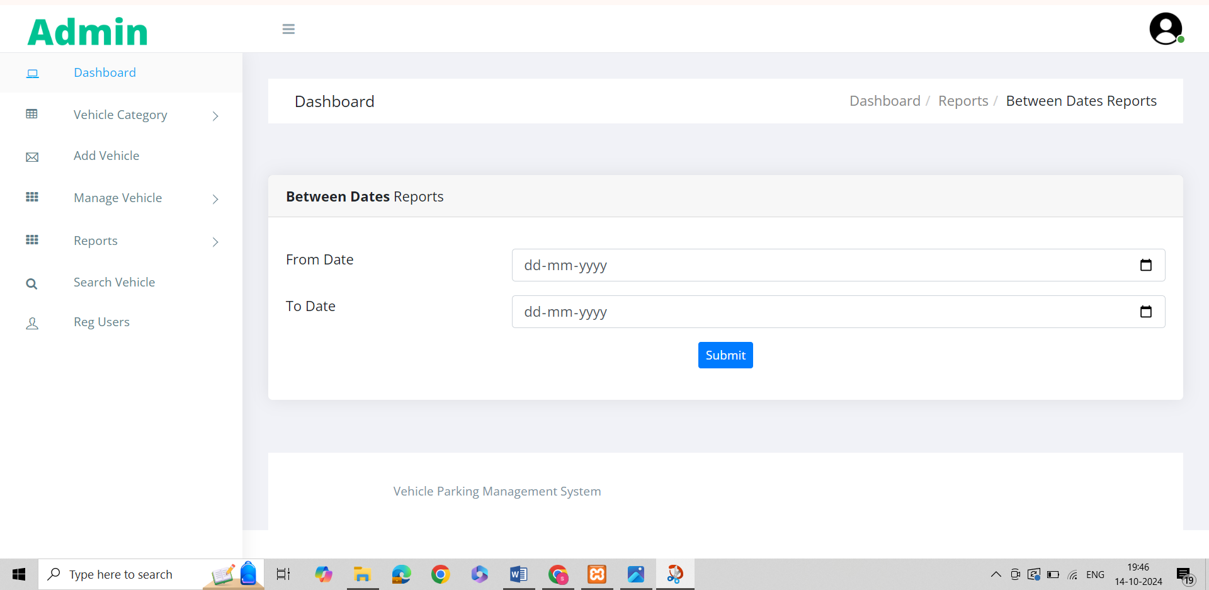

**Search Vehicle:**

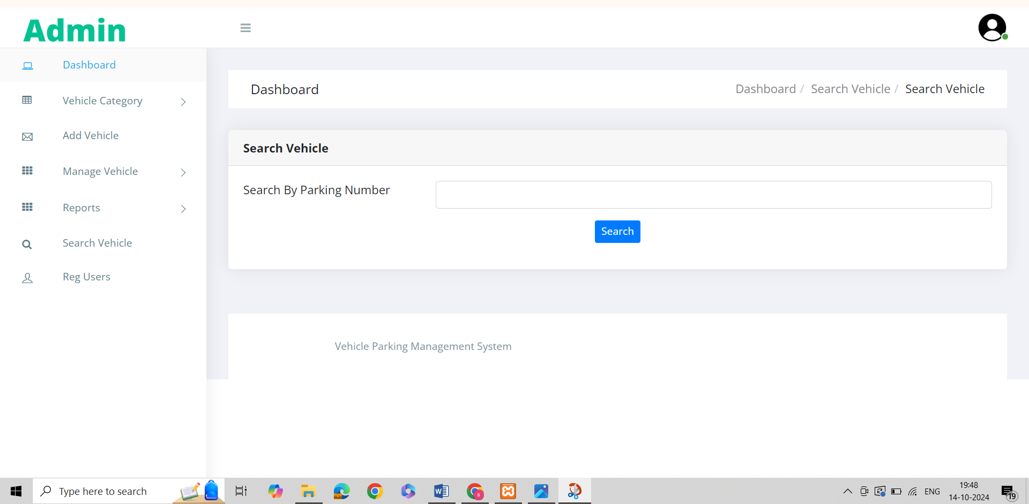

**Reg user:**

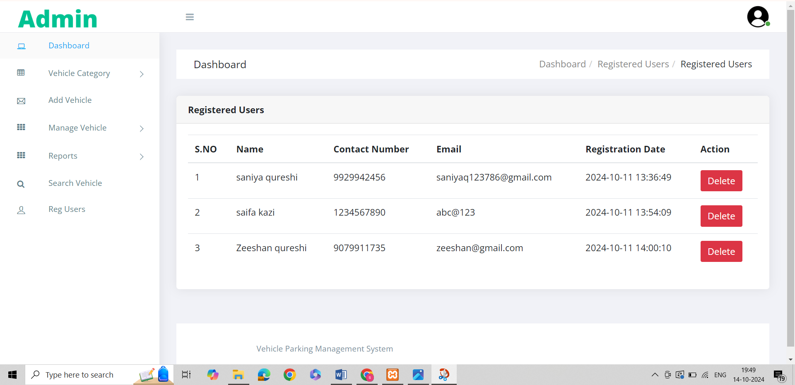

**Change password:**

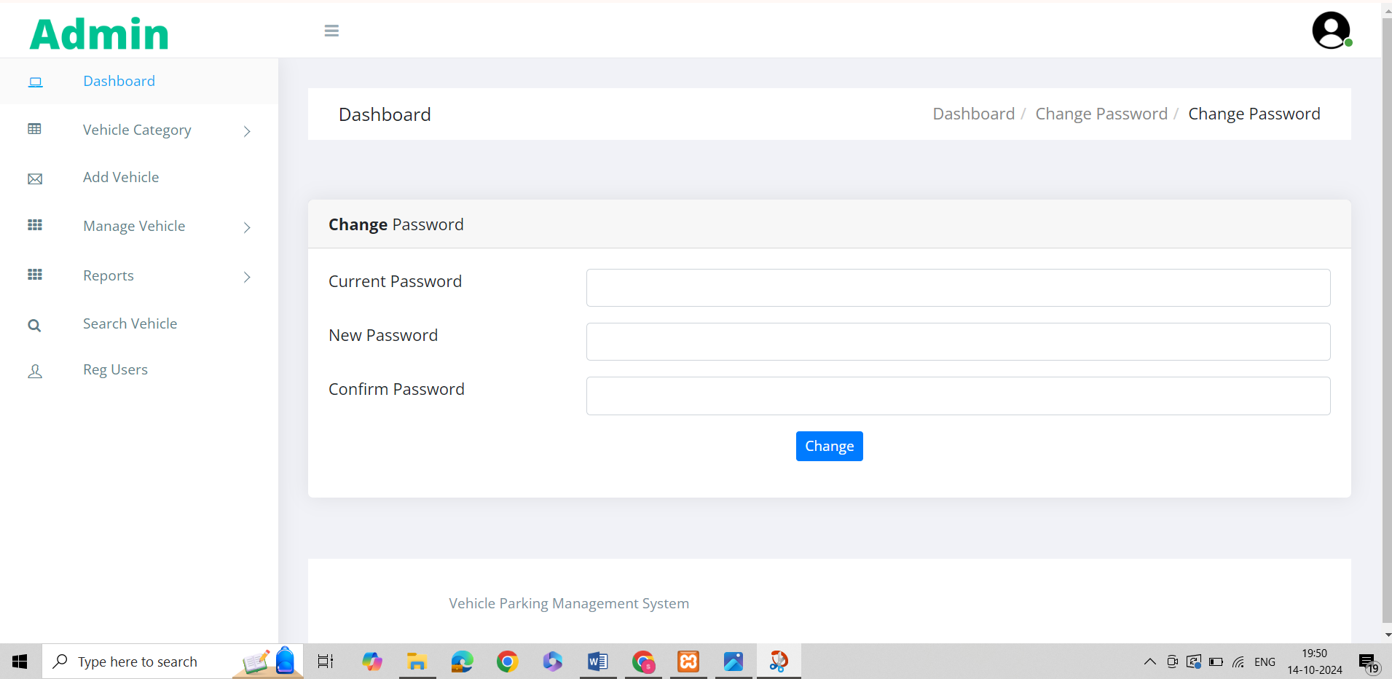

**Admin profile:**

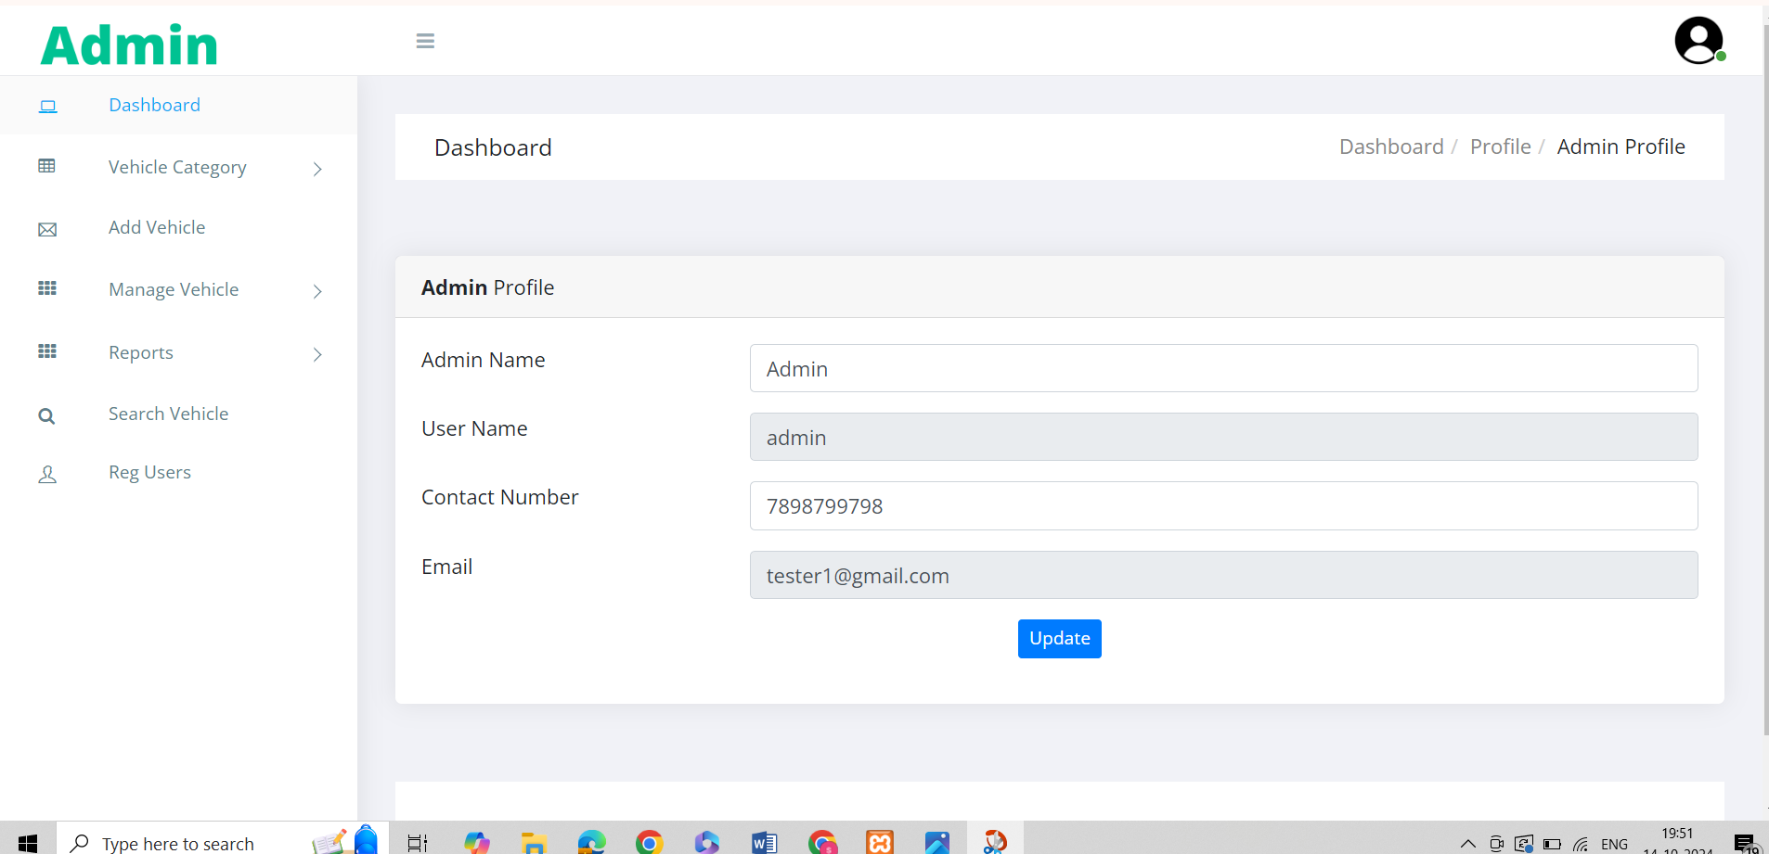

**User login:**

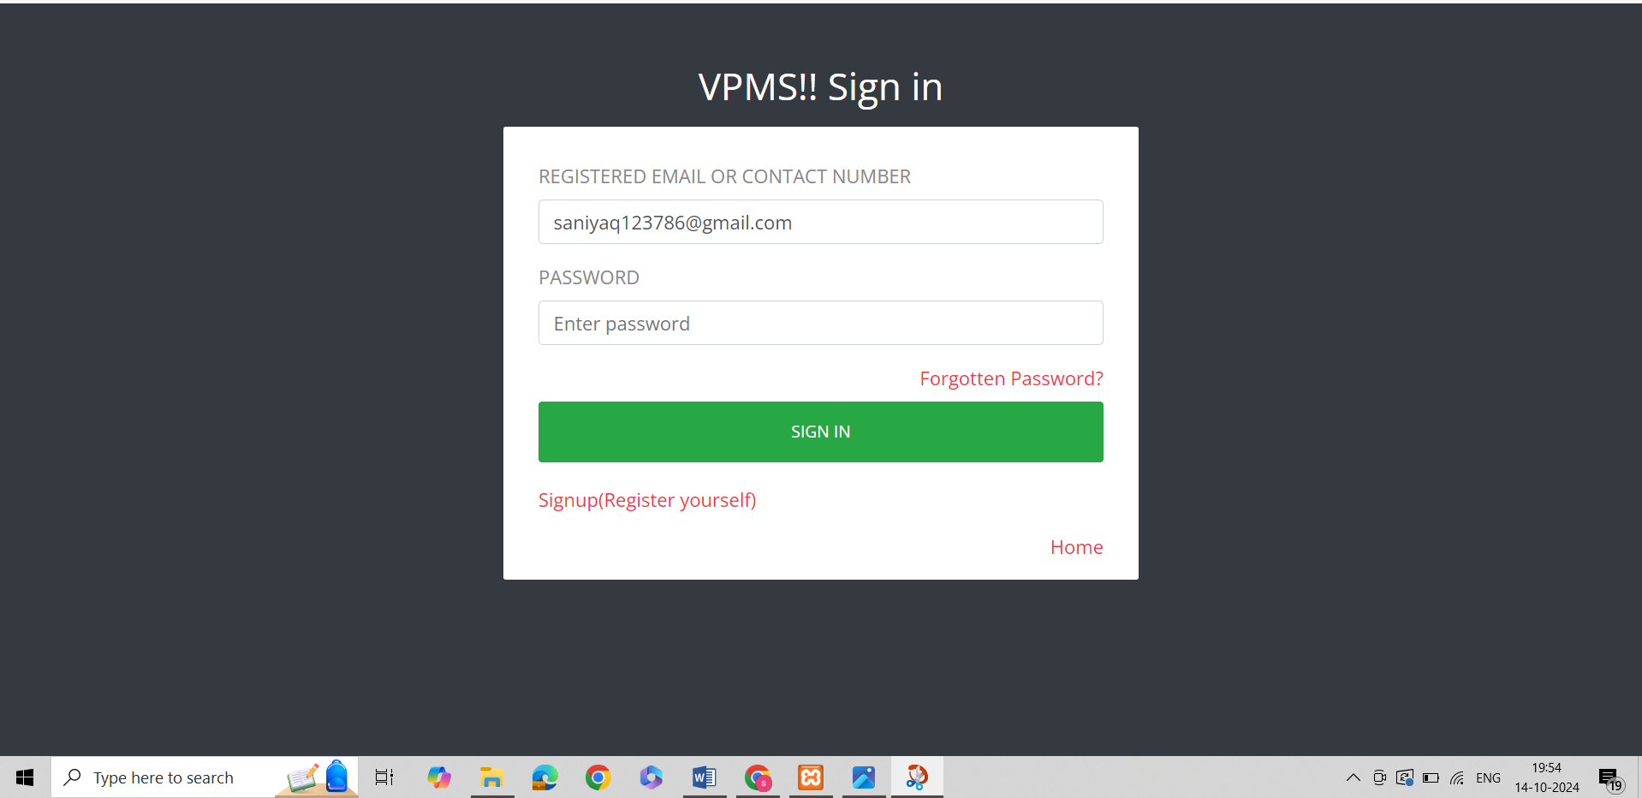

**Userdashboard:**

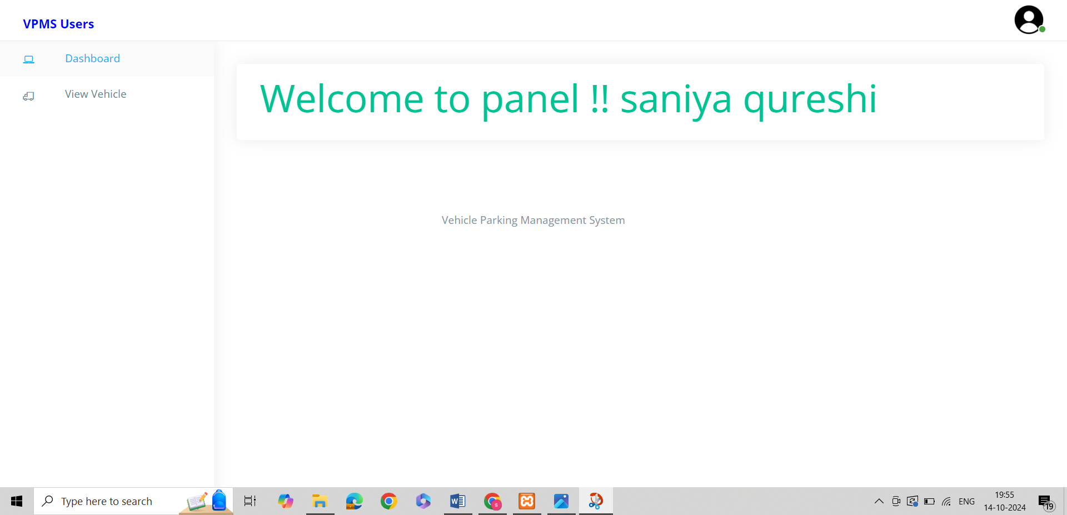

**View vehicle:**

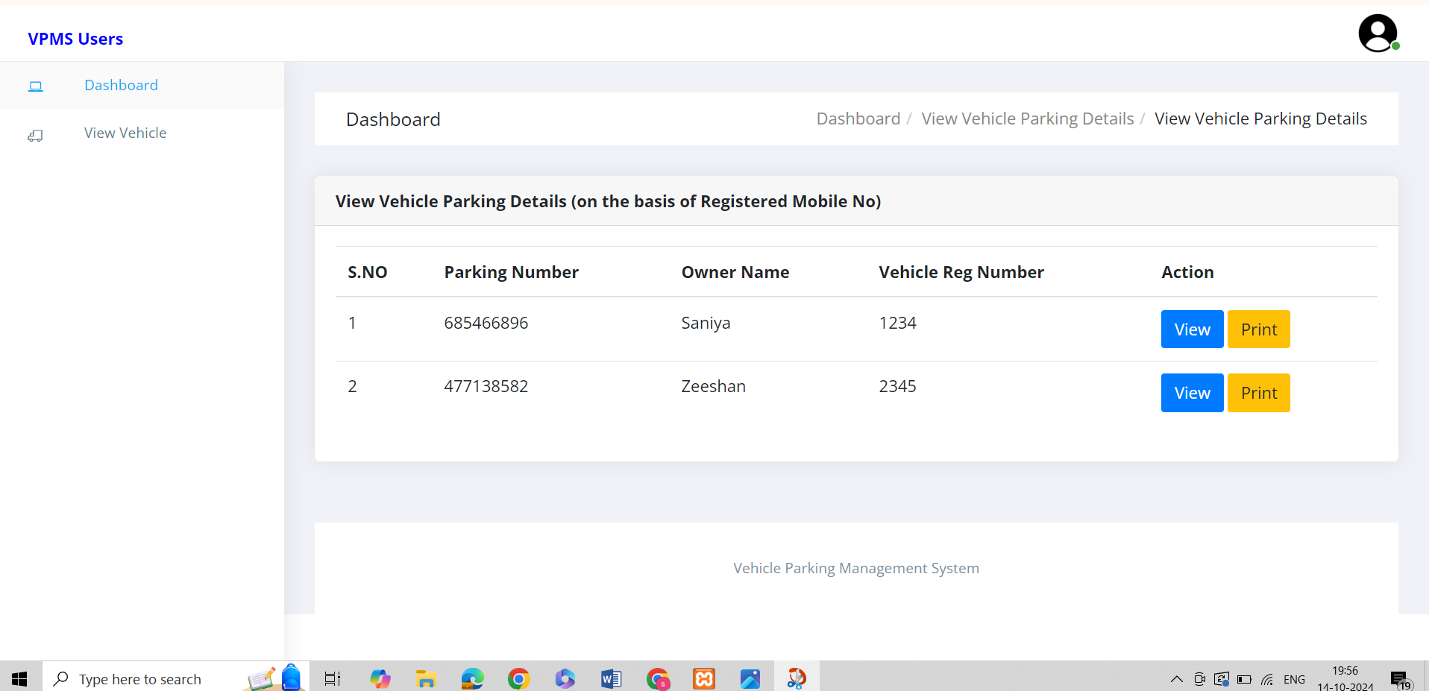

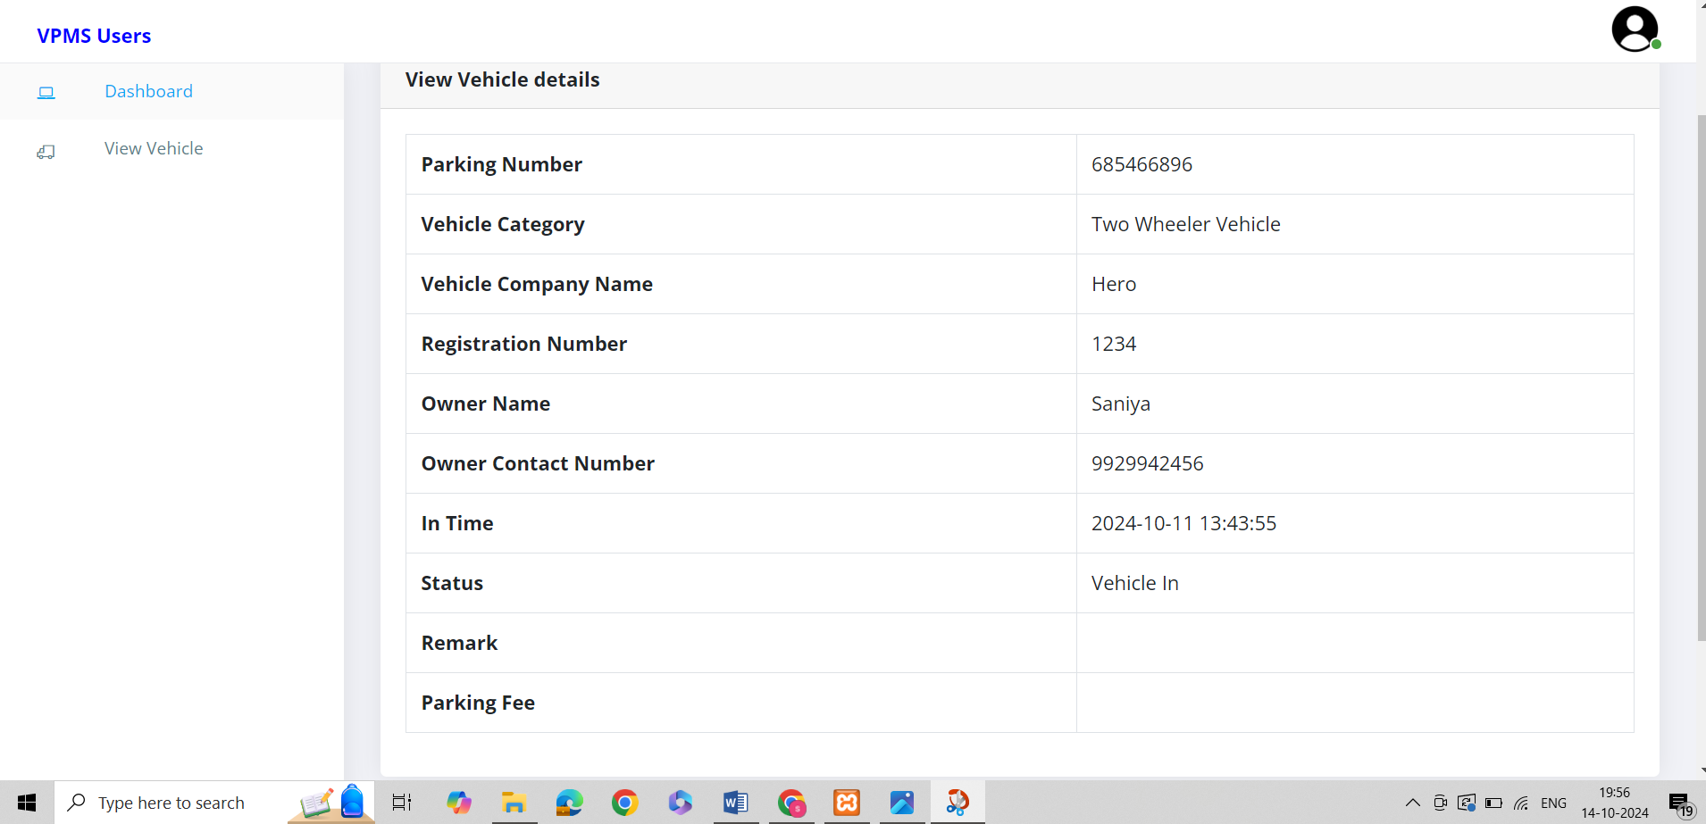

##### 4.2 Limitations

* **Limited Physical Space:** The availability of physical space for parking is a fundamental constraint, especially in densely populated urban areas where finding adequate parking space can be challenging.
* **Cost of Infrastructure:** Implementing a comprehensive parking management system, including sensors, cameras, and other infrastructure, can be expensive, making it a limitation for budget-conscious projects.
* **Maintenance Challenges:** The technology used for parking management requires regular maintenance, and system failures or breakdowns can disrupt the smooth functioning of the project.
* **Resistance to Technology Adoption:** Users may be resistant to adopting new technologies, especially in areas where there is a lack of awareness or understanding of the benefits of a parking management system.
* **Privacy Concerns:** The use of surveillance technologies in parking management systems may raise privacy concerns among users, and addressing these concerns is crucial for the project's acceptance.
* **Dependency on Power and Connectivity:** Parking management systems often rely on continuous power and network connectivity. Power outages or network failures can affect the system's functionality.
* **Implementation Complexity:** Deploying a parking management system can be

complex, involving coordination with multiple stakeholders such as local authorities, property owners, and technology providers.

* **User Education and Training:** Users may need to be educated and trained on how to use the parking management system, and resistance or lack of awareness can be a limitation.
* **Limited Applicability in Remote Areas:** In rural or less-developed areas, where vehicle density is low, implementing an advanced parking management system may not be cost-effective or practical.
* **Regulatory Compliance:** Adhering to local regulations and obtaining necessary approvals can be time-consuming and may pose challenges during the project implementation phase.

**4.3 Future Enhancement:**

1. **Smart Parking Systems:** 
   * Sensor Technology: Implement advanced sensor technologies, such as ultrasonic sensors, cameras, or lidar, to detect and monitor parking space occupancy in real-time.
   * IoT Integration: Connect sensors to the Internet of Things (IoT) to enable seamless communication and data exchange between parking infrastructure and management systems.
2. **Mobile Apps and Digital Platforms:** 
   * Reservation Systems: Allow users to reserve parking spaces in advance through mobile apps, reducing the time spent searching for parking and minimizing congestion.
   * Payment Integration: Enable mobile payment options for parking fees to streamline the payment process and reduce reliance on physical payment methods.
3. **Data Analytics and Predictive Modeling:** 
   * Predictive Analytics: Utilize historical parking data and real-time information to predict parking space availability, helping users plan their routes more effectively.
   * Demand Forecasting: Analyze trends and patterns to forecast parking demand, allowing for better resource allocation and planning.
4. **Automated Parking Systems:** 
   * Automated Valet Parking: Develop and implement automated valet parking systems that enable vehicles to park themselves efficiently, reducing the need for large parking spaces.
   * Robotic Parking Facilities: Explore the use of robotic systems to manage parking, including automated parking garages where robots handle the task of parking and retrieving vehicles.
5. **Integration with Smart Cities:** 
   * Traffic Management Integration: Coordinate parking management with broader urban traffic management systems to optimize traffic flow and reduce congestion.
   * Environmental Impact Monitoring: Integrate sensors to monitor the environmental impact of parking activities, promoting sustainability and green initiatives.
6. **Electric Vehicle (EV) Infrastructure:** 
   * EV Charging Stations: Incorporate electric vehicle charging stations into parking facilities to support the growing demand for electric vehicles.
   * Smart Grid Integration: Implement smart grid technologies to optimize the charging process and balance the load on the power grid.
7. **User-Friendly Interfaces:** 
   * Augmented Reality (AR) Navigation: Develop AR navigation systems within mobile apps to guide users to available parking spaces with real-time overlays on their device screens.
   * Voice-Activated Systems: Implement voice-activated commands for parking apps to enhance accessibility and reduce distractions for users.
8. **Safety and Security:** 
   * Surveillance Systems: Enhance security measures through the integration of advanced surveillance systems, including AI-powered video analytics for threat detection.
   * Emergency Response Integration: Connect parking management systems with emergency services for quick response in case of accidents or security incidents. **9. Community Collaboration:**
   * Crowdsourced Parking Information: Encourage users to share real-time parking information and experiences, creating a community-driven approach to parking management.

**10. Green and Sustainable Practices:**

• Green Roof Parking: Explore the concept of green roofs on parking structures, incorporating vegetation to improve air quality and provide environmental benefits.

## BIBLIOGRAPHY

**Books**

1. The Joy of PHP Programming: A Beginner’s Guide – by Alan Forbes
2. Learn PHP & MySQL – Zero to Hero Programming Crash Course – by Paul

Madoff

1. PHP & MySQL Web Development – by Luke Welling & Laura Thompson

**Website**

1. JavaScript: <https://www.w3schools.com/js/>
2. HTML: <https://www.w3schools.com/html/default.asp>
3. CSS: <https://www.w3schools.com/css/default.asp>
4. PHP: <https://www.phptpoint.com/>