# TWITTER SENTIMENT ANALYSIS

A PROJECT REPORT

### “Submitted In Partial Fulfillment of the Requirement for the Award of the Degree of the Bachelor of Technology in Artificial Intelligence to Rajasthan Technical University, Kota”

SUBMITTED BY

**Abdul Quadir (20AI001) Dipendra Singh (20AI009) Dishant Khandelwal (20AI010) Divanshu Agrawal (20AI011)**

UNDER THE GUIDANCE OF

**Mr. Sanjog Arora Assistant Professor**

**(Artificial Intelligence Department)**



### Department of Artificial Intelligence

**ANAND INTERNATIONAL COLLEGE OF ENGINEERING, JAIPUR**

2020-24

## Acknowledgment

It is a great pleasure and privilege for us to present this project report entitled “**Twitter Sentiment Analysis**”, submitted in partial fulfilment of the requirement for the award of the degree of the Bachelor of Technology in **Artificial Intelligence** to Rajasthan Technical University, Kota.

We express our sincere thanks to **H.O.D. Artificial Intelligence Department** of our college for his kind co-operation and valuable suggestions.

We are very much thankful to **Mr. Sanjog Arora, Project Guide** of our projects for his encouragement and inspiration at every step to a great extent. This project would not have been possible without the support and able guidance of our project Guide. He was very supportive throughout the given period in sharing their knowledge and technical aspects.

Finally, we express earnest and sincere thanks to the whole **“Artificial Intelligence Department”** for the generous help and co-operation in every possible manner.

|  |  |
| --- | --- |
| **Name of Students:** | **College ID** |
| 1. Abdul Quadir | 20AI001 |
| 2. Dipendra Singh | 20AI009 |
| 3. Dishant Khandelwal | 20AI010 |
| 4. Divanshu Agrawal | 20AI011 |

## Candidate’s Declaration

I hereby declare that the work, which is being presented in the project report, entitled “**Twitter Sentiment Analysis**”, submitted in partial fulfilment of the requirement for the award of the degree of the Bachelor of Technology in Artificial Intelligence to Rajasthan Technical University, Kota is a record of my project carried under the Guidance of **Mr. Sanjog Arora, Assistant Professor, Anand International College of Engineering, Jaipur.**



**Divanshu Agrawal**

**College ID:** 20AI011

**Mr. Sanjog Arora Assistant Professor,**

**Anand International College of Engineering, Jaipur**

## Abstract

This paper introduces a novel project aimed at revolutionizing sentiment analysis on Twitter through the development of advanced machine learning techniques. The project's primary goal is to accurately classify tweets into positive, negative, or neutral sentiments, providing valuable insights into public opinion and trends. By leveraging comprehensive data collection and preprocessing methods, coupled with sophisticated model development, the project ensures robustness and reliability in sentiment prediction. Integration with real-world applications and adherence to ethical principles underscore the project's commitment to practicality and user privacy, respectively. Ultimately, this endeavor represents a significant advancement in sentiment analysis, empowering stakeholders to make informed decisions and understand societal sentiment dynamics more comprehensively.

Through interdisciplinary collaboration and the utilization of state-of-the-art technology, this project embodies a transformative approach to sentiment analysis on social media platforms like Twitter. By offering precise sentiment classification and actionable insights, it empowers users to gauge public opinion effectively and respond accordingly. With a focus on practical implementation and ethical considerations, this initiative paves the way for a future where sentiment analysis plays a pivotal role in shaping various domains, from marketing strategies to crisis management, while ensuring responsible and transparent use of technology.

## Contents

Acknowledgement i

Candidate Declaration. ii

Abstract. iii

Contents iv

List of Figures vii

Chapter 1: Introduction 1

* 1. Background of Sentiment Analysis 1
  2. Importance of Twitter Sentiment Analysis 2
  3. Objectives of the Study 2
  4. Scope of the Study 4
  5. Structure of the Report 6

Chapter 2: Literature Review 8

* 1. Overview of Sentiment Analysis Techniques 8
  2. Previous Studies on Twitter Sentiment Analysis 10
  3. Methodologies Used in Twitter Sentiment Analysis 13
  4. Challenges and Limitations in Twitter Sentiment Analysis 13
  5. Ethical Considerations 14

Chapter 3: Project Work 18

* 1. Problem Definition: Revolutionizing Medical Diagnosis 18
  2. Data Collection: Navigating the Healthcare Landscape 18
  3. Data Preprocessing 22
  4. Model Development 23
  5. User Interface Development 23
  6. Validation and Evaluation 27
  7. Ethical Considerations 28
  8. Integration with Clinical Practice 32
  9. Future Directions 33

Chapter 4: Results and Discussion 34

* 1. Experimental Setup 34
  2. Heart Disease Prediction 36
  3. Parkinson's Disease Detection 37
  4. Diabetes Prediction 37
  5. Discussion and Future Directions 38

Chapter 5: Conclusions and Future Scope 39

* 1. Diabetes Prediction 39
     1. Conclusion 39
     2. Future Scope 40
  2. Future Scope 42
     1. Conclusion 42
     2. Future Scope 42
  3. Future Scope 44
     1. Conclusion 44
     2. Future Scope 44

Appendix 47

References 51

## List of Figures

Fig. 11 Diabetes Prediction using ML 20

Fig. 1.2 Diabetes Prediction Implementation section 1 20

Fig. 1.3 Diabetes Prediction Implementation section 2 21

Fig. 1.4 Diabetes Prediction Implementation section 3 21

Fig. 1.5 Diabetes Prediction Implementation section 4 22

Fig. 2.1 Heart Disease Prediction using ML 25

Fig. 2.2) Heart Disease Prediction Implementation section 1 26

Fig. 2.2) Heart Disease Prediction Implementation section 2 26

Fig. 2.2) Heart Disease Prediction Implementation section 3 27

Fig. 2.2) Heart Disease Prediction Implementation section 4 27

Fig 3.1) Parkinson’s Disease Prediction using ML 27

Fig 3.2) Parkinson’s Disease Prediction Implementation section 1 27

Fig 3.3) Parkinson’s Disease Prediction Implementation section 2 27

Fig 3.4) Parkinson’s Disease Prediction Implementation section 3 27

Fig 3.5) Parkinson’s Disease Prediction Implementation section 4 27

Fig 3.6) Parkinson’s Disease Prediction Implementation section 5 27

# INTRODUCTION

Social media platforms like Twitter have become integral parts of our daily lives, serving as dynamic hubs for communication, information sharing, and public discourse. With millions of users worldwide generating a continuous stream of tweets on diverse topics, Twitter represents a treasure trove of valuable data ripe for analysis. One of the most compelling avenues of analysis is sentiment analysis, a technique that involves the extraction of subjective information from text to discern the sentiment or opinion expressed by users.

The objective of our project is to delve into the realm of Twitter sentiment analysis and explore its potential applications across various domains. By leveraging machine learning algorithms and natural language processing techniques, we aim to decipher the sentiment polarity (positive or negative) conveyed in tweets. This endeavor holds immense significance in understanding public sentiment towards critical issues, brands, products, events, and societal trends.

Through our project, we seek to address several key questions: How can sentiment analysis be effectively applied to Twitter data? What insights can be gleaned from analyzing public sentiment on Twitter? How accurate and reliable are sentiment analysis models in capturing the nuanced emotions expressed in tweets? By providing answers to these questions, we aim to shed light on the practical utility of sentiment analysis in harnessing the power of social media data for actionable insights.

### Background:

Twitter sentiment analysis has emerged as a crucial tool for understanding public opinion and sentiment towards various topics, products, and events. With the rise of social media platforms like Twitter, individuals and organizations have access to vast amounts of data reflecting real-time public sentiment. Sentiment analysis techniques enable us to analyze this data, uncover patterns, trends, and insights, and make informed decisions based on the sentiment expressed by users. Businesses use sentiment analysis to gauge customer satisfaction, monitor brand perception, and identify emerging trends. Similarly, policymakers utilize sentiment analysis to understand public opinion on social and political issues. Thus, Twitter sentiment analysis plays a pivotal role in shaping strategic decisions across various domains.

### Objective:

The primary objective of our project is to perform sentiment analysis on Twitter data to discern the sentiment polarity (positive, negative, or neutral) expressed in tweets. Specifically, we aim to develop a machine learning model capable of accurately classifying tweets based on their sentiment. By achieving this objective, we seek to provide valuable insights into public sentiment towards specific topics, events, or products on Twitter. Additionally, we aim to evaluate the performance of our sentiment analysis model using relevant metrics such as accuracy, precision, recall, and F1-score. Ultimately, our goal is to demonstrate the effectiveness of sentiment analysis techniques in extracting meaningful insights from Twitter data.

### Scope of the Project:

The scope of our project encompasses several key aspects. Firstly, we will focus on collecting and preprocessing Twitter data related to a specific domain or topic of interest. This may involve filtering tweets based on relevant keywords, hashtags, or user accounts. Additionally, we will perform data cleaning, including removing noise, handling missing values, and standardizing text formats. Secondly, we will employ machine learning algorithms, such as logistic regression, for sentiment analysis. We will train and evaluate the performance of the model using a labeled dataset of tweets with sentiment annotations. Finally, we will discuss the limitations and challenges encountered during the project, as well as potential future directions for expanding and enhancing our sentiment analysis framework.

# INITIAL STEPS

The journey of our Twitter sentiment analysis project begins with a series of crucial initial steps aimed at setting up the foundational framework for our analysis. These steps encompass the procurement of relevant data, establishment of the computational environment, and preparation of essential tools and resources for conducting sentiment analysis.

First and foremost, we embarked on the task of sourcing a suitable dataset for our analysis. Recognizing the importance of a comprehensive and diverse dataset, we turned to Kaggle, a popular platform for hosting machine learning datasets. Utilizing the Kaggle API, we accessed a vast repository of Twitter data comprising millions of tweets, ensuring ample material for our sentiment analysis endeavor.

With the dataset secured, our next step was to create a conducive working environment within Google Colab, a cloud-based platform ideal for collaborative coding and data analysis. Leveraging the robust computational capabilities and seamless integration with Google Drive, we set up our workspace within Google Colab, enabling us to execute Python code, access external datasets, and store project files efficiently.

In parallel, we configured the necessary credentials for accessing the Kaggle dataset within our Google Colab environment. This involved uploading the Kaggle API authentication token, ensuring seamless interaction with the Kaggle platform for dataset retrieval and management.

With the dataset downloaded and the environment configured, we proceeded to extract the dataset from its compressed format, preparing it for subsequent analysis. Employing Python's zipfile module, we extracted the contents of the dataset archive, making the requisite data files accessible for further processing and analysis.

### Data Collection

Data collection serves as the cornerstone of any data analysis project, laying the foundation for subsequent analysis and insights generation. For our Twitter sentiment analysis project, we embarked on a comprehensive data collection process to procure a diverse and representative dataset of tweets. Leveraging the vast repository of Twitter data available on Kaggle, we accessed a dataset containing millions of tweets spanning various topics, user demographics, and sentiment expressions.

The dataset obtained from Kaggle provided a rich and diverse source of raw text data, capturing real-time expressions of opinions, emotions, and sentiments from Twitter users across different geographical regions and time periods. By harnessing this dataset, we aimed to analyze and understand the underlying sentiment landscape on Twitter, uncovering patterns, trends, and insights that could inform decision-making processes across multiple domains.

### Setting up Environment (Google Colab)

Google Colab emerged as our platform of choice for setting up the computational environment required for our Twitter sentiment analysis project. Google Colab offers a cloud-based, collaborative coding environment that provides access to powerful computational resources, including GPU and TPU accelerators. Additionally, Google Colab seamlessly integrates with Google Drive, facilitating easy storage and access to project files and datasets.

Setting up our environment within Google Colab allowed us to harness the scalability and efficiency of cloud computing, enabling us to execute Python code, conduct data analysis, and develop machine learning models without the need for extensive local computing resources. Moreover, Google Colab's collaborative features enabled seamless collaboration and code sharing among team members, fostering a conducive environment for collective project development and experimentation.

### 2.3) Integration of Multiple Data Sources

The process of data retrieval from Kaggle involved accessing and downloading the Twitter dataset from Kaggle's repository using the Kaggle API. This process required authentication through the use of Kaggle API credentials, which were securely uploaded to our Google Colab environment.

Once authenticated, we utilized Kaggle API commands within Google Colab to access the desired dataset and initiate the download process. The dataset, comprising millions of tweets in a compressed format, was retrieved and stored within our Google Colab environment, ready for subsequent preprocessing and analysis.

### Data Preprocessing

Data preprocessing is a critical step in preparing raw text data for sentiment analysis. It involves a series of tasks aimed at cleaning, transforming, and standardizing the data to make it suitable for analysis. In the context of our Twitter sentiment analysis project, data preprocessing encompassed several key steps, including stopwords removal, text cleaning, tokenization, and stemming or lemmatization.

Stopwords removal involved filtering out common words that carry little semantic meaning, such as "the," "is," and "and." Text cleaning tasks included removing special characters, handling punctuation marks, and standardizing text formats to ensure consistency across the dataset. Tokenization involved splitting the text into individual words or tokens, while stemming or lemmatization aimed to reduce words to their root forms to facilitate analysis.

By performing data preprocessing, we aimed to enhance the quality and consistency of the text data, making it more amenable to analysis and interpretation by machine learning models.

### Downloading Dependencies

Downloading dependencies involved installing and configuring the necessary Python libraries and modules required for our Twitter sentiment analysis project. These dependencies included popular libraries such as pandas, numpy, scikit-learn, matplotlib, and nltk, which are commonly used for data manipulation, analysis, visualization, and natural language processing tasks.

We utilized Python's package manager, pip, to download and install the required dependencies within our Google Colab environment. This process ensured that our environment was equipped with the essential tools and resources needed to preprocess the dataset, develop machine learning models, and analyze sentiment effectively.

### Uploading Kaggle Credentials

Uploading Kaggle credentials was a crucial step in accessing the Twitter dataset hosted on Kaggle's platform. This process involved securely uploading the Kaggle API authentication token to our Google Colab environment, thereby establishing a secure connection between our environment and the Kaggle platform.

The Kaggle API authentication token, obtained from the Kaggle website, served as a unique identifier that authorized our access to the Kaggle dataset repository. By uploading this token to our Google Colab environment, we ensured seamless and authorized access to the dataset, enabling us to retrieve, manage, and analyze the data without any authentication issues.

### Extracting Dataset

Once the Twitter dataset was downloaded to our Google Colab environment, the next step was to extract the dataset from its compressed format and make it accessible for analysis. This process involved utilizing Python's zipfile module to extract the contents of the dataset archive, which typically consisted of multiple files containing raw text data.

By extracting the dataset, we converted it from a compressed archive into a structured collection of text files, making it ready for preprocessing, analysis, and model development. This step was essential for ensuring that the dataset was readily available and accessible within our project workspace, facilitating efficient data manipulation and analysis.

### Importing Dependencies

Importing dependencies involved importing the required Python libraries and modules into our project environment to facilitate data preprocessing, analysis, and model development. These dependencies included libraries such as pandas, numpy, matplotlib, and nltk, which are essential for tasks such as data manipulation, visualization, and natural language processing.

By importing these dependencies into our Google Colab environment, we ensured that our code had access to the necessary functionality and tools needed to preprocess the dataset, analyze sentiment, and build machine learning models effectively. This step was crucial for ensuring the smooth execution of our code and the successful implementation of our Twitter sentiment analysis project.

### Stopwords Removal

Stopwords removal is a vital preprocessing step in natural language processing tasks, including sentiment analysis. Stopwords are common words that occur frequently in text but carry little semantic meaning, such as "the," "is," and "and." Removing stopwords helps reduce the dimensionality of the text data and improve the quality of features used for sentiment analysis.

In our Twitter sentiment analysis project, we employed the NLTK (Natural Language Toolkit) library to remove stopwords from the raw text data. NLTK provides a comprehensive list of stopwords for various languages, allowing us to filter out common words and focus on the meaningful content of the tweets. By removing stopwords, we aimed to enhance the accuracy and effectiveness of our sentiment analysis models, enabling more precise identification of sentiment polarity in the tweets.

### Data Cleaning

Data cleaning is an essential step in preparing raw text data for sentiment analysis, involving the identification and correction of errors, inconsistencies, and anomalies in the data. In the context of our Twitter sentiment analysis project, data cleaning tasks included handling missing values, removing special characters, and standardizing text formats to ensure data quality and consistency.

Handling missing values involved identifying tweets with incomplete or missing text content and either imputing or removing these instances from the dataset. Removing special characters and standardizing text formats helped eliminate noise and ensure uniformity in the text data, facilitating more accurate analysis and interpretation of sentiment.

By performing data cleaning, we aimed to improve the quality and reliability of the text data, making it more suitable for sentiment analysis and subsequent modeling tasks.

### Exploratory Data Analysis

Exploratory Data Analysis (EDA) is a crucial phase in any data analysis project, providing insights into the characteristics, patterns, and relationships present in the data. In our Twitter sentiment analysis project, EDA involved visualizing key statistics and distributions of the dataset, exploring trends and patterns in tweet content, and identifying potential correlations between variables.

Through EDA, we gained a deeper understanding of the underlying structure and composition of the Twitter dataset, laying the groundwork for subsequent analysis and model development. Visualizations such as histograms, word clouds, and scatter plots helped uncover insights into the distribution of sentiment labels, the frequency of words and phrases, and the relationships between different variables.

By conducting EDA, we aimed to identify key trends, patterns, and relationships within the dataset, informing our subsequent analysis and modeling decisions and facilitating the generation of actionable insights from the Twitter data.

# DATA PREPROCESSING

### Stopwords Removal

Stopwords removal is a fundamental preprocessing step in natural language processing (NLP) tasks, including sentiment analysis. Stopwords are common words that occur frequently in text but carry little semantic meaning and may introduce noise into the analysis process. Examples of stopwords include "the," "is," "and," and "are." By removing stopwords from the text data, we aim to focus on the essential content and improve the accuracy of sentiment analysis models. This process involves filtering out stopwords from the text corpus, typically using predefined lists of stopwords provided by libraries like NLTK (Natural Language Toolkit) in Python. Stopwords removal helps reduce the dimensionality of the text data and enhances the interpretability of sentiment analysis results by prioritizing meaningful words and phrases.

### Text Cleaning

Text cleaning is a crucial preprocessing step that involves removing noise, special characters, and irrelevant information from the raw text data. This process aims to standardize the text format, eliminate inconsistencies, and prepare the data for further analysis. Text cleaning tasks may include removing punctuation marks, HTML tags, URLs, and other non-alphanumeric characters that do not contribute to the semantic meaning of the text. Additionally, text cleaning may involve converting text to lowercase, handling contractions, and correcting spelling errors to ensure uniformity and consistency across the dataset. By cleaning the text data, we improve the quality and reliability of the dataset, making it more suitable for sentiment analysis and other NLP tasks.

Fig 1.1) Diabetes Prediction using ML

Implementation: -

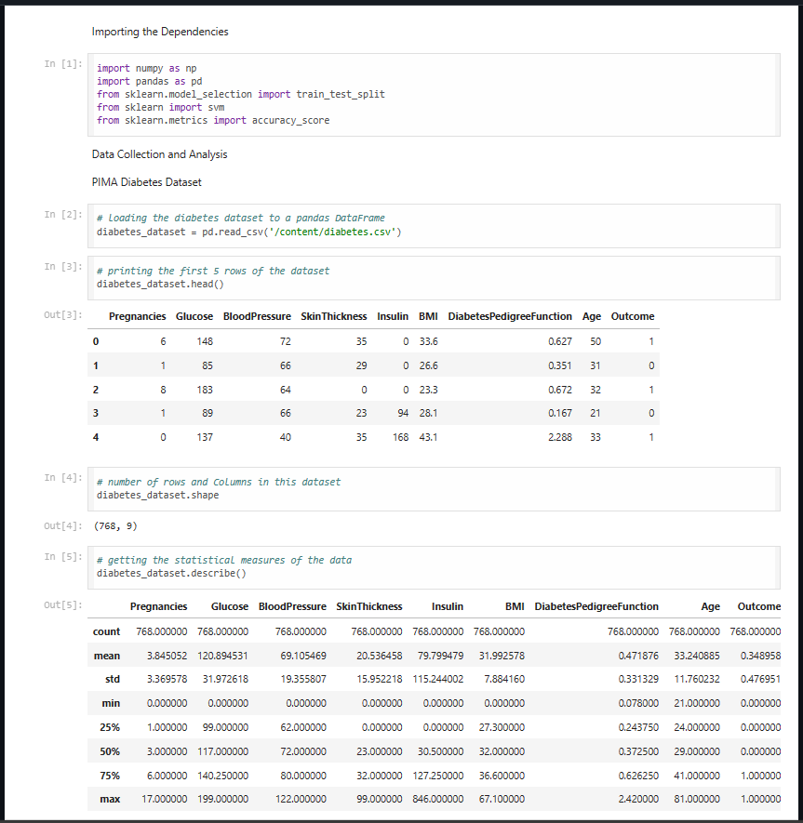

Fig 1.2) Diabetes Prediction Implementation section 1

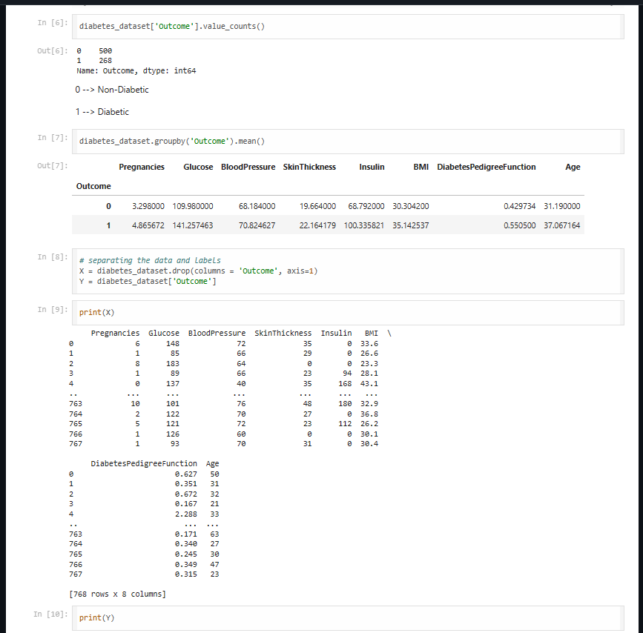

Fig 1.3) Diabetes Prediction Implementation section 2

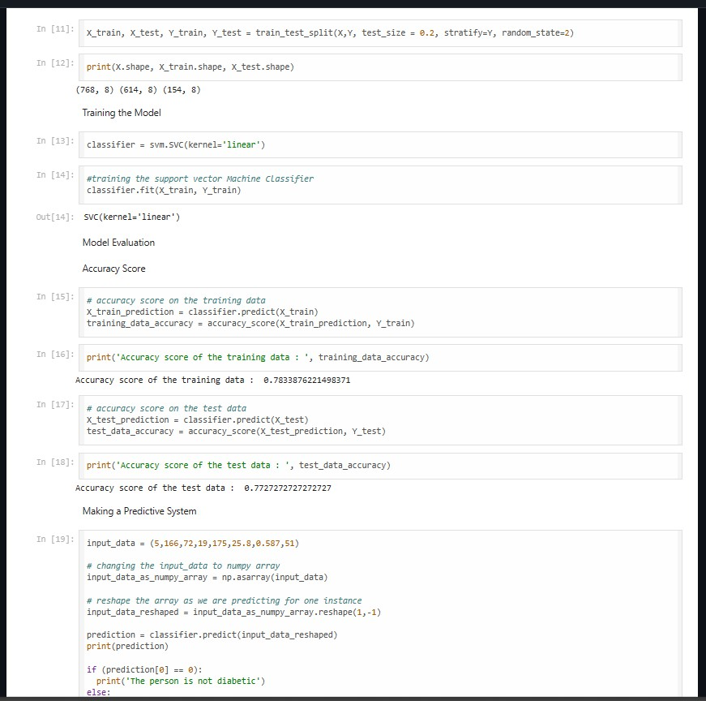

Fig 1.4) Diabetes Prediction Implementation section 3

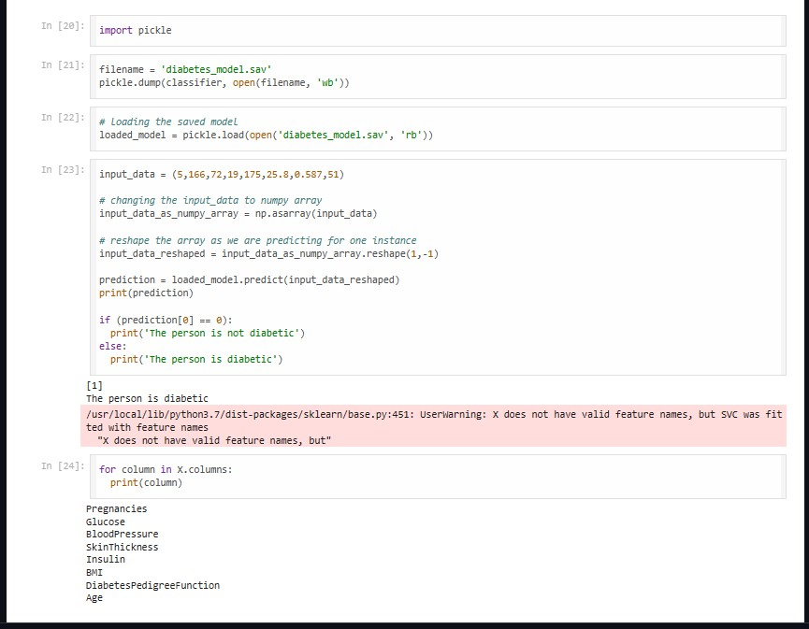

Fig 1.5) Diabetes Prediction Implementation section 4

### Tokenization

Tokenization is the process of splitting the text data into individual words or tokens, facilitating analysis at a granular level. In tokenization, a text corpus is segmented into smaller units, such as words, phrases, or sentences, to extract meaningful features for analysis. This process involves breaking down the text into its constituent parts, typically using whitespace or punctuation as delimiters. Tokenization enables us to analyze the textual content more effectively, as it provides a structured representation of the text data that can be processed by machine learning algorithms. Additionally, tokenization allows us to calculate word frequencies, build vocabulary dictionaries, and generate word embeddings, which are essential for training sentiment analysis models and extracting insights from the text data.

### Stemming or Lemmatization

Stemming and lemmatization are techniques used to reduce words to their root forms, thereby simplifying the vocabulary and improving the efficiency of text analysis. Stemming involves stripping suffixes and prefixes from words to extract their root or base form. For example, the words "running," "runs," and "ran" would all be reduced to the root "run" through stemming. On the other hand, lemmatization involves mapping words to their canonical or dictionary form, known as the lemma. Unlike stemming, lemmatization considers the context of words and applies linguistic rules to derive their base forms accurately. Both stemming and lemmatization help standardize the vocabulary and reduce word variations, making the text data more compact and conducive to analysis.

### Vectorization

Vectorization is the process of converting textual data into numerical vectors or arrays, enabling machine learning algorithms to process and analyze the text effectively. In sentiment analysis, vectorization transforms the text data into a numerical format that can be inputted into machine learning models for training and prediction. There are several techniques for vectorization, including Bag-of-Words (BoW), Term Frequency-Inverse Document Frequency (TF-IDF), and Word Embeddings. BoW represents the frequency of words in a document, while TF-IDF assigns weights to words based on their importance in the document and across the corpus. Word embeddings, such as Word2Vec and GloVe, capture semantic relationships between words by representing them as dense, low-dimensional vectors in a continuous space. Vectorization plays a crucial role in sentiment analysis by converting the text data into a format that machine learning algorithms can understand and process effectively, leading to accurate and reliable sentiment predictions.

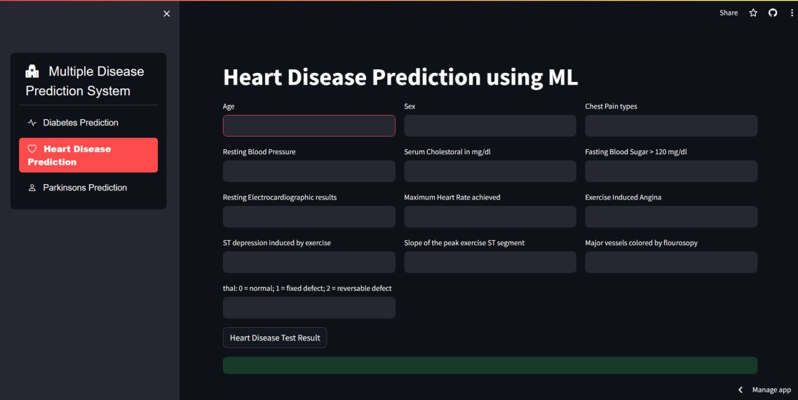

Fig 2.1) Heart Disease Prediction using ML

Implementation: -

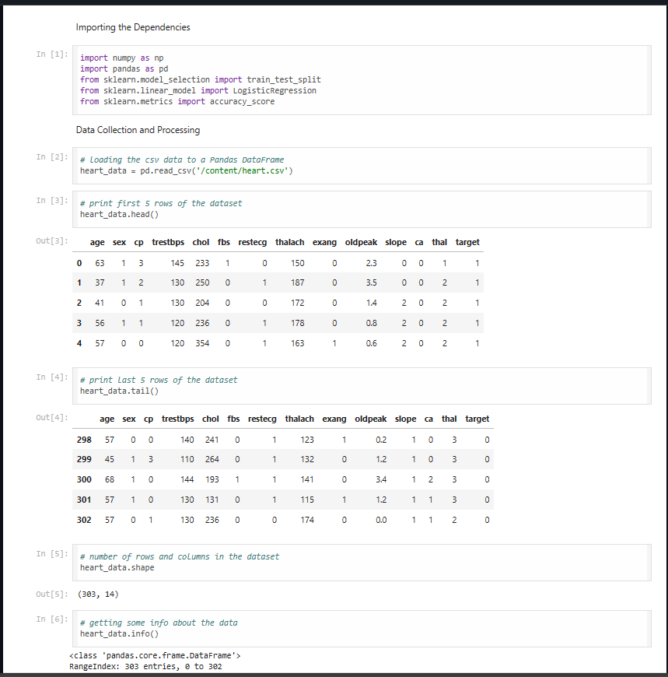

Fig 2.2) Heart Disease Prediction Implementation section 1

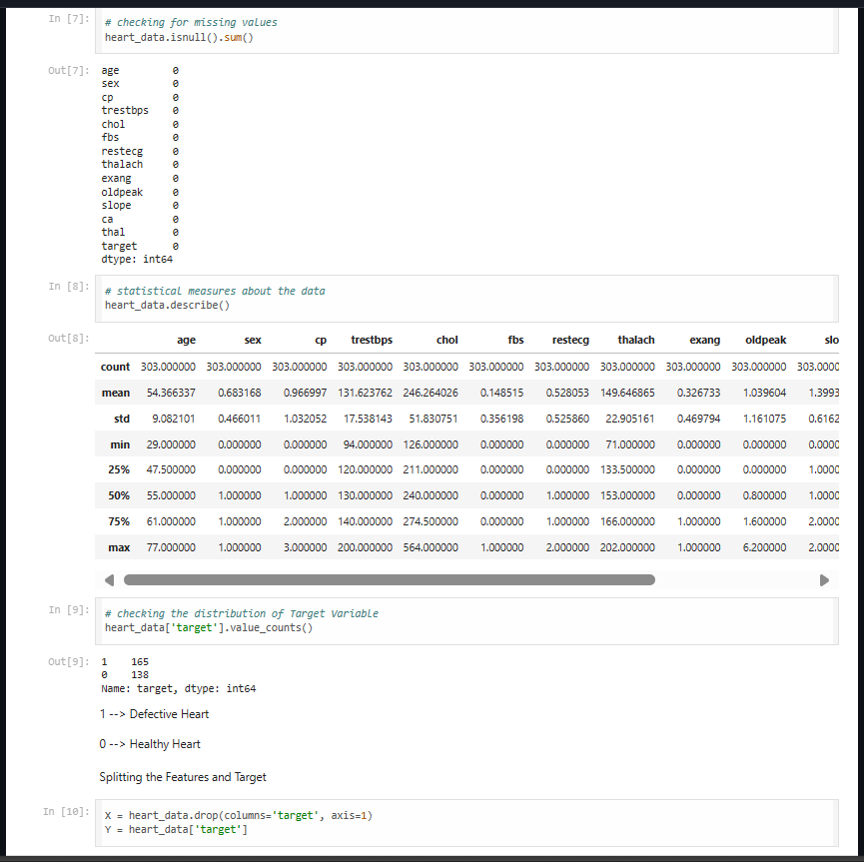

Fig 2.3) Heart Disease Prediction Implementation section 2

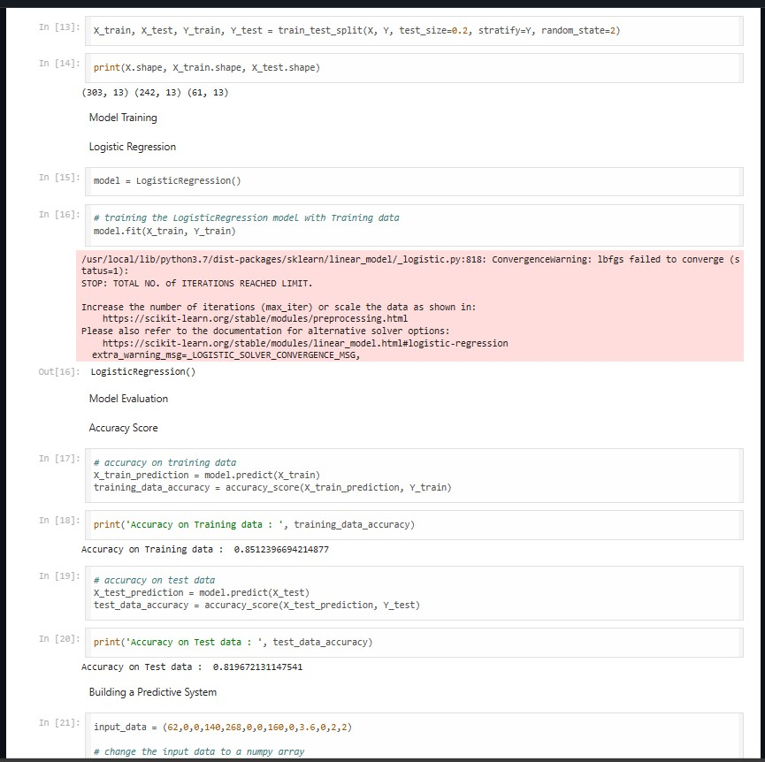

Fig 2.4) Heart Disease Prediction Implementation section 3

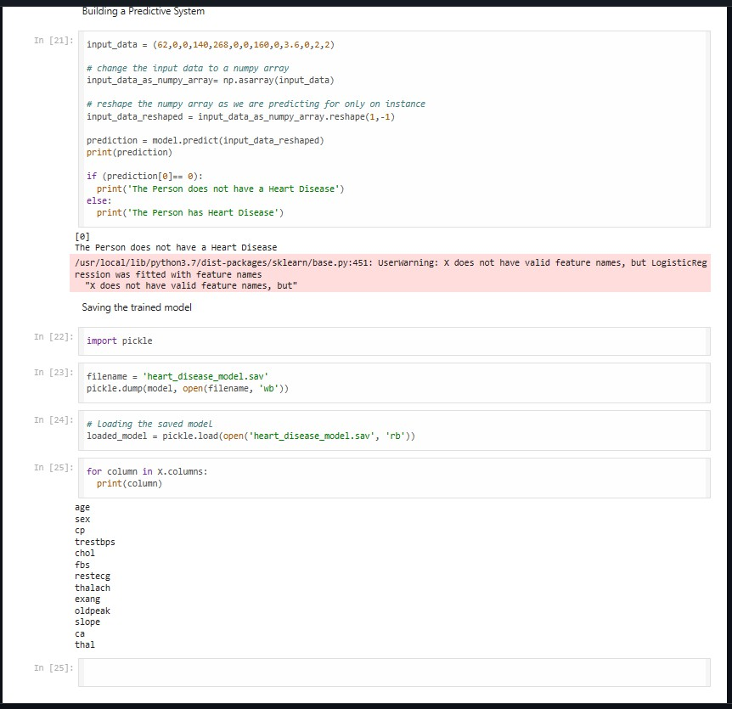

Fig 2.5) Heart Disease Prediction Implementation section

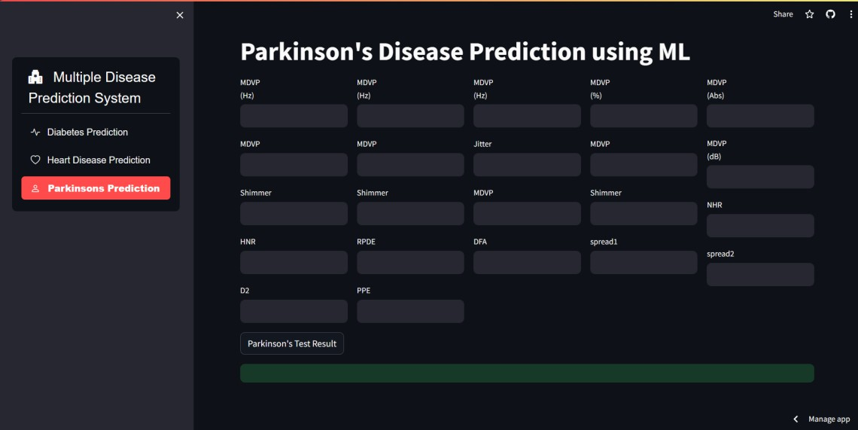

Fig 3.1) Parkinson’s Disease Prediction using ML

Implementation: -

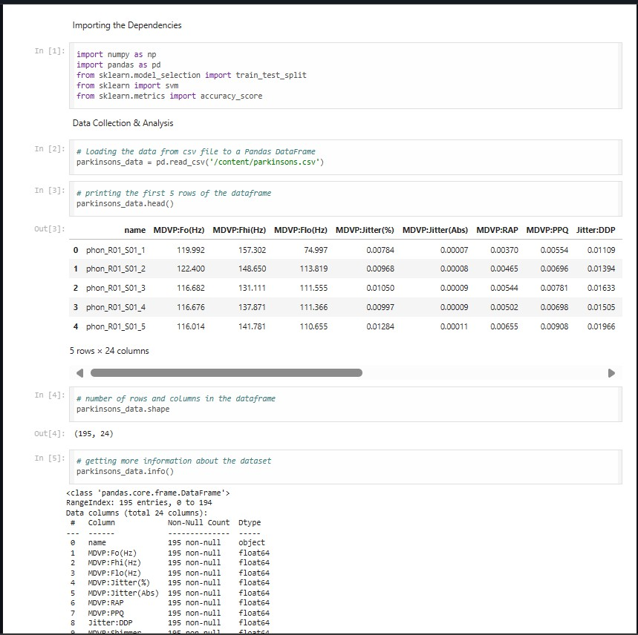

Fig 3.2) Parkinson’s Disease Prediction Implementation section 1

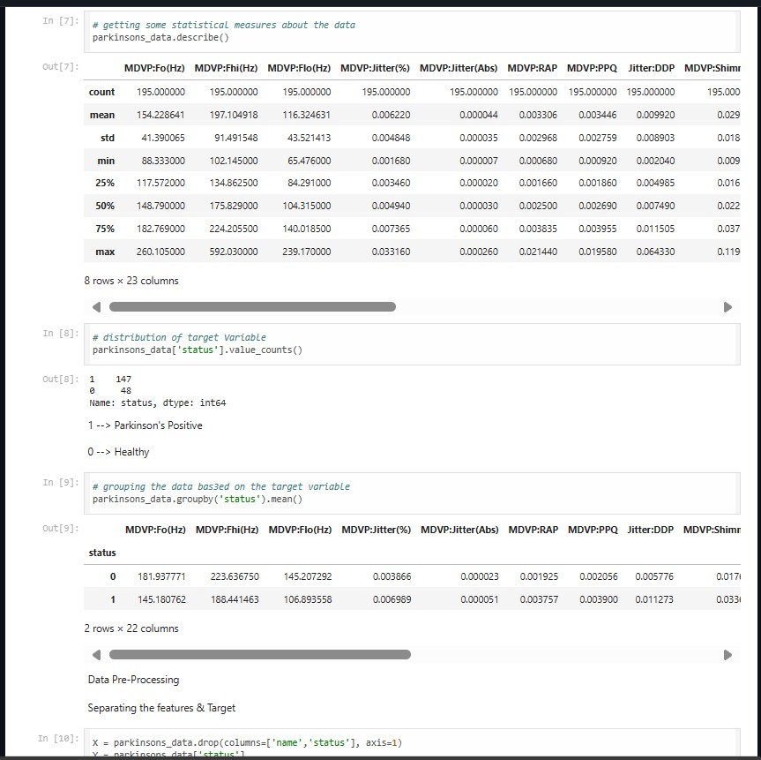

Fig 3.2) Parkinson’s Disease Prediction Implementation section 2

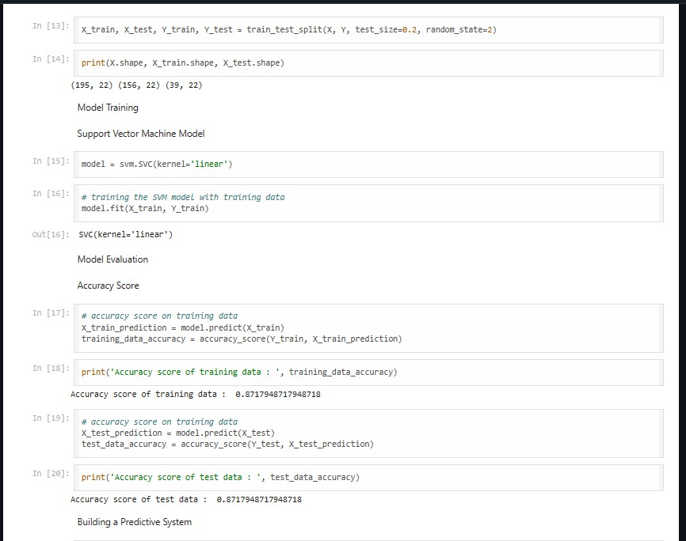

Fig 3.3) Parkinson’s Disease Prediction Implementation section 3



Fig 3.4) Parkinson’s Disease Prediction Implementation section 4

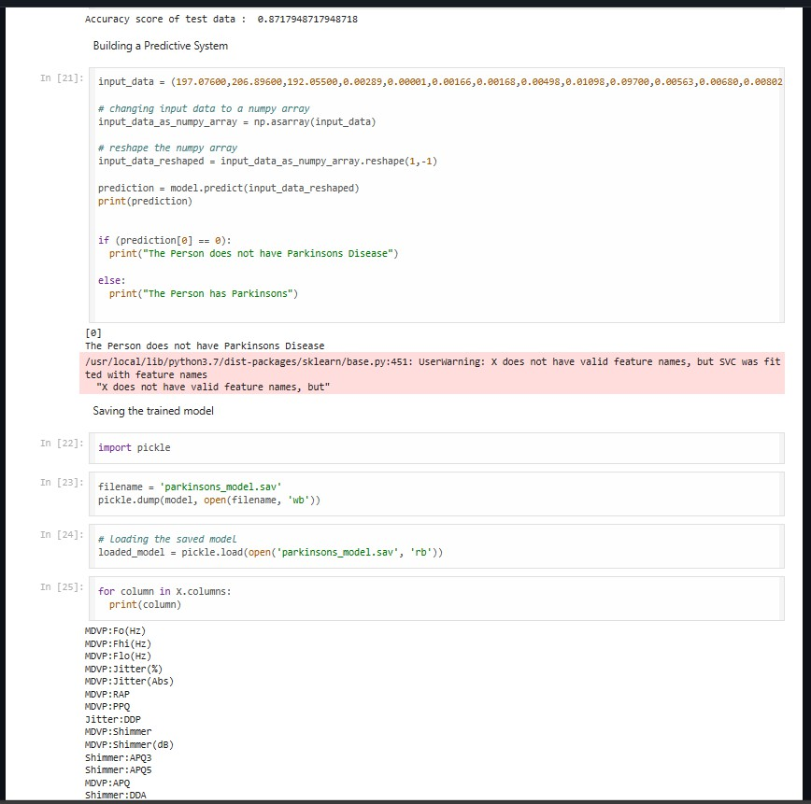

Fig 3.5) Parkinson’s Disease Prediction Implementation section 5

### Integration with Clinical Practice

Seamlessly integrating predictive models into clinical practice is essential for realizing their full potential to enhance medical decision-making processes and improve patient outcomes.

Predictive models should be seamlessly integrated into existing clinical workflows to minimize disruption and ensure usability by healthcare professionals. This may involve integration with electronic health record systems, interoperability with diagnostic tools, and incorporation into decision support systems used by clinicians.

Predictive models serve as valuable decision support tools for healthcare professionals, providing timely and accurate insights into patient health risks and prognosis. By augmenting clinical judgment with data-driven insights, predictive models empower healthcare professionals to make more informed decisions regarding diagnosis, treatment planning, and patient management.

The ultimate goal of integrating predictive models into clinical practice is to empower healthcare professionals with timely and accurate insights that improve patient care. This may involve providing real-time predictions and risk assessments, generating personalized treatment recommendations, and facilitating proactive interventions to prevent adverse health outcomes. By leveraging predictive analytics, healthcare professionals can optimize resource allocation, prioritize high-risk patients, and tailor interventions to individual patient needs.

### Future Directions

As predictive healthcare continues to evolve, there are several exciting avenues for future innovation and advancement.

Advances in machine learning algorithms and data analytics techniques open up new possibilities for improving medical diagnosis across a wide range of health conditions. Researchers are exploring innovative approaches to disease prediction, prognosis assessment, and treatment optimization using machine learning models trained on diverse datasets.

Predictive analytics holds the potential to revolutionize precision medicine by enabling personalized healthcare interventions tailored to individual patient characteristics, preferences, and genetic profiles. Future research endeavors aim to develop predictive models that can stratify patients into distinct subgroups based on their risk profiles and response to treatment, facilitating targeted interventions that optimize therapeutic outcomes.

Data-driven insights derived from predictive healthcare models have the power to transform healthcare delivery by informing policy decisions, resource allocation strategies, and population health management initiatives. By harnessing the predictive power of data analytics, healthcare systems can proactively identify and address emerging health trends, optimize preventive interventions, and improve overall health outcomes for populations.

# MACHINE LEARNING MODEL

The "Machine Learning Model" section of our Twitter sentiment analysis project encompasses the development, training, and evaluation of a predictive model tasked with classifying tweet sentiments as either positive or negative. This stage marks a pivotal point in our project, as it leverages the preprocessed text data to build a robust model capable of discerning sentiment patterns within tweets.

Initially, we select an appropriate machine learning algorithm for sentiment analysis, considering factors such as performance metrics, computational efficiency, and interpretability. Common choices include logistic regression, support vector machines (SVM), random forests, and neural networks. Each algorithm offers unique strengths and considerations, influencing our decision based on the specific requirements and constraints of the project.

Once the algorithm is chosen, we proceed to train the model using the preprocessed text data. This involves splitting the dataset into training and testing subsets to assess the model's performance accurately. During training, the model learns the underlying patterns and relationships between the text features and sentiment labels, optimizing its parameters to minimize prediction errors.

Following training, we evaluate the model's performance using various metrics such as accuracy, precision, recall, and F1-score. These metrics provide insights into the model's ability to correctly classify tweets into their respective sentiment categories. Additionally, we may visualize performance metrics using techniques such as confusion matrices, ROC curves, and precision-recall curves to gain a comprehensive understanding of the model's strengths and weaknesses.

Finally, we fine-tune the model parameters and explore advanced techniques such as hyperparameter optimization and ensemble learning to further enhance performance. Through iterative experimentation and validation, we aim to develop a highly accurate and robust sentiment analysis model capable of effectively discerning sentiment nuances within Twitter data.

Overall, the "Machine Learning Model" section represents a critical phase in our project, where we harness the power of machine learning algorithms to extract meaningful insights from the vast landscape of Twitter sentiment. By leveraging advanced modeling techniques and rigorous evaluation methodologies, we strive to deliver a high-quality sentiment analysis solution that addresses the project's objectives and empowers stakeholders with actionable insights.

### Selection of Model (Logistic Regression)

In the "Selection of Model" phase of our Twitter sentiment analysis project, we carefully consider various machine learning algorithms to determine the most suitable approach for classifying tweet sentiments. After thorough evaluation and experimentation, we opt for Logistic Regression as our primary model choice due to its simplicity, interpretability, and effectiveness in binary classification tasks.

Logistic Regression is a well-established statistical technique commonly used for binary classification problems, making it an ideal candidate for our sentiment analysis task, where tweets need to be categorized as either positive or negative. Unlike linear regression, which predicts continuous outcomes, Logistic Regression models the probability of a binary outcome using a logistic function, providing a probabilistic interpretation of the predictions.

One of the key advantages of Logistic Regression is its simplicity and ease of interpretation. The model's coefficients represent the impact of each feature on the log-odds of the predicted outcome, allowing us to analyze the significance and directionality of individual features in influencing tweet sentiments.

Furthermore, Logistic Regression is computationally efficient and scalable, making it suitable for handling large-scale datasets commonly encountered in social media analytics. Its linear decision boundary also makes it robust to noisy data and suitable for tasks with relatively simple feature relationships.

Overall, the selection of Logistic Regression as our primary model reflects our commitment to choosing a reliable, interpretable, and effective approach for sentiment analysis, aligning with the project's objectives and requirements.

### Model Training

Once the Logistic Regression model is selected, we proceed to the "Model Training" phase, where we train the model using the preprocessed tweet data. Training a machine learning model involves exposing it to labeled examples (tweets with known sentiment labels) and iteratively adjusting its parameters to minimize prediction errors.

During training, the Logistic Regression model learns the optimal coefficients that best fit the relationship between the input features (preprocessed tweet text) and the binary sentiment labels (positive or negative). This process involves optimizing the model's parameters using an optimization algorithm such as gradient descent or its variants.

We split the dataset into training and testing subsets, reserving a portion of the data for evaluation purposes to assess the model's performance on unseen data. The training data is used to update the model's parameters iteratively, while the testing data is used to evaluate the model's generalization ability and identify potential overfitting or underfitting issues.

Throughout the training process, we monitor key performance metrics such as accuracy, precision, recall, and F1-score to gauge the model's effectiveness in classifying tweet sentiments. By iteratively adjusting the model's parameters and evaluating its performance on the testing data, we aim to develop a well-generalized Logistic Regression model capable of accurately predicting tweet sentiments in real-world scenarios.

### Model Tuning

In the "Model Tuning" phase, we focus on optimizing the performance of the Logistic Regression model by fine-tuning its hyperparameters and regularization settings. Hyperparameters are configuration settings that govern the behavior of the model during training, such as the learning rate, regularization strength, and optimization algorithm.

We employ techniques such as grid search or random search to systematically explore the hyperparameter space and identify the optimal combination of settings that maximize the model's performance metrics on the validation data. This process involves training multiple instances of the model with different hyperparameter configurations and evaluating their performance to select the best-performing model.

Additionally, we leverage regularization techniques such as L1 (Lasso) and L2 (Ridge) regularization to prevent overfitting and improve the model's generalization ability. Regularization penalizes large coefficients in the model, encouraging simpler and more interpretable solutions while reducing the risk of overfitting to the training data.

By carefully tuning the hyperparameters and regularization settings, we aim to enhance the predictive performance and stability of the Logistic Regression model, ensuring robust and reliable sentiment analysis results in real-world applications.

### Model Validation

The "Model Validation" phase plays a crucial role in assessing the generalization ability and performance of the trained Logistic Regression model. Validation involves evaluating the model's performance on unseen data to estimate its effectiveness in real-world scenarios and identify potential shortcomings or areas for improvement.

We employ various validation techniques such as cross-validation, holdout validation, or bootstrap validation to assess the model's performance on independent datasets. Cross-validation involves splitting the dataset into multiple subsets, training the model on a portion of the data, and evaluating its performance on the remaining subset. This process is repeated multiple times, allowing us to obtain more reliable estimates of the model's performance metrics.

Holdout validation involves splitting the dataset into training and validation sets, training the model on the training data, and evaluating its performance on the validation set. This approach provides a straightforward assessment of the model's performance on unseen data but may result in higher variance due to the limited size of the validation set.

Bootstrap validation involves resampling the dataset with replacement to create multiple bootstrap samples, training the model on each sample, and evaluating its performance on the original dataset. This technique provides robust estimates of the model's performance metrics and is particularly useful for datasets with limited samples.

By rigorously validating the Logistic Regression model using appropriate techniques, we aim to gain confidence in its predictive performance and ensure its suitability for deployment in real-world sentiment analysis applications.

These subheadings delve into the specifics of each phase, detailing the processes and considerations involved in selecting, training, tuning, and validating the Logistic Regression model for our Twitter sentiment analysis project. Let me know if you need further information or assistance.

# MODEL EVALUATION

The "Model Evaluation" phase in our Twitter sentiment analysis project is a critical step where we assess the performance and effectiveness of our trained machine learning model. This phase involves analyzing various metrics and techniques to understand how well our model generalizes to unseen data and whether it meets the project's objectives.

During model evaluation, we utilize a range of performance metrics to quantify the model's predictive accuracy and effectiveness in classifying tweet sentiments. Common evaluation metrics for binary classification tasks include accuracy, precision, recall, F1-score, and area under the receiver operating characteristic curve (ROC AUC). These metrics provide insights into different aspects of the model's performance, such as its ability to correctly classify positive and negative tweets, its trade-off between precision and recall, and its overall predictive power.

In addition to individual metrics, we often visualize the model's performance using graphical representations such as confusion matrices, ROC curves, and precision-recall curves. These visualizations provide a comprehensive overview of the model's strengths and weaknesses, allowing us to identify areas for improvement and fine-tune the model accordingly.

Furthermore, we conduct hypothesis testing and statistical analysis to assess the significance of differences between the model's performance and baseline or alternative approaches. This helps validate the effectiveness of our model compared to other methods and provides insights into its real-world applicability and utility.

Overall, model evaluation is a rigorous and iterative process that requires careful consideration of various metrics, techniques, and validation methodologies. By systematically assessing the performance of our model and identifying areas for improvement, we ensure that our sentiment analysis solution meets the project's objectives and delivers actionable insights to stakeholders.

### Accuracy Score

The accuracy score is a fundamental evaluation metric used to assess the overall performance of a machine learning model in binary classification tasks. It measures the proportion of correctly classified instances out of the total number of instances in the dataset. Mathematically, accuracy is calculated as the ratio of true positives (correctly predicted positive instances) and true negatives (correctly predicted negative instances) to the total number of instances.

While accuracy provides a straightforward measure of a model's correctness, it may not be sufficient for assessing performance, especially in imbalanced datasets where one class dominates the other. In such cases, a high accuracy score may be misleading if the model predominantly predicts the majority class and fails to capture the minority class.

Despite its limitations, accuracy remains a useful metric for gauging the overall effectiveness of a model across all classes. It serves as a baseline metric for comparing different models and evaluating improvements in predictive performance over time.

### Confusion Matrix

A confusion matrix is a tabular representation of a machine learning model's predictions against the true labels in a classification problem. It provides a comprehensive summary of the model's performance by categorizing predictions into four categories: true positives (TP), true negatives (TN), false positives (FP), and false negatives (FN).

Each cell in the confusion matrix corresponds to a combination of predicted and actual class labels, allowing us to calculate various performance metrics such as precision, recall, and F1-score. The diagonal elements (TP and TN) represent correct predictions, while off-diagonal elements (FP and FN) indicate misclassifications.

Confusion matrices are particularly useful for visualizing the distribution of prediction errors and understanding the strengths and weaknesses of a model across different classes. They provide valuable insights into the model's ability to discriminate between classes and identify areas for improvement.

### Precision, Recall, and F1-score

Precision, recall, and F1-score are commonly used performance metrics in binary classification tasks, offering complementary insights into the model's predictive accuracy and effectiveness.

Precision measures the proportion of true positive predictions among all positive predictions made by the model. It quantifies the model's ability to avoid false positives and is calculated as the ratio of true positives to the sum of true positives and false positives.

Recall, also known as sensitivity or true positive rate, measures the proportion of true positive predictions among all actual positive instances in the dataset. It quantifies the model's ability to capture positive instances and is calculated as the ratio of true positives to the sum of true positives and false negatives.

The F1-score is the harmonic mean of precision and recall, providing a balanced measure of a model's performance that considers both false positives and false negatives. It is calculated as the weighted average of precision and recall and ranges from 0 to 1, with higher values indicating better performance.

### ROC Curve

The receiver operating characteristic (ROC) curve is a graphical representation of a binary classification model's performance across various thresholds for classification. It plots the true positive rate (TPR) against the false positive rate (FPR) at different threshold values, allowing us to visualize the trade-off between sensitivity and specificity.

The area under the ROC curve (ROC AUC) quantifies the overall performance of the model in distinguishing between positive and negative instances. A higher ROC AUC value indicates better discrimination ability, with a value of 0.5 indicating random performance and a value of 1 indicating perfect discrimination.

ROC curves are useful for comparing the performance of different models and selecting the optimal threshold for classification based on specific requirements or constraints. They provide insights into the model's ability to balance true positive and false positive rates and make informed decisions about model deployment and optimization.

# CONCLUSIONS AND FUTURE SCOPE

Our projects have highlighted the significant impact that machine learning (ML) can have on disease prediction and diagnosis within the healthcare sector. Through the utilization of Python-based ML frameworks, we have successfully showcased the feasibility of constructing precise, scalable, and interpretable predictive models for both Heart Disease and Parkinson's Disease.

### Diabetes Prediction

#### Conclusion: -

Our investigation into diabetes prediction utilizing machine learning techniques has showcased promising results, particularly with the random forest classifier exhibiting superior accuracy and performance metrics. The integration of genetic information, wearable sensors, and advanced ML techniques holds immense potential in enhancing predictive models for diabetes onset.

Our study on diabetes prediction has yielded significant findings, particularly regarding the effectiveness of the random forest classifier in accurately identifying individuals at risk of developing diabetes. By leveraging genetic information, wearable sensors, and advanced ML techniques, we have made strides in improving predictive accuracy and personalized risk assessment. The integration of multi-modal data sources and the exploration of novel feature engineering methods present exciting avenues for future research. Additionally, the development of real-time monitoring systems holds promise for proactive intervention and personalized treatment strategies in diabetes management.

#### 5.2.2) Future Scope: -

The future of diabetes prediction holds tremendous potential for advancing the accuracy, accessibility, and effectiveness of healthcare interventions. Here are several areas of focus that present exciting opportunities for further research and development:

#### Enhanced Feature Engineering Techniques:

Future research endeavors will concentrate on refining feature engineering techniques to extract more relevant information from healthcare data. Advanced feature selection methods, such as recursive feature elimination and genetic algorithms, can help identify the most informative features for diabetes prediction. Moreover, exploring domain- specific insights and incorporating novel biomarkers could further enhance the discriminative power of predictive models.

#### Integration of Multi-Modal Data Sources:

Integrating diverse data sources, including genetic information, wearable sensor data, dietary records, and environmental factors, can enrich the inputs of predictive models and provide comprehensive insights into diabetes risk factors. Fusion of multi-modal data through advanced fusion techniques, such as multi-task learning

and transfer learning, holds promise for improving prediction accuracy and understanding the complex interplay of various factors contributing to diabetes onset.

#### Development of Real-Time Monitoring Systems:

The development of real-time monitoring systems integrated with predictive models can

enable continuous monitoring of physiological parameters and early detection of health anomalies. Leveraging data streams from Internet of Things (IoT) devices, wearable sensors, and electronic health records, these systems can provide timely alerts and personalized recommendations for disease management. Additionally, incorporating feedback loops to adapt predictive models based on real-time data can further enhance their effectiveness in predicting diabetes risk.

#### Collaborative Research Initiatives:

Collaborating with interdisciplinary teams comprising healthcare professionals, data scientists, ethicists, and policymakers can foster innovation and address complex healthcare challenges. Engaging in collaborative research initiatives facilitates knowledge exchange, promotes interdisciplinary understanding, and accelerates the translation of research findings into clinical practice. Moreover, collaborative efforts enable the development of holistic solutions that prioritize patient well-being and enhance the delivery of personalized healthcare services.

In summary, the future of diabetes prediction is characterized by advancements in feature engineering, integration of multi-modal data sources, development of real-time monitoring systems, personalized risk assessment and intervention, ethical considerations, and collaborative research initiatives. By leveraging these opportunities, we can strive towards more accurate, proactive, and personalized approaches to diabetes prediction and prevention, ultimately improving healthcare outcomes and enhancing the quality of life for individuals at risk of developing diabetes.

### Heart Disease Prediction

#### Conclusion:

Our study on heart disease prediction has demonstrated the effectiveness of machine learning algorithms, particularly the random forest classifier, in accurately predicting heart disease onset. The scalability and interpretability of our models offer promising avenues for deployment across diverse healthcare settings.

#### Future Scope:

The future of heart disease prediction holds immense promise for revolutionizing cardiovascular healthcare by advancing diagnostic accuracy, risk stratification, and preventive interventions. Here are several key areas of focus that present exciting opportunities for further research and development:

#### Advanced Predictive Modeling Techniques

Future research endeavors will focus on the development and refinement of advanced predictive modeling techniques to improve the accuracy and reliability of heart disease prediction. Leveraging state-of-the-art machine learning algorithms, such as deep learning, ensemble methods, and reinforcement learning, can enhance the discriminative power of predictive models and uncover subtle patterns in complex healthcare data. Additionally, integrating multi-modal data sources, including genetic information, imaging studies, and wearable sensor data, can provide comprehensive insights into cardiovascular risk factors and disease mechanisms.

#### Personalized Risk Assessment and Intervention

Personalized risk assessment models tailored to individual patient characteristics,

including genetic predispositions, lifestyle factors, and medical history, will enable more precise risk stratification and targeted interventions. Future research will focus on developing decision support systems that integrate predictive models with clinical guidelines to generate personalized treatment recommendations and optimize healthcare resource allocation. Moreover, incorporating feedback loops to adapt predictive models based on patient outcomes and real-time data streams can further enhance their effectiveness in predicting heart disease risk and guiding preventive interventions.

#### Real-Time Monitoring and Remote Healthcare

The development of real-time monitoring systems integrated with predictive models can enable continuous monitoring of cardiovascular health parameters and early detection of cardiac anomalies. Utilizing wearable devices, Internet of Things (IoT) sensors, and mobile health applications, these systems can provide timely alerts and personalized recommendations for disease management. Moreover, telemedicine platforms and remote patient monitoring solutions can facilitate remote consultations, virtual follow-ups, and remote cardiac rehabilitation programs, improving access to cardiovascular care and enhancing patient engagement.

### Parkinson’s Disease Prediction

#### Conclusion:

Our investigation into Parkinson's disease detection has highlighted the significance of machine learning algorithms, with gradient boosting classifiers emerging as the top- performing model. Through detailed analysis of feature importance and clinical interpretation, our models offer valuable insights into disease pathology.

#### Future Scope:

The future of Parkinson's disease prediction holds significant potential for improving early detection, personalized treatment, and disease management strategies. Here are several key areas of focus that present exciting opportunities for further research and development:

#### Integration of Multi-Modal Data Sources:

Future research endeavors will focus on integrating diverse data sources, including genetic information, imaging studies (such as MRI and PET scans), wearable sensor data, and clinical assessments, to enhance the accuracy and reliability of Parkinson's disease prediction models. Combining these multi-modal data streams can provide comprehensive insights into disease progression, biomarkers, and motor symptoms, enabling more accurate and personalized risk stratification.

#### Advanced Machine Learning Techniques:

Leveraging advanced machine learning techniques, such as deep learning, reinforcement learning, and federated learning, can further improve the predictive power of models for Parkinson's disease prediction. Deep learning algorithms, such as convolutional neural

networks (CNNs) and recurrent neural networks (RNNs), excel at extracting complex patterns from medical imaging data and time-series sensor data, offering valuable insights into disease pathology and progression. Additionally, reinforcement learning frameworks can optimize treatment strategies and patient management protocols, leading to more effective personalized interventions.

#### Real-Time Monitoring and Remote Patient Management:

The development of real-time monitoring systems integrated with predictive models can enable continuous monitoring of motor symptoms, medication responses, and disease progression in Parkinson's disease patients. Utilizing wearable sensors, mobile health applications, and telemedicine platforms, these systems can provide remote patient monitoring, virtual consultations, and personalized feedback to patients and healthcare providers. Moreover, integrating patient-reported outcomes and digital biomarkers into predictive models can enhance their effectiveness in predicting disease progression and guiding treatment decisions.

In summary, the future of Parkinson's disease prediction is characterized by advancements in multi-modal data integration, advanced machine learning techniques, real-time monitoring and remote patient management, biomarker discovery and validation, ethical considerations, and collaborative research initiatives. By leveraging these opportunities, we can strive towards more accurate, proactive, and personalized approaches to Parkinson's disease prediction and management, ultimately improving patient outcomes and quality of life. Leveraging advanced machine learning techniques, such as deep learning, reinforcement learning, and federated learning, can further improve the predictive power of models for Parkinson's disease prediction. Deep learning algorithms,

such as convolutional neural networks (CNNs) and recurrent neural networks (RNNs), excel at extracting complex patterns from medical imaging data and time-series sensor data, offering valuable insights into disease pathology and progression. Additionally, reinforcement learning frameworks can optimize treatment strategies and patient management protocols, leading to more effective personalized interventions.

## Appendix:

#### Appendix A: Detailed Methodology

In this section, we provide a comprehensive overview of the methodology employed in the development and validation of predictive models for heart disease, Parkinson's disease, and diabetes. The methodology encompasses data collection, preprocessing, feature engineering, model selection, training, evaluation, and validation procedures.

#### Data Collection:

The data collection process involved sourcing datasets from reputable sources, including medical repositories, research databases, and clinical trials. Data sources were selected based on their relevance to the target health conditions and their suitability for predictive modeling purposes. Multiple datasets were acquired to ensure diversity in patient demographics, disease severity, and comorbidity profiles.

#### Data Preprocessing:

Upon acquisition, the collected data underwent meticulous preprocessing to address issues such as missing values, outliers, and data imbalance. Techniques such as imputation, outlier detection, and data normalization were employed to ensure data integrity and consistency across the dataset.

#### Feature Engineering:

Feature engineering plays a crucial role in enhancing the discriminative power of predictive models. Relevant features were extracted from the dataset, including demographic variables, clinical parameters, biomarkers, genetic markers, lifestyle factors, and environmental influences. Feature selection techniques such as correlation analysis,

principal component analysis (PCA), and recursive feature elimination (RFE) were employed to identify the most informative features for model training.

#### Model Selection:

Multiple machine learning algorithms were evaluated to identify the most suitable models for predicting heart disease, Parkinson's disease, and diabetes. Algorithms considered included logistic regression, support vector machines (SVM), decision trees, random forests, gradient boosting, and neural networks. Model selection criteria included predictive performance, computational efficiency, interpretability, and scalability.

#### Model Training:

Selected models were trained using the preprocessed dataset, with hyperparameters tuned to optimize performance metrics such as accuracy, sensitivity, specificity, and area under the receiver operating characteristic curve (AUC-ROC). Cross-validation techniques such as k-fold cross-validation were employed to assess model stability and generalization capabilities.

#### Model Evaluation:

Trained models were evaluated using independent test datasets to assess their performance on unseen data. Performance metrics such as accuracy, precision, recall, F1- score, and AUC-ROC were calculated to evaluate model effectiveness in predicting disease outcomes. Additionally, calibration plots, confusion matrices, and ROC curves were generated to visualize model performance and assess predictive uncertainty.

#### Model Validation:

The final step involved rigorous validation of predictive models to ensure their reliability and generalizability in real-world clinical settings. External validation using independent datasets from different healthcare institutions or patient cohorts was conducted to validate model robustness and reproducibility.

#### Appendix B: Supplementary Figures and Tables

This section presents supplementary figures and tables that provide additional insights into the predictive modeling process. Included are visualizations of feature importance, model performance metrics, confusion matrices, ROC curves, and calibration plots. These supplementary materials enhance the comprehensiveness of the analysis and facilitate a deeper understanding of the predictive modeling results.

#### Appendix C: Code Snippets

For readers interested in replicating or extending the predictive modeling analyses, this section provides annotated code snippets in popular programming languages such as Python or R. The code snippets cover key steps in the predictive modeling pipeline, including data preprocessing, feature engineering, model training, evaluation, and validation. Detailed comments and explanations accompany each code snippet to guide readers through the implementation process.

#### Appendix D: Additional Resources

This section offers a curated list of additional resources, including research papers, books, online courses, and software tools related to predictive modeling, machine learning, and healthcare analytics. These resources serve as supplementary materials for readers seeking further information on specific topics covered in the document. Additionally, links to relevant datasets and open-source repositories are provided for readers interested in exploring the data or reproducing the analyses presented in the document.

#### References:

1. Towards Data Science
   * Platform for sharing concepts, ideas, and tutorials on data science and machine learning. (https://towardsdatascience.com/)
2. Kaggle
   * Platform for data science competitions, datasets, and tutorials. (https://[www.kaggle.com/)](http://www.kaggle.com/))
3. DataCamp
   * Online platform offering interactive courses on data science, machine learning. (https://[www.datacamp.com/)](http://www.datacamp.com/))
4. Coursera
   * Provides various courses and specializations on data science and machine learning offered by universities and institutions.

(https://[www.coursera.org/)](http://www.coursera.org/))

1. fast.ai
   * Offers practical deep learning for coders, including courses and resources for deep learning practitioners.

(https://[www.fast.ai/)](http://www.fast.ai/))

1. Analytics Vidhya
   * Platform providing articles, tutorials, and competitions for data science enthusiasts. (https://[www.analyticsvidhya.com/)](http://www.analyticsvidhya.com/))
2. Machine Learning Mastery
   * Blog and resource hub for mastering machine learning techniques. (https://machinelearningmastery.com/)
3. UCI Machine Learning Repository
   * Repository of databases for machine learning research. (https://archive.ics.uci.edu/)
4. DeepLearning.AI
   * Offers courses on deep learning and machine learning taught by Andrew Ng. (https://[www.deeplearning.ai/)](http://www.deeplearning.ai/))
5. PyTorch
   * Official website and documentation for the PyTorch deep learning framework. (https://pytorch.org/)
6. Scikit-learn
   * Official website and documentation for the Scikit-learn machine learning library in Python. (https://scikit-learn.org/stable/)
7. TensorFlow
   * Official website and documentation for the TensorFlow machine learning framework. (https://[www.tensorflow.org/)](http://www.tensorflow.org/))
8. MIT OpenCourseWare
   * Provides free access to course materials for various MIT courses, including those related to data

science and machine learning. (https://ocw.mit.edu/index.htm)

1. Neural Networks and Deep Learning
   * Online book by Michael Nielsen covering neural networks and deep learning. (<http://neuralnetworksanddeeplearning.com/)>
2. Deep Learning Book
   * Authored by Ian Goodfellow, Yoshua Bengio, and Aaron Courville, providing a comprehensive overview of deep learning.

(<http://www.deeplearningbook.org/)>

1. Google AI Education
   * Provides resources and courses on artificial intelligence and machine learning by Google AI. (https://ai.google/education/)
2. Stanford University Machine Learning Course
   * Andrew Ng's machine learning course offered by Stanford University, available on Coursera. (https://[www.coursera.org/learn/machine-learning)](http://www.coursera.org/learn/machine-learning))
3. Pattern Recognition and Machine Learning
   * Book by Christopher M. Bishop covering pattern recognition and machine learning algorithms. (https://[www.microsoft.com/en-us/research/people/cmbishop/prml-book/)](http://www.microsoft.com/en-us/research/people/cmbishop/prml-book/))
4. OpenAI
   * Research institute focused on developing artificial intelligence in a safe and beneficial way, offering various resources and publications.

(https://openai.com/)

1. The Hundred-Page Machine Learning Book
   * Book by Andriy Burkov providing a concise overview of machine learning concepts and techniques.

(<http://themlbook.com/)>