DBMS LAB REPORT  
NETWORK PACKET DATABASE

SANJAY SUNIL, PES1UG21CS535

SAI SOORAJ RAMAGIRI, PES1UG21CS515

STRUCTURE OF TABLES:

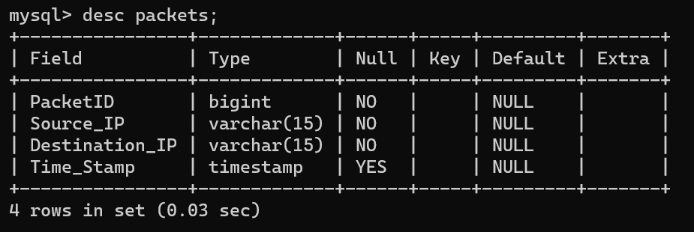

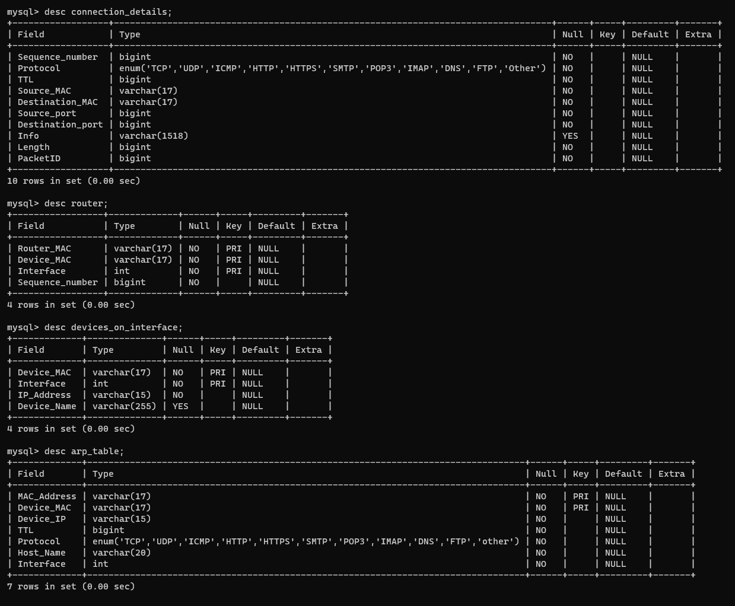

* The database consists of four main tables: packets, connection_details, router, and devices_on_interface, each designed to store specific information related to network communication and device connectivity.
* The packets table captures packet level details, including PacketID, source and destination IP addresses, and a timestamp, providing a granular view of network traffic.
* The connection_details table contains information about network connections, such as sequence number, protocol type, Time To Live (TTL), source and destination MAC addresses, ports, packet length, and additional information.
* The router table maintains data about routers, with Router_MAC, Device_MAC, Interface, and Sequence_number fields, facilitating the organization and management of routing devices in the network.
* The arp_table table focuses on Address Resolution Protocol (ARP) details, featuring MAC_Address, Device_MAC, Device_IP, TTL, protocol type, host name, and interface fields, offering insights into device connectivity and address resolution within the network.

LINKS

* Linkage between packets and connection_details: Both tables have a common field named PacketID, which serves as a foreign key in the connection_details table, linking each connection detail entry to a specific packet in the packets table.
* Linkage between connection_details and router: The connection_details table contains a field named Sequence_number, which serves as a foreign key in the router table, linking each router entry to a specific connection detail.
* Linkage between devices_on_interface and router: The devices_on_interface table has two fields, Device_MAC and Interface, serving as foreign keys that link to the Router_MAC and Interface fields in the router table. This linkage establishes the relationship between devices connected to specific router interfaces.
* Linkage between arp_table and devices_on_interface: The arp_table table has a field named Device_MAC, which is a foreign key linking to the Device_MAC field in the devices_on_interface table. This linkage connects ARP details to specific devices on interfaces.
* Linkage between arp_table and router: The arp_table table also contains an Interface field, serving as a foreign key that links to the Interface field in the router table. This linkage associates ARP details with specific router interfaces.

Content of the DB after executing the code which we have put up after the output:

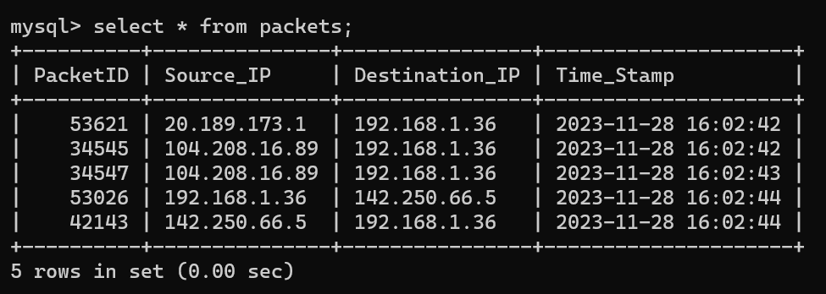

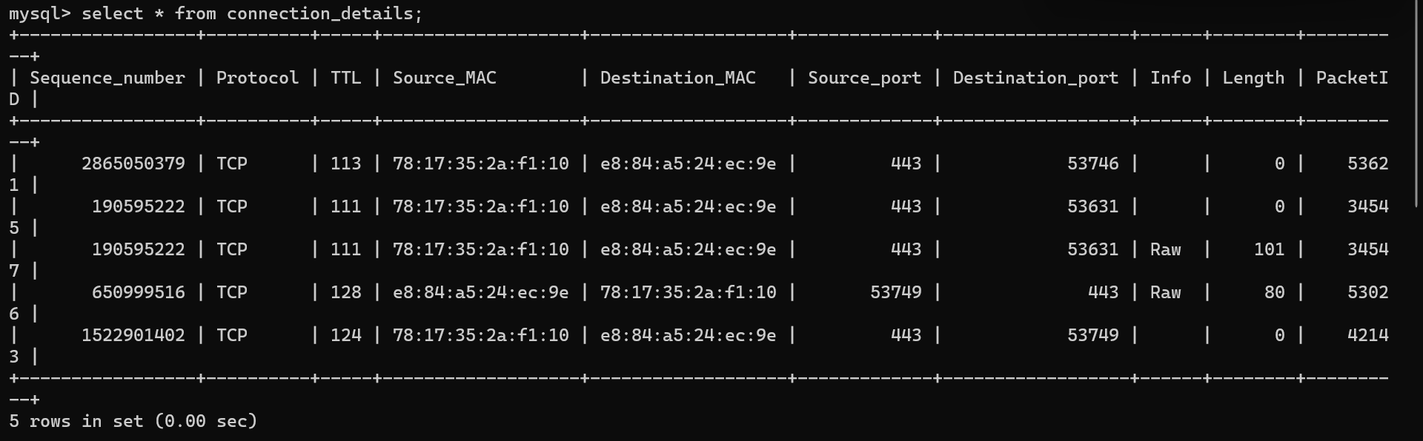

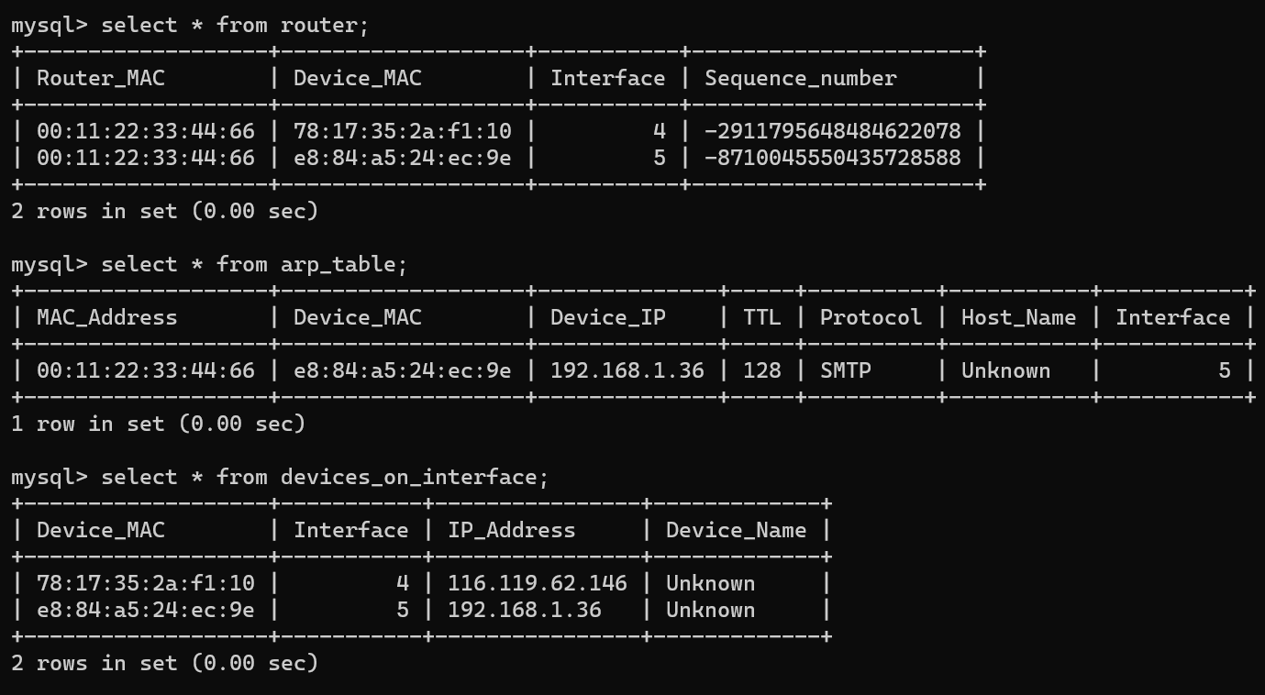

FRONTEND:

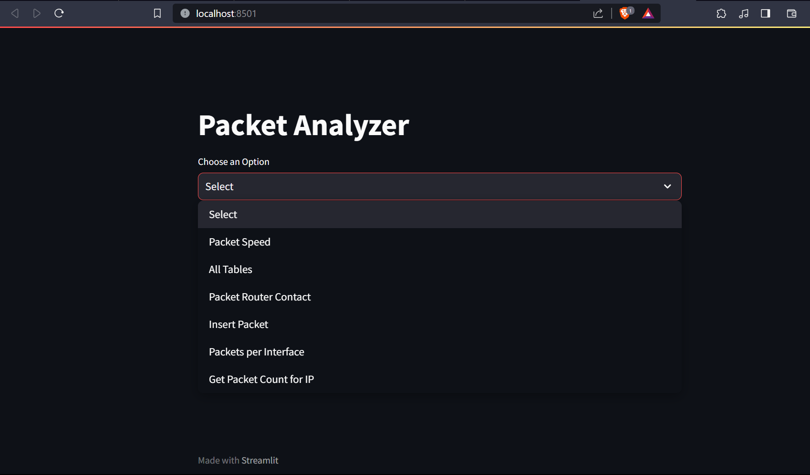

6 options as seen above  
  
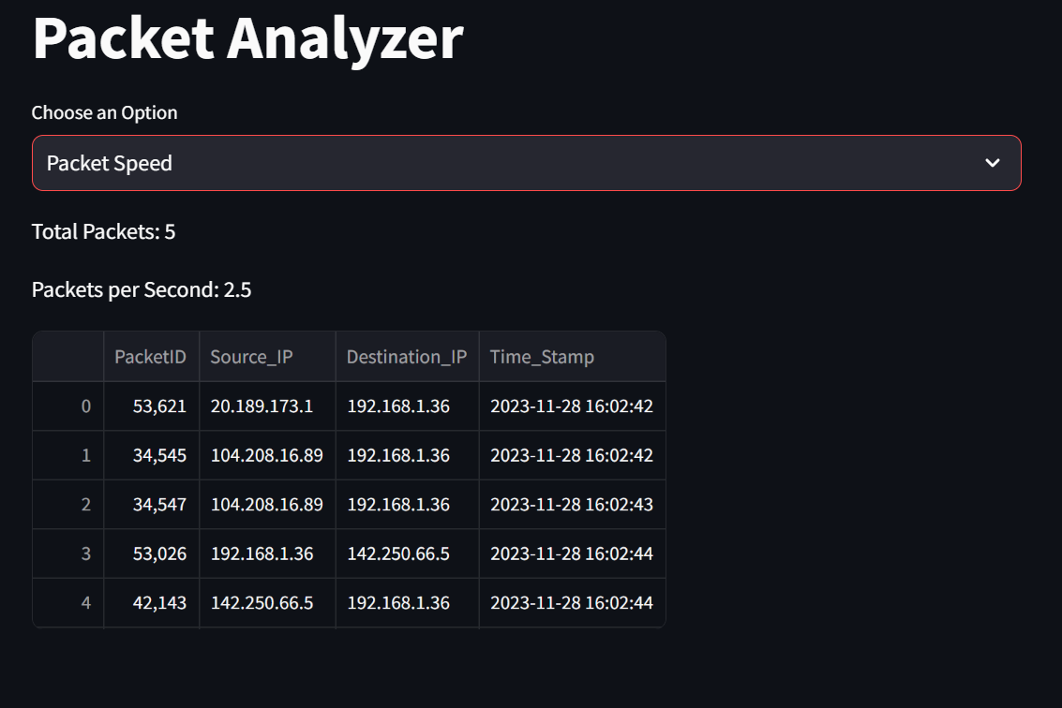

This computes the packet speed based on the first and last timestamps of packet table entries.

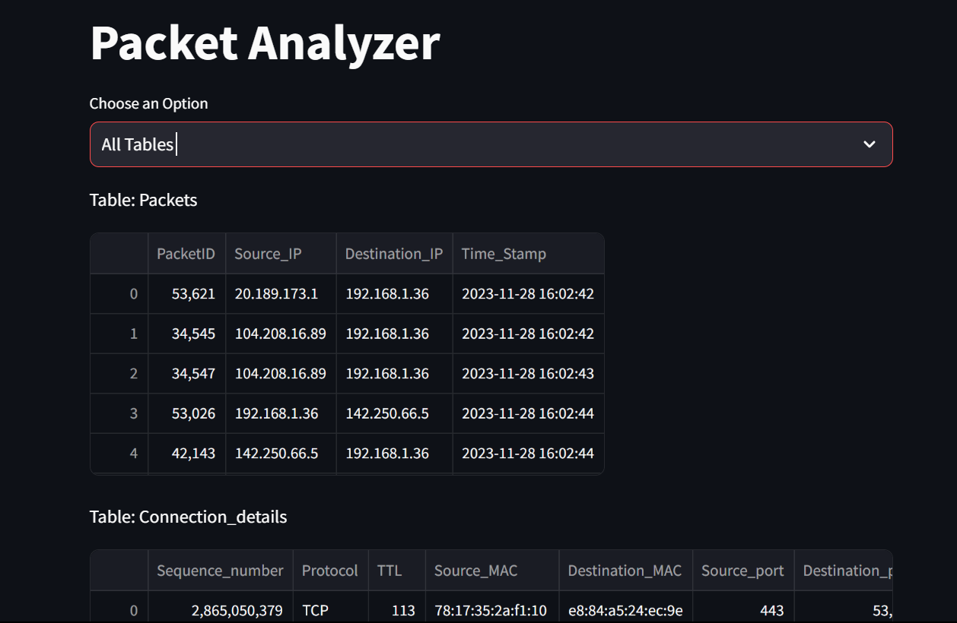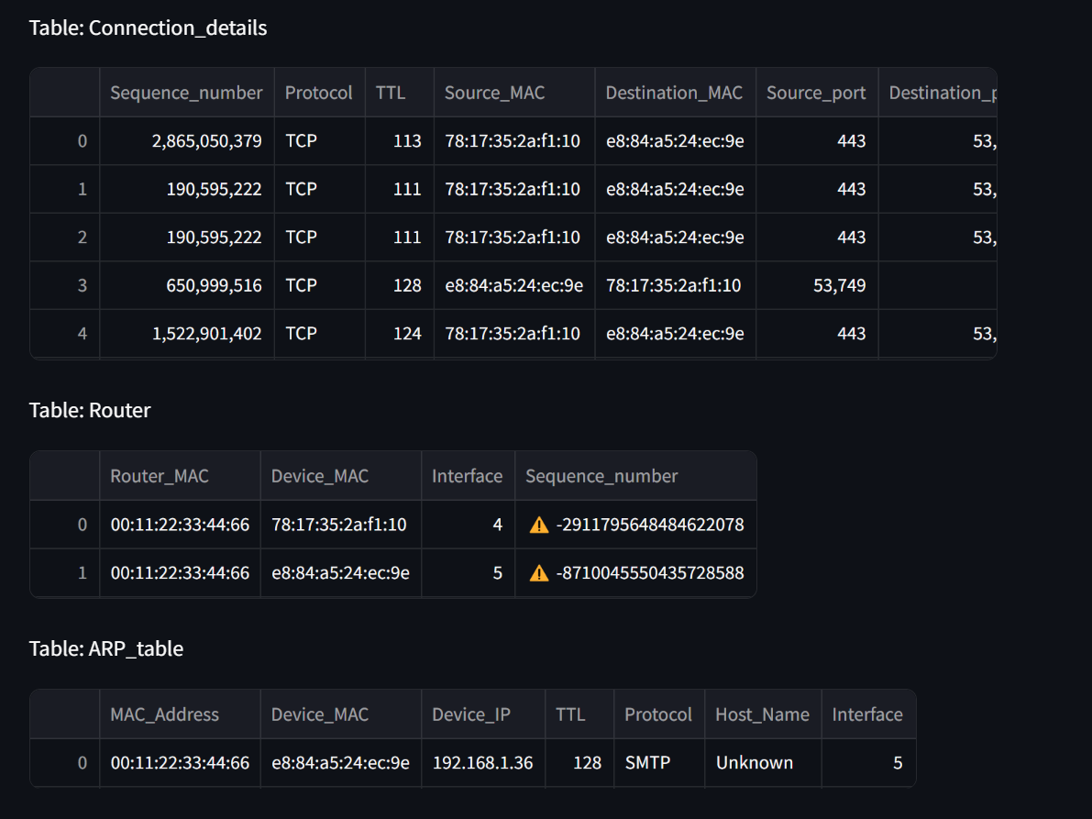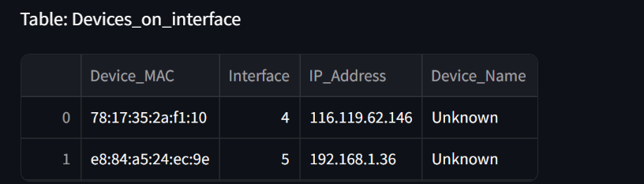

All the tables are displayed.

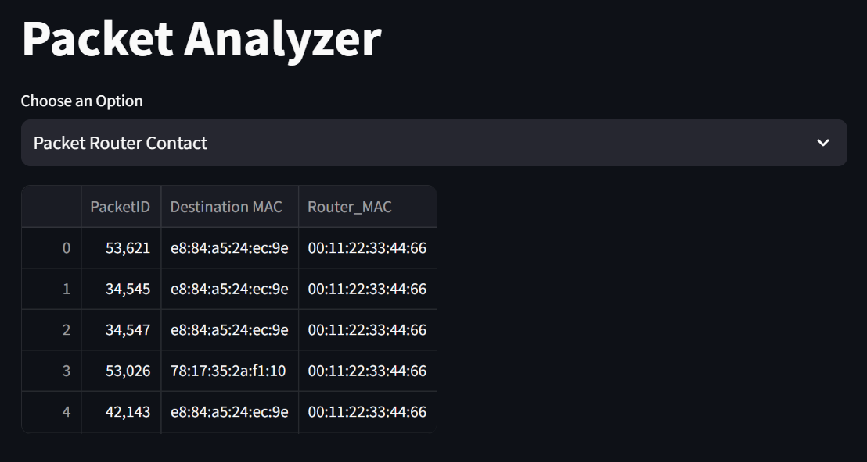

Displays the packets and the routers they pass through along with the device MAC addresses.

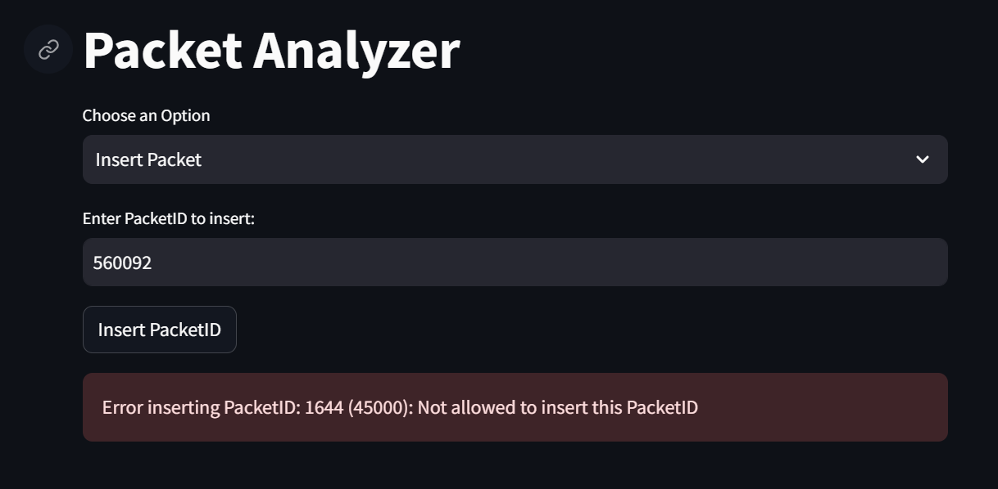

A procedure has been defined to prevent the addition of packets by anyone logged in other than the admin.

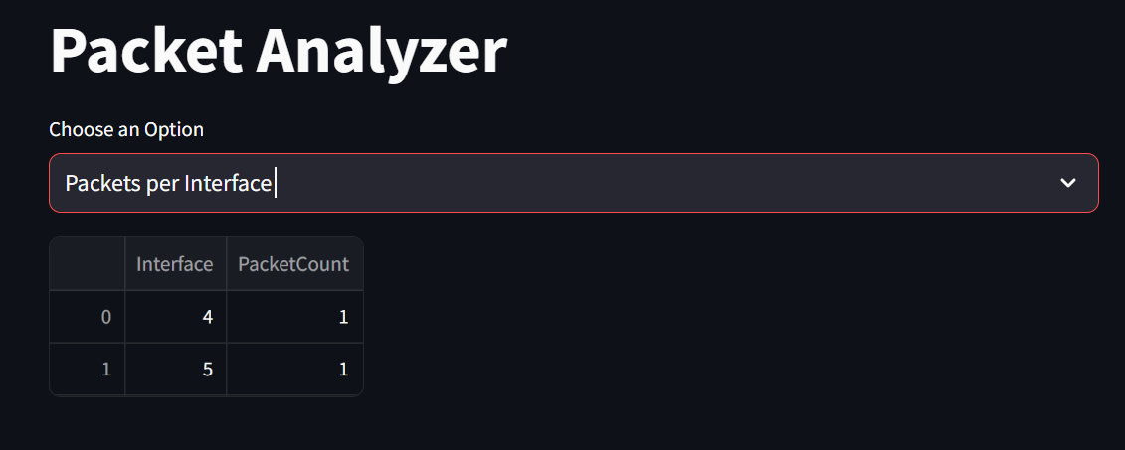

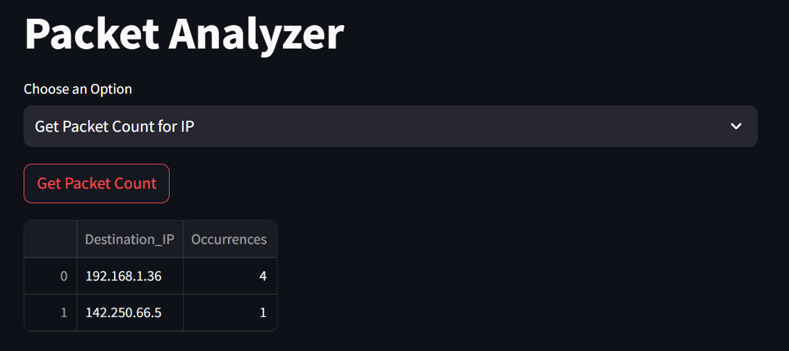

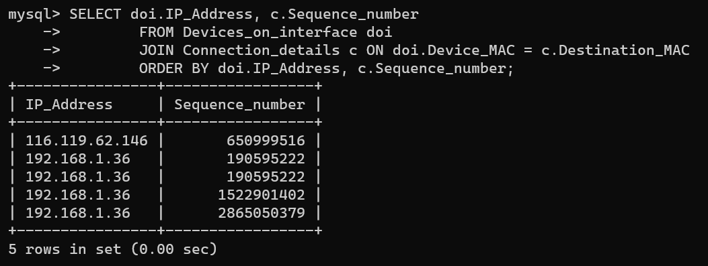

We had plans to display the packets and to which IP addresses they are going to. Unfortunately, this wasn’t being displayed on the front end.