**AL/ML Internship - Problem Test**

**Problem Statement:**

Create a small LLM application to generate Mobile UI Designs.

**Overview of the Project:**  
The goal of this project is to develop a retrieval-augmented generation (RAG) program that can produce mobile user interface designs. Based on user-provided text inputs, the application creates user interface (UI) graphics using Stable Diffusion for computer vision and a Large Language Model (LLM) for natural language processing.  
  
**Objective:**

* Model Selection & Training: Produce UI designs using pretrained models.
* Develop an application that allows users to enter text and obtain UI design graphics using Gradio UI or a Python-based command-line interface.
* **Evaluation:** Assess the design quality based on visual clarity and user input response.
* **Text Input:** The LLM (GPT-Neo) is used to generate descriptive text based on the user’s input query.
* **Image Generation:** The Stable Diffusion model interprets this text to generate corresponding UI design images.

**Steps Followed:**

**1. Dataset Exploration**

* **Dataset Used:** Mobile UI Design Dataset from Hugging Face https://huggingface.co/datasets/mrtoy/mobile-ui-design.
* **Dataset Exploration:** The dataset contains various mobile UI screenshots with metadata. Each data entry has:
  + Image of the UI design.
  + Bounding boxes for different objects in the UI.
  + Metadata regarding the dimensions, objects, etc.
* We used the Hugging Face datasets library to load and inspect the data:

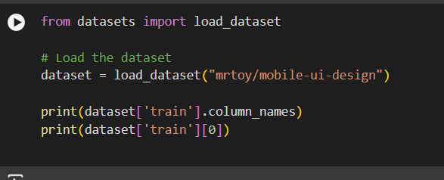

**2. Model Selection**

* **LLM for Text Generation:** We selected GPT-Neo (125M parameters) from EleutherAI for generating design descriptions from user input.
* **Stable Diffusion for Image Generation:** The Stable Diffusion model from the diffusers library was used for generating high-quality images based on text descriptions.
* **Dependencies:**
  + transformers for GPT-Neo.
  + diffusers for Stable Diffusion.
  + datasets for loading the Mobile UI dataset.
  + gradio for creating a simple user interface.

**3. Model Loading and Text Generation**

* We first load the text-generation model (GPT-Neo):

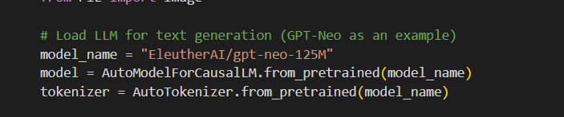

#### **Why GPT-Neo:** GPT-Neo is a model built by EleutherAI that is open-source and offers powerful text-generation capabilities. For this project:

**Pretrained on General Text:** GPT-Neo is pre-trained on a vast corpus, allowing it to understand and generate relevant design descriptions from short input queries.

**Flexibility:** We can fine-tune the model if needed, but the current setup uses the pretrained model directly for generating text based on user input.

* Then, we use a pipeline to generate a description from a user query:

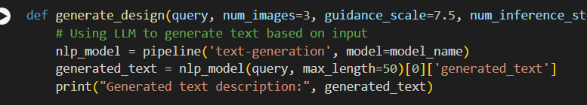

**4. Image Generation with Stable Diffusion**

* After generating the design description, Stable Diffusion was used to generate mobile UI images:



#### **Why Stable Diffusion:** Stable Diffusion is a state-of-the-art image-generation model:

**High-Quality Images:** It can generate photorealistic images based on text prompts.

**Efficiency:** The model runs efficiently on GPUs, making it ideal for generating multiple high-quality UI designs in a reasonable amount of time.

**Flexibility in Image Generation:** By tweaking parameters like guidance_scale and num_inference_steps, we can control the level of creativity and refinement in the generated images.

**5. Application Development**

* **Gradio Interface:** For a user-friendly interface, Gradio was used to allow users to input a query, generate a description using GPT-Neo, and then create an image using Stable Diffusion.

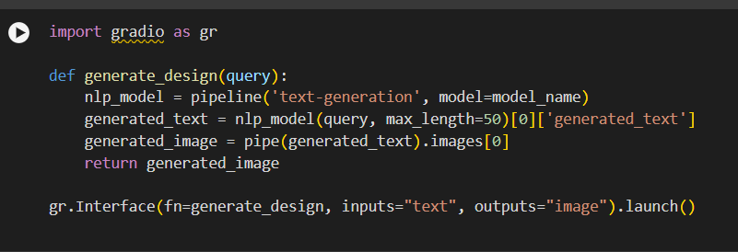

**Dependencies:**

The application depends on the following libraries:

* transformers: For loading the GPT-Neo model.
* diffusers: For the Stable Diffusion model used in image generation.
* datasets: For loading the Mobile UI design dataset.
* gradio: For creating a simple user interface.
* torch: Required for running both GPT-Neo and Stable Diffusion on GPU.

**Performance Evaluation:**

* **Design Accuracy:** The generated designs are evaluated based on their similarity to the user-provided text description.
* **Visual Quality:** The images generated are reviewed for clarity and fidelity.
* **Speed:** GPU support significantly improves the time taken to generate the images. GPU is critical for efficiently generating images, especially for large models like Stable Diffusion.

**Running the Application in Google Colab:**

To simplify the process of running the project, we can use Google Colab for a cloud-based environment with GPU support. Below are the steps specific to Colab:

1. **Open a Google Colab Notebook:**
   * Go to Google Colab.
2. **Install Dependencies:** Run the following commands to install required libraries:



1. **Check GPU Availability:** Ensures that the Colab notebook is using a GPU runtime. We can verify this by running:

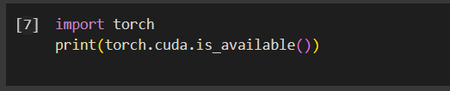

1. **Running the Gradio UI:** We can also launch the Gradio-based interface from Colab by running the Gradio interface code:

