ISSUE ID | #001
TITLE | [Home page] The image in the 'Gunnar James Bond Schäfer' section is broken
TESTER | Sanja Segedinski
SEVERITY | Low
ISSUE TYPE | Content
FREQUENCY | Every Time
USED DEVICE/BROWSER | Chrome ( Version 101.0.4951.67 (64-bit)) on Windows 11 Pro
NETWORK | Wi-Fi
LOCATION | Serbia
URL | http://www.007museum.com/
STEPS TO REPRODUCE | - Open the http://www.007museum.com/ page  - Navigate to the section 'Gunnar James Bond Schäfer'
EXPECTED RESULT | Users can read the article about 'Gunnar James Bond Schäfer' and two pictures about that topic should be successfully displayed.
ACTUAL RESULT | Users can read an article about 'Gunnar James Bond Schaefer', but cannot see the first picture because is broken.
ERROR MESSAGE | /
ATTACHMENTS

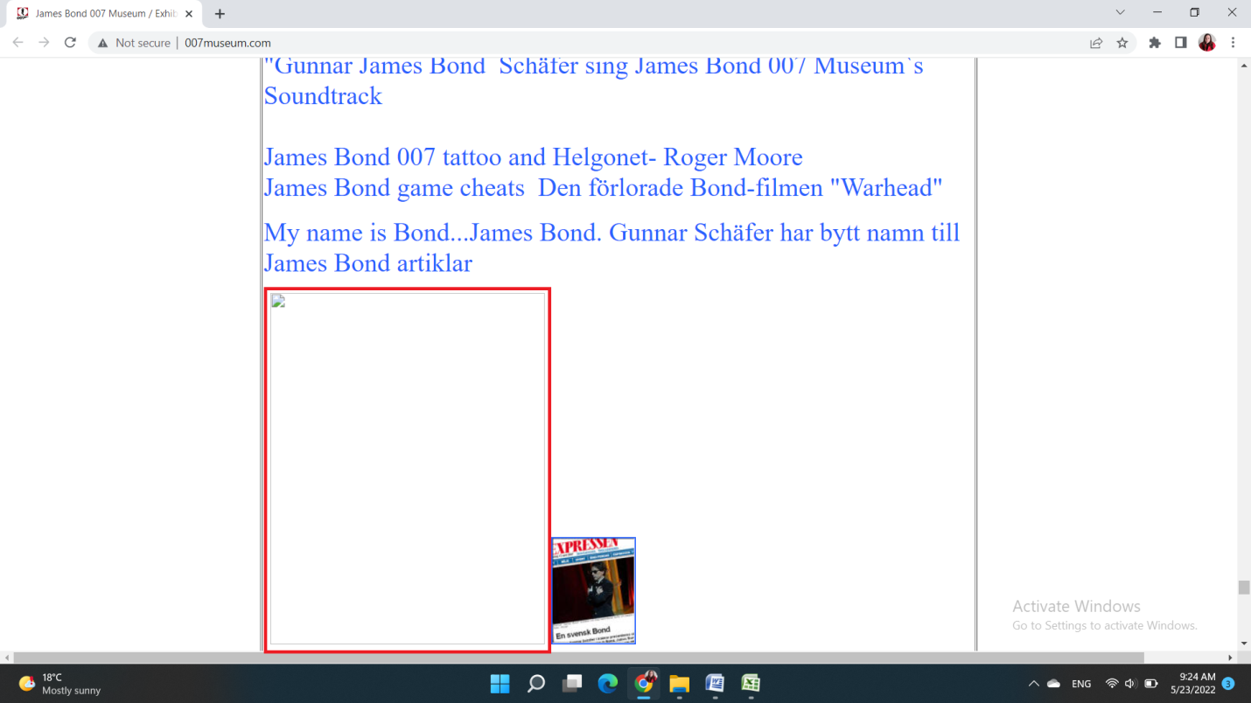
ISSUE ID | #002
TITLE | [Home page] SVT's cultural program link in the ‘Nybro and James Bond 007 Museum’ section is broken
TESTER | Sanja Segedinski
SEVERITY | Medium
ISSUE TYPE | Content
FREQUENCY | Every Time
USED DEVICE/BROWSER | Chrome ( Version 101.0.4951.67 (64-bit)) on Windows 11 Pro
NETWORK | Wi-Fi
LOCATION | Serbia
URL | http://www.007museum.com/
STEPS TO REPRODUCE | - Open the http://www.007museum.com/ page  - Navigate to the section ‘Nybro and James Bond 007 Museum are highlighted in SVT's cultural program Sweden.’  - Click on the link
EXPECTED RESULT | This link leads users to more information about this topic.
ACTUAL RESULT | SVT's cultural program link opens an error page.
ERROR MESSAGE | There is nothing on this page  It may be due to:  That you followed a link that does not work  That the program you tried to reach is no longer shown on SVT Play  You can:  Change the URL  Do a new search at the top of the page  Go to Start or Programs  If you do not find what you are looking for then just ask.  Contact Us
ATTACHMENTS
Videocast_issue_#002

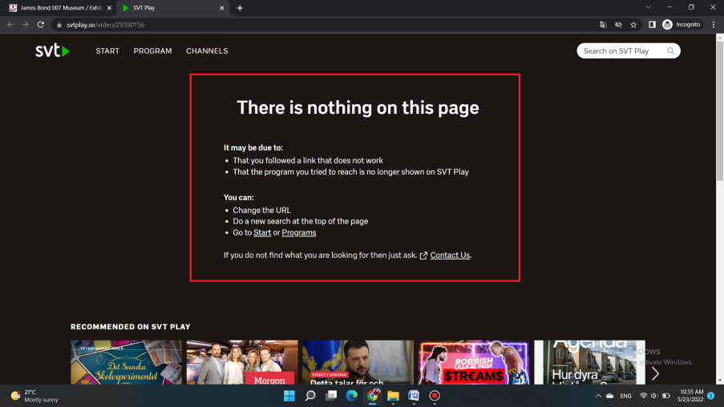
ISSUE ID | #003
TITLE | [Fan phenomena] The main banner, at the top of the page, overlaps the text
TESTER | Sanja Segedinski
SEVERITY | Low
ISSUE TYPE | Visual
FREQUENCY | Every Time
USED DEVICE/BROWSER | Chrome ( Version 101.0.4951.67 (64-bit)) on Windows 11 Pro
NETWORK | Wi-Fi
LOCATION | Serbia
URL | http://www.007museum.com/fan_phenomena.htm
STEPS TO REPRODUCE | - Open the http://www.007museum.com/ page  - Navigate to the section ‘Fan phenomena’  - Click on the ‘Fan Phenomena: James Bond Edited by Claire Hines intervju with James Bond (Gunnar Schäfer)’
EXPECTED RESULT | The main banner is displayed at the top of the web page, and below the banner, is information about booking tickets.
ACTUAL RESULT | Above the main banner is the text overlapped by the banner.
ERROR MESSAGE | /
ATTACHMENTS

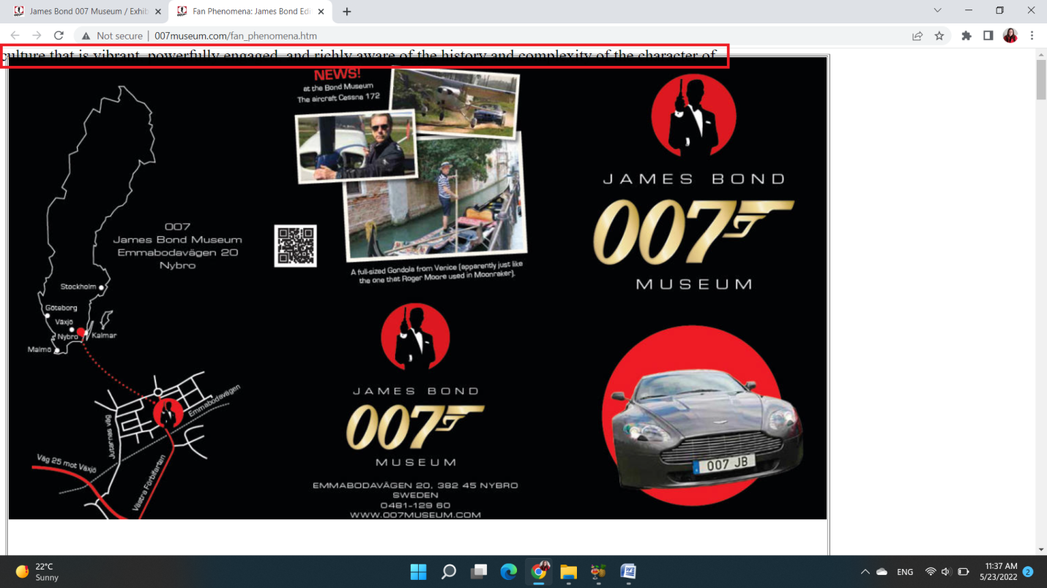

ISSUE ID | #004
TITLE | [Fan phenomena] A broken image in the Book Review section leads to a broken link
TESTER | Sanja Segedinski
SEVERITY | Medium
ISSUE TYPE | Content
FREQUENCY | Every Time
USED DEVICE/BROWSER | Chrome ( Version 101.0.4951.67 (64-bit)) on Windows 11 Pro
NETWORK | Wi-Fi
LOCATION | Serbia
URL | http://www.007museum.com/fan_phenomena.htm
STEPS TO REPRODUCE | - Open the http://www.007museum.com/ page  - Navigate to the section ‘Fan phenomena’  - Click on the ‘Fan Phenomena: James Bond Edited by Claire Hines intervju with James Bond (Gunnar Schäfer)’  ***The ‘Fan phenomena’ page will be displayed***  - Scroll to the ‘Book Review: Fan Phenomena: James Bond’ section and observe that there is a broken picture  - Click on the broken picture
EXPECTED RESULT | The ‘Book Review: Fan Phenomena: James Bond’ section contains an image that is displayed and when you click on it, redirect your to a link where you can find more information about this topic.
ACTUAL RESULT | In the 'Book Review: Fan Phenomenon: James Bond' section, the image is not displayed, and clicking on the broken image takes you to the broken page.
ERROR MESSAGE | Page Not Found!  404  We're sorry, but we can't find the page you were looking for. It's probably some thing we've done wrong but now we know about it and we'll try to fix it. In the meantime, try one of these options:  Go to Previous Page  Go to Homepage
ATTACHMENTS
Videocast_issue_#004

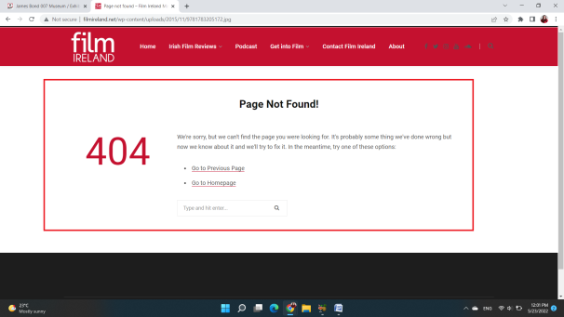
ISSUE ID | #005
TITLE | [Home page] A link, that should reveal the styles that will appear in the movie, leads to a broken page.
TESTER | Sanja Segedinski
SEVERITY | Medium
ISSUE TYPE | Content
FREQUENCY | Every Time
USED DEVICE/BROWSER | Chrome ( Version 101.0.4951.67 (64-bit)) on Windows 11 Pro
NETWORK | Wi-Fi
LOCATION | Serbia
URL | www.007museum.com/crockett-jones.htm
STEPS TO REPRODUCE | - Open the http://www.007museum.com/ page  - Navigate to the section ‘Crockett & Jones’ on the home page  Observe that there are two links that leads to the detailed information about this fashion brand  - Click on the first link > www.007museum.com/crockett-jones.htm
EXPECTED RESULT | By clicking on this link we can observe the revealed styles that will appear in the movie No Time to Die and the 007 Limited Edition shoe.
ACTUAL RESULT | ‘Crockett & Jones’ link opens a broken page.
ERROR MESSAGE | Not Found  The requested URL was not found on this server.  Apache/2.4.52 (FreeBSD) mpm-itk/2.4.7-04 PHP/7.4.27 Server at www.007museum.com Port 80
ATTACHMENTS

Videocast_issue_005
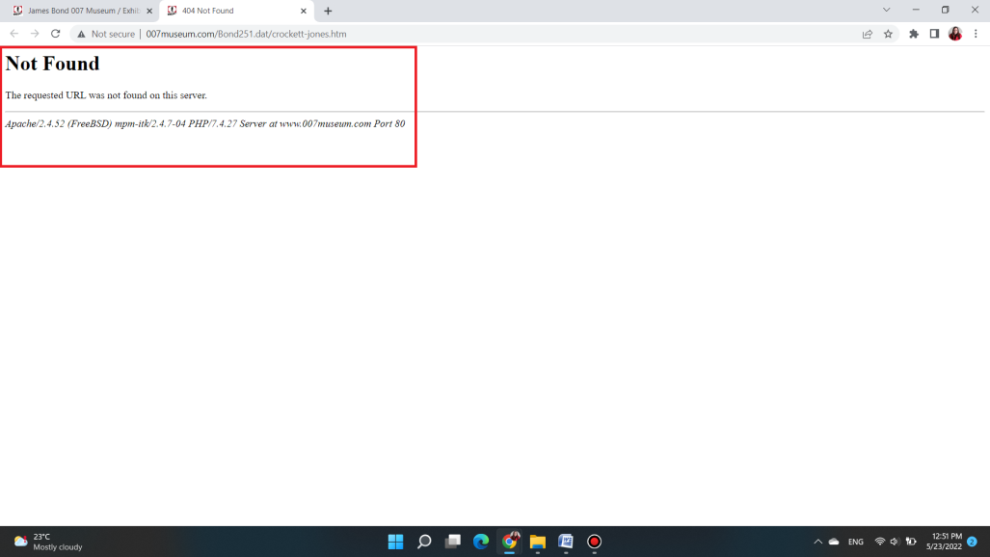

BUG REPORT CONTENT

[Home page] The image in the 'Gunnar James Bond Schäfer' section is broken 1
[Home page] SVT's cultural program link in the ‘Nybro and James Bond 007 Museum’ section is broken 2
[Fan phenomena] The main banner, at the top of the page, overlaps the text 3
[Fan phenomena] A broken image in the Book Review section leads to a broken link 4
[Home page] A link, that should reveal the styles that will appear in the movie, leads to a broken page. 5

