ISSUE ID | #001
TITLE | [Links/Fishing] There are no links or content for the all listed fields
TESTER | Sanja Segedinski
SEVERITY | Low
ISSUE TYPE | Content
FREQUENCY | Every Time
USED DEVICE/BROWSER | Chrome ( Version 101.0.4951.67 (64-bit)) on Windows 11 Pro
NETWORK | Wi-Fi
LOCATION | Serbia
URL | http://www.gatesnfences.com/links/fishing.html
STEPS TO REPRODUCE | - Open the http://www.gatesnfences.com/index.html page.  - Navigate to the bottom of the page and click on the button ‘Link’ in the footer.  The ‘Links’ page will be displayed.  - Observe that under the title 'Below are Directories' is the table.  - Click on the tile 'Fishing' from the table.
EXPECTED RESULT | All listed links contain the word 'fishing' , have an ordinal number, and short content.
ACTUAL RESULT | Fields 7,8,9,10 and 11 have no links or content. They are empty and have only an ordinal number.
ERROR MESSAGE | /
ATTACHMENTS

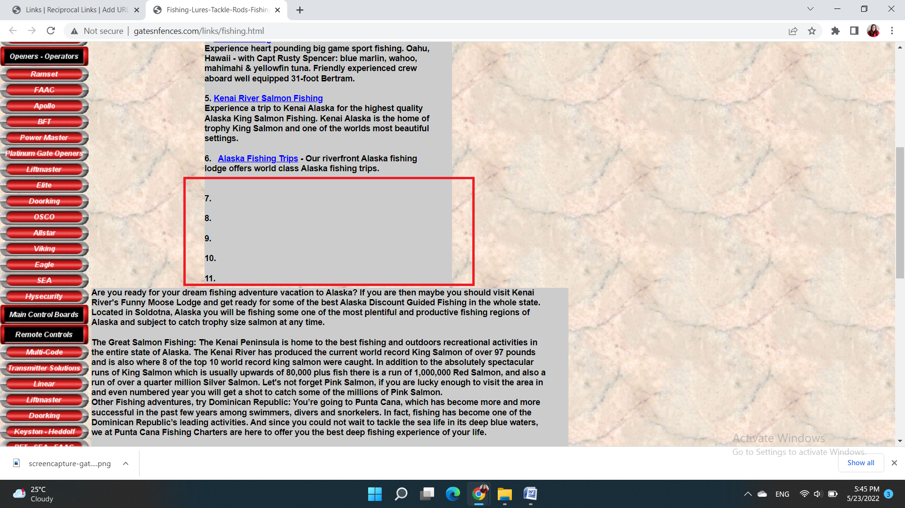

ISSUE ID | #002
TITLE | [Home page] Some hyperlinked words on webpage lead to broken links
TESTER | Sanja Segedinski
SEVERITY | Medium
ISSUE TYPE | Content
FREQUENCY | Every Time
USED DEVICE/BROWSER | Chrome ( Version 101.0.4951.67 (64-bit)) on Windows 11 Pro
NETWORK | Wi-Fi
LOCATION | Serbia
URL | http://www.gatesnfences.com/index.html
STEPS TO REPRODUCE | - Open the http://www.gatesnfences.com/index.html page.  - Scroll down to the two last paragraphs.  Observe that there are a lot of hyperlinked words in these two paragraphs.  - Click on a few hyperlinked words.
EXPECTED RESULT | When users click on a word with a hyperlink, they will be taken to a link that relates to the word they clicked on.
ACTUAL RESULT | When users click on some words with a hyperlink they are taken to broken links.
ERROR MESSAGE | /
ATTACHMENTS
Videocast_issue_002

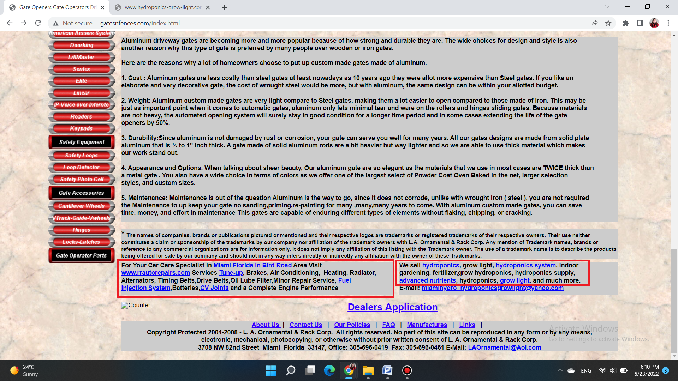

ISSUE ID | #003
TITLE | [Home page] The ‘Search’ button is broken, it fails to return the results that the user wants
TESTER | Sanja Segedinski
SEVERITY | Medium
ISSUE TYPE | Functional
FREQUENCY | Every Time
USED DEVICE/BROWSER | Chrome ( Version 101.0.4951.67 (64-bit)) on Windows 11 Pro
NETWORK | Wi-Fi
LOCATION | Serbia
URL | http://www.gatesnfences.com/.search?results_page=&p=Pool+fences&name=Search
STEPS TO REPRODUCE | - Open the http://www.gatesnfences.com/index.html page.  - Navigate to the Search bar in the upper right corner.  - Click on the text field and type ‘Pool fences’.  - Click on the button ‘Search’.
EXPECTED RESULT | This search should list everything about 'Pool Fences' that can be found on the site.
ACTUAL RESULT | By clicking on the 'Search' button, an error message appears. Users cannot get what they wanted to search for.
ERROR MESSAGE | Unauthorized
ATTACHMENTS
Videocast_issue_003

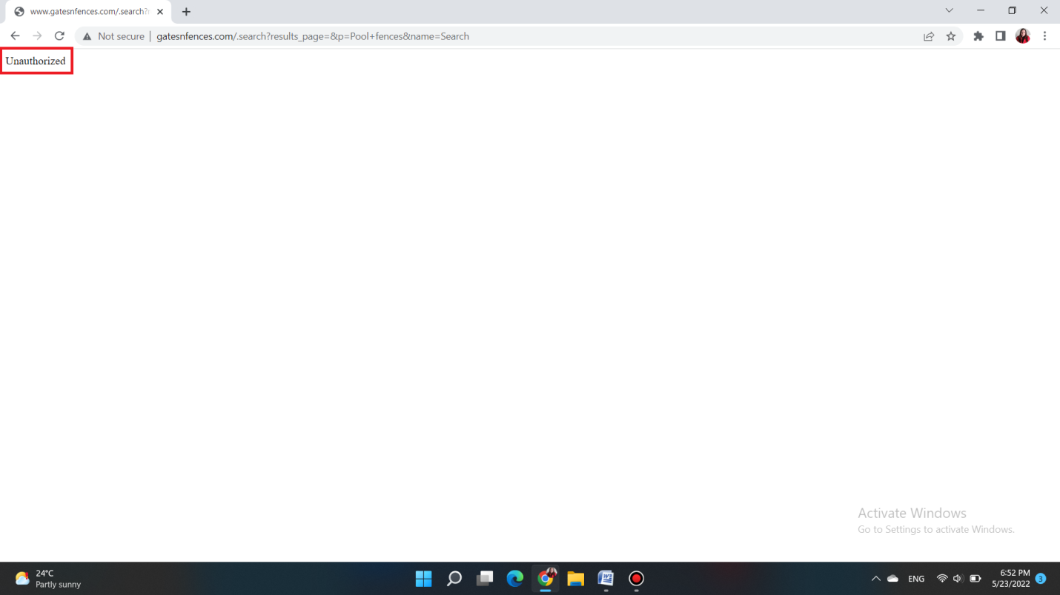
ISSUE ID | #004
TITLE | [PLP] The product has two identical images in the field provided for one image
TESTER | Sanja Segedinski
SEVERITY | Low
ISSUE TYPE | Visual
FREQUENCY | Every Time
USED DEVICE/BROWSER | Chrome ( Version 101.0.4951.67 (64-bit)) on Windows 11 Pro
NETWORK | Wi-Fi
LOCATION | Serbia
URL | http://www.gatesnfences.com/Select-Engineered-Entry-System.html
STEPS TO REPRODUCE | - Open the http://www.gatesnfences.com/index.html page  - Navigate to the paragraph that starts with hyperlinked word ‘Access Control’ and click on that word  The http://www.gatesnfences.com/Gate_Access_Control_Accesories/Linear_Remote_Control_Card_Reader_Phone_Entry_Commecial_Residential_Wireless.html page will be displayed  - Scroll down to the table ‘SES MODEL AVAILABLE’ on the right side of the page and click on it  The http://www.gatesnfences.com/Select-Engineered-Entry-System.html will be displayed  - Navigate to the ‘Select Engineered Systems CAT Vision Access Entry Control - SES CAT VISION’ item
EXPECTED RESULT | Each product has one picture in the table that fits in the field in which it is located.
ACTUAL RESULT | The 'SES CAT VISION' product has two identical images. The second image obscures the visibility of the image that is blended into the field in the table.
ERROR MESSAGE | /
ATTACHMENTS

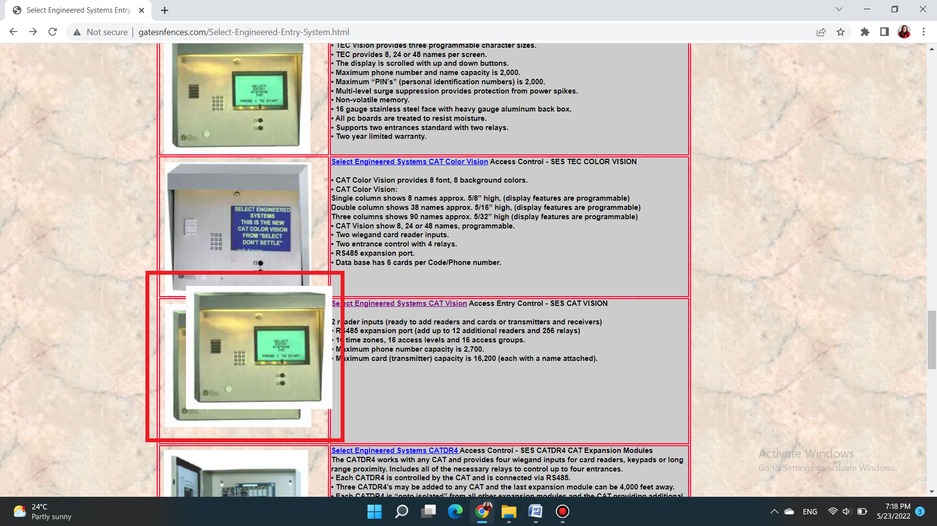

ISSUE ID | #005
TITLE | [PLP] The product's price and details are missing
TESTER | Sanja Segedinski
SEVERITY | High
ISSUE TYPE | Content
FREQUENCY | Every Time
USED DEVICE/BROWSER | Chrome ( Version 101.0.4951.67 (64-bit)) on Windows 11 Pro
NETWORK | Wi-Fi
LOCATION | Serbia
URL | http://www.gatesnfences.com/Access-Control-TelePhone-Entry-Intercom-Systems-Keypads/SES-Select-Engineered-CATVision-Telephone-Entry.html
STEPS TO REPRODUCE | - Open the http://www.gatesnfences.com/index.html page  - Navigate to the paragraph that starts with hyperlinked word ‘Access Control’ and click on that word  The http://www.gatesnfences.com/Gate_Access_Control_Accesories/Linear_Remote_Control_Card_Reader_Phone_Entry_Commecial_Residential_Wireless.html page will be displayed  - Scroll down to the table ‘SES MODEL AVAILABLE’ on the right side of the page and click on it  The http://www.gatesnfences.com/Select-Engineered-Entry-System.html will be displayed  - Navigate to the ‘Select Engineered Systems CAT Vision Access Entry Control - SES CAT VISION’ item and click on it
EXPECTED RESULT | A table of 'SES CAT VISION' models is presented with details about each product and the price of each individual model.
ACTUAL RESULT | The price and details of the product 'SES CATVHF2700 Controlled', which is last in the table, are missing.
ERROR MESSAGE | /
ATTACHMENTS

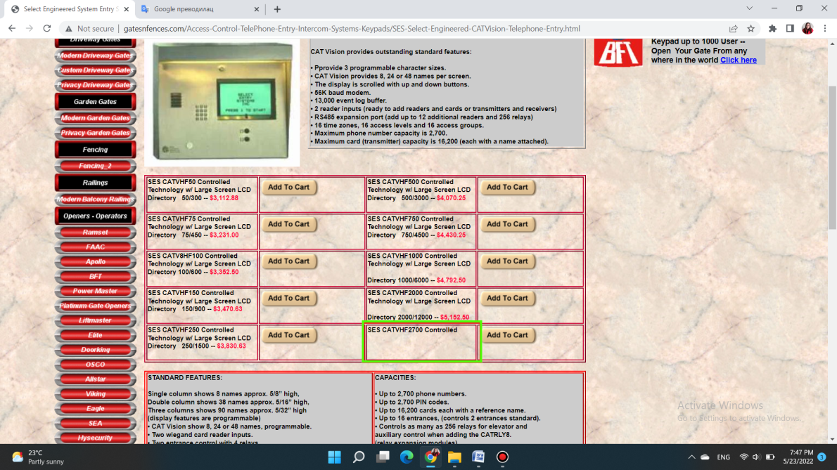

BUG REPORT CONTENT

[Links/Fishing] There are no links or content for the all listed fields 1
[Home page] Some hyperlinked words on webpage lead to broken links 2
[Home page] The ‘Search’ button is broken, it fails to return the results that the user wants 3
[PLP] The product has two identical images in the field provided for one image 4
[PLP] The product's price and details are missing 5

