

**TICKET RESERVATION WEBPAGE**

**USING SQL,**

**HTML AND CSS**

Submitted by

SAJIV JESS B I (231501143)

SANJAI T (231501144)

RUBARAJAN (231501138)

**CS23332 – DATABASE MANAGEMENT SYSTEM**

Department of Artificial Intelligence and

Machine Learning

Rajalakshmi Engineering College, Thandalam

BONAFIDE CERTIFICATE

This is to certify that the Mini project work titled “**TICKET RESERVATION WEBPAGE USING SQL, HTML AND CSS”** done by, SAJIV JESS B I (231501143), SANJAI T (231501144), RUBARAJAN (231501138) is a record of Bonafide work carried out by him/her under my supervision as a part of MINI PROJECT for the subject CS23332 - DATABASE MANAGEMENT SYSTEM by Department of Artificial Intelligence and Machine Learning.

SIGNATURE SIGNATURE

INTERNAL EXAMINER EXTERNAL EXAMINER

**TABLE OF CONTENTS:**

|  |  |  |
| --- | --- | --- |
| **S. No** | **Chapter** | **Page Number** |
| 1. | PROBLEM STATEMENT |  |
| 2. | NOVELTY |  |
| 3. | KEY FEATURES |  |
| 4. | IMPACTS |  |
| 5. | FUNDAMENTALS FOR DATABASE |  |
| 6. | TECH STACK |  |
| 7. | QUERIES |  |
| 8. | ER DIAGRAM |  |
| 9. | RESULT |  |
| 10. | CONCLUSION |  |
| 11. | REFERENCES |  |

JOURNEY JET

**PROBLEM STATEMENT:**

Existing ticket reservation systems often struggle with poor user interfaces, inefficient data management, and limited real-time functionality. This project aims to develop a **Ticket Reservation Webpage** using **SQL, HTML, and CSS** to provide an intuitive interface and robust backend support. The solution will enable users to search, book, and manage tickets seamlessly while ensuring real-time data synchronization and an enhanced user experience.

**NOVELTY:**

This project introduces a **user-friendly, lightweight ticket reservation system** that integrates modern web design principles with efficient SQL database management. Unlike traditional systems, it emphasizes **real-time updates**, an **intuitive interface**, and **customizable booking options**. The project also incorporates **responsive design** for seamless access across devices and focuses on **streamlined query execution** to enhance booking speed and reliability, setting it apart as a more efficient and user-centric solution.

**KEY FEATURES:**

**Key Features of the Ticket Reservation Webpage:**

1. **User-Friendly Design**:
   * Simple, responsive interface for all devices.
2. **Real-Time Updates**:
   * Dynamic ticket availability display.
3. **Secure Booking System**:
   * User authentication and data protection.
4. **SQL Database Integration**:
   * Efficient management of bookings, users, and tickets.
5. **Search and Filter**:
   * Quick search by date, location, or category.
6. **Input Validation**:
   * Ensures accurate and complete submissions.
7. **Booking Management**:
   * View, modify, or cancel reservations easily.
8. **Scalable Design**:
   * Ready for future features like payment gateways.

**IMPACTS:**

The Ticket Reservation Webpage project enhances user convenience by simplifying the ticket booking process with real-time accessibility and secure data handling. It improves efficiency by automating ticket management, reducing manual errors and costs associated with physical infrastructure. The system is scalable for future needs and promotes sustainability by minimizing paper usage. By fostering trust through secure data management, this project supports digital transformation and modernizes the ticketing experience.

**POTENTIAL FUTURE APPLICATION:**

Potential future applications of the Ticket Reservation Webpage include integration with mobile applications for enhanced user accessibility and convenience. It can support dynamic pricing algorithms to optimize revenue based on demand. Incorporating AI-driven recommendations can personalize user experiences, such as suggesting preferred routes or events. Expanding multi-language support can cater to a global audience, while integrating with payment gateways and digital wallets ensures seamless transactions. The platform could also incorporate real-time updates, such as live tracking for transportation or event notifications, and support for booking-related services like accommodations, dining, or parking, creating a comprehensive ecosystem for users.

**FUNDAMENTAL FOR DATABASE:**

**1. Purpose**

**The database is designed to manage data for the ticket reservation system, including users, itineraries, reservations, and payments, ensuring reliable and efficient operations.**

**2. Key Concepts**

* **Relational Database:** Data is stored in interconnected tables.
* **Normalization:** Reduces redundancy and maintains integrity.
* **Data Operations:** Supports creation, retrieval, updating, and deletion.

**3. Database Structure**

* **Users Table:** Stores user details.
* **Itineraries Table:** Holds travel routes and schedules.
* **Reservations Table:** Links users with their bookings.
* **Payments Table:** Tracks payment transactions.

**4. Relationships**

* **Users → Reservations:** One-to-many.
* **Reservations → Itineraries & Payments:** One-to-one.

**5. Workflow**

1. Users register and log in.
2. View and select itineraries.
3. Reserve tickets and make payments.

**6. Benefits**

* Ensures accuracy and eliminates redundancy.
* Supports scalability and data security.
* Enhances system efficiency.

**TECH STACK:**

FRONTEND:

**HTML**: For structuring the content of the web application.

**CSS**: For styling the web application, ensuring it is visually appealing and user-friendly.

**BACKEND:**

PHP: For server-side scripting to manage data interactions and business logic.

**Database** - MySQL: For storing user, product, and transaction data in a structured format.

**QUERIES:**

<!DOCTYPE html>

<head>

<meta charset="utf-8">

<meta name="viewport" content="width=devidev-width, initial-scale=1.0, maximum-scale=1.0, user-scalable=no">

<meta http-equiv="X-UA-Compatible" content="IE=edge">

<title>JourneyJet</title>

<!-- [ FONT-AWESOME ICON ]

=========================================================================================================================-->

<link rel="stylesheet" type="text/css" href="library/font-awesome-4.3.0/css/font-awesome.min.css">

<!-- [ PLUGIN STYLESHEET ]

=========================================================================================================================-->

<link rel="shortcut icon" type="image/x-icon" href="images/icon.png

<link rel="stylesheet" type="text/css" href="css/animate.css">

<link rel="stylesheet" type="text/css" href="css/owl.carousel.css">

<link rel="stylesheet" type="text/css" href="css/owl.theme.css">

<link rel="stylesheet" type="text/css" href="css/magnific-popup.css">

<!-- [ Boot STYLESHEET ]

=========================================================================================================================-->

<link rel="stylesheet" type="text/css" href="library/bootstrap/css/bootstrap-theme.min.css">

<link>rel="stylesheet"type="text/css" href="library/bootstrap/css/bootstrap.css">

<!-- [ DEFAULT STYLESHEET ]

=========================================================================================================================-->

<link rel="stylesheet" type="text/css" href="css/style.css">

<link rel="stylesheet" type="text/css" href="css/responsive.css">

<link rel="stylesheet" type="text/css" href="css/color/rose.css"

</head>

<body>

<div class="preloader" style="display: none;">

<div class="loader theme_background_color">

<span></span>

</div>

</div>

<div class="wrapper">

<nav class=" nim-menu navbar navbar-default navbar-fixed-top" style="height: 0px; padding: 15px; background: rgb(0, 0, 0); box-shadow: rgba(0, 0, 0, 0.3) 2px 2px 3px 3px;">

<div class="container">

<!-- Brand and toggle get grouped for better mobile display -->

<div class="navbar-header">

<button type="button" class="navbar-toggle" data-toggle="collapse" data-target="#bs-example-navbar-collapse-1" aria-expanded="true">

<span class="sr-only">Toggle navigation</span>

<span class="icon-bar"></span>

<span class="icon-bar"></span>

<span class="icon-bar"></span>

</button>

<a class="navbar-brand" href="index.html" style="color: rgb(255, 255, 255);">Journey<span class="themecolor">JET</span></a>

</div>

<!-- Collect the nav links, forms, and other content for toggling -->

<div class="navbar-collapse collapse in" id="bs-example-navbar-collapse-1" aria-expanded="true" style="">

<ul class="nav navbar-nav navbar-right">

<li></li>

<li><a href="admin/" class="page-scroll" style="color: rgb(250, 250, 250);"><h3>Login</h3></a></li>

</ul>

</div>

<!-- /.navbar-collapse -->

</div><!-- /.container-fluid -->

</na>

<section class="main-heading" id="home">

<div class="overlay">

<div class="container">

<div class="row">

<div class="main-heading-content col-md-12 col-sm-12 text-center">

<h1 class="main-heading-title"><span class="typed-cursor">JOURNEY JET</span></h1>

<p class="main-heading-text">JourneyJet is your ultimate travel companion for booking tickets with ease and efficiency. Designed to streamline your travel planning, JourneyJet offers an intuitive, user-friendly interface to browse, reserve, and manage tickets for flights, buses, and trains. Keep track of your bookings, receive real-time notifications on schedules, and enjoy safe, secure payment options. Whether it's for a quick weekend getaway or a detailed travel itinerary, JourneyJet simplifies your journey from start to finish. Start your adventure now with JourneyJet, your gateway to seamless travel.<br></p>

<div class="btn-bar">

<ahref="reserved.php" class="btn btn-custom theme_background_color">Reserve Now</a>

</div>

</div>

</div>

</div>

</div>

</section>

FRONTEND-HTML AND CSS

<!DOCTYPE html>

<html lang="">

<head>

<meta charset="utf-8">

<meta http-equiv="X-UA-Compatible" content="IE=edge">

<meta name="viewport" content="width=device-width, initial-scale=1">

<title>JourneyJet Admin</title>

<!-- Bootstrap CSS -->

<link rel="stylesheet" type="text/css" href="../assets/css/bootstrap.min.css">

<link rel="stylesheet" type="text/css" href="../assets/css/bootstrap-theme.min.css">

</head>

<body>

<nav class="navbar navbar-inverse">

<div class="container-fluid">

<a class="navbar-brand" href="#">JourneyJet Online Ticketing</a>

<ul class="nav navbar-nav">

<li>

<a href="#"></a>

</li>

<li>

<a href="#"></a>

</li>

</ul>

<ul class="nav navbar-nav navbar-right">

<li><a href="../"><span class="glyphicon glyphicon-backward"></span> Return Home</a></li>

</ul>

</div>

</nav>

<div class="col-md-3"></div>

<div class="col-md-6">

<div class="panel panel-success">

<div class="panel-heading">

<h3 class="panel-title">Please Login Here</h3>

</div>

<div class="panel-body">

<form class="form-horizontal" role="form" id="form-login">

<div class="form-group">

<label class="control-label col-sm-2" for="un">Username:</label>

<div class="col-sm-10">

<input type="text" class="form-control" id="un" placeholder="Enter Username" autofocus="" required="">

</div>

</div>

<div class="form-group">

<label class="control-label col-sm-2" for="pwd">Password:</label>

<div class="col-sm-10">

<input type="password" class="form-control" id="pwd" placeholder="Enter password" required="">

</div>

</div>

<div class="form-group">

<div class="col-sm-offset-2 col-sm-10">

<div class="checkbox">

<label><input type="checkbox"> Remember me</label>

</div>

</div>

</div>

<div class="form-group">

<div class="col-sm-offset-2 col-sm-10">

<button type="submit" class="btn btn-default">Login

<span class="glyphicon glyphicon-check" aria-hidden="true"></span>

</button>

</div>

</div>

</form>

</div>

</div>

</div>

<div class="col-md-3"></div>

<?php require_once('modal/message.php'); ?>

<script type="text/javascript" src="../assets/js/jquery-3.1.1.min.js"></script>

<script type="text/javascript" src="../assets/js/bootstrap.min.js"></script>

<script type="text/javascript">

$(document).on('submit', '#form-login', function(event) {

event.preventDefault();

/* Act on the event */

// console.log('test');

var un = $('#un').val();

var pwd = $('#pwd').val();

$.ajax({

url: '../data/login.php',

type: 'post',

dataType: 'json',

data: {

un: un,

pwd : pwd

},

success: function (data) {

// console.log(data);

if(data.valid == true){

window.location = data.url;

}else{

$('#modal-message').find('#body-cont').text(data.msg);

$('#modal-message').modal('show');

$('#un').val("");

$('#pwd').val("");

$('#un').focus();

}

},error: function(){alert('Error: L99+');

}//

});

});

</script>

</body>

</html>

**ER DIAGRAM**

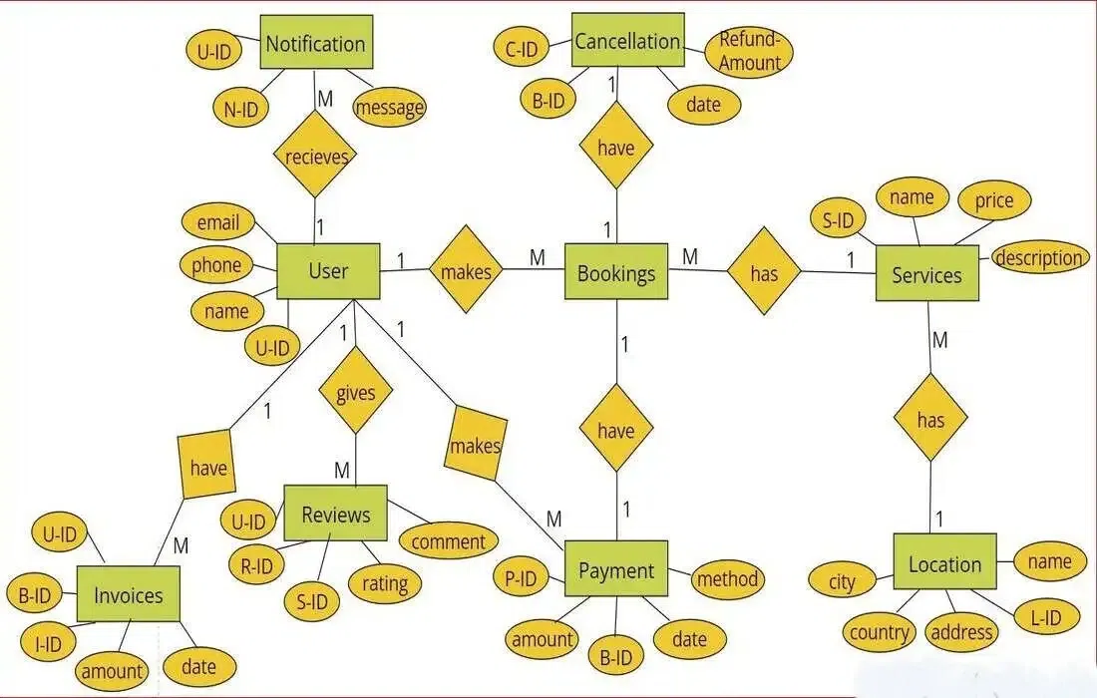

**RESULT:**

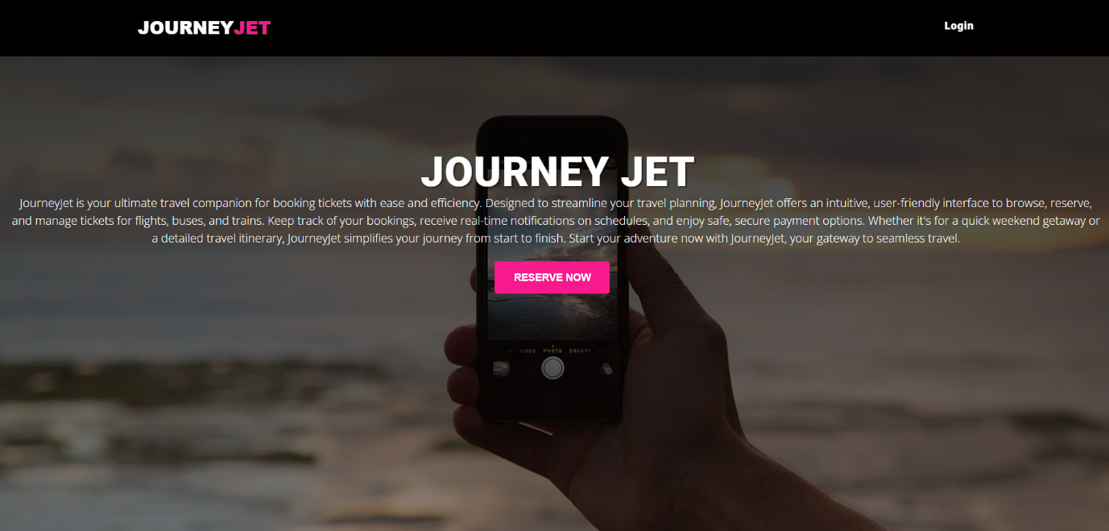

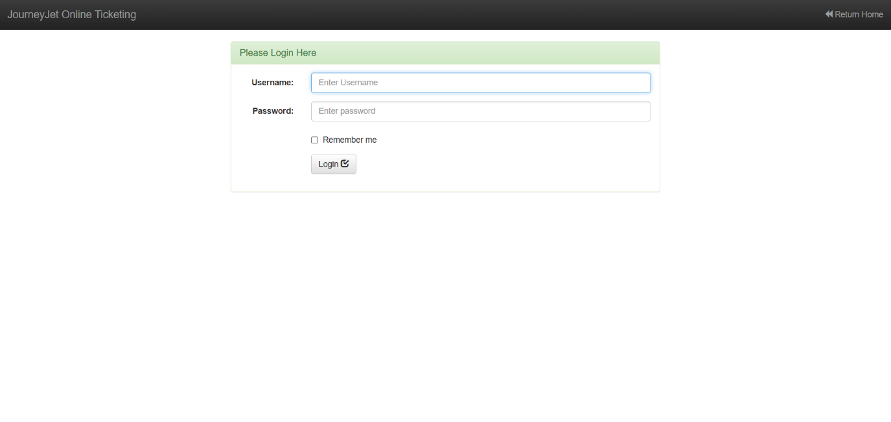

**CONCLUSION:**

The agricultural marketplace project effectively bridges the gap between farmers and buyers, facilitating efficient transactions in the agricultural sector. Utilizing HTML and CSS for the frontend and PHP with a MySQL database for the backend, the platform offers a user-friendly interface for product listings, user profiles, and feedback mechanisms. This project empowers farmers with better market access while providing buyers with transparent and informed purchasing options.

With potential for future enhancements such as mobile access and secure payment integration, this marketplace not only modernizes agricultural practices but also fosters a collaborative community. Overall, the project is a significant step toward enhancing efficiency and sustainability in the agricultural industry.

**REFERENCES:**

1. Books and Academic Resources
   * + - Silberschatz, A., Korth, H. F., & Sudarshan, S. *Database System Concepts*. McGraw-Hill Education.

* Elmasri, R., & Navathe, S. B. *Fundamentals of Database Systems*. Pearson Education.

1. Web Development

* Duckett, J. *HTML and CSS: Design and Build Websites*. John Wiley & Sons.
* W3Schools. *HTML and CSS Tutorials*. Available at: <https://www.w3schools.com>

1. SQL Resources

* Murach, J. *Murach's MySQL*. Mike Murach & Associates.
* TutorialsPoint. *SQL Tutorial*. Available at: https://www.tutorialspoint.com/sql/index.htm

1. Tools and Frameworks

* MySQL Documentation. *The Complete Reference for MySQL Database Management*. Available at: <https://dev.mysql.com/doc/>
* Bootstrap. *CSS Framework for Web Design*. Available at: <https://getbootstrap.com>

1. Project Inspiration and Examples

* GitHub Repositories for DBMS Projects. Available at: <https://github.com>

1. Stack Overflow for Database and Web Development Queries. Available at: <https://stackoverflow.com>
2. Research Papers

* "Optimizing Ticket Reservation Systems Using Database Management" - International Journal of Computer Applications.
* "Modern Practices in Database Design for Web Applications" - ACM Digital Library.