Research Validation and Comparative Analysis for TriNetra AI
Empirical Evidence Report for Project Supervisor Review (5-Minute Discussion)
1. Executive Summary
This report provides empirical research evidence validating the core necessity of the TriNetra AI platform. The analysis is based on 484 total research papers (184 relevant), 162 real-world e-commerce customer complaints across 5 platforms, and 6 leading commercial SaaS return/fraud products (Riskified, Forter, Signifyd, Appriss Retail, Narvar, Loop Returns).
Key Empirical Findings:
• Problem Reality: Trust and verification failures represent 60.5% of real-world complaints, yet Seller Trust is covered by only 2 research papers.
• Literature Limitations: Existing research is fragmented into isolated sub-problems; 0 academic papers integrate multi-stakeholder evidence into a unified dispute engine.
• SaaS Limitations: Commercial products solve either fraud scoring (Riskified) or logistics workflow (Narvar) as black boxes with 0 decision explainability.
• TriNetra Solution: Fills all 8 identified research gaps by combining multi-modal evidence orchestration, adaptive verification, and explainable decision support.
Real-World Complaint Evidence (N = 162)
Analysis of public complaints confirms that customer dissatisfaction stems primarily from trust and verification breakdowns: Trust/Process Failures (60.5%), Damaged Products (13.0%), Counterfeit Products (11.1%), Used Items (6.2%), and Customer Support Rejections (4.3%). 58.0% of complaints are classified as High or Critical severity, dominated by rejected return requests with no explanation.
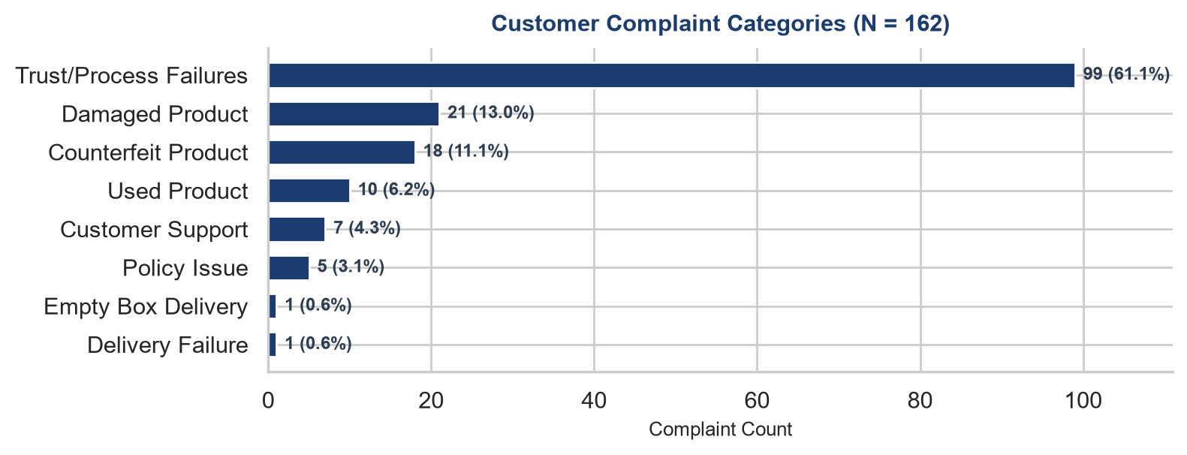
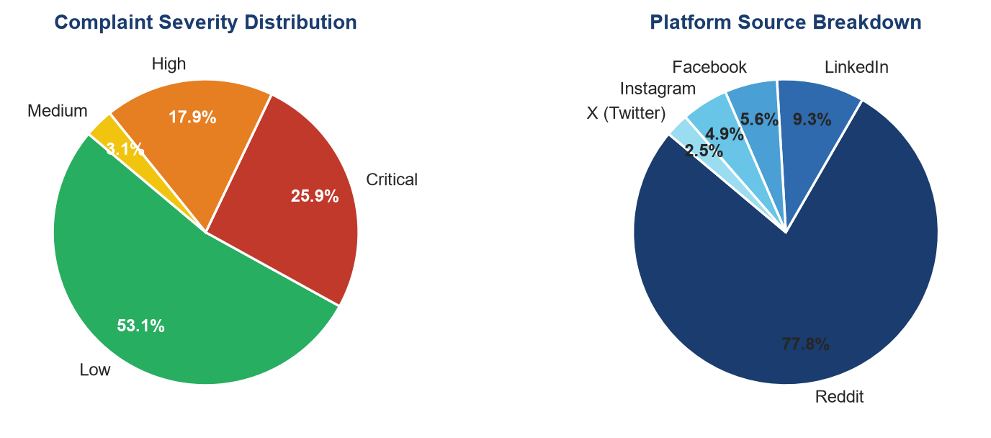
2. Comprehensive Capability & Gap Matrix (Centerpiece)
Capability | Research Papers | Existing Commercial SaaS | Research Gap | TriNetra AI
Fraud Detection | ✓ | ✓ | Isolated transaction classification; lacks physical evidence integration | ✓
Return Policy Optimization | ✓ | Partial | Policies are static; fail to dynamically adjust friction per risk profile | ✓
Reverse Logistics | ✓ | ✓ | Logistics routing decoupled from fraud risk & physical evidence verification | Partial
Consumer Trust Analysis | ✓ | Limited | Survey-based conceptual models lacking real-time evidence dispute engine | ✓
Seller Trust Analysis | Rare | ✗ | Neglects seller fraud, counterfeit listings, and abusive return rejections | ✓
Explainable Decisions | Partial | ✗ | Black-box decision models; fail to provide human-readable rationale | ✓
Evidence Aggregation | Rare | Limited | Lacks unified ingestion of customer photos, carrier scans, & weights | ✓
Evidence Consistency | Rare | ✗ | No algorithmic cross-verification of multi-modal physical evidence | ✓
Cross-Stakeholder Evidence Fusion | ✗ | ✗ | Buyer, seller, carrier, and warehouse data isolated in operational silos | ✓
Adaptive Verification | Rare | Limited | Uniform verification friction penalizes honest buyers & misses fraud | ✓
Human-in-the-Loop Review | Rare | Limited | High manual agent workload without transparent AI evidence summarization | ✓
Case Timeline Reconstruction | Partial | Limited | Simple order status tracking; lacks immutable dispute lifecycle logging | ✓
Decision Support | Partial | Partial | Binary approve/deny rules without risk-proportional action guidance | ✓
End-to-End Case Resolution | ✗ | Partial | Fragmented tools: logistics separate from fraud scoring & governance | ✓

3. Research Gap & Literature Analysis
Analysis of 184 relevant research papers reveals significant structural imbalances in literature focus:
• Most Researched: Refund Management (39 papers), Marketplace Operations (29 papers), Explainable AI (22 papers), Consumer Trust (20 papers).
• Least Researched / Frequently Ignored: Seller Trust (2 papers), Human-in-the-Loop Review (2 papers), Return Abuse (3 papers), Adaptive Verification (4 papers).
• Frequently Solved: Isolated transaction fraud classification using ML; reverse logistics facility location optimization.
• Unsolved Research Gaps: Algorithmic cross-verification of physical evidence (photos, carrier weight, scans) and risk-proportional verification friction.
4. Commercial SaaS Platform Comparison
Evaluation of 6 major commercial products (Riskified, Forter, Signifyd, Appriss Retail, Narvar, Loop Returns) highlights where industry solutions stop:
• Fraud Platforms (Riskified, Forter, Signifyd): Excel at payment/checkout fraud scoring but operate as black boxes with zero decision explainability and no evidence verification.
• Return Platforms (Narvar, Loop Returns, Appriss): Excel at return workflow & logistics routing but lack multi-modal fraud detection, seller risk protection, and evidence fusion.
• Where TriNetra Begins: TriNetra bridges fraud scoring and return logistics by introducing multi-stakeholder evidence cross-verification, symmetric buyer/seller trust scoring, and transparent XAI decision rationales.
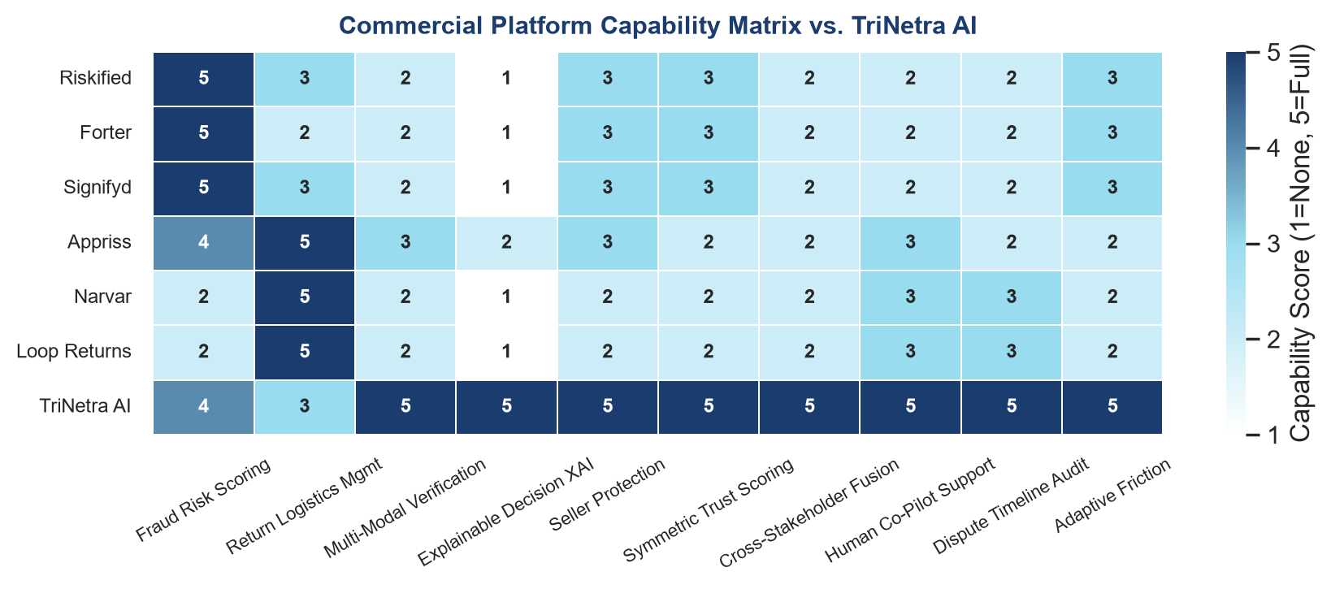

5. Research Contribution
TriNetra AI is explicitly NOT another standalone fraud detection classifier or post-purchase logistics portal. Instead, TriNetra AI is an evidence-driven decision support and trust governance platform designed to resolve dispute uncertainty across e-commerce marketplaces.
Core Research Contributions:
1. Multi-Source Evidence Aggregation: Ingests and structures physical customer photos, carrier weight logs, warehouse scan records, and seller declarations.
2. Evidence Consistency Engine: Applies algorithmic cross-verification to detect discrepancies, item switching, and empty box fraud before refund issuance.
3. Adaptive Verification Friction: Dynamically scales inspection friction proportional to transaction risk, protecting honest buyers while intercepting high-risk returns.
4. Explainable Decision Rationale: Generates natural language explanations and evidence attributions for buyers, sellers, and marketplace ops.
5. Human Review Co-Pilot: Synthesizes complex multi-stakeholder evidence cases into concise AI summaries for human arbitrators, drastically reducing manual review time.
6. Multi-Stakeholder Transparency: Provides symmetric trust scoring and immutable dispute timeline reconstruction for all market participants.
6. Conclusion
Existing literature primarily studies isolated sub-problems such as statistical fraud classification or reverse logistics optimization in silos. Existing commercial products solve narrow operational workflows — either black-box payment fraud scoring or post-purchase logistics routing. TriNetra AI integrates evidence orchestration, adaptive verification, explainable decision support, stakeholder transparency, and human-in-the-loop review into one unified, empirically validated framework.

