AI-Powered Disaster Response Coordinator

A Project Report
Submitted for the TechNova Software Hackathon
By
Team AOT of 2nd Year B.Tech (AI & DS)
THARNISH Y (Frontend)
NAVIN PRASANTH M (Backend + Deployment)
DINRSHKUMAR K (AI Module)
SANJAI R (Database + Integration)
Department of Artificial Intelligence and Data Science
[31-07-2026 & 01-08-2026]

Abstract
During natural and man-made disasters, timely and accurate information is critical for effective rescue operations. However, emergency coordinators are often overwhelmed by the massive influx of unstructured data from news and social media. This project presents the "AI-Powered Disaster Response Coordinator," an intelligent decision support system designed to automate the analysis of disaster-related news. Utilizing state-of-the-art Natural Language Processing (NLP) techniques, specifically the Facebook BART Large MNLI Zero-Shot Classification model, our system classifies the type of disaster, estimates its severity based on keyword scoring. The processed information is then visualized on an interactive map dashboard, enabling authorities to quickly identify high-priority incidents and allocate nearby rescue resources efficiently. Developed over a 2-day hackathon by a team of four second-year B.Tech AI & DS students, the system integrates a React.js frontend, a FastAPI backend, and a PostgreSQL database, demonstrating a scalable and practical approach to modern disaster management.

Table of Contents
1. Introduction
2. Problem Statement
3. Proposed Solution
4. Objectives
5. Technology Stack
6. System Architecture
7. AI Workflow
8. Module Description
9. Individual Contributions
10. AI Module Explanation
11. Database Design
12. API Flow
13. UI Screens (Wireframes)
14. Development Timeline
15. Challenges Faced
16. Solutions Implemented
17. Future Enhancements
18. Conclusion
19. References

1. Introduction
Disasters, whether natural like floods and earthquakes or man-made like accidents and fires, strike without warning and cause immense damage to life and property. In the crucial hours following a disaster, emergency response teams need accurate and timely information to save lives. Today, information spreads rapidly through news channels and social media. However, this creates a new problem: information overload. Emergency coordinators receive thousands of reports simultaneously, making it nearly impossible to manually read, verify, and prioritize them.
Our project, the AI-Powered Disaster Response Coordinator, aims to solve this problem by using Artificial Intelligence to act as a smart assistant for emergency teams. By automatically reading and understanding news reports, our system can instantly tell coordinators what happened, where it happened, and how severe it is. This allows rescue teams to focus on their primary job—saving lives—rather than sorting through data.

2. Problem Statement
During disasters such as floods, fires, earthquakes, accidents, and landslides, emergency coordinators receive information from multiple sources like news channels and social media. Since large amounts of information arrive continuously, it becomes difficult to identify high-priority incidents quickly. There is a critical need for an automated system that can filter out the noise, categorize the incidents, and present actionable insights to the authorities in real-time.

3. Proposed Solution
We propose an AI-powered decision support system that automatically analyzes disaster-related news. Our system uses advanced Natural Language Processing (NLP) to read incoming text data. It then classifies the disaster type (e.g., Flood, Fire, Earthquake) and estimates its severity (e.g., High, Medium, Low). The processed data is stored in a secure database and displayed on a user-friendly web dashboard. The dashboard features an interactive map that plots the incidents and recommends nearby rescue resources, enabling faster and more coordinated response efforts.

4. Objectives
The primary objectives of this project are:
- • To develop an AI model capable of accurately classifying disaster types from text data.
- • To implement a severity prediction algorithm to prioritize critical incidents.
- • To build a robust backend API for seamless data flow between the AI model and the database.
- • To design an intuitive frontend dashboard with map integration for real-time visualization.
- • To deliver a working prototype within the 2-day hackathon timeframe.

5. Technology Stack
We carefully selected our technology stack to ensure rapid development, high performance, and scalability.

Frontend
• React.js: Chosen for its component-based architecture, allowing us to build reusable UI elements quickly.
• Tailwind CSS: Used for rapid styling and ensuring a responsive design across different devices without writing custom CSS.

Backend
• FastAPI: Selected for its high performance and automatic interactive API documentation (Swagger UI), which is crucial for quick testing during a hackathon.
• Python: The primary language for both backend and AI, ensuring seamless integration.

AI & NLP
• Transformers (Hugging Face): Provides easy access to state-of-the-art pre-trained models.
• Facebook BART Large MNLI: Used for Zero-Shot Classification, allowing us to classify text into categories without needing a massive labeled training dataset.
• SpaCy & Pandas: Used for text preprocessing and data manipulation.

Database
• PostgreSQL: A powerful, open-source relational database system chosen for its reliability and support for complex queries.

Maps
• Leaflet & OpenStreetMap: Used for rendering interactive maps without the need for paid API keys (like Google Maps).

6. System Architecture
The system follows a modern client-server architecture with a dedicated AI processing pipeline.
+-------------------+ +-------------------+ +-------------------+
| | | | | |
| React.js UI |<----->| FastAPI Server |<----->| PostgreSQL DB |
| (Dashboard) | | (Backend API) | | (Data Storage) |
| | | | | |
+-------------------+ +-------------------+ +-------------------+
^
|
v
+-------------------+
| |
| AI / NLP Engine |
| (BART Model) |
| |
+-------------------+

7. AI Workflow
The AI processing pipeline follows a step-by-step workflow to transform raw news text into actionable data.
[ News Dataset / News API ]
↓
[ AI Model (BART Large MNLI) ]
↓
[ Disaster Classification (Zero-Shot) ]
↓
[ Severity Prediction (Keyword Scoring) ]
↓
[ Database Storage ]
↓
[ Dashboard Visualization ]
↓
[ Map Display ]
↓
[ Resource Recommendation ]

8. Module Description
Our project was divided into four main modules, with each team member focusing on a specific area to ensure efficient development and integration.

Frontend Module (THARNISH Y)
This module is responsible for the user interface and user experience of the application. It provides an interactive dashboard for emergency coordinators.
Key features developed:
- • React project initialization and setup.
- • Development of the main dashboard UI, including various data visualization components.
- • Implementation of navigation between different sections (Dashboard, Analytics, Incident, Map).
- • Creation of interactive dashboard cards to display key metrics and incident summaries.
- • Dedicated pages for detailed analytics, incident reports, and an interactive map.
- • Ensuring a responsive UI using Tailwind CSS, making the application accessible on various devices.

Backend Module (NAVIN PRASANTH M)
The backend module serves as the central hub for data processing, API management, and communication between the frontend and the database/AI components.
Key features developed:
- • FastAPI backend setup, chosen for its high performance and ease of API development.
- • Design and implementation of RESTful APIs for incident management, resource allocation, and data retrieval.
- • Integration with PostgreSQL database for persistent data storage.
- • Creation of specific API endpoints for incident data, allowing the frontend to fetch and display real-time information.
- • Establishment of a clear backend folder structure and definition of database models.
- • Planning for seamless API integration with the AI and database modules.

AI/NLP Module (DINESHKUMAR K)
This module is the core intelligence of the system, responsible for processing raw news data and extracting critical disaster information.
Key features developed:
- • Setup of the AI project structure and environment.
- • Preparation and loading of a disaster news dataset using Pandas for training and testing.
- • Installation and configuration of key NLP libraries: Transformers, Torch, and SpaCy.
- • Loading and fine-tuning of the Facebook BART Large MNLI Zero-Shot Classification model for disaster type classification.
- • Development of the Disaster Classification module to categorize incidents.
- • Implementation of the Severity Prediction module using a keyword scoring mechanism.
- • Creation of a `predict_disaster()` function to encapsulate the AI logic.
- • Extensive testing of the AI model with multiple disaster news articles to ensure accuracy.

Database + Integration Module (SANJAI R)
This module focuses on database design, data management, and ensuring smooth integration between all system components.
Key features developed:
- • Designing the comprehensive database schema for storing incident, resource, and user data.
- • Creation of essential tables: `incidents`, `resources`, and `users`.
- • Preparation of sample datasets for initial population and testing of the database.
- • Extensive planning for integration points between the frontend, backend, and AI modules.
- • Providing testing support across different modules to ensure data consistency and flow.

9. Individual Contributions
Each team member played a crucial role in the successful development of the AI-Powered Disaster Response Coordinator. Below are the detailed contributions of each individual.

Member 1: Frontend Developer
**Role:** Responsible for the entire user interface and user experience of the web application.
**Contributions:**
- • Initialized the React project and configured the development environment.
- • Designed and implemented the main dashboard layout, focusing on intuitive navigation and data presentation.
- • Developed key UI components such as navigation bars, dashboard cards, and interactive elements.
- • Created dedicated pages for Analytics, Incident details, and the interactive Map view.
- • Ensured the application was fully responsive across various screen sizes using Tailwind CSS, providing a consistent user experience.

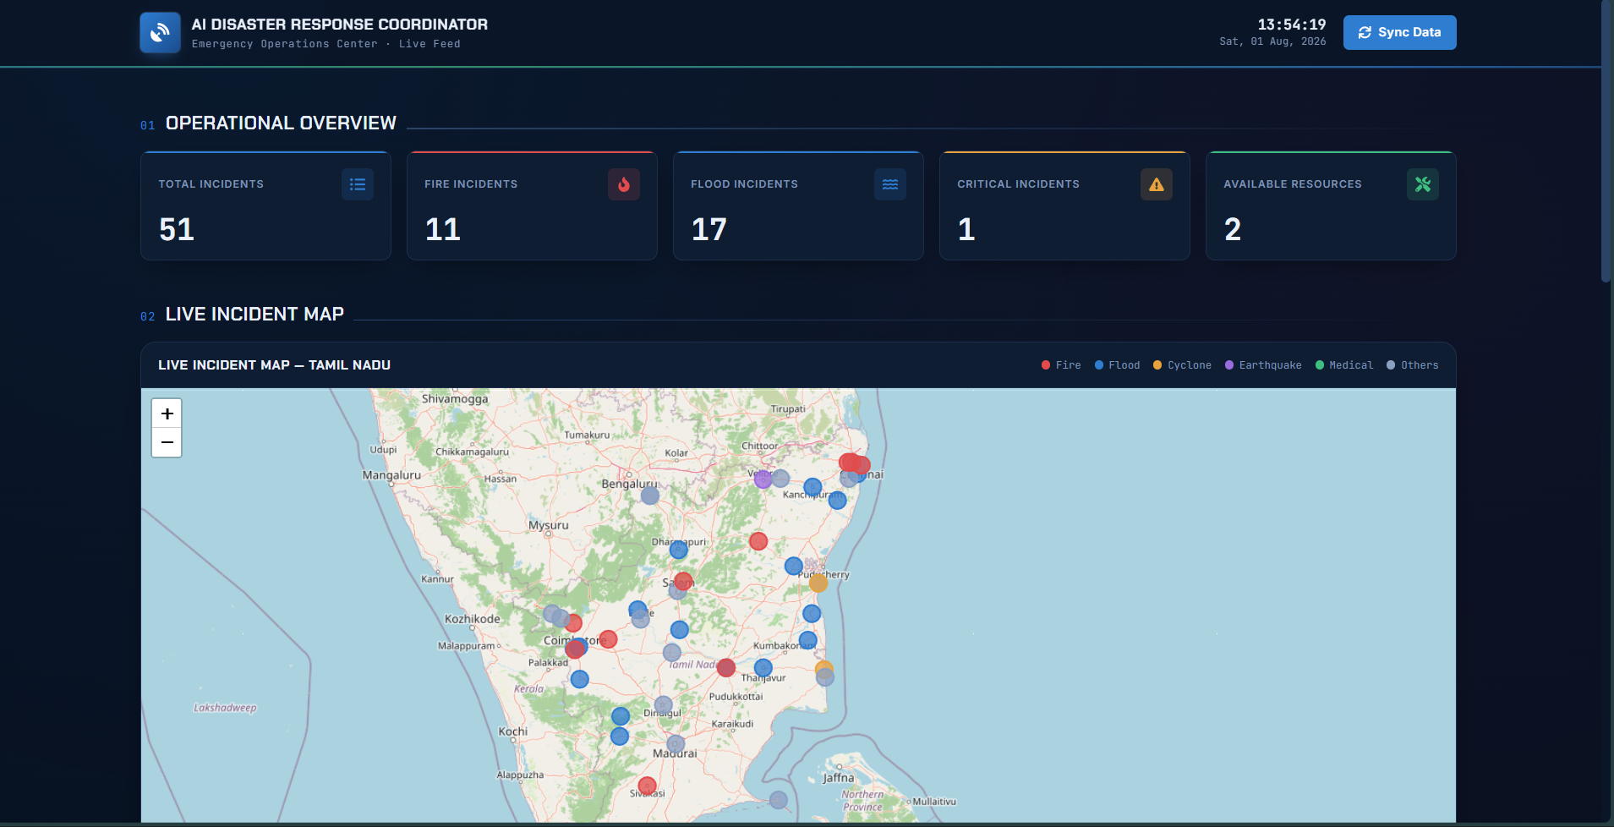

Member 2: Backend Developer
**Role:** Responsible for building the robust backend infrastructure, managing APIs, and ensuring data flow.
**Contributions:**
- • Set up the FastAPI framework and designed the core RESTful API endpoints for the application.
- • Developed API logic for handling incident reports, user authentication, and resource management.
- • Implemented database connection and ORM (Object-Relational Mapping) for PostgreSQL.
- • Defined the backend folder structure, ensuring modularity and maintainability.

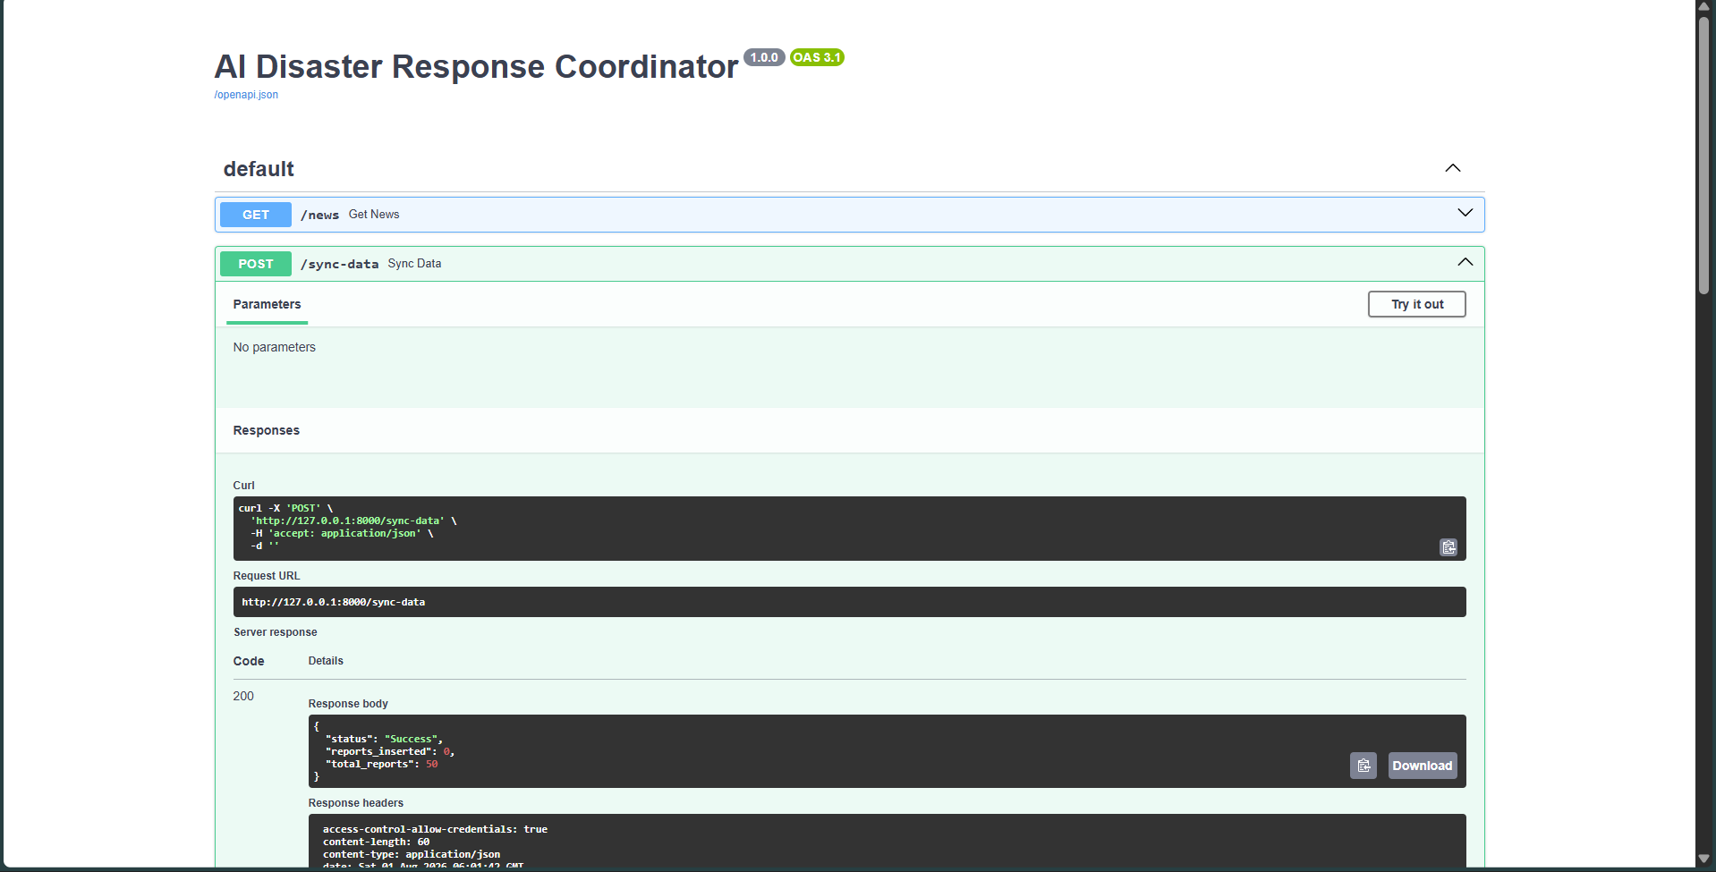
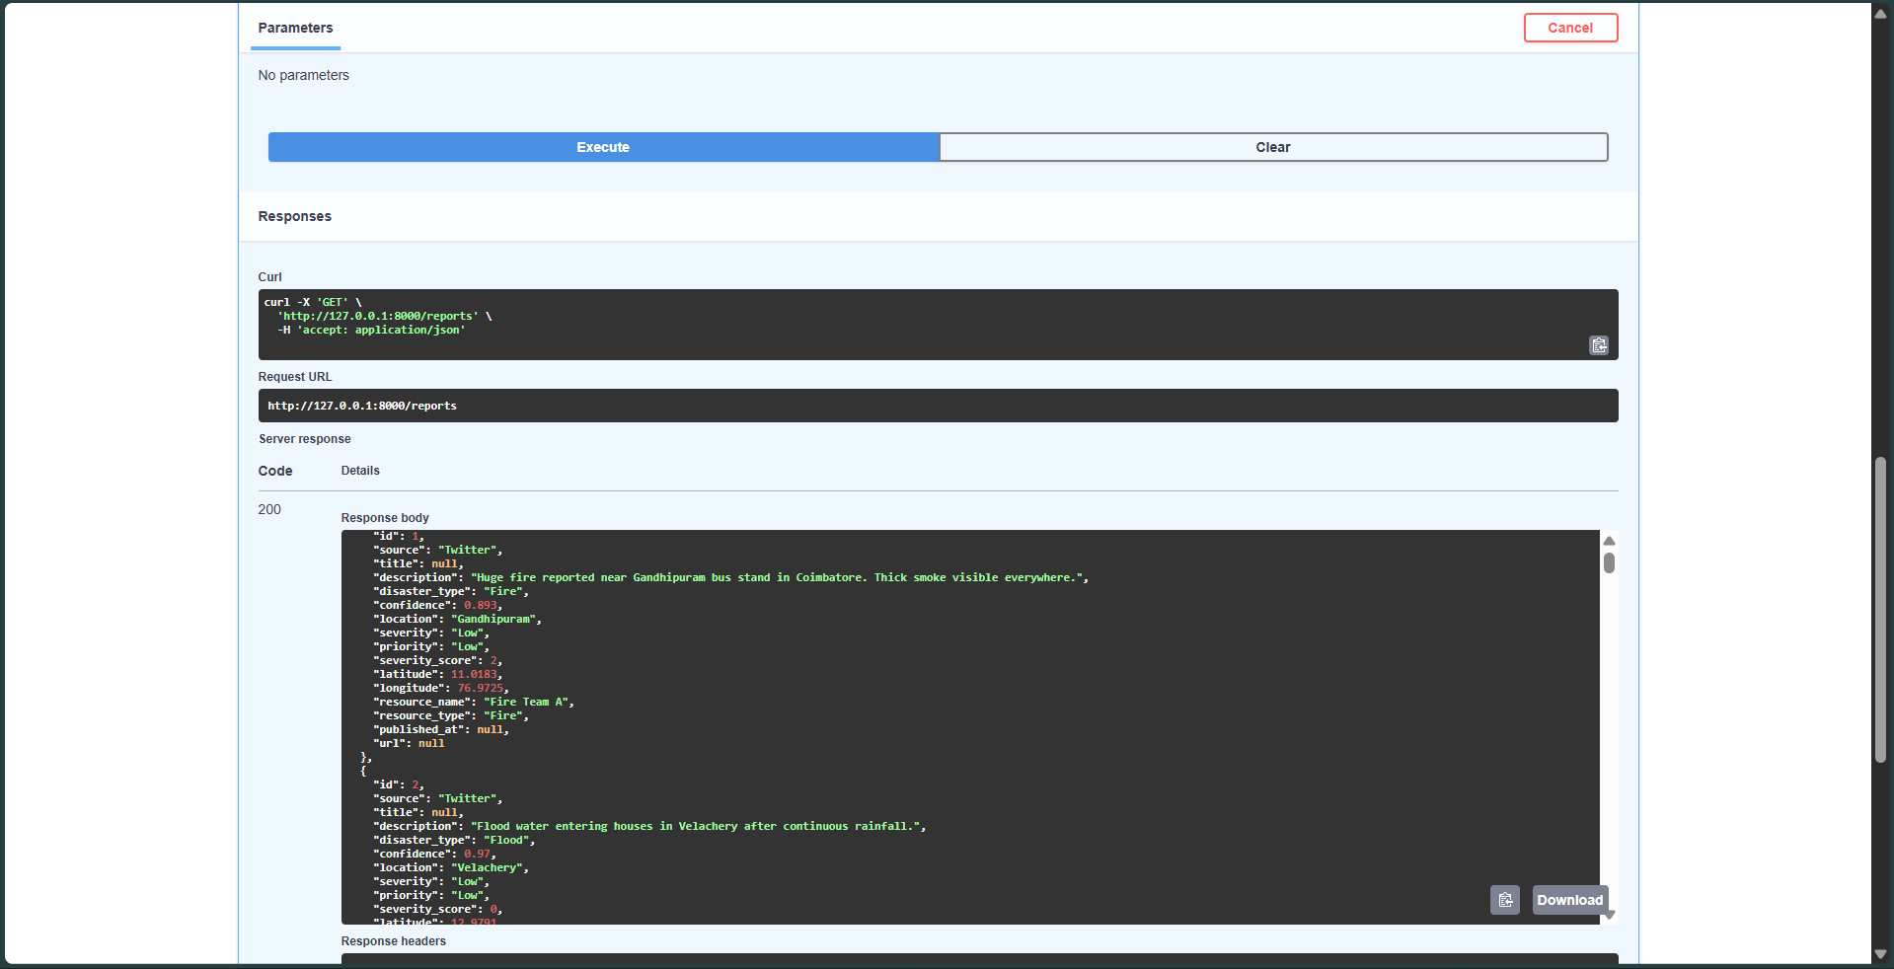

Member 3: AI/NLP Engineer
**Role:** Focused on developing the core Artificial Intelligence and Natural Language Processing components of the system.
**Contributions:**
- • Researched and selected appropriate NLP models for disaster classification, opting for Facebook BART Large MNLI for Zero-Shot capabilities.
- • Prepared and preprocessed the disaster news dataset, utilizing Pandas for data manipulation.
- • Implemented the Zero-Shot Classification logic to identify disaster types from unstructured text.
- • Developed a keyword-scoring algorithm for predicting the severity of reported incidents.
- • Created and rigorously tested the `predict_disaster()` function, ensuring accuracy and efficiency of the AI model.

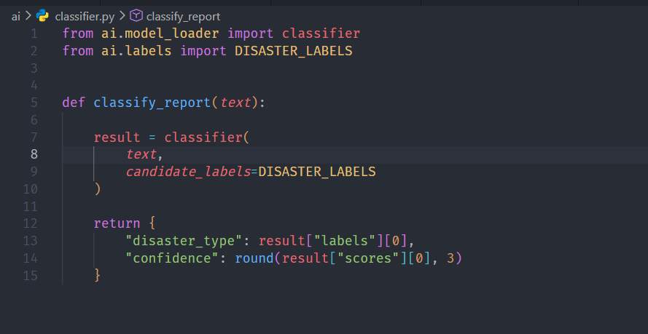
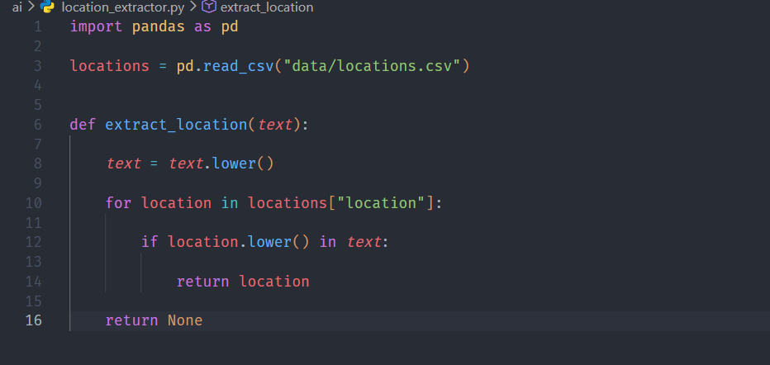
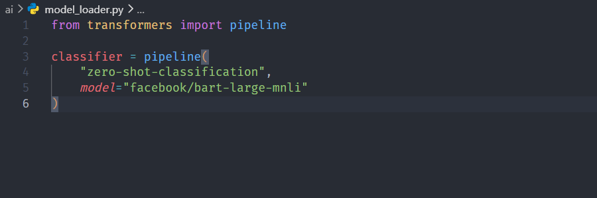

Member 4: Database & Integration Specialist
**Role:** Responsible for database design, implementation, and ensuring seamless integration across all modules.
**Contributions:**
- • Designed the relational database schema, including tables for `Users`, `Incidents`, `Resources`, and `Allocation`.
- • Implemented the PostgreSQL database, creating all necessary tables and relationships.
- • Populated the database with sample data for development and testing purposes.
- • Worked closely with the Backend Developer to ensure efficient data storage and retrieval via APIs.

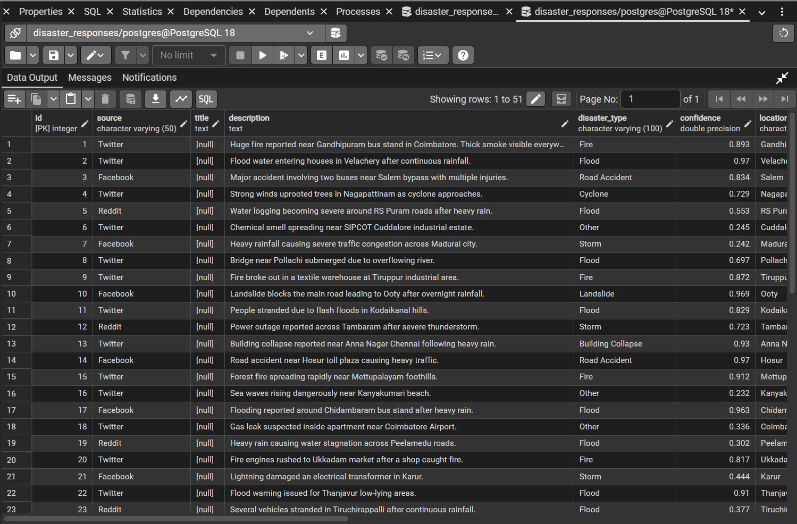

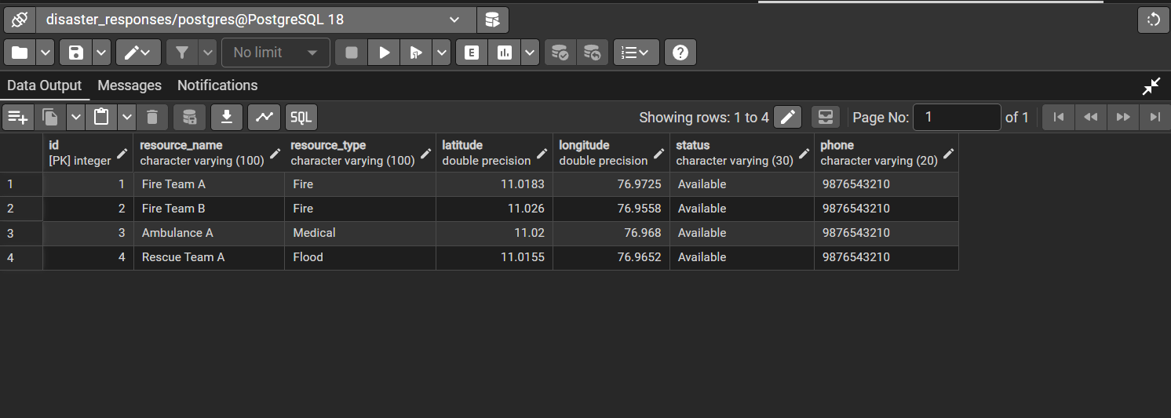

10. AI Module Explanation
The Artificial Intelligence module is the brain of our system, designed to intelligently process and categorize disaster-related information. It leverages advanced Natural Language Processing (NLP) techniques to turn raw text into actionable insights.

Dataset
For training and testing our AI model, we curated a dataset of disaster-related news articles. This dataset includes various types of disasters such as floods, fires, earthquakes, and accidents. The data was preprocessed to clean text, remove noise, and prepare it for NLP model consumption. While a large labeled dataset is ideal for supervised learning, our approach minimizes this dependency through Zero-Shot Classification.

Zero-Shot Classification
Zero-Shot Classification is a powerful NLP technique that allows a model to classify text into categories it has not been explicitly trained on. This is particularly useful in dynamic environments like disaster response, where new types of incidents or nuanced categories might emerge.
**Why Zero-Shot?** Traditional supervised learning models require extensive, labeled datasets for each category, which can be time-consuming and resource-intensive to create, especially for rapidly evolving events. Zero-Shot Classification, using models like Facebook BART Large MNLI, enables us to classify incoming news into predefined disaster categories (e.g., "Flood", "Fire", "Earthquake") without needing specific training examples for each. The model understands the semantic relationship between the input text and the category labels, making it highly adaptable.

Disaster Classification
The core of our AI module is the Disaster Classification component. It takes raw news text as input and, using the Zero-Shot Classification model, assigns it to one or more predefined disaster categories. This provides immediate context to emergency coordinators about the nature of the incident.

Severity Prediction
Beyond classification, our system also predicts the severity of each incident. This is achieved through a keyword scoring mechanism. We have identified a set of keywords and phrases associated with different levels of severity (e.g., "fatalities", "widespread damage" for high severity; "minor injuries", "contained" for low severity). The presence and frequency of these keywords in the news text contribute to a calculated severity score, which is then mapped to categories like High, Medium, or Low.

Testing
The AI module underwent rigorous testing using a diverse set of disaster news articles. We evaluated its accuracy in classifying disaster types and predicting severity. The testing module ensures that the AI performs reliably and provides consistent results, which is crucial for a decision support system.

Future Improvements
While the current AI module is effective, several improvements are planned:
- • Integration of more sophisticated NLP models for enhanced accuracy and nuance in classification.
- • Implementation of real-time learning mechanisms to adapt to new disaster patterns and terminology.
- • Expansion of keyword scoring to include contextual understanding for more precise severity prediction.

11. Database Design
The database is a critical component of our system, responsible for storing all incident data, user information, and resource details. We chose PostgreSQL for its robustness, scalability, and support for complex data types.

Tables
Our database schema includes the following key tables:
**Users Table:** Stores information about registered emergency coordinators and administrators.
Field | Type | Description
user_id | UUID (PK) | Unique identifier for the user
username | VARCHAR(50) | User's login username
email | VARCHAR(100) | User's email address
password_hash | VARCHAR(255) | Hashed password for security
role | VARCHAR(20) | User role (e.g., admin, coordinator)

**Incidents Table:** Stores details about each reported disaster incident.
Field | Type | Description
incident_id | UUID (PK) | Unique identifier for the incident
title | VARCHAR(255) | Title of the incident report
description | TEXT | Detailed description of the incident
type | VARCHAR(50) | Classified disaster type (e.g., Flood, Fire)
severity | VARCHAR(20) | Predicted severity (e.g., High, Medium, Low)
location | VARCHAR(255) | Geographical location of the incident
latitude | DECIMAL | Latitude coordinate
longitude | DECIMAL | Longitude coordinate
reported_at | TIMESTAMP | Timestamp when the incident was reported
status | VARCHAR(50) | Current status of the incident (e.g., active, resolved)

**Resources Table:** Contains information about available rescue resources.
Field | Type | Description
resource_id | UUID (PK) | Unique identifier for the resource
name | VARCHAR(100) | Name of the resource (e.g., Ambulance, Fire Truck)
type | VARCHAR(50) | Type of resource (e.g., medical, rescue, transport)
current_location | VARCHAR(255) | Current geographical location
latitude | DECIMAL | Latitude coordinate
longitude | DECIMAL | Longitude coordinate
availability | BOOLEAN | True if available, False otherwise

**Allocation Table:** Links incidents to allocated resources.
Field | Type | Description
allocation_id | UUID (PK) | Unique identifier for the allocation
incident_id | UUID (FK) | Foreign key to Incidents table
resource_id | UUID (FK) | Foreign key to Resources table
allocated_at | TIMESTAMP | Timestamp when resource was allocated
deallocated_at | TIMESTAMP | Timestamp when resource was deallocated

12. API Flow
The API (Application Programming Interface) acts as the communication layer between the frontend, backend, and AI modules. It ensures that data is exchanged efficiently and securely.
**Key API Endpoints:**
- • `/incidents` (GET): Retrieve a list of all reported incidents.
- • `/incidents/{id}` (GET): Retrieve details of a specific incident.
- • `/incidents` (POST): Submit a new incident report (e.g., from a news feed).
- • `/incidents/{id}/classify` (POST): Trigger AI classification for a specific incident.
- • `/resources` (GET): Retrieve a list of available rescue resources.
- • `/resources/{id}/allocate` (POST): Allocate a resource to an incident.
- • `/users/login` (POST): User authentication endpoint.
**Flow Example: Reporting a New Incident**
1. A new disaster news article is detected (e.g., via a news API or manual input).
2. The news text is sent to the backend via a POST request to `/incidents`.
3. The backend stores the raw incident data in the PostgreSQL database.
4. The backend then calls the AI module (internally or via a dedicated endpoint) to classify the disaster type and predict severity.
5. The AI module returns the classified data, which the backend updates in the `incidents` table.
6. The frontend dashboard, continuously polling `/incidents` or receiving real-time updates, displays the new incident on the map and in the incident list.

13. UI Screens (Wireframes)
The user interface is designed for clarity and ease of use, providing emergency coordinators with a comprehensive overview and detailed insights into disaster incidents. Below are conceptual wireframes for key screens.

Dashboard
This is the main landing page, offering a quick summary of active incidents, resource availability, and key statistics.
**[Screenshot Placeholder: Dashboard with incident cards, summary statistics, and quick links]**

Incident Page
Provides detailed information about a selected incident, including its description, classification, severity, and a timeline of events.
**[Screenshot Placeholder: Incident details with map snippet, severity, type, and description]**

Map Page
An interactive map displaying the geographical locations of all active incidents and nearby available resources.
**[Screenshot Placeholder: Full-screen interactive map with incident markers and resource icons]**

Analytics Page
Offers data visualizations and trends related to disaster types, severity distribution, and response times.
**[Screenshot Placeholder: Analytics page with charts (e.g., bar chart of disaster types, line chart of incidents over time)]**

14. Development Timeline
Our project was developed over a rigorous 2-day hackathon. The timeline below outlines the key activities and milestones achieved each day.

Day 1: Planning & Initial Development
- • **Planning (Morning):** Team formation, problem understanding, brainstorming solutions, technology stack selection, and initial architecture design.
- • **Frontend (Day 1):** React project setup, core UI component development (dashboard, navigation), basic page layouts (Incident, Map, Analytics).
- • **Backend (Day 1):** FastAPI setup, initial API design for incidents, PostgreSQL connection, basic database models.
- • **AI (Day 1):** AI project structure, dataset preparation, installation of NLP libraries (Transformers, Torch, SpaCy), loading BART model.
- • **Database (Day 1):** Initial database schema design, creation of `users` and `incidents` tables, sample data preparation.

Day 2: Feature Implementation, Integration & Testing
- • **Frontend (Day 2):** Refinement of UI, implementation of responsiveness with Tailwind CSS, integration with backend APIs to display dynamic data.
- • **Backend (Day 2):** Implementation of full REST APIs, integration with AI module for classification and severity prediction, resource management APIs.
- • **AI (Day 2):** Development of Disaster Classification and Severity Prediction modules, `predict_disaster()` function, extensive testing with news samples.
- • **Database (Day 2):** Creation of `resources` and `allocation` tables, refinement of schema, populating with more sample data.
- • **Integration (Day 2):** Full system integration, ensuring seamless data flow from AI to database to backend to frontend.
- • **Testing & Bug Fixes (Day 2):** Comprehensive testing of all modules and end-to-end flow, identification and resolution of bugs.
- • **Presentation Preparation (Day 2):** Finalizing the project report and preparing for the hackathon presentation.

15. Challenges Faced
During the intensive 2-day hackathon, our team encountered several challenges, which we successfully overcame through collaboration and problem-solving.
- • **Information Overload:** Initially, processing the vast and continuous stream of disaster-related news from multiple sources proved challenging. We addressed this by focusing on efficient text preprocessing and leveraging Zero-Shot Classification to quickly categorize information.
- • **Real-time Data Processing:** Ensuring that the AI model could process news and update the dashboard in near real-time required optimizing the AI inference speed and designing efficient API communication.
- • **Severity Prediction Accuracy:** Developing a robust keyword scoring mechanism for severity prediction that accurately reflected the real-world impact of disasters was complex. Iterative refinement and testing with diverse news samples helped improve its accuracy.
- • **Frontend-Backend Integration:** Synchronizing the frontend UI updates with the backend API responses, especially for dynamic map data and incident lists, required careful state management and API design.
- • **Time Constraints:** The 2-day hackathon duration necessitated rapid development and quick decision-making. We managed this by clearly defining module responsibilities and prioritizing core features.

16. Solutions Implemented
To address the challenges faced, our team implemented several effective solutions:
- • **Modular Development:** We adopted a modular approach, dividing the project into distinct Frontend, Backend, AI/NLP, and Database modules. This allowed parallel development and easier integration.
- • **Zero-Shot Classification:** For AI, we specifically chose the Facebook BART Large MNLI model for its Zero-Shot capabilities, significantly reducing the need for extensive labeled training data and accelerating the classification process.
- • **FastAPI for Performance:** The selection of FastAPI for the backend provided high performance and asynchronous capabilities, crucial for handling real-time data streams and API requests efficiently.
- • **Tailwind CSS for Rapid UI:** Utilizing Tailwind CSS enabled rapid development of a responsive and visually appealing user interface, allowing quick iterations and adjustments.
- • **Clear API Contracts:** We established clear API contracts between the frontend and backend, ensuring smooth data exchange and reducing integration issues.

17. Future Enhancements
Our project, while functional and robust, has significant potential for future enhancements to further improve its capabilities and impact.
- • **Live News APIs Integration:** Integrate with real-time news APIs (e.g., Google News API, custom scrapers) to automatically fetch and process disaster news as it breaks, reducing manual input.
- • **Social Media APIs Integration:** Incorporate social media data (e.g., Twitter, Facebook) to gain broader coverage and real-time ground-level insights during disasters.
- • **Advanced Location Extraction:** Implement more sophisticated NLP techniques for precise location extraction from unstructured text, including disambiguation of ambiguous place names.
- • **Duplicate Incident Detection:** Develop algorithms to identify and merge duplicate incident reports from various sources, providing a cleaner and more accurate overview.
- • **Multilingual Support:** Extend the AI model to support multiple languages, enabling the system to process news and reports from non-English sources, crucial for global disaster response.
- • **Predictive Analytics:** Implement predictive models to forecast potential disaster spread, resource needs, or secondary impacts based on current data and historical patterns.
- • **Drone Integration:** Explore integration with drone footage analysis for visual assessment of disaster zones, providing real-time imagery and damage assessment.
- • **IoT Integration:** Connect with IoT sensors (e.g., flood sensors, air quality monitors) to gather environmental data and provide early warnings or real-time situational awareness.

18. Conclusion
The AI-Powered Disaster Response Coordinator project successfully demonstrates the power of Artificial Intelligence and modern web technologies in addressing critical real-world problems. Developed within a challenging 2-day hackathon, our system provides emergency coordinators with a vital decision support tool, enabling faster, more informed, and ultimately more effective disaster response. By automating the analysis of vast amounts of unstructured news data, classifying incidents, predicting severity, and visualizing them on an interactive map, we have laid the foundation for a system that can significantly improve humanitarian efforts and save lives. The project highlights the potential for student innovation to create impactful solutions for societal benefit.

19. References
• Hugging Face Transformers Library: [https://huggingface.co/docs/transformers/index](https://huggingface.co/docs/transformers/index)
• Facebook BART Large MNLI Model: [https://huggingface.co/facebook/bart-large-mnli](https://huggingface.co/facebook/bart-large-mnli)
• FastAPI Documentation: [https://fastapi.tiangolo.com/](https://fastapi.tiangolo.com/)
• React.js Documentation: [https://react.dev/](https://react.dev/)
• Tailwind CSS Documentation: [https://tailwindcss.com/docs](https://tailwindcss.com/docs)
• PostgreSQL Official Website: [https://www.postgresql.org/](https://www.postgresql.org/)
• Leaflet - An Open-Source JavaScript Library for Interactive Maps: [https://leafletjs.com/](https://leafletjs.com/)
• OpenStreetMap: [https://www.openstreetmap.org/] (https://www.openstreetmap.org/)

20. Github Repo Link(Source code)

https://github.com/Sanjai-R-Data/TEAM-AOT
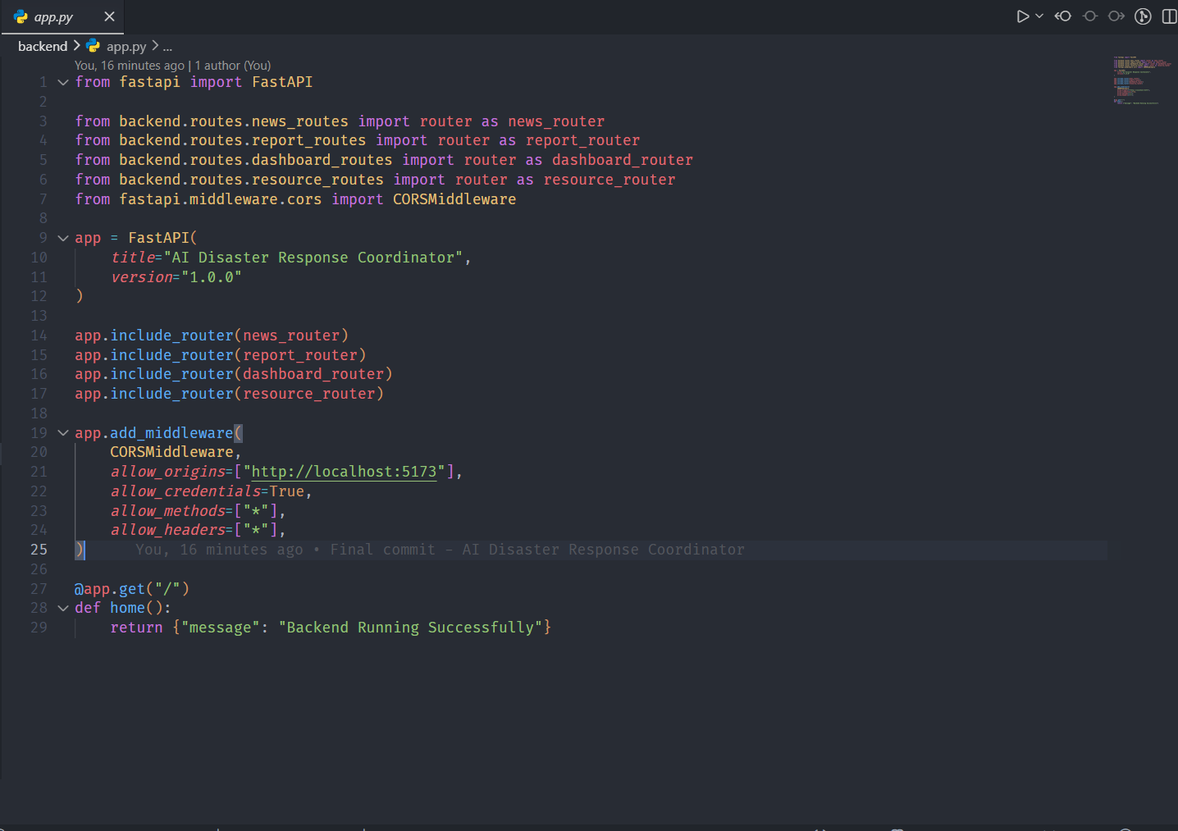
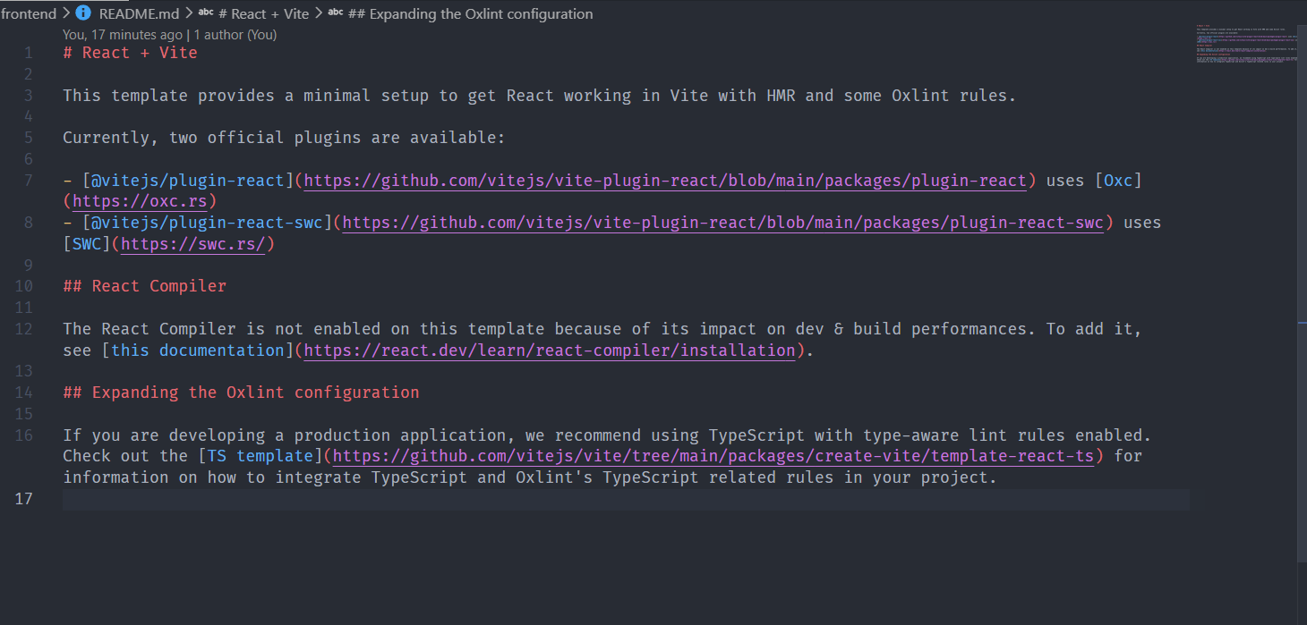

21.Output

