**A NOVEL 13-LEVEL INVERTER TOPOLOGY WITH REDUCED COMPONENTS COUNT, BUILT-IN SELF-BALANCING CAPABILITY FOR EV APPLICATIONS**

**PROJECT REPORT**

**(Phase- II)**

***Submitted by***

**SANJAI.S REGISTER NO: 20TE0159**

**HARI RAJAN.T REGISTER NO: 20TE0155**

**VARUN VALSAN REGISTER NO: 20TEL035**

***Under the guidance of***

**Ms. R. PRIYA**

**Assistant Professor/EEE**

***in partial fulfillment for the award of the degree***

***of***

**BACHELOR OF TECHNOLOGY**

***in***

**DEPARTMENT OF ELECTRICAL AND ELECTRONICS ENGINEERING**



**MANAKULA VINAYAGAR INSTITUTE OF TECHNOLOGY,**

**KALITHEERTHALKUPPAM, PUDUCHERRY**

**PONDICHERRY UNIVERSITY, INDIA.**

**MAY 2024**

**MANAKULA VINAYAGAR INSTITUTE OF TECHNOLOGY**

**PONDICHERRY UNIVERSITY**

**DEPARTMENT OF ELECTRICAL AND ELECTRONICS ENGINEERING**

**BONAFIDE CERTIFICATE**

This is to certify that the project work entitled **“A NOVEL 13-LEVEL INVERTER TOPOLOGY WITH REDUCED COMPONENTS COUNT, BUILT-IN SELF-BALANCING CAPABILITY FOR EV APPLICATIONS”** is a bonafide work done by **SANJAI.S [REGISTER NO: 20TE0159], HARI RAJAN.T [REGISTER NO: 20TE0155], VARUN VALSAN [REGISTER NO: 20TEL035] in** partial fulfillment of the requirement for the award of B. Tech Degree in Electrical and Electronics Engineering by Pondicherry University during the academic year 2023-2024.

|  |  |
| --- | --- |
| **PROJECT GUIDE** | **HEAD OF THE DEPARTMENT** |
| Ms. R. PRIYA, | Dr. C. SHANMUGASUNDARAM, |
| Assistant Professor, | Head of the Department, |
| Dept. of EEE., | Dept. of EEE., |

Viva-Voce Examination held on..........................

**INTERNAL EXAMINER EXTERNAL EXAMINER**

**DECLARATION**

This is to certified that the Report entitled “**A NOVEL 13-LEVEL INVERTER TOPOLOGY WITH REDUCED COMPONENTS COUNT, BUILT-IN SELF-BALANCING CAPABILITY FOR EV APPLICATIONS** ” is the bonafide record of independent work done by **SANJAI.S** Register No. **20TE0159, HARI RAJAN.T** Register No. **20TE0155**, and **VARUN VALSAN** Register No. **20TEL035** for the award of B.Tech Degree in **ELECTRICAL AND ELECTRONICS ENGINEERING** under the supervision of **Ms. R.PRIYA,** Assistant Professor Certified further that the work reported here in does not form part of any other thesis or dissertation on the basis of which a degree or award was conferred earlier.

|  |  |
| --- | --- |
| 1. SANJAI.S - |  |
| 1. HARI RAJAN.T - |  |
| 1. VARUN VALSAN - |  |

|  |  |
| --- | --- |
| **PROJECT GUIDE** | **HEAD OF THE DEPARTMENT** |

**ACKNOWLEDGEMENT**

We express our deep sense of gratitude to **Theiva Thiru. N. Kesavan,** Founder, **Shri. M. Dhanasekaran,** Chairman & Managing Director**, Shri. S. V. Sugumaran,** Vice-Chairman and **Dr. K. Gowtham Narayanasamy,** Secretary of **Sri Manakula Vinayagar Educational Trust, Puducherry** for providing necessary facilities to successfully complete our project and report works.

We express our sincere thanks to our beloved Principal **Dr. S. Malarkkan** for having provided necessary facilities and encouragement for successful completion of this project work. We express our sincere thanks to **Dr. Shanmugasundaram, Professor and Head of the Department**, **Electrical and Electronics Engineering** for his support in making necessary arrangements for the conduction of Project and for guiding us to execute our project successfully.

We extent our sincere and heartfelt thanks to our project coordinator **Mr. R. Priya, Assistant Professor, Electrical and Electronics Engineering** providing the right ambience for carrying out this work and his valuable guidance and suggestions for our project work.

We thank all our department faculty members, non-teaching staffs and my friends of EEE for helping us to complete the document successfully on time. We would like to express our eternal gratitude to our parents for the sacrifices they made for educating and preparing us for our future and their everlasting love and support. We thank the Almighty for blessing us with such wonderful people and for being with us always.

**Sanjai.S - 20TE0159**

**Hari Rajan.T - 20TE0155**

**Varun Valsan ­- 20TEL035**



**SUSTAINABLE DEVELOPMENT GOALS (SDGs) MAPPING**

**Title: A NOVEL 13-LEVEL INVERTER TOPOLOGY WITH REDUCED COMPONENTS COUNT, BUILT-IN SELF-BALANCING CAPABILITY FOR EV APPLICATIONS**

**SDG Goal : SDG Goal - 7 (Affordable and clean energy)**



**SDG Goal : SDG Goal - 9 (Industry, Innovation, and Infrastructure)**



**SDG Goal : SDG Goal - 11 (Sustainable Cities and Communities)**



**SDG Goal : SDG Goal - 12 (Responsible Consumption and Production)**



**SDG Goal : SDG Goal - 13 (Climate Action)**



**SDG Goal - 7:**

SDG Goal 7, part of the United Nations' 2030 Agenda for Sustainable Development, targets universal access to affordable, reliable, sustainable, and modern energy by 2030. It acknowledges that energy is central to nearly every major challenge and opportunity the world faces today, from poverty eradication and healthcare to environmental sustainability and economic growth. Key aspects of SDG 7 include ensuring access to electricity and clean cooking facilities, increasing the share of renewable energy in the global energy mix, and improving energy efficiency across all sectors. By promoting renewable sources like solar, wind, and hydroelectric power, SDG 7 aims to mitigate climate change, reduce air pollution, and enhance energy security. Moreover, it seeks to foster innovation in clean energy technologies and infrastructure, creating new economic opportunities and jobs. Achieving SDG 7 requires strong policy frameworks, investment in infrastructure, and collaboration between governments, businesses, and civil society. Progress has been made, but significant challenges remain, particularly in rural and remote areas where energy access is limited. By advancing SDG 7, we can drive sustainable development, improve livelihoods, and build a more equitable and resilient future for all.

**SDG Goal - 9:**

SDG Goal 9, "Build resilient infrastructure, promote inclusive and sustainable industrialization, and foster innovation," is a pivotal component of the United Nations' Sustainable Development Goals (SDGs) framework. It addresses the fundamental need for robust infrastructure, sustainable industrial development, and innovation to propel global economic growth while ensuring social inclusivity and environmental sustainability. Infrastructure development is essential for enabling economic activities, enhancing connectivity, and providing access to essential services like transportation, energy, water, and communication. SDG 9 underscores the importance of resilient infrastructure that can withstand natural disasters and other adverse events, particularly in vulnerable regions. Investing in infrastructure not only drives economic growth but also improves living standards and facilitates sustainable development. Promoting inclusive and sustainable industrialization is another critical aspect of SDG 9. This entails fostering the growth of manufacturing sectors in a manner that creates decent jobs, promotes value addition, and minimizes environmental impact. Sustainable industrialization aims to balance economic prosperity with social equity and environmental conservation, ensuring that development benefits are shared equitably across society. Furthermore, fostering innovation is integral to achieving SDG 9. Encouraging research, technological development, and innovation across various sectors can address pressing global challenges, improve productivity, and promote sustainable consumption and production patterns. Innovation drives progress in areas such as renewable energy, healthcare, agriculture, and information technology, contributing to sustainable development and enhancing human well-being.

**SDG Goal - 11:**

SDG Goal 11, "Sustainable Cities and Communities," is a crucial aspect of the United Nations' Sustainable Development Goals (SDGs) framework, focusing on creating inclusive, safe, resilient, and sustainable urban environments for all. As the world becomes increasingly urbanized, with more people residing in cities, the need to address urban challenges and promote sustainable urban development becomes paramount.

At its core, SDG 11 aims to ensure that cities and human settlements are inclusive, safe, resilient, and sustainable. This involves various interconnected Encouraging participatory and integrated urban planning processes that prioritize the needs of all residents, including vulnerable and marginalized groups. This includes access to affordable housing, basic services, and infrastructure for all. Enhancing urban resilience to disasters, including natural hazards and climate change impacts, through improved infrastructure, land-use planning, and disaster risk reduction measures. This ensures the safety and well-being of urban populations in the face of evolving environmental challenges. Promoting sustainable transportation systems, such as public transit and non-motorized transport, to reduce congestion, air pollution, and greenhouse gas emissions. Additionally, investing in sustainable urban infrastructure, including energy-efficient buildings and green spaces, contributes to environmental sustainability and enhances the quality of life in cities. Safeguarding cultural heritage and promoting inclusive and sustainable urbanization that respects and preserves cultural diversity and heritage sites within cities. Ensuring access to parks, green spaces, and recreational facilities within urban areas, which contributes to physical and mental well-being, biodiversity conservation, and climate resilience.

Achieving SDG 11 requires collaboration and partnerships between governments, local authorities, civil society, and the private sector. It involves implementing policies and strategies that prioritize sustainable urban development, promote social inclusion, and address the root causes of urban challenges.

**SDG Goal - 12:**

SDG Goal 12, "Responsible Consumption and Production," is a cornerstone of the United Nations' Sustainable Development Goals (SDGs) framework, aiming to promote sustainable patterns of consumption and production worldwide. At its core, SDG 12 seeks to address the unsustainable use of natural resources, reduce waste generation, and promote efficient resource management to achieve sustainable development and environmental protection. Encouraging individuals and households to adopt sustainable consumption practices by promoting awareness, education, and access to information about the environmental impacts of their consumption choices. This includes promoting sustainable lifestyles, reducing food waste, and choosing products that are environmentally friendly and ethically produced. Promoting resource-efficient and environmentally sound production processes across all sectors, including agriculture, manufacturing, and services. This involves adopting cleaner production technologies, improving resource efficiency, and reducing the environmental footprint of production activities. Implementing strategies to minimize waste generation, promote recycling and reuse, and manage waste in an environmentally sound manner. This includes investing in waste management infrastructure, supporting recycling initiatives, and promoting circular economy principles to reduce the reliance on finite resources.

Promoting sustainability throughout supply chains by encouraging responsible sourcing, production, and consumption practices among businesses and industries. This involves promoting transparency, accountability, and ethical standards in supply chain management to ensure social and environmental sustainability.

Achieving SDG 12 requires collaboration and partnerships between governments, businesses, civil society, and consumers. It involves implementing policies, regulations, and incentives that promote sustainable consumption and production practices while addressing the root causes of unsustainable consumption patterns**.**

**SDG Goal - 13:**

SDG Goal 13, "Climate Action," is a critical component of the United Nations' Sustainable Development Goals (SDGs) framework, aiming to address the urgent global challenge of climate change. This goal emphasizes the need for immediate and ambitious action to mitigate greenhouse gas emissions, adapt to the impacts of climate change, and build resilience to its effects. SDG 13 calls for reducing greenhouse gas emissions to limit global warming and mitigate the adverse effects of climate change. This involves transitioning to low-carbon energy sources, increasing energy efficiency, and implementing policies and measures to decarbonize various sectors such as energy, transportation, industry, and agriculture. Recognizing that climate change impacts are already being felt worldwide, SDG 13 emphasizes the importance of adaptation measures to build resilience and protect communities, ecosystems, and economies from the impacts of climate change. This includes enhancing infrastructure resilience, implementing climate-smart agricultural practices, and developing early warning systems for extreme weather events 13 underscores the need for enhanced climate governance at all levels, including international cooperation, national policy frameworks, and local initiatives. This involves implementing climate-related policies, mobilizing financial resources for climate action, and promoting transparent and participatory decision-making processes.

SDG 13 promotes capacity building and awareness-raising efforts to empower individuals, communities, and institutions to take climate action. This includes education and training programs, knowledge sharing, and public awareness campaigns to foster climate literacy and encourage sustainable behaviors.

**ABSTRACT**

**A new dual T-type 13-level inverter topology**

**is developed in our project.**

A new dual T-type 13-level inverter topology is developed in our project. The traditional multilevel inverter topologies, such as neutral point clamped, flying capacitor, T-type and cascaded H-bridge inverters employs more no of switches, gate drivers and diodes to produce the 13-level output. In our proposed inverter topology, there is no additional circuits to equalize the voltage of capacitors present in each pole. Hence the reduction in number of switches, driver circuits, modulation strategies and balancing circuits leads to reduction of cost and power losses in the proposed topology, makes it much suitable for EV applications. The proposed topology performance was simulated and efficiency and THD performance parameters verified with experimental results.

**TABLE OF CONTENTS**

|  |  |  |
| --- | --- | --- |
| **CHAPTER NO.** | **TITLE** | **PAGE NO.** |

|  |  |  |  |  |
| --- | --- | --- | --- | --- |
|  |  |  | **BONAFIDE CERTIFICATE** | **ii** |
|  |  |  | **DECLARATION** | **iii** |
|  |  |  | **ACKNOWLEDGEMENT** | **iv** |
|  |  |  | **SDG GOALS MAPPING** | **v** |
|  |  |  | **ABSTRACT** | **xi** |
|  |  |  | **LIST OF TABLES** | **xv** |
|  |  |  | **LIST OF FIGURES** | **xvi** |
|  |  |  | **LIST OF NOMENCLATURE** | **xvii** |
| **1** |  |  | **INTRODUCTION** | **1** |
|  | 1.1 |  | Overview | 1 |
|  | 1.2 |  | Software Used | 2 |
|  |  | 1.2.1 | Necessity | 3 |
|  |  | 1.2.2 | Advantages | 3 |
|  | 1.3 |  | Objective | 4 |
|  |  |  |  |  |
| **2** |  |  | **EXISTING SYSTEM** | **5** |
|  | 2.1 |  | Existing topology circuit | 5 |
|  | 2.2 |  | Existing system switching configuration | 8 |
|  | 2.3 |  | Existing system switching Table | 9 |
|  | 2.4 |  | Existing system switching patterns | 9 |
|  | 2.5 |  | Existing system simulation results | 10 |
|  | 2.6 |  | Existing system hardware results | 10 |
|  | 2.7 |  | Existing system overview | 11 |
|  | 2.8 |  | Existing system overview | 11 |
|  |  |  |  |  |
| **3** |  |  | **PROPOSED SYSTEM** | **12** |
|  | 3.1 |  | Proposed topology circuit | 12 |
|  | 3.2 |  | Proposed topology switching path | 13 |
|  | 3.3 |  | Proposed topology switching configuration | 15 |
|  | 3.4 |  | Proposed topology switching diagram | 32 |
|  | 3.5 |  | Capacitor voltage self-balancing | 17 |
|  | 3.6 |  | 13-LDT three-phase configurations | 18 |
|  | 3.7 |  | Cost analysis of proposed system | 19 |
| **4** |  |  | **PROPOSED SYSTEM HARDWARE** | **22** |
|  | 4.1 |  | Hardware | 22 |
|  | 4.2 |  | Components | 22 |
|  |  | 4.2.1 | Transformer | 22 |
|  |  | 4.2.2 | PIC Microprocessor | 23 |
|  |  | 4.2.3 | Diode | 24 |
|  |  | 4.2.4 | Capacitor | 25 |
|  |  | 4.2.5 | SCR | 26 |
|  |  | 4.2.6 | MOSFET | 28 |
| **5** |  |  | **RESULTS AND OUTPUT** | 30 |
|  | 5.1 |  | Hardware results | 30 |
|  | 5.2 |  | Simulation results | 31 |
| **6** |  |  | **CONCLUSION** | **33** |
|  | 6.1 |  | Conclusion | 33 |
|  | 6.2 |  | Scope for future work | 61 |
|  |  |  | **REFERENCES** | **35** |

LIST OF FIGURES

|  |  |  |
| --- | --- | --- |
| **FIGURE. NO.** | **TITLE** | **PAGE NO.** |
| 1 | General MLI with capacitor | 5 |
| 2 | Existing system topology circuit | 6 |
| 3 | Switching states of existing module | 8 |
| 4 | Switching patterns of existing module | 9 |
| 5 | Output voltage simulation | 10 |
| 6 | Output voltage Hardware | 10 |
| 7 | Proposed inverter Circuit | 12 |
| 8 | Switching states of proposed circuit | 13 |
| 9 | Switching configuration | 15 |
| 10 | Switching states of proposed circuit | 16 |
| 11 | Switching combination vs capacitor currents | 17 |
| 12 | Cost of transformer with windings | 20 |
| 13 | Proposed system hardware | 22 |

LIST OF TABLES

|  |  |  |
| --- | --- | --- |
| **TABLE NO.** | **TITLE** | **PAGE NO.** |
| 1 | Switching table for existing system | 9 |
| 2 | Switching table for proposed system | 15 |
| 3 | Switching Combinations VS Capacitor current | 17 |
| 4 | Comparison of different 13-level topologies | 19 |
| 5 | Cost comparison of different 13-level topologies | 21 |
|  |  |  |
|  |  |  |
|  |  |  |
|  |  |  |

NOMENCLATURE

|  |  |
| --- | --- |
| **ABBREVIATIONS** | |
| MLI | Multi-Level Inverter |
| THD | Total Harmonic Distortion |
| EV | Electrical Vehicle |
| PWM | Pulse Width Modulation |
| NLM | Nearest Level Modulation |
| TOC | Total Operating Cost |
| SHE | Selective Harmonic Elimination |
| **ENGLISH SYMBOLS** | |
| *C* | Capacitance |
| *V* | Voltage |
| *iTHD* | Current Through THD |
| and | resistance and reactance of a branch connected between nodes-k and m |
| **GREEK SYMBOLS** | |
|  | power factor angle of the power at the receiving end of feeder- |
|  | change in |

**CHAPTER 1**

**INTRODUCTION**

**1.1 OVERVIEW**

MULTILEVEL inverters (MLIs) are today an attractive alternative to conventional two-level inverters (TLIs) in medium voltage electrical power transmission and high-speed drives. MLI topologies in general feature a reduced distortion of output ac voltages and currents than TLI operating at the same switching frequency, as well as lower voltage gradients, lower switching stresses and lower switching power losses. Furthermore, MLI is effective in reducing transient overvoltage at the terminals of motor windings, harmonic losses in the cables, common mode disturbance currents and power losses on grid side sine-filters. On the other hand, MLI requires a higher number of power switches than conventional TLI, although with lower voltage ratings. This is a key disadvantage of MLI topologies because the higher the number of power switches, the higher the cost and circuital complexity. Progress in semiconductor technology led to availability of low-cost.

High-power switches, making possible the realization of very efficient MLI based on traditional topologies, such as neutral point clamped (NPC), T-type, flying capacitor (FC), cascaded H- bridge (CHB), modular multilevel inverter, or their derivatives. On any kind of MLI the smaller the amount of output voltage levels, the higher the output voltage and current total harmonic distortions (THD) indexes achieved for a given switching frequency. Therefore, on simpler and cheaper MLI, operating at low switching frequency and with a small number of output voltage levels, quite high THD occurs, leading to additional power losses and torque oscillations in the case of electric motor drives. Several possible solutions have been proposed to improve the output current *i*THD on MLI. Among

them, line reactors and tuned harmonic filters are simple passive measures, which gained popularity because of the low cost, even if they are poorly flexible and could generate resonance issues. Active techniques based on the injection of suitable current harmonics by auxiliary converters are more expensive but provide an effective harmonic attenuation, as well as some additional functions such as power factor correction. MLI can also benefit from high switching frequency pulse width modulation (PWM) strategies, although at the cost of increased switching losses. MLI using open-end winding configurations have been recently also developed, where the ac machine is fed by two separate power converters sharing the load, to improve the harmonic content of phase voltages and currents. Such an approach produces a lower stator current distortion than conventional MLI topologies switching at the fundamental frequency, while requiring less power switches than PWM multilevel inverters featuring the same THD.

**1.2 SOFTWARE USED**

The simulation and analysis for this project were conducted using MATLAB (**MAT**rix **LAB**oratory), a powerful software platform widely utilized for technical computing and data visualization. MATLAB provided a comprehensive environment for implementing algorithms, visualizing data, and carrying out numerical computations essential for our study.

MATLAB enabled us to model and simulate complex systems with ease, leveraging its extensive libraries and tools for signal processing, image analysis, control systems design, and more. The interactive nature of MATLAB allowed for rapid prototyping and iterative development of algorithms, ensuring efficient problem-solving throughout the project lifecycle.

Key features of MATLAB utilized in this project include its intuitive programming language, optimized matrix operations, and built-in functions tailored for engineering and scientific applications. Moreover, MATLAB's graphical capabilities facilitated the visualization of simulation results, aiding in the interpretation and presentation of our findings.

The use of MATLAB not only streamlined the simulation process but also contributed significantly to the accuracy and reliability of our analysis. Its versatility and robustness made it an indispensable tool in achieving the objectives of this project.

**1.2.1 NECESSITY**

The necessity of using MATLAB lies in its efficiency, versatility, and comprehensive feature set, which collectively enable researchers and engineers to tackle complex problems, conduct simulations, and analyse data effectively in various technical domains.

**1.2.2 ADVANTAGES**

**Rich Functionality**: MATLAB provides a vast array of built-in functions and toolboxes tailored for various engineering and scientific applications. Whether you're working on signal processing, control systems, image processing, machine learning, or numerical analysis, MATLAB offers ready-to-use functions and algorithms that can significantly accelerate development.

**Efficient Prototyping**: MATLAB's interactive environment allows for quick prototyping of algorithms and models. This means you can iterate rapidly on your designs, test different approaches, and refine your solutions without the need for extensive low-level programming.

**Comprehensive Visualization**: MATLAB excels in data visualization, offering powerful plotting tools that enable you to create informative and professional-quality visualizations of your simulation results. This is crucial for understanding complex data and presenting findings effectively in reports and presentations.

**Numerical Computing**: MATLAB is optimized for numerical computations, especially those involving matrices and vectors. Its efficient handling of linear algebra operations and numerical methods makes it ideal for solving equations and performing simulations with large datasets.

**Interdisciplinary Capabilities**: MATLAB is widely used across various disciplines, from engineering and physics to biology and finance. Its versatility makes it a common choice for interdisciplinary projects where different domains intersect.

**Integration with Other Tools**: MATLAB can seamlessly integrate with other software and hardware tools commonly used in engineering and research, allowing for enhanced interoperability and flexibility in project workflows.

**Community and Support**: MATLAB benefits from a large and active user community, with extensive documentation, forums, and resources available online. This support network can be invaluable for troubleshooting issues and expanding your knowledge of MATLAB's capabilities.

**1.3 OBJECTIVE**

The objective of this project is to develop and evaluate a novel 13-level inverter topology tailored for electric vehicle (EV) applications. This project aims to achieve multiple key objectives:

* To design an innovative inverter configuration capable of generating 13 distinct voltage levels using a reduced number of components compared to existing multilevel inverters, thereby simplifying manufacturing, and enhancing system reliability.
* To integrate a built-in self-balancing mechanism within the topology to automatically distribute voltage across switching devices, minimizing thermal stress and improving overall lifespan, critical for EV operation.
* To comprehensively evaluate performance in EV contexts, assessing efficiency, power quality, harmonic distortion, and thermal management to ensure compatibility with EV powertrain requirements.
* To validate feasibility through advanced simulation tools and experimental validation, ensuring robustness and reliability under real-world conditions.
* To conduct a comparative analysis against existing topologies, highlighting the superiority and unique advantages of the proposed topology in terms of efficiency, complexity, and cost-effectiveness for future EV power electronics.

**CHAPTER 2**

**EXISTING SYSTEM**

**2.1 EXISTING TOPOLOGY CIRCUIT**

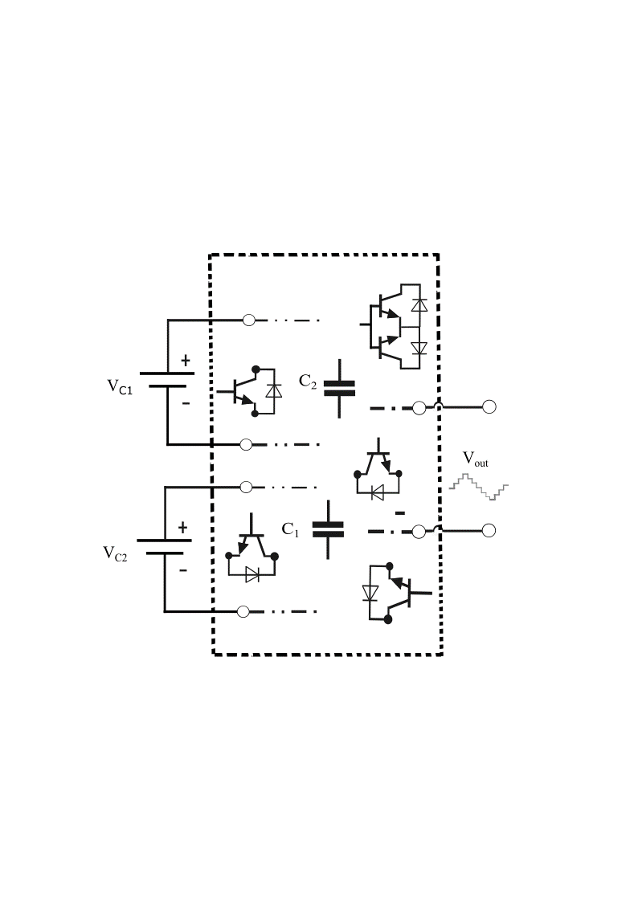

Fig.1 The general conceptual asymmetric MLIs with capacitors

Fig.1 shows a general conceptual diagram of multilevel inverters. A suitable design of power converter can achieve maximum output levels from two DC sources. It is possible to use capacitors to create some extra DC links to get more levels than expected. In this kind of configuration, the charging path of capacitors should be provided in addition to the output levels paths. It would be more complicated to use an additional circuit for the charging of capacitors.

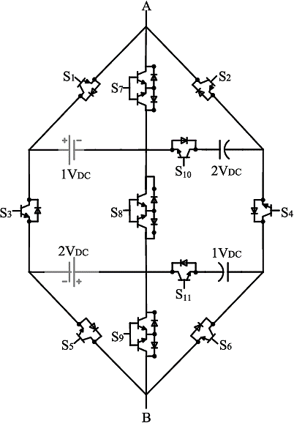

Fig. 2 The Existing system topology circuit.

There are two DC sources with different amounts as 1Vdc and 2 Vdc. Using unequal DC sources for asymmetric multilevel inverters produces different number of output voltage levels by fewer semiconductors and lower harmonic components as well. It would be better to create two extra DC links with capacitors. It gives four DC links, in total. Fig.2 introduces the existing system with a new component arrangement including 14 switches (8 unidirectional switches and 3 bidirectional switches), 14 diodes and 2 unequal DC sources and 2 capacitors. This configuration generates six positive levels, six negative levels and zero level (13 levels total). The shape of the existing topology is like a Kite, and it is named “K-Type” (Kite Type). The main concept of this circuit is creating different paths from different sides of a DC link to be connected to other DC links to create negative levels to remove H-bridge. It is noticeable that DC source with 1 Vdc charges the capacitor with 1 Vdc , and DC source with 2 Vdc charges the capacitor with 2 Vdc without any additional circuit. Fig.3 and Table 1 show switching patterns of the output levels in the proposed structure. The designing of the module and their switching paths are selected smartly in such a way that there is no positive pole of DC links on the anode side of diode to conduct. In addition, Fig.3 depicts the switching paths that do not form any close loop for DC links. Thus, diodes polarity and bidirectional switches guarantee for suppressing of switches that short-circuiting will be not occurred in the module.

**2.2 EXISTING SYSTEM SWITCHING CONFIGURATION**

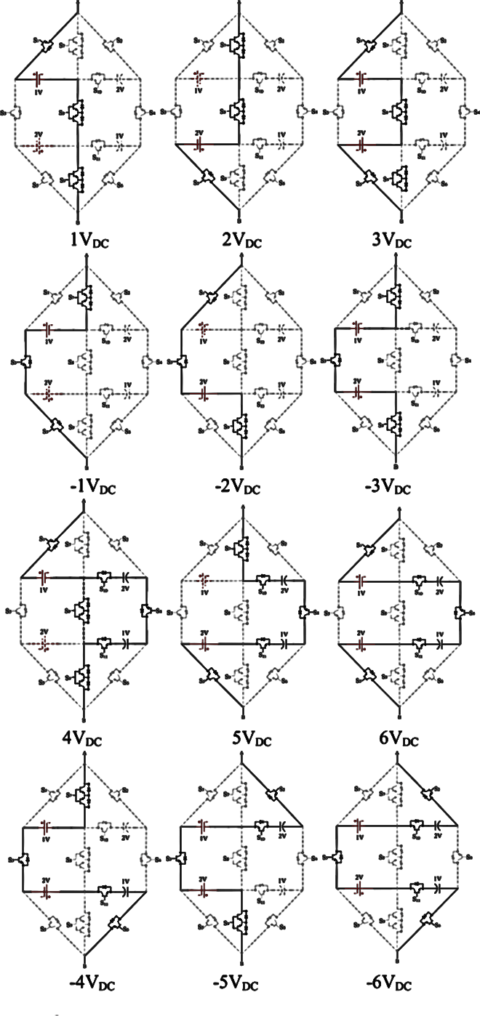

Fig. 3 The switching states of the existing module.

**2.3 EXISTING SYSTEM SWITCHING TABLE**

|  |  |  |  |  |  |  |  |  |  |  |  |
| --- | --- | --- | --- | --- | --- | --- | --- | --- | --- | --- | --- |
|  | **S1** | **S2** | **S3** | **S4** | **S5** | **S6** | **S7** | **S8** | **S9** | **S10** | **S11** |
| **6VDC** | 1 | 0 | 0 | 1 | 1 | 0 | 0 | 0 | 0 | 1 | 1 |
| **5VDC** | 0 | 0 | 0 | 1 | 1 | 0 | 1 | 0 | 0 | 1 | 1 |
| **4VDC** | 1 | 0 | 0 | 1 | 0 | 0 | 0 | 0 | 1 | 1 | 1 |
| **3VDC** | 1 | 0 | 0 | 0 | 1 | 0 | 0 | 1 | 0 | 0 | 0 |
| **2VDC** | 0 | 0 | 0 | 0 | 1 | 0 | 1 | 1 | 0 | 0 | 0 |
| **1VDC** | 1 | 0 | 0 | 0 | 0 | 0 | 0 | 1 | 1 | 0 | 0 |
| **-1VDC** | 0 | 0 | 1 | 0 | 1 | 0 | 1 | 0 | 0 | 0 | 0 |
| **-2VDC** | 1 | 0 | 1 | 0 | 0 | 0 | 0 | 0 | 1 | 0 | 0 |
| **-3VDC** | 0 | 0 | 1 | 0 | 0 | 0 | 1 | 0 | 1 | 0 | 0 |
| **-4VDC** | 0 | 0 | 1 | 0 | 0 | 1 | 1 | 0 | 0 | 0 | 1 |
| **-5VDC** | 0 | 1 | 1 | 0 | 0 | 0 | 0 | 0 | 1 | 1 | 0 |
| **-6VDC** | 0 | 1 | 1 | 0 | 0 | 1 | 0 | 0 | 0 | 1 | 1 |

Table 1: Switching table for existing System.

**2.4 EXISTING SYSTEM SWITCHING PATTERNS**

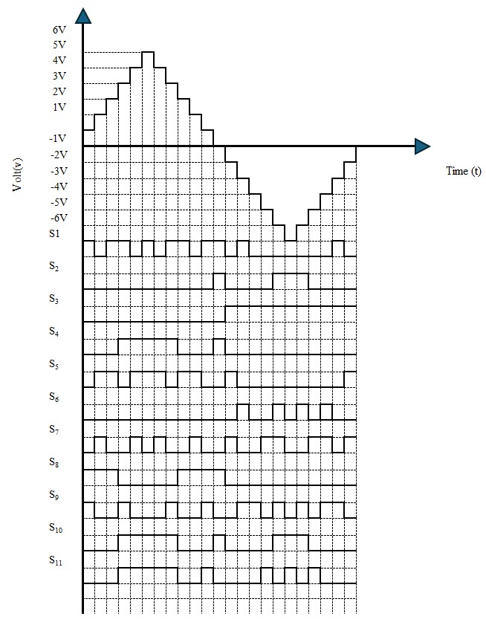

Fig.4 switching pattern inverter in one-cycle.

This existing system with a new component arrangement including 14 switches (8 unidirectional switches and 3 bidirectional switches), 14 diodes and 2 unequal DC sources and 2 capacitors. This configuration generates six positive levels, six negative levels and zero level (13 levels total).

**2.5 EXISTING SYSTEM SIMULATION RESULTS**

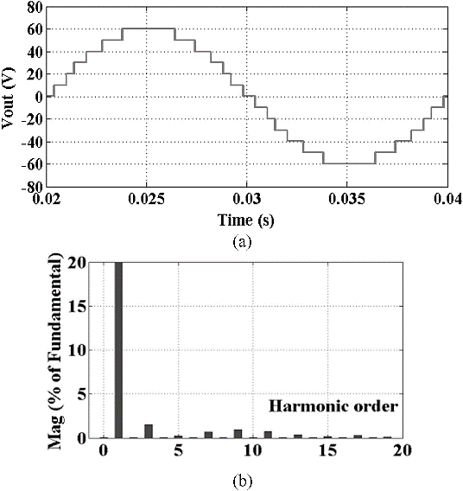

Fig.5 The waveform of output Voltage (simulation)

**2.6 EXISTING SYSTEM HARDWARE RESULT**

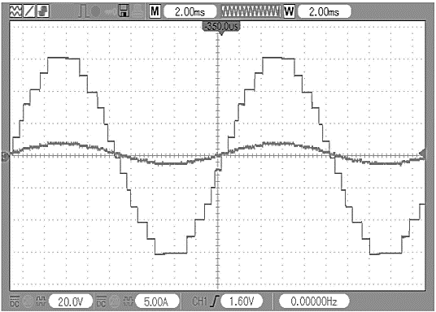

volt (v)

time (t)

Fig.6 The waveform of output Voltage (Hardware)

**2.7 EXISTING SYSTEM OVERVIEW**

This System is for multilevel inverters to produce 13 levels by two DC sources. This multilevel is designed based on two back-to-back T-Type modules with some switches around them. The existing System is named K-Type. The configuration of K-type provides two extra DC links by capacitors (as the virtual DC supply) to achieve more levels to create staircase waveform. This System needs more components including two DC sources, two capacitors, and 14 semiconductors. Since it requires a greater number of components, it is not a more efficient system in converting DC sources to AC source with 13-Level. can also be easily modularized in two strategies in cascade arrangements to form high voltage outputs with low stress on semiconductors and lowering the number of devices.

**2.8 EXISTING SYSTEM DISADVANTAGES**

The main disadvantage of the existing system is this system uses a greater number of switches for the inverter circuit which will lead to more cost in production and leads to the larger space occupancy. And these disadvantages lead to the main loss on the cost where the component used in the system is more expensive and it will take up lots of space in the circuit.

**CHAPTER 3**

**PROPOSED SYSTEM**

**3.1 PROPOSED TOPOLOGY CIRCUIT**

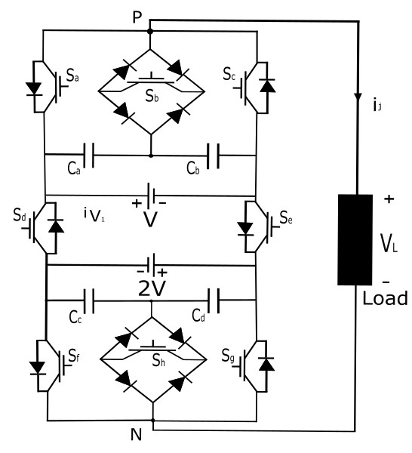

Fig.7 proposed inverter circuit.

This proposed system is for multilevel inverters to produce 13 levels by two DC sources. This multilevel is designed based on two back-to-back T-Type modules with some switches around them. This System is named T-Type. The configuration of T-type provides two extra DC links by capacitors (as the virtual DC supply) to achieve more levels to create staircase waveform. This System needs lesser components compared with the existing system which includes two DC sources, two capacitors, 14 semiconductors and with only 8 switches.

**3.2 PROPOSED TOPOLOGY SWITCHING PATH**

**POSITIVE SEQUENCE**

|  |  |
| --- | --- |
|  |  |
| Output Voltage Vo = 3V | Output Voltage Vo = 2.5V |
|  |  |
| Output Voltage Vo = 2V | Output Voltage Vo = 2V |

|  |  |
| --- | --- |
|  |  |
| Output Voltage Vo = 1.5V | Output Voltage Vo = V |
|  |  |
| Output Voltage Vo = V | Output Voltage Vo = 0.5V |

**NEGATIVE SEQUENCE**

|  |  |
| --- | --- |
|  |  |
| Output Voltage Vo = -0.5 V | Output Voltage Vo = -V |
|  |  |
| Output Voltage Vo = -V | Output Voltage Vo = -1.5V |

|  |  |
| --- | --- |
|  |  |
| Output Voltage Vo = -2V | Output Voltage Vo = -2V |
|  |  |
| Output Voltage Vo = -2.5V | Output Voltage Vo = -3V |

**ZERO SEQUENCE**

|  |  |
| --- | --- |
|  |  |
| Output Voltage Vo = 0V | Output Voltage Vo = 0V |

Table: 2. The switching states of the proposed module.

A pole of the proposed 13-LDT topology encompasses eight switches, as shown in Fig.1. It consists of two three-level T-type sections, two isolated dc voltage sources V, 2V, four capacitors , , , and two switches and Each T-type section includes two bidirectional switches and which consist of an IGBT embedded in a diode bridge. This configuration has the advantage of reducing the complexity of the system and its cost compared to common-collector or common-emitter solutions. The disadvantage is that three devices are conducting whenever the switch is turned on. In this article, it was decided to minimize the cost since the losses are already low thanks to a low frequency modulation. For the safe operation of the proposed structure, the couples of switches (), (), (), (), (), and () are operated with a suitable dead time to prevent short-circuiting of the dc voltage sources. If the ratio between the voltage sources changes, the number of output voltage levels varies from 9 to 17. More specifically, for the voltage ratio equal to 1/1, 2/1 and 3/1, the corresponding voltage levels generated by the inverter at its output are respectively, 9, 13, and 17. However, by increasing the voltage ratio, the voltage stress on power switches , , and increases, generating an uneven power losses distribution. A good tradeoff between THD, distribution of power losses and number of output voltage levels is achieved by considering 13 voltage levels.

**3.3 PROPOSED TOPOLOGY SWITCHING CONFIGURATION**

|  |  |  |  |  |  |  |  |  |  |
| --- | --- | --- | --- | --- | --- | --- | --- | --- | --- |
| **SC** | **Sa** | **Sb** | **Sc** | **Sd** | **Se** | **Sf** | **Sg** | **Sh** | **Vo** |
| 1 | 1 | 0 | 0 | 0 | 1 | 1 | 0 | 0 | 3V |
| 2 | 0 | 1 | 0 | 0 | 1 | 1 | 0 | 0 | 2.5V |
| 3 | 0 | 0 | 1 | 0 | 1 | 1 | 0 | 0 | 2V |
| 4 | 1 | 0 | 0 | 0 | 1 | 0 | 1 | 0 |
| 5 | 0 | 1 | 0 | 0 | 1 | 0 | 1 | 0 | 1.5V |
| 6 | 1 | 0 | 0 | 0 | 1 | 0 | 0 | 1 | V |
| 7 | 0 | 0 | 1 | 0 | 1 | 0 | 1 | 0 |
| 8 | 0 | 1 | 0 | 0 | 1 | 0 | 0 | 1 | 0.5V |
| 9 | 0 | 0 | 1 | 0 | 1 | 0 | 0 | 1 | 0 |
| 10 | 1 | 0 | 0 | 1 | 0 | 1 | 0 | 0 |
| 11 | 0 | 1 | 0 | 1 | 0 | 1 | 0 | 0 | -0.5V |
| 12 | 0 | 0 | 1 | 1 | 0 | 1 | 0 | 0 | -V |
| 13 | 1 | 0 | 0 | 1 | 0 | 0 | 1 | 0 |
| 14 | 0 | 1 | 0 | 1 | 0 | 0 | 1 | 0 | -1.5V |
| 15 | 1 | 0 | 0 | 1 | 0 | 0 | 0 | 1 | -2V |
| 16 | 0 | 0 | 1 | 1 | 0 | 0 | 1 | 0 |
| 17 | 0 | 1 | 0 | 1 | 0 | 0 | 0 | 1 | -2.5V |
| 18 | 0 | 0 | 1 | 1 | 0 | 0 | 0 | 1 | -3V |

Table 2: Switching table for proposed System.

Switches are operated at the fundamental frequency, to determine the polarity of the output voltage Vo. When is OFF and is ON, the output voltage Vo is positive. Otherwise, the output voltage is negative. Zero-voltage level is obtained by turning on or Table I and Fig. 2 deal with 13 LDT pole switching configurations and corresponding output voltage Vo. Redundant switching combi- nations exist, named as: 3-4, 6-7, 9-10, 12-13, and 15-16, which generates same output voltage. . Thus, the two dc voltage sources are set at V and 2V, and voltages are set respectively at 0.5V, 0.5V, V, V.

**3.4 PROPOSED TOPOLOGY SWITCHING CONFIGURATION**

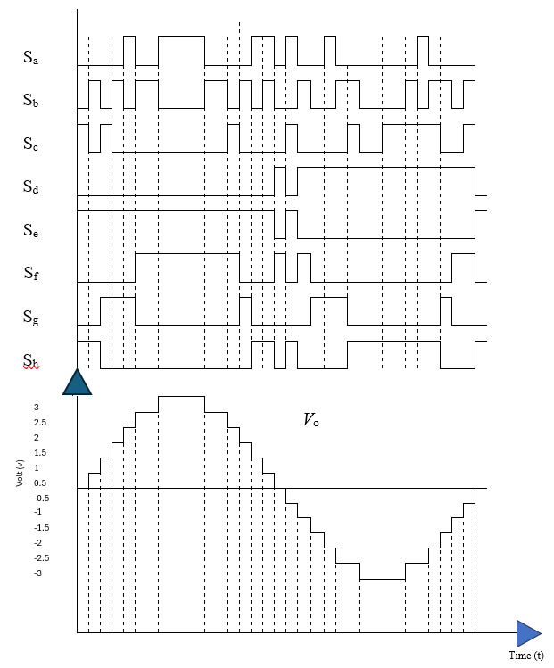

Fig. 9 The switching configuration of the proposed module.

This is the switching configuration for the proposed system. Which denotes the mode of operation of various switches used in the circuits. This switching configuration helps in the formation of 13-Level waveform with the help of the Table 2. Thus, the DC source is converted in the AC source with lesser components count.

**3.5 CAPACITOR VOLTAGE SELF BALANCING**

|  |  |  |  |  |  |  |  |  |  |
| --- | --- | --- | --- | --- | --- | --- | --- | --- | --- |
| **SC** | **Vo** | **ica** | **icb** | **icc** | **icd** | io > 0 | | io < 0 | |
| Discharge | Charge | Discharge | Charge |
| 1 | 3V | 0 | 0 | 0 | 0 | / | / | / | / |
| 2 | 2.5V | io | -io | 0 | 0 | Cb | Ca | Ca | Cb |
| 3 | 2V | 0 | 0 | 0 | 0 | / | / | / | / |
| 4 | 0 | 0 | io | -io | Cd | Cc | Cd | Cc |
| 5 | 1.5V | io | io | -io | -io | CbCd | CaCc | CaCc | Cb Cd |
| 6 | V | 0 | 0 | 0 | 0 | / | / | / | / |
| 7 | 0 | 0 | io | -io | Cd | Cc | Cc | Cd |
| 8 | 0.5V | io | -io | 0 | 0 | Cb | Ca | Ca | Cb |
| 9 | 0 | 0 | 0 | 0 | 0 | / | / | / | / |
| 10 |
| 11 | -0.5V | -io | -io | 0 | 0 | Cb | Ca | Ca | Cb |
| 12 | -V | 0 | 0 | 0 | 0 | Cd | Cc | Cc | Cd |
| 13 | io | -io | 0 | 0 | / | / | / | / |
| 14 | -1.5V | -io | io | -io | io | Cb Cd | CaCc | CaCc | Cb Cd |
| 15 | -2V | 0 | 0 | 0 | 0 | / | / | / | / |
| 16 | 0 | 0 | io | -io | Cd | Cc | Cc | Cd |
| 17 | -2.5V | io | -io | 0 | 0 | / | / | / | / |
| 18 | -3V | 0 | 0 | 0 | 0 | Ca | Cb | Cb | Ca |

Table 3: Switching combinations vs. capacitor currents.

Two pairs of capacitors, and are present in a pole of the 13-LDT inverter. The voltage at the terminals of each pair of capacitors is determined by the two dc power sources. A key feature of this topology is the automatic balancing of the voltage between each pair of capacitors, leading to achieve Fig. 7. Switching frequency of 13-LDT devices versus mNML (fo = 50 Hz). Fig. 8. Output voltage VTHD versus mNML. TABLE II SWITCHING COMBINATIONS VS. CAPACITOR CURRENTS 01 null average capacitor currents in each fundamental period To, without using extra circuits or special modulation techniques. In fact, according to Table 2 and Fig. 8, the capacitors are charged and discharged when the inverter takes specific switching configurations (), as shown in Table II. Due to the symmetry of the output voltage waveform in a fundamental period To, positive and negative voltage levels feature same magnitude at steady state, for the same amount of time, leading to null average capacitors currents.

**3.6 13-LDT THREE-PHASE CONFIGURATIONS**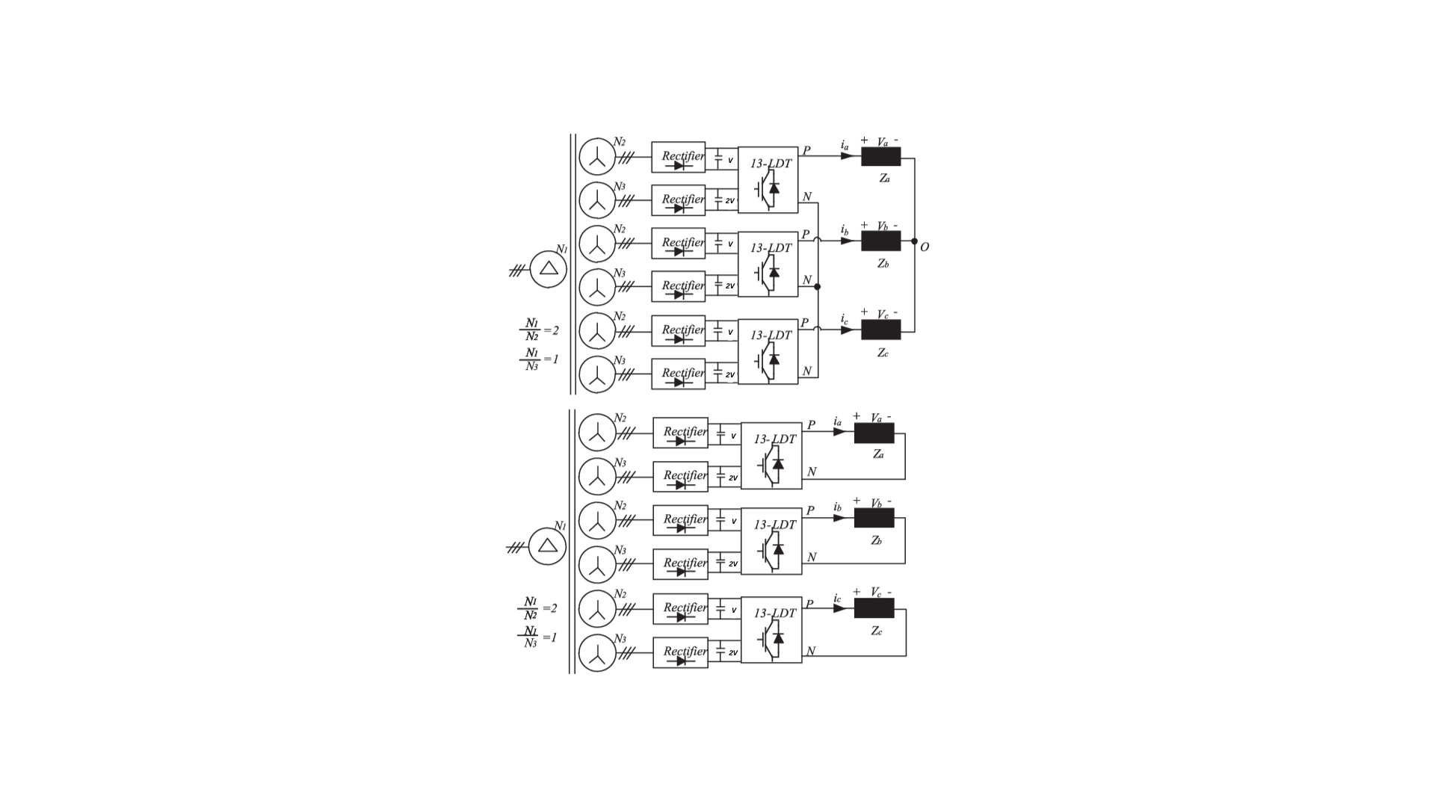

Fig. 10 13-LDT three-phase configurations: up), down) open-end winding.

* 1. **COST ANALYSIS OF THE PROPOSED SYSTEM**

The results obtained in Table 4. must be confirmed by a cost analysis also considering the power system of each configuration. Each isolated independent voltage source needs an ac transformer and an ac/dc rectifier. Thus, in case of more of one isolated voltage sources, more of one ac/dc converter and more windings transformer are needed. Many solutions can be considered about the type of ac transformer. It is possible to use NDC number of transformers or a multilinking transformer with NDC number of windings. However, it has been demonstrated that in case of more than one dc-link input, a multi- winding transformer is more efficient in terms of lower weight, losses, and cost of using more of one two windings transformer, with the same rated power. Even in, the weight of the core and copper versus the number of secondary windings Ncoil have been found and shown in Fig. 11.

Fig. 11. Cost of the transformer

The cost of the transformer that considers only the cost of core and windings, has been obtained by considering the average cost of copper (869 ₹/kg) and core (210 ₹/kg). The minimum cost is obtained for three windings. Table 5. shows the total cost which includes the cost of power switches, power diodes, capacitors, gate drives, ac/dc rectifier and ac transformer. About the ac/dc, a three-phase uncontrolled diode rectifier equipped with 6 power diodes has been considered for each NDC isolated voltage source.

**CHAPTER 4**

**HARDWARE PROPOSED SYSTEM**

**4.1 HARDWARE**

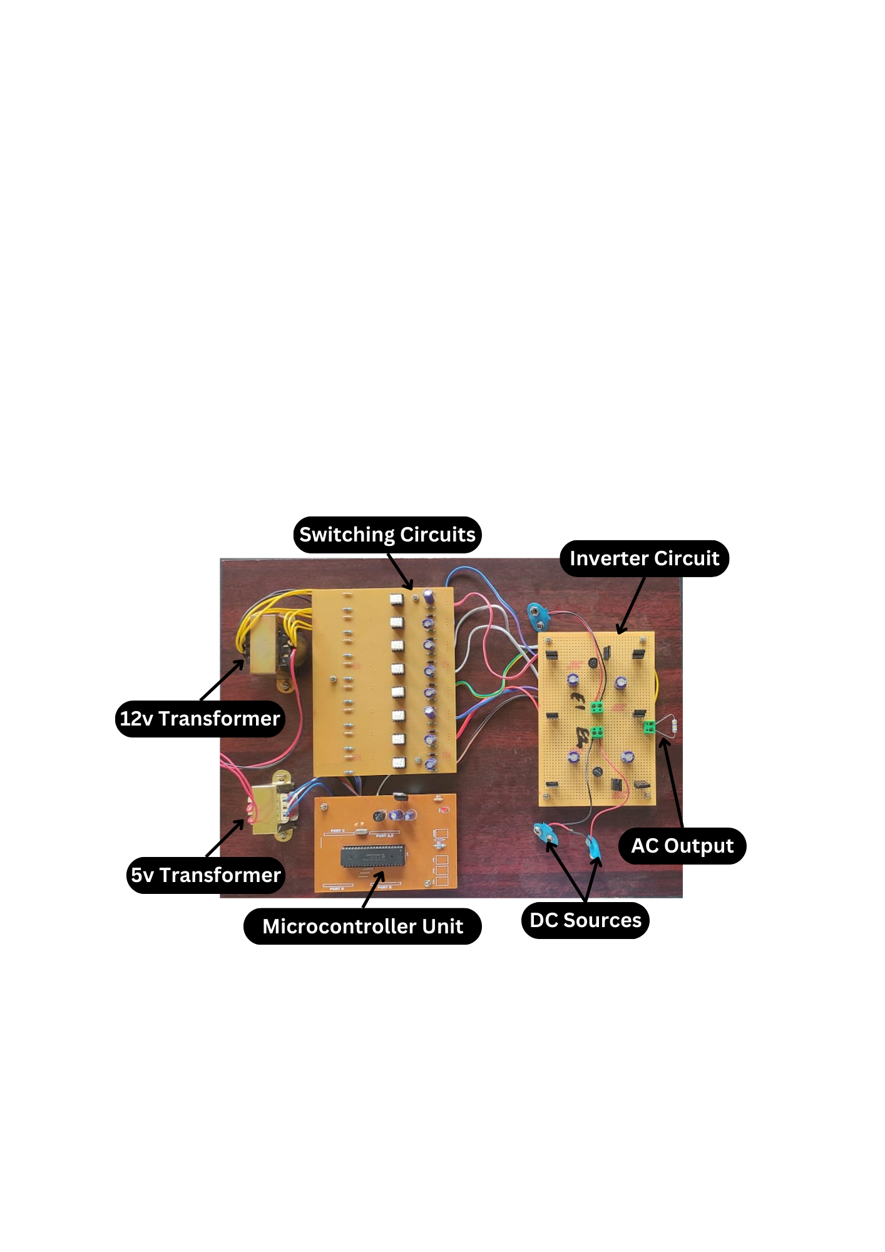

Fig.12 Proposed System Hardware.

**4.2 COMPONENTS**

|  |  |  |
| --- | --- | --- |
| **Sl. No.** | **Components Used** | **Specifications** |
| **1.** | Transformer | 12 volts & 5 volts step-down transformer. |
| **2.** | Pic Microprocessor | PIC16F877A microcontroller |
| **3.** | Capacitor | 400 µf and 450 µf |
| **4.** | Diode | IN4007 |
| **5.** | Resistor | 1k, 5k, 22k resistances |
| **6.** | MOSFET | TLP250 mosfet diver |
| **7.** | SCR | TIC126D |
| **8.** | Wires | Copper Alloy wires |

**TRANSFORMER**

A transformer in a power electronics circuit is a crucial component used for voltage transformation and isolation. It consists of two or more coils of wire wrapped around a magnetic core. In power electronics, transformers are employed to step up or step-down voltage levels to match the requirements of different parts of the circuit or external devices. They enable efficient transmission of electrical energy by changing voltage levels while minimizing losses. Transformers also provide isolation between input and output circuits, ensuring safety and preventing ground loop issues in complex electronic systems. Overall, transformers play a fundamental role in optimizing power distribution and control in various applications within power electronics circuits.

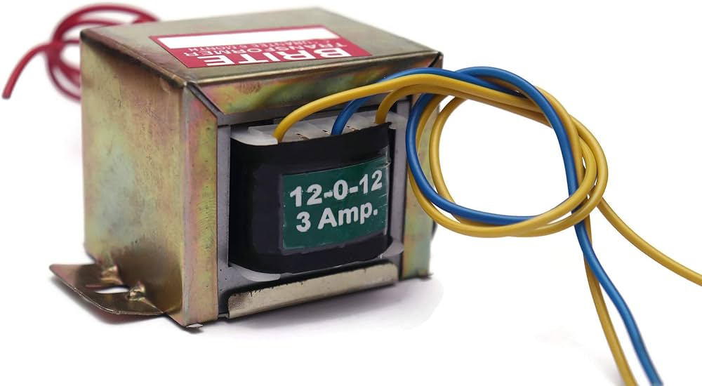

Fig.13 12-volt Transformer.

**PIC MICROCONTROLLER**

The PIC microcontroller, developed by Microchip Technology, is commonly used in power electronics circuits for control, monitoring, and regulation purposes. In power electronics applications, a PIC microcontroller can manage tasks such as generating PWM (Pulse Width Modulation) signals for controlling power switches like MOSFETs or IGBTs, implementing closed-loop control algorithms for voltage or current regulation, and interfacing with sensors for feedback and protection. The PIC microcontroller's versatility, low power consumption, and ease of programming make it suitable for applications ranging from switch-mode power supplies and motor control to renewable energy systems and battery management. Its integration with analog-to-digital converters (ADCs) allows precise measurement of parameters critical for efficient power electronics operation, contributing to improved performance and reliability in various power electronics designs.

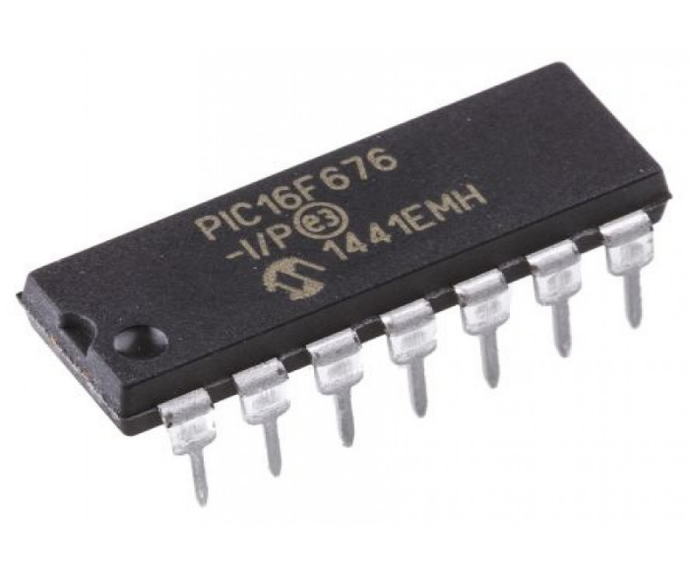

Fig.14 PIC Microcontroller.

**DIODE**

A diode is a fundamental semiconductor device used in power electronics circuits. It consists of a PN junction that allows current to flow in one direction while blocking it in the opposite direction. Diodes are commonly used for rectification, converting AC (alternating current) into DC (direct current) by allowing current to flow during the positive half-cycle of the AC waveform and blocking it during the negative half-cycle. This process results in a unidirectional flow of current. Diodes also find applications in voltage regulation, where they can protect sensitive components from reverse voltage and over-voltage conditions. In power electronics, different types of diodes such as Schottky diodes, Zener diodes, and fast recovery diodes are used based on specific requirements like switching speed, forward voltage drop, and breakdown voltage. Overall, diodes play a critical role in controlling and manipulating electrical currents in power electronics circuits to achieve desired performance and functionality.

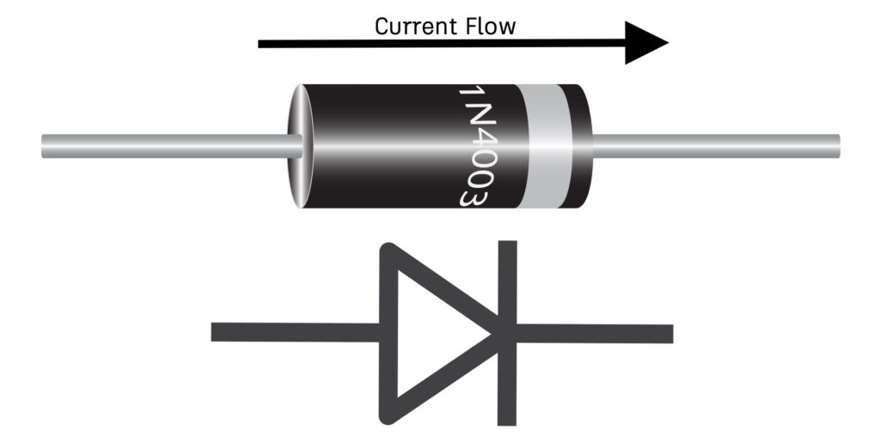

Fig.15 PN Junction Diode.

**CAPACITOR**

A capacitor is a passive electronic component commonly used in power electronics circuits. It consists of two conductive plates separated by an insulating material (dielectric). Capacitors store electrical energy in the form of an electric field. In power electronics, capacitors serve several purposes:

1. **Energy Storage:** Capacitors can store electrical charge and release it when needed, providing a temporary source of energy to smooth out voltage fluctuations or provide bursts of power.
2. **Filtering:** Capacitors are used in filtering circuits to remove noise or ripple from power supplies. They can stabilize voltage levels by filtering out AC components from a DC signal.
3. **Coupling and Decoupling:** Capacitors are used for coupling signals between different stages of a circuit and for decoupling AC signals from DC components, ensuring that only AC signals pass through while blocking DC.
4. **Power Factor Correction:** In power factor correction circuits, capacitors are used to improve the efficiency of electrical systems by offsetting the effects of inductive loads and correcting the phase difference between voltage and current. Capacitors come in various types and sizes, each suited for specific applications based on factors like capacitance value, voltage rating, tolerance, and temperature stability. They are essential components in power electronics for maintaining stability, improving efficiency, and ensuring proper operation of electrical systems.

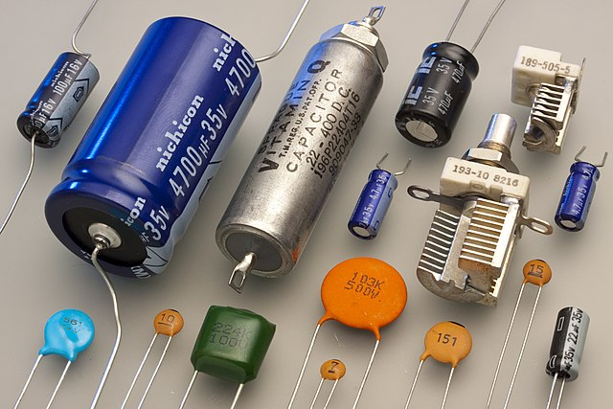

Fig.16. Capacitors.

**SCR – (SILICON CONTROLLED RECTIFIER)**

An SCR (Silicon Controlled Rectifier) is a type of semiconductor device used in power electronics circuits for switching and controlling high currents. It is a four-layer solid-state device with three terminals: Anode (A), Cathode (K), and Gate (G). The SCR behaves like a controllable switch that can conduct current when triggered by a gate signal and remains conducting even after the gate signal is removed until the current through the device drops below a certain threshold (known as the holding current) or the voltage across the SCR reverses.

Key characteristics and uses of SCR in power electronics include:

1. **Switching:** SCR can handle high currents and voltages, making it suitable for switching applications in AC power control, such as in motor speed control, light dimming, and heating control.
2. **Rectification:** SCR can be used for converting AC to DC by controlling the conduction angle of the device, allowing selective passage of AC cycles.
3. **Protection:** SCR devices are used for over-current protection and surge suppression in power circuits, helping to protect sensitive components from voltage spikes and electrical faults.
4. **Thyristor Control:** SCRs are often used in conjunction with other components like diodes and resistors to form complex thyristor-based control circuits for various industrial applications.

The operation of an SCR is governed by its firing characteristics and holding current, making it a versatile and reliable component in power electronics for switching and controlling AC power with high efficiency and reliability.

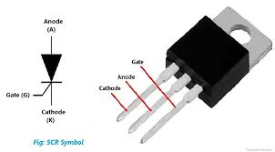

Fig.17. Silicon Controlled Rectifier.

**MOSFET – (METAL-OXIDE-SEMICONDUCTOR FIELD-EFFECT TRANSISTOR)**

A MOSFET is a type of transistor used extensively in power electronics circuits due to its ability to efficiently switch and control large amounts of electrical power. It operates based on the principle of a voltage-controlled switch and consists of three terminals: Gate (G), Drain (D), and Source (S).

Key features and uses of MOSFETs in power electronics include:

1. **Switching:** MOSFETs can rapidly switch on and off in response to gate voltage changes. This switching capability is utilized in applications like motor control, power converters, and voltage regulators.
2. **Low RDS (on):** MOSFETs are available with very low on-resistance (RDS (on)), which minimizes power loss and heat generation during conduction. This makes them suitable for high-efficiency power conversion.
3. **High Current Handling:** MOSFETs can handle high current levels, making them ideal for power electronics applications where significant amounts of electrical power need to be controlled or switched.
4. **Voltage Regulation:** MOSFETs are used in synchronous rectification circuits and DC-DC converters to efficiently regulate voltage levels by controlling the flow of current.
5. **PWM Control:** MOSFETs are often controlled using Pulse Width Modulation (PWM) signals to achieve precise control over power delivery, enabling applications like motor speed control and LED dimming.
6. **Protection Circuits:** MOSFETs can be integrated into protection circuits to safeguard against over-current, over-voltage, and thermal issues in power electronics systems.

Overall, MOSFETs are versatile semiconductor devices that play a critical role in modern power electronics, offering high efficiency, fast switching speeds, and robust performance in various applications ranging from consumer electronics to industrial power systems.

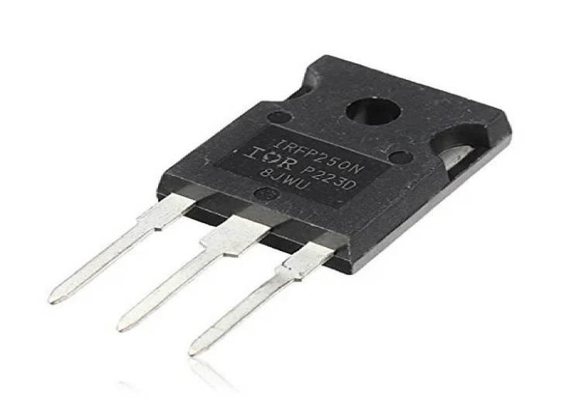

Fig.18. Metal-Oxide-Semiconductor Field-Effect Transistor.

**CHAPTER 5**

**RESULTS AND OUTPUT**

**5.1 HARDWARE RESULT**

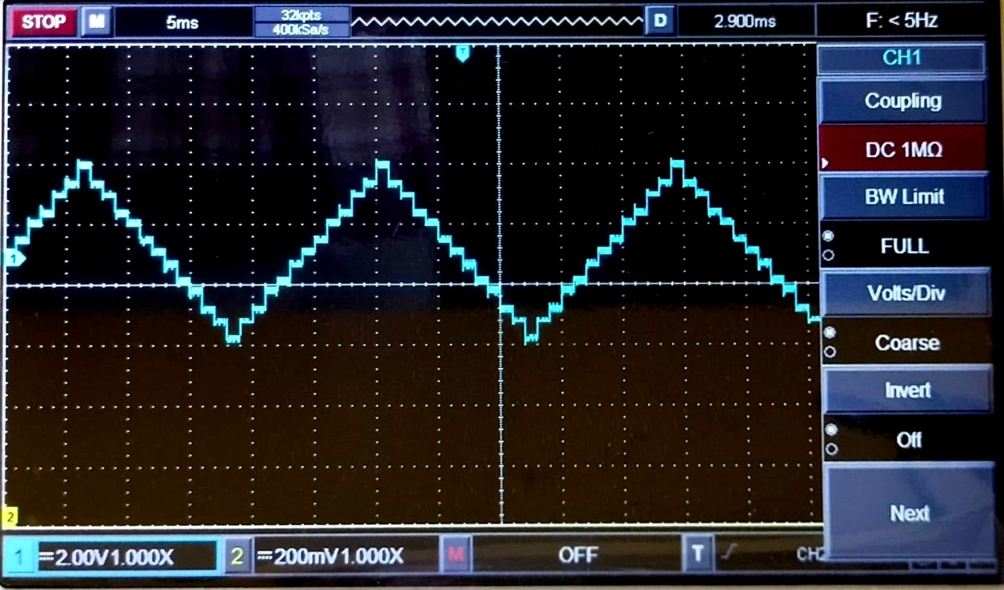time (t)

volt (v)

Fig.19. Output voltage from the Hardware.

In the realm of hardware testing and analysis, the utilization of a CRO (Cathode Ray Oscilloscope) proves invaluable for visualizing and interpreting complex signals, particularly in scenarios where the output exhibits a distinctive 13-level pattern. A CRO, known for its ability to display waveforms in real-time, becomes a pivotal tool for capturing and analyzing such intricate results.

When dealing with a 13-level output displayed on a CRO, each level signifies a specific amplitude or voltage level within the signal. This pattern can indicate various aspects of the underlying signal's characteristics, such as digital data encoding, multilevel modulation techniques, or discrete voltage states in an analog system.

To effectively analyze a 13-level output using a CRO, technicians and engineers carefully observe the waveform's shape and amplitude distribution across the screen. The CRO's high-resolution display facilitates precise measurement of voltage levels and helps identify any abnormalities or distortions within the signal.

Moreover, the CRO's triggering capabilities enable synchronization with the input signal, allowing for stable and repeatable waveform observation. This synchronization is crucial for accurately capturing and analyzing signals that exhibit specific patterns or timing requirements.

**5.2 SIMULATION RESULT**

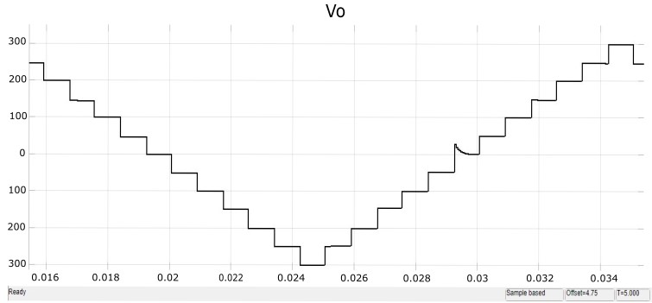

Fig.20. Output voltage from the Simulation.

Simulation results displayed in a scope within MATLAB software provide valuable insights into the behaviour and performance of complex systems, particularly in power electronics applications such as multi-level inverters. When simulating a 13-level output using MATLAB, the scope visualization becomes a crucial tool for analysing waveform characteristics and validating the effectiveness of control strategies.

In the context of a 13-level output simulation, the scope graph reveals intricate details of the output voltage waveform, showcasing the smooth transitions between voltage levels and the overall waveform quality. Each level represents a distinct voltage state, and the scope enables engineers to assess parameters like voltage ripple, harmonic content, and switching behaviour.

The simulation results depicted in the MATLAB scope can be used to optimize control algorithms, refine modulation techniques, and troubleshoot circuit issues. Engineers can observe real-time responses and make informed adjustments to enhance system performance and efficiency.

Furthermore, analysing simulation results in the scope facilitates the validation of theoretical models against practical outcomes, aiding in the development of robust and reliable power electronics systems. By leveraging MATLAB's simulation capabilities and visualization tools, engineers can accelerate the design process and achieve optimized solutions for complex 13-level power conversion challenges.

Top of Form

2

**CHAPTER 6**

**CONCLUSIONS**

In conclusion, the development of a novel 13-level inverter topology with reduced component count and built-in self-balancing capability represents a significant advancement in power electronics technology, particularly for electric vehicle (EV) applications. By streamlining the design and integration of innovative self-balancing features, this topology offers several key benefits. First, the reduction in component count leads to cost savings, reduced size, and improved efficiency, addressing some of the key challenges associated with traditional multi-level inverters. This makes the technology more accessible and practical for widespread adoption in EV powertrains. Secondly, the built-in self-balancing capability enhances operational stability and reliability by ensuring voltage balance across the inverter's output phases without the need for external control mechanisms. This simplifies the design process and contributes to overall system robustness, critical factors for EV performance and safety.

Furthermore, the topology's feasibility and effectiveness have been validated through comprehensive simulation and experimental studies, demonstrating its potential for real-world EV applications. Its compatibility with existing EV infrastructure and compatibility with sustainable energy sources further underline its importance in advancing the transition towards sustainable transportation.

The novel 13-level inverter topology represents a promising solution for improving the efficiency, reliability, and compactness of power electronics in electric vehicles. Its development underscores the importance of innovation and research in addressing the evolving needs of the automotive industry while contributing to the broader goals of sustainability and environmental protection. As EV technology continues to evolve, the adoption of advanced power electronics solutions like this topology will play a crucial role in shaping the future of transportation towards a cleaner, more sustainable future.

**REFERENCES**

A. Poorfakhraei, M. Narimani, and A. Emadi, “A review of multilevel

inverter topologies in electric vehicles: Current status and future trends,”

IEEE Open J. Power Electron., vol. 2, pp. 155–170, 2021.

J.-S. Lai and F. Z. Peng, “Multi-level converters-a new breed of

power converters,” IEEE Trans. Ind. Appl., vol. 32, no. 3, pp. 509–517,

May/Jun. 1996.

P.M. Bhagwatand V.R.Stefanovic,“Generalized structure of a multi-level

PWM inverter,” IEEE Trans. Ind. Appl., vol. IA-19, no. 6, pp. 1057–1069,

Nov. 1983.

J. Rodriguez, J.-S. Lai, and F. Z. Peng, “Multilevel inverters: A survey of

topologies, controls, and applications,” IEEE Trans. Ind. Electron., vol.49,

no. 4, pp. 724–738, Aug. 2002.

S. Kuro et al., “Recent advances and industrial applications of multilevel

converters,” IEEE Trans. Ind. Electron., vol. 57, no. 8, pp. 2553–2580,

Aug. 2010.

S. Foti et al., “Overvoltage mitigation in open-end winding AC mo

tor drives,” in Proc. Int. Conf. Renewable Energy Res. Appl., 2015,

pp. 238–245.

S. De Caro et al., “Over-voltage mitigation on SiC based motor drives

through an open-end winding configuration,” in Proc. IEEE Energy Con

vers. Congr. Expo., 2017, pp. 4332–4337.

R. Mecke, “Energy efficiency of two-level and multilevel inverters-A

drive system comparison,” in Proc. 17th Eur. Conf. Power Electron. Appl.,

2015, pp. 1–8.

P. Omer, J. Kumar, and B. S. Surjan, “A review on reduced switch count

multilevel inverter topologies,” IEEE Access, vol. 8, pp. 22281–22302,

2020.

A. Salem, H. Van Khang, K. G. Robbersmyr, M. Norambuena, and J.

Rodriguez, “Voltage source multi-level inverters with reduced device count:

Topological review and novel comparative factors,” IEEE Trans. Power

Electron., vol. 36, no. 3, pp. 2720–2747, Mar. 2021.

K.K.Gupta,A.Ranjan, P. Bhatnagar, L. K. Sahu, and S. Jain, “Multilevel

inverter topologies with reduced device count: A review,” IEEE Trans.

Power Electron., vol. 31, no. 1, pp. 135–151, Jan. 2016.

N. Thitichaiworakorn, M. Hagiwara, and H. Akagi, “Experimental verify

cation of a modular multilevel cascade inverter based on double star bridge

cells,” IEEE Trans. Ind. Appl., vol. 50, no. 1, pp. 509–519, Jan./Feb. 2014.

M. Hagiwara, K. Nishimura, and H. Akagi, “A medium-voltage motor

drive with a modular multilevel PWM inverter,” IEEE Trans. Power

Electron., vol. 25, no. 7, pp. 1786–1799, Jul. 2010.

J. Mei, B. Xiao, K. Shen, L. M. Tolbert, and J. Y. Zheng, “Modular

multilevel inverter with new modulation method and its application to

photovoltaic grid-connected generator,” IEEE Trans. Power Electron.,

vol. 28, no. 11, pp. 5063–5073, Nov. 2013.

A. Viatkin, M. Ricco, R. Mandrioli, T. Kerekes, R. Teodorescu, and G.

Grandi, “Sensorless current balancing control for interleaved half-bridge

Submodules in modular multi-level converters,” IEEETrans.Ind.Electron.,

vol. 70, no. 1, pp. 5–16, Jan. 2023.

A. Viatkin, M. Ricco, R. Mandrioli, T. Kerekes, R. Teodorescu, and

G. Grandi, “A novel modular multilevel converter based on interleaved

half-bridge submodules,” IEEE Trans. Ind. Electron., vol. 70, no. 1,

pp. 125–136, Jan. 2023.

Y. Ye, G. Zhang, J. Huang, S. Chen, and X. Wang, “Comparative analysis

of hybrid NPP and NPC seven-level inverter with switched-capacitor,”

IEEE Access, vol. 9, pp. 85852–85863, 2021.

J. I. Guzman et al., “Digital implementation of selective harmonic elimi

nation techniques in modular current source rectifiers,” IEEE Trans. Ind.

Inf., vol. 9, no. 2, pp. 1167–1177, May 2013.

B. Badrzadeh and M. Gupta, “Practical experiences and mitigation meth

ods of harmonics in wind power plants,” IEEE Trans. Ind. Appl., vol. 49,

no. 5, pp. 2279–2289, Sep./Oct. 2013.

M. S. A. Dahidah and V. G. Agelidis, “Selective harmonic elimina

tion PWM control for cascaded multi-level voltage source converters:

A generalized formula,” IEEE Trans. Power Electron., vol. 23, no. 4,

pp. 1620–1630, Jul. 2008.