NON-INVASIVE BLOOD GLUCOSE DETECTION USING RF BASED BIOSENSOR

1. **Executive Summary of the proposed research topic**

Non-Invasive Blood Glucose Detection using RF-Based Biosensor. This research project investigates the potential of Radio Frequency (RF) technology for creating a non-invasive blood glucose monitoring system. Currently, diabetic patients rely on finger pricking to draw blood samples for glucose testing. This method is painful and inconvenient, leading to difficulties with consistent monitoring. An RF-based biosensor offers a promising alternative for painless and continuous glucose level detection.

The core principle lies in the fact that the dielectric properties of blood correlate with glucose concentration. The sensor utilizes radio waves to interact with the target tissue. As the blood sugar level changes, the electrical properties of the tissue are altered, causing a shift in the RF signal. This shift can then be measured and correlated to the glucose concentration. The research explores the design and testing of an RF biosensor for non-invasive blood glucose detection. The project likely involves,

* Development of an RF sensor prototype using technologies like microstrip patch antennas such as metamaterial structure.
* Experimentation with different operating frequencies to optimize signal penetration and sensitivity.
* Calibration of the sensor's response using solutions with varying glucose concentrations.
* Potential use of microfluidic channels mimicking blood vessels for sensor validation.

The successful development of this technology would revolutionize diabetic care. A non-invasive biosensor would enable,

* Painless and continuous glucose monitoring.
* Improved management of blood sugar levels.
* Reduced risk of complications associated with diabetes.

The research holds significant promise for the future of diabetes management. By eliminating the need for finger pricking, this technology could significantly improve patient compliance and quality of life. Further details to explore,

* The specific type of RF sensor employed (e.g., metamaterial patch antenna).
* The operating frequency ISM band range chosen for the sensor.
* The achieved sensitivity and accuracy of the blood glucose detection.
* The long-term stability and feasibility of the biosensor for real-world application.

1. **Proposed Solution**

The proposed solution introduces a novel approach to non-invasive blood glucose monitoring utilizing an RF-based biosensor comprising Four Complementary Split Ring Resonators (CSRRs) on a Rogers RO4003C substrate, operating within the 2.4 GHz ISM band. By placing a finger on the sensing elements, changes in S-Parameter magnitude concentration are observed and correlated with blood glucose levels typical of type 2 diabetes, ranging from 0 to 300 mg/dl, following the Cole-Cole model.

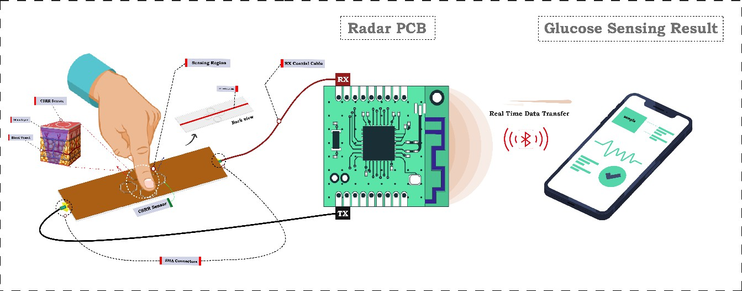

Figure 1. Proposed Non-Invasive RF microwave Sensor for Glucose monitoring

This innovative method aims to overcome the limitations of invasive and minimally invasive techniques, offering a more comfortable and convenient alternative for individuals with diabetes. Figure 1 shows the Proposed Non-Invasive RF microwave Sensor for Glucose monitoring. The development of a blood glucose detection kit based on this technology represents a significant advancement in diabetes management, potentially improving the quality of life for patients by providing accurate, continuous, and non-invasive monitoring.

If successful, this solution could revolutionize how blood glucose levels are monitored, leading to better disease management, reduced complications, and enhanced overall health outcomes for individuals living with diabetes. Additionally, its accessibility and ease of use could empower patients to take more proactive control of their health, ultimately contributing to improved long-term prognosis and well-being.

1. **Target users**

Targets individuals managing diabetes, particularly those who currently rely on invasive methods for glucose testing. These individuals often face inconvenience and discomfort due to the pain and slow healing associated with frequent testing. The target market also includes healthcare providers who seek accurate and reliable monitoring tools to enhance patient care. By offering a more comfortable and convenient alternative to traditional methods, the solution addresses the unmet needs of both patients and healthcare professionals, ultimately improving the monitoring experience and overall management of diabetes.

1. **Novelty**

Blood glucose monitoring by utilizing an RF-based biosensor with Four Complementary Split Ring Resonators. Operating within the 2.4 GHz ISM band, this non- invasive method correlates S-Parameter magnitude concentration with blood glucose levels, offering a comfortable and effective alternative to traditional invasive techniques. We took a different types of finger analysis, because people having a different types of body structures, so these analysis help us to precisely show the glucose level. The business model involves designing, producing, and distributing the RF-based biosensor and its monitoring kit for blood glucose levels. Revenue comes from direct sales to individuals and healthcare institutions. Expansion strategies include licensing agreements, partnerships with medical device firms, and subscription services for continuous monitoring, aiming for profitability and market sustainability.