- Using alert & HTML:

<html>
<head>
<script src="https://ajax.googleapis.com/ajax/libs/jquery/3.5.1/jquery.min.js"></script>
<script>
$(document).ready(function(){
$("#b1").click(function(){
alert("Text: " + $("#hai").text());
});
$("#b2").click(function(){
alert("HTML: " + $("#hai").html());
});
});
</script>
</head>
<body>
<p id="hai">This is some <b>bold</b> hello text.</p>
<button id="b1">click</button>
<button id="b2"> click </button>
</body>
</html>

Output:

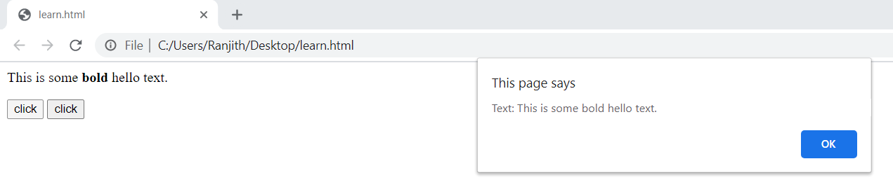

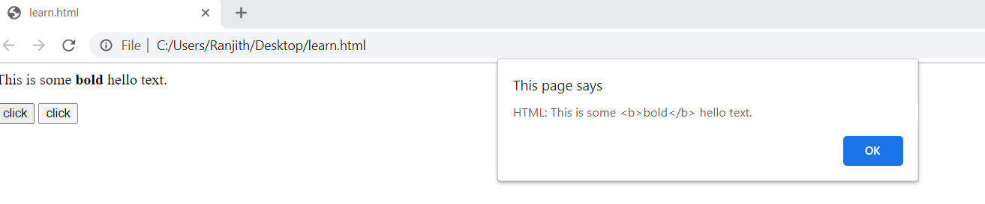

- Using alert:

<html>
<head>
<script src="https://ajax.googleapis.com/ajax/libs/jquery/3.5.1/jquery.min.js"></script>
<script>
$(document).ready(function(){
$("button").click(function(){
alert("Value: " + $("#t1").val());
});
});
</script>
</head>
<body>
<p>Name: <input type="text" id="t1" value="students"></p>
<button>Show Value</button>
</body>
</html>

Output:

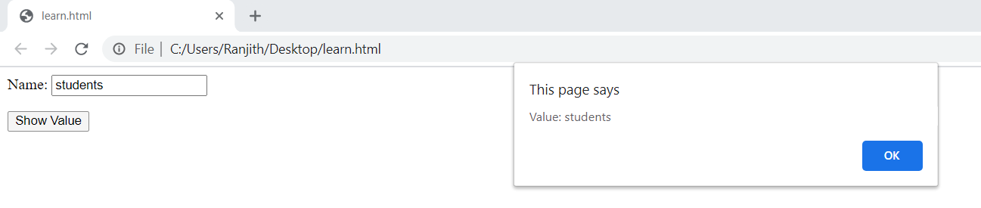

3)
<html>
<head>
<script src="https://ajax.googleapis.com/ajax/libs/jquery/3.5.1/jquery.min.js"></script>
<script>
$(document).ready(function(){
$("#b1").click(function(){
$("#t1").text("Hello world!");
});
$("#b2").click(function(){
$("#t2").html("<b>Hello world!</b>");
});
$("#b3").click(function(){
$("#t3").val("jolly jolly");
});
});
</script>
</head>
<body>
<p id="t1">This is a text.</p>
<p id="t2">This is another text.</p>
<p>Input field: <input type="text" id="t3" value="jolly "></p>
<button id="b1">Set Text</button>
<button id="b2">Set HTML</button>
<button id="b3">Set Value</button>
</body>
</html>

Output:
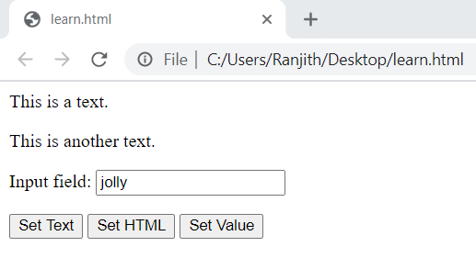

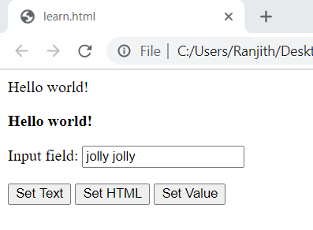

4.Using Append:

<html>
<head>
<script src="https://ajax.googleapis.com/ajax/libs/jquery/3.5.1/jquery.min.js"></script>
<script>
function appendText() {
var txt1 = "<p>Text.</p>";
var txt2 = $("<p></p>").text("Text.");
var txt3 = document.createElement("p");
txt3.innerHTML = "Text.";
$("body").append(txt1, txt2, txt3); }
</script>
</head>
<body>
<button onclick="appendText()">Append</button>
</body>
</html>

Output:
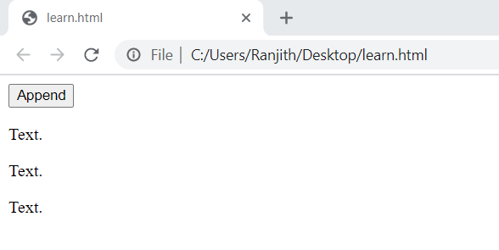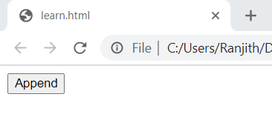

5.Using Remove:

<html>
<head>
<script src="https://ajax.googleapis.com/ajax/libs/jquery/3.5.1/jquery.min.js"></script>
<script>
$(document).ready(function(){
$("button").click(function(){
$("p").remove(".t1");
});
});
</script>
<style>
.t1{
color: red;
font-size: 20px;
}
</style>
</head>
<body>
<p>This is a paragraph.</p>
<p class="t1">This is another text.</p>
<p class="t1">This is another text .</p>
<button>Remove</button>
</body>
</html>

Output:
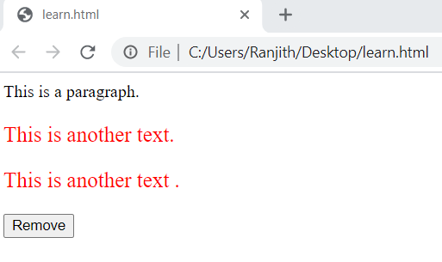
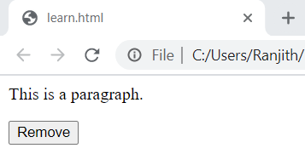

- Using addClass:
<html>
<head>
<script src="https://ajax.googleapis.com/ajax/libs/jquery/3.5.1/jquery.min.js"></script>
<script>
$(document).ready(function(){
$("button").click(function(){
$("h1, h2, p").addClass("blue");
$("div").addClass("important");
});
});
</script>
<style>
.important {
font-weight: bold;
font-size: xx-large;
}
.blue {
color: blue;
}
</style>
</head>
<body>
<h1>Heading 1</h1>
<h2>Heading 2</h2>
<p>This is a paragraph.</p>
<p>This is another paragraph.</p>
<div>This is some important text!</div><br>
<button>Add classes to elements</button>
</body>
</html>

Output:
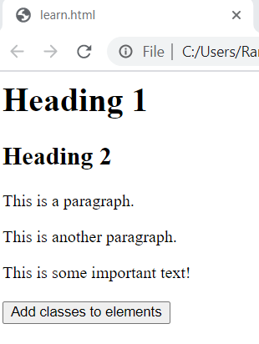

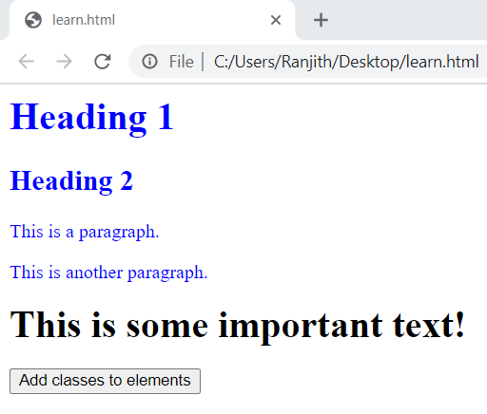

7: <html>
<head>
<script src="https://ajax.googleapis.com/ajax/libs/jquery/3.5.1/jquery.min.js"></script>
<script>
$(document).ready(function(){
$("button").click(function(){
var txt = "";
txt += "Width of div: " + $("#div1").width() + "</br>";
txt += "Height of div: " + $("#div1").height() + "</br>";
txt += "Inner width of div: " + $("#div1").innerWidth() + "</br>";
txt += "Inner height of div: " + $("#div1").innerHeight();
$("#div1").html(txt);
});
});
</script>
</head>
<style>
#div1 {
height: 100px;
width: 300px;
padding: 10px;
margin: 3px;
border: 1px solid blue;
background-color:lime;
}
</style>
<body>
<div id="div1"></div>
<br>
<button>Display</button>
</body>
</html>

Output:

