1. Examples of Healthcare Analytics:

* Predictive Analytics for disease outbreaks.
* Patient readmission rate analysis.
* Health economic analysis for cost optimization.
* Clinical decision support systems.
* Patient segmentation for personalized treatments.

2. Importance of Data Standards in Healthcare:

Data standards ensure consistency and interoperability in healthcare data. They facilitate seamless data exchange between different systems, improve data accuracy, and support better decision-making. Standardized data also enhances patient safety and enables effective research and analysis.

3. Purpose of Using Data Standards in Healthcare:

The purpose of using data standards in healthcare is to establish uniformity and consistency in data formats and structures. By adhering to these standards, healthcare organizations can ensure that patient information is accurately recorded, easily shared, and interpreted uniformly across various systems and applications. This consistency enhances the quality of care and simplifies administrative processes.

4. Benefits of a Machine Learning Pipeline:

* Automation: Streamlines the process from data preprocessing to model deployment.
* Efficiency: Automates repetitive tasks, saving time and effort.
* Reproducibility: Ensures consistent results by documenting the entire workflow.
* Scalability: Adaptable to handle large datasets and complex models.
* Optimization: Allows for fine-tuning of models and parameters for better performance.

5. Comparison of Filter and Wrapper Methods in Feature Selection:

* Filter Methods: Select features based on their statistical properties, such as correlation or mutual information with the target variable. They are computationally efficient but might overlook feature interactions.
* Wrapper Methods: Evaluate feature subsets using a specific machine learning algorithm, selecting the subset that yields the best model performance. They consider feature interactions but can be computationally intensive and prone to overfitting.

6. Why Sensitivity/Specificity Are Meaningless Statistics for a Clinician:

Sensitivity and specificity are important metrics in diagnostics, but they don't provide a complete picture of a test's performance. Clinicians need information about the likelihood of a positive or negative result being correct, which is expressed through positive predictive value (PPV) and negative predictive value (NPV).

7. List various factors that affect the IoT healthcare application

* Security and privacy
* Interoperability
* Data quality and accuracy
* Scalability
* Network connectivity

8. State the purpose of using smart sensors in healthcare management.

* Remote patient monitoring
* Early detection of health issues
* Enhanced diagnostics
* Efficient resource utilization

9. What is predictive modelling in healthcare?

Predictive modelling in healthcare refers to the use of statistical algorithms, machine learning techniques, and data analysis to make predictions about future health outcomes, patient behaviors, or trends within the healthcare system.

10. Why do we prefer Convolutional Neural networks (CNN) over Artificial Neural networks (ANN) for image data as input?

* CNNs are designed to recognize spatial hierarchies and local patterns within images.
* CNNs employ parameter sharing, where the same set of weights is used for different parts of the input image.
* CNN architectures are designed to automatically learn hierarchical features from raw pixel values.

11. How would you use mobile analytics for healthcare data?

Mobile analytics in healthcare involves the collection, analysis, and interpretation of data generated by mobile devices and applications. Utilizing mobile analytics in healthcare can offer valuable insights into patient behaviours, improve engagement, enhance care delivery, and optimize overall healthcare processes.

12. Why do healthcare professionals use a Clinical Decision Support System?

Enhanced Decision-Making:

* CDSS assists healthcare professionals in making well-informed and evidence-based decisions.

Improved Patient Outcomes:

* The use of CDSS contributes to improved patient outcomes by promoting adherence to best practices and clinical guidelines.

13. What is the most powerful predictor of mortality for cardiovascular disease?

Left ventricular ejection fraction (LVEF) is the most powerful predictors of mortality for cardiovascular disease. LVEF is a measure of the percentage of blood that is pumped out of the left ventricle of the heart with each contraction. It is a crucial indicator of cardiac function and is commonly assessed through imaging techniques such as echocardiography or cardiac magnetic -resonance imaging (MRI).

14. How does emerging technology affect healthcare?

* Patient engagement and Adherence
* Health and fitness monitoring
* Remote Patient monitoring
* User behaviour analysis

# 1a) Three persons A, B and C apply for a job of Manager in a Private company. Chance of their selection (A, B and C) are in the ratio 1:2:4. The probability that A, B and C can introduce changes to improve profits of company are 0.8,0.5 and 0.3 respectively, if the changes does not take place, find the probability that it is due to the appointment of C.

#### **Let the events be described as below :**

#### **A: No change takes place**

#### **E1: Person A gets appointed**

#### **E2: Person B gets appointed**

#### **E3: Person C gets appointed.**

#### **The chances of selection of A, B and C are in the ratio 1:2:4.**

#### **Hence, P(E1) = 1/7, P(E2) = 2/7, P(E3) = 4/7**

#### **Probabilities of A, B and C introducing changes to improve profits of company are 0.8,0.5 and 0.3 respectively. Hence probability of no changes on appointment of A,B and C are 0.2,0.5 and 0.7 respectively.**

#### **Hence, P(A|E1) = 0.2=210**

#### **P(A|E2) = 0.5=510**

#### **P(A|E3) = 0.7=710**

#### **Therefore, the required probability is**

#### **P(E3|A) = P(A|E3). P (E3)/P(A|E1). P (E1) + P(A|E2). P (E2) + P(A|E3). P (E3)**

#### **(4/7) * (7/10) = --------------------------------------------------------------------**

#### **(1/7) * (2/10) + (2/7) * (5/10) + (4/7) * (7/10)**

#### **28/70 = ---------------------------------------**

#### **(2/70) + (10/70) + (28/70)**

#### **=28/40=7/10**

#### **Therefore, if no change takes place, the probability that it is due to appointment of C is 7/10**

1b) If the test can only diagnose 25 out of the 50 patients and has reported the others as

healthy. Calculate accuracy, sensitivity, and specificity

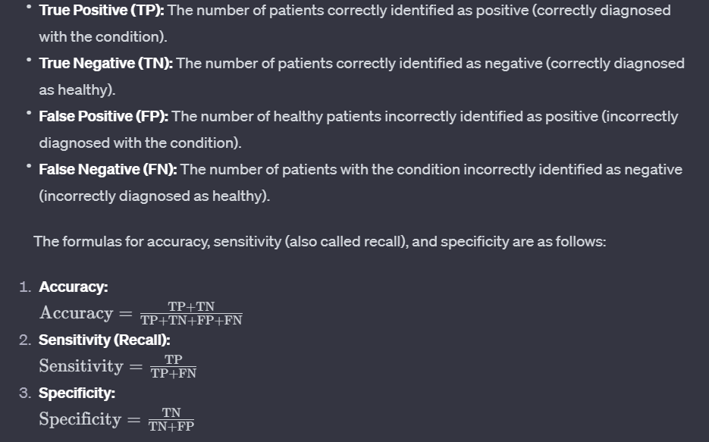

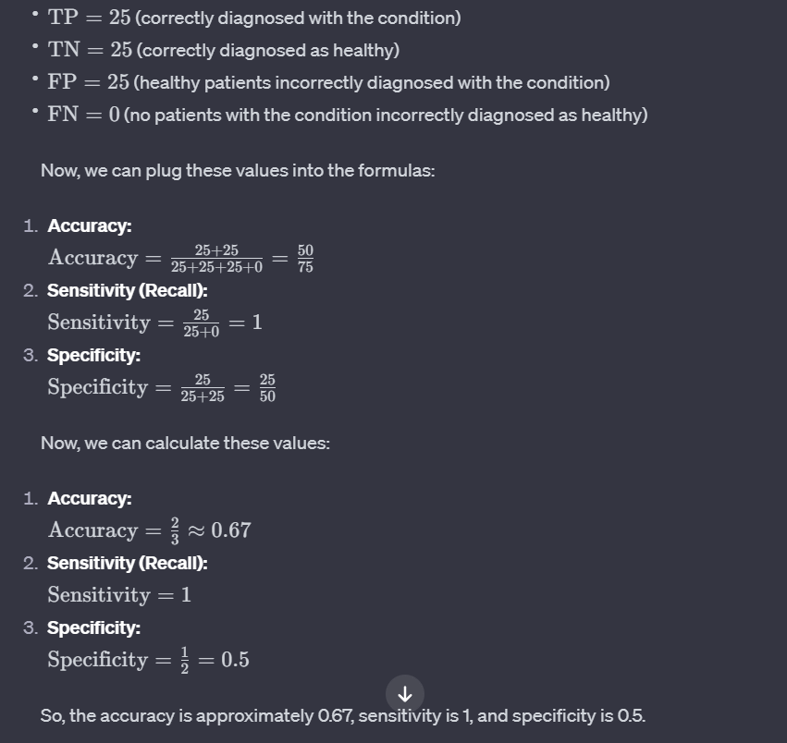

2a) Classify the types of wrapper methods in feature selection.

Types of wrapper methods in feature selection

Forward Selection: Forward selection is an iterative method in which we start with having no feature in the model. In each iteration, we keep adding the feature which best improves our model till an addition of a new variable does not improve the performance of the model.

Backward Elimination: In backward elimination, we start with all the features and removes the least significant feature at each iteration which improves the performance of the model. We repeat this until no improvement is observed on removal of features.

Recursive Feature elimination: It is a greedy optimization algorithm which aims to find the best performing feature subset. It repeatedly creates models and keeps aside the best or the worst performing feature at each iteration. It constructs the next model with the left features until all the features are exhausted. It then ranks the features based on the order of their elimination.

Bidirectional Search:

Combines forward selection and backward elimination. It starts with an empty set, adds features until no further improvement is observed, and then removes features one by one until the optimal subset is found.

Sequential Feature Selection:

Similar to forward selection but allows for more flexibility in selecting subsets of features. It explores different combinations of features to find the best-performing subset.

Floating Search:

A variation of sequential feature selection that considers adding or removing features in each iteration based on a performance criterion. It provides more flexibility by allowing features to be swapped in and out during the selection process.

Genetic Algorithms:

Utilizes principles from genetic algorithms to search for the optimal feature subset. It involves encoding potential solutions (feature subsets) as individuals in a population, applying crossover and mutation operations, and selecting individuals based on their fitness (model performance).

Simulated Annealing:

Adapts the annealing process in metallurgy to the feature selection problem. It involves iteratively accepting or rejecting feature subsets based on a probability distribution, allowing the algorithm to escape local optima and explore the solution space more effectively.

2b) Analyse the factors to consider when building a machine learning pipeline.

1. Define your objectives:

* Clearly understand the problem you're trying to solve and the business goals you want to achieve.
* This will guide your choices throughout the pipeline and ensure you're building the right solution.

2. Data considerations:

* Data quality: Ensure your data is accurate, consistent, and free from errors or biases. This significantly impacts model performance.
* Data quantity: Do you have enough data to train your model effectively? Consider data augmentation techniques if needed.
* Data access and management: Design a system for easy access, versioning, and tracking of data throughout the pipeline.

3. Model selection:

* Choose the appropriate machine learning model based on your problem and data characteristics.
* Consider factors like complexity, interpretability, and computational resources.

4. Feature engineering:

* Extract relevant features from your data that explain the target variable.
* Feature selection and engineering can significantly improve model performance.

5. Pipeline design:

* Break down the pipeline into modular components (data preprocessing, training, evaluation, etc.) for easier development and maintenance.
* Consider automation as much as possible to streamline the process and improve efficiency.

6. Testing and evaluation:

* Rigorously test your model using appropriate metrics and metrics based on your objectives.
* Consider different evaluation techniques like cross-validation and model comparison to ensure unbiased results.

7. Deployment and monitoring:

* Design a plan for deploying your model into production and integrating it with existing systems.
* Continuously monitor the model's performance and retrain it periodically to maintain accuracy and adapt to changing data.

8. Additional factors:

* Scalability: Consider the potential for future growth and design a pipeline that can handle increased data volume or complexity.
* Interpretability: Choose models and techniques that explain their predictions, especially for critical applications.
* Data privacy and security: Implement necessary safeguards to protect sensitive data throughout the pipeline.

3a) Describe the features, parameters and classes in machine learning.

1. Features

* Definition: Features are the individual, measurable characteristics or attributes that describe the data points you're working with. They serve as the input variables for machine learning models.
* Examples:
  + In a dataset about people, features could include age, height, weight, gender, income, etc.
  + In a dataset about email, features could include sender, subject line, word count, number of attachments, etc.
* Importance: Features are crucial because they provide the model with the information it needs to learn patterns and make predictions.

2. Parameters

* Definition: Parameters are the internal variables of a machine learning model that are learned or estimated from the data during training. They directly control the model's behaviour and how it maps input features to output predictions.
* Examples:
  + In linear regression, the slope and intercept are the parameters.
  + In a neural network, the weights and biases of the connections between neurons are the parameters.
* Learning Process: Training a model involves adjusting these parameters to minimize errors and find the best possible fit for the data.

3. Classes

* Definition: Classes are the possible output categories or labels that a machine learning model can predict, especially in classification tasks.
* Types of Problems:
  + In binary classification, there are only two classes (e.g., "spam" or "not spam" for emails).
  + In multi-class classification, there are more than two classes (e.g., "cat", "dog", or "bird" for images).
* Relationship to Features and Parameters: The model learns how to map the input features to these output classes based on the parameters it has learned during training.

3b) Compare the different evaluation model with an example.

1. Donabedian Model:

Developed by Avedis Donabedian, this model focuses on three key components of healthcare quality: structure, process, and outcomes. It helps assess the quality of healthcare delivery by examining the organizational structure, the processes involved in care, and the resulting health outcomes.

2. Outcome-Based Evaluation:

This model evaluates the effectiveness of healthcare interventions by measuring the outcomes achieved. It emphasizes assessing the impact of healthcare programs on patient health and wellbeing. Common outcome measures include mortality rates, morbidity rates, patient satisfaction, and quality of life.

3. Cost-Effectiveness Analysis (CEA):

CEA evaluates the cost-effectiveness of healthcare interventions by comparing the costs and outcomes of different treatment options. It helps decisionmakers allocate resources efficiently by identifying interventions that provide the most health benefits for the least cos

4. Quality Improvement Models:

Models such as the Plan-Do-Study-Act (PDSA) cycle or the Six Sigma approach focus on continuous quality improvement. These models involve iterative cycles of planning, implementing, studying results, and making adjustments to enhance the quality and efficiency of healthcare processes.

5. Logic Models:

Logic models provide a visual representation of the relationships between program inputs, activities, outputs, and outcomes. They help in understanding the underlying assumptions and causal pathways of healthcare interventions, making it easier to evaluate program effectiveness.

6. Balanced Scorecard:

This model assesses healthcare organizations from multiple perspectives, including financial, customer satisfaction, internal processes, and learning and growth. It provides a comprehensive view of organizational performance beyond traditional financial metrics.

7. Health Impact Assessment (HIA):

HIA evaluates the potential health effects of policies, programs, or projects in sectors outside of the health domain. It helps decisionmakers consider health implications when planning and implementing initiatives in areas such as transportation, urban planning, or environmental policies.

8. Decision Analytic Models:

These models use mathematical and statistical methods to analyse complex healthcare decisions. Examples include Markov models and decision trees, which help evaluate the potential outcomes and costs associated with different healthcare interventions.

9. Patient-Centred Outcomes Research (PCOR):

PCOR emphasizes incorporating patient preferences and experiences into the evaluation of healthcare interventions. It aims to produce evidence that is directly relevant to patients and supports shared decision-making.

10. Technology Assessment Models:

These models evaluate the adoption and impact of new healthcare technologies, considering factors such as effectiveness, cost, and ethical considerations.

4a) Consider a case where we have to select the best candidate among 5 candidates who are appearing for an interview. Table 1 consists of the details of 5 students which includes their CGPA, the salary that they are expecting per month, their scores in the technical exam and the grades achieved by them in the aptitude test.

|  |  |  |  |  |
| --- | --- | --- | --- | --- |
| **Attribute** | **CGPA** | **Expected Stipend** | **Technical Exam Score** | **Aptitude Test Grade** |
| Student 1 | 9 | 15000 | 72 | B1 |
| Student 2 | 7.6 | 7500 | 68 | B1 |
| Student 3 | 8.2 | 10500 | 63 | B2 |
| Student 4 | 8.5 | 10000 | 70 | A2 |
| Student 5 | 9.3 | 14000 | 72 | A2 |

Consider the weights assumed by the interviewing panel as follows:   
CGPA = 30%, Expected Stipend = 20%, Technical Exam Score = 25%, Aptitude Test Grade = 25%

Consider the following points for the grade system.  
A1–5   
A2–4   
B1–3   
B2–2   
C1–1

Select the best student by using Weighted Sum method.

Sol: https://www.geeksforgeeks.org/weighted-sum-method-multi-criteria-decision-making/

4b) Describe the steps involved in health care data analytics.

Healthcare data analytics is a process of collecting, analysing, and interpreting healthcare data to improve patient care and operational efficiency. The steps involved in healthcare data analytics typically include the following:

* Data collection: Healthcare data can come from a variety of sources, such as electronic health records (EHRs), claims data, patient surveys, and wearable devices. The first step in the healthcare data analytics process is to collect and integrate data from these disparate sources.
* Data cleaning and preparation: Once the data has been collected, it needs to be cleaned and prepared for analysis. This may involve removing errors, inconsistencies, and missing values. It may also involve transforming the data into a format that is suitable for analysis.
* Exploratory data analysis (EDA): EDA is a process of exploring the data to understand its characteristics and patterns. This can be done using a variety of techniques, such as data visualization, descriptive statistics, and outlier detection.
* Feature engineering: Feature engineering is the process of creating new features from the existing data. This can be done to improve the performance of the machine learning models that will be used later in the process.
* Model selection and training: Once the data has been prepared, a machine learning model can be selected and trained. There are a variety of machine learning algorithms that can be used for healthcare data analytics, such as logistic regression, decision trees, and random forests.
* Model evaluation: Once the model has been trained, it needs to be evaluated to ensure that it is performing well. This can be done using a variety of metrics, such as accuracy, precision, and recall.
* Deployment and monitoring: Once the model has been evaluated, it can be deployed into production. It is important to monitor the model's performance over time to ensure that it is still performing well.
* Communication and collaboration: Healthcare data analytics is a collaborative effort that involves a variety of stakeholders, including data analysts, clinicians, and healthcare administrators. It is important to communicate the results of the analysis in a way that is understandable to all stakeholders.

5a) Describe the architecture of IoT in the healthcare system.

The architecture of the Internet of Things (IoT) in healthcare involves the integration of various devices, sensors, networks, and platforms to collect, transmit, and analyze health-related data. The goal is to improve patient care, monitor health conditions, and streamline healthcare processes. Here is a general overview of the architecture of IoT in the healthcare system:

1. Devices and Sensors:

* Wearable Devices: These include smartwatches, fitness trackers, and other wearable sensors that continuously monitor vital signs, activity levels, and other health-related metrics.
* Medical Devices: Specialized medical devices, such as glucometers, blood pressure monitors, and ECG devices, are equipped with sensors to collect patient-specific data.

2. IoT Gateways:

* IoT gateways act as intermediaries between the devices and the cloud or central server. They aggregate data from various devices, preprocess it, and send it to the cloud for further analysis. Gateways may also provide local processing and filtering to reduce latency.

3. Communication Protocols:

* Wireless Communication: IoT devices typically use wireless communication protocols such as Wi-Fi, Bluetooth, Zigbee, or cellular networks to transmit data to the cloud or gateways.
* Health Level 7 (HL7): A standard for exchanging health information, often used for communication between healthcare systems and devices.

4. Cloud Infrastructure:

* Cloud Services: Health data is often stored and processed in the cloud. Cloud platforms provide scalable and secure storage, computing power, and data analytics capabilities.
* Data Management: Health data is stored in databases, and data management systems ensure the integrity, security, and accessibility of the data.

5. Data Analytics and Machine Learning:

* Data Processing: Analytical tools process the incoming data to derive meaningful insights. This can include real-time monitoring, trend analysis, and anomaly detection.
* Machine Learning Models: Predictive analytics and machine learning models can be applied to detect early signs of diseases, personalize treatment plans, and improve overall healthcare outcomes.

6. Security and Privacy:

* Authentication and Authorization: Strict security measures, including user authentication and authorization, are implemented to protect patient data.
* Encryption: Data transmission and storage are often encrypted to ensure the confidentiality and integrity of sensitive health information.
* Compliance: Healthcare IoT systems must comply with industry regulations and standards such as the Health Insurance Portability and Accountability Act (HIPAA) to safeguard patient privacy.

7. User Interface and Applications:

* Healthcare Applications: User interfaces and applications provide healthcare professionals, patients, and caregivers with access to relevant information. These applications may include dashboards, mobile apps, and web interfaces.
* Alerts and Notifications: Automated alerts and notifications can be generated based on predefined thresholds or abnormal patterns detected in the data.

8. Integration with Electronic Health Records (EHR):

* Integration with existing healthcare IT infrastructure, including electronic health records, allows for a seamless flow of information between IoT devices and the broader healthcare system.

9. Regulatory Compliance:

* Adherence to regulatory standards and guidelines is crucial in healthcare IoT to ensure patient safety, data security, and legal compliance.

5b) Compare knowledge-based vs non-knowledge-based Clinical Decision Support System.

**Knowledge-Based Clinical Decision Support System:**

1. Basis of Decision-Making:

Knowledge-driven Approach: Knowledge-based CDSS relies on explicit knowledge, rules, and logic encoded by human experts. It involves a rule-based system where predefined rules guide decision-making.

2. Knowledge Representation:

Explicit Knowledge: The knowledge base includes explicit rules, guidelines, and best practices derived from medical literature, clinical guidelines, and expert opinions.

3. Flexibility and Interpretability:

High Interpretability: Since decisions are based on explicit rules, it is generally easier to interpret and understand the reasoning behind the system's recommendations.

4. Adaptability:

May Require Manual Updates: Knowledge-based systems may need manual updates by experts to incorporate new medical knowledge or guidelines.

5. Examples:

MYCIN: A classic example of a knowledge-based CDSS used for infectious disease diagnosis and treatment.

**Non-Knowledge-Based Clinical Decision Support System:**

1. Basis of Decision-Making:

Data-driven Approach: Non-knowledge-based CDSS relies on machine learning algorithms and statistical models that learn patterns and relationships from large datasets.

2. Knowledge Representation:

Implicit Knowledge: The system learns patterns from historical data and identifies associations without explicit representation of medical knowledge.

3. Flexibility and Interpretability:

May Lack Interpretability: Machine learning models, particularly complex ones, may lack transparency, making it challenging to interpret the reasons behind specific recommendations.

4. Adaptability:

Adapts Automatically: Non-knowledge-based systems can adapt to new data without manual intervention, making them potentially more adaptive to changes.

5. Examples:

Predictive Models: Models predicting patient outcomes, readmission risks, or disease progression based on historical patient data.

6a) Show how RC6 encrypts and decrypts the message with an example

RC6 is a symmetric key block cipher designed for efficient software implementation. It operates on fixed-size blocks of data and supports key sizes of 128, 192, and 256 bits. The encryption and decryption processes involve a series of modular additions, bitwise XOR operations, and modular multiplications. Here, I'll provide a simplified explanation of the RC6 encryption and decryption processes along with a simple example.

RC6 Encryption:

1. Key Expansion:

* Expand the key into an array of round keys.

2. Initialization:

* Divide the plaintext into blocks (e.g., 128 bits).
* Initialize the working variables and mix in the plaintext.

3. Rounds:

* Perform a series of rounds (typically 20 rounds for a 128bit key).
* Each round includes operations such as modular additions, bitwise XOR, and modular multiplications.

4. Finalization:

* XOR the final intermediate values with the round keys.

RC6 Decryption:

1. Key Expansion:

* Expand the key into an array of round keys.

2. Initialization:

* Divide the ciphertext into blocks (e.g., 128 bits).
* Initialize the working variables and mix in the ciphertext.

3. Rounds (in reverse order):

* Perform the same series of rounds as in encryption but in reverse order.

4. Finalization:

* XOR the final intermediate values with the round keys.

Example: Let's walk through a simple example using a 128bit key and a 64bit block size. The plaintext is "HELLO123" (64 bits).

Key and Block:

* Key: `0x0123456789ABCDEF0123456789ABCDEF`
* Plaintext Block: `0x48454C4C4F313233`

Encryption:

1. Key Expansion: The key expands into an array of round keys.

2. Initialization: Initialize the working variables and mix in the plaintext block.

3. Rounds: Perform multiple rounds of operations.

4. Finalization: XOR the final intermediate values with the round keys.

The resulting ciphertext block after encryption is `0x5C3D45A81E764D1F`.

Decryption:

1. Key Expansion: The key expands into an array of round keys.

2. Initialization: Initialize the working variables and mix in the ciphertext block.

3. Rounds (in reverse order): Perform the same series of rounds as in encryption but in reverse order.

4. Finalization: XOR the final intermediate values with the round keys.

The decrypted plaintext block should be `0x48454C4C4F313233`, which corresponds to "HELLO123."

6b) Discuss the steps involved in using RNN for sequence labelling and provide mathematical explanations along with relevant examples

Steps involved in using RNN for sequence labelling and provide mathematical explanations along with relevant examples.

Data Preparation: To start, we need a labelled dataset for training and evaluation. The dataset should consist of input sequences and their corresponding output labels. For example, consider a named entity recognition task where we want to label named entities in sentences. The dataset would contain sentences and their associated entity labels.

Input and Output Encoding: Next, we need to encode the input and output data in a suitable format for the RNN. In NLP, inputs are typically represented as word embeddings or one-hot vectors, while outputs are often represented as numerical labels or one-hot vectors.

RNN Architecture: Choose the appropriate RNN architecture for the sequence labelling task. The most commonly used architectures are Long Short-Term Memory (LSTM) and Gated Recurrent Units (GRUs) due to their ability to capture long-term dependencies. Let’s consider LSTM for our explanation.

Forward Pass: The forward pass of the RNN involves processing the input sequence and generating the corresponding output sequence.

Let’s denote the input sequence as X = [x₁, x₂, …, xₙ], where each xᵢ represents the input at time step i. Similarly, let Y = [y₁, y₂, …, yₙ] represent the output sequence.

At each time step t, the LSTM computes the hidden state hₜ and the output oₜ using the following equations:

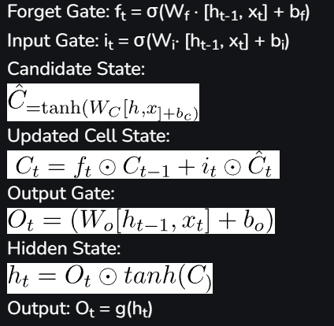

Here, σ represents the sigmoid activation function, ⊙ denotes element-wise multiplication, and W and b represent the weight and bias matrices/parameters of the LSTM.

Loss Calculation: To train the RNN, we need a loss function that measures the discrepancy between the predicted output Ot and the true output yt. Commonly used loss functions for sequence labelling tasks include cross-entropy loss and categorical loss. The loss at each time step t can be computed as:

Lt = loss (yt, Ot)

The overall loss L is calculated as the sum of the losses across all time steps:



Backpropagation Through Time (BPTT): To update the model parameters and minimize the loss, we use the technique of backpropagation through time (BPTT). BPTT involves calculating the gradients of the loss with respect to the parameters at each time step and updating the parameters using gradient descent optimization.

Training and Evaluation: Iteratively trains the RNN using the labelled dataset. Monitor the loss on a separate validation set and perform early stopping to prevent overfitting. Once trained, evaluate the RNN on a test set using metrics such as accuracy, precision, recall, and F1 score to assess its performance.

Example: Named Entity Recognition (NER)

Let’s consider the task of named entity recognition, where the goal is to identify and label named entities in sentences. For instance, given the sentence “John lives in New York,” the named entity labels would be [PERSON, O, O, LOCATION, LOCATION].

7a) Explain the tasks involved in semantic analysis with your example.

Tasks involved in Semantic Analysis

In order to understand the meaning of a sentence, the following are the major processes involved in Semantic Analysis:

* Word Sense Disambiguation
* Relationship Extraction

Word Sense Disambiguation:

In Natural Language, the meaning of a word may vary as per its usage in sentences and the context of the text. Word Sense Disambiguation involves interpreting the meaning of a word based upon the context of its occurrence in a text.

For example, the word ‘Bark’ may mean ‘the sound made by a dog’ or ‘the outermost layer of a tree.’

Likewise, the word ‘rock’ may mean ‘a stone ‘or ‘a genre of music; – hence, the accurate meaning of the word is highly dependent upon its context and usage in the text.

Thus, the ability of a machine to overcome the ambiguity involved in identifying the meaning of a word based on its usage and context is called Word Sense Disambiguation.

Relationship Extraction:

Another important task involved in Semantic Analysis is Relationship Extracting. It involves firstly identifying various entities present in the sentence and then extracting the relationships between those entities.

For example, consider the following sentence:

Health Care Analysis is a course of honours degree which was learnt by the students by their own. The entities involved in this text, along with their relationships, are shown below.

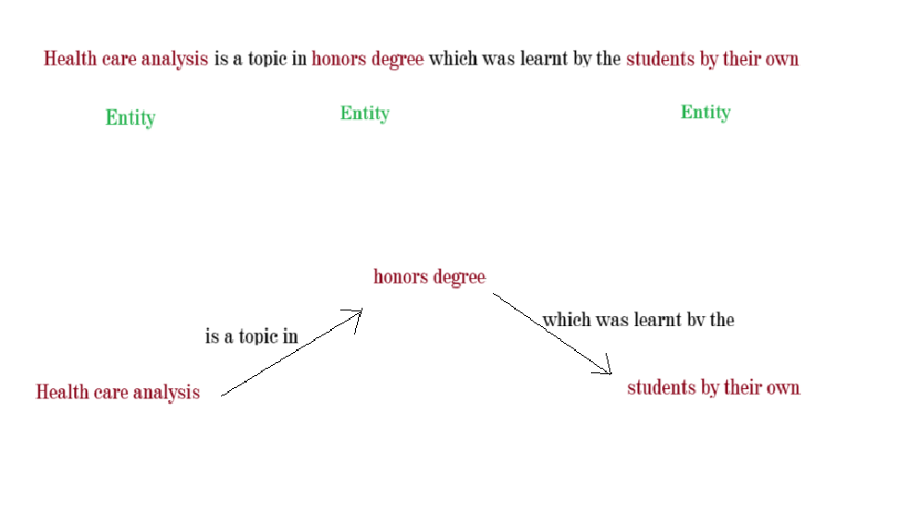  
7b) Describe the working process of Decoupled Dynamic Filter Networks.

1. Input:

* DDF takes an input feature map, often from a previous convolutional layer in a deep neural network.
* This feature map represents spatial information (e.g., pixels in an image or regions in a feature map).

2. Decoupling Depth-Wise Filters:

* DDF decouples a standard depth-wise convolution into two separate operations:
  + Spatial filter generation: A lightweight spatial attention module generates spatial filters dynamically based on the input features.
  + Channel-wise filter generation: A channel-wise attention module generates channel-specific filters to capture channel-wise dependencies.

3. Applying Filters:

* The generated spatial filters are applied to the input feature map through depth-wise convolution.
* This focuses on capturing spatial patterns and relationships within the input.
* The generated channel-wise filters are applied to the output of the depth-wise convolution through point-wise convolution.
* This focuses on refining feature representations across channels.

4. Output:

* The final output is a feature map with enhanced spatial and channel-wise information, tailored to the specific input.

Key Advantages:

* Reduced Parameters and Computational Cost: Decoupling filters into spatial and channel-wise components significantly reduces the number of parameters and computational cost compared to standard convolutions.
* Adaptive Feature Learning: Dynamic generation of filters allows the model to learn different filters for different input regions and channels, leading to better feature representation and accuracy.
* Improved Performance: DDF has been shown to improve performance in various tasks, including image classification, object detection, and semantic segmentation.

Applications:

* Image recognition
* Object detection
* Semantic segmentation
* Video analysis
* Medical image analysis
* Natural language processing

8a) Describe the strategies for migrating from SQL to NoSQL database.

Migrating from a SQL database to a NoSQL database can be a complex process, but there are several strategies that can be used to make the transition smoother. Here are some common strategies for migrating from SQL to NoSQL:

* Analyse the current SQL schema and data model: Before starting the migration, it’s important to analyse the current SQL schema and data model to identify any potential issues that may arise during the migration. This analysis can help to identify any data relationships that may need to be modified, and any data that may need to be denormalized or split across multiple tables.
* Choose the right NoSQL database: There are several types of NoSQL databases, each with their own strengths and weaknesses. Choosing the right NoSQL database for the specific needs of the application is important to ensure that the data is stored efficiently and can be accessed easily.
* Identify data access patterns: NoSQL databases are optimized for different types of data access patterns than SQL databases. Identifying the data access patterns in the application is critical to selecting the right NoSQL database and designing an effective data model.
* Plan the data migration: Once the NoSQL database and data model have been chosen, it’s important to plan the data migration process. This can involve exporting data from the SQL database into a format that can be imported into the NoSQL database, and then importing the data into the new database.
* Modify the application code: Because NoSQL databases often have different data access patterns and query languages than SQL databases, it may be necessary to modify the application code to work with the new database. This can involve modifying data access code, query language, and data structures.
* Test the new system: After the migration is complete, it’s important to thoroughly test the new system to ensure that it is working properly and providing the expected performance gains. This can involve testing data access times, query performance, and overall system reliability.

Overall, migrating from SQL to NoSQL can be a complex process, but by following these strategies and carefully planning the migration, organizations can take advantage of the scalability, performance, and flexibility of NoSQL databases.

8b) Discuss the need for image processing in the healthcare system.

Image processing plays a crucial role in modern healthcare by enabling non-invasive and accurate examination of the human body and supporting numerous medical applications. Here are some key reasons why image processing is vital in the healthcare system:

1. Diagnosis and Prognosis:

* Early disease detection: Medical imaging techniques like X-rays, CT scans, MRIs, and ultrasounds are processed to diagnose diseases like cancer, tumours, and bone fractures at early stages, leading to better treatment outcomes.
* Improved diagnosis accuracy: Image processing algorithms can analyse medical images to highlight subtle anomalies or abnormalities that might be missed by the human eye, aiding in more accurate diagnoses.
* Differential diagnosis: Differentiating between similar diseases becomes easier with advanced image processing techniques that can extract finer details from medical images.
* Prognosis and treatment planning: Analysing medical images helps predict the course of a disease and plan optimal treatment strategies, including surgery, radiation therapy, and medication.

2. Medical Interventions and Surgery:

* Image-guided surgery: Image processing aids in precise surgical planning by creating 3D models of organs and guiding surgeons during minimally invasive procedures, reducing risks and improving surgical outcomes.
* Robotic surgery: Image processing algorithms inform and control robotic surgical instruments, enhancing precision and dexterity in complex operations.
* Radiation therapy planning: Precise targeting of tumours and minimizing damage to surrounding tissues is achieved by processing medical images to create radiation therapy plans.

3. Monitoring and Detection

* Monitoring disease progression: Medical images are used to track the progress of medical conditions and treatment response, enabling adjustments to treatment plans when needed.
* Early detection of complications: Image processing algorithms can detect subtle changes in medical images that may indicate potential complications, allowing for proactive interventions.
* Remote patient monitoring: Telemedicine utilizes image processing to analyse medical images captured by patients at home, enabling remote diagnosis and monitoring by healthcare professionals.

4. Research and Development:

* Developing new diagnostic tools and treatments: Image processing plays a crucial role in developing new medical imaging techniques, diagnostic algorithms, and personalized treatment plans based on individual patient data.
* Understanding disease mechanisms: Analysing medical images allows researchers to study the progression of diseases at a cellular level, leading to a deeper understanding of disease mechanisms and potential cures.

9a) Explain the step-by-step process to analyse a patient’s ECG

1. Data Acquisition:

* Acquire the ECG recording, either through a traditional electrocardiograph or a portable device.
* Ensure proper electrode placement for accurate lead positions.
* Check for signal quality and identify any artifacts or noise that might interfere with analysis.

2. Initial Assessment:

* Heart Rate: Measure the heart rate by calculating the distance between R-waves (time between two consecutive peaks). Normal resting heart rate ranges from 60 to 100 beats per minute.
* Rhythm: Check if the rhythm is regular or irregular. Look for missed beats, extra beats, or variations in R-R intervals.

3. Waveform Analysis:

* P wave: Observe the P wave before each QRS complex, indicating atrial depolarization. Analyse its shape, size, and duration for potential atrial abnormalities.
* PR interval: Measure the time between the beginning of the P wave and the beginning of the QRS complex. This represents the atrioventricular conduction time. Prolonged or shortened intervals can indicate conduction issues.
* QRS complex: Examine the QRS complex, representing ventricular depolarization. Check for its width, amplitude, and morphology (shape). Wide or abnormal QRS complex can suggest various problems including bundle branch block or ventricular hypertrophy.
* ST segment: Analyse the ST segment between the end of the QRS complex and the beginning of the T wave. Elevation or depression can indicate ischemia or injury to the heart muscle.
* T wave: Observe the T wave, representing ventricular repolarization. Check its direction (upright or inverted), shape, and symmetry. Abnormal T waves can suggest myocardial infarction or electrolyte imbalances.
* QT interval: Measure the time from the beginning of the QRS complex to the end of the T wave. Prolonged QT interval can increase the risk of arrhythmias.

4. Advanced Analysis:

* QTc calculation: Correct the QT interval for heart rate to account for individual variability.
* Axis determination: Calculate the electrical axis of the heart from the QRS complex morphology. Abnormal axis deviation can indicate structural heart disease.
* Holter monitoring: Analyse an extended ECG recording (24-48 hours) to capture intermittent or infrequent arrhythmias that might miss a single 12-lead ECG.

5. Interpretation and Diagnosis:

* Interpret the findings in the context of the patient's clinical history, symptoms, and other diagnostic tests.
* Make a preliminary diagnosis based on the identified abnormalities and correlate it with clinical findings.
* Consult with a cardiologist for further evaluation and management if necessary.

9b) Discuss how the Smart Ambulance System is working with an IoT

The Smart Ambulance System leverages the power of the Internet of Things (IoT) to revolutionize emergency medical services.

Sensors and Wearables:

* Patients can wear biosensors or carry portable devices that monitor vital signs like heart rate, blood pressure, oxygen saturation, and temperature.
* Ambulances are equipped with various sensors that track environmental parameters like temperature, humidity, and air quality.

Data Transmission:

* Sensor data is transmitted in real-time through cellular networks or dedicated IoT communication protocols like NB-IoT or LoRaWAN.
* This data is uploaded to a cloud platform for centralized monitoring and analysis.

Real-time Monitoring and Analysis:

* The cloud platform receives and analyses the data from patients and ambulances.
* Advanced algorithms can detect potential health events, predict complications, and prioritize emergency cases.
* This information is shared with medical professionals at the hospital and in the ambulance.

Improved Care and Efficiency:

* Real-time insights allow medical personnel to prepare for a patient's arrival at the hospital, potentially speeding up diagnosis and treatment.
* Physicians can remotely monitor patients in the ambulance and guide paramedics if needed.
* Efficient route planning based on traffic conditions and hospital availability can minimize ambulance response times.

Additional Benefits:

* Remote patient monitoring: Allows healthcare professionals to remotely monitor patients with chronic conditions, reducing hospital visits.
* Improved data collection: Provides valuable data for research and development in emergency medicine.
* Enhanced safety: Environmental sensors in ambulances can detect hazards like gas leaks or temperature spikes, ensuring patient and paramedic safety.

Challenges and Considerations:

* Data security and privacy: Protecting sensitive patient data requires robust security measures and adherence to data privacy regulations.
* Interoperability: Ensuring seamless data exchange between different devices and systems is crucial.
* Infrastructure and connectivity: Reliable and widespread communication infrastructure is needed for effective data transmission.
* Cost and sustainability: Implementing and maintaining a smart ambulance system requires significant investment and ongoing operational costs.