High Level Design (HLD)

Heart Disease Diagnostic Analysis



# Contents

Document Version Control 2

Abstract 3

1. Introduction 4
   1. Why this High-Level Design Document? 4
   2. Scope… 4
2. General Description 5
   1. Product Perspective & Problem Statement 5
   2. Tools Used 5
3. Design Detail 6
   1. Functional Architecture 6
   2. Optimization 7
4. KPI 8
   1. KPIs (Key Performance Indicators) 9
5. Deployment 9

# Abstract

Health is real wealth in the pandemic time. We all have realized the brute effects of covid- 19 on all irrespective of any status. Heart disease is a term covering any disorder of the heart. Located in the chest region of the body, the heart beats around 80 beats per minute. Heart diseases have become a major concern to deal with as studies show that the number of deaths due to heart diseases have increased significantly over the past few decades in India it has become the leading cause of death in India.

Thus, preventing heart diseases has become more than necessary. Good data-driven systems for predicting heart diseases can improve the entire research and prevention process, making sure that more people can live healthy lives.

# Introduction

## Why this High-Level Design Document?

The purpose of this High-Level Design (HLD) Document is to add the necessary detail to the current project description to represent a suitable model for coding. This document is also intended to help detect contradictions before coding and can be used as a reference manual for how the modules interact at a high level.

**The HLD will:**

* + - Present all of the design aspects and define them in detail
    - Describe the user interface being implemented
    - Describe the hardware and software interfaces
    - Describe the performance requirements
    - Include design features and the architecture of the project
    - List and describe the non-functional attributes like:

-Security

-Reliability

-Maintainability

-Portability

-Reusability

-Application compatibility

-Resource utilization

-Serviceability

## Scope

The HLD documentation presents the structure of the system, such as the database architecture, application architecture (layers), application flow (Navigation), and technology architecture. The HLD uses non-technical to mildly- technical terms which should be understandable to the administrators of the system.

# General Description

## Product Perspective & Problem Statement

The goal of this project is to analyze to predict the probability of heart disease occurrence, based on a combination of features that describes the disease. To achieve the goal, we used a data set that is formed by taking into consideration some of the information of 303 individuals. The problem is based on the given information about each individual we have to calculate whether that individual will suffer from heart disease or not.

## Tools used

Business Intelligence tools and libraries works such as NumPy, Pandas, Matplotlib, MS-Excel, Tableau, Jupyter Notebook and Python Programming Language are used to build the whole framework.

# Design Details

## Functional Architecture

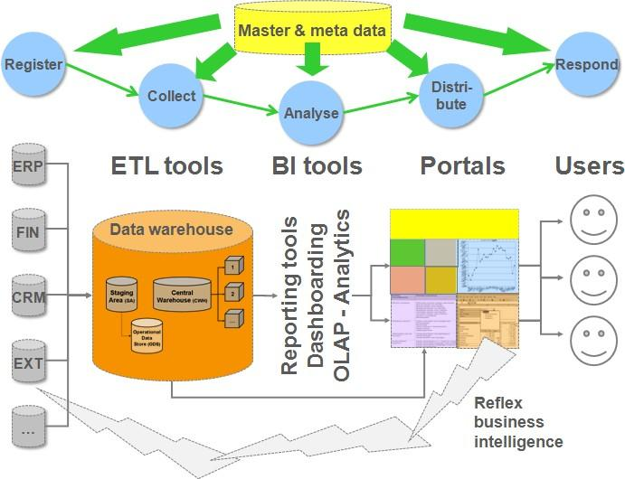

**How BI Works**

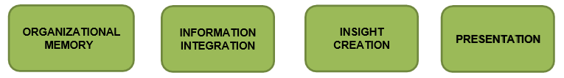

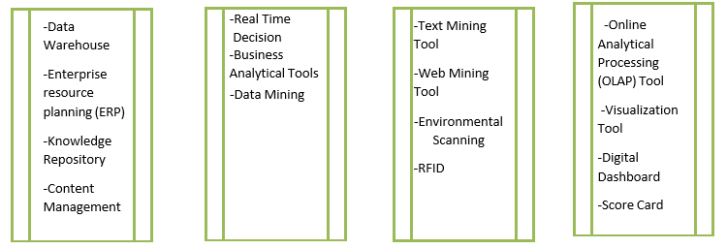

## Optimization

### Your data strategy drives performance

* Minimize the number of fields
* Minimize the number of records
* Optimize extracts to speed up future queries by materializing calculations, removing columns and the use of accelerated views

### Reduce the marks (data points) in your view

* Practice guided analytics. There’s no need to fit everything you plan to show in a single view. Compile related views and connect them with action filters to travel from overview to highly-granular views at the speed of thought.
* Remove unneeded dimensions from the detail shelf.
* Explore. Try displaying your data in different types of views.

### Limit your filters by number and type

* Reduce the number of filters in use. Excessive filters on a view will create a more complex query, which takes longer to return results. Double-check your filters and remove any that aren’t necessary.
* Use an include filter. Exclude filters load the entire domain of a dimension while including filters do not. An include filter runs much faster than an exclude filter, especially for dimensions with many members.
* Use a continuous date filter. Continuous date filters (relative and range-of- date filters) can take advantage of the indexing properties in your database and are faster than discrete data filters.
* Use Boolean or numeric filters. Computers process integers and Booleans (t/f) much faster than strings.
* Use parameters and action filters. These reduce the query load (and work across data sources).

### Optimize and materialize your calculations

* Perform calculations in the database
* Reduce the number of nested calculations.
* Reduce the granularity of LOD or table calculations in the view. The more granular the calculation, the longer it takes.
  + LODs - Look at the number of unique dimension members in the calculation.
  + Table Calculations - the more marks in the view, the longer it will take to calculate.
* Where possible, use MIN or MAX instead of AVG. AVG requires more processing than MIN or MAX. Often rows will be duplicated and display the same result with MIN, MAX, or AVG.
* Make groups with calculations. Like include filters, calculated groups load only named members of the domain, whereas Tableau’s group function loads the entire domain.
* Use Booleans or numeric calculations instead of string calculations. Computers can process integers and Booleans (t/f) much faster than strings. Boolean>Int>Float>Date>Date Time>String.

# Key Performance Indicators

Dashboards will be implemented to display and indicate certain KPIs and relevant indicators for the disease.

As and when the system starts to capture the historical/periodic data for a user, The dashboards will be included to display charts over time with progress on various indicators or factors

## KPIs (Key Performance Indicators)

Key indicators displaying a summary of the heart disease and its relationship with different metrics

1. Percentage of People Having Heart Disease
2. Variation of ‘thal’ (Thalassemia type) with ‘sex’
3. Variation of ‘chol’ (Cholesterol), ‘trestbps’ (Resting blood pressure) with ‘fbs’ (Fasting Blood Sugar).
4. Variation of ‘exang’ (Exercise induced angina) with ‘cp’ (Chest Pain type).
5. Variation of ‘num’ (Angiographic disease status) with ‘sex’.
6. Variation of the ‘age’ with ‘chol’ (Cholesterol) and ‘sex’
7. Variation of ‘cp’ (Chest Pain type) with ‘sex’
8. Variation of ‘thalach’ (Maximum heart rate) with ‘age’
9. Variation of ‘restecg’ (Resting electrocardiograph results) with ‘sex’ 10.Variation of ‘slope’ (Slope of the peak exercise ST segment), ‘restecg’ (Resting Electrocardiograph results) and ‘oldpeak’ (ST depression induced by exercise relative to rest)

# Deployment

Prioritizing data and analytics couldn’t come at a better time. Your company, no matter what size, is already collecting data and most likely analyzing just a portion of it to solve business problems, gain competitive advantages, and drive enterprise transformation. With the explosive growth of enterprise data, database technologies, and the high demand for analytical skills, today’s most effective IT organizations have shifted their focus to enabling self-service by deploying and operating Tableau at scale, as well as organizing, orchestrating, and unifying disparate sources of data for business users and experts alike to author and consume content.

Tableau prioritizes choice in flexibility to fit the enterprise architecture. Tableau Server and Tableau Online leverages your existing technology investments and integrate into your IT infrastructure to provide a self-service, modern analytics platform for users. With on-premises, cloud and hosted options, there is a version of Tableau to match your requirements. Below is a comparison of the three types: Types:

1. Tableau Server - On Premises
   * Full control of hardware and software
   * Infrastructure and data remain behind your firewall
   * Need dedicated administrators to manage hardware and software
   * Additional infrastructure needed to access off-network (mobile, external)
2. Tableau Server - Public Cloud (IaaS)
   * Full control of software on managed hardware
   * Puts infrastructure in same place as data (for migration to cloud)
   * Flexibility to spin up/down hardware as needed
   * Need dedicated administrators to manage software
   * Additional infrastructure needed to access off-network (mobile, external)
3. Tableau Online (SaaS)
   * Fully hosted solution (hardware, software upgrades)
   * Fast to deploy

