**Wireframe Diagram**

Heart Disease Diagnostic Analysis

We Performed Exploratory Data Analysis on Jupyter Notebook and then created Tableau Desktop Dashboard.

# Distribution of People having Heart Disease

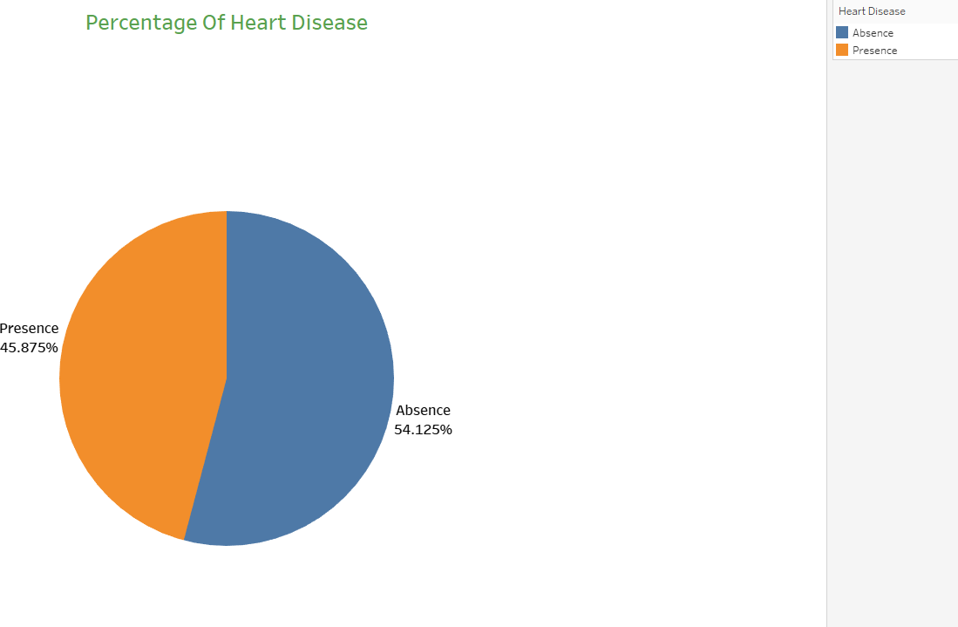

1)We can see that 45.87% of People suffer from heart disease.

2)The Absence of heart disease is in 54.125% of people.

# Variation Of ‘age’ with ‘chol’ (cholesterol) Variables

* 1. The scatter plot of age vs chol shows that there is no specific relation between the Age and the chol. Low aged people also show moderate to high chol levels and vice versa.

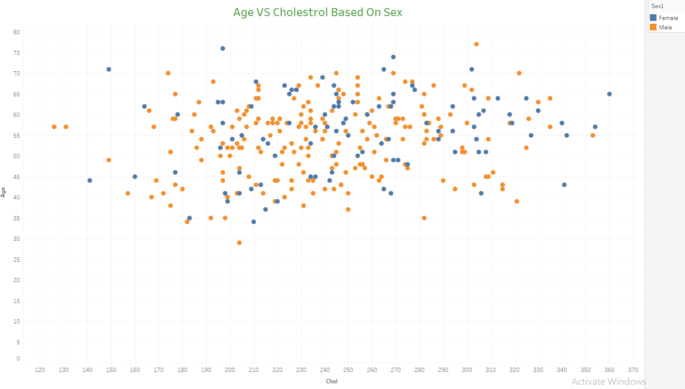

# Variation of ‘thal’ (Thalassemia) with ‘sex’

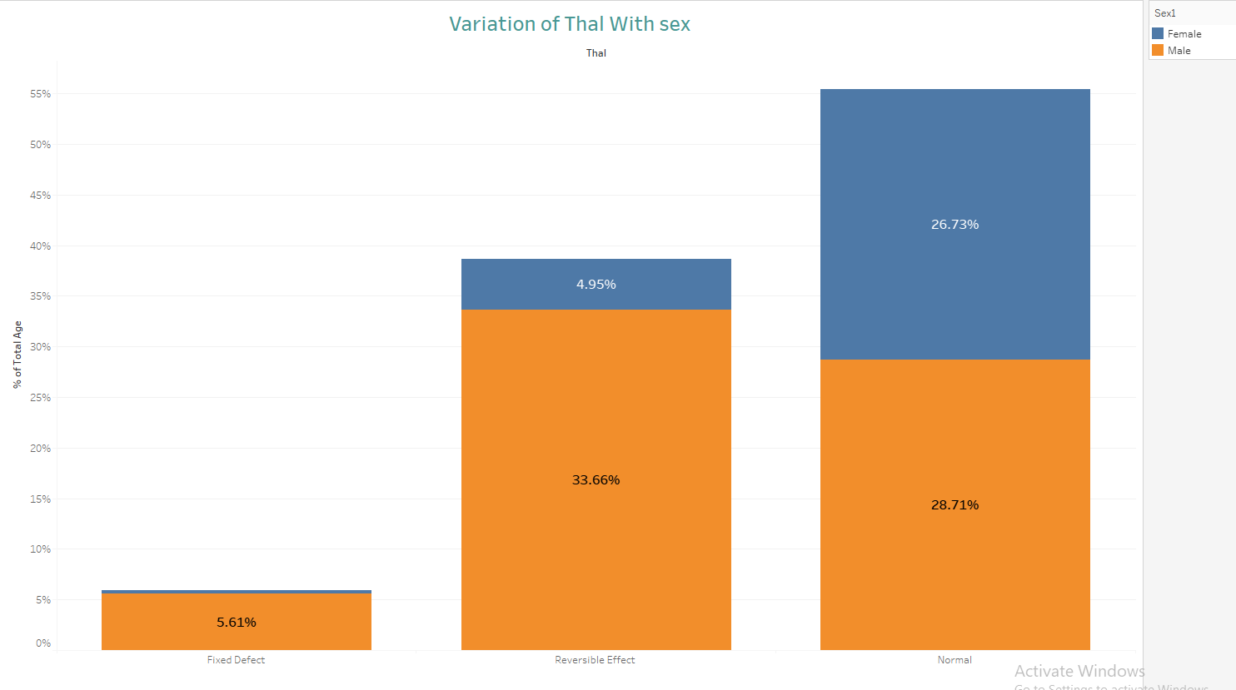

1. We observe that the normal type of thalassemia is common in both males and females and there are equal chances to contradict the disorder.
2. As opposed to the normal type, the fixed and reversible types of thalassemia are more likely to be found in the Male sex. The proportion of the Males having these disorders is much greater than the females.

# Variation Of ‘cp’ (Chest Pain Type) with ‘sex’ variables

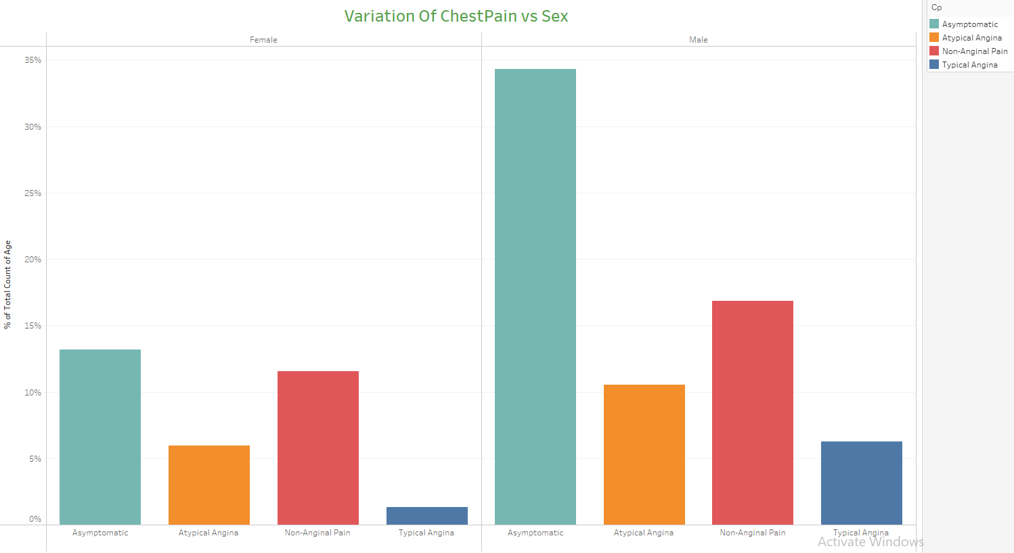

1. When comparing the individual Chest Pain type percentages for Males and Females, it is clear that Males are more prone to the Chest Pain symptoms.
2. The Asymptomatic type of Chest Pain is the one which affects both Males and Females in the higher proportion. But in Males it surpasses the rate as compared to Females by more than double.

# Variation of thalach (maximum heart rate) with age

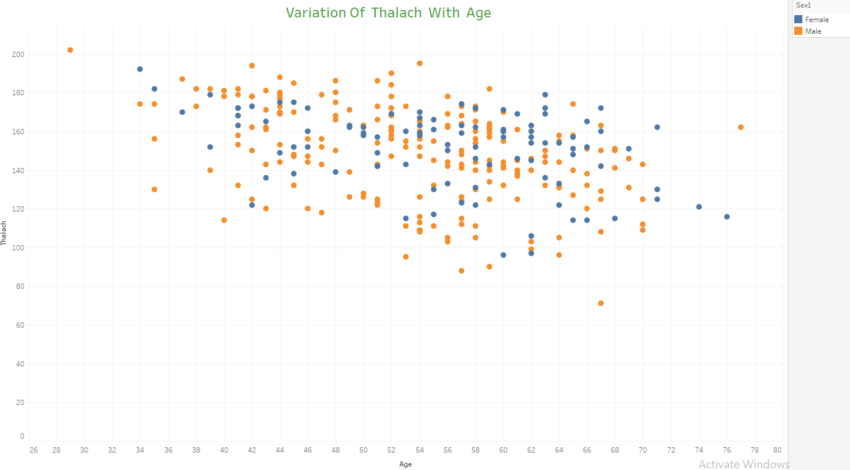

1. We can see a general negative correlation between the Age and Thalach parameters.
2. If we highlight the Sex attribute, we will be able to see an approximate downward trend indicating that as the age increases the thalach (maximum heart rate) starts decreasing.

# Variation of ‘exang’ (Exercised induced angina) with ‘cp’ (Chest Pain Type)

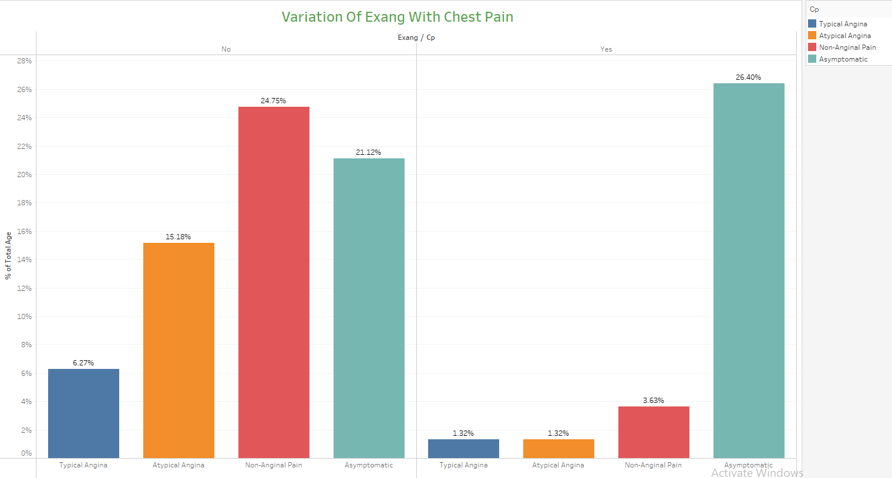

1. This is a graph showing the variation of the exercise induced angina against Chest Pain type and the count in each category.
2. It can be clearly seen that the Asymptomatic angina type has shown increase in those people for whom the exang variable is Yes. Meaning that people who have performed exercise have a higher chance of experiencing the Asymptomatic angina type.
3. The remaining Chest Pain types have shown a great downfall when the people have performed exercise.

# Variation of ‘slope’ (Slope of the peak exercise ST segment), ‘restecg’ (Resting Electrocardiograph results) and ‘oldpeak’ (ST depression induced by exercise relative to rest)

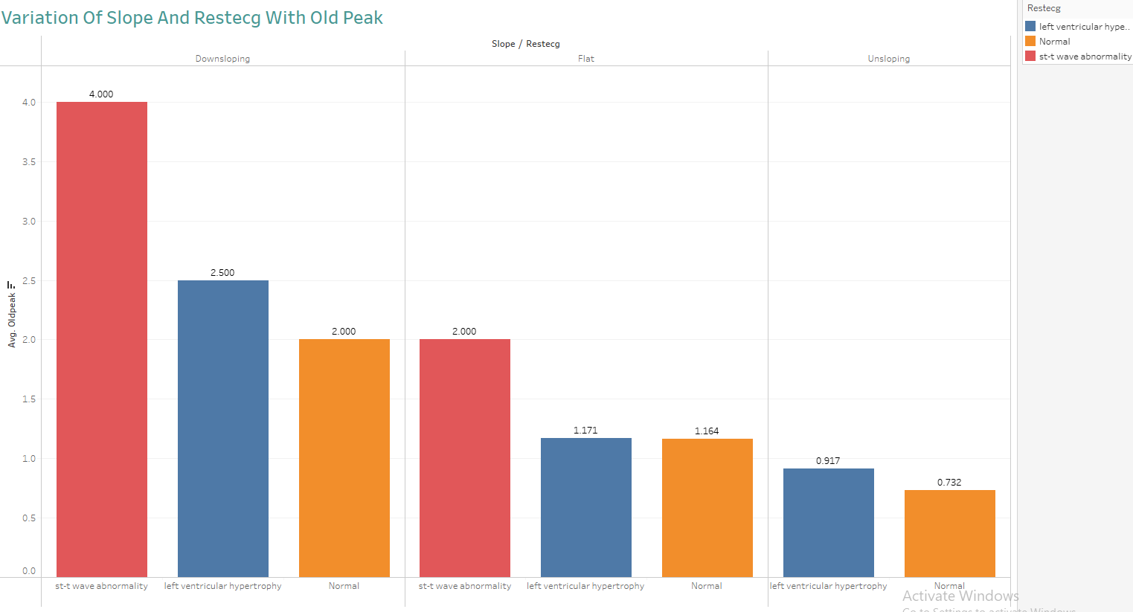

1. This graph shows the variation of the Slope and RestEcg against Oldpeak value.
2. We can infer that the people for whom the Slope is Upsloping, they experience the Normal or left ventricular hypertrophy type of Restecg
3. But for people with Flat or Downsloping Slope, they experience all 3 different types of Restecg categories.

# Variation of ‘num’ (Angiographic disease status) with ‘sex’

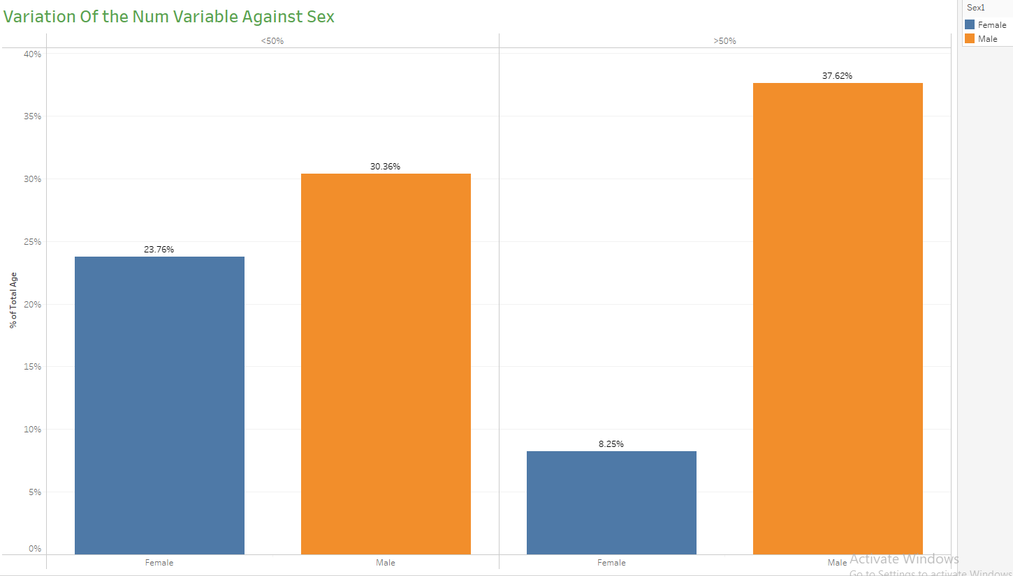

1. We can see that out of the total Female population, close to 24% have less than 50% diameter narrowing and hence less chances of angiographic disease and around 8% have more than 50% diameter narrowing.
2. But in Males, this trend is reversed. The Males have higher chances of suffering the angiographic disease owning to around 38% of Male population having more than 50% diameter narrowing.